
Master of Business Administration
International Business pathway


Contemporary employability skills
Assessment 1: Individual report. Weight: 50%
Module name: Marketing Management
Module code: LCMB7024
Lecturer name: Laila Maazouz
Taonga Kaonga Sobere-
Snithers

Student name: Sanket kumar bipinbhai pandya
Student ID: 2538532

Word count: 2575
Submission date: 14/08/2026
AI Acknowledgement
I confirm that no Artificial Intelligence (AI) tools, including generative AI applications, were used in the research, writing, analysis, or preparation of this assignment. All work presented is entirely my own, based on independent study, critical analysis, and the use of appropriate academic sources, in accordance with university academic integrity policies.
Table of Contents
Element 1: Sustainable Brand Extension Poster Presentation 3
Element 2: Develop a Segmentation, Targeting, Differentiation, and Positioning (STDP) 4
2.1 Market Segmentation 4
2.2 Target Audience and Customer Appeal 6
2.3 Differentiation from Competitors 7
2.4 Positioning of the Sustainable Brand Extension 8
Element 3: Marketing Mix (4Ps or 7Ps) 9
3.1 Product 9
3.2 Price 11
3.3 Place 11
3.4 Promotion 12
3.5 People 13
3.6 Process 14
3.7 Physical Evidence 14
Element 4: Reflection 15
4.1 Concrete Experience 15
4.2 Reflective Observation 15
4.3 Abstract Conceptualisation 16
4.4 Active Experimentation 16
Reference List 17
Appendix: Kolb’s Reflective Cycle 20

Element 1: Sustainable Brand Extension Poster Presentation
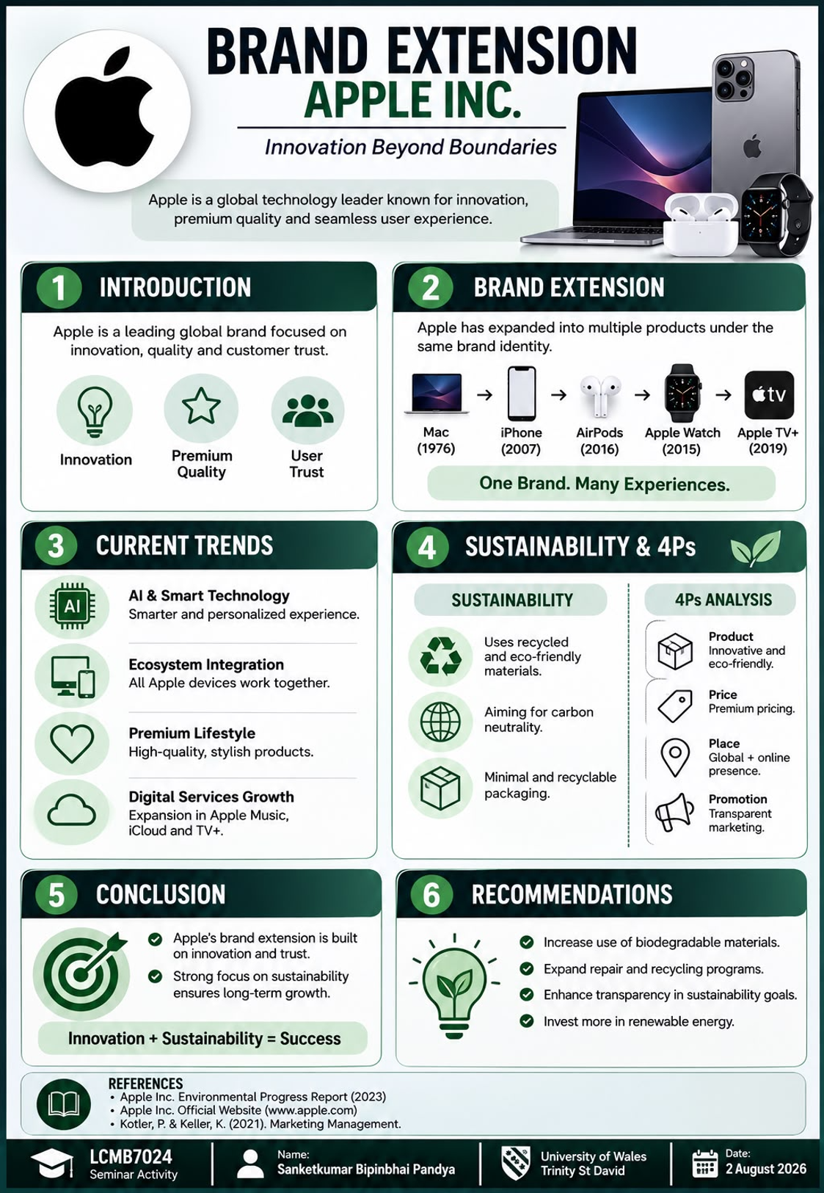
Figure 1: Poster
(Source: self-developed)

Element 2: Develop a Segmentation, Targeting, Differentiation, and Positioning (STDP)

2.1 Market Segmentation
Using geographic, demographic, psychographic and behaviour segmentation, the consumers with needs that align with high tech technology and environmental concerns for the proposed sustainable Apple brand extension should be identified. Geographically speaking, it is smart to begin in the markets that are developed and technologically advanced such as in the UK, US, Western Europe, Australia and some important cities in Asia, where the penetration of smartphones, online shopping, as well as the interest in sustainable products is high (Saputra et al., 2025). In terms of demographics, the extension can be targeted at younger age-groups (18-45) like university students, young professionals, technology users and higher income households. One of the things you have to bear in mind when purchasing Apple items is having a high spending power and it's a costly item.
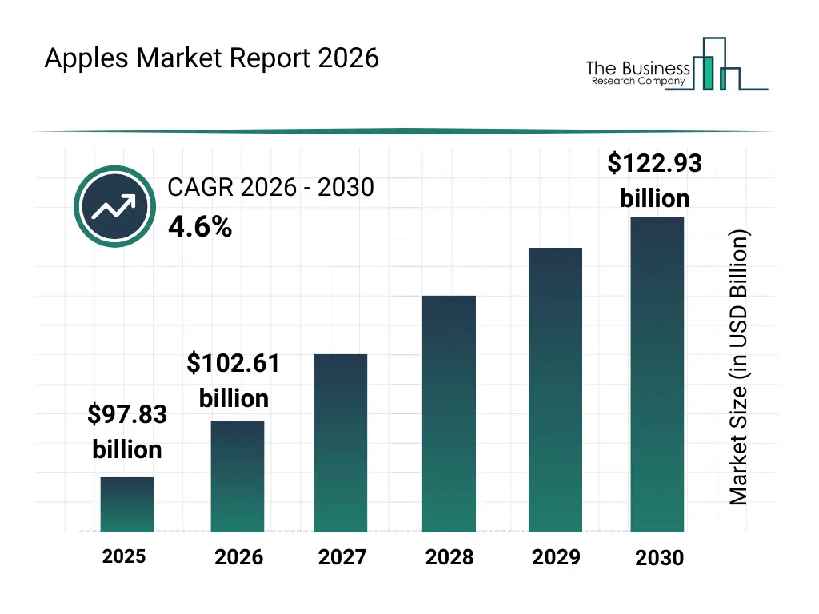
Figure 2: Apple market size data
(Source: thebusinessresearchcompany.com, 2025)
The most interested in innovation, quality, modern life, ethical consumption and environmental protection are the strongest segment from the psychograph point of view. Consumers' interest and values in sustainability are growing and they are looking for ways to buy products that satisfy their sustainability interest and values, both in terms of process and in terms of design and performance (Yang and Liu, 2024). The extension should target existing Apple users, customers who buy technology frequently, and customers who are interested in the trade-in and towards active consumer involvement in e-waste recycling. With recycling programmes in place in 99% of the countries Apple sells its products, there is a good foundation in place to support a circular sustainable proposition..

2.2 Target Audience and Customer Appeal
The target is the people that are between the age of 18-45, tech-savvy, already interested in Apple's quality ecosystem, and have higher income, and are already environment conscious. This objective is attractive because it offers Apple a chance to build on brand recognition, instead of creating new customers. The sustainable extension could be: More products with recycled content; Packaging which is recyclable; Improved recycling opportunity; Improved product life; Energy efficient technology. This is because Apple is moving towards becoming sustainable. Of that year's material that Apple shipped, 30% was from recycled content, and Apple stated that emissions were over 60% less than in 2015 in 2025 (apple.com, 2026). Also used was 100% cobalt recycled batteries and 100% rare-earth elements (REE) recycled magnets. The achievements are not just a sales pitch leveraging on selling sustainability, it's real and actual results. The audience that the target user is likely to encounter, will therefore be able to judge the extension as technically performing, a high class in design and that it is being used responsibly (Liao and Sundar, 2022). The idea also has the potential to attract investors as sustainability can enhance Apple's brand image in the long term, promote resource efficiency, and meet growing environmental demands.
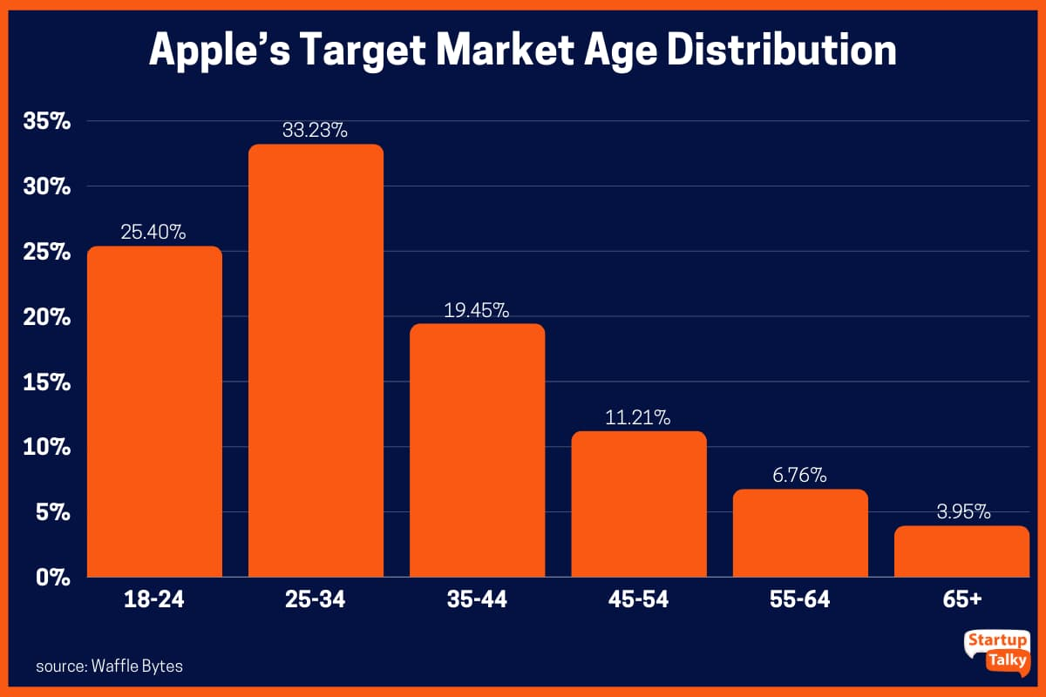
Figure 3: Apple target market age data
(Source: Vyshnavi et al., 2025)

2.3 Differentiation from Competitors
Apple needs to offer high-tech, environmental, design and ecosystem. The contestants can invent their own environmental products, but the magic of Apple is it can be sustainable from hardware to software to services to manufacturing and recycling. For instance, Apple has pledged to be carbon neutral in its total scope of operations by 2030 with a step one in the strategy of cutting emissions by 75% before addressing the remaining emissions by removing carbon (apple.com, 2026). The proposed extension can help to follow this route by utilizing recycled aluminium, recycled rare earth materials, responsible sourcing using fibre components and packaging. Apple is already 100% fibre-based, and the company stated that the MacBook Neo that it has just released has 60% recycled content, overall (apple.com, 2026). These quantifiable features may be the ones that set the extension apart from all the other products that would be the subject of discussion on sustainability. The Apple Watch, Mac, AirPods and Apple services integration will give an ecosystem benefit, too. The differentiation proposition can then be given the form of “Premium Apple innovation with measurable environmental responsibility.” This would enable sustainability to build on, not on the back of, Apple's traditional connotations of quality, innovation and design.

2.4 Positioning of the Sustainable Brand Extension
The sustainable extension should be offered as an added value, innovative and environmentally responsible technology solution for consumers having a high interest in the high performance without compromising their sustainable values. Placing should evoke that consumers don't have to sacrifice luxury technology for responsible consumption (Machado, 2025). The intended consumer's desired perception of the extension needs to be connected to the elements of innovation, high quality, sustainability, durability and trust. The positioning statement could be, “Apple Sustainable Technology – high-end innovation for a more sustainable future.” These are the most recent environmental gains of Apple, with 30% of all Apple products shipped being made from recycled materials, more than 60% of the Apple's GHGs emissions were cut when compared to 2015, and all cobalt in Apple-designed batteries came from recycled materials (apple.com, 2026) The extension will also include repair, recycling, trade in and responsible end-of-life management to reinforce the sustainability beyond the point of sale.
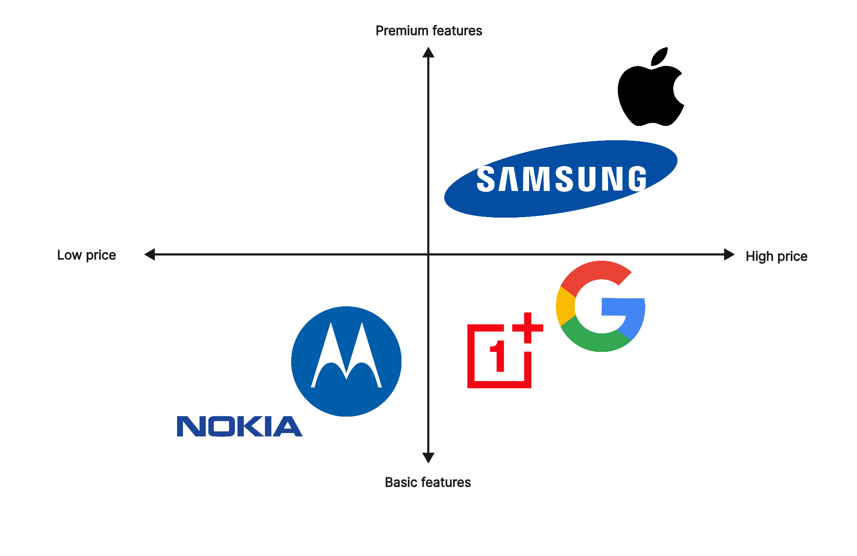
Figure 4: Apple market positioning
(Source: self-developed)

Element 3: Marketing Mix (4Ps or 7Ps)

3.1 Product
Apple's innovative ability, design and user experience should be combined with its newfound environmental capability to create the suggested sustainable brand extension for Apple. These may be in higher proportions in more components of the product that are recycled or responsibly sourced, energy efficient, long-life or recyclable. Sustainability should not only be a talking point, but should also be a part of the product (Lefebvre, 2023). It is believable if used with recycled materials which Apple already uses and fits in the Apple ecosystem, reducing users switching costs. The product proposition will thus provide a functional value through technology, and an emotional value through sustainable consumption, thus further solidifying Apple's premium brands image.
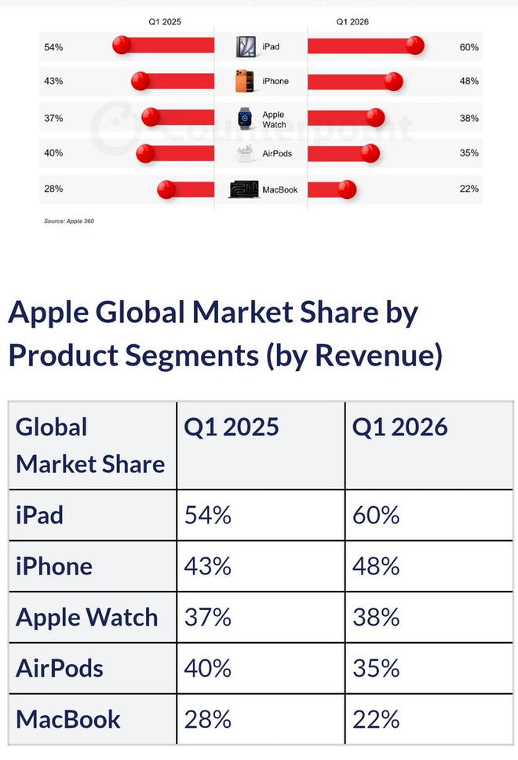
Figure 5: Apple product segment by revenue
(Source: Webmaster, 2026)

3.2 Price
The sustainable extension should be priced more and be sold in the same way as it's sold in the market by Apple. The more expensive, the more advanced, the better materials, the greater investment in research and development and the increased environmental performance. But for Apple to go green doesn't have to be too expensive for those who want to do their part for the environment—and more than a marketing ploy (Collins, Ocampo and Thomhave, 2024). Therefore a value based pricing would be suitable where the price will be fixed not just according to the cost of production, but also the benefits which the customers think of. There's a possibility that Apple might be able to have more than one option of these products so that Apple users have the choice and yet have that high-end image (Lefebvre, 2023).. Trade-ins can also assist the customer in making the device more affordable to them, and encourage customers to return their used device for a responsible recyclable or refurbishment process. This will help to earn income and circular utilization. Prices should, therefore, reflect a high value, durability and innovation; incentives should facilitate the ability to afford these products and promote sustainable consumption, including trade-in products.

3.3 Place
The company should roll out the sustainable extension via its existing retail and online and authorised reseller network around the world, thus efficiently reaching existing customers. In particular, Apple Stores would be crucial as they would offer an opportunity for customers to physically experience the product and learn about the environmental characteristics of the product. It may be helpful to consumers if the company offers information about recycled content, energy consumption, packaging and recycling and other environmental issues on their web site that they can use to choose their products (Thangam and Chavadi, 2023). The distribution of products should also take sustainability into account, e.g., by minimizing the need for unnecessary transport, optimizing packages and/or by adopting the most carbon efficient logistics if it is possible. Established trade-in and recycling policies can be included in the distribution program, and an extra value-added service can be offered – that is, customers will bring their old phones when they get the new extension.

3.4 Promotion
Communicate the sustainable extension via integrated marketing communications, all digital advertising, social media, Apple Stores, websites, public relations and product demonstrations. The message should be made clear that innovation and sustainability is not a compromise and customers don't have to sacrifice on performance or design for sustainability (Kaivonen, Mesiranta and Närvänen, 2026). Product videos and interactive digital content can be employed to demonstrate the use of recycled content, energy conservation, durability of products and recycling. To minimise the possibility of greenwashing, sustainability claims must be supported by clear evidence and be measurable. Tech writers / bloggers can be gloating about the product, discussing the environment, and features of the product (Ahumada, 2023). A program could be established that would incentivize people to purchase Apple products, and then have a recycling program. The theme could be 'Innovation with lesser environmental impact'. This will help to further reinforce the sustainable extension, while maintaining Apple's premium and innovative communication format.
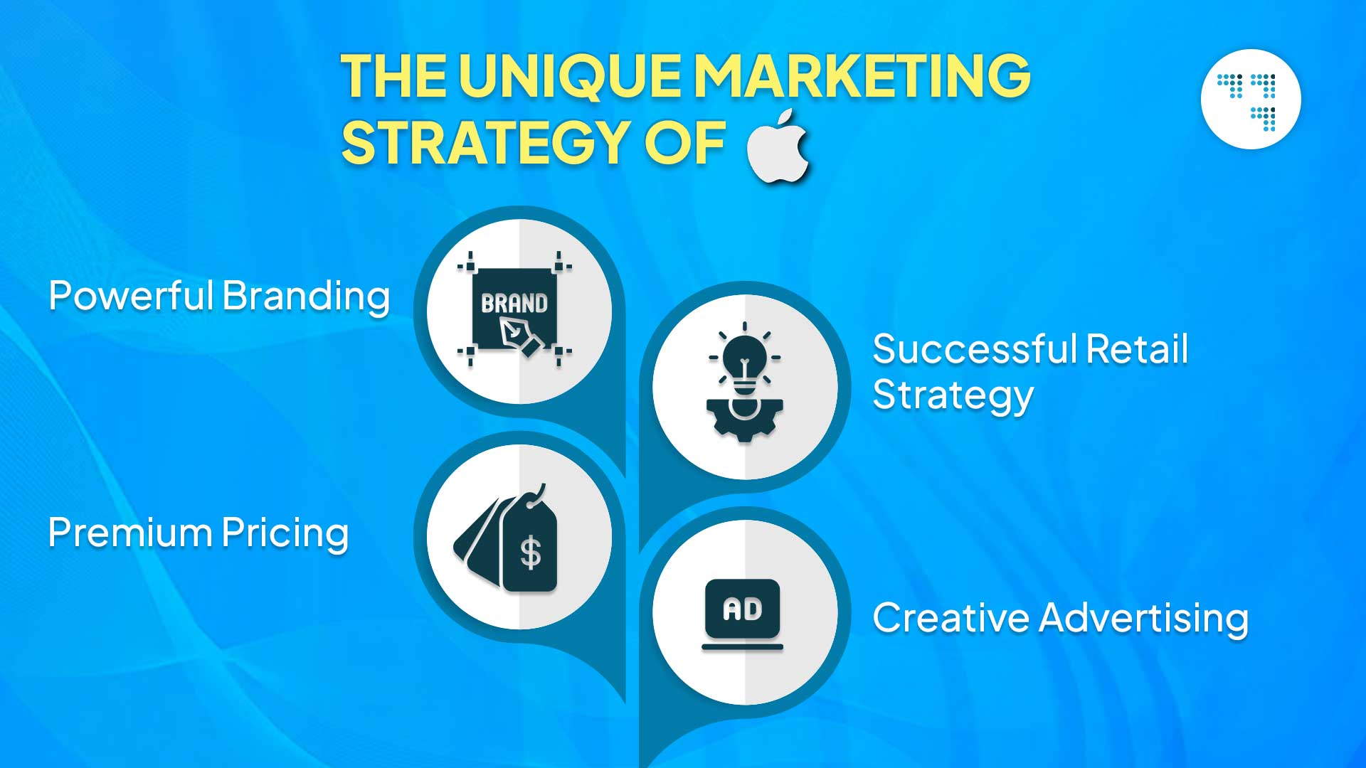
Figure 6: Marketing strategy of Apple
(Source: rdsdigital.in, 2025)

3.5 People
Employees are especially important as they interact with the customers and are part of the sustainability brand extension's credibility. All employees in the Apple store, customer service, technical and supply-chain departments should receive the necessary training on the sustainability features, materials and repair data, and recycling methods of the product. They should be able to articulate the value of the environment to the employees and they should not be "marketing speak" (Kaivonen, Mesiranta and Närvänen, 2026). This is because having an informed workforce can help create customer trust and illustrate that sustainability is an integral part of the organisation. Apple might also incentivize staff to provide their own suggestions on how to make products more sustainable, packaging and customer recycling more convenient. Moreover, suppliers should be accountable for appropriate and sustainable environmental and ethical practices cannot be a customer facing initiative (Ahumada, 2023). However, the people element should be more or less as good as knowledge (of employees), service to customer, ethical supply-chain relationships and employee commitment and the sustainable proposition should be on the way.

3.6 Process
The process element should include sustainability as part of the process from the customer life cycle to the product's life cycle. The design and production of products, buying of products, using products, repairing products and trade-in and recycling should be all part of the overall sustainability strategy. Digital information on the care of the product, software updates, repair and recycling can be offered to customers (Han et al., 2023). The extended sustainable element can be incorporated right into a straightforward trade-in buy, where the client presents the purchase an outdated gadget. The material supply, manufacturing emissions and transportation and material recovery should be monitored at the Apple level to ensure the company is continually improving its performance. A clear process would also enhance consumer trust as sustainability would be tangible as opposed to marketing. Therefore the process design should be efficient, clear, circular and stable in customer relationship from the angle of customer relationship.

3.7 Physical Evidence
The tangible aspects that help customers to evaluate a part intangible brand promise. Again, this will reinforce the physical attributes of the sustainable Apple extension – in terms of quality and environmental responsibility. Packaging could be minimum materials (that are easy to recycle), fibre and displays could be set within Apple Stores to explain how products are recycled, how energy efficiency is used and how recycled materials are used (Samkari, 2026). Further credibility will be gained with certification or environmental reports, and honest product information. Please be careful not to do too much 'greeny' without evidence to support this or else it can cause problems with greenwashing. Instead, Apple must demonstrate their sustainability by what they see and what they know, through beautiful presentations and environmental impacts they are able to quantify, and through the customer experience, as a whole.

Element 4: Reflection

4.1 Concrete Experience
In this project, I developed a sustainable brand extension strategy of Apple and made a poster presentation on the concept. Along the way I was able to learn about researching the sustainable technology market, defining customer segments and developing the STDP analysis. I also utilized the 7Ps Marketing Mix to get to know more about the product, price, place, promotion, people, process and physical evidence that could be beneficial to the extension (as per Appendix-1). Creating the poster had allowed me to condense and make information that I researched simple to understand. I also had the opportunity to learn how to execute the marketing concepts in a short time frame in this presentation (Wijnen-Meijer et al., 2022). Initially it was hard to find out what was most relevant information, but when I organised and was more selective and confident in presenting strategic marketing information, I felt I became more organised.

4.2 Reflective Observation
Hindsight is a beautiful thing, and I was made aware of the fact that it is not sufficient to merely append environmental attributes to an existing product in order to make it a sustainable brand extension. I learned that sustainability needed to be related to the customer expectation, the brand and competitive positioning and the entire marketing strategy. As I was preparing the poster, I decided that it should be simple and obvious in communicating. Getting in as much information as possible into the poster and not overwhelming it was the challenge (Vince, 2022). During my talk, I was more conscious of how, and when, I communicate and when it is appropriate to do it, and realized I could do more without having to read from a number of papers. I believe that I could still develop and improve my skills in areas like confidence and clarity of speaking in a succinct manner. In general, I learnt more about the linkage between strategic planning and effective marketing communication.

4.3 Abstract Conceptualisation
This project will enable me to gain some knowledge in the field of using marketing theories in a real life case of sustainable brand extension. Through the STDP analysis I had learned that the geographic, demographic, psychographic & behavioral aspects can be used to find a suitable target market (Wijnen-Meijer et al., 2022). I was able to see that sustainability should be so much more than just the product and that I could use the 7Ps for it. Also, I discovered that the worth of differentiation must be introduced to the client, and position is an interaction of the brand guarantee.

4.4 Active Experimentation
For future projects, I'll begin with a direction and then establish the “big argument” for the project first, and then proceed to the details of content and materials for the project. I will develop and practice my presentation skills in many ways and make a video of myself to observe how I pace, how clearly I speak, how confident I am and how I use my body (Vince, 2022). I will also practice the skill of a skill long message with a few visual statement words, instead of a lot of words. With the sustainable marketing projects I will be studying customer expectations and responses and, in the future, will be making recommendations based on a larger and more robust set of market data. I will also develop my own critical thinking abilities by considering potential limitations, alternate choices and taking risks.

Reference List
apple.com (2026) Apple Newsroom (India). Available at: https://www.apple.com/in/newsroom/2020/07/apple-commits-to-be-100-percent-carbon-neutral-for-its-supply-chain-and-products-by-2030/ (Accessed: 10 August 2026).
Collins, C., Ocampo, O. and Thomhave, K., (2024). Greenwashing the skies: How the private jet lobby uses “sustainable aviation fuels” as a marketing ploy. https://seatacnoise.info/wp-content/uploads/Report-Greenwashing-the-Skies.pdf
Han, Y., Shevchenko, T., Yannou, B., Ranjbari, M., Shams Esfandabadi, Z., Saidani, M., Bouillass, G., Bliumska-Danko, K. and Li, G., (2023). Exploring how digital technologies enable a circular economy of products. Sustainability, 15(3), p.2067. https://www.mdpi.com/2071-1050/15/3/2067
Kaivonen, I., Mesiranta, N. and Närvänen, E., (2026). ‘We need to play with the same rules as others’: circular fashion start‐ups and the emerging logic of circularity. Business strategy and the environment, 35(1), pp.424-437. https://onlinelibrary.wiley.com/doi/pdf/10.1002/bse.70192
Lefebvre, A.L., (2023). iWaste: Analyzing Apple's Sustainable Technology Production. https://digitalcommons.salve.edu/cgi/viewcontent.cgi?article=1004&context=glo100
Liao, Q.V. and Sundar, S.S., (2022), June. Designing for responsible trust in AI systems: A communication perspective. In Proceedings of the 2022 ACM conference on fairness, accountability, and transparency (pp. 1257-1268). https://dl.acm.org/doi/pdf/10.1145/3531146.3533182
Machado, M.G.F.D.A., (2025). Consumer perceptions on how the luxury fashion industry is adapting to sustainability and ethical dilemmas. https://repositorio.ulisboa.pt/bitstreams/5fc2bb0b-bb1a-4b4a-a7b9-5aa8090b7063/download
Mansilla-Obando, K., Llanos, G., Gómez-Sotta, E., Buchuk, P., Ortiz, F., Aguirre, M. and Ahumada, F., (2023). Eco-innovation in the food industry: exploring consumer motivations in an emerging market. Foods, 13(1), p.4. https://www.mdpi.com/2304-8158/13/1/4
rdsdigital.in (2025). Available at: https://rdsdigital.in/marketing-strategy-of-apple/ (Accessed: 10 August 2026).
Samkari, G., (2026). Reverse Logistics in the Technology Industry: A Case Study on Apple's Returns and Recycling Programs. https://repository.effatuniversity.edu.sa/bitstreams/231b5f13-130f-4780-b17d-60be6225d53d/download
Saputra, S.A.J., Tofani, M.R.U., Risma, N., Aisyah, N. and Kesuma, M.R., (2025). Navigating digital horizons: A bibliometric exploration of digitalization in family businesses and emerging research agendas. Ekopedia: Jurnal Ilmiah Ekonomi, 1(4), pp.2926-2942. http://indojurnal.com/index.php/ekopedia/article/download/1458/1285
Thangam, D. and Chavadi, C., (2023). Impact of digital marketing practices on energy consumption, climate change, and sustainability. Climate and Energy, 39(7), pp.11-19. https://www.researchgate.net/profile/Dhanabalan-Thangam/publication/367032118_Impact_of_Digital_Marketing_Practices_on_Energy_Consumption_Climate_Change_and_Sustainability/links/63cf8e8d6fe15d6a5742a5a2/Impact-of-Digital-Marketing-Practices-on-Energy-Consumption-Climate-Change-and-Sustainability.pdf
thebusinessresearchcompany.com (2025) Apples Market Statistics, Size And Trends Report 2026, The Business Research Company. Available at: https://www.thebusinessresearchcompany.com/report/apples-global-market-report (Accessed: 10 August 2026).
Vince, R., (2022). Reflections on “behind and beyond Kolb’s learning cycle”. Journal of Management Education, 46(6), pp.983-989. https://researchportal.bath.ac.uk/files/326970822/Vince_JME_2022_Behind_Beyond_LIA.pdf
Vyshnavi, P., StartupTalky, Makhija, M., Rathi, R., Shrivastava, D. and Nensee, K. (2025) Apple Marketing Strategy: Inside the iPhone Marketing Strategy & Apple’s Advertising Success (2025), StartupTalky. Available at: https://startuptalky.com/apples-marketing-strategy/ (Accessed: 10 August 2026).
Webmaster, M. (2026) Apple’s dominance deepens with global market share gains across key product segments, MacDailyNews. Available at: https://macdailynews.com/2026/06/12/apples-dominance-deepens-with-global-market-share-gains-across-key-product-segments/ (Accessed: 10 August 2026).
Wijnen-Meijer, M., Brandhuber, T., Schneider, A. and Berberat, P.O., (2022). Implementing Kolb s experiential learning cycle by linking real experience, case-based discussion and simulation. Journal of medical education and curricular development, 9, p.23821205221091511. https://journals.sagepub.com/doi/pdf/10.1177/23821205221091511
Yang, X. and Liu, X., (2024). Optimal Trade‐In and Pricing Strategy under Strategic Consumers and Sequential Innovation. Discrete Dynamics in Nature and Society, 2024(1), p.2024124. https://onlinelibrary.wiley.com/doi/pdf/10.1155/2024/2024124

Appendix: Kolb’s Reflective Cycle


