Student Name: Md Tanvir Ahmed
Student ID 2009431
University of Wales Trinity Saint David

Professional career Development
(BMSW4005)

Lecturer Mr Husam Alharahsheh
University of Wales Trinity Saint David

JUNE 2021

Contents
Task 2 2
Introduction 2
Reflection on own role play describing key learnings plus challenges in doing the role play with identification 2
Personal action plan 5
Self-evaluation review 6
Career ambitions and aspirations 10
Personal Development plan to enable achieve own ambitions. 10
Conclusion 11
References 12

Task 2

Introduction
Self-analysis provide several outcomes of personal and career development. Considering Janet’s life as an instance of career development analysis, she has high point on completing her BSc and gained her very first job after 20. Along with that, near the age of 25 she did PhD scholarship and then moved to German, did post doctorate in Japan, then again moved to German and got married to her partner at 30. These are the remarkable high points of her life. However, with those ups, Janet has few downs or low points like resigning job at initial period of career. On the age of 30, she fallen into serious illness and diversely returned to UK. Near 35 age, she is looking for research post which became down points in Janet’s life. This paper is focused on the skills and developments of working as a ‘Customer Service Advisor’. As part of the Property Manager role, I responded to a variety of client inquiries in a professional and accurate manner in line with RMG rules and procedures. Professional techniques have a number of advantages, which are detailed in the assignment. In this assignment, basic self-analysis of abilities and competences is also discussed, as well as how this may be accomplished. Self-SWOT analysis and the requirements for achieving an individual's overall growth are briefly outlined.Moreover, this theoretical report will assist to develop professional life and given analysis measure the performance of the author.

Reflection on own role play describing key learnings plus challenges in doing the role play with identification
Personal reflection on own role performanceprovethe ability to analyse an individual's talents and capacities against a set of benchmark targets is critical since it allows me to track any type of significant improvement in personal skills (Cottrell, 2017).
Key learnings and challenges in doing the role play
Numerous learning acquired by me during the professional journey. Throughout customer advisory role to prepare for a problem, I gained experience and self-confidence during dealing with the issue in real life, as well as created rapid and instinctively right reactions to circumstances. This implies that instead of making mistakes or being overwhelmed by events, I can react efficiently as conditions change. Following learning come about on customer service advisory role playing:
Excellent Customer Service skills
Remembering plus thanking repeat customers, building a local connection with consumers, put the product expertise to good use, and more are all instances of outstanding customer service in retail (Borg, 2018).
IT skills
Gathering information about organization and customers, then technically using them is very crucial to learn. During COVID-19 situation, IT skills became mandatory in term of professionalism. Employees learn internet and computer software to get every tasks done.
Confident communicator
It's undeniable that employees interact in numerous ways relying on the occasion. However, once it comes to successful workplace communication, individuals can't afford to be nervous when everyone stand up in meetings, initiate up discussions with our co-workers, or seek to talk with company managers.
Captivating contract of customer requests
Initiating the first call for the customer has been a crucial part in own professional area. There should be learning ability to manage a variety of circumstances using telephone and administrative activities to provide excellent customer service(Patton and Higgs, 2018).
Along with these key learning, diverse challenges are confronted working as Customer Service Advisors as follows:
- A power outage or other emergency arises.
- Not being able to respond to the customer's diverse questions.
- Disputed Business Priorities.
- Not capable to provide customer’s expected discount
Identification for ranges of further development for being interviewer and interviewee
The objective of giving or taking job interview in to selecting and providing relevant solutions to provide proper services to the customers. A person who understands customer requirements and know how to fulfil them (Higgs, 2018).
Recruitment and Selection procedure is the crucial and mandatory portion for both interviewer and interviewee. Gibbs reflecting cycle can be described to measure the activities and the areas of professional development as an interviewer and interviewee,
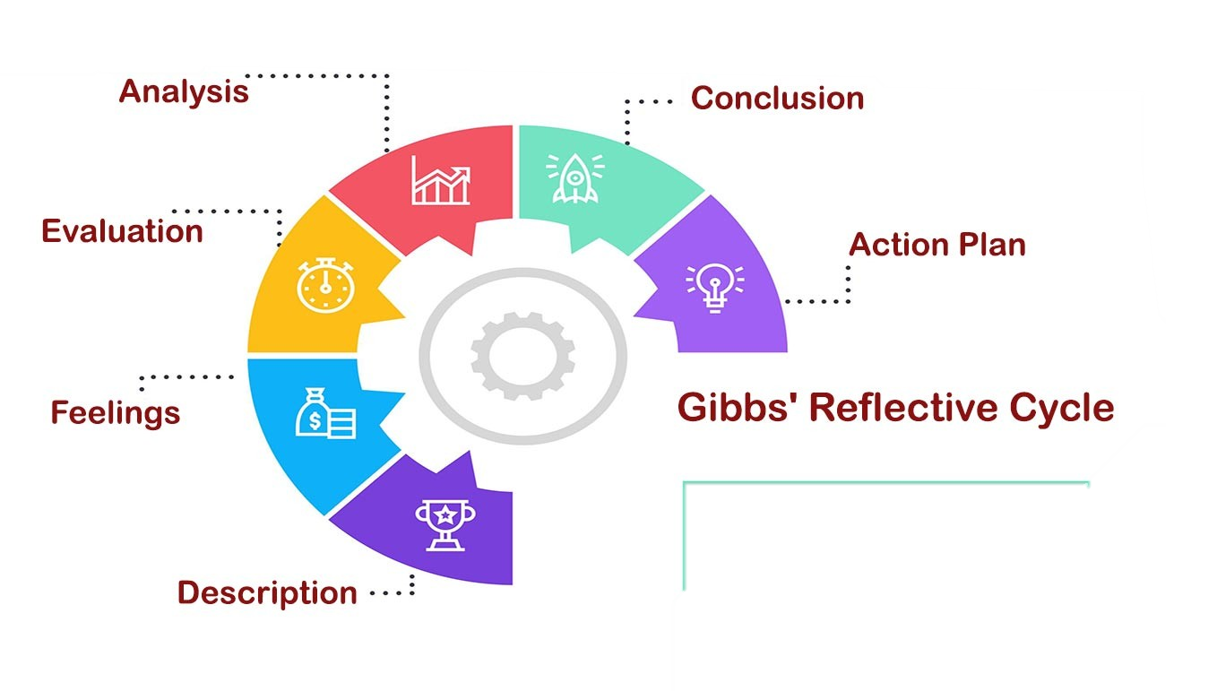
Figure 1:Gibbs reflective cycle (Source: Potter, 2015).
- Description
As an interviewer I need to ask personal details and descriptions of the experiences on initial part. For instance, ‘describe about yourself and your strengths that you have obtained on past few years’- would be the query in interview. And as an interviewee, a person has to add research element for each.
- Feelings
Interviewer use this section to analyze any sentiments or ideas interviewee had throughout the experience and how they may have influenced it. The reason for hiring the candidate and if he/she have any weakness on facing challenges that mentioned before will be described here(Borg, 2018).
- Evaluation
Focus from both the positive as well as bad elements of the scenario, even whether it was predominantly this or that, to get the utmost out of an interviewee's reflection. The interviewer has the opportunity to assess what worked or what didn't in the circumstance. Make an effort to be as neutral and truthful as possible (AkashT., 2021).

- Analysis
The purpose of analysis is to explain why an event was great or unpleasant, and it should take up the majority of an interviewee's thought. Consider the issues raised in the previous phases and find any elements that aided the interviewer.
- Conclusion
The interviewer can draw inferences about what transpired in this part(Higgs, 2018). This is when the interviewee summarizes their lesson and identifies what steps they may take in the future to enhance the outcome. It ought to be a natural reaction to the preceding parts.
- Action plan
for how you would deal with similar situations in the future, or general changes you might find appropriate
They are performed for the goal of obtaining information, solving problems, or changing a party's behaviour. Their goals are clear, and both parties must work together to achieve them(Cottrell, 2017).
Typically, open-ended questions will be utilized to maximize the amount of data obtained. By scheduling an interview session, a summary of endings is created at the conclusion.

Personal action plan
It is defined as the development plan of own area that applied for recovering the previous inaccuracies and gathering ideas for facing potential challenges.
Personal Action Plan
Skills | Areas for Improvement | Actions for development | Confirmation | Timeline
Professional knowledge | Knowledge of software installation in depth. | Obtaining information from internet sources and attending a lecture. | Givingmaterials, technology (IT) operations training. | 3 months
Decision making | Confusions along with self-reliance lacking. | Keeping an eye on the higher-ups and successfully consulting through them. | Participating in the British Computer project planning choices. | 2 months
Creating variations | Allocating real-life skills. | Diverse break plans. | Single-case scenario research | 2 months
Planning through cooperating | Execution of concepts in a proper manner and other lack of linguistic command. | Having awareness of customers' requirements and creating contacts with others(Higgs, 2018). | Effectively organise an IT project with international customers or co-workers. | 3 months
Time management | Inability to adhere to established deadlines. | previous planning, sequencing, resource identification, and allocation. | Creating organizational goals with time constraints. | 3 months
Table 1: Action plan
Self-evaluation review
Self-evaluation aids for adopt the workplace relationship and professional culture. Integrated knowledge necessitates a proactive approach to gaining new insights and information to supplement existing knowledge(AkashT., 2021). Elements for self-assessment tools are as follows:
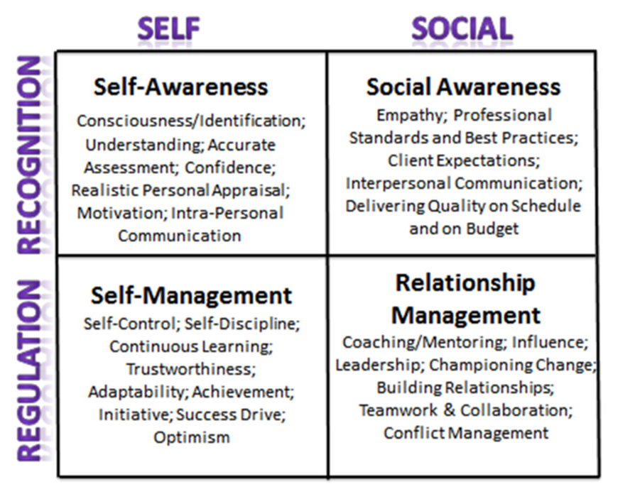
Figure 2: Own professionalism tools for Self-evaluation (Source: Robert J. 2015).
Self-incentive in career direction
This stage provided me the purpose of performing every task. Self-awareness motivated me to become conscious about my gaps or inaccuracies(Patton and Higgs, 2018).Self-management aided to fix the error and understand the ways to fill up the gaps. With the help of intrapersonal commination, I was able to compare my professional activities and develop them by organizational expectation.
Learning styles
There are major three kind of learning styles that can be applied in professional development as; auditory, visual and kinaesthetic. To keep relationship management in professionalism, I implemented online Platform as own learning style. Video courses and internet has b\every learning style that I implemented in own area of specialism (Potter, 2015).
Own professionalism
It is critical to control the IT team's communication flow in order to establish synchronization amongst some of the team members. Verbal talks, which can take the shape of one-on-one conversations, meetings, and brainstorming sessions, are examples of different communication sources in my area of professionalism. Through social media, I updated my social awareness on customer service.
Personal development planning
Employees at various levels of an organization encounter a variety of issues while working there. All of these issues should be examined as part of a personal development strategy for progress(Borg, 2018). I am now employed as a Customer Service Advisory. If I want to compare my present abilities and capabilities to a benchmark, I'll need to do a quick examination of my skills as well as competencies like this:
Strength | Weakness
- Easily accessed website  - Responsive approaches  - Company subsidised qualifications  - Prefer running multitasking  - Concession Portal | - Deficiency of professional language abilities  - A lack of industry experience  - No uniqueness on customers choice
Opportunities | Threats
- Development withprogress opportunities  - Enough holidays to enjoy  - Life Assertion  - Pension System | - Negative behavior can hamper business’s image  - Excessive target-achieving pressure  - Managing a higher number of clients poses a tremendous risk (Potter, 2015).
Table 2: Personal SWOT analysis.
For improvement of professional career SMART objective plan. The analysis of this plan increase the performance and gather more output in workplace.

Figure 3: SMART objectives of self-development (Source: Akash T., 2021).
SMART objective plan promote self-learning by establishing my own vision and purpose, analysing them, and working towards attaining them. In following ways, SMART objective analysis assist and develop professional objective:
- Having technical abilities is crucial in every field as businesses become increasingly reliant on computer systems. This will assist to satisfy specific customers. Identifying your transferrable abilities is beneficial to me. Many organizations look for applicants with transferable talents, which are valuable personal advantages.
- A structured objective might help me to track career development. Measurable progress allows me to easily recognize and make the classification of goals as short-, mid-, or long-term.
- Experiential learning, interaction, education, plus reflection are some of the ways I should mention.
- Available resources are sites where I may learn new skills and advance professionally. They may provide courses or networking opportunities, and they have the ability to significantly improve a person's professional path.
- When I accomplish milestones, alter tactics, or change goals, I have a precise time schedule to update my professional growth plan (Robert J.,2015).
Review of own understanding and expectations of the world of employment
My aspirations for the employer are that it creates an organizational climate in which I can produce positive outcomes, recognized for my accomplishments, have employment stability, and have the opportunity to advance within the organization
My own academic understanding is, success need to be measured by experience, not ordinary points. A student with average or lower points can also prosper in professional arena. Only good grades are not scale for professional future. In term academic expectation, more site visiting and practical learning is needed for newcomers(Cottrell, 2017).
For both personal or professional purposes, I chosen the Customer Service Advisory project. On a professional level, I aim to boost overall customer service at remote field sites. For a long time, I've been the major source of information and assistance in my region, so I'm familiar with their requirements.I am confident that by developing a technical assistance Web platform to support remote sites, client satisfaction would improve. I began addressing the problem with the mind-set that "I can find a better way".
Career ambitions and aspirations
My career ambition is to attain a position as job analyst. Successful senior employees are my aspiration. I aimed at a better grasp of existing alternatives and learn certain new technologies even during research and innovation phases. Also, neural network searches and IP telephony for immediate access to support staff across the network were among the features (Borg, 2015).
Personal Development plan to enable achieve own ambitions.
On a personal level, I get joy from this initiative since I'm intending to assist colleagues and friends in better serving clients. In the COVID-19 scenario, I briefed the technical support Web site strategy at the global system manager conference. The concept was universally praised by the intended audience, and even outperformed many of the other presenters.

Conclusion
A professional objective should be more tactical in nature. In other words, it is feasible in the foreseeable future.Theoretical knowledge may assist anybody in becoming a good leader and boss in the real world. Different sorts of ways to developing any manager's ability are analyzed for professional growth, as well as the successful application of these knowledge in real life in the organization, which play a key part in the good management of the business and leads to the firm's success.

References

- Akash Tripathi, 2021.How to Create SMART Career Development Plans?Online. Available at: https://www.under30ceo.com/career-development-plan/
- Borg, S., 2018. Evaluating the impact of professional development. RELC Journal, 49(2), pp.195-216.
- Cottrell, S., 2017. Critical thinking skills: Effective analysis, argument and reflection. Macmillan International Higher Education.
- Higgs, J., 2018. Judgment and reasoning in professional contexts. In Textbook of Catheter-Based Cardiovascular Interventions (pp. 15-25). Springer, Cham.
- Patton, N. and Higgs, J., 2018. The Crucible Model Underpinning Holistic Clinical Educator Professional Development. In Developing Practice Capability (pp. 223-234). Brill Sense.
- Potter, C., 2015. Leadership development: an applied comparison of Gibbs’ Reflective Cycle and Scharmer’s Theory U. Industrial and Commercial Training.
- Robert Jerus, 2015. SPHR - Always on Your Mind. How is your professionalism? Online. Available at: https://www.linkedin.com/pulse/show-professionalism-through-emotional-intelligence-jerus-sphr[Accessed on 7th August, 2021]

 | Company Name

Employment Application Helvisia

Applicant Information
Full Name: | Rebeka | William |  | Date: | 31/07/2021
 | Last | First | M.I.

Address: | London , Westfield
 | Street Address | Apartment/Unit #

 | London
 | City | State | ZIP Code

Phone: | 0000000000 | Email | Rebecaka@yahoo.com

Available to start : | Anytime | Social Security No.: | 00000000 | Desired Salary: | £25k p/a

Position Applied for: | Customer service advisor

Are you a citizen of the United Kingdom? | YES  X | NO | If no, are you authorized to work in the U.K.? | YES | NO

Have you ever worked for this company? | YES | NO  X | If yes, when? | N/A

Have you ever been convicted of a felony? | YES | NO  X

If yes, explain:

Education
High School: | St albans School | Address: | St Albans

From: | 2015 | To: | 2018 | Did you graduate? | YES | NO | Diploma:

College: | Trinity College | Address: | Westminister London

From: | 2008 | To: | 2010 | Did you graduate? | YES | NO | Degree: | BBA

Other: | MBA | Address:

From: | 2015 | To: | 2017 | Did you graduate? | YES | NO | Degree: | MBA

References
Please list three professional references.
Full Name: | Jullian Hamburg | Relationship: | Line Manager
Company: | Paddy power | Phone: | 02073770725
Address: | 59 William cross road W1T 5T
Full Name: | Steve Collins | Relationship: | Store Manager
Company: | Wasabi | Phone: | 02079770217
Address: | Tottenham cout road
Full Name: |  | Relationship:
Company: |  | Phone:
Address:

Previous Employment
Company: | Paddy power | Phone: | 02073770725
Address: | 59 william close | Supervisor:

Job Title: | Sales Assistant | Starting Salary: | £17K | Ending Salary: | £17K

Responsibilities: | Daily to daily customer service

From: | 2019 | To: | 2020 | Reason for Leaving: | Got better job

May we contact your previous supervisor for a reference? | YES | NO

Company: | Betfred | Phone: | 02075331409
Address: | Tottenham road | Supervisor: | Steve

Job Title: | Assistant manager | Starting Salary: | 19K | Ending Salary: | 19K

Responsibilities: | Customer service

From: | 2020 | To: | 2021 | Reason for Leaving: | Still in there

May we contact your previous supervisor for a reference? | YES  X | NO

Company: | Mc Donald | Phone: | 02073770790
Address: | Leytonston , London | Supervisor: | John son

Job Title: | Shift Manager | Starting Salary: | £8 p/h | Ending Salary: | £8.30p/h

Responsibilities: | Working at the till

From: | 2019 | To: | 2020 | Reason for Leaving: | Got better job

May we contact your previous supervisor for a reference? | YES  X | NO

Military Service
Branch: |  | From: |  | To:

Rank at Discharge: |  | Type of Discharge:

If other than honorable, explain:

Disclaimer and Signature
I certify that my answers are true and complete to the best of my knowledge.
If this application leads to employment, I understand that false or misleading information in my application or interview may result in my release.
Signature: | Rebeca William | Date: | 31/07/2021

Task 1 Job Details and Interview questionaries

HALVESHIA PROPERTY MANAGEMENT LTD
Property Management sector and we are now looking for skilled Customer Service Advisors to take Inbound calls from our existing customers.
The Role of the Customer Service Advisor:
As part of the Property Manager function you will handle customer inquiries of a varied nature
Responded in an accurate and timely manner in accordance with RMG policies and procedures.
Receive, understand and assess customer contacts and inquiries to establish requirements for advice, guidance and service/solutions.
Select and provide relevant service/solutions
Skills of the Customer Service Advisor:
Confident communicator
Excellent Customer Service skills
IT skills
Self-motivated
Able to work to KPIs and deadlines
The ability to handle a range of different situations via telephony and admin-based tasks to service customer queries to a high standard.
Taking ownership of customer requests, offering first call resolutions and escalating when required.
Previous contact centre experience is desirable
Previous experience using web chat is beneficial
Benefits of the Customer Service Advisor Role:
Development and progression opportunities
25 days holiday + Bank holidays + Birthday
Pension Scheme
Company funded qualifications
Discount Portal
Life Assurance

Interview question
1.Tell me about yourself
2.What is your strength
3.Why would we hire you
4.What is your weakness
5. why do you want to work here
6.Tell me Three positive things that your boss would say about you.
7. your Salary Expectation

