Constantin Ovidiu Strinu (2321711)
2321711@student.uwtsd.ac.uk
Lecturer: Renuga Jayakumar
Supervisor: Dr. Amit Naik

Independent Project (ACCA6020_LON) - Proposal

Contents
1. Introduction and Background 2
Aims 3
Objectives 3
Expected Outcomes/Deliverables 3
2. Project Design 4
2.1 Design Outline 4
2.2 Data Collection 4
2.3 Specialist Methods and Techniques 4
2.4 Risks, Limitations, Ethical and Legal Issues 5
2.5 Generalisability, Reliability and Validity 5
2.6 Data Analysis and Evaluation Methods 5
3. Resources and Planning 5
3.1 Resources 5
3.2 Project Schedule 6
3.3 Preliminary Risk Assessment 6
References 8

Figure 1 - Gantt chart showing project activities across the 24-week schedule 9
Table 1 - Detailed timeframes and objective mapping. 6
Table 2 - Preliminary risk assessment with backup options. 7

1. Introduction and Background
Security Operations Centres (SOCs) are responsible for the continuous monitoring, detection, and triage of security alerts. A well-established literature identifies alert fatigue, analyst desensitisation from high alert volumes, a large proportion of which are false positives, as one of the most pressing SOC challenges, contributing to slower response times, missed genuine threats and analyst burnout [1]. Qualitative studies of working SOCs corroborate this, finding that workflow complexity and interdependence are frequently underestimated by purely technical solutions [2].
Microsoft recently released GUIDE, the largest public collection of real-world, analyst-labelled security incidents, alongside Copilot Guided Response, a machine-learning system that triages incidents into true positive, false positive and benign positive categories [3]. GUIDE shows that classical, tabular approaches achieve high-quality triage at scale but function as black boxes, offering a label without transparent justification. This echoes earlier intrusion-detection work, where adaptive alert classifiers reduced false positives while still requiring analyst trust in an opaque process [4]. Recent classical approaches address the class imbalance central to triage using ensemble techniques such as XGBoost [5], a gradient-boosting method now a de facto standard for structured classification [6], often benchmarked against Random Forest [7].
Large Language Models (LLMs) are increasingly explored as SOC components capable of reasoning over security artefacts, including alert triage [8], [9]. Because LLMs generate natural language, they can, in principle, both classify and explain an alert, addressing the black-box limitation of classical models. However, LLM explanations are not guaranteed to be faithful to the model’s actual reasoning, and chain-of-thought rationales can be systematically unfaithful even when plausible [10], [11]. Two recent studies are close to this proposal: a cloud-edge framework compressing LLM reasoning chains for auditable, low-latency SOC triage [12], and a system automating alert classification and prioritisation [13]. Both focus on latency or prioritisation rather than a direct, benchmarked comparison of accuracy against explanation quality on a shared, public dataset, the gap this project addresses. Structured, few-shot prompting has been shown to improve LLM text-classification reliability without fine-tuning [14], offering a lightweight route realistic for resource-constrained teams.
Little published work benchmarks an off-the-shelf, prompting-based LLM triage approach against a classical baseline on the same public, labelled dataset while also evaluating justification interpretability. This matters because resource-constrained organisations are unlikely to fine-tune bespoke models but could adopt a prompting-based layer if its accuracy and explanation quality are demonstrated empirically. The research is timely, given rapid LLM uptake in cybersecurity, and practically motivated by professional experience of resource-constrained security operations.

Aims
To design, implement and evaluate an LLM-based triage component that classifies SOC alerts into standard triage grades and produces analyst-interpretable justifications, benchmarking its accuracy and practicality against a classical machine-learning baseline using the publicly available Microsoft GUIDE dataset.

Objectives
1. Critically reviewing the existing literature on SOC alert fatigue, triaging via classical machine learning, and explainable security automation via LLMs.
2. Designing, implementing, and evaluating a classical machine-learning baseline classifier based on a stratified sample of GUIDE, as measured by macro-F1, precision, and recall scores.
3. Designing and implementing an LLM-based triaging pipeline involving two models hosted separately in the cloud and locally, to output triaging score and its justification for each alert.
4. Evaluating and comparing both methods in terms of quantitative measures and a rubric for the quality of justification, with discussion of limitations and ethical considerations.

Expected Outcomes/Deliverables
Expected outcomes include a comparative evaluation of triage accuracy and explanation quality across both approaches; a working prototype pipeline, including a minimal web dashboard demonstrating triage on sample alerts; and evidence-based recommendations on the feasibility of LLM-assisted, explainable triage for resource-constrained SOC teams.

2. Project Design

2.1 Design Outline
The research methodology utilized by the project is that of Design Science Research [15] along with empirical comparative evaluation, which involves developing an artifact, the triage pipeline, and evaluating it based on certain criteria using a labelled data set. The research is experimental and quantitative in nature.

2.2 Data Collection
For Objective 1, the data will be extracted from scholarly and industry literature on alert triage, explainability of classical machine learning and LLM. For Objectives 2 to 4, only data from the publicly available GUIDE dataset will be used and from it a stratified sample will be taken depending on the triage grade; in case this becomes too large for the available compute, an alternate class-balanced smaller sample will be used. No primary data will be collected by interacting with human participants; all data will be collected secondarily and anonymously. In the LLM pipeline, the anonymised alert record will be sent, along with structured prompts, to an LLM hosted on a cloud service (free-tier Gemini API) and on local infrastructure (open-source Ollama), providing structured JSON output consisting of triage grade and explanation. The local LLM will serve as an alternate: in case the use of the free-tier service causes any disruption in data collection, the same pipeline will run on the local LLM without any changes.

2.3 Specialist Methods and Techniques
The classical classification model will leverage XGBoost as the main algorithm because of the superior performance of the same algorithm on structured security data in literature; Random Forest is kept as an alternative if training turns out to be inconsistent or prone to overfitting. The LLM module will employ structured few shot prompting with constrained JSON response for uniform and machine-readable answers. Other alternatives were evaluated but not adopted: tuning the LLM was inappropriate in terms of time and computational cost; deep learning models were ruled out in favour of interpretable ensembles of trees that require much fewer training data; and post-hoc approaches like SHAP or LIME were chosen to be disregarded as the explanation method due to their obscure output.

2.4 Risks, Limitations, Ethical and Legal Issues
This dataset is a publicly available and anonymised dataset, with an ethics check done that has verified there is no personal data being used, in compliance with the UWTSD ethics guidelines [16] and Research Data Management Policy [17]; the ethics form is provided at the end. The use of the free-tier of a commercial large language model API means the presence of provider-specific data terms, which is addressed by ensuring only publicly available and anonymised data is used in the inputs and fixing the model versions for consistency.

2.5 Generalisability, Reliability and Validity
The internal validity is assured using the labels provided by the analysts as the benchmark for evaluating performance. The reliability is assured by controlling the template used for prompt, versions of the model used as well as the seed of sampling. The external validity is compromised by the construction of GUIDE as it was generated by Microsoft Defender XDR users.

2.6 Data Analysis and Evaluation Methods
The classification metrics that will be used include macro F1 scores, precision, and recall, per class, and confusion matrices, all standard metrics for dealing with imbalanced multi-class classification [18]. The justification quality metrics will include the application of a detailed rubric that scores for accuracy, relevance, and actionability of the justifications compared to the true label and the alert evidence provided.

3. Resources and Planning

3.1 Resources
The resources needed for the project include a personal computer with the Python environment (pandas, scikit-learn, and XGBoost), access to Gemini API free version, LLM hosted locally using Ollama, and GUIDE dataset from Kaggle. Sources of literature are UWTSD library databases and open access sources like arXiv.

3.2 Project Schedule

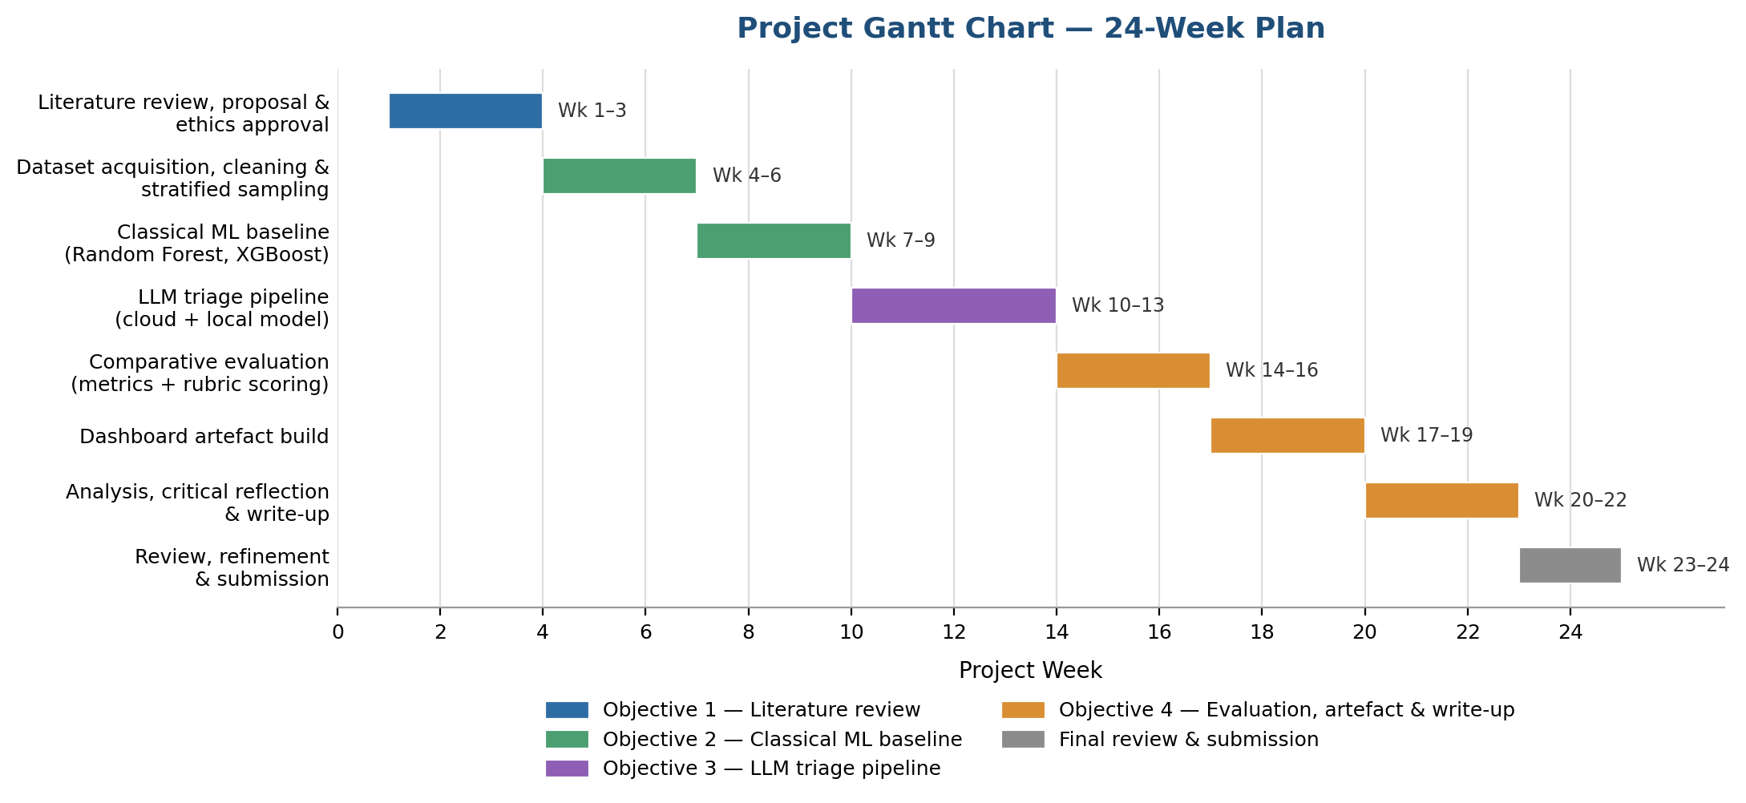
Figure 1 - Gantt chart showing project activities across the 24-week schedule
Table 1 - Detailed timeframes and objective mapping.
Weeks | Activity | Obj.
Wks 1–3 | Literature review, proposal, ethics approval | 1
Wks 4–6 | Dataset acquisition and stratified sampling | 1–2
Wks 7–9 | Classical ML baseline (RF, XGBoost) | 2
Wks 10–13 | LLM triage pipeline (cloud + local) | 3
Wks 14–16 | Comparative evaluation and rubric scoring | 4
Wks 17–19 | Dashboard artefact build | 4
Wks 20–22 | Analysis and write-up | 4
Wks 23–24 | Review and submission | —

3.3 Preliminary Risk Assessment
Table 2 summarises the principal project risks, each paired with a mitigation and, where relevant, a backup option.
Table 2 - Preliminary risk assessment with backup options.
Risk | Lik. | Imp. | Mitigation / Backup Option
Gemini free-tier access withdrawn / rate-limited | Med | Med | Restrict batch size; fall back to the local Ollama model (identical pipeline).
XGBoost training unstable / overfits | Low | Med | Tune hyperparameters; substitute Random Forest as the baseline.
GUIDE dataset access or download issues | Low | High | Cache data locally after first download; use an alternative Kaggle mirror.
Time constraints (full-time employment) | Med | Med | Front-load literature/data work; reduce sample size while keeping class balance.
LLM justification quality hard to score | Low | Med | Expand rubric-scored sample incrementally; add a brief second-rater check.
Data-protection / reputational risk | Low | High | Public, anonymised data only; follow RDM Policy (Section 2.4).

References
[1] S. Tariq, M. Baruwal Chhetri, S. Nepal and C. Paris, “Alert Fatigue in Security Operations Centres: Research Challenges and Opportunities,” ACM Computing Surveys, vol. 57, no. 9, Article 224, 2025.
[2] F. B. Kokulu, A. Soneji, T. Bao, Y. Shoshitaishvili, Z. Zhao, A. Doupé and G. J. Ahn, “Matched and Mismatched SOCs: A Qualitative Study on Security Operations Center Issues,” in Proc. ACM SIGSAC Conf. on Computer and Communications Security (CCS), 2019, pp. 1955–1970.
[3] S. Freitas, J. Kalajdjieski, A. Gharib and R. McCann, “AI-Driven Guided Response for Security Operation Centers with Microsoft Copilot for Security,” in Proc. ACM Web Conference (WWW), Sydney, Australia, 2025. [Also available: arXiv:2407.09017]
[4] T. Pietraszek, “Using Adaptive Alert Classification to Reduce False Positives in Intrusion Detection,” in Proc. 7th Int. Symp. Recent Advances in Intrusion Detection (RAID), Sophia Antipolis, France, 2004, pp. 102–124.
[5] S. Ndichu, T. Takahashi and D. Inoue, “AI-Assisted Security Alert Data Analysis with Imbalanced Learning Methods,” Applied Sciences, vol. 13, no. 3, Article 1977, 2023.
[6] T. Chen and C. Guestrin, “XGBoost: A Scalable Tree Boosting System,” in Proc. 22nd ACM SIGKDD Int. Conf. on Knowledge Discovery and Data Mining, 2016, pp. 785–794.
[7] L. Breiman, “Random Forests,” Machine Learning, vol. 45, no. 1, pp. 5–32, 2001.
[8] A. Habibzadeh, F. Feyzi and R. Ebrahimi Atani, “Large Language Models for Security Operations Centers: A Comprehensive Survey,” arXiv:2509.10858, 2025.
[9] N. O. Jaffal, M. Alkhanafseh and D. Mohaisen, “Large Language Models in Cybersecurity: A Survey of Applications, Vulnerabilities, and Defense Techniques,” AI, vol. 6, no. 9, Article 216, 2025.
[10] H. Zhao, H. Chen, F. Yang, N. Liu, H. Deng, H. Cai, S. Wang, D. Yin and M. Du, “Explainability for Large Language Models: A Survey,” ACM Transactions on Intelligent Systems and Technology, vol. 15, no. 2, pp. 1–38, 2024.
[11] M. Turpin, J. Michael, E. Perez and S. Bowman, “Language Models Don’t Always Say What They Think: Unfaithful Explanations in Chain-of-Thought Prompting,” in Advances in Neural Information Processing Systems (NeurIPS), vol. 36, 2023.
[12] G. Zhao, Y. Zhang, C. Tian, D. Xie, H. Liu and B. Wang, “Information-Dense Reasoning for Efficient and Auditable Security Alert Triage,” arXiv:2512.08169, 2025.
[13] M. Turcotte, F. Labrèche and S. O. Paquette, “Automated Alert Classification and Triage (AACT): An Intelligent System for the Prioritisation of Cybersecurity Alerts,” arXiv:2505.09843, 2025.
[14] M. Liu and G. Shi, “Enhancing LLM-Based Text Classification in Political Science: Automatic Prompt Optimization and Dynamic Exemplar Selection for Few-Shot Learning,” arXiv:2409.01466, 2024.
[15] A. R. Hevner, S. T. March, J. Park and S. Ram, “Design Science in Information Systems Research,” MIS Quarterly, vol. 28, no. 1, pp. 75–105, 2004.
[16] University of Wales Trinity Saint David, Research Ethics & Integrity Code of Practice, July 2022.
[17] University of Wales Trinity Saint David, Research Data Management Policy, V2.0, 2022.
[18] M. Sokolova and G. Lapalme, “A Systematic Analysis of Performance Measures for Classification Tasks,” Information Processing & Management, vol. 45, no. 4, pp. 427–437, 2009.

