Restaurant Caprice

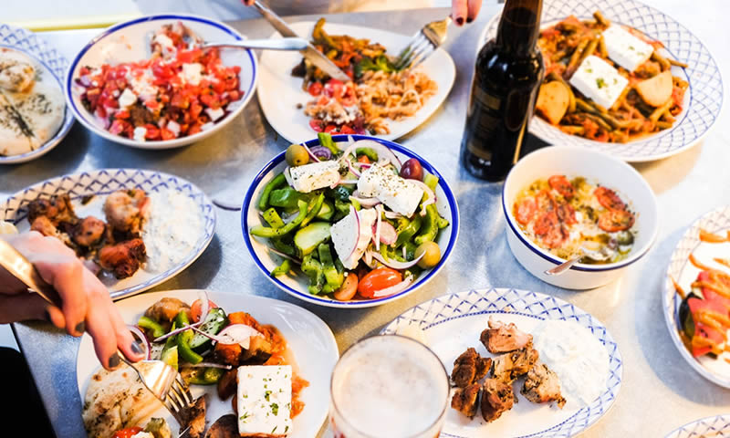
Marigklen Chotza
(1906498)

Managing Enterprise in the 21st Century (BMSW4006_LON)

Lecturer’s name: Afzal Munna
Contents

Executive Summary ii
Introduction iii
Business Structure iii
Product and Services iii
Market Analysis and Needs iv
Technology Plan vii
Management and Organisation viii
Financial Plan viii
Conclusion viii
References ix

Executive Summary

Through making this report it is described that the company’s goal is to the market share and gain the competitive advantage. Restaurant ‘Caprice’ which is in Woodford, London, wants to serve their consumers with the best services and food, to increase their market share. The restaurant caprice is giving their consumers high quality food at an attractive price range. In this report its it said that the restaurant will have to take various licences and various permission for their operations. There are various marketing plans and strategy that will help them in having a good consumer relation. This report is also providing a brief about the funds and their allocation. As this business is a service sector business so they are having a lot of growth opportunities and they are also having various big competitors in the market.

Introduction

When being or entering in the service sector or the restaurant business what the company must do is that they should be having a complete overview about the market and they should be having complete knowledge about their competitors and their services. The restaurant businesses are having a lot and lot competition these days. There are also various types of restaurants that are entering the market and that are changing the likes and dislikes of the consumers. So before entering the market they are analysing about the consumers. Without proper analysis the company would have to face lose from their initial days. Restaurant Caprice, which is located in Woodford, London, will provide their services to the consumer all seven days from 12am to 10pm, with a total staff of 10 which includes waitress and barista and five professional chefs.
This report will be providing an overview of the business development plan that the company should adopt.

Business Structure

This business is a sole proprietor business, and being a sole proprietor business, it is having various benefits like the owner of restaurant Caprice will be able to make his own decisions and he also will not have to share any profit with anyone. This is the service sector business, and we will be providing our consumers with high quality of food and services. We will be engaged in processing of food (Tzabbar et al. 2017). We are also providing our consumer with Greek menu, we are providing them meat, vegetarian dishes, and some gluten options. As we also will be providing them with services of the bar, we have to take various licence for that there are various requirement such as permitted hours. In UK there are fix hours for the selling and buying of the drinks and if the business wants to provide drinks after bars, we will have to get our licenses extended. Also, another requirement is policy and fees. For the licensing we have to agree all the terms and conditions that the license is needing and after that we also have to pay some charges for acquiring the license.

Product and Services

The product which the restaurant Caprice will be offering is high quality Greek food, high quality meat, vegetarian dishes, and some gluten options. We are providing these dishes because there is a high demand of these dishes in London and when we are providing the consumer with their needs, we will automatically increasing our consumer base and as these products are having high demand in the market, so the restaurant is also having a high potential market in front of them (Wikhamn, 2019). As we will be providing our consumer with both food and drinks this will give a competitive edge over our competitors and as we are offering our consumers with both food and drinks this will give a competitive edge over our competitors and as we are offering our consumers balanced service then it will help them in engaging and coping up the increase and decrease in the market demand. We will be providing our consumers with fresh food and drinks (Chowhan, 2016). We will have to have something in our inventory so that we fulfil the needs and demands of the consumer whenever they want. We will be needing stock of beer bottles, wine etc so that whenever the consumer will them, we can easily provide them. We should also be having a proper security system in order to protect the inventory from thieves and bandits.

Market Analysis and Needs

Target consumers
As being new for the business, we restaurant Caprice have to target audience and some specific region. As different region will have different types of food and different types of beverage variety with them. We will have to target those regions in which the people will love our food (El-Ghalayini, 2017). During the initial days we have to keep our expectation low because during our initial days we have to provide our food and services to the consumer with innovation and creativity and this will attract more and more consumers for us, and this will also give us an upper hand over our competitors.
Market and competition
In Woodford, London the restaurant Caprice will be facing many competitors but the most important of them all are the Grill Hustle and Lokkum bar and grill. They are one of the top restaurants that are operating in that area. As they are already established brands, they have many innovative and creative ideas with them (Nunkoo et al. 2020). So, with the help of survey conducted and with the help of the personal reviews it is found that the competitors are providing their consumers the food and service at their convince and they are also providing their food through online sources. For completing in the market, they will have to be technologically advanced as they should use latest technology like their competitors so that they will not fall behind in the competition.

Lokkum bar and grill
Table created from the author
Strengths  - Providing good food at affordable rates  - Providing food to the consumers at their convenience | Weakness  - Some time the management is not proper  - Waiting time is very long
Opportunity  - As they are taking order online this will help them in increasing the consumer satisfaction  - As their rates are less, in future it will help them to increase the consumer base | Threats  - Having poor management will result in the loss of consumer  - Today’s audience need on the go food and the waiting time is long, the audience will not use their service

Grill Hustle
Table created from the author
Strengths  - Premier quality food at affordable prices  - Loyal consumer base | Weakness  - Inability to adapt to changes  - Enhanced expenditure on decoration
Opportunity  - Digital landscape and infinite opportunities associated with it  - Efficiency in operations enabling opportunities of earning consumer loyalty | Threats  - Increasing competitors on the sector  - Recession in International markets

Restaurant Caprice
Table created from the author
Strengths  - Efficient Management  - Ability to subdue competition  - Proper time management  - Quality food at affordable rates | Weakness  - Insufficient market analysis practices  - Underdeveloped monitoring meta-analysis  - Weak customer base  - Excessive expenditure on discounts
Opportunity  - Market expansion  - Diversification of services  - Market penetration  - Product development | Threats  - Threats of new entrances  - Threats of competition  - Threats of arising due to a power that their suppliers have  - Threats of free flow of market forces

The marketing strategies will revolve around digital landscape and infinite solutions that it has to offer. Restaurant Caprice will use active monitoring to analyze all the dynamics and use them as a foundation to develop digital marketing campaigns, develop specifically to attract their target consumers.
Promotion of business
The promotional activities undertaken by Restaurant Caprice will be an accumulation of four unites, which will include our websites along with the strategic use of our discounts and advertisements over digital landscape (El-Adly, 2019), along with the Restaurant Caprice, plan on utilizing the benefits that social media has to offer in today’s world where every decision that their potential consumers take are influenced by the information available online. Along with the Restaurant Caprice plans on going traditional promotional activities at our retailing store. In addition to that the organization also plans on motivating consumers in being carrying out the role of promotions using the technique of discounts by app referral.

Key promotional activities in order to meet business objectives
- Using mouth-to-mouth promotional activities. Restaurant Caprice, plans on developing the overall quality of their services in a manner that their consumers automatically play the role of probationers
- Restaurant Caprice, plans using omni-channel promotional activities that are a mix of traditional and digital promotional activities in order acquire their target consumers and retain existing consumers
- Restaurant Caprice, plans on using promotions on other websites as well

Operations
In order to enhance operational efficiency Restaurant Caprice plans on maintaining a healthy relationship with their suppliers where we have the power to negotiate as well.

Other operational considerations
Restaurant Caprice is currently not hiring any staff as the requirements are full.

How many staff do you currently employ?
Restaurant Caprice, employment criteria revolve around having a manager, along with 10 employees as waiters and bartender. In addition to that Restaurant Caprice have 5 chefs with a lot of experience in our field of expertise.
Where does or will the business operate from?
Restaurant Caprice plans on focusing on retail store. The digital marketing activities will be outsourced.

Laws or regulations considered for business and/or industry
The laws and regulations revolve around having bartending licensing and working within the conventions set by UK legislation.

Insurance currently in place or intended to put in place for the business
Restaurant Caprice have insurance against theft and loss by fire.

Technology Plan

Restaurant Caprice plans on acquisition of associated technological advancements as soon as they see a good opportunity in the market. This acquisition will be planned in a manner so that there is no obsolete loss of our assets.

Management and Organisation

Restaurant Caprice HRM practices allows them to have trained management, experienced enough to synchronise all the individual efforts of employees and moving them towards the common organisational goals (Zhao et al, 2019). The management of Restaurant Caprice will recognise the motivation of each and every employee and use the to enhance the overall efficiency in the workforce.

Financial Plan

Restaurant Caprice will acquire funds using traditional methodologies of fund raising. In order to avoid any wastage of funds the organisation plans on maintaining proper books and cash flow statement (Lee et al, 2016). The organisation plans on using the methodologies of crowd funding using marketable securities one we have the credibility and accountability in our target market.

Conclusion

The report concludes that Restaurant Caprice faces threats of new entrances, threats of competition, threats arising due to power that their suppliers have and the threats arising due to free flow of market forces. The organisation plans on mitigating these risks by their efficient management and effective strategies. Restaurant Caprice also plans on using digital marketing strategies and effective promotional activities as a tool to enhance customer involvement and customer satisfaction. The report concludes that Restaurant Caprice plans on using traditional methodologies of fund raising and active monitoring practices to analyse the market and strategically plan our future course of action in accordance with it.

References
Chowhan, J., 2016. Unpacking the black box: understanding the relationship between strategy, HRM practices, innovation and organizational performance. Human Resource Management Journal. 26(2). pp.112-133.
El-Adly, M.I., (2019), ‘Modelling the relationship between hotel perceived value, customer satisfaction, and customer loyalty’, Journal of Retailing and Consumer Services. 50. pp.322-332.
El-Ghalayini, Y., 2017. Human resource management practices and organizational performance in public sector organization. Journal of Business Studies Quarterly. 8(3). pp.65.
Lee, Y.C., et al, (2016) ‘An empirical research on customer satisfaction study: A consideration of different levels of performance’, SpringerPlus, 5(1). pp.1-9.
Nunkoo, R., et al, (2020), Service quality and customer satisfaction: The moderating effects of hotel star rating. International Journal of Hospitality Management. 91. pp.102414.
Tzabbar, D., Tzafrir, S. and Baruch, Y., (2017), A bridge over troubled water: ‘Replication, integration and extension of the relationship between HRM practices and organizational performance using moderating meta-analysis’, Human Resource Management Review. 27(1). pp.134-148.
Wikhamn, W., (2019),CABDirect, Available at: https://www.cabdirect.org/cabdirect/abstract/20193016012 (Accessed 30/12/2020).
Zhao, Y., Xu, X. and Wang, M., (2019), ‘Predicting overall customer satisfaction: Big data evidence from hotel online textual reviews’ International Journal of Hospitality Management. 76. pp.111-121.

Appendix
Power point slides
Note that I have upload the slides as power point file on this appendix but because I could not open it when I upload it I have also add screenshots of the slides.


