Problem Solving and Decision Making - BMSK4004
Student: Errol Malcolm 1709503
Lecturer: Mr Mushfiqur Rahman

Contents
Introduction………………………………………...……………………………………….1
Problem Statement…………………………………………………………………………2
Theoretical Framework……………………………………………………………………2
Six Sigma Statement……………………………………………………………………….3
Six Sigma Diagram Sample Figure A……………………………………………………3
Six Sigma Diagram Figure B ……………………………………………………………..4
Gathering Information……………………………………………………………………..5
Fishbone Diagram Figure C……………………………………………………………6
How are criminal gangs involved?........................................................................7
Why are criminal gangs involved?........................................................................8
How are unemployed individuals involved?.........................................................8
Unregistered individuals and migrant workers seeking employment?..............9
Decision making techniques to evaluate the range of solutions:……………… 9
Go-Smart…………………………………………………………………………………10
Weighing up Alternatives:…………………………………………………………….11
Weigh up Decisions:…………………………………………………………………….11
Selecting Decision……………………………………………………………………….12
Thomas Saatay’s Analytical Hierarchy Process Figure D………………………...12
Conclusion………………………………………………………………………………12
Appendices A…………………………………………………………………………. 13
Appendices B………………………………………………………………………… 14
Appendices C………………………………………………………………………… 15
References……………………………………………………………………………..16
References…………………………………………………………………………… 17
References……………………………………………………………………………… 18
References……………………………………………………………………………… 19

Assignment Title
The problem with fake CSCS cards in the Construction Industry

Introduction:
The purpose of this report is to focus on problems that are faced by the construction industry with fake CSCS cards, which are issued by the Construction Skills Certification Scheme. The report will also suggest how the industry can implement strategies to solve this problem.
I have selected this industry because I have worked in this industry for 15 years as a bricklayer, working on many projects in and around London and the home counties. I became aware of fake CSCS cards while working for a brickwork company, where I witnessed a fake CSCS card which had been presented to a site manager, who used my card as comparison. My card details had revealed my qualifications, and relevant trade once my card number had been entered into the CSCS computer link. However, the individual’s card had not shown his details because most likely it was a fake. Furthermore, that individual was not allowed to work on that site, and his CSCS card was retained by the site manager.
Donseed are the leading supplier of specialist software for the construction industry. According to Donseed, the history of The Constructions Skills Certification Scheme, was put together in 1995 to modernize the system within the UK construction industry, by making sure workers stayed safe and were properly trained, as well as being qualified. (Donseed, 2018).
This was carried out by the allocation of the CSCS card. According to Construction Support (2013), this caused may-hem for the health and safety sector, which at the time was the worst performing sector in the UK, with construction sites being top of the most dangerous locations to work in the UK. Furthermore, the government jointly with the Health and Safety Commission deemed that these failures where happening due to the lack of properly trained operatives in the industry, so looking for answers to this problem, many positives were taken from the Gas Engineering Sector for similarities to the CORGI system, which had suffered a similar fate, but through accreditation had drastically lowered their accident rates. Additionally, the construction industry had a varied range of workers with no proper standard health and safety checks, unlike the gas CORGI system. With this lack of a proper standardized system in place, this meant that it was unattainable to fathom the levels of health and safety knowledge on construction sites. In addition, because it was so hard to attain who had health and safety knowledge, it was deemed unsatisfactory, and unsafe to deliver site safety, which led to a vast number of fatal accidents within the industry, yearly. To reduce the problem (The Construction Skills Certification Scheme), CSCS test was conceptualized, the test which covered all trades was the standard by which they were measured for health and safety knowledge and competencies. Furthermore, According, to Whitehurst (2013), This demonstrated the level of qualifications an individual hold’s, and what experience the individual has. In addition, individuals who take and pass the test are issued with a CSCS card as proof of competency. This introduction meant that skilled workers could now be standardized across the industry, so that all construction workers from the various sectors could all be assessed. The cards had a range of colours to represent the various trades, and skills levels according to Health and Safety Test (2019).

Problem Statement:
As stated above, the cards were first issued in 1995, to regulate the industry. Subsequently the first fakes started to appear in 2002 (Fitzpatrick 2002). The Construction Industry Training board (CITB) and The Home Office Immigration border enforcement team have worked together to identify fraud within the construction industry. “Operation Magnify” was launched in 2015/16 and carried out raids on 69 separate construction sites throughout the UK, which resulted in 257 labourers arrested, who had been working unlawfully across these sites. Furthermore, construction employers are urged to check CSCS cards for signs of forgery, according to Clarks legal (2017). Employers must now carry-out their own due diligence on new employees way before they begin working, and as long as the employer has stayed within these guidelines, this will have a statutory right against being liable for any sort of civil fine (which at present is £20,000 per person) if this is found to be true, at some later date, that an unlawful worker has carried out work in the UK. Additionally, according to Gov.UK, when checking job applicant’s rights to work, an employer must check that:
- That documents are real, not copies, and belonging to the individual in question
- Check that dates for individual in question have not lapsed and are able to work in UK
- That photo of applicant is the same across all documentation
- Check that birthdates are the same across all documentation
- That individual can carry-out work being offered (also able to work the hours offered)
- For students you witness their study and vacation schedules
- If you are given a document with two different names, you have individual explain why, it could be because of name change through marriage, or divorce

Theoretical Framework:
To assist me with the first part of my decision making, I have selected 5 W’s and one H approach to the Six Sigma method (Appendix A), and by using this methodology of problem solving I will be asking questions further on for solutions to the fake CSCS card problem.
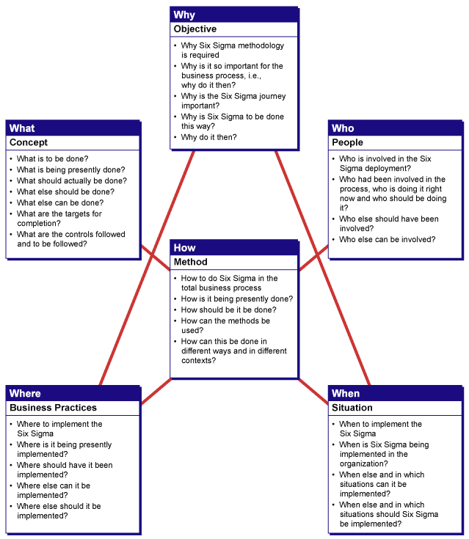
(Figure A)
Six Sigma method started in 1986 by Bill Smith, an engineer at Motorola who developed the methodology to standardize defect measurements to drive forward improving the manufacturing industry. After developing this method, it was the very start process that gave the tools that began measuring and comparing the quality improvement rates for all their business groups (Goodwin 2011).
If we now consider the Six Sigma method above and relate it to the fake CSCS card issue, this will acknowledge the various links to the problem which are affected, as
Six Sigma Diagram:
What? = Fake CSCS cards, Scope UK wide, Affects Employability, Health and Safety, Consequences are Prison.
Where? = Construction Industry, The United Kingdom.
When? = Problem since 2002, Currently & Ongoing.
Why? = Employability, Unemployment, Shortfall in Qualified Skilled Workers. Criminal gangs.
How? = Affects the industry, Unregistered Workers.
Who? = Criminal gangs, Migrant workers, The Home Office Boarder Enforcement team, Companies, the Construction Industry. Trading Standards, HMRC, Police.

(Figure B)
Relates to fake CSCS
Cards.

How? = Criminal gangs:
Unemployed Individuals:
Unregistered workers/migrant workers:
What? = Do these fake CSCS cards effect, they effect the construction Industry.
The scope has effects throughout the whole of the UK.
The effect has a critical impact on Health and Safety.
The (Construction Industry Training Board) CITB. Once notified will involve the relevant Enforcement Teams.
These Effects are brought to the attention of The Home Office Boarder Enforcement Team/ The Police.

Why? = Because it is a Backdoor into the Industry without the Standard Checks.
To become Employable.
To avoid Unemployment.
The Shortfall of Qualified Workers.
This is an Issue, because it is Illegal, Dangerous to all Who Work on Site, and represents Poor Working Standards?

Where? The Construction Industry.
The United Kingdom. The Fake issue was first discovered in 2002.
Can this Problem be Resolved?
Problem was Identified / by Construction News 20th 06. 2002.

Gathering Information:
From the information I have gathered from the Six Sigma method, I have transferred key information to a Fishbone diagram from Template lab, brainstorming more questions above and with this information I have selected three key elements that I believe are linked to the causes of this problem. With my fishbone analysis I have selected the four P’s approach, (People, Policy, Process, Plant), which are listed in the paragraph below the introduction of the cause and-effect diagram.

Cause and effect-diagram:
According to (Vivek, 2013, p.320) The Cause and Effect Diagram can be used as a system to identify and relate causes to a problem, with visual aid through linking key relevant information along the journey. The graphics will show the bond between certain factors which will influence the results. The diagram being used for this purpose has been known as the “Ishikawa diagram” because it has been invented by Kaoru Ishikawa, but the correct name is a “fishbone diagram” because of the resemblance to a fishbone skeleton.

Why we should use a cause-and-effect diagram?
The Cause-and-Effect Diagram can be used for identifying but most importantly arranging and revealing probable causes, with a certain amount of excellence, or may-be a lack of it. The framework of the diagram steers one’s thought processes to contemplate in a methodical way. The advantages of this Cause-and-Effect Diagram are:
- Assists with pin pointing causes of a problem or standard using a structured framework method.
- Motivates team engagement and activates team education of the procedure.
- Practical and step-by-step approach to cause-and effect relations.
- Pin points probable causes in modification approach.
- Higher learning of procedures which assists all individuals to grasp the additional factors at work and how they are connected.
- The data identifies areas where additional information gathered needs to be studied further. Template Lab, Fishbone Diagram 16.

Below:

Fishbone Diagram

(Figure C)

 |  |  | Problem Statement
  policy
  People
  plant
  process
  Affects CSCS Rules
  Company Policies
  Fines Issued
  Nationwide
  Employment
  Unregistered Workers
  Danger to Industry
  Criminal Gangs
  Employability
  Health and Safety
  Need to Live
  Unregistered Workers
  Fines
   | Unregistered Worker |  | Health and Safety
  Money
   |  |  |  |  |  |  |  | Fake CSCS Cards within the Construction Industry

People. Refers to, individuals involved, which are unregistered workers, and the reason why is for employability, the need for money, and the need to live.
Policy. Refers to, Health and Safety, rules being broken, jointly with CSCS rules, this affects company policies, which is also a problem for company bosses who can be fined by the authorities.
Process. Refers to, the criminal gangs who spear-head these activities, along-side unregistered workers. The problem affects Health and Safety by breeching rules.
Plant. Refers to, the problem is Nationwide, the reason is simply that these individuals seek employment, along-side unregistered individuals, which has a knock-on effect, these individuals without the proper health and safety knowledge are a danger to all who work at construction-sites.
I believe the three top causes from the information gathered above are:
- Criminal gangs
- Unemployed individuals
- Unregistered individuals and migrant workers seeking employment
With the three top causes above I will be asking why this is the case?

How are criminal gangs involved?
Criminal gangs are involved because they deal with the forgeries of these CSCS cards, which are then sold onto the black-market. According to Morby, (2018) in an article entitled “Fake construction skills card gang jailed”, a gang who supplied fake CSCS cards as well as other additional documentation to aid illegal immigrants to obtain work in the UK received a total of 16 years.
Additionally, according to Sullivan, et al, (2016) one of the biggest underground industries world-wide is the counterfeit goods market, this has several issues with a range of problems for companies, governments, and consumers. Furthermore, I have gathered primary qualitive data from Peter Flynn, who holds the title of Compliance Manager, who I interviewed on the subject, at the Keybridge House Development, in Vauxhall, London. His specific role is to induct all new employees to the construction-site, which means he must process all new employees’ CSCS cards, on the first day employees enter the site for induction. Flynn expressed that “over the years he had seen many fake cards, which he is now able to spot straight away, just by feeling them, these fake cards do not have the raised CSCS logo in the top left-hand corner of the card”. He expressed further, that the fake cards “do not get through on the very big sites, because of all the extra stringent checks that have now been put in-place, with all new employees starting work asked to bring along, additional documentation, such as a current driving licence and passport as well”. Once the documents have passed all the necessary checks and are considered genuine, they are all photocopied, logged, and kept in a master folder. In addition, Flynn finally expressed that “it may be possible for some fake cards to go undetected on some of the smaller-sites, or private jobs, for the man in the street, i.e. carrying out work on conservatories, garden wall’s etc. where the checks are not so stringent, and to the untrained eye, not that easy to detect”. Cards that are considered fake will be explained in more detail below. (Flynn, 2018).
The rules of procedure once a suspected card has been issued are, according to Build UK, (Realizing the benefits of Smart Card Technology, 2018: p.2):
- The card should be retained.
- Photocopies should be made of both sides of the card.
- The card holders name and address recorded.
- Make enquiries about where the card was issued.
- The local police must be notified.
- Deny access to site (Subject to company policy).
- Copies of all evidence and crime number given to police.

According to Sullivan and Chermak (2012, p.305-306), a crime that is on the rise at present is financial crime, jointly with counterfeiting crime. The estimation in world-wide trade for counterfeit goods is believed to be in the region of $600 billion. The financial gain for this sort of illegal activity has been measured, as the demand for these products can be fulfilled by a varied number of counterfeiting processes.
Furthermore, Sullivan, et al (2016, p.345) has pointed out that product counterfeiting is now levelled more informal, limited social arrangements steered by opportunistic criminals that have introduced themselves to resist the established lawbreaking networks with defining cultural characteristics.

Why are criminal gangs involved?
Criminal gangs are involved in these forgeries simply for profit. Furthermore, the fake CSCS cards had a market value of £200, also on sale were UK passports which were selling for £900. The gang were caught, following an operation by Immigration Enforcement’s Criminal and Financial Investigation Team, according to Morby, (2018).

How are unemployed individuals involved?
Additionally, according to van Koppen (2012, p.8 – p.18) states that individuals that carry out criminal behaviour may have lost recent employment, or a current spouse may not be happy with this new line of illegal employment and have decided to part company with their partner. Financial success is the major reward and requirement, additionally this is the motivating factor to be involved in organized criminal behaviour. Financial profits from the successful organized crime operations in fraud and drugs are seriously lucrative. However, the crossroads to which some offenders turn to crime usually have some sort of sudden change in their lives, that alters their usual behaviour in a negative way, it is these changes that have influenced this new behaviour towards organized criminality. Additionally, according to van Koppen (2012) some offenders have revealed a variety of problems, some have mentioned that they had financial hardship, this was due to drug addiction, others have revealed this happens through being unemployed. The implications of a negative life of crime fit a certain view point, as those mentioned above, who are battling with personal issues, or those individuals who believe there is much to obtain by taking that step nearer towards criminal behaviour.

Unregistered individuals and migrant workers seeking employment?
In October 2015, The Rt Hon James Brokenshire MP (Immigrations Minister) created a campaign to tackle illegal working in the construction industry (Gov.UK, 2015). On October 14th, 2015, he chaired a meeting amongst construction industry leaders on plans to end unregistered workers in this sector. He expressed that he would like very much for all key employers and influencers within the industry to join forces with a chance for all to participate, with those that are like minded in upholding the integrity of the sector. Unregistered workers damage the credibility of employers, which is harmful to the industries reputation, this also has a major downturn on wages, and denies employability to those hard-working individuals working in the UK, and those individuals who are working in the UK legally. Additionally, employers in the construction industry have a vital role to carry-out, by helping to fight this by guaranteeing they vet individuals properly, with straightforward ‘Rights to Work’ checks, on individual employees that are employed, which will prevent unregistered workers in the UK.
However, according to The Chartered Institute of Building (2015) on why immigration matters to the construction industry, it is most important as Britain has a vast historical presence in this field, of exporting construction talent, but the industry has always attracted it too. In the UK, the construction industry contributes to one in ten of the industry works, its potential to impact and be impacted by migrant workers is enormous. Viewing the supply side migration has been crucial for providing the adjustable supply of workforce required, to handle the demand produced at local levels. This has lowered the shortages when projects expand quickly. Which has also reduced unemployment for construction workers when workloads take a down-turn. This has helped the wage rates by lowering financial uncertainty for clientele, sub-contractors, and the general workforce. It might be a coincidence but unemployment levels that were encountered recently, in the last recession were tough, but less strenuous than in the past. The construction-sector unemployment rates are now in comparison with pre-recession indicators. Within the industry, admittance to the first-class worldwide talent has provided opportunities to progress the systematics, and effectiveness of the UK business and international ambitiousness. Businesses now not only benefit from the capable global talented workforce, but from the knowledge and transferable skills that they bring with them.

Decision making techniques to evaluate the range of solutions:
To assist further in evaluating options to decide, the next process will discover the needs to identify groups that are associated with the issue, which will attempt to find common ground for solutions.
According to (Construction News, 2015), CSCS and CITB survey highlight fake certification card problem. CITB’s Head of Production Management, Brandon Connolly believes further action is required to stamp out fraudsters, and he also seeks further action from the industry to embrace new technology to help deal with the problem (Construction News, 2015).
According to (Construction News, 2015), CSCS and CITB survey highlights fake certification card problem. CSCS’s Chief Executive, Graham Wren, has also voiced his opinion and believes more technology has to be adopted to tackle the issue of fraud, and to root out those engaging in this process
Wren has also said that CSCS Smart Card is the cost-effective way forward to achieve this. It is his belief that using a Smart Card reader, that works with compatible devices, like a tablet or smartphone, which will allow for individuals cards being checked for the correct qualifications of the card owner (Construction News, 2015). Furthermore, according to (Build UK, 2018) Realizing the benefits of smart card Technology, Build UK Smart Card Audit Results 2018. “The Smart Card is a simple way to carry out card checks to ensure that construction workers are who they say they are and have the correct qualifications for the job they do. Reading cards electronically leads to improved standards, and productivity on site”. Graham Wren, Chief Executive of CSCS.
Go-Smart
Go-Smart is the app for checking CSCS cards electronically (Go-smart, 2019) which removes the need to carry a card physically. Go smart has the ability to be used both on and off-line, allowing cards to be checked at any time, the system also allows for other relevant partner CSCS cards to be read this way also.
Go Smart can also be used for:
- Laptops
- Pc’s
- Android devices
- iOS devices (virtual cards only)
Why use Go Smart?
Go Smart has the ability which allows users to access CSCS information in real time, which enables identification, qualifications, and validation of the card holder. The system enables users to easily identify ‘fake cards’ with additional information of cards that have been expired, according to Go-smart (2019) this will ultimately improve Health and Safety in the Construction Industry. The reader enables user’s fast access to:

- Check updates and see when card was issued
- Verification and validity of card
- Check that card issuer has the correct training and qualifications for the work
- Record that card has been examined; with time and area, where possible
- Recording additional data, which dispels the need for paper
In my view, Donseed the leading supplier of specialist’s software, Brian Connolly CITB Chief Executive, Graham Wren, CSCS Chief Executive, and the Go Smart company, are the key players within the industry, that I have identified who are, I believe are able to drive forward new changes to correct this fake card issue.

Weighing up Alternatives:
To assist me with this next step, I will be using Professor Thomas Saatay’s Analytical Hierarchy Process. According to, (Bozic, et. al, 2017, p.386) Professor Saatay studied at Pittsburgh University in 1977. His mathematical methodology which uses both Qualitative, and Quantative data, to enable individuals to verbally present qualitative information on a certain topic, clearly put to them by the researcher, in-stead of structuring their answers in a more detailed qualitative way, so that (AHP) procedure supplies extensive explanatory depth, unlike other analysis methods. The combined Quantative and Qualitative data shows that the methodology can be applied to make a more detailed knowledge on the fake CSCS card preferences, far beyond a simple ranking process which enables the researcher to more informed decisions to consider, and how to use the information gathered using the (AHP) approach. The purpose of (AHP) is to make a less complex, multi criterion problem by dissecting it down into a multilevel hierarchical framework (Hacker and Vargas, 1987), this then reveals the identity of a series of information which effects the final decision-making procedure. In framework terms the final decision-making aim is located at the top of the hierarchy, while criteria, and sub criteria, and all other choices are lower levels and sub levels of the hierarchy system. Applying information gathered by individuals on their procedure of decision-making, (AHP) that creates a small positive or negative change and compares choices, which are then measured by their effects on the final outcome of decision making. Additionally, this then assists with the procedure of how decisions are produced in a complicated context, where there is multiple selection (Saatay, 1980).
Using the information around the criminal gangs, unemployed individuals, and unregistered workers, and then applying Professor Thomas Saatay’s methods, I believe that CSCS cards should have more vital elements added to them: 1. Finger printing. 2. Eye retina scanning. 3. Gov. UK Verifier company.

Weigh up Decisions:
Finger-printing is already being used at construction sites to gain entry to some sites, through a biometric turnstile system. According to Biosite, (2019) Biometric Access Control, but what I am suggesting is that all CSCS cards are fitted with not just the regular card reading abilities, but an additional finger print mechanism as well, according to (Fingerprint Cards AB, 2018). Fingerprints Showcases Smartcard Solution in MWCS in Shanghai, where an extra chip is added to the regular card, so individuals have their fingerprint reading at the same time, which authenticates users, which can be used at a standard card reading terminal.
Eye Retina Scanning, according to Explainer, Retinal Scan Technology, (Biometric.com 2013), which was developed in the 1980’s and highly reliable, and reads eyes uniquely, this is carried out by a low infrared beam, that reads unique eye patterns. However, this method has been used by Governments, Banks, to combat welfare fraud, but it seen as being too costly, not widely produced.
According to, Certified Companies, how our certified companies support our users to verify, (Gov. UK Verifier, 2017). Which are companies certified by the Government to carry out identifications, they are also known as ‘Identity Providers’. This takes place over the telephone, or on-line where you have to produce documents i.e. passport details, diving licence, bank card details, as well as name and address, how long you have lived at address, and age, once these are all given they can be checked on a data base, by the company. I believe that these details could be linked to a CSCS card, similar to the fingerprint scanner.
Selecting a Decision:
For its: Suitability, Feasibility, & Flexibility, Total

Thomas Saatay’s Analytical Hierarchy Process:

(Figure D)

Conclusion:
The problem with Fake CSCS cards is they are easily copied, but as my report has discovered, there are many of the key industry heads in place to tackle the problem. Brian Connolly CIBT Chief Executive, alongside Go-Smart, who already in partnership with CSCS Chief Executive Graham Wren, between these key industry heads have the capabilities to make the changes needed. As for the suggestion of a Fingerprint Smartcard, I believe it could be the way forward, I also believe that being able to have your fingerprint read, simultaneously with having your qualification and relevant details on could be the way forward, for the industry, which I believe could be the way to stop fake CSCS cards, in the Construction Industry.

Appendices
Appendix A

Below a sample copy of a CSCS cards.
There are various different colour CSCS cards which represents the varied skills levels and diverse trades they belong to as seen below:



Simon Nicholas Associates 2016.
Appendix B
Below: Swot Analysis

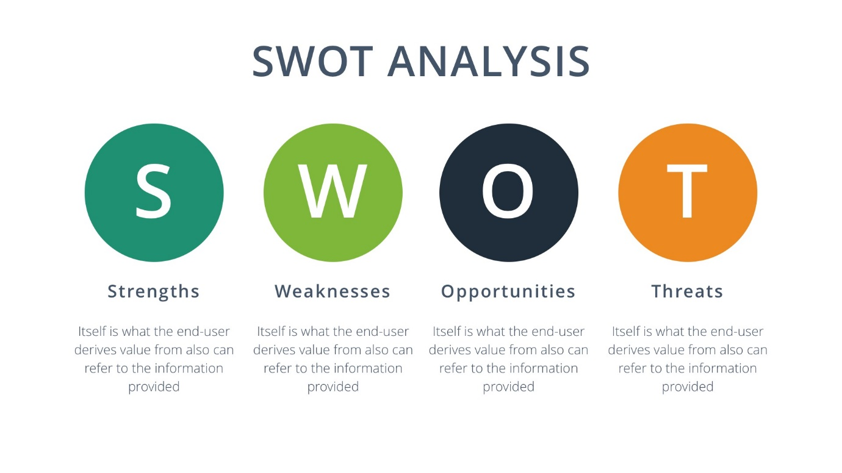
(Source: Femplate.com)
This section will focus on Strengths, Weaknesses, Opportunities, Threats, faced by the Construction Industry.
Strengths:
The strengths of having a CSCS card which is legal, and above board, are that construction workers, will all be that much safer on construction sites knowing that, all workers have the correct health and safety training.
Weaknesses:
These are the criminal gangs, unemployed workers, and unregistered workers, who try to penetrate the industry with fake CSCS cards looking for a way into the construction industry.
Opportunities:
Are that the construction industry needs the right individuals to enter this sector with the correct qualifications?
Threats: Are that targets set out by government, for the amount of properties required yearly will not be met?

Appendix C
Pestle:
According to Pestle Analysis, (2019), A Pestle Analysis looks at the environment of a business and where it operates in, or an area where it may-be thinking of operating in, i.e. a new product, service, or business, etc. The word Pestle represents P for political, E for Economic, S for Social, T for Technological, E for Environmental, and L for Legal. This enables individuals to see a plan view of all the environmental issues from the various perspectives.

See Diagram Below:

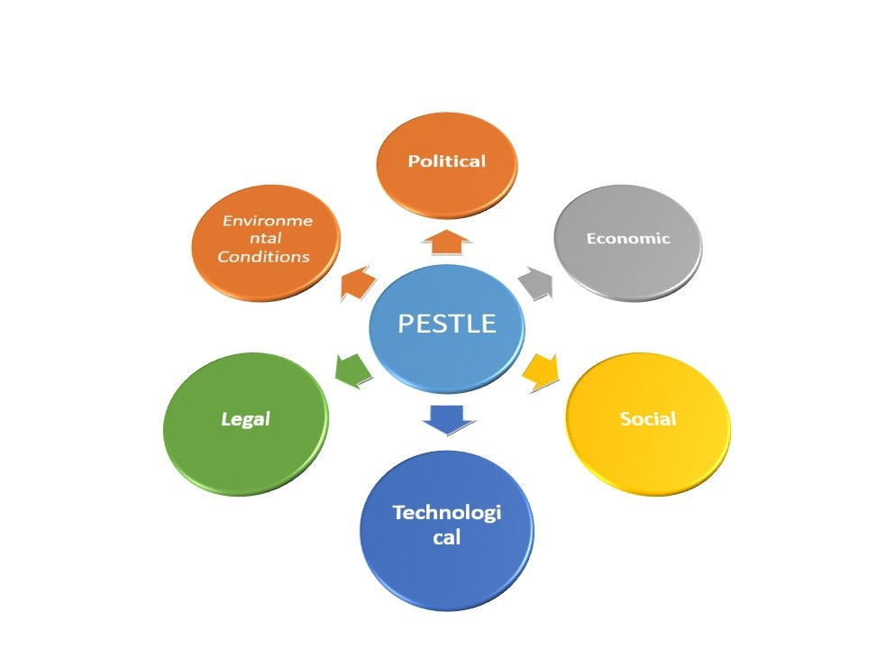

Political: These relate to what governments put forward into the economy. This may-be, government policy, tax laws, environmental laws, etc.
Economic: factors play a major role in how companies carry out their business. Companies need to be able to react, and prepare for new changes, i.e. Brexit.
Social: These relate to the same beliefs, viewpoints of residence, the factors also consider, population, trends, age, job prospects, and supplies vital marketing information for construction planners, estate agents etc.
Technological: This has a vital impact on the way products are marketed, this gives new insight into the way goods and services are targeted, distributed, giving new ways to hit the target market, through new forms of communication.
Environmental: these factors relate to environmental, pollution, carbon footprint targets set by the government. This also relate to ethical and sustainable issues.
Legal: Factors represents health and safety laws, product labelling, company compliance laws, how companies do global business lawfully etc.
Reference:
Biometric update.com (2019) Explainer: Retinal Scan Technology. Available at:https://www.biometricupdate.com/201307/explainer-retinal-scan-technology (Accessed: 14. January 2019).

Biosite, (2019) Biometric Access Control. Available at :https://www.biositesystems.com/products/access-control/ (Accessed: 14. January 2019).

Bozic, Sanjay. Kennell, James. Vujicic, Miroslav D. Jovanovic, Tamara. (2017). ‘Urban tourist motivation’: why visit Ljubljana? Volume, 3, issue /4. P.382-398 :https://search-proquest-com.ezproxy.uwtsd.ac.uk/docview/1973325421?accountid=130472&rfr_id=info%3Axri%2Fsid%3Aprimo Accessed: 11. January 2019.
Build UK, (2018) Realizing the Benefits of Smart Card Technology, Available at: https://builduk.org/wp-content/uploads/2018/11/Smart-Card-Audit-Report-2018.pdf (Accessed: 08. January 2019).

The Chartered Institute of Building (2015) CIOB Perspective: An Analysis on Migration in the Construction Sector. Why Migration Matters to Construction: Available at: https://www.ciob.org/sites/default/files/CIOB%20research%20-%20Analysis%20on%20Migration%20in%20the%20Construction%20Sector_1.pdf/ (Accessed: 30 November 2018).

Construction Support (2013) The History of CSCS. Available at: http://www.constructionsupport.co.uk/guide/the-history-of-cscs/ (Accessed: 12.11.2018).
Clarks legal (2017) Construction employees urged to CSCS cards for signs of forgery. Available at: https://www.clarkslegal.com/Blog/Post/Construction_employers_urged_to_check_CSCS_cards_for_signs_of_forgery/ (Accessed: 12 November 2018).

CSCS (2018) Results of 2018 Smart Card Audit Released. Available at: https://www.cscs.uk.com/news/results-of-2018-smartcard-audit-released/ (Accessed: 26. November 2018).

Deshpande, V. A. (2013) ‘PDCA Analysis for Quality and Productivity Improvement in BISE Plant of Apollo Tyres Limited Company,’ Productivity, 54 (3), p.310-324 Available at: https://search-proquest-com.ezproxy.uwtsd.ac.uk/docview/1512624323?accountid=130472&rfr_id=info%3Axri%2Fsid%3Aprimo/ Accessed: 05. January 2019.

Designing Buildings Wiki (2017) Skills shortage and Brexit. Available at :https://www.designingbuildings.co.uk/wiki/Skills_shortage_and_Brexit (Accessed: 07. January 2019).

Designing Buildings Wiki (2018) UK Construction Industry. Available at: https://www.designingbuildings.co.uk/wiki/UK_construction_industry (Accessed: 07. January 2019).
Donseed (2018) Digitizing UK construction: Validating CSCS cards electronically, Available at:https://www.donseed.com/wp-content/uploads/2018/09/Donseed_White_Paper_CSCS_Smart_Technology.pdf (Accessed: 01. January 2019).

Available at: https://www.youtube.com/watch?v=LdGWVgDWHEM/ (Accessed. 14th. January 2019).
Fitzpatrick, T. Editor (2002) First fake CSCS cards appear. Available at: https://www.constructionnews.co.uk/news/first-fake-cscs-cards- appear/871782.article/ (Accessed: 12. November. 2018).

Flynn, P, Compliance Manager. (2018) Conversation. Errol Malcolm, 20. December 2018
Femplate (No Date) Analysis: Free Printable Swot Analysis Template, Available at: https://www.femplate.com/swot-analysis-template/free-printable-swot-analysis-template/ (Accessed: 08. January 2019).

Fingerprint Cards AB (2018) Fingerprints Showcases Smartcard Solutions in MWCS. YouTube. June. 2018.

Goodwin, T. (2011) Motorola’s Six Sigma Journey: In pursuit of perfection. Available at: https://www.supplychaindigital.com/procurement/motorolas-six-sigma-journey-pursuit-perfection (Accessed: 23. November 2018).
Go Smart. (2019) The app for checking CSCS cards electronically. Available at: https://gosmart.co.uk/ (Accessed: 02. January 2019).
Gov. UK Verify. How our certified companies support users to verify. Available at:https://identityassurance.blog.gov.uk/tag/certified-companies/ (Accessed: 14. January 2019).

GOV.UK (2015) Campaign to tackle illegal working in construction. : https://www.gov.uk/government/news/campaign-to-tackle-illegal-working-in-construction-begins/ (Accessed: 30. November 2018).

Health and Safety Test (2019) What are the different colour CSCS cards?. Available at: http://www.healthsafetytest.co.uk/answers/2168/what-are-the-different-colours-of-cscs-cards/ (Accessed: 06. January 2019).
Morby, A. (2018) ‘Fake construction skills card gang jailed’, Construction Enquirer, 29th January. Available at:https://www.constructionenquirer.com/2018/01/29/fake-construction-skills-card-gang-jailed/ (Accessed: 25. November 2018).

M. V, V, Koppen (2012) ‘Involvement Mechanisms for Organized Crime’ Crime Law and Social Change Vol, 59. Issue 1. P.1-20: https://search-proquest-com.ezproxy.uwtsd.ac.uk/docview/1429638714?accountid=130472&rfr_id=info%3Axri%2Fsid%3Aprimo/ (Accessed: 24. December 2018).

Pestle Diagram. Long Tail. Available at: www.keywordsking.com/cGVzdGxlIGRpYWdyYW0

Professional Academy, (No Date) Marketing Theory’s- Pestel Analysis. Available at: https://www.professionalacademy.com/blogs-and-advice/marketing-theories---pestel-analysis/ (Accessed: 15. January 2019).
Realizing the Benefits of Smart Technology. Build UK Smart Card Audit Results 2018. Available at: https://builduk.org/wp-content/uploads/2018/11/Smart-Card-Audit-Report-2018.pdf// (Accessed: 26.November 2018).
Sullivan, Brandon, A. Chan, Fiona. Fenoff, Roy. Wilson, Jeromy, M. ‘Trends in Organised Crime’ (2016) Assessing the development of knowledge-base of product counterfeiting: a content analysis of four decades of research. Vol, 20. issue 3-4 p.338. p.369: https://search-proquest-com.ezproxy.uwtsd.ac.uk/docview/1962717530?accountid=130472&rfr_id=info%3Axri%2Fsid%3Aprimo/ (Accessed: 18th. December 2018).

Simon Nicholas Associates (2016) News: CRO (Construction Related Occupation) Card Changes [Image]. Available at: www.simonnicholasassociates.com/news/cro-construction-related-occupation-card-changes/ (Accessed: 07. January 2019).

Sullivan, B, A. Chermak, M, S. (2012) The Media’s Portrayal of Product Counterfeiting and Financial Crimes. International Journal of Comparative and Applied Criminal Justice Vol, 36 issue/ 4. P.305/326: https://search-proquest-com.ezproxy.uwtsd.ac.uk/docview/1283744752?accountid=130472&rfr_id=info%3Axri%2Fsid%3Aprimo/ (Accessed: 24. December 2018).

Template Lab (No date) Fishbone diagram 16. Available at: http://templatelab.com/fishbone-diagram-templates// (Accessed: 05. January 2019)

UK Construction Online (2015) CSCS and CIBT survey highlights fake certification card problem, Available at: https://www.ukconstructionmedia.co.uk/news/cscs-and-citb-survey-highlights-fake-certification-card-problem// (Accessed: 01. January 2019).

Whitehurst, P. (2013) Fake Safety Cards in Construction. Available at: http://www.gmbwalesandsouthwest.org.uk/news/fake-safety-cards-in-construction. (Accessed: 14. November 2018).

