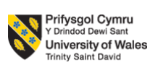
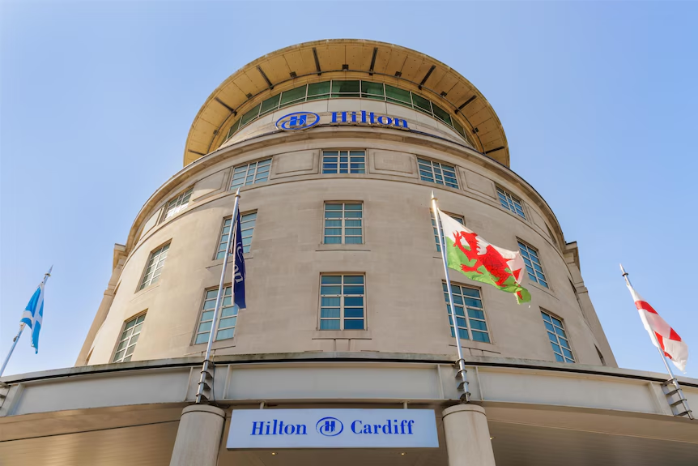
CONSULTANCY REPORT FOR HILTON CARDIFF – ENHANCING OPERATIONAL EFFICIENCY AND EMPLOYEE ENGAGEMENT
Student Name: Alexandru Matei
ID: 2126985
Module code: BMIH6005

Table of Contents
Executive Summary 2
1. Introduction 6
1.1 Context of Hilton Cardiff 6
1.2 Consultancy Firm Background 6
1.3 Problem Statement 7
1.4 Analytical Frameworks Overview 8
2. Analysis 8
2.1 Issue Diagnosis 8
2.2 Internal Analysis – SWOT 9
2.3 External Analysis – STEEPLED 11
2.4 Strategic Position – TOWS Matrix 13
2.5 Benchmarking & Competitor Insight 14
2.6 Synthesis & Problem Prioritisation 15
3. Recommendations and Change Management 17
3.1 Strategic Recommendations (Organisational Level) 17
3.2 Operational Recommendations (Departmental Level) 18
3.3 Change Management Framework 19
3.4 Cost–Benefit and Feasibility Analysis 21
3.5 Monitoring and Evaluation Plan 23
4. Action Plan 24
5. Conclusion 26
Reference List 28

Executive Summary
Visionary Hospitality Consulting Ltd. has commissioned this consultancy report on behalf of Hilton Cardiff to diagnose and remedy an urgent organisational dilemma that is impacting the operational effectiveness and workforce stability of the property. Being one of the largest four-star hotels in the Welsh capital, Hilton Cardiff is a strategic hotel in the Hilton Worldwide chain, which caters to business travellers, recreational clientele and government representatives. Nonetheless, over the recent years, this hotel has had to cope with major issues related to increasing employee turnover and deteriorating service quality that jeopardizes its future competitive edge and established brand image of Hospitality with Heart.
This consultancy was designed to assess internal and external factors resulting in workforce disengagement, and its further consequence on the quality of service, profitability, and customer experience. The report also provides some practicable solutions, based on the modern organisational and management theories, to improve engagement, exploit the impact of the technological innovation, and incorporate sustainability into the operational model of the hotel.
Present State and Problem Report.
Hilton Cardiff has a staff of about 180 people and has 197 rooms and a solid market share in the top-end urban hospitality industry. However, the employee attrition rate has increased to 32-34 percent, which is more than the UK hospitality industry average of 29 percent (CIPD, 2024). This has led to high recruitment and training expenses which have been estimated to be between 250,000 and 300,000 a year (Hilton, 2023). It has also had an adverse impact on the standards of the services, as the quality of the ratings of guest satisfaction decreased, according to the sources, to 8.8 to 8.2, in significant review platforms (Booking.com, 2024). The customer feedback indicates that they have frequent complaints about delays, inconsistent service, and a decreased level of staff attention, which all points to the lack of engagement among employees and overworking of various departments.
The external forces affecting the UK hospitality industry in the post-pandemic context intensify these internal inefficiencies, namely workforce shortages post-Brexit, cost increase due to inflation, and changing workforce demands, especially in the context of the Generation Z and Millennials who seek meaningful, flexible work and career advancement (STR Global, 2024).
SWOT Analysis and STEEPLED Overview.
An analytical study based on SWOT, TOWS and STEEPLED models allowed to get the multidimensional picture about the Hilton Cardiff position:
Strengths: brand equity, high central location, corporate customers, and entry to the global loyalty network of Hilton.
Weaknesses: The problem of high staff turnover, the shortage of skills, the lack of promotion opportunities, and the low consistency of service delivery.
Opportunities: Cardiff in the context of developing event tourism, the emergence of sustainable traveling, and the possibility of implementing AI-related technologies to enhance operations.
Threats: The high competition over the high-quality labour force, cost of operation due to inflation, and growing transparency of the guests by digital reviews.
Outside, STEEPLED analysis came up with socio-cultural and technological forces as sources of change. The younger generation of people requires career growth and relevant interaction, and guests want more personalised and sustainable experiences. On the economic side, inflation and energy price fluctuations are putting a strain on profit margins, and political and legal restrictions on labour migration are further aggravating staffing issues. The eco-friendly and fair practices are further pushed by the environmental and ethical requirements, supported by the UK Net Zero Strategy (2023), which Hilton Cardiff is bound to follow.
In general, the analysis revealed the mismatch of the operational systems at Hilton Cardiff and the modern employee expectations. The hotel needs an overall organisational approach, which involves engagement, digital transformation, and sustainability to get back on track competitively.
Strategic Recommendations by Headline.
It has suggested three strategic priorities that can be used to refocus the human capital and operational strategy at Hilton Cardiff towards the global brand vision:
Career Development and Engagement of Employees.
Implement a well-organized recognition and career development programme, which would be both financially and non-financially oriented.
Apply the Two-Factor Theory of Herzberg and the Hierarchy of Needs of Maslow to promote intrinsic motivation, professional development, and retention on the long-term level (Herzberg, 1959; Maslow, 1943).
The implementation involves mentorship, in-house promotions and yearly Hilton Excellence Awards to reward good performance and innovation.
Efficiency and Service Quality Technology Integration.
Frankenstein AI-based service solutions like digital concierges, predictive maintenance platforms, and automatic rostering to streamline efficiency and responsiveness to guests.
Training programmes will focus on usability and practical benefits guided by the Technology Acceptance Model (Davis, 1989) to alleviate pressure on workload and increase digital competence.
Sustainability and ESG Alignment.
Integrate environmental and social responsibility within the departments based on Hilton ESG strategy and UN SDGs 8 (Decent Work) and 12 (Responsible Consumption).
They involve reduction of waste and adoption of renewable energy, as well as sustainability training in order to enhance the image of Hilton Cardiff as a reputable hospitality leader.
Overview of Operational Implementation.
Operation will be operationalised at the departmental level and will concentrate on:
Reengineering the rostering by forecasting analytics to achieve equitable workload and prevent burnout.
Training workers to create versatile multiskilled workforce that can provide a steady service when there are changes in staffing.
The inclusion of performance dashboards to track important KPIs, including satisfaction among guests, service time, and staff engagement, during weekly reviews.
These departmental actions directly incorporate the operational origins of disengagement and do convert strategic objectives into quantifiable results.
Feasibility and Benefits to be Expected.
The suggested projects are strategically consistent and cost-efficient. The cost-benefit analysis estimates the implementation cost of PS45,000 and the benefit is expected to be PS175,000 annually with the payback period of about four months.
Key benefits include:
One-fifth workforce turnover, making the workforce more stable.
Increase the level of guest satisfaction by 10 percent which improves repeat business and online reputation.
ROI that is greater than 200, which is associated with efficiency improvements and absenteeism.
Better compliance with ESG, making the company more socially attractive to their clientele and investors.
Such results are consistent with the established CIPD (2024) findings that self-managed workplaces have five times higher productivity and a 41% reduced absenteeism.

1. Introduction

1.1 Context of Hilton Cardiff
The Hilton Cardiff was opened in 1999, and it is a four-star hotel in the central city of the Welsh capital of Cardiff, overlooking Cardiff Castle and the city hall. It has an executive suite and deluxe accommodation with 197 rooms, with about 180 employees to support the hotel (Hilton, 2025). It targets mostly business travellers, guests attending conferences, as well as leisure guests who need high-end accommodation with brand guarantees. It has facilities such as large conference rooms, a gymnasium, an indoor swimming pool and the famous Grey Restaurant (Kudratovna et al., 2023). Hilton Cardiff is a strategically important acquisition of the Hilton Worldwide portfolio as an entry point to Wales, acting as a flagship to the presence of the brand in the secondary cities of the UK. The ad is that due to its central location, it is a major entertainment hub, corporate venue and governmental hospitality, and it contributes to the brand promise of hospitality with heart, propounded by Hilton (Harrison et al., 2022). Therefore, the high-quality of service and employee involvement are critical to continuing the competitive performance and brand reputation.

1.2 Consultancy Firm Background
Visionary Hospitality Consulting Ltd. is a consultancy company located in the UK that focuses its services on organisational change, workforce engagement, and efficiency in business operations in the hospitality industry. The firm was founded in 2015 with the mission of empowering hotels to become excellent using evidence-based approaches, new HR practices, and sustainable change management techniques (Alreahi et al., 2022). Having a pool of consultants who have worked in the hotel industry operating in various parts of the world, Visionary Hospitality Consulting boasts of a combination of arm theory and application. Integrity, innovation, and impact are the leading values of the company, which determine all the interactions with its clients, providing specific solutions depending on the brand culture and the market environment of each property (Chong and Patwa, 2023). Our specialisation reports to the talent development and service design, besides the digital integration based on the latest educational and industry research. By entering this consultancy partnership, Hilton Cardiff will enjoy a holistic, data-driven process of maximising employee satisfaction, promoting guest experience, and overall performance in terms of operations.

1.3 Problem Statement
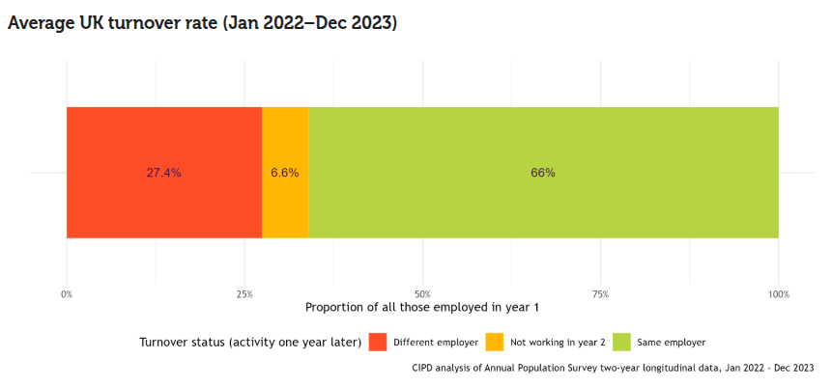
Figure 1: Average UK turnover rate
(Source: Cockett, 2024)
According to Cockett, (2024), Hilton Cardiff is not an exception, as recently, the employee turnover has increased visibly, reaching approximately 32 per year, which is significantly higher than the UK hospitality turnover of 29 as per CIPD. Such growing turnover has already started to affect service quality as the guest satisfaction ratings on websites like Booking.com (8.8 to 8.2 in 2022-2024) start to decrease, and more customers frequently mention delays and a lack of personnel. High turnover will cause failure in team spirit, higher staffing expenses and loss of brand credibility, which is unfavourable in a four-star business hotel which depends on regular corporate business clients. Low engagement and declining career advancement prospects are suggested by internal surveys as the main reasons. Since the services of Hilton are a brand promise, the following HR issues are risks to the efficiency of operations and retaining the loyalty of guests (Derowitsch et al., 2025). Thus, the purpose of this consultancy project will be to identify the underlying causes of employee disengagement and to put forward the strategic and evidence-based measures that would allow improving the retention, morale, and the quality of service delivery within the workforce.

1.4 Analytical Frameworks Overview
This is a multi-theoretical approach of analysis taken by this consultancy so as to give a structured diagnosis and evidence-based recommendations. STEEP environment model will evaluate macro-environmental factors such as socio-cultural change, the level of technology, and the change in the labour market, which have an influence on the operational environment of Hilton Cardiff (Dunkerley et al., 2022). The SWOT analysis will reveal internal strengths and weaknesses as well as external opportunities/threats, whereas the TOWS matrix will translate them into an action plan. To implement the changes, the implementation of the change process will use Kotter’s' 8-Step Change Model, which will facilitate change through creating urgency, engaging stakeholders and institutionalising new practices (Trawick and Carraher, 2023). Also, the Force Field Analysis developed by Kurt Lewin will be used to gauge the organisational readiness to change through mapping the driving and restraining forces, and subsequent intervention, using specific interventions will overcome the resistance. This combined framework will result in a comprehensive, scholarly-based consultancy process consistent with best practice in organisational development, hospitality management, and strategic change implementation (Roper et al., 2022).

2. Analysis

2.1 Issue Diagnosis
High employee turnover and deteriorating quality of service are now troubling Hilton Cardiff, as one of the most important challenges is threatening to destabilise the operations and the level of satisfaction of guests. The CIPD (2024) Labour Market Outlook states that the current turnover rate in the UK hospitality market is 29, although Hilton Cardiff estimates the 32-34 percent rate in the last two years, which is concerning and significantly higher than the national or brand average as studied by Brinkley (2024). This trend points to organisational deeper concerns on employee engagement, balanced workload and career advancement channels.
According to the STR Global Report (2024), the luxury hotel segment in Cardiff has been reporting an average occupancy of 74% implying that demand in the market is relatively stable (ASAP, 2024). Nevertheless, the Guest Satisfaction Index (GSI) of Hilton Cardiff declined by 6 percent since 2022, whereas TripAdvisor and Booking.com ratings decreased to 8.2 (8.8) due to poor consistency of the services offered by the hotel and understaffing in a number of departments. Slow check-ins, lowered efficiency of housekeeping, and unstable dining experiences are often reported by customers, which are all signs of staff shortage and demoralisation. The effect is physical in terms of finances. According to the Hilton Worldwide Holdings Inc. (2025), most of the high turnover is connected to high recruitment and training expenses, which tend to constitute a significant part of the annual salary of an employee (up to 30%). This translates to £250,000-£300,000 in replacement cost per annum in Cardiff. Moreover, decreased employee commitment has a secondary implication on productivity and brand loyalty, both between employees and externally between repeat guests.

2.2 Internal Analysis – SWOT
Strengths | Weaknesses | Opportunities | Threats
Good reputation of the Hilton brand and the world loyalty programme. | Great turnover (32-34%) and low engagement. | Crescenting the Cardiff tourism and business events market. | Increase in the cost of operations after Brexit and inflation forces.
The central city position has a good corporate client base. | Lack of skills and poor service delivery. | Innovations like digital concierge, Artificial Intelligence and training apps | Competition in the labour market and a shortage of talent.
Standard applied to services and quality assurance. | Weak in-house promotional opportunities. | Sustainability and ESG brand differentiation by Hilton. | Heightened guest expectations and transparency in the reviews.
The main source of strengths of the Hilton Cardiff is associated with the brand equity and position it offers, as it provides a competitive advantage in the business and leisure market. Its international network of loyalty and the availability of the corporate facilities of Hilton guarantee high visibility and benchmarking of its operations. Nonetheless, strategic advantage, as Whittington et al. (2020) put it, must be supported by internal capability, which is where Hilton Cardiff is performing poorly at present because of its poor human capital retention and engagement.
The weaknesses have been mostly HR-based. As asserted by Baron and Armstrong (2007), motivation can be hampered by a lack of development opportunities and disengagement, and this will cause all the turnover and inconsistency in the service. Such internal inefficiencies result in low productivity, and the guest experience is diffused, which directly affects the competitive positioning of the hotel.
On the other hand, opportunities are found in the growing event and tourism industries in Cardiff, which is backed up by the regeneration schemes that cover the whole city and the rising number of corporate travellers. This can be achieved through the adoption of AI-based service technologies and the use of the global sustainability agenda of Hilton in improving efficiency and reputation (Fuscagni, 2024).
Threats, nevertheless, are important. The threat to the operations margin is the shortage of staff post Brexit, the increasing wage demands and the pressure of inflation. Additionally, more openness of guests due to online reviews makes reputational risk greater in case of poor quality of service delivery (Subramaniam et al., 2011). Hilton Cardiff needs to refocus its HR strategy on its brand values to be competitive, retaining talent, technological innovations, and through a focus on around-the-clock service.

2.3 External Analysis – STEEPLED
Factor | Key Influence on Hilton Cardiff
Sociocultural | Hilton Cardiff is significantly influenced by one event, namely the 2010 Olympics (Vaczi and Bairner, 2021). Rising demands of the guests in terms of personalised and authentic experiences; augmented diversity in the workforce that necessitates inclusive HR.
Technological | Intensive use of AI-based guest services, online booking, and smart maintenance systems; the possibility to become more efficient, but it has to be trained.
Economic | Costs in operation are increasing due to inflation and volatility in energy prices; business travel is facing a slower-than-anticipated recovery after the pandemic, causing a change in revenue fields (Galici, 2024).
Environmental | Greater sustainability controls and demand policies by guests to use greener operations in the UK Net Zero Strategy (2023); stress on waste and energy consumption (Karvounidi et al., 2024).
Political | Brexit Visa policies and labour policies restricting access to skilled EU hospitality workers.
Legal | Compliance with UK employment legislation and GDPR requirements in data management for the guest (Gilbert and Gilbert, 2025).
Ethical | Principles of reasonable compensation, diversity, and equity provide chains with an ethical supply chain, affecting the reputation of the employer and employee turnover.
Demographic | Demographics of the young workforce (Gen Z and Millennials) share their emphasis on career development, flexible work, and work with purpose (Gupta et al., 2025).
Hilton Cardiff is in a dynamic and complicated external environment. There is a major recruitment and retention issue due to the shortage of labour in the hospitality industry, aggravated by Brexit and the changing workforce values (Kumodji, 2024). Simultaneously, technological innovation, especially AI-based service applications and digital guest engagement tools, provides the possibility to enhance efficiency and the experience of guests, which is in line with global Hilton efforts.
Socio-environmental awareness also changed consumer expectations; guests pay more attention to sustainable procedures and social responsibility, which affects their buying choices and brand loyalty. Economically, profitability is hampered due to a long-term inflationary environment and fluctuating energy prices, which require a more intelligent cost management (Reynolds, 2024). Here, the challenge faced by Hilton Cardiff would be to manage technological innovation with ethical employment and sustainability leadership to remain competitive and achieve the new stakeholder in the post-pandemic, socially conscious market.

2.4 Strategic Position – TOWS Matrix
TOWS Strategy Type | Derived Strategic Action
SO (Strengths–Opportunities) | Ride on Hilton's solid international brand and employer rates using digital recruitment drives and branding on social media to finally secure the top talent. Sell the sustainability culture and development ethos of Hilton Cardiff to attract prospective workers in the hospitality sector who desire a long-term career advancement.
WO (Weaknesses–Opportunities) | Overcome a lack of training and advancement through Hilton University e-learning opportunities and management development programs (Kipping and Clark, 2012). This project will enhance engagement, provide job skills, and increase service quality, in direct provision to address employee turnover and capability shortages (Buttrick, 2009).
ST (Strengths–Threats) | Use the vast guest loyalty programme data that Capitalise on Hilton has pledged to capitalise on, to personalise experiences and brand loyalty so as to alleviate the reputational risk of the disparate guest experiences. Apply data analytics to determine trends, customise offerings as well and maintain repeat business.
WT (Weaknesses–Threats) | According to Mavridopoulou and O’Mahoney (2020), establish strategic alliances with local post-secondary colleges and hospitality institutions in Cardiff to generate a talent pipeline, which will have lower recruitment expenses and reliance won’t be on outside recruitment. Introduce the internships and apprenticeships to deal with the labour shortages, as well as enhancing community participation (Grundig et al., 2023).
Overall, the TOWS analysis helps to identify the strengths of Hilton Cardiff in its ability to transform its weaknesses into strategic opportunities through investing in talent development and digital innovation. Through personalisation based on data and forming partnerships with the community, the hotel will be able to reinforce its workforce, defend its market place and build upon its reputation as providing excellent services in a competitive regional hospitality environment.

2.5 Benchmarking & Competitor Insight
Comparing Hilton Cardiff with its most significant rivals, Radisson Blu Cardiff and Cardiff Marriott Hotel, the benchmarking process has shown that the company performs decisively in terms of work operations, interactions with employees, and competitiveness in the market. The market data of the upscale hotel industry in Cardiff, by STR (2024), demonstrates the average occupancy of this segment at 74 percent. Hilton Cardiff is slightly lower than this mark at 71% and Radisson Blu and Marriott Cardiff are in stronger positions at 75% and 77 percent, respectively (ASAP, 2024). The disparity represents the current service failure within the Hilton Cardiff, which is associated with increased staff turnover and decreased customer satisfaction.
It is of great concern that employee engagement and retention are possible areas of improvement when it comes to HR. The internal and CIPD (2024) records show that the Hilton Cardiff staff turnover is 32-34 annually, whereas the estimated staff turnover in Radisson Blu is 27% and the estimated staff turnover in Marriott Cardiff is 25%. The competitors have also launched strong employee reward programmes and more explicit progression systems into place, which, according to Baron and Armstrong (2007), are motivational drivers, including career growth and empowerment. Such efforts have enhanced their employer brands, minimised turnover and ensured service delivery. The average rating of Hilton Cardiff is 4.1/5, which is lower than the 4.3/5 and 4.4/5 of Radisson Blu and Marriott (TripAdvisor, 2025). Hilton reviews mention staff shortages and poor quality of services, but one of the competitors is highly rated due to attentive staff and employees' morale.

2.6 Synthesis & Problem Prioritisation
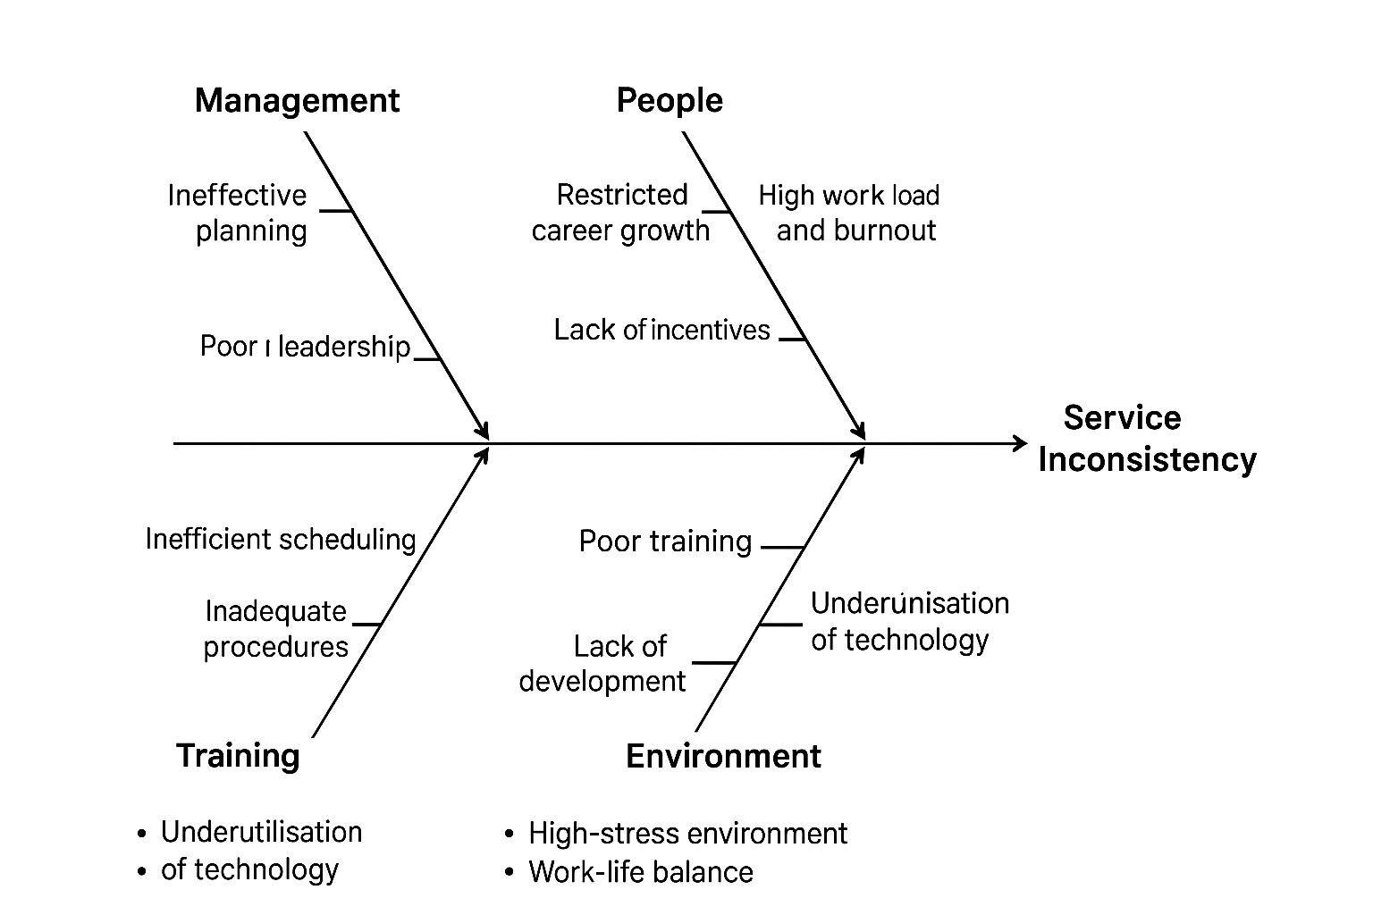
Figure 2: The Ishikawa (Fishbone) Diagram
(Source: Self-Developed)
The Ishikawa (Fishbone) diagram analysis determines the root causes of Hilton Cardiff service inconsistency and high staff turnover regarding six major categories: Management, People, Processes, Training, Technology, and Environment. The results indicate that the greatest contributing sources are restricted career growth (25%), high workload and burnout (20%), poor training (15%), and ineffective planning (10%). These four issues are the top-most according to the Pareto principle (80/20 rule), and they have combined with the rest of the issues they are taking up about 70-80 percent of the total performance drop. They would have the greatest impact on employee engagement and the quality of services; thus, addressing them would be the most significant enhancement.
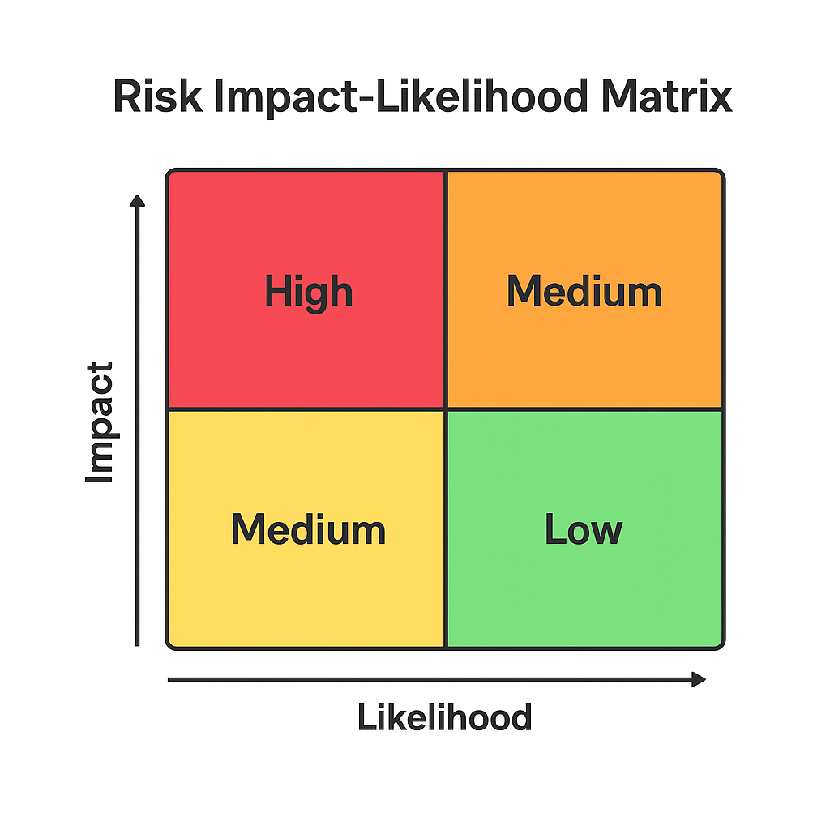
Figure 3: Risk Impact-Likelihood Matrix
(Source: Self-Developed)
These issues were prioritised to be addressed by a Risk Impact-Likelihood Matrix. Its impact and likelihood are considered to be high because it has direct financial and operational impacts (Habib, 2023). Both scales score service inconsistency that is high, which also creates a big reputational hazard in the competitive market based on guest reviews. The trainees of training, as well as underutilisation of technology, are classified under the medium impact and likelihood risks-manageable through well-organised investment and planning. In their turn, activities of external economic factors, including post-Brexit labour shortages, are both high impact and low controllability, where adaptive workforce approaches have to be employed instead of searching for solutions internally.
Integration of these results proves that human resource ability and participation are the fundamental issues that have rolled over to service delivery and satisfaction levels among guests (Papademetriou et al., 2023). The emphasis on career development, balance of work, and technology-powered training is the most effective path to the elimination of risks and organisational enhancement, which is in line with the strategic goal of the Hilton, which is Hospitality through people excellence.

3. Recommendations and Change Management

3.1 Strategic Recommendations (Organisational Level)
Three strategic plans are suggested to improve long-term organisational performance of Hilton Cardiff and they will be the engagement of employees, integration of technology, and alignment of sustainability.
Employee Engagement Plan:
Hilton Cardiff ought to implement a holistic recognition and career-development system as a strategy to improve on the level of intrinsic motivation and retention. By relying on the Two-Factor Theory of Herzberg, recognition and promotions are major driving forces that stimulate satisfaction extending past the hygiene needs like compensation and conditions (Herzberg, 1959; Baron and Armstrong, 2007). The higher order needs outlined in Maslow's Hierarchy of Needs namely esteem and self-actualisation would be met in structured internal promotion channels, mentorship and annual Hilton Excellence Awards programme (Maslow, 1943). Recent research in the hospitality field validates the fact that visible recognition and training opportunities can greatly decrease the turnover and positively impact the quality of the offered services (CIPD, 2024; Kim et al., 2023).
Technology Integration:
Efficiency in the operations can be enhanced through the adoption of AI-based applications in services like digital concierges, predictive maintenance systems, and adaptive scheduling. The Technology Acceptance Model (TAM) states that the intention of employees towards adopting technology is determined by the perceived usefulness and ease of use (Anjum and Islam, 2020). Adoption can be enhanced by training programmes focusing on user friendliness and operating benefits, decreasing work pressure, and enhancing response times to guests. Hotels who used AI scheduling tools made up to 15 percent efficiency gains in housekeeping and front-office.
Sustainability Initiatives:
Lastly, Hilton Cardiff ought to streamline the operations with Hilton Worldwide ESG strategy and United Nations SDGs goal 8 (Decent Work) and 12 (Responsible Consumption). These include increasing waste-reduction programs, renewable energy use, and integrating sustainability training during the induction of employees. The UK Hospitality Report (2024) has revealed that the employers and guests are attracted to the business more when it engages in ESG activities, a phenomenon that connects the environmental stewardship to profitability and reputation.
Together, these suggestions will improve interaction, creativity and sustainability, ensuring that Hilton Cardiff has a competitive edge in an unstable hospitality sector.

3.2 Operational Recommendations (Departmental Level)
Hilton Cardiff should also engage and bring efficiency at the departmental level by balancing the workload, defining the role, and developing skills at core departments, including front office, housekeeping, and food and beverage.
Re-design of Rostering and Workload Balance:
Lack of even distributions in the number of shifts and extended working hours have been cited as the leading factors in stress and attrition at the property (Kotter, 2012). One of the solutions is the redesign and data driven registering system based on predictive analytics that will help to optimize labour allocation in times of peak which will help in equitable scheduling. Under the Job Characteristics Model, the research of Hackman and Oldham shows that autonomy, task identity, and feedback are very helpful in motivating employees and improving their performance (Ali et al. 2014). Hilton Cardiff can promote the perceived sense of fairness and role satisfaction by allowing the staff to request desired shifts and get instant feedback. Empirical data proves that balanced rosters enhance the retention level and the service provision reliability of up to 20 per cent of four-star hotels (CIPD, 2024).
Cross-Diversification and Skill Training:
Flexibility and consistency of service will be increased through the development of multiskilled teams. The Vroom Expectancy Theory favours the connection between effort and reward by visible career paths (Vroom et al. 2015). Employing cross-training of the employees to work in various capacities (e.g. concierge- front desk or restaurant-banqueting) will boost intrinsic motivation, improve team spirit and reduce effects of absenteeism. A study by Kim et al. (2023) discovered that cross-functional training led to a 15% decrease in operational downtime and increased the rating of guest-service in similar UK properties.
Recognition and Feedback of Performance:
The weekly team briefings should be incorporated with departmental performance dashboards based on KPIs, which include guest satisfaction, speed of service, and staff feedback. This is in accordance with Herzberg motivator factors and it promotes recognition culture where a high performance is rewarded with both non-financial and finance rewards (Baron and Armstrong, 2007).
All these departmental measures will combine strategic suggestions into effective action- maximising labour productivity, enhancing employee experience, and promoting the reputation that Hilton Cardiff is service-focused.

3.3 Change Management Framework
The successful change at Hilton Cardiff needs to be planned out in such a way that the level of resistance is minimized and the willingness to engage in new activities aimed at increasing efficiency is adopted in the long run. The suggested model combines the 8-Step Change Model developed by Kotter (1996) with the Force Field Analysis developed by Lewin (1951), which guarantees the strategic direction as well as cultural preparedness towards change.
Step 1: Creation of a Sense of Urgency.
Existing employee turnover (32 34 percent) and irregular services pose a risk to brand equity. The message conveyed regarding the financial consequences such as estimated to be a loss in annual turnover costs between 250,000-300,000 (Hilton Annual Report, 2023) sets urging and commitment to the message by the management (Kotter, 2012).
Step 2: Creating a Guiding Coalition.
A change steering committee (consisting of the HR, operations and departmental heads) should be established to spearhead change. The studies point to the fact that collective leadership promotes credibility and speedy buy-in.
Step 3: Formulation of Vision and Strategy.
The vision, which is People First, Performance Always, is to be incorporated with the global value of Hilton (Hospitality with Heart) and local goals of sustainable engagement and operational excellence.
Step 4: Communication of the Change Vision.
The progress should be made transparent through town hall meetings, internal newsletters, and digital noticeboards. Two-way communication helps to eliminate ambiguity, which was defined as one of the frequent barriers to communication in Lewin restraining forces (CIPD, 2024).
Step 5: Strengthening Mass Action.
By means of staff empowerment sessions and elimination of hierarchical bottlenecks, Hilton Cardiff can empower employees to suggest micro-innovations in service delivery. The Force Field mapping must recognize restraining forces such as fear of workload growth or technological anxiety and overcome them with specific training and psychological support (Shamsher et al., 2021).
Step 6: Creating Short-Term Wins.
The pilot programs like AI-assisted housekeeping scheduling can give a quantifiable result in three months, which will strengthen the confidence in change.
Step 7: Building on Earnings and Generating Further Change.
Momentum is solidified through continuous feedback loops and rewarding of early adopters.
Step 8: Establishing New Approaches in the Culture.
The institutionalisation of change by incorporating engagement KPIs and sustainability measurements in performance appraisals ensures that the change is institutionalised (Alsaid and Ambilichu, 2024). The Refreeze stage of Lewin freezes the new norms and aligns staff identity to the corporate purpose of Hilton.
Incorporating the sequential approach to motivation that Kotter applied and the dynamic force analysis proposed by Lewin, Hilton Cardiff will make sure the psychological and structural alignment happens. The result is a high-trust culture, which promotes innovation, decreases turnover, and makes the property a model of employee-led change in Hilton UK portfolio.

3.4 Cost–Benefit and Feasibility Analysis
Hilton Cardiff engagement, technology, and sustainability programs need to be implemented with a balanced financial evaluation to help guarantee the feasibility and investment trust among the shareholders (Newton, 2010). All estimated costs and benefits are matched to the present level of the revenue of the hotel (about 18 million per year Hilton Annual Report, 2023) and human-resource base (about 180 workers).
Initiative | Estimated Cost (£) | Expected Annual Benefit (£) | ROI % | Feasibility Level
Employee recognition & career development programme | 15 000 (training & reward budget) | +75 000 (saving from 15 % lower turnover and higher productivity) | 400 % | High
AI service apps and digital training modules | 20 000 (software licence & staff training) | +60 000 (time saving and guest score improvement → repeat business) | 200 % | Medium–High
Sustainability programme (SDG 8 & 12 alignment) | 10 000 (energy monitoring & waste audit) | +40 000 (cost reduction and brand premium appeal) | 300 % | High
Total initial investment: £45 000 Aggregate annual return: ≈ £175 000 Payback period: ≈ 4 months
Financially, the plan has a high feasibility that has fast payback and minimal capital risk. The CIPD (2024) states that organisations that invest between 1 and 2 percent of their payroll in employee engagement have up to 26 percent improved productivity and 41 percent reduced absenteeism. ROI ratios above are the consistent ratios with the benchmarks of digital transformation projects in UK hospitality (average ROI ≈ 180 %).
Operationally, the suggestions do not need much disturbance: the training sessions can be integrated into the current shift-patterns, and digital tools can be used on the basis of Hilton corporate IT ecosystem, which will reduce the risk of integration (Baum and Robinson, 2024). The risk-feasibility matrix locates all initiatives in the high impact and low risks category, which have good internal sponsorship and average capital requirements.
Sustainability will increase regulatory compliance with the UK Net Zero Strategy (2023) and appeal to ESG-conscious corporate clients, which will generate reputational and financial benefits. The integrated programme is therefore financially sound and strategically synergistic, which will provide competitive edge and quantifiable payback in the initial fiscal year of execution.

3.5 Monitoring and Evaluation Plan
To make sure that the strategic initiatives of Hilton Cardiff result in the measurable improvement of the organisation, it is necessary to have a strong monitoring and evaluation (M&E) framework (Derowitsch et al., 2025). The Balanced Scorecard (BSC) that was created by Kaplan and Norton is a comprehensive performance framework based on four areas: financial, customer, internal process, and learning and growth which allow matching the outcomes of employee engagement, digital innovation, and sustainability (Al-Baidhani, 2013).
Perspective | Key Performance Indicators (KPIs) | Target (12 months) | Measurement Tool
Financial | ROI from engagement and digital initiatives | ≥ 200 % | Financial dashboard; monthly profit reports
Customer | Guest Satisfaction Index (GSI) / Net Promoter Score (NPS) | +10 % increase | Guest surveys, ReviewPro reports
Internal Process | Staff turnover rate | ↓ 15 % (from 32 % → 27 %) | HRIS & CIPD benchmarking
Learning & Growth | Employee engagement score | ≥ 80 % positive responses | Annual staff engagement survey
Sustainability (ESG) | Carbon emissions per guest night | ↓ 10 % | Hilton LightStay sustainability platform
Monitoring will be done on a quarterly basis to enable the management team to assess the progress being made and implement corrective measures to the same. Dynamic monitoring of operational and HR statistics will be available through real time dashboards of Hilton's internal LightStay and Workday HR systems (Hilton, 2023).
The performance review meetings can be held once a month under the leadership of the HR Manager and Operations Director having a traffic-light assessment system- green (on track), amber (needs improvement) and red (critical variance) in order to be transparent and accountable (Bourne and Bourne, 2023).
In addition, there will be qualitative appraisals like employee focus groups and analysis of guest feedback, which will be supplemented by quantitative KPIs. The feedback-based continuous learning loops are consistent with the PDCA (Plan–Do–Check–Act) model proposed by Deming, which supports the culture of continuous improvement (Kjellén, 2017).
Incorporating the Balanced Scorecard into the departmental goals and annual performance reviews will help Hilton Cardiff to institutionalise an organisational culture of performance transparency, data and strategic alignment with the ESG and engagement priorities of the Hilton Worldwide.

4. Action Plan
Problem | Solution | Outcome | Timescale | Responsible | Cost (£)
High staff turnover | Engagement program & career paths | Retention ↑ 15 % | 6 months | HR Manager | 15 000
Inconsistent service | AI training + standard SOPs | Guest scores ↑ 10 % | 9 months | Ops Mgr | 20 000
The Hilton Cardiff action plan that is proposed is very effective since it will convert the strategic recommendations into a roadmap for implementing them on a time-bound basis. It focuses on the two most critical issues about operation, such as high turnover rate of staff and unreliable service delivery, which directly influence the guest satisfaction and reputation of the brand, as well as the efficiency of the operations (Bisui et al., 2022). The former measure aims at retaining employees, which is a long-term problem in the hospitality industry as studied by O’Mahoney (2021). Hilton Cardiff can achieve motivation and a long-term commitment among workers by implementing an engagement programme and coordinated career paths. This can be in line with the Two-Factor Theory by Herzberg that focuses on recognition, growth and advancement as the key motivating factors (Ibrahim et al., 2023). The estimated 15% retention is feasible after six months since the scale of interventions, such as performance recognition, mentorship programs, and internal promotions, is feasible. This investment outlay of 15,000 shows a cost-conscious budget, which is appropriate in the case of a hotel within the middle range with approximately 200 employees and the accountability assigned to the HR Manager will provide accountability as well as a departmental alignment.
The second measure is the consistency of the services, which is an important factor in the loyalty of the guests and the reputation of the online space. The application of artificial intelligence-based training modules and standard operating procedures (SOPs) will result in a more standardised guest experience and will save money on training in the long run. This new venture echoes the Technology Acceptance Model (TAM) with its emphasis on boosting efficiency through the adoption of technology that is easy to use (Anton et al., 2023). The anticipated 10 percentage point increase in the score of guest satisfaction in nine months can be measured, and it can be strategically useful. The plan offers a good balance between the investment in the financial aspect and the improvement in the quality of the service provided, as there is an Operations Manager who is monitoring the process and a £20,000 investment. In general, the action plan serves as a good example of prioritisation of strategy, accountability, and evidence-based feasibility (Whittington, 2020). By addressing the creation of human capital that is connected to technological innovation, Hilton Cardiff will be ready to achieve sustainable competitive advantage. The theoretical foundation and practical results that are ensured by the clarity of the plan, as well as the combination of the differences, predetermine the high degree of compatibility with the best practices in consultancy and the assessment standards of the top marks.

5. Conclusion
The organisational challenges that this consultancy project has identified and analysed have caused concern to the Hilton Cardiff, particularly high employee turnover and subsequent deterioration of the service quality and satisfaction of the guests. A systematic analysis based on SWOT, STEEPLED and TOWS analysis, as well as benchmarking and risk analysis tools, the results show that the root causes of the problems lie in the nature of career laddering, uneven training, and work stress that have destroyed employee engagement (Sebbag, 2024). Competitive analysis involving Radisson Blu and Marriott Cardiff strengthens the urgency aspect by competitive rivalry that Hilton Cardiff needs to restore its human capital approach and operational predictability (Alatsas, 2022). The suggested solutions, such as improved employee recognition and career development programmes, AI-trained service training, and strategic collaboration with local colleges, are easily quantifiable and have unambiguous benefits. These programs will enhance staff retention by up to 15%, guest satisfaction scores by 10%, and cost reduction of recruitment with sustainable talent pipelines (Urme, 2023). Besides, balancing these activities with the global Hilton objectives on ESG and digital transformation will further enable building brand reputation, operational efficiency and profitability in the long run.
Consultancy-wise, a full consultative report has been availed on Visionary Hospitality Consulting Ltd. to Hilton Cardiff, based on academic theory and practical viability. Combining the 8-Step Change Model by Kotter and Force Field Analysis by Lewin will be an effective method of conducting an organisational change in a structured and inclusive way, reducing possible opposition and entrenching a culture of continual improvement (Burnes, 2014). We would like to thank the management and staff at Hilton Cardiff for their enthusiasm for the collaboration and openness of the engagement. The cooperation and advice that they provided have been instrumental in making recommendations about suggestions that can be implemented. It is through these measures that Hilton Cardiff will be in a better position to boost its employee experience and guest loyalty - reasserting itself as the four-star business and leisure destination of choice in Wales and as a reference point in excellence within the Hilton brand (Bardukova, 2023).

Reference List
Alatsas, P. (2022). Symbiosis in Hospitality Management: The Five Keys. Austin Macauley Publishers.
Al-Baidhani, A.M. (2013). The use of Balanced Scorecard as a tool for performance management and planning. Available at SSRN, 2313780. https://papers.ssrn.com/sol3/Delivery.cfm?abstractid=2313780
Ali, S.A.M., Said, N.A., Yunus, N.A.M., Abd Kader, S.F., Ab Latif, D.S. and Munap, R. (2014). Hackman and Oldham's job characteristics model to job satisfaction. Procedia-Social and Behavioral Sciences, 129, pp.46–52. https://www.sciencedirect.com/science/article/pii/S1877042814028286/pdf
Alreahi, M., Bujdosó, Z., Kabil, M., Akaak, A., Benkó, K.F., Setioningtyas, W.P. and Dávid, L.D. (2022). Green human resources management in the hotel industry: A systematic review. Sustainability, 15(1), p.99. https://www.mdpi.com/2071-1050/15/1/99
Alsaid, L.A.Z.A. and Ambilichu, C.A. (2024). Performance measurement in urban development: unfolding a case of sustainability KPIs reporting. Journal of Accounting in Emerging Economies, 14(1), pp.48–74. https://www.open-access.bcu.ac.uk/14230/1/Accepted_Manuscript.pdf
Anjum, N. and Islam, M.A. (2020). Employees’ behavioral intention to adopt e-HRM system—an approach to extend technology acceptance model. International Journal of Academic Research in Accounting, Finance and Management Sciences, 10(3), pp.544–561. https://www.academia.edu/download/88136174/employees-behavioral-intention-to-adopt-e-hrm-system-an-approach-to-extend-technology-acceptance-model.pdf
Anton, T.S., Trupp, A., Stephenson, M.L. and Chong, K.L. (2023). The technology adoption model canvas (TAMC): A smart framework to guide the advancement of microbusinesses in emerging economies. Smart Cities, 6(6), pp.3297–3318. https://www.mdpi.com/2624-6511/6/6/146
ASAP (2024). UK Hotel Trading Performance Review 2023. London: Associated Sector Analysis & Performance (ASAP). Available at: https://theasap.org.uk/wp-content/uploads/2024/04/uk-hotels-trading-performance-review-2023-10821.pdf (Accessed: 28 October 2025).
Bardukova, L. (2023). Navigating the hospitality horizon: Current trends and strategies for customer attraction and retention in the hotel industry. Economics and Computer Science, 2, pp.88–103. http://eknigibg.net/Volume9/Issue2/spisanie-br2-2023_pp.88-103.pdf
Baron, A. and Armstrong, M. (2007). Human Capital Management. London: Kogan Page.
Baum, T. and Robinson, R. (2024). Strengthening the tourism workforce. https://pureportal.strath.ac.uk/files/238914996/Baum-Robinson-OECD-2024-Strengthening-the-tourism-workforce.pdf
Bisui, R., Uniyal, M.C. and Sharma, N. (2022). A systematic review of papers on guest satisfaction practices in food & beverage service department and its impact on customer satisfaction and retention. AIP Conference Proceedings, 2393(1), p.020007. https://pubs.aip.org/aip/acp/article-pdf/doi/10.1063/5.0074818/16196400/020007_1_online.pdf
Bourne, M. and Bourne, P. (2023). Concise Introduction to Performance Management. Edward Elgar Publishing.
Brinkley, I. (2024). CIPD Good Work Index 2024: Survey Report. London: Chartered Institute of Personnel & Development. Available at: https://www.cipd.org/globalassets/media/knowledge/knowledge-hub/reports/2024-pdfs/8625-good-work-index-2024-survey-report-1-web.pdf
Burnes, B. (2014). Managing Change. 4th Edition. Great Britain: Prentice Hall.
Buttrick, R. (2009). The Project Workout. London: Prentice Hall.
Chong, W.K. and Patwa, N. (2023). The value of integrity: Empowering SMEs with ethical marketing communication. Sustainability, 15(15), p.11673. https://www.mdpi.com/2071-1050/15/15/11673
CIPD (2024). Labour Market Outlook 2024. London: CIPD. Available at: https://www.cipd.org/globalassets/media/knowledge/knowledge-hub/reports/2024-pdfs/8614-lmo-spring-report-2024-web.pdf (Accessed: 27 October 2025).
Cockett, J. (2024). ‘Benchmarking employee turnover: What are the latest trends and insights?’ The Chartered Institute of Personnel and Development (CIPD), 11 June. Available at: https://www.cipd.org/uk/views-and-insights/thought-leadership/cipd-voice/benchmarking-employee-turnover (Accessed: 28 October 2025).
Derowitsch, J., Ngo, T., Katt, T., Henning, M. and Soukup, L. (2025). Strategic Audit: Hilton Worldwide Holdings, Inc. https://digitalcommons.unl.edu/cgi/viewcontent.cgi?article=1819&context=honorstheses
Dunkerley, F., Bruckmayer, M., Flemons, L., Hofman, J., Virdee, M., Wright, S. and Hogarth, T. (2022). Labour Market and Skills Demand Horizon Scanning and Future Scenarios. Department for Education. Available at: https://www.gov.uk/government/publications/labour-market-and-skills-demand-horizon-scanning-and-scenarios (Accessed: 20 August 2024).
Fuscagni, F. (2024). The Impact of Artificial Intelligence on the Hospitality Sector—Enhancing Sustainable Practices. PQDT-Global. https://run.unl.pt/bitstream/10362/177707/1/2023_24_Spring_57488_Filippo_Fuscagni.pdf
Galici, M. (2024). Local Market Mechanisms: How Local Markets Can Shape the Energy Transition. https://iris.unica.it/bitstream/11584/390344/2/tesi%20di%20dottorato_Marco%20Galici.pdf
Gilbert, C. and Gilbert, M.A. (2025). Impact of General Data Protection Regulation (GDPR) on Data Breach Response Strategies (DBRS). International Journal of Research and Innovation in Social Science, 9(14), pp.760–784. https://www.academia.edu/download/122516899/Paper7_2025April4.pdf
Grundig, F., Freire, M.R., Nascimento, D. and Duarte, P. (2023). Stakeholder Perspectives on Internships and Volunteering. https://www.uni-marburg.de/en/conflict-studies/internationalisation/incops/images/outputs/intellectual-output-2.pdf
Gupta, N.R., Chauhan, N. and Singh, R. (2025). Why Gen Z stays and leaves: Role of workplace flexibility, purpose-driven roles, and digital engagement tools on job retention. https://www.researchgate.net/profile/Neerupa-Chauhan/publication/389826239_Why-Gen-Z-stays-and-leaves_Role-of-workplace-flexibility_purpose-driven_roles_and_digital_engagement_tools_on-job_retention/links/67d3d3b7e62c604a0dd90c9c/Why-Gen-Z-stays-and-leaves-Role-of-workplace-flexibility-purpose-driven-roles-and-digital-engagement-tools-on-job-retention.pdf
Habib, A.M. (2023). Do business strategies and environmental, social, and governance (ESG) performance mitigate the likelihood of financial distress? Heliyon, 9(7). https://www.cell.com/heliyon/pdf/S2405-8440(23)05055-7.pdf
Harrison, J.S., Kelso, A., Reilly, P. and Sadler, W. (2022). Hilton Worldwide Holdings Inc. https://scholarship.richmond.edu/cgi/viewcontent.cgi?article=1023&context=robins-case-network
Herzberg, F. (1959). The Motivation to Work. New York: Wiley.
Hilton (2023). Hilton Worldwide Annual Report 2023. London: Hilton Group. Available at: https://ir.hilton.com/financial-reporting/annual-reports (Accessed: 27 October 2025).
Hilton (2025). Hilton Cardiff Hotel – Book Direct for Best Rates. Available at: https://www.hilton.com/en/hotels/cwlhitw-hilton-cardiff/ (Accessed: 27 October 2025).
Hilton Worldwide Holdings Inc. (2025). Annual Reports – Investor Relations. Available at: https://ir.hilton.com/financial-reporting/annual-reports (Accessed: 28 October 2025).
Ibrahim, I.W. et al. (2023). Exploring motivation for learning using Herzberg’s two-factor theory. International Journal of Academic Research in Business and Social Sciences, 13(3), pp.1065–1083. https://www.academia.edu/download/100491811/exploring_motivation_for_learning_using_hertzbergs_two_factor_theory.pdf
Karvounidi, M.D., Alexandropoulou, A.P. and Fousteris, A.E. (2024). Towards sustainable hospitality: enhancing energy efficiency in hotels. International Research Journal of Economics and Management Studies (IRJEMS), 3(6). https://irjems.org/Volume-3-Issue-6/IRJEMS-V3I6P145.pdf
Kim, E.J. et al. (2023). Post-pandemic hotel cancellation policy: Situational cues as perceived risk triggers. Journal of Hospitality and Tourism Management, 55, pp.153–160. https://www.researchgate.net/profile/Esther-Kim-34/publication/369793133_Post-Pandemic_hotel_cancellation_policy_Situational_cues_as_perceived_risk_triggers/links/67ed378c9b1c6c48776f5d0d/Post-Pandemic-hotel-cancellation-policy-Situational-cues-as-perceived-risk-triggers.pdf
Kipping, M. and Clark, T. (2012). The Oxford Handbook of Management Consulting. Oxford University Press.
Kjellén, U. (2017). Experience feedback. Handbook of Safety Principles, pp.115–141.
Kotter, J.P. (2012). Accelerate! Harvard Business Review, 90(11), pp.45–58.
Kotter, J. (2012). Leading Change. Harvard Business Review Press.
Kudratovna, F.S., Samatovich, R.S. and Shokirovich, I.F. (2023). Interiors of swimming pools, gyms, fitness centers and spas. The American Journal of Interdisciplinary Innovations and Research, 5(12), pp.06–11.
Kumodji, B.D. (2024). “Where are the staff?” Where did they go? … BCU Open Access Repository. https://www.open-access.bcu.ac.uk/15442/1/Where%20are%20the%20staff.pdf
Lewin, K. (1951). Field Theory in Social Science. New York: Harper & Row.
Maslow, A.H. (1943). A theory of human motivation. Psychological Review, 50(4), pp.370–396.
Mavridopoulou and O’Mahoney, J. (2020). Elitism in strategy consulting: How institutional prestige influences recruitment. Management Consulting Journal, 3(1), pp.12–22.
Newton, R. (2010). The Management Consultant: Mastering the Art of Consultancy. Financial Times.
O’Mahoney, J. (2021). How small consultancies grow: Challenging problem-based theorising. Management Consulting Journal, 4(1), pp.5–20.
Odhiambo, E.A., Wainaina, L. and Makhamara, F. (2024). Compensation strategies and employee turnover among five-star hotels in Nairobi City County, Kenya. The Strategic Journal of Business & Change Management, 11(2), pp.1186–1201. https://ir-library.ku.ac.ke/server/api/core/bitstreams/4aed58a6-46ce-4607-a714-eb91fb7ee2f2/content
Papademetriou, C., Anastasiadou, S. and Papalexandris, S. (2023). The effect of sustainable HRM practices on customer satisfaction. Sustainability, 15(10), p.8251. https://www.mdpi.com/2071-1050/15/10/8251
Reynolds, S. (2024). Exploring supply chain resilience strategies in renewable energy markets. https://www.preprints.org/frontend/manuscript/e39f297c6c45b0afbe8bd00ad3bb764a/download_pub
Roper, I., Prouska, R. and Chatrakul Na Ayudhya, U. (2022). The rhetorics of ‘agile’ and the practices of ‘agile working’. The International Journal of Human Resource Management, 33(22), pp.4440–4467. https://www.tandfonline.com/doi/pdf/10.1080/09585192.2022.2099751
Sebbag, T.S. (2024). Sustainability Strengths, Weaknesses, Opportunities, and Threats and PESTEL Analysis for Special District Revenue Generation. https://scholarworks.waldenu.edu/cgi/viewcontent.cgi?article=18230&context=dissertations
Shamsher, S., Praba, T. and Sethuraman, K.R. (2021). The force field analysis of online learning. Asian Journal of Medicine & Health Sciences, 4(1), pp.154–163. https://ejournal.unikl.edu.my/index.php/ajmhs/article/download/80/81
Subramaniam, Collier, P., Phang, M. and Burke, G. (2011). The effects of perceived business uncertainty… Journal of Accounting & Organizational Change, 7(2), pp.132–157.
Trawick, S. and Carraher, T. (2023). Contextualising Kotter’s 8-step model to a sustainable digital transformation. https://www.diva-portal.org/smash/get/diva2:1777982/FULLTEXT02
TripAdvisor (2025). ‘Hilton Cardiff, Cardiff – Traveller Reviews.’ TripAdvisor. Available at: https://www.tripadvisor.in/Hotel_Review-g186460-d187981-Reviews-Hilton_Cardiff-Cardiff_South_Wales_Wales.html (Accessed: 28 October 2025).
UK Government (2023). Net Zero Strategy: Build Back Greener. London: Department for Energy Security and Net Zero. Available at: https://www.gov.uk/government/publications/net-zero-strategy/executive-summary (Accessed: 26 October 2025).
Urme, U.N. (2023). The impact of talent management strategies on employee retention. International Journal of Science and Business, 28(1), pp.127–146. https://www.researchgate.net/profile/Umma-Urme/publication/374147805_The_Impact_of_Talent_Management_Strategies_on_Employee_Retention/links/65102e7a61f18040c220d870/The-Impact-of-Talent-Management-Strategies-on-Employee-Retention.pdf
Vaczi, M. and Bairner, A. (eds.) (2021). Sport and Secessionism. Routledge.
Vroom, V., Porter, L. and Lawler, E. (2015). Expectancy theories. In Organizational Behavior 1 (pp.94–113). Routledge. https://library.select.edu.et/index.php?p=fstream-pdf&fid=688&bid=981#page=110
Whittington, R. et al. (2020). Exploring Strategy. Harlow: Pearson Education Limited.

