Action Research Project

Introduction/justification of study area
This research project will focus on the Post Compulsory Education and Training (PCET) and professional development of student social workers undertaking the BSc or MSc degree programme in Higher Education in Wales. The project will focus particularly on the use of one-to-one professional supervision during a student social worker’s practice placement in a social work setting. To successfully complete and pass the degree in Social Work in Wales, student social workers are required to complete ‘200 days of assessed practice learning’ (Social Care Wales (SCW), 2019) over the whole duration of the programme. During placements, student social workers are required to undertake a minimum of 1.5 hours per five working days of supervision with their Practice Educator (PE) (SCW, 2019). A PE is a ‘social worker responsible for the student’s practice learning,’ (SCW, 2019 p.4). SCW also note that the term ‘Practice Educator’ has been used ‘to capture the role’s range of responsibilities for promoting learning, teaching, assessing and managing the practice placement’ (SCW, 2019 p.4) (A3, UK Professional Standards Framework (UKPSF), 2023)
PEs are responsible for providing ‘regular professional and developmental supervision, including evaluative feedback on all aspects of the student’s work’ (SCW, 2019 p. 6) (A3, UKPSF, 2023). PEs should also support student social workers to develop the skill of utilising ‘supervision as a tool to aid professional development’ during placements and on to their post-qualifying profession (SCW, 2019 p.41) (A5, UKPSF, 2023). Furthermore, the National Occupational Standards (NOS) state that social workers and student social workers should ‘develop social work practice through supervision and reflection’ (NOS 2, SCW, 2011).
I am interested to learn the views and perspectives of PEs and students as to whether they feel supervision is an effective tool for assessing and aiding the educational development of student social workers during placements and whether there are general views on the process, and to consider any suggestions for development in this area. I will focus on social work in Wales primarily, considering Welsh specific standards, requirements, and legislation.
Review of Literature
Social Care Wales (SCW), the regulating body for social care in Wales comment ‘social workers in Wales have a central role to play in ensuring the social care and support needs of people are understood and met in a way that promotes their well-being and safety’ (SCW, 2019, p3). A vital part of ensuring both qualified and student social workers are prepared for supporting people who use services is by training practitioners to a high standard to develop essential skills. SCW also state that ‘the professional training of social workers is a key element in preparing professional, competent and confident social workers’ (SCW, 2019 p.3) (V4, UKPSF, 2023). Supervision plays a key part in promoting reflection and self-awareness as well as identifying professional development needs and is a vital part of social work education (Zahav, 2020; V4, K5, A5, UKPSF, 2023).
In their study, of 28 social workers in England, Turner-Daly and Jack (2014) discuss a gap between the ‘rhetoric and reality’ of supervision in social work. The rhetoric of what should be covered in supervision was not always happening in reality. Supervision should educate, support and be administrative (Kadushin, 1976; Ketner 2017) (A2, UKPSF, 2023). England, Turner-Daly and Jack (2014) consider that there should be a space for reflection and identifying personal development needs. They found that only a quarter of social work practitioners were happy with the quality of supervision received. They also note that a lot of research has focussed on the role of the supervisor without giving much consideration to the role of the supervisee and their input. However, an issue with this particular research is that it considers qualified social workers 3 years or above post-qualifying and not students and it is based in England, not Wales. When considering student social workers in Wales, to assess competencies, students are required to evidence Performance Indicators (PI) 1-8 of the NOS (SCW, 2011) and take some responsibility for their own learning and development during supervision and not solely rely on the PE to meet every aspect of their supervision. In his theory of Andragogy, Knowles’ (1973/2012) suggests that adult learners have a feeling of responsibility for their own lives and learning. According to this theory, they do not want others to impose their views on them, however, when adults enter back in to education, they revert to their experiences from school and can adopt an attitude of dependency on the teacher. Knowles (2012 p.64) suggests that educators therefore, need to make an effort to create learning environments which support the ‘transition from dependent to self-directed learning.’
Despite the gaps in this research, it does provide an insight into deficits with the supervision process generally, such as a focus on cases more than reflection on practice and professional learning and development.
In his article, Wilkins (2023) suggests that a space for shared discussions is essential for effective learning. He proposes ‘seven principles of effective supervision.’ The first proposed principle is ‘collaboration’ whereby he states that having an agenda is helpful and a shared and respectful space for conversation. Collaboration and promoting the learner voice is a key consideration for Post Compulsory Education and Training (PCET) in line with the Principles for Change document (Welsh Government, 2020) which is informed by the Wellbeing of Future Generations (Wales) Act 2015 and the UK Professional Standards Framework (UKPSF, 2023). A safe space for effective collaboration during supervision has the potential to provide an opportunity to express positives and struggles in relation to learning (V5, UKPSF, 2023). This idea also corresponds to Maslow’s (1943) hierarchy of needs, where he proposes that individuals thrive on routine and the need to feel safe before having a sense of belonging and respect to comfortably contribute to discussions which will improve their self-esteem and achieve ‘self-actualisation’ (Kurt, 2021).
However, throughout Wales there is no standardised approach for supervision, which could potentially limit effective collaboration and result in different opportunities being offered to students.
Cleak, Roulston, and Vreugdenhil (2016) found in their study of social work students from two universities in Northern Ireland that there were inconsistencies in the quality of learning experience, including supervision offered to students. They note that despite the courses being subject to regulation and standards, content and learner experience varied. They conclude that a positive relationship with PEs is vital for effective learning, especially when feedback is received which contributes to development (A3, UKPSF, 2023). An effective student and PE relationship would create a shared and respectful space as proposed by Wilkins (2023) which would lead to students being more receptive to feedback. Mohammed (2022 p.60) agrees that feedback is essential to student development and that the ‘role of the PE is crucial in providing learner with feedback so that they can reflect on their practice’. Supervision should therefore be utilised as a safe space to provide feedback to learners about their development and to support with reflection for development (A2, A3, A5, UKPSF, 2023). The placement aspect of the social work degree is an opportunity for experiential learning (Kolb, 1984) whereby students can apply their academic learning, and theory to practice experience. However, as Dewey (1933) and Kolb (1984) proposed, individuals learn not simply from experience, but from reflecting on experience. Bogo (2015) agrees with this premise of experiential learning, and that it is a cornerstone for social work education. Furthermore, Bogo (2015) emphasises that the idea of experiential learning reinforces Knowles’ (2015) theory of Andragogy.
Brodie and Williams (2012) also considered the relationship between PEs and students in their small-scale study, analysing audio recordings and semi-structured interviews of 16 participants at the end of a 65-day placement on a post graduate social work programme in Scotland. They also found that having a good relationship between student and PE was key to a positive practice placement which led to students being more open to receive feedback. Duncanson et al (2024 p.1) agree with this and state ‘the relationship between social work students and Field Educators (PEs) is considered a major influence on student learning outcomes.’ Their article reports on the findings that a positive relationship between students and their PEs leads to higher quality supervision and wellbeing post-placement. Bogo (2015) also agrees that a positive relationship between the PE and student that is supportive and trustworthy is significant and results in the student being more receptive to feedback. Furthermore Bogo (2015) emphasises the need for students to actively be involved in their learning and that the collaborative working relationship leads to better outcomes, which is a view shared by Ketner (2017).
Brodie and Williams (2012) also found that there was a generally positive integration of the academic aspects of social work training in to the practical, such as a discussion of theories (V3, UKPSF, 2023). Furthermore, another finding was that learning was promoted and enhanced when a variety of learning activities were provided (A1, UKPSF, 2023). By their own admission, they note limitations to their study such as it was small scale. In terms of relevance for this particular action research project, limitations include the fact that it takes place in Scotland and not Wales, and that it took place in 2012. There have been developments in social work and supporting students in the past 12 years. Nevertheless, the findings relating to the importance of the PE and student relationship and the query of effective integration of academic topics in to the practical element of social work study are areas that will be reflected upon and explored further.
Ketner, Cooper-Bolinskey and VanCleave (2017) made similar findings in their study in to supervision and ‘field’ education, which is the term used in America for student placements where this study was undertaken. Their study compromised of 22 field instructors (Practice Educators) and 86 social work students which compromised of 9 male and 77 female students as participants and they were asked to complete a qualitative survey. They note that the relationship between the supervisor and supervisee is significant for effective discussions where there may be a degree of insecurities and uncertainties. Findings concluded that students value the space to process feedback and when analysing the top two most common words in the student responses, supervision was the most frequently used one, suggesting that this is arguably the area of placements that is at the forefront of student minds. Notwithstanding the importance of the other aspects of placement such as case managing, recording, observations; supervision is the space where all the learning should come together for reflection and identification of future developmental needs.
Common themes that have emerged from the literature considered in this action research project include the need for a safe collaborative environment for students (V5, UKPSF, 2023) with a positive relationship between PE and students. As supervision is usually a one-to-one environment where reflection and feedback should be explored, it is key that this setting is safe and encouraging to promote the best learning environment for students and practitioners from all backgrounds in PCET (V1, UKPSF, 2023).
Some of the identified gaps in the above literature include no consideration to student social workers in Wales. Furthermore, there is no consideration to specific supervision agenda items. Sample sizes vary and it is important to remember that each learner is different, with their own experiences (Knowles, 2012). Curriculum as experienced varies and some students will contribute more to the learning environment than others.
This research project will explore the views of students and PEs in a Local Authority in Wales and whether supervision is in fact, an effective tool to promote learning and reflection in its intended way and whether rhetoric meets reality (Turner- Daly and Jack, 2014; Wilkins, 2023).
Methodology used (400 words)
The overall aim of this research project was to gather the views of PEs and student social workers on the effectiveness of structured supervision as a tool for learning and assessing students during social work placements in Wales.
Ethical approval was obtained from University of Wales Trinity St David on 14th December 2023 to engage up to 10 x PEs who are qualified social workers and have the PE qualification and 10 x students on the social work degree programme across level 2 and 3 as part of the Bsc and MSc programme who are involved on placements in one Welsh Local Authority.
This proposed number was chosen to realistically meet the timescales of this assignment deadline. Participants were identified through existing professional networks. I contacted a wide network of PEs and student social workers who were linked to one Local Authority in Wales where I worked. I gauged interest in participation and explained that I would send a Microsoft Forms survey to the first 10 who returned the consent form. Once interested participants were identified, I e-mailed them a consent form on a word document attachment by explaining my research question. The consent form outlined the interest in the subject and clearly specified that participants were able to withdraw their engagement in the survey at any point and could withdraw their data up to a month after completing and submitting the survey.
Responses to the survey were set to ‘anonymous’ and all information provided remained anonymous. For clarity, and data collection purposes, participants were asked to identify whether they were PE or student.
All information collected was stored on a password protected laptop with access granted to only the researcher. All data collecting regulations were followed.
A link to the Microsoft Forms survey was sent out via email to individuals who agreed to participate and had completed and returned their consent forms.
Qualitative and quantitative data was collected via questions posed on a Microsoft Forms survey. Questionnaires were the chosen methodology as they have the benefit of anonymity and participants can take their time to respond (Race, 2020). Participants were each asked 20 optional questions, apart from whether they were a PE or student which was a required answer.
When initial interest was gauged, 9 PEs and 6 students expressed an interest in participating. When consent forms were distributed to the above 15 interested individuals, 9 PEs and 3 students returned their consent forms and therefore the survey link was sent out electronically to the 12 consenting participants. Out of these 12 consenting participants, 7 PEs and 2 students completed the survey by the stipulated deadline. As their responses to the survey were anonymous, it was not clear which consenting individuals completed the surveys, however as they were asked to specify whether they were PE or student, this information was made available.
Results and Discussion
I was interested in the views of PEs and student social workers as to whether they feel supervision is an effective tool for assessing and aiding the educational development of student social workers during placements. Participants were asked 20 questions which were a mix of qualitative and quantitative. Results were provided by 2 student social workers (22%) and 7 PEs (78%). Participants were asked to explain what type of placement/service area they had experienced. This varied between adults and children’s services with a balanced representation from both service areas.
Themes that emerged from the findings of this study were in keeping with the common themes identified in the above considered literature. Namely, the importance of a positive relationship between student and PE, reflection, the importance of feedback and additionally, the challenges of exploring Welsh context and considering social work specifically in Wales. Furthermore, it was clear that apart from theories, the academic taught aspects of the course were not naturally integrated in to supervision discussion, contrary to Brodie and Williams’ (2012) findings which suggested in their study that there is generally a good integration of academic learning in to placement. The topic of ‘agenda’ was explored with a varying response. Due to the inconsistencies of universities providing agenda items and proformas, this led to some PEs being creative and relying on their own past experiences of supervision and their own knowledge, or expecting the student to bring their own priorities to the supervision forum.
Participants were initially asked ‘what has been your experience of student supervision between Practice Educator and student to date. Please comment on frequency, consistency, agenda item discussion, limitations, and opportunities.’ The consistent response to this question from all participants was that supervision would take place weekly/every 5 working days for the duration of 1.5- 2 hours. One PE commented that it was difficult to manage the time to have effective supervision and that it felt more like a ‘tick box’ exercise. They felt that there was too much emphasis on Welsh context in learning. Some PEs commented that this time was not enough, with one commenting that they would provide ‘informal supervision throughout the week.’ Responses indicated that some universities would provide an agenda for supervision but others did not. However, one PE commented that for the ones that did not provide an agenda, they would tend to use the same one as the university that did provide one. Additionally, this PE said that limitations to supervision would include if a student did not complete set work by the next supervision session. This raises queries about the student’s motivation and whether they have ‘arrived at self-concept’ (Knowles 2012 p.63) and whether they acknowledge that they need to take responsibility for their own learning. PEs and students referred to similar agenda topics which include ‘Anti-oppressive and Anti Discriminatory Practice, Welsh context, theory, and the Codes of Professional Practice.’ Several PEs said that they would book supervision in advance, which supports Maslow (1943) and Kurt (2021)’s views for the need for stability and routine for students as discussed in the above literature.
The participants were asked to answer ‘in your view, what is the purpose of supervision?’ The two student responses stated that it was to ‘catch up, discuss caseloads, wellbeing and any issues,’ and ‘to have conversation on caseloads, have advice and to learn from the PE, to ask questions and seek learning opportunities and to have feedback from your PE.’ Generally, PE responses included ‘discuss cases,’ ‘provide practical advice, ‘discuss wellbeing and impact of work,’ ‘to teach and learn,’ ‘time for reflection.’
When asked ‘what is the most important part of supervision for you?’ The students said ‘support with caseload, case discussion and check in,’ and ‘a learning opportunity to understand the team and processes.’ Out of the 7 PE responses, 4 referred to student wellbeing and ensuring that students have a space to discuss how they are feeling and progressing. One PE said ‘relationship,’ another said receiving feedback and another said applying the academic aspect of the course to practise.
The next question posed was ‘who should take responsibility for leading supervision during student social work placement?’ Both student responses said that they felt it should be a shared responsibility between student and PE. Four PEs agreed that it should be a mutual and shared responsibility, two stated it that it should be the responsibility of the student to take the lead in terms of priorities and for the PE to guide discussion. One PE stated that it depends on the stage and level of confidence of the student. The more they advanced through the programme, the more responsibility they should take for their learning.
Participants were asked ‘In your opinion, how does the student and practice educator relationship impact on supervision?’ All participants unanimously answered that the relationship between the PE and student is vital in ensuring ‘a safe space’ to discuss, and an ‘environment of trust,’ ‘the more comfortable and relaxed both are, the more able to discuss in-depth information.’
Participants were then asked, ‘In your experience, what has been the most and least discussed topic/issue during supervision between PE and student.’ One PE answered ‘theories are often overlooked. Welsh context is overly prioritised.’ Whereas 5 participants stated that Welsh context is least discussed with one PE stating ‘students often struggle with what it means and how to include it.’ One PE responded saying that the least discussed topic is university work.
When participants were asked ‘In your experience of student placements, where and when does the most learning occur?’ The PEs answered saying ‘throughout the placement, office team discussions, from reflection, case managing and shadowing, informal discussions and reflection in supervision, reflection, supervision, or team discussions. Student answers included, ‘shadowing, managing own caseload’ The themes that were apparent from this question included ‘shadowing, case managing, reflection.’
When considering the integration of the academic, taught aspect of the course in to the practical element, participants were asked, ‘To what extend it University taught content and modules discussed during placement supervision sessions?’ Practice Educators provided the following variety of answers, ‘In supervision,’ ‘use syllabus to consider theory and reality,’ ‘not much,’ ‘discussed weekly, but if the student is doing well academically, it is not dwelt on,’ ‘very rarely,’ ‘minimal,’ ‘somewhat,’ ‘minimally.’ The student responses were as follows: ‘discuss theory and methods and relevant research.’ ‘Theory is incorporated in to supervision.’ This was an interesting range of responses as it proposed the query of who is responsible for bringing in this element to the placement and to supervision. Arguably, the student has responsibility for self-directed learning as individuals involved in PCET and in line with Andragogy theory and they are the link between the university and the placement. Yet, I wondered whether the university has some responsibility for informing the PEs of the taught content for this to prompt discission during supervision. Ultimately, I feel that it is not enough to just bring in theories to discussion, the range of information taught in the university lectures should be incorporated to ensure that is it is not a separate entity. However, as universities teach different content, this may be difficult to standardise. It does seem advantageous, however, to standardise the supervision proforma and agenda and provide prompts for discussions to ensure students are offered the same opportunity to explore issues.
Quantitative data:
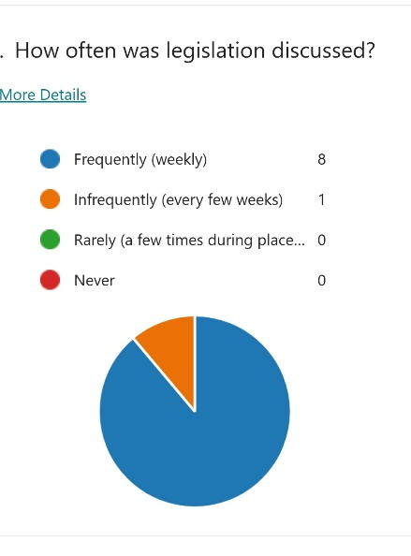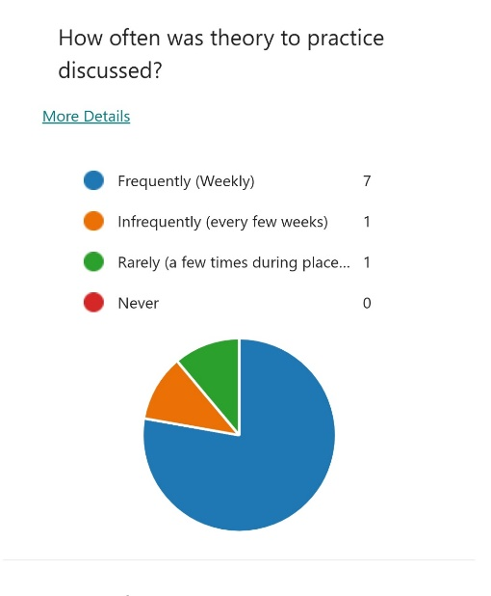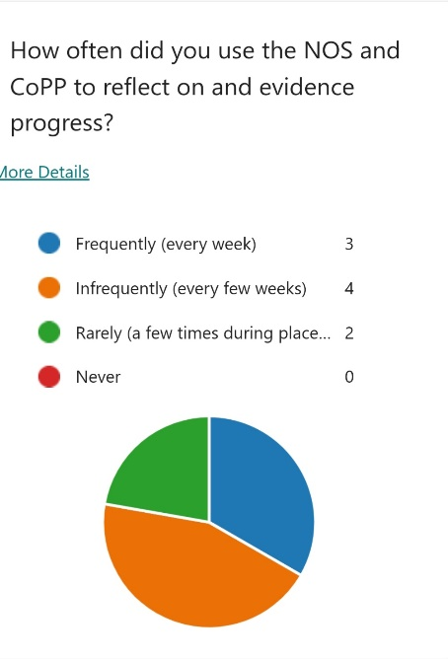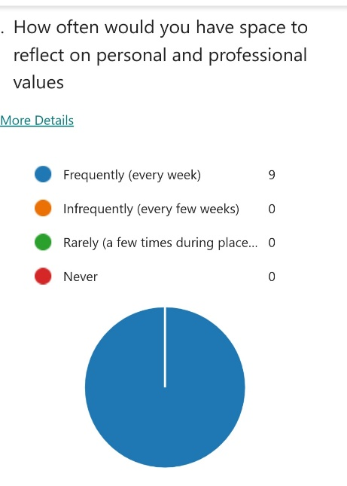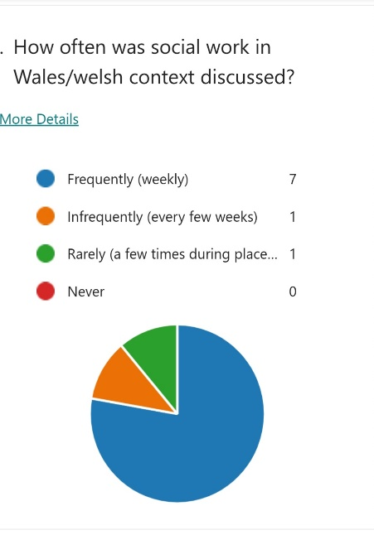
Participants were asked their opinion on whether supervision is an effective tool for teaching, assessing, and aiding the educational development of student social workers. The students responded by saying it is a good tool for enhancing and developing learning and discussing cases. All PEs felt that it was a good tool for assessing and aiding development of students, although one PE commented, ‘I think it is more of an effective way of gauging how things are going and supporting them along the way rather than a tool for teaching/assessing as this is something that an actual experience can provide.’ This is an interesting view and is somewhat contrary to Dewey’s (1933) view that learning comes from reflecting on experience and not solely from experience itself.
Debatably, supervision is only an effective tool for assessing and aiding student learning as far as the PE is committed to promoting this and the student is committed to engaging in this process and receptive to feedback.
There are limitations in this study in that there is a small sample group and proportionally more PE responses than students. Despite this, responses were not too far removed from each other although there were differences in the view of who has the responsibility for leading on supervision. Also, the survey was only done with a small sample from one Local Authority in Wales. It is not a true representation of the views of PEs and students throughout Wales. It would also be useful to undertake follow up interviews to gather more in-depth information in the future. Although the study has considered some aspect of social work in Wales, it has not considered Welsh language placements. This could be explored further in the future, linking it to the Well-being goal of the Wellbeing of Future Generations (Wales) Act 2015 ‘A Wales of Vibrant Culture and Thriving Welsh Language.’
In order to address some of the findings, the following action plan is proposed:
Findings | Proposed Action | UK Professional Standard Framework 2023
Not all PEs have the same level of confidence and experience with Practice Educating and offering supervision. | Upskilling training for Practice Educators before they support a student placement to ensure they are equipped with updated knowledge and skills | V2  promote engagement in learning and equity of opportunity for all to reach their potential
There is no consistent link between academic taught content and integration in to placement and supervision | Universities to provide a list of module/syllabus content to PEs to inform discussion  Students to bring more discussion from lectures in to supervision  Supervision proforma to be devised which includes prompt questions relating to academic work and placement. | V4  respond to the wider context in which higher education operates, recognising implications for practice
A positive relationship is needed between PEs and students for a safe collaborative space during supervision to enhance student success, and for students to be open to feedback from PEs. | PEs to ensure students are provided with an opportunity to discuss any concerns and to offer support. PE and student to work together to identify priorities for discussion and to acknowledge difference in experiences, backgrounds and knowledge. | V5  collaborate with others to enhance practice  A3  assess and give feedback for learning
Students can develop an over-dependence on PEs to provide them with all the learning opportunities. | PEs should utilise a range of learning strategies which are appropriate. PEs should guide learners and encourage self-directed learning by setting tasks and work to review during supervision. | A1  design and plan learning activities and/or programmes  A2  teach and/or support learning through appropriate approaches and environments  A4  support and guide learners
Discussion in supervision can be heavily focussed on case discussion more than learning and reflection.  Finding the time to discuss all that needed to be discussed was also highlighted as a challenge. | PEs are provided with a list of prompt questions which will help facilitate and enrich discussion and learning during supervision. A standardised proforma will ensure that all students will receive the same opportunity to explore agenda items in an equitable way without relying solely on the experience of the PE or the priorities of the student. This could be devised by Local Authorities as student hosts as university taught content can vary by different institutions. The agenda items can be developed to promote collaboration and clear expectations. | A2  teach and/or support learning through appropriate approaches and environments  V2  promote engagement in learning and equity of opportunity for all to reach their potential  V5  collaborate with others to enhance practice  K5  requirements for quality assurance and enhancement, and their implications for practice

Conclusion
In conclusion, the question posed was whether supervision is an effective tool for assessing and aiding the professional development of student social workers. Literature and research findings identified themes which included the need for a positive relationship between PE and student, supervision needs to be a collaborative space whereby PEs support learning but empower the student to take responsibility for their own development and provide constructive feedback, and students need to take responsibility for their own priorities and learning. To achieve this, the above proposed action points could be considered, to support the supervision forum to be an effective tool for assessing and aiding the educational development of student social workers during placements, which will lead to positive outcomes of both student and PEs.

Reference List
Advance HE (2023) Professional Standards Framework for teaching and supporting learning in higher education 2023. Available at: PSF 2023 - Screen Reader Compatible - final_1675089549.pdf (Accessed: 3.3.24)
Bogo, M. (2015) ‘Field Education for Clinical Social Work Practice: Best Practices and Contemporary Challenges.’ Clinical Social Work Journal. 43:317–324. Available at: Field Education for Clinical Social Work Practice: Best Practices and Contemporary Challenges (bu.edu) (Accessed 2.3.24)
Brodie, I., & Williams, V. (2013) ‘Lifting the Lid: Perspectives on and Activity within Student Supervision,’ Social Work Education, 32:4, pp. 506-522. Available at: DOI: 10.1080/02615479.2012.678826 Full article: Lifting the Lid: Perspectives on and Activity within Student Supervision (tandfonline.com) (Accessed: 25.2.24)
Cleak, H., Roulston, A., Vreugdenhil, A., (2016) ‘The Inside Story: A Survey of Social Work Students' Supervision and Learning Opportunities on Placement,’ The British Journal of Social Work, Volume 46, Issue 7, Pages 2033–2050. Available at: https://doi.org/10.1093/bjsw/bcv117 Accessed 26.2.24 (Accessed: 29.2.24)
Dewey, J. (1933) How We Think: A Restatement of the Relation of Reflective Thinking to the Educative Process. Boston, MA: DC Heath & Co Publishers.
Duncanson, K., Kingston, P., Tran, P., Blundell, B., Gillieatt, S., Mahboub, L., Martin, R. (2014) ‘Bearing Witness: The Impact of Lived Experience Educators Participating in Social Work Student Supervision during Placement,’ The British Journal of Social Work, Available at: https://doi.org/10.1093/bjsw/bcad268 (Accessed: 26.2.24)
Kadushin, A. (1976) Supervision in Social Work. Columbia University Press: New York
Ketner, M., Cooper-Bolinskey, D., VanCleave, D. (2017) The Meaning and Value of supervision in Social Work Field Education, Field Educator, Simmons School of Social Work: Volume 7.2. Available at: The Meaning and Value of Supervision in Social Work Field Education : Field Educator (simmons.edu) (Accessed: 2.3.24)
Knowles, M; Holton, E; Swanson, R (2012) The Adult Learner: The definitive Classic in Adult Education and Human Resource Development. 7th edn. Routledge: Oxon
Kolb, D. A. (1984) Experiential Learning: Experience as the Source of Learning and Development. Prentice Hall: New Jersey.

Kurt, S. (2021) Maslow’s Hierarchy of Needs in Education. Available at: Maslow's Hierarchy of Needs in Education - Education Library. (Accessed: 1.3.24)

Maslow, A. (1943) A Theory of Human Motivation. Originally Published in Psychological Review, 50, 370-396. Available at: Classics in the History of Psychology -- A. H. Maslow (1943) A Theory of Human Motivation (yorku.ca) (Accessed: 1.3.24)
Race, P. (2020) The lecturer’s toolkit: A practical guide to assessment learning and teaching. 5th edn. Oxon: Routledge
Reuven Even Zahav, R., Refaeli, T., Shemesh, S., Gottlieb, S., & Ben-Porat, A. (2020). ‘Supervision Satisfaction Among Social Work Students in Israel: Supervision Components, Peer Support, and Trauma-Related Factors.’ Research on Social Work Practice, 30(8), 884-894 Available at: https://doi-org.ezproxy.uwtsd.ac.uk/10.1177/1049731520936755 Accessed 26.2.24 (Accessed 29.2.24)
Social Care Wales (2011) National Occupational Standards. Available at: Social Work | Social Care Wales (Accessed: 25.2.24)
Social Care Wales (2011) Develop Social Work Practice through supervision and Reflection (PIs NOS) Available at: Develop social work practice through supervision and reflection (socialcare.wales) (Accessed: 25.2.24)
Social Care Wales (2019) Practice Education Guidance for Social Work Degree in Wales. Available at: Practice-education-guidance-2019-English.pdf (socialcare.wales) (Accessed: 25.2.24)

Turner-Daly, B., Jack, G. (2014) ‘Rhetoric vs. reality in social work supervision: the experiences of a group of child care social workers in England.’ Child and Family Social Work. Available at: https://doi org.ezproxy.uwtsd.ac.uk/10.1111/cfs.12191 (Accessed: 25.2.24)
Wellbeing of Future Generations (Wales) Act 2015, anaw 2. Available At: Well-being of Future Generations (Wales) Act 2015: the essentials [HTML] | GOV.WALES (Accessed: 29.2.24)
Welsh Government (2020) PCET Principles for Change. Available at: principles-for-change-post-compulsory-education-and-training.pdf (gov.wales) (Accessed: 29.2.24)

Wilkins, D. (2023) ‘Seven Principles of Effective Supervision for Child and Family Social Work,’ Practice, Social Work in Action. Available at: DOI: 10.1080/09503153.2023.2261148 (Accessed: 25.2.24)

