Business Report:
Comparison of Two Hospitality Organisations
Module: Financial Management for the Hotel Industry
Module Code: BMIH 5007
Lecturers Name: Tristan Hawkins
Student Name: Marcin Patryk Segrecki
Student ID Number: 2219780

Executive Summary
This report examines the financial performance and strategic positioning of two well-known hotel chains that cater to different market segments: Shangri-La and Travelodge. While Travelodge caters to consumers on a tight budget, stressing cost-effectiveness and economical lodging, Shangri-La targets the luxury market, providing upscale lodgings and exclusive services for wealthy travellers.
Shangri-La has demonstrated impressive revenue growth and financial stability, strategically expanding its high-end market presence globally. This strategic growth, particularly in North America and Europe, positions Shangri-La for a promising future and instils optimism in its potential.
On the other hand, Travelodge has increased its income and occupancy rates by taking advantage of the rebound in domestic tourism, especially in the UK. Travelodge has effectively closed the budget market by providing affordable hotel options and innovative pricing. The company's hybrid strategy combines low costs with added value and keeps competitive pricing and operational efficiency while drawing in a large consumer base.
Shangri-La and Travelodge have shown remarkable resilience in the face of the COVID-19 pandemic, each finding unique opportunities. While Travelodge capitalised on the surge in domestic travel, Shangri-La navigated a decline in overseas demand. These contrasting market dynamics underscore the adaptability and resilience of the two chains, instilling confidence in their future strategies.
Two of Shangri-La's top recommendations are enhancing digital engagement through virtual concierge services and customised itineraries to increase customer pleasure and loyalty. Keeping a competitive edge also requires constant innovation in luxury experiences and the incorporation of cutting-edge technologies. Travelodge may increase guest comfort and draw in additional business by enhancing cost efficiency through lean management techniques and energy-efficient technologies, concentrating on property enhancements, and launching local marketing efforts.

By implementing the recommendations outlined in this report, both Shangri-La and Travelodge have the potential to enhance their market positions, meet client needs, and achieve steady growth in their respective markets.

Introduction
Within the hotel sector, Shangri-La and Travelodge cater to different market niches. Shangri-La caters to the luxury market by offering upscale lodging and premium amenities to well-to-do tourists. On the other hand, Travelodge caters to consumers on a tight budget by providing reasonably priced accommodation that prioritises cost-effectiveness. Revenue Per Available Room (RevPAR) is a crucial performance indicator for both chains that shows how well they can generate income from available rooms. Due to travel restrictions and lockdowns, the COVID-19 pandemic significantly affected both. Shangri-La saw a decline in demand for foreign travel, while Travelodge saw an increase in demand for domestic travel. These dynamics highlight the two hotel brands' different approaches and reactions to the market.

Incomes Reported
The overall revenue of Shangri-La Hotels and Resorts increased significantly from GBP 1169.68 million in 2022 to GBP 1713.44 million in 2023. The group's EBITDA increased significantly from GBP 139.52 million in 2022 to GBP 417.76 million in 2023. In addition, there was noteworthy growth as the overall Revenue Per Available Room (RevPAR) climbed by 69%, from GBP 51.20 to GBP 86.40. The occupancy rate increased dramatically, from 42% in 2022 to 62% in 2023 (Shangri-La, 2024).
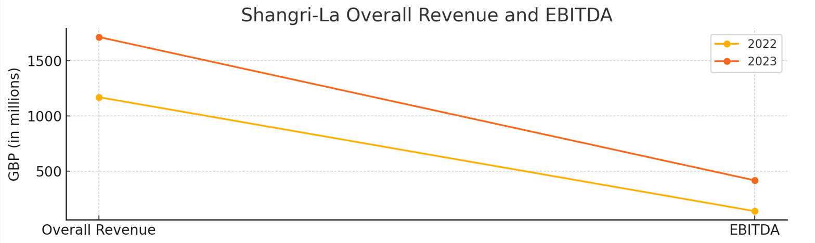
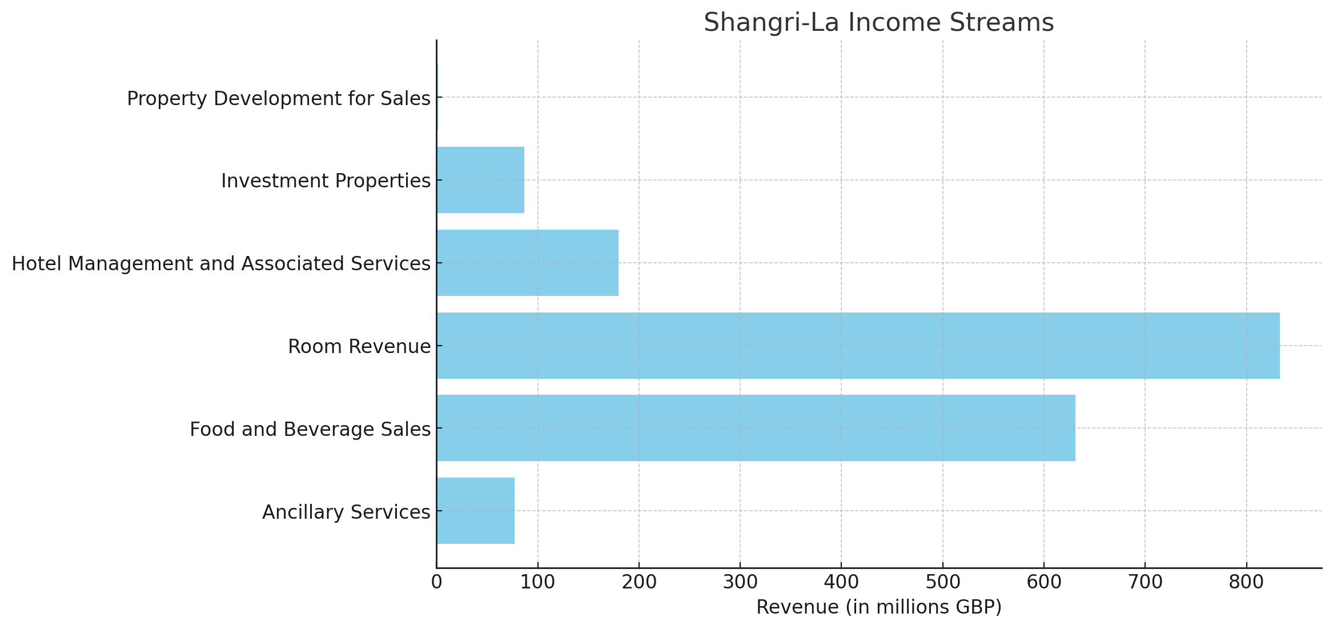
An analysis of Shangri-La's income streams shows that GBP 77.28 million was earned from ancillary services, GBP 630.96 million from food and beverage sales, and GBP 832.80 million from room revenue. Furthermore, hotel management and associated services generated GBP 179.44 million in gross revenue and GBP 75.84 million in net income. GBP 86.64 million was earned from investment properties, while an additional GBP 1.28 million was made from property development for sales (Shangri-La, 2024).
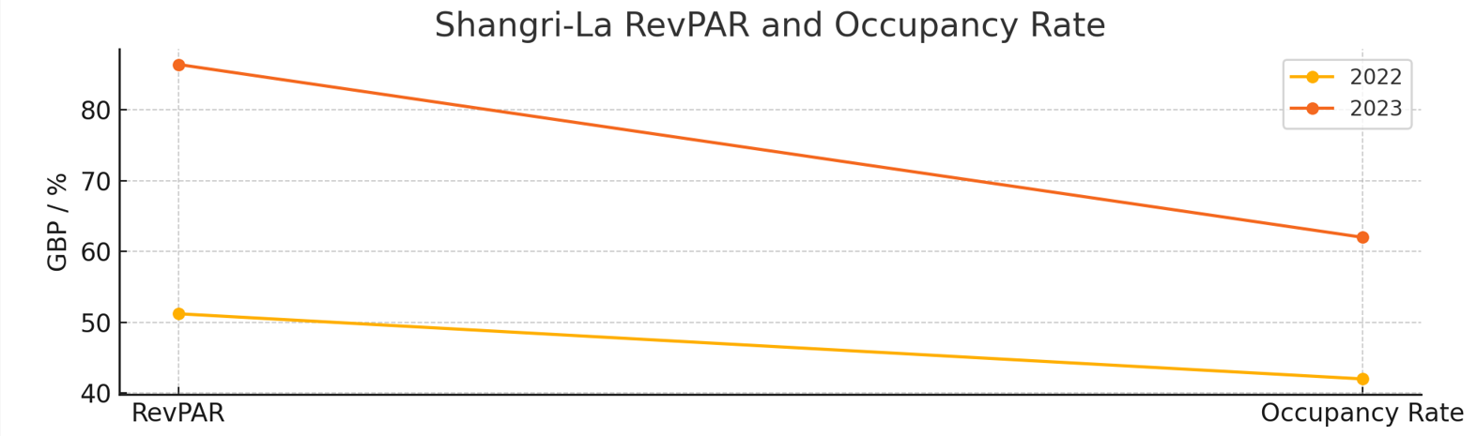Regarding geography, Shangri-La's holdings in Mainland China's RevPAR increased significantly to GBP 60.80 after a solid post-COVID-19 recovery. Similarly, Hong Kong's RevPAR surged to GBP 159.20, primarily due to more travellers. Due to the strong demand for international tourism, Singapore's RevPAR increased to GBP 166.40 (Shangri-La, 2024). Research shows that after the pandemic, there is a rise in demand for upscale services worldwide, which benefits upscale hotels such as Shangri-La (Kataya, 2021).
In contrast, Travelodge recorded GBP 1035.2 million in total revenue in 2023, an increase from GBP 910.8 million in 2022. Additionally, the Adjusted EBITDA increased from GBP 212.9 million in 2022 to GBP 243.9 million in 2023. The occupancy rate improved somewhat to 83.8% in 2023 from 81.8% in 2022, but the group's RevPAR increased by 12.4%, from GBP 52.62 to GBP 59.14 (Travelodge, 2024).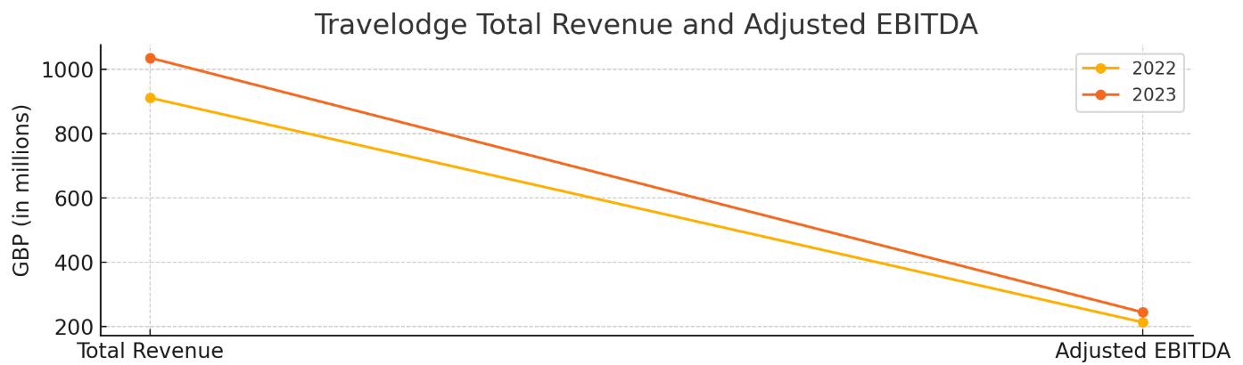

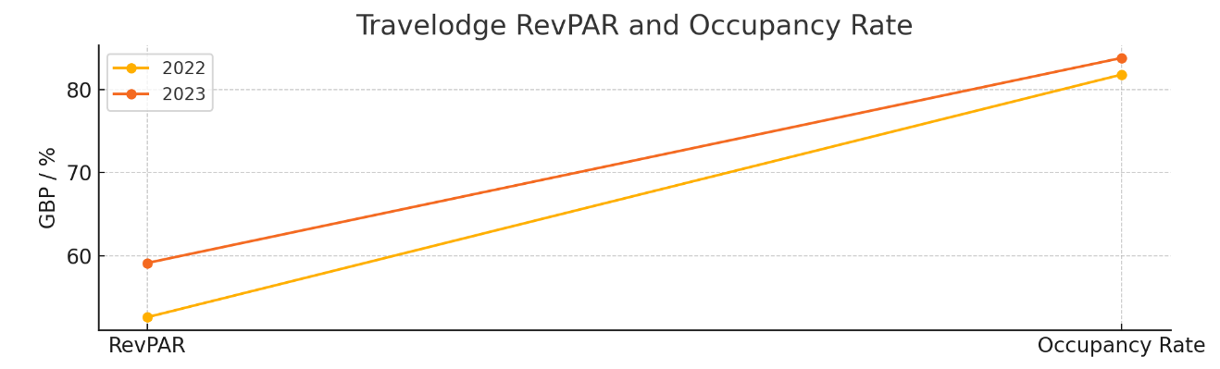
According to Travelodge's revenue breakdown, hotel services accounted for around 93% of total revenue, with food and beverage and retail sales accounting for the remaining 7%. Travelodge's primary source of income is its reasonably priced hotel services offered throughout the United Kingdom (Travelodge, 2024). According to Ivanov and Ayas's (2017) research, low-cost lodging establishments such as Travelodge have benefited from domestic travel and strategic pricing to increase their income and occupancy rates.
Regarding geography, Travelodge profited from the rebound in domestic travel in the UK, fueled by intelligent pricing and higher occupancy rates (Travelodge, 2024). Budget hotel businesses have benefited most from the post-pandemic surge in the popularity of staycations and domestic tourism (Lai et al., 2023).
Comparative Evaluation of Income and Expenditures
Comparison of revenue generation strategies
Shangri-La and Travelodge use different income generation tactics that align with their target markets. Shangri-La specialises in providing luxury services to those who can afford more for unique experiences, offering upscale lodging, first-rate food and beverage options, and a wealth of amenities. Shangri-La can command excellent pricing and achieve strong profit margins thanks to this strategy (Shangri-La, 2024). On the other hand, Travelodge caters to travellers on a tight budget by offering affordable accommodation. The chain ensures affordability through targeted pricing and high occupancy rates while maintaining operational efficiency and maximising revenue (Travelodge, 2024).
Analysis of RevPAR growth in different markets
RevPAR, or revenue per available room, is crucial for both hotel companies. Mainland China and Hong Kong saw significant increases in RevPAR for Shangri-La, primarily due to the relaxation of COVID-19 limitations and the resurgence of foreign travel. For example, the RevPAR in Hong Kong surged to GBP 159.20, but the RevPAR in Mainland China grew to GBP 60.80 (Shangri-La, 2024). According to Travelodge's Annual Report (2024), the company's RevPAR increased by 12.4%, from GBP 52.62 to GBP 59.14. This growth was primarily attributable to the UK's rebounding domestic tourist industry and clever pricing tactics.
Cost management strategies and their impact on profitability
Because of its dedication to providing premium services, Shangri-La must invest significantly in real estate and top-notch amenities, which raises operating costs. Shangri-La can keep healthy profit margins since it may charge higher prices (Vives et al., 2018). Travelodge, on the other hand, emphasises cost-effectiveness and operational efficiency. Travelodge successfully manages expenses while offering value to its consumers by streamlining processes, cutting waste, and implementing lean management techniques (Ivanov and Ayas, 2017).
Detailed operational expenditures and cost control methods
High maintenance costs for Shangri-La's luxurious standards, great sites, and comprehensive amenities are among the resort's operational expenses. To guarantee a premium visitor experience, significant investments must be made in staff training, facility improvements, and first-rate service provision (Shangri-La, 2024). However, to cut costs and boost profitability, Travelodge uses strict cost control measures like standardised processes, energy-efficient technologies, and well-timed refurbishments (Tribe, 2020). Using these strategies, Travelodge can maintain high occupancy rates at competitive prices, which helps them stay profitable in the low-cost market.
Shangri-La and Travelodge successfully serve their different market segments using their unique tactics. They do this by showcasing efficient cost management and revenue generation techniques that fit their company models and customer needs.

Growth Potential
Shangri-La's Global Expansion Strategy Targeting High-End Markets
Shangri-La is concentrated on growing its share in upscale markets worldwide, especially in North America and Europe. The corporation emphasises important cities and well-liked tourist spots by using its distinguished brand to attract wealthy customers. Yang (2013) claims that Shangri-La can take advantage of this tactic to capitalise on the expanding market for upscale tourism and business lodging by using its well-established reputation.
Travelodge's Focus on Expanding in the UK and Targeting Underdeveloped Areas
Travelodge wants to grow its footprint in the UK by concentrating on undeveloped regions. The company takes advantage of the growing trend of domestic tourism by providing affordable lodging options for tourists on a tight budget. With this strategy, Travelodge can take advantage of localised travel demands and break into less crowded markets (Travelodge, 2024)

Market Potential and Strategic Focus for Growth
Due to growing prosperity and a rise in international travel in Asia and the Middle East, Shangri-La has a substantial market potential in these regions' luxury travel sectors. Tajeddini et al. (2020) emphasise that the company's target market is affluent customers looking for upscale experiences. On the other hand, Travelodge's market potential is based on its capacity to offer reasonably priced accommodation in the UK, supported by the growing trend of staycations and domestic travel. With an emphasis on Kaur's (2020) findings, Travelodge can maintain stable development and competitiveness in the low-cost hotel industry.
Challenges and Opportunities in the Luxury and Budget Hotel Sectors
Challenges for Shangri-La include the possibility of market saturation in prime locations and economic volatility, which could affect the resort's profitability. Fan et al. (2022) point out that a route to long-term growth is the chance to move into emerging markets and serve high-net-worth individuals. In the low-cost market, Travelodge faces tough competition. It also needs to cater to its target customer base's sensitivity to pricing. Lai et al. (2023) highlight that despite these obstacles, there is a significant chance for growth due to the rising demand for reasonably priced housing.
Shangri-La and Travelodge have adapted their growth plans to suit their respective market niches, taking advantage of openings and minimising obstacles. Both businesses are well-positioned to see sustainable development since they concentrate on expanding into upscale markets and providing affordable domestic travel.
Financial Commitment to CSR
Shangri-La's CSR Initiatives
Shangri-La concentrates its CSR initiatives on community involvement, environmental sustainability, and cultural preservation. To cater to high-end clients who appreciate moral and responsible corporate behaviour, these measures include sponsoring regional heritage projects, cutting carbon footprints, and promoting eco-friendly processes (Shangri-la, 2024). According to Chen and Peng (2016), this strategy fits global sustainability trends and improves the brand's luxury appeal.
Travelodge's CSR Efforts
The main goals of Travelodge's CSR approach are environmental advantages, including waste and energy savings and operational efficiency. The business runs community outreach initiatives to support sustainable practices and create jobs locally (Travelodge, 2024). To remain competitive in the low-cost hotel market, these initiatives seek to increase operational performance and cost-effectiveness (Pimonenko et al., 2020).
Impact of CSR on Brand Image and Financial Performance
Both hotel chains' financial performance and brand image are strongly impacted by CSR programmes. High-impact, high-cost CSR initiatives help Shangri-La attract clients prepared to pay more for ethical luxury by enhancing the brand's reputation as a socially conscious luxury company (Das and Bocken, 2024). On the other hand, Travelodge's modest CSR initiatives draw in price-conscious clients who value corporate responsibility and increase operational efficiency, which is crucial for budget hotels to remain competitive (Legrand et al., 2022). According to Lacap et al. (2021), both tactics boost brand loyalty, essential for maintaining revenue and market position.

Positioning of Each Hotel Group on Bowman's Clock
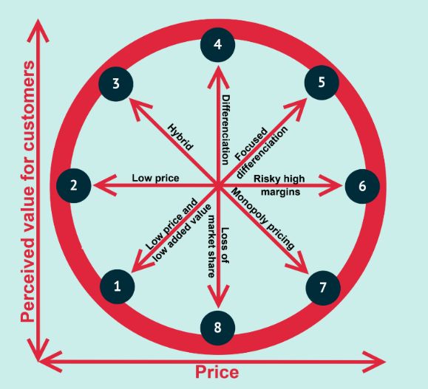
Explanation of Bowman's Strategic Clock Theory
Bowman's notion of the Strategic Clock delineates eight strategic positions contingent upon perceived value and pricing. According to Farida and Setiawan (2022), it aids businesses in determining their competitive strategy and comprehending their market standing.
Shangri-La's Positioning as Focused Differentiation (Position 5)
Shangri-La is situated within Bowman's Clock's concentrated differentiation sector. This tactic offers the most excellent quality and service to attract premium-paying clients. The brand's reputation is a competitive advantage within this market niche, and customers exhibit brand loyalty (Vives et al., 2018).
Travelodge's Positioning as Hybrid (Position 3)
Travelodge holds a hybrid position on Bowman's Clock. This strategy's combination of cheap cost and perceived additional value appeals to a vast portion of the market looking for cost-effective solutions without sacrificing quality. Because of its positioning, Travelodge can retain competitive pricing and attract a wide range of customers (Ivanov and Ayas, 2017).
Strategic Implications for Market Segments and Profitability
Shangri-La's premium status enables it to keep strong profit margins and repeat business from customers, but it also necessitates constant investment in new and improved services. Shangri-La can charge premium pricing because of its focus on exclusivity, which meets the high expectations of its wealthy clientele (Chen & Peng, 2016). On the other hand, Travelodge's low-cost approach helps it grow its market share and volume sales in the cutthroat low-cost hotel industry. For Travelodge to save costs and increase profit margins while attracting budget-conscious travellers, efficient operations and economic expansions are essential (Pimonenko et al., 2020).
Shangri-La and Travelodge successfully cater to their target customers by matching their strategies with their market segments, which drives profitability and sustains growth within their respective markets.

Conclusion
The research presents an analysis of the disparate strategies implemented by Travelodge and Shangri-La, which are representative of their different market niches. Shangri-La offers upscale services, leveraging its brand to attract affluent clients and maintain significant profit margins via strategic differentiation. On the other hand, Travelodge employs a hybrid strategy combining affordable rates with added benefits to maximise occupancy rates and appeal to tourists on a tight budget. Both companies have excellent target market alignment: Travelodge successfully captures the low-cost market with cost-effectiveness and strategic pricing, while Shangri-La excels at offering luxury experiences. They successfully serve their target audiences thanks to their market positioning and strategic methods, which promote profitability and long-term growth.

Recommendations
Strategic Recommendations for Shangri-La
- Enhance Digital Engagement: Shangri-La should enhance its digital presence by introducing personalised itineraries and virtual concierge services. According to research by Li et al. (2020), by offering personalised experiences, digital platforms can significantly increase consumer happiness and loyalty. AI-driven itineraries can be included to customise the visitor experience further and make Shangri-La live up to the high standards of its sophisticated, tech-savvy clientele.
- Innovate to Maintain Relevance: In the premium market, constant innovation is necessary to stay ahead of the competition. Shangri-La should invest in brand-new, abundant experiences and incorporate cutting-edge technologies to stay ahead of its rivals. This approach is consistent with Kumar's research (2020), which indicates that innovative customer engagement increases brand loyalty and trust.

Strategic Recommendations for Travelodge
- Improve Cost Efficiency: Travelodge should implement lean management techniques and energy-efficient technology to increase cost efficiency. Energy-efficient equipment can minimise utility costs and increase total profitability, while lean management can maximise output and cut labour costs (Nota et al., 2020). Maintaining competitive pricing in the low-cost hotel industry requires this strategy.
- Focus on Property Upgrades and Local Marketing: To continue growing, Travelodge needs to improve its facilities to enhance visitor appeal and comfort. Additionally, localised marketing efforts can draw in more clients by highlighting the unique advantages and reasonable prices of Travelodge locations. Effective local marketing can attain higher occupancy rates and brand visibility in regional markets (De Jorge and Suarez, 2014).
By implementing these suggestions, Shangri-La and Travelodge may improve their market positions, satisfy customers, and promote sustainable growth.

References
- Chen, X. and Peng, Q., 2016. A content analysis of corporate social responsibility: Perspectives from China’s top 30 hotel-management companies. Hospitality & Society, 6(2), pp.153-181. https://www.researchgate.net
- Das, A. and Bocken, N., 2024. Regenerative business strategies: A database and typology to inspire business experimentation towards sustainability. Sustainable Production and Consumption. https://doi.org/10.1016/j.spc.2024.06.024
- De Jorge, J. and Suárez, C., 2014. Productivity, efficiency and its determinant factors in hotels. The Service Industries Journal, 34(4), pp.354-372. https://doi.org/10.1080/02642069.2013.778977
- Fan, Y., Isa, S.M., Yang, S. and Wen, J., 2023. Effects of the guest experience, well-being, and eWOM intention for resort hotels: A positive psychology perspective. Journal of Hospitality and Tourism Management, 56, pp.197-206. https://doi.org/10.1016/j.jhtm.2023.06.014
- Farida, I. and Setiawan, D., 2022. Business strategies and competitive advantage: the role of performance and innovation. Journal of Open Innovation: Technology, Market, and Complexity, 8(3), p.163. https://doi.org/10.3390/joitmc8030163
- Ivanov, S. and Ayas, Ç., 2017. Investigation of the revenue management practices of accommodation establishments in Turkey: An exploratory study. Tourism management perspectives, 22, pp.137-149. https://doi.org/10.1016/j.tmp.2017.03.007
- Kataya, A., 2021. Current Trends and Issues of Luxury Tourism. Empirical Research on Supply and Demand Effects of Covid-19 Pandemic. Annals of the University Dunarea de Jos of Galati: Fascicle: I, Economics & Applied Informatics, 27(2). https://doi.org/10.35219/eai15840409191
- Kaur, G. and Kaur, C., 2020. COVID-19 and the rise of the new experience economy. FIIB Business Review, 9(4), pp.239-248. https://doi.org/10.1177/2319714520958575
- Kumar, V., 2020. Building customer-brand relationships through customer-brand engagement. Journal of Promotion Management, 26(7), pp.986-1012. https://doi.org/10.1080/10496491.2020.1746466
- Lai, Y.L. and Cai, W., 2023. Enhancing post‐COVID-19 work resilience in hospitality: A micro-level crisis management framework. Tourism and Hospitality Research, 23(1), pp.88-100. https://doi.org/10.1177/14673584221075182
- Li, M.W., Teng, H.Y. and Chen, C.Y., 2020. Unlocking the customer engagement-brand loyalty relationship in tourism social media: The roles of brand attachment and customer trust. Journal of Hospitality and Tourism Management, 44, pp.184-192. https://doi.org/10.1016/j.jhtm.2020.06.015
- Nota, G., Nota, F.D., Peluso, D. and Toro Lazo, A., 2020. Energy efficiency in Industry 4.0: The case of batch production processes. Sustainability, 12(16), p.6631. https://doi.org/10.3390/su12166631
- Pimonenko, T., Bilan, Y., Horák, J., Starchenko, L. and Gajda, W., 2020. Green brand of companies and greenwashing under sustainable development goals. Sustainability, 12(4), p.1679. https://doi.org/10.3390/su12041679
- Shangri-La, 2024. https://www.shangri-la.com/group/investors/public-disclosures
- Tajeddini, K., Martin, E. and Ali, A., 2020. Enhancing hospitality business performance: The role of entrepreneurial orientation and networking ties in a dynamic environment. International Journal of Hospitality Management, 90, p.102605. https://doi.org/10.1016/j.ijhm.2020.102605
- Travelodge, 2024. https://www.travelodge.co.uk/investors/home
- Tribe, J., 2020. The economics of recreation, leisure and tourism. Routledge. https://doi.org/10.4324/9780429278259
- Vives, A., Jacob, M. and Payeras, M., 2018. Revenue management and price optimisation techniques in the hotel sector: A critical literature review. Tourism Economics, 24(6), pp.720-752. https://doi.org/10.1177/1354816618777590
- Yang, H.P., 2013. Case study 12: Shangri-La hotels expanding to non-Asian markets. In Marketing Cases from Emerging Markets (pp. 113-116). Berlin, Heidelberg: Springer Berlin Heidelberg. https://www.academia.edu

