

Module code: LCBB6006
Module: Project Management
Assignment Title: Component 1: Coursework: Essay
Student Name: Amadu Barrie
Student ID: 2323784

Executive Summary
Distributing clean energy in households has become a necessary step to conserve resources. The following project has briefly shed light on the development of a solar-powered microgrid for a suburban community. This plan has included technical design, regulatory approval, equipment installation and long-term maintenance. Clear objectives have been made that focused on reducing grid usage and cutting household energy costs within the first year of operation. Additionally, a structured timeline, responsibilities, and detailed budgeting support has also been made for proper project delivery. Important stakeholders such as residents, investors and authorities have been segregated through planned communication as well.

Table of Contents
1. Introduction 4
2. Aim, Objectives and Scope 5
3. Main Body: 7
Project output (deliverables) 7
Stakeholders and Communication Plan 7
Activities & WBS 13
Tasks, Milestones and Responsibilities 14
Resources and Cost Accounts 15
4. Conclusion 17
5. References 18

1. Introduction
Solar-powered systems are very important so that clean energy can be gained without wasting them. The following project will focus on building a solar-powered microgrid to provide a suburban community with affordable energy from the main grid. The project scope will cover every necessary aspect ranging from site assessment to final grid integration. Some of the prominent stakeholders who are vital for this project will be covered with the help of a stakeholder matrix. A detailed Work Breakdown Structure will also be included to highlight the main tasks and its distribution. Proper resources and cost accounts will further make sure that budgets get used effectively to deliver long-term value.

2. Aim, Objectives and Scope
Aim
To design and implement a solar-powered microgrid which will provide a sustainable energy source for a suburban residential community and reduce utility costs.
Objectives
1. To achieve a 30% reduction in community grid electricity consumption within the first 12 months of operation.
2. To complete the installation and testing of all photovoltaic arrays and battery storage units throughout 50 residential units within 6 months from construction.
3. To decrease the average monthly household energy costs by 40% after 12 months of operation.
Scope
Project Cost
The total predicted cost for this solar-based microgrid project mainly comes around £150,000 and £400,000. A standard 50kW solar system on its own will also cost within £62,000 but a true microgrid will need higher additional investment in battery storage and smart controls as well. High-capacity lithium-ion batteries are very useful for storing electricity for longer duration (Möller and Krauter, 2022). However, they are the most expensive component which could be double the number of solar panels so that the community can stay off-grid during night time. Infrastructure and labour will be needed for professional installation and scaffolding along with electrical hardware that connects 50 separate homes into one channel. Smart meters with a central control system will also be important to balance power supply and demand (Athanasiadis et al., 2024).
Project Time
The project is expected to be completed within 8 to 12 months. Design and planning will be the longest phase since it will include site surveys, structural roof checks and getting plant permissions for 4-6 months. Construction stage in 2-3 months will involve physical installation of panels, wiring and the central battery hub. Final safety checks and commissioning will be done by 2-3 months from the local Distribution Network Operator (DNO) before the system can go live (Landau, 2025).
Project Constraints
There are many factors which can bring disruption throughout the project lifecycle. The first one may come from the UK law on over-the-fence power sharing between neighbours and present regulations on one energy supplier per address. Furthermore, suburban homes should have suitable and unshaded roof space for a ground-mounted array. The microgrid is also required to safely disconnect during power cuts without releasing electricity back to the main grid (Asana, 2025).

3. Main Body:

Project output (deliverables)
The primary output will be a fully installed solar array with a central battery storage hub. Each home will get a smart meter for tracking instant energy consumption. A local distribution network will also be delivered. This network will include important wiring, switches and a central control panel for managing electricity flow. On the other hand, a Digital Energy Management System will also be delivered for remote monitoring and automatic load balancing. The project will deliver a Maintenance & Safety Manual along with a Community Training Program where local residents are taught on how to manage basic system operations (Malsam, 2025).

Stakeholders and Communication Plan
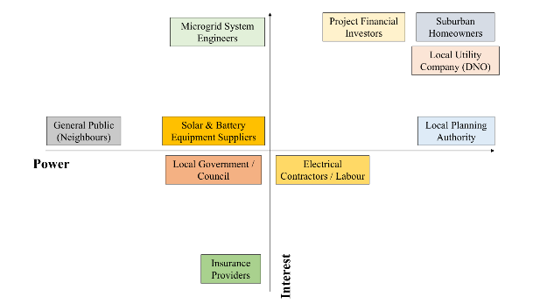
Figure: Stakeholder Matrix (Power-Interest Grid)
Source: (Author)
Stakeholders | Power | Interest | Role and Involvement | Communication Plan
Suburban Homeowners | High | High | Homeowners will be the main users of this solar microgrid. The system will be installed on their homes or within their community. They will benefit from less electricity bills and more reliable power. Their approval and support will be very important for the project to succeed. | Weekly email newsletters with simple updates. Monthly town hall meetings to answer questions and listen to feedback. Providing a mobile app where residents can track energy production, battery levels and cost savings in real time (Forster et al., 2024).
Local Utility Company (DNO) | High | High | The local utility company will connect the microgrid to the main electricity grid. They will make sure that the system will follow technical rules and operate safely. They will also track how the microgrid interacts with the national grid. | Formal technical reports with system data. Monthly meetings to review compliance and safety standards. Sharing access to grid connection data for transparency and coordination.
Project Financial Investors | High | High | Investors will provide the money to design and build the microgrid. They will also expect financial returns from energy savings and long-term system performance. Their funding will keep the project running. | Sharing quarterly financial reports which will show income, costs and savings. Providing online dashboards to show return on investment (ROI). Conducting formal presentations to review financial performance and future plans (Forster et al., 2024).
Local Planning Authority | High | Medium | The planning authority will approve construction permits and ensure the project follows building and environmental rules. They will also check that the project fits local development plans. | Submit official planning applications and required documents. Providing site inspection reports during construction. Sharing public consultation documents to show community involvement.
Microgrid System Engineers | Medium | High | Engineers will design and test the solar panels, battery storage and control systems. They will make sure the system works efficiently and safely. They will further solve technical problems during installation and operation. | Perform daily technical briefings during active phases. Using Slack or Teams channels for quick problem solving. Organising weekly design review meetings to improve performance and fix issues (Müller, 2023).
Solar & Battery Equipment Suppliers | Medium | Medium | Suppliers will provide the solar panels, batteries, inverters and monitoring equipment. Their products will be essential for building the microgrid. | Sending regular procurement updates and confirming technical requirements. Tracking delivery schedules closely (Mayo-Alvarez et al., 2022). Conducting quarterly reviews to evaluate product quality and performance.
Electrical Contractors / Labour | Medium | Medium | Contractors and workers will install the solar panels, wiring and battery systems. They will also perform the physical construction work on-site. | Conducting daily safety briefings before the work will start. Using on-site task boards to show daily goals. Reviewing progress weekly to ensure timelines are met.
Local Government / Council | Medium | Medium | The local council will support sustainability and carbon reduction goals. They may promote the project as part of environmental initiatives. | Providing sustainability reports twice a year to show the carbon savings. Arrange formal briefings to explain community benefits and environmental impact.
Insurance Providers | Medium | Low | Insurance companies will provide coverage for equipment, construction risks and system operation. | Conduct annual risk assessment audits (Wright, 2022). Provide policy renewal updates.
General Public (Neighbours) | Low | Medium | Neighbours will be affected by construction noise or | Distribute informational flyers about construction schedules and possible noise. Create a simple community feedback website where people can ask questions.

Activities & WBS
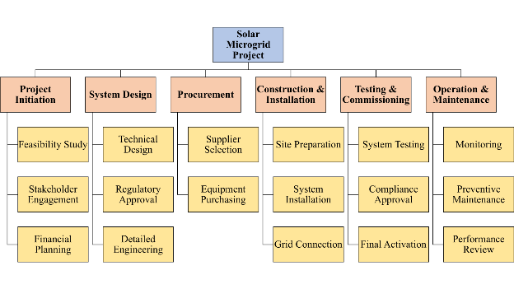
Figure: Work Breakdown Structure
Source: (Author)
The above structure has shown the complete way by which the solar microgrid project is organised. It will mainly start with project initiation which includes planning, checking feasibility and securing funding. Then the phase will shift to system design where technical and legal approvals will be done. The procurement phase after that will make sure that all equipment and suppliers are selected within time. Construction and installation will involve building the physical system and connecting it to the grid. Testing and commissioning will make sure the system works safely and correctly. Operation and maintenance at the last step will ensure long-term performance (Atlassian, 2025).

Tasks, Milestones and Responsibilities
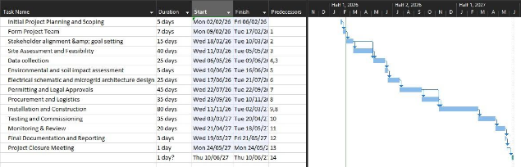
Figure: Gantt Chart
Source: (Author)
Every activity which is mentioned in the schedule has been connected to a specific leader so that the project can be executed smoothly. This structure has created a clear pathway by shifting from initial ideas to a live power system. Accumulating tasks into different phases will make sure that all work is done correctly without missing important steps. The project manager will supervise the whole steps by focusing on early planning along with final closure. The main goal will be to reach the Feasibility Approval milestone to show that the project can work. Design Engineers will be present to handle the technical blueprints and software setups. Their responsibility will be confirmed when the project hits the Technical Design Completion so that the system is safe and efficient. Administrative Staff will then handle the complex paperwork as well as legal filings. They will be responsible to secure the planning and utility permits since it is an important aspect for the construction to begin. Installation Crews will take the lead on the physical work when the permits are ready. They have the responsibility for mounting panels and setting up batteries while working on the Construction Completion milestone. Technicians will handle the testing and handover phases so that the system runs perfectly before the Official Commissioning milestone.

Resources and Cost Accounts
Planning and Technical Personnel
The primary resources for this project will come from intellectual and professional standards. The project manager here will be responsible to coordinate all phases while the Solar Design Engineer will create the electrical blueprints. Legal Consultants will be necessary to go through all the planning laws and utility contracts. After the project can start with the construction, Certified Electricians and Structural Engineers will become the most important personnel. They will make sure that the panels are safely mounted on roofs where the high-voltage battery systems are wired correctly (Vige, 2025). Software Technicians will then be needed to manage the energy management system that balances the community's power.
Hardware and Physical Materials
The project will need a high amount of physical inventory where the most expensive materials are the Monocrystalline Solar Panels and the Lithium-Ion Battery Banks. Hybrid Inverters will also be required so that the sun’s energy can be converted into usable household electricity. The Balance of System materials will involve heavy-duty copper cabling, mounting racks and weatherproof enclosures for the central hub. Every home should be further equipped with a Smart Meter as well as Network Gateway to interlink with the central control system.
Resource Costs and Account Allocation
Each expense will be tracked through specific accounts so that the project can be kept on a budget. The Capital Equipment Account will cover the bulk expenses by including panels and batteries at an approximate value of £180,000 to £220,000. The Labour and Professional Services Account will cover the wages for engineers and installers, usually ranging from £60,000 to £90,000. A separate Administrative and Legal Account will also be used for permit fees and insurance which can cost around £15,000. Finally, a Contingency Account with 10% of the total budget will be kept aside to cover unexpected material price changes or site delays (Bridges, 2024). Such actions will help the project team to monitor expenses in real-time and ensure that the community’s investment is protected.

4. Conclusion
The above solar-powered microgrid project has covered all the practical ways to provide clean and affordable energy to a suburban community. This section has covered clear planning, defined roles and proper budgeting such that the project can be delivered in a structured and controlled manner. Strong coordination between technical teams, authorities, investors and residents has also been covered for success. Appropriate stakeholder and resource allocation has been demonstrated that has the potential to lower household expenses and support environmental goals.

5. References
Asana, (2025). 6 project constraints and how to manage them for project success. [Online]Available at: https://asana.com/resources/project-constraints [Accessed 14 February 2026].
Athanasiadis, C.L., Papadopoulos, T.A., Kryonidis, G.C. and Doukas, D.I., (2024). A review of distribution network applications based on smart meter data analytics. Renewable and Sustainable Energy Reviews, 191, p.114151.
Atlassian, (2025). Work breakdown structure (WBS): Definition and step-by-step guide. [Online]Available at: https://www.atlassian.com/work-management/project-management/work-breakdown-structure [Accessed 16 February 2026].
Bridges, J., (2024). Project Cost Management Basics. [Online]Available at: https://www.projectmanager.com/training/basics-project-cost-management [Accessed 17 February 2026].
Forster, M., Durity, A. and Cole, C., (2024). SMART Meetings.
Landau, P., (2025). What Is Project Scope? Scope Management Steps, Tips & Tools. [Online]Available at: https://www.projectmanager.com/blog/project-scope [Accessed 14 February 2026].
Malsam, W., (2025). What Is a Project Deliverable? Definition, Examples & More. [Online]Available at: https://www.projectmanager.com/blog/project-deliverable [Accessed 15 February 2026].
Mayo-Alvarez, L., Alvarez-Risco, A., Del-Aguila-Arcentales, S., Sekar, M.C. and Yáñez, J.A., (2022). A systematic review of earned value management methods for monitoring and control of project schedule performance: An AHP approach. Sustainability, 14(22), p.15259.
Möller, M.C. and Krauter, S., (2022). Hybrid energy system model in matlab/simulink based on solar energy, lithium-ion battery and hydrogen. Energies, 15(6), p.2201.
Müller, S., (2023). How slack facilitates communication and collaboration in seminars and project-based courses. Journal of Educational Technology Systems, 51(3), pp.303-316.
Vige, W., (2025). What is a project team? Plus, why your enterprise needs one. [Online]Available at: https://asana.com/resources/project-team [Accessed 17 February 2026].
Wright, C., (2022). Agile Project Management, Assurance and Auditing: A practical guide for auditors, reviewers and project teams.

