UWTSD
WISA



Performance Analysis
Motorcycle Dynamics
ACHA5004

Daniel Jack Briggs
2312568
05/01/2026
Contents
1 Introduction 1
1.1 Justification 1
1.2 Aims 1
1.3 Objectives 1
2 Comparison of 3 Riders 2
2.1 Analysis Of Simon Crafar 3
2.2 Improvements For Simon Crafar 4
2.3 Analysis of John Hopkins 5
2.4 Improvements for Johns Hopkins 6
2.5 Analysis Of Gary McCoy 7
2.6 Improvements for Gary McCoy 8
3 Design a Data Analysis System for the Kawasaki ZXR750 9
4 Calibration, setup and testing 9
5 Analysis of Data From Pembrey (20/03/2026) 14
5.1 Lap 1 Analysis 16
5.2 Lap 2 Analysis 16
5.3 Lap 3 Analysis 17
5.4 Conclusion of Pembrey Data 17
6 Conclusion 17
7 References 18
7.1 Research References 18
7.2 Image References 18

Figures & Tables
Figure 1 (Donington Park Circuit) [51gt3.com. (2026)]. 2
Figure 2 (Lap Analysis for Simon Crafar) [2D Data]. 3
Figure 3 (Throttle and Front Braking Control for Simon Crafar) [2D Data]. 3
Figure 4 (RPM and Gear Positioning for Simon Crafar) [2D Data]. 4
Figure 5 (Lap Analysis for John Hopkins) [2D Data]. 5
Figure 6 (Throttle and Front Braking Control for John Hopkins) [2D Data]. 5
Figure 7 (RPM and Gear Positioning for John Hopkins) [2D Data]. 6
Figure 8 (Lap Analysis of Gary McCoy) [2D Data]. 7
Figure 9 (Throttle and Front Braking Control for Gary McCoy) [2D Data]. 7
Figure 10 (RPM and Gear Positioning for Gary McCoy) [2D Data]. 8
Figure 11 (Sensor Wiring Diagram) [D.Briggs]. 9
Figure 12 (CAN and Digital Test) [D.Briggs 2026]. 12
Figure 13 (Analogue Test) [D.Briggs 2026) 13
Figure 14 (Where the sensors will go on the motorcycle) [D.Briggs 2026] 13
Figure 15 (The space under the fuel tank) [D.Briggs 2026]. 14
Figure 16 (Pembrey Circuit) [Motorsport-timing.co.uk. (2026)]. 15
Figure 17 (Pembrey Lap 1 Analysis) [2D Data]. 16
Figure 18 (Pembrey Lap 2 Analysis) [2D Data]. 16
Figure 19 (Pembrey Lap 3 Analysis) [2D Data]. 17

Table 1 (Lap Times). 2
Table 2 (Sensor Table) [2d-datarecording.com. (2021)]. 9
Table 3 (Pembrey Lap Times). 15

Introduction

Justification
To show a basic understanding of how to analyse data and what type of sensors are needed to collect data

Aims
To show a basic understanding of performance analysis

Objectives
- Compare the performance of 3 riders
- Design a data analysis system for the ZXR 750
- Calibration, Setup and Testing
- Analysis of Data

Comparison of 3 Riders
This section shows the data from 3 riders (Simon Crafar, John Hopkins and Gary McCoy), on a two-stroke Yamaha MotoGP bike going around Donington Park Circuit.
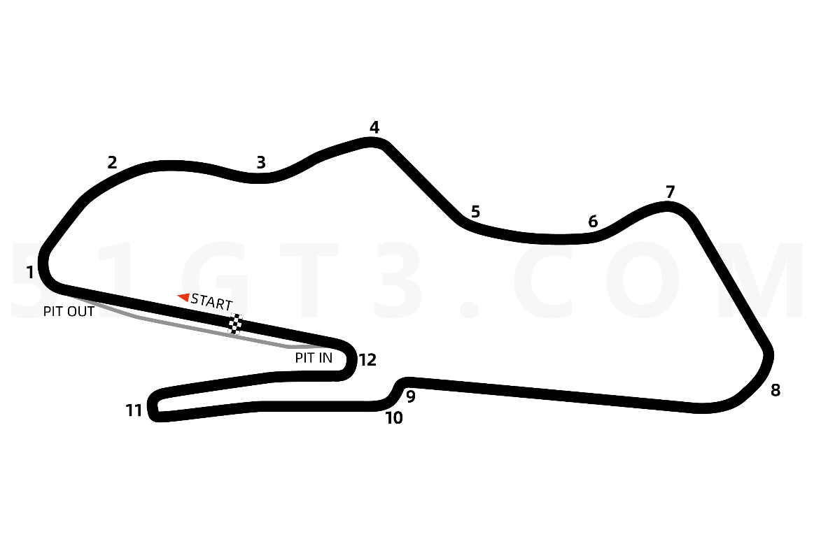
Figure 1 (Donington Park Circuit) [51gt3.com. (2026)].

Table 1 (Lap Times).
Riders Name | Lap Time
Simon Crafar | 1:32.147
John Hopkins | 1:31.960
Gary McCoy | 1:32.787

Analysis Of Simon Crafar

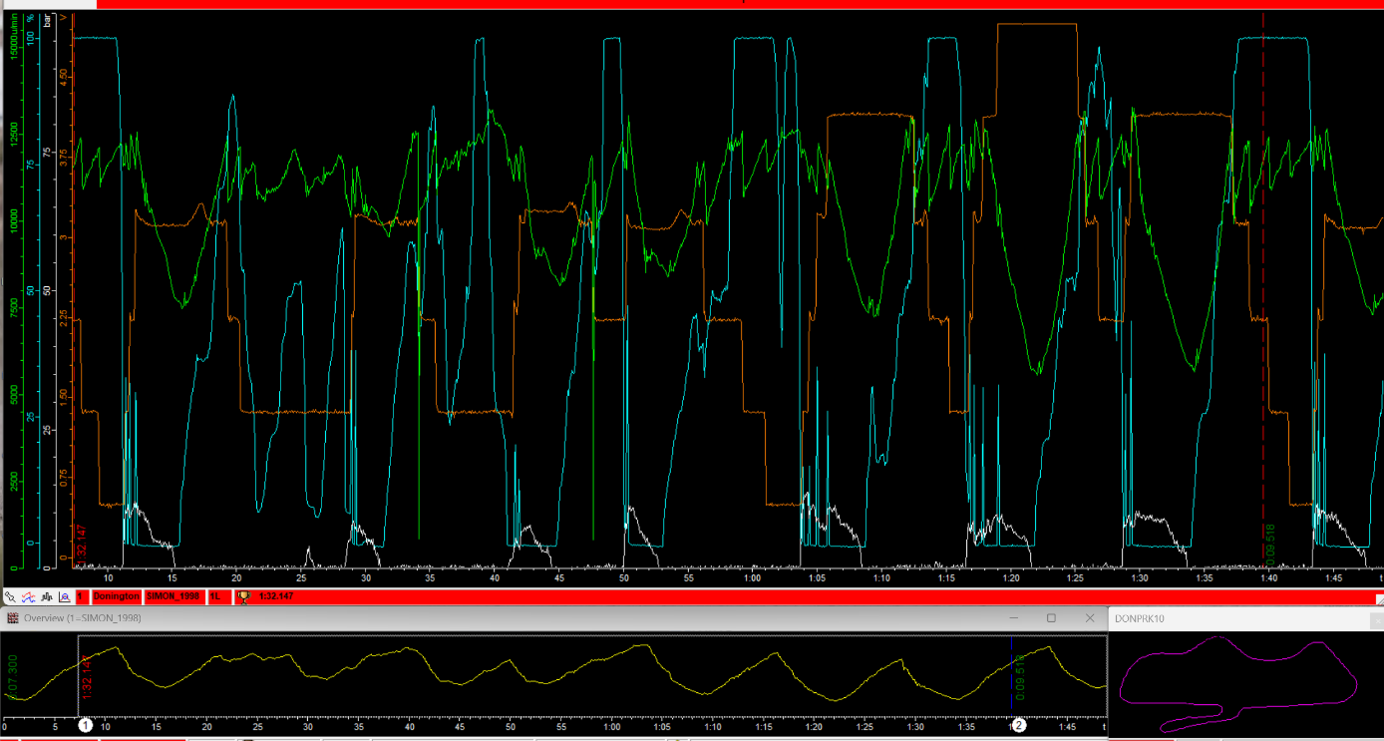
Figure 2 (Lap Analysis for Simon Crafar) [2D Data].

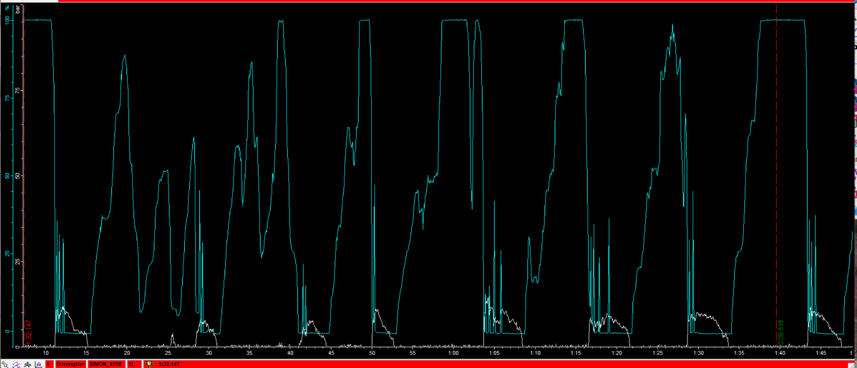
Figure 3 (Throttle and Front Braking Control for Simon Crafar) [2D Data].
Looking at how the rider uses throttle and braking Control when entering the corners, the rider comes completely off the throttle before applying the front brake, then jumps back on the throttle. The rider has been delaying the throttle for a split second after braking. This is reducing the corner exit speed and is costing the rider lap time.
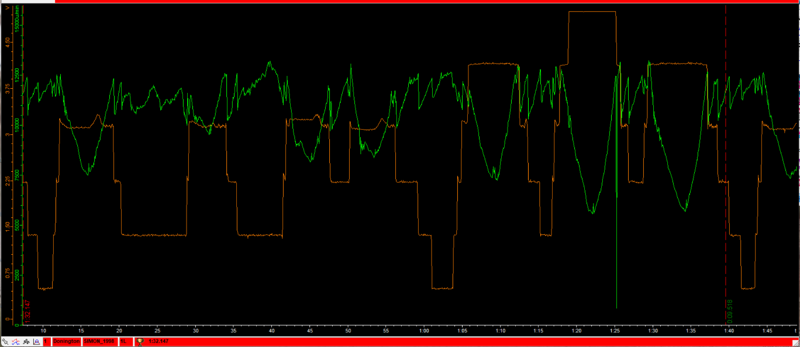
Figure 4 (RPM and Gear Positioning for Simon Crafar) [2D Data].
1:25.000, the rider dropped from 13000 RPM to 500 RPM for a split second, even though the rider was on the throttle. This is because of being out of gear or the gear not being engaged quickly enough.

Improvements For Simon Crafar
After braking, the rider needs to get on the throttle just before releasing the front brake.

Analysis of John Hopkins

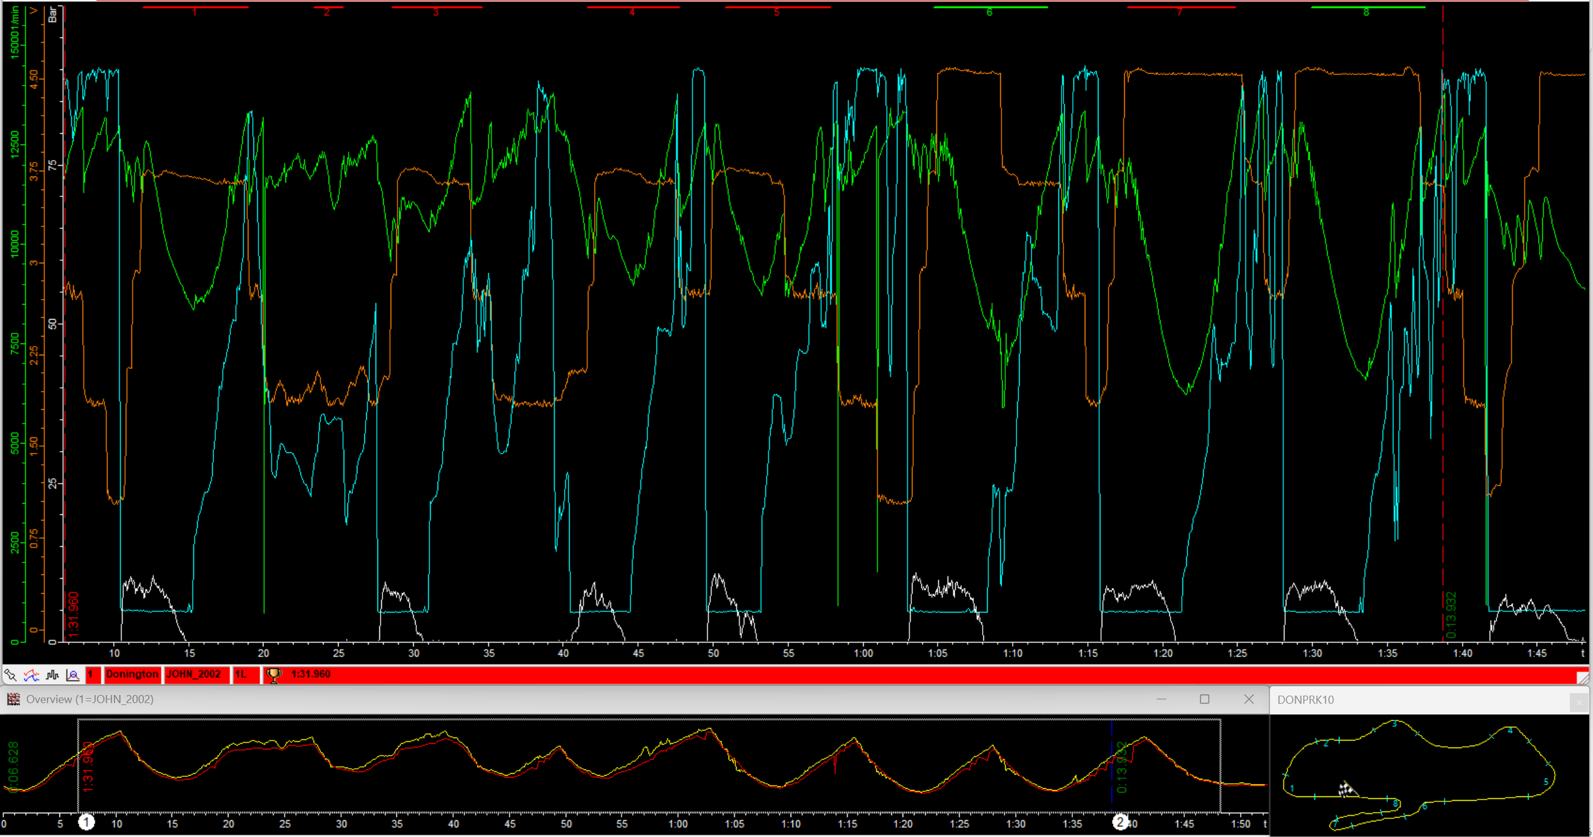
Figure 5 (Lap Analysis for John Hopkins) [2D Data].

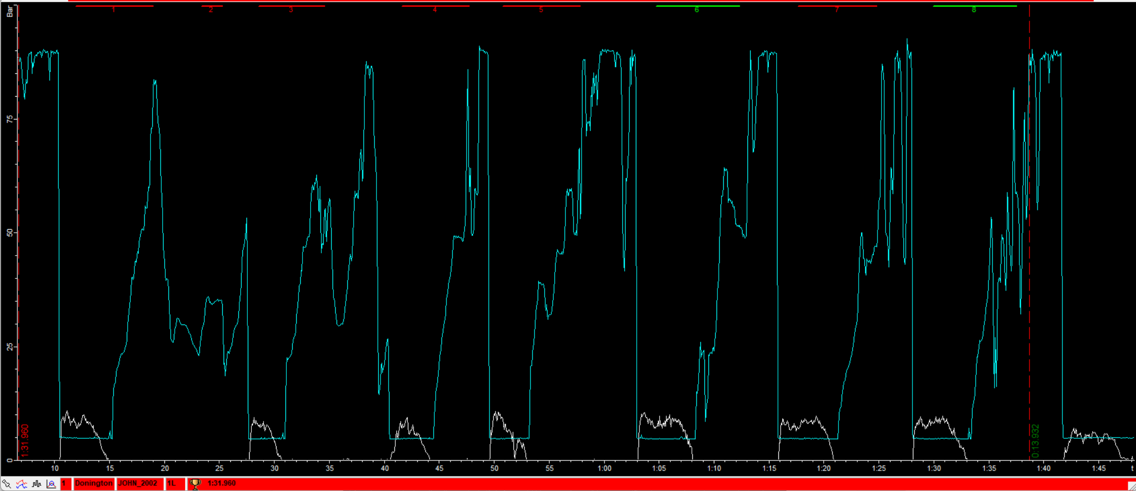
Figure 6 (Throttle and Front Braking Control for John Hopkins) [2D Data].
Looking at how the rider uses throttle and braking Control when entering the corners, the rider comes completely off the throttle before applying the front brake, then jumps back on the throttle.
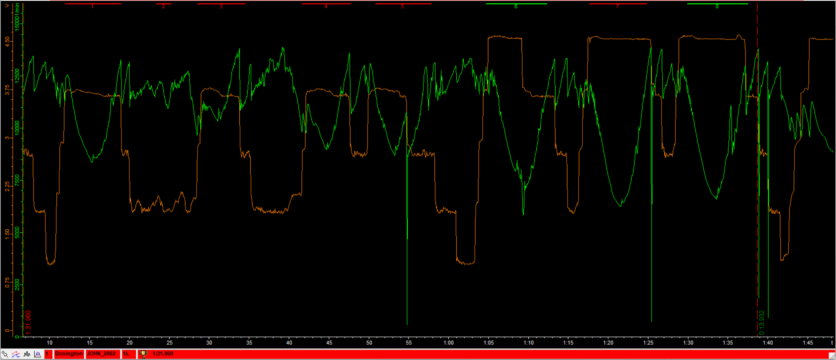
Figure 7 (RPM and Gear Positioning for John Hopkins) [2D Data].
The rider's rpm dropped 4 times even though the rider was on the throttle. This is because of being out of gear or the gear not being engaged quickly enough. This could have an impact on the speed, which could affect the lap time. Another cause for the rpm to drop could be due to engine braking when in a corner.

Improvements for Johns Hopkins
Even though John has the quickest time, he could improve his time by working on how quickly his gear changes are when dropping down gears.

Analysis Of Gary McCoy
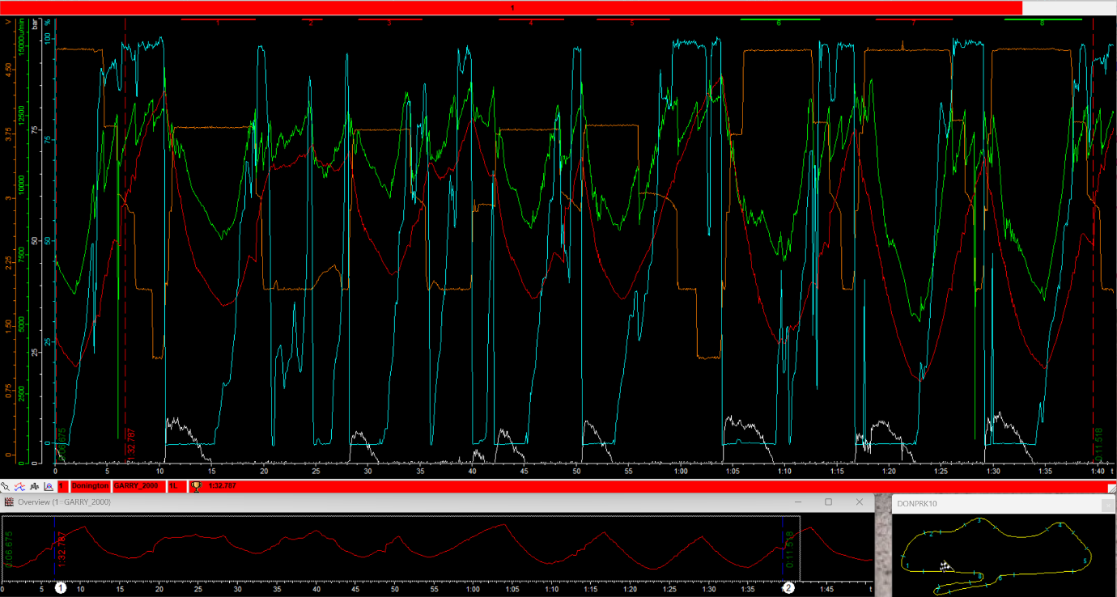
Figure 8 (Lap Analysis of Gary McCoy) [2D Data].

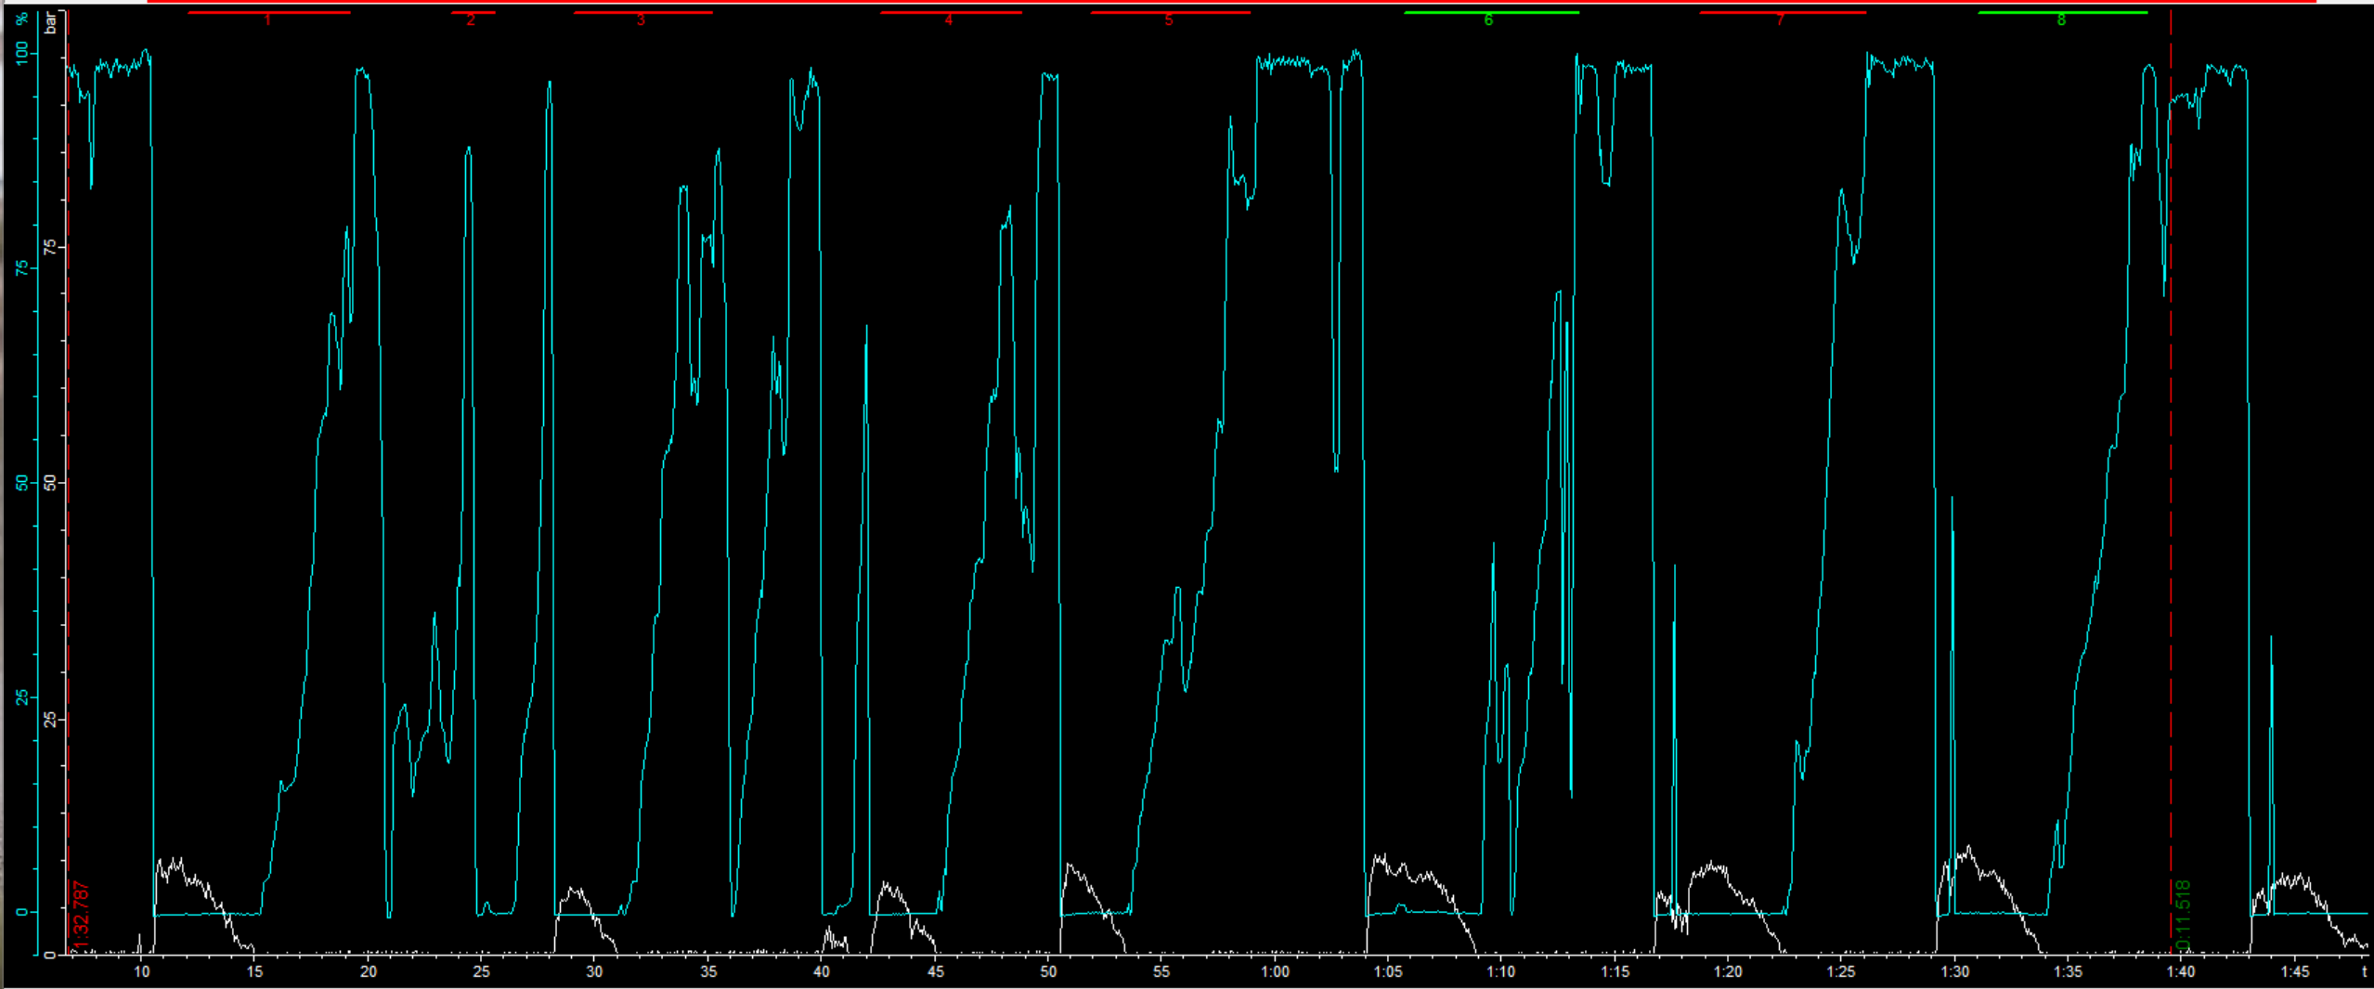
Figure 9 (Throttle and Front Braking Control for Gary McCoy) [2D Data].
Looking at how the rider uses throttle and braking Control when entering the corners, the rider comes completely off the throttle before applying the front brake, then jumps back on the throttle.
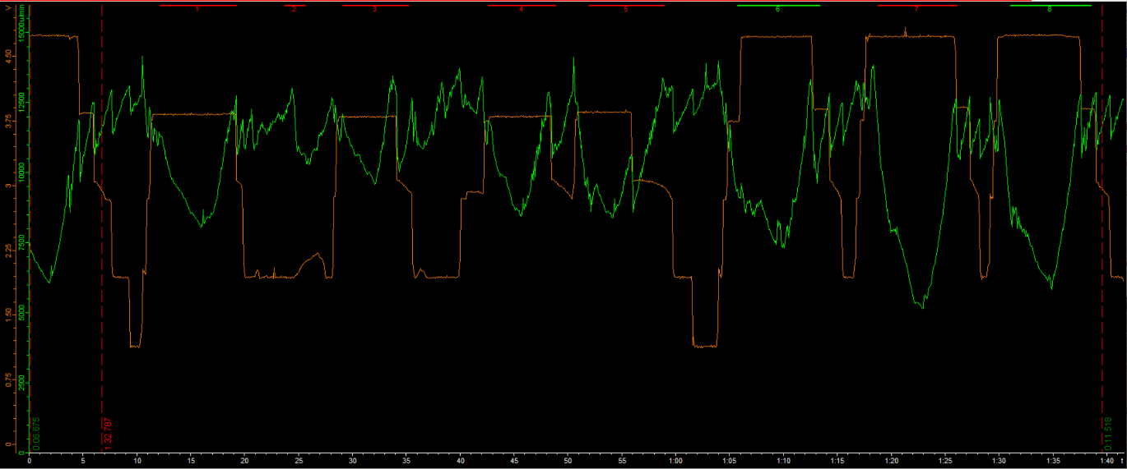
Figure 10 (RPM and Gear Positioning for Gary McCoy) [2D Data].
Gary’s rpm does not drop below 6000 rpm, unlike the previous 2 riders, which shows a higher rpm consistency.

Improvements for Gary McCoy
To improve the lap time, the rider could brake later in the corners and get on the throttle just before coming off the brake. This would increase the corner exit speed, which in turn increases the speed the motorcycle is travelling at coming onto the straights.

Design a Data Analysis System for the Kawasaki ZXR750

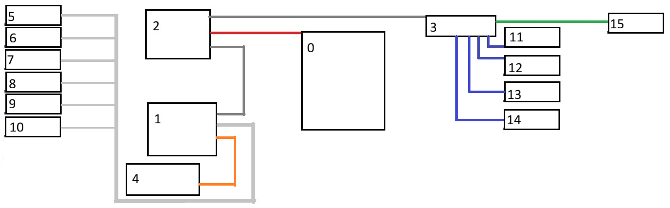
Figure 11 (Sensor Wiring Diagram) [D.Briggs].

Table 2 (Sensor Table) [2d-datarecording.com. (2021)].
Sensor Number | Sensor Type | Sensor
0 | Battery | N/A
1 | Data Log | USB-Sticklogger_V3-4050
2 | CAN | LG-CANStick2C_v3-000
3 | CAN | WB-CANHUB-000
4 | Dash | T-HQdash
5 | Front Brake Sensor | SA-PKxxxM10-000
6 | Front Tyre Pressure Sensor | SA-TMS_LDL_B(_C)_V3
7 | Front Suspension Sensor | SA-LPxxx-000
8 | Throttle Position Sensor | SA-MAPxx-000
9 | Coolant Temperature Sensor | SA-IRxxxxV6-000
10 | RPM Engine Sensor | SA-APS04-000
11 | Lambda | SA-LSU4.2-000
12 | Rear Brake Sensor | SA-PKxxxM10-000
13 | Rear Tyre Pressure Sensor | SA-TMS_LDL_B(_C)_V3
14 | Rear Suspension Sensor | SA-LPxxx-000
15 | GPS | BC-GNSS2CAN-000

Discuss the sensors

Data Logging & Sampling Rates
Each sensor requires a sampling rate specifically for the application of that sensor, for example:
The suspension sensors have a sampling rate of 100 Hz to 200 Hz for basic travel tracking and 500 Hz to 1000 Hz for detailed velocity and high-speed damping analysis. For this reason, the group will use a 500 Hz to 1000 Hz sampling rate so that we can capture high-speed compression events with accuracy.
The wheel speed sensor sampling rate ranges from 100 Hz to 5 kHz; For normal applications, the sampling rate is 100 Hz to 1 kHz and for motorsports is 4.6 kHz to 5.0 kHz; the group will use the Motorsports Sampling rate because this will allow the group to capture transient slip and dynamic load changes.
The brake pressure sensors' sampling rate can vary from 20 Hz to 10 kHz. For standard track day testing, the sampling rates are 20 Hz to 50 Hz. For motorsports, the sampling rates are 100 Hz to 500 Hz. For standard dynamic research, the sampling rates are 500 Hz and for High-speed lab testing, the sampling rates are 1kHz to 10kHz. The group will use the recommended motorsports 500Hz sampling rate
The RPM sensor sampling rate ranges from 10 Hz to 10 kHz; for example, vehicle data logging uses 10 Hz to 50 Hz. An engine control Sensor sampling rate uses 100 Hz to 500 Hz and the crankshaft positioning timing sensor sampling rate uses 1 kHz to 10 kHz. The group decided to use the Crankshaft positioning timing sensor for a more accurate RPM reading.
The Throttle Position Sensor (TPS) has a sampling rate ranging from 20 Hz to 500 Hz. For general data logging, the sampling rate ranges from 20 Hz to 50 Hz; for motorsports logging, the sample rate ranges from 100 Hz to 200 Hz and for OEM logging (Original Equipment Manufacturer), the sampling rate ranges from 100 HZ to 500 Hz. The Group will use the Motorsports sampling rate because the motorcycle is for racing, and that means the sampling rates match the application.
The GPS sampling Rates range from 1 Hz to 25 Hz is then broken down into 3 Types: general GPS with a sampling rate of 1 Hz, motorsports GPS with a sampling rate of 5 Hz to 10 Hz and advanced motorsport GPS with a sampling rate of 25 Hz. The Group will use the advanced motorsports GPS because this will give the group telemetry data as well as lean angles and braking data.
The advantage of having a higher sampling rate is more detailed data and larger data files for analysis, enabling the group to make more informed decisions on what the motorcycle and rider are doing when going around the track.

Wiring & Installation
To ensure reliable operation, all wiring should be routed away from heat sources and moving parts such as the drive chain, suspension components, engine and exhaust system to prevent damage during operation. Cables should be protected with durable sleeving and waterproof connectors to improve durability and resistance to environmental conditions.
Sensors must be securely mounted to minimise vibration, ensuring accurate and consistent measurements. The data logger should be installed in a low-vibration, easily accessible location, such as the subframe under the fuel tank, to protect the unit while allowing convenient access. The overall system was designed to enable quick and simple data downloads between testing sessions and improve efficiency during data collection and analysis.

Calibration, setup and testing
The calibration and setup phase focused on preparing the data acquisition system for installation on the Kawasaki ZXR750. Due to time constraints, the system was not powered or fully tested; however, the hardware was assembled on the bench to gain an understanding of the logger, extender modules, and sensor connections.
Sensor mounting locations and wiring routes were planned to ensure reliable data collection while avoiding heat sources, moving components, and high-vibration areas. The calibration requirements of key sensors, including the throttle position sensor and brake pressure transducer, were also considered, as these devices require appropriate scaling to provide accurate measurements.
As the system was not completely installed or validated, the final performance, sensor accuracy, and signal quality could not be confirmed. Further work would involve completing the installation, calibrating all sensors, and conducting on-track testing to evaluate the reliability and effectiveness of the data acquisition system under real operating conditions.
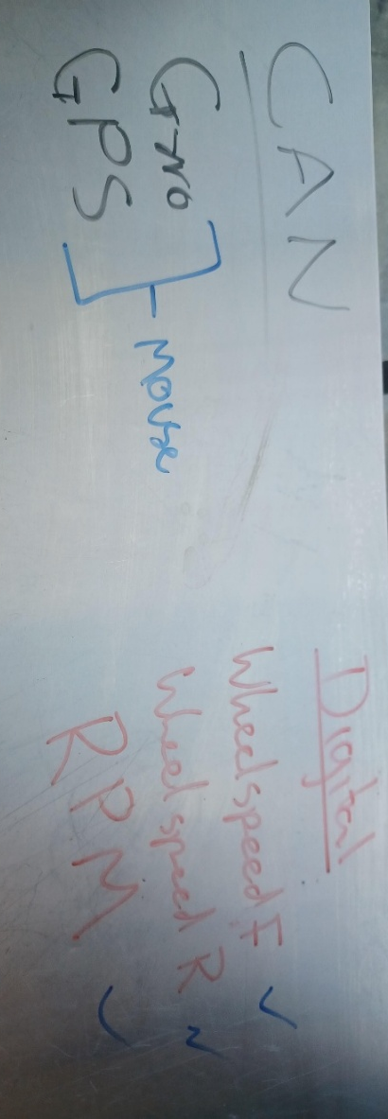
Figure 12 (CAN and Digital Test) [D.Briggs 2026].
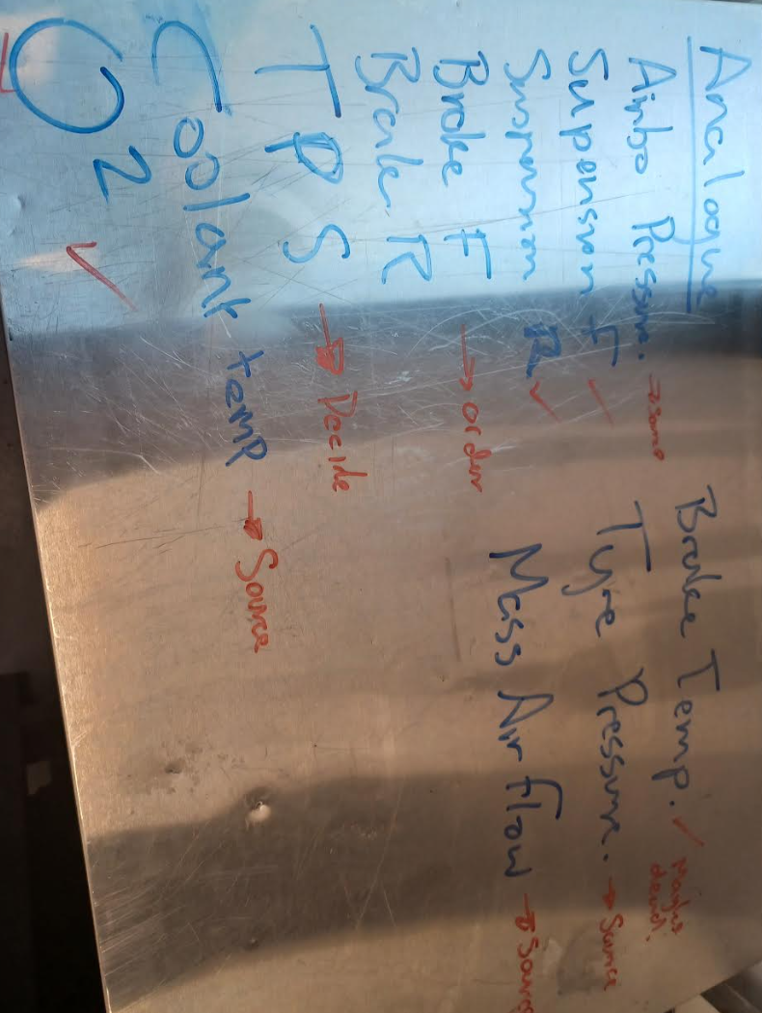
Figure 13 (Analogue Test) [D.Briggs 2026)

The group also discussed what sensors would go on the motorcycle and which sensors would go where.
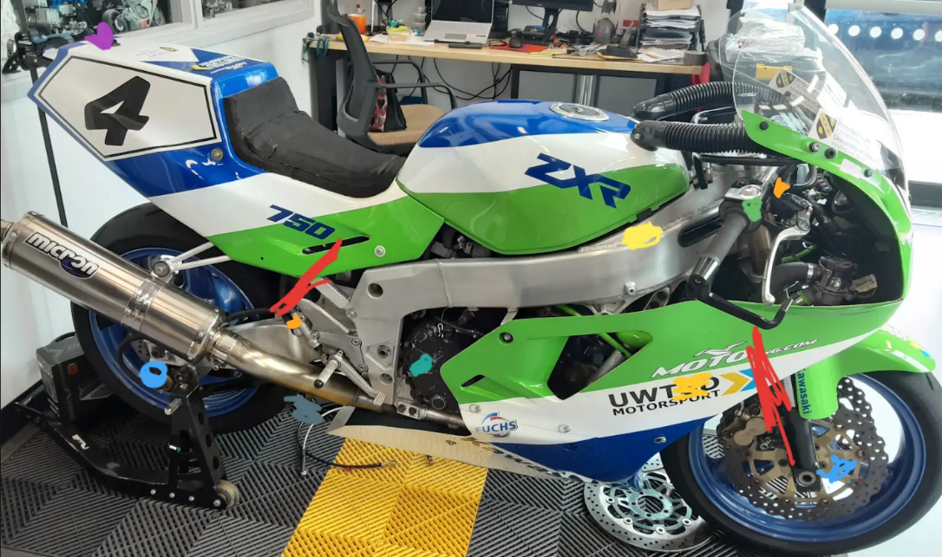
Figure 14 (Where the sensors will go on the motorcycle) [D.Briggs 2026]
The different colours indicate different sensors on the motorcycle and roughly where the sensors would go. The group also looked at putting the data logger and CAN under the fuel tank, where there is some space, as shown in the image below; however, the group will need to test how hot this section of the motorcycle gets to prevent the data logger from overheating.
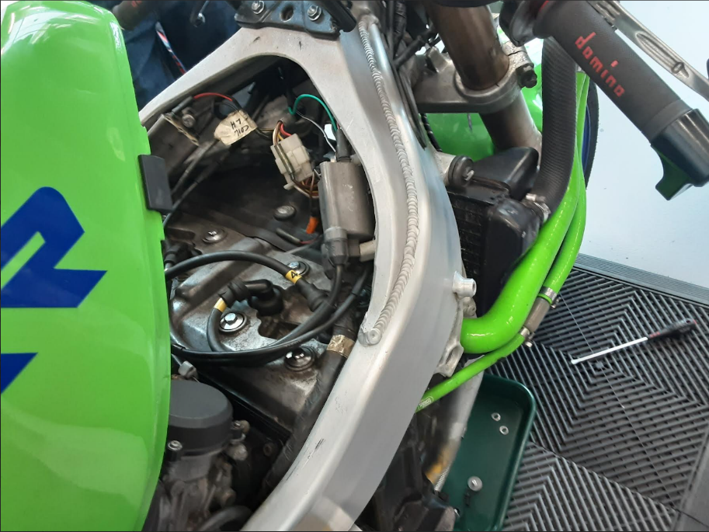
Figure 15 (The space under the fuel tank) [D.Briggs 2026].
The reason for looking at putting the data logger in this place is that the motorcycle frame would offer protection to the logger if or when the motorcycle had a crash; also this position is in the centre of the motorcycle and has wiring ports in the frame that the sensor wires could follow, so that the team could keep the wires tidy and out of the way.
Due to time constraints, the group could not perform a fitted live test; however, the group did connect up the sensors on the workbench to run a plenary test to check the sensors and see how they worked. As a result, the group couldn't conduct a signal and performance test on the motorcycle

Future work
- Install system onto the motorcycle
- Perform a calibration and sensor test
- Complete track day testing the sensors in a live application
- Analyse the data from the track day

Analysis of Data From Pembrey (20/03/2026)

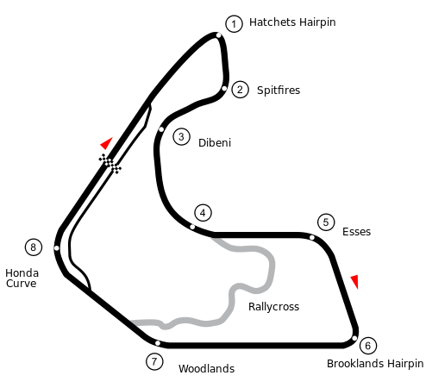
Figure 16 (Pembrey Circuit) [Motorsport-timing.co.uk. (2026)].

Table 3 (Pembrey Lap Times).
Lap Number | Lap Time
1 | 1:10.100
2 | 1:17.930
3 | 1:09.400

Lap 1 Analysis
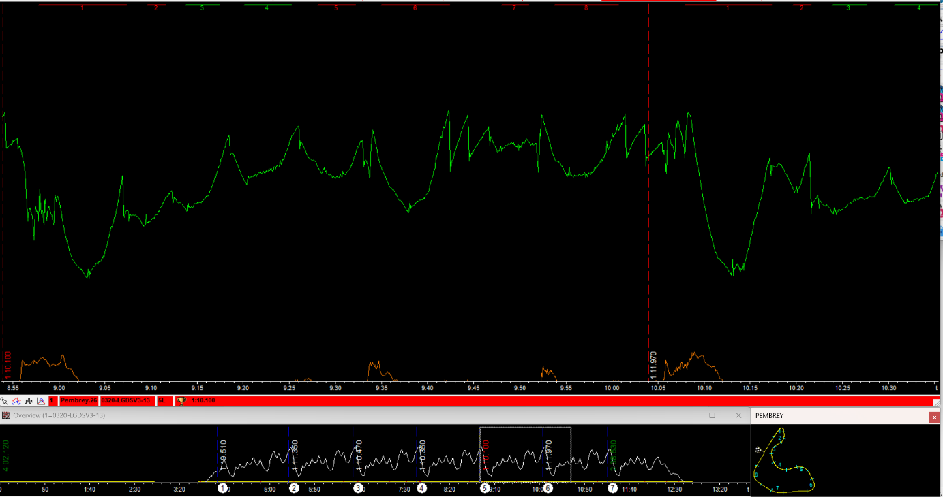
Figure 17 (Pembrey Lap 1 Analysis) [2D Data].
Looking at the data, the rear brake was not used during this lap; however, the front brake was utilised the most.

Lap 2 Analysis
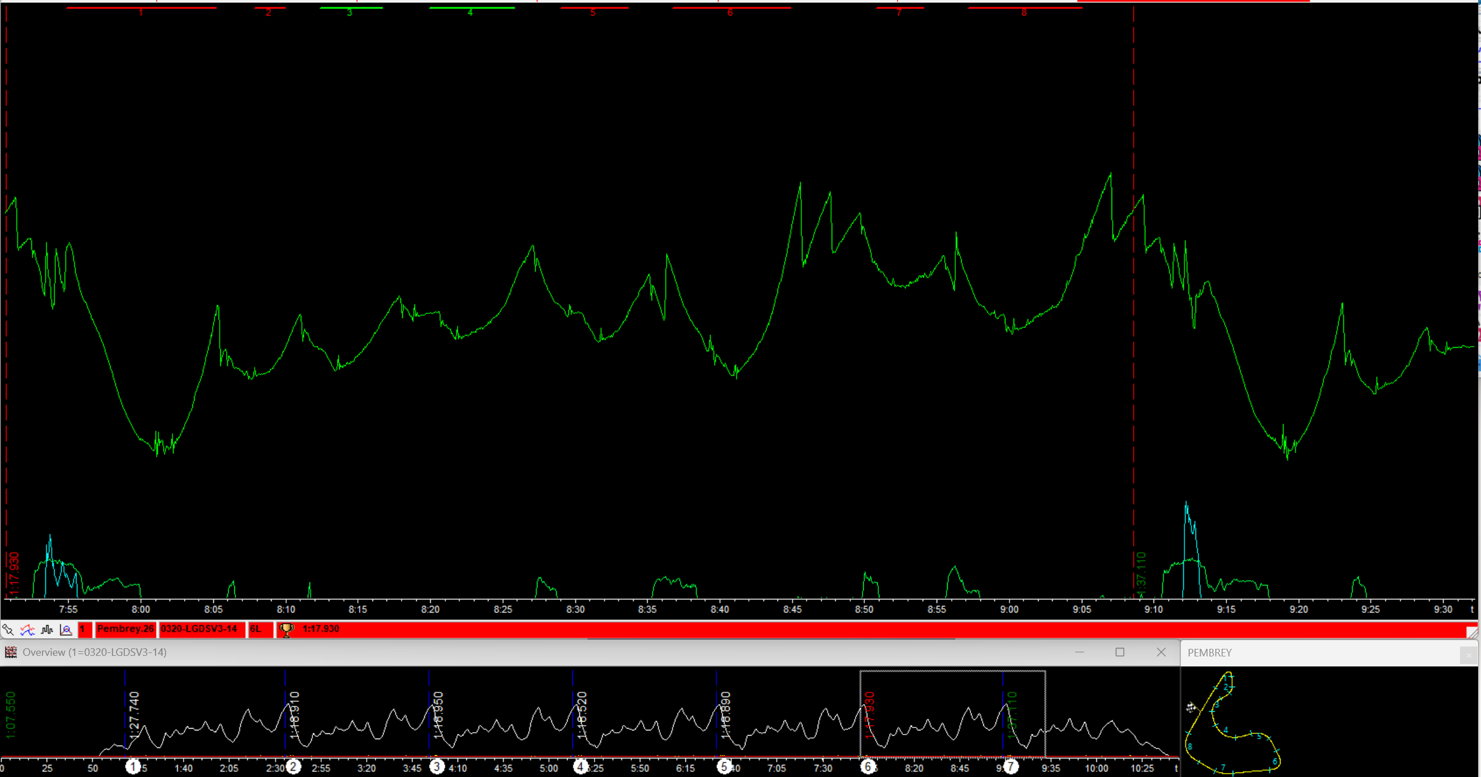
Figure 18 (Pembrey Lap 2 Analysis) [2D Data].
The front brake was utilised more than the rear brake. The rpm was lower than the first lap. This shows the rider was not pushing the motorcycle as hard, which led to a 7-second time difference between the first and second laps.

Lap 3 Analysis
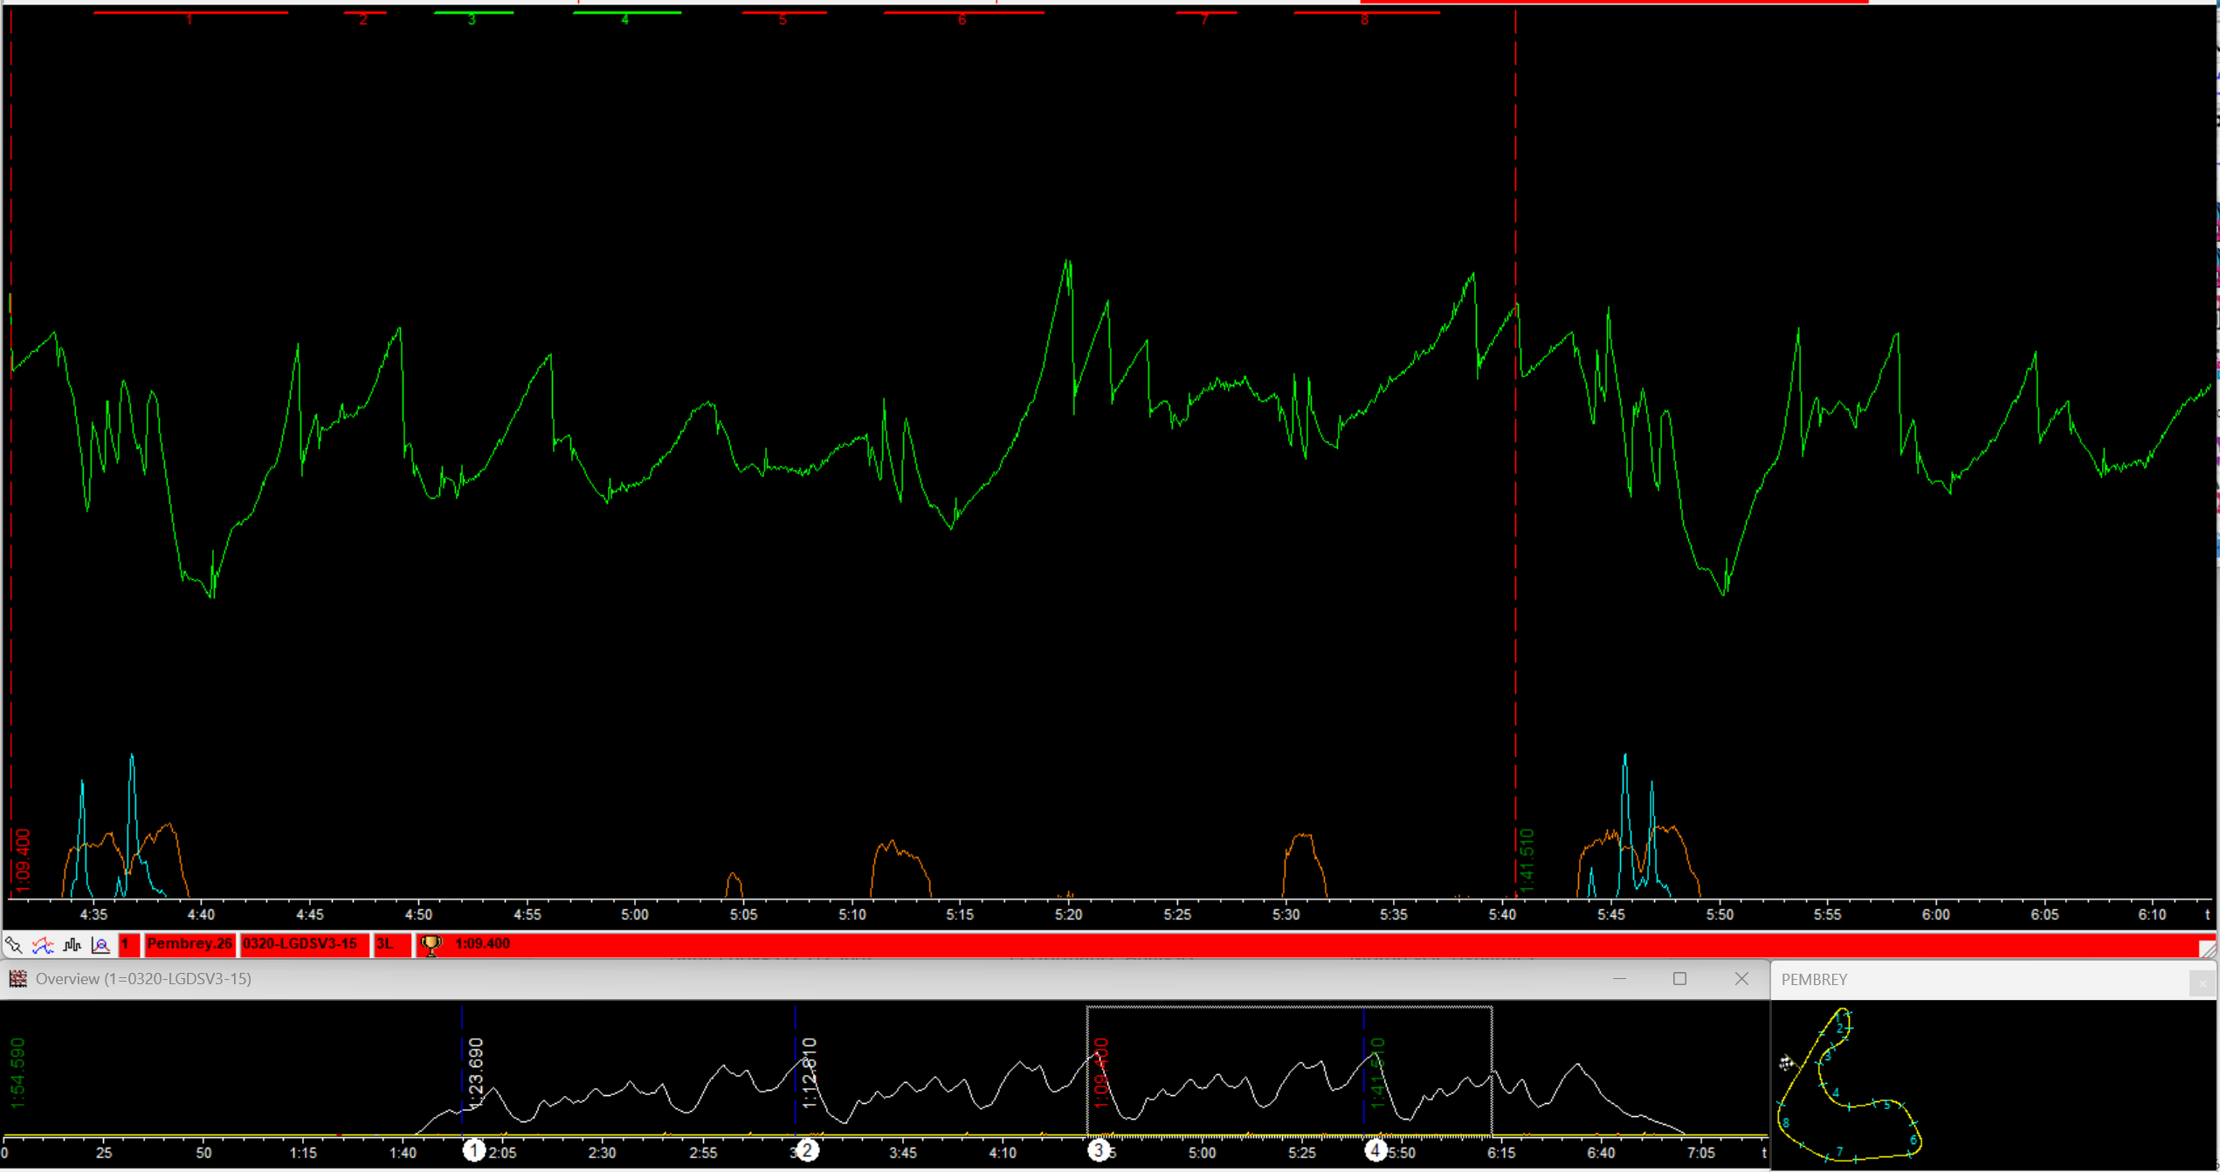
Figure 19 (Pembrey Lap 3 Analysis) [2D Data].
This lap shows a quick tap on the rear brake

Analysis of the laps
During corner 1 (Hatchets hairpin) between lap 1 and lap 2 and lap 3 is during lap 2, the rider slowed down gradually before the corner rather than braking heavily and after the corner lap 3 increased speed straight away.
During corners 2 (Spitfire),3 (Dibeni) and 4 (Paddock), lap 1, lap 2 and lap 3 used throttle control and engine braking to slow down and didn’t use the brake.
During corner 5 (Esses) lap 2 and lap 3 braked early and lap 1 braked during the corner; lap 3 managed to keep its speed through the corner and out the exit.
During corner 6 (Brookland Hairpin) all three laps braked heavily before the corner to slow down
During corner 7 (Woodlands) Lap 1 and lap 3 didn’t brake on this corner; however, Lap 2 did brake and slowed down for the corner, losing valuable speed.
During corner 8 (Honda Curve), lap 1, lap 2 and lap 3 applied their brakes before the corner however, lap 3 then got straight on the accelerator and exited the corner faster than entering it

Conclusion of Pembrey Data
Looking at the lap times, the rider was getting more comfortable with the motorcycle as the laps progressed, although lap 2 was the slowest, lap 3 was able to reduce the lap times as the rider went around the circuit.
The rider applied the brake less than lap 3 and only applied the brake when absolutely necessary and got straight back onto the acceleration to pick up speed exiting the corner.

Conclusion
If given more time and had all of the sensors, the group could have outfitted the ZXR 750 with the data logger and sensors and recorded the data to analyse and may have put the ZXR 750 on the dyno to get a baseline of the motorcycle before going out on the circuit.

References

Research References
2d-datarecording.com. (2024). » Sticklogger V3. [online] Available at: https://2d-datarecording.com/sticklogger-v3/
2d-datarecording.com. (2024). » GPS/GNSS 2 CAN. [online] Available at: https://2d-datarecording.com/gps-gnss-2-can/
2d-datarecording.com. (2024). » CAN Hub 4 Port. [online] Available at: https://2d-datarecording.com/can-hub-4-port/
2d-datarecording.com. (2021). » Datasheets. [online] Available at: https://2d-datarecording.com/datasheets/#sensors

Image References

51gt3.com. (2026). Available at: https://img2.51gt3.com/rac/track/202305/04ed487923dc4373bdab93c252584a7b.png
Motorsport-timing.co.uk. (2026). Available at: https://www.motorsport-timing.co.uk/content/uploads/2020/06/Pembrey-Circuit.png

