

Population Health and Digital Health Promotion

Student’s name: Anjaliben Rathod
Student’s numbers: 2226911
Module code and title: LCHS7007- Population health and digital health promotion
Lecturer’s name: Dr Diola Bijlhout
Assignment title: Assessment component 1
Part a - Blog
Part b – Poster Design

Contents
TASK 1 3
Blog 1- Critically discuss the impact of an existing digital technology currently used for a digital health promotion intervention 3
Blog 2- Critically discuss the impact of a digital technology you designed for a digital Health promotion intervention 5
TASK 2 POSTER 8
References 9

TASK 1

Blog 1- Critically discuss the impact of an existing digital technology currently used for a digital health promotion intervention

Global problems with health have received a lot of attention, particularly those that are connected to illnesses of mental health. Persons generally are affected by anxiety and depressive disorders, which may have a number of detrimental impacts. Digital technology, like mobile apps, has recently shown promise as potentially a tool for initiatives aimed at promoting health (Gomes et al., 2021). This blog analyses the effectiveness of mobile apps in treating emotional issues.
Public health issue: Worldwide rates of disorders of the mind, such as depressive disorders, anxiety, and illnesses caused by stress, have risen alarmingly.

Mobile applications' role in promoting health:
A practical and available forum for advocating for psychological wellness is provided by smartphone applications. These applications offer an extensive variety of functions, such as telephone therapy discussions, lessons, relaxing approaches, mood following, and tools for self-assessment.

"ActiveMe." Mobile applications have reportedly demonstrated beneficial impacts in supporting psychological wellness. This is confirmation that suggests modern technology promotes psychological wellness. Using Smartphone programs to treat anxieties and depression significantly reduced the degree of symptoms and enhanced emotional well-being.

Benefits of Mobile Devices for Promoting Health:
Accessibility: People who might lack access to regular medical facilities owing to physical or geographic constraints can still get rapid access to behavioral health options thanks to Smartphone applications (Chen et al., 2023).
Cost-effectiveness: Smartphone are an economical option for population-wide wellness initiatives since they possess the ability to provide psychological care at a lower cost than traditional therapies.

Mobile applications' drawbacks/deficiencies in promoting health:
Absence of scientific support
While several apps for mental wellness have shown promising results, many lack scientific validity and rigor. These applications range widely in terms of both quality and efficacy.
Addressing the Shortcomings: Multiple techniques can be used to solve the shortcomings of mobile apps for promoting health:
Normative principles: It is possible to guarantee the caliber, effectiveness, and data security of behavioral health apps by setting explicit legal guidelines and standards.
Treatments based on data: The legitimacy of apps for mental healthcare can be raised by persuading producers to include treatments that are scientifically proven and by undertaking extensive studies on how they work.

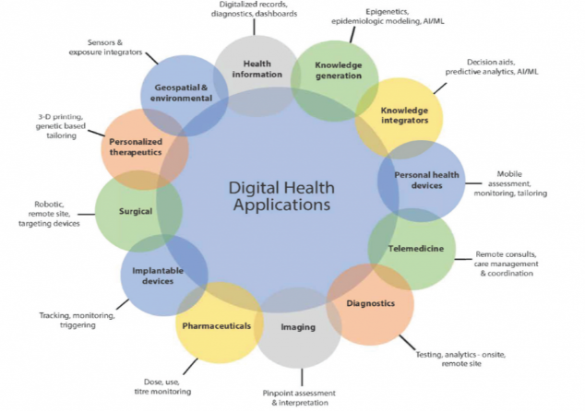
Figure: 1 Application of digital technology in healthcare
Source: edu, 2022

Blog 2- Critically discuss the impact of a digital technology you designed for a digital Health promotion intervention

Sedentary habits and a lack of sport have raised more and more public health issues. This blog critically examines the effects of a Smartphone application website created to encourage inactive people to get out there more. A number of detrimental health impacts are greatly exacerbated by physical inactivity, which has become a worldwide problem (Morris et al., 2022). The danger of contracting long-term diseases like coronary artery disease, type-2 diabetes, and mental health issues increases during prolonged moments of idleness and boredom, such as prolonged sitting.

Designed digital technology description:
Telemedicine services could be provided via a website like HealthPlus, allowing patients to get healthcare guidance and consults from a distance. Individuals in areas that are underserved or remote could especially profit from this because it will increase their access to healthcare services.

Usage in Healthcare Promotion: Elements in HealthPlus may encourage people to become more involved in managing their health. And encourages sedentary people to partake in frequent physical activity to combat the public wellness problem of physical lethargy. This might include the availability of learning materials, meeting, and prescription reminders, including personalized health data, all of which would improve the quality of life. Appointment scheduling, managing prescriptions, and storing health information are just a few of the activities that the software might digitize and improve in the healthcare sector. It can improve the overall effectiveness and lessen the administrative strain on healthcare practitioners (Morris et al., 2022).

Benefits
Accessibility: People can use HealthPlus whenever and wherever they like to know about healthcare into their schedules.
Privacy and security of data are essential components of any electronic health platform. In order to safeguard confidential patient knowledge and adhere to applicable privacy laws, HealthPlus will have to take strong measures. To guarantee a continuum of service and prevent duplicate data or dispersion, HealthPlus must be able to communicate smoothly with already-existing medical facilities, including digital health records (EHRs). Designing the user experience would be crucial to HealthPlus's performance. It needs to be simple to use, instinctive, and open to users of every age and skill level. HealthPlus will have to follow healthcare standards for interoperability in order to reach its full capability. This would allow for easy data transmission across various healthcare systems and providers of services, promoting thorough patient care (Richardson et al., 2022).

Disadvantages/Shortfalls:
Technological Obstacles Since the website's efficacy depends upon users having access to an internet connection, people with insufficient means or little digital literacy may be excluded.

Impact Of Digital Technology
By strengthening patient participation, expanding access to care, streamlining procedures, and fostering better medical outcomes, an internet-based healthcare network like HealthPlus might have a profound effect on the medical industry. However, resolving crucial issues including data protection, customer experience, connectivity, physician uptake, and moral considerations would be necessary for it to be successful. It would require thorough planning, cooperation, and continuing evaluation to maximize any possible advantages while minimizing any dangers and problems.

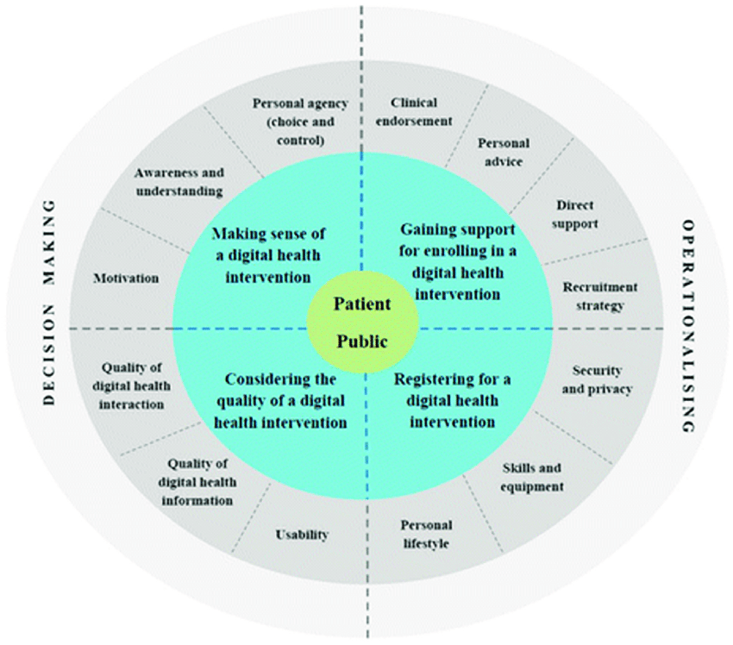
Figure: 2 Digital health engagements
Source: Fulton et al., 2018

TASK 2 POSTER

References

Chen, Q., Chan, K.L., Guo, S., Chen, M., Lo, C.K.M. and Ip, P., 2023. Effectiveness of digital health interventions in reducing bullying and cyberbullying: A meta-analysis. Trauma, Violence, & Abuse, 24(3), pp.1986-2002.
Gomes, M., Murray, E. and Raftery, J., 2022. Economic evaluation of digital health interventions: methodological issues and recommendations for practice. Pharmacoeconomics, 40(4), pp.367-378.
Morris, B.B., Rossi, B. and Fuemmeler, B., 2022. The role of digital health technology in rural cancer care delivery: A systematic review. The Journal of Rural Health, 38(3), pp.493-511.
Richardson, S., Lawrence, K., Schoenthaler, A.M. and Mann, D., 2022. A framework for digital health equity. NPJ digital medicine, 5(1), p.119.
https://nam.edu/the-promise-of-digital-health-then-now-and-the-future/
Fulton, E.A., Kwah, K.L., Wild, S. and Brown, K.E., 2018, July. Lost in translation: transforming behaviour change techniques into engaging digital content and design for the StopApp. In Healthcare (Vol. 6, No. 3, p. 75). MDPI.

