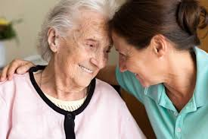

December 2019

Theories of dealing with bereavement in the elderly
Section 1: Executive Summary

Contents
2 Section 1:  Executive Summary  4 Section 2:  Introduction  5 Section 3:  Theories of Aging |  | 8 Section 4:  Theories and Research Findings of Dealing with  Bereavement in the Elderly  11 Section 5:  Poster: Ways of improving the way in which  we deal with bereavement in the elderly  NB: Please zoom to enlarge.  12 Section 6:  References

Executive Summary
Bereavement is not an area that is overly prioritised in the UK. The support on offer for elderly bereaved individuals is localised and the policy’s that do exist, are fundamentally different and unrelated.
Therefore, support is dependent on the availability of third sector organisations.
Elderly adult’s experiences of the loss of loved ones greatly differ depending on many factors, including the individual’s race, gender and social connections.
This report aims to address what can be done to help elderly bereaved individuals have the support they need and hopefully a more positive outcome.

Why is this important?
Bereavement in the elderly adult is more common than in any other age group.
The person they have lost is usually someone they have relied upon for happiness and support and quite often have been their lifelong partner. Thus, making it one of the most difficult transitions in their life. Loss of a partner is one of the most devastating forms of bereavement.
The elderly bereaved adult has less chance of getting the support they need, as they are less likely to seek out help, also, they are less likely to get a referral for bereavement support than the younger generation.
Section 1: Executive Summary
Who are affected the most?
- Men are more affected by loneliness and isolation than women
- Elderly adults over 85
- Individuals that have no family and friends for support
- Income and practical issues have a more negative affect on women (Corden, Hirst, and Nice, 2010).
Mental and physical health
Elderly bereaved adults are at a much higher risk of suffering depression than non-bereaved elderly adults.
Elderly adults suffer from more mental health issues during bereavement than younger adults.
Elderly adults are prone to experience health problems due to bereavement, more so if they were caring for a dying partner (Detering, Hancock, Reade, & Silvester, 2010).
GPs have very little knowledge and standard training to help individuals deal with grief.
This reports view is to make sure…
Elderly bereaved adults get the support they need by giving them all available options open to them.
Explaining to them how to access that support.
Helping the individual deal with their bereavement and living without a partner, by planning in advance anything likely to cause more stress. E.g. financial and health problems.
It’s important that everyone has these options and support open to them in the future.
Discussing their personal experience of bereavement is nearly always felt to be beneficial.
Action plan
A bereavement support plan should be established by the government in order to show the way to elderly bereaved individuals service and support options.
Explain the benefits of planning ahead, many elderly adults that have relied upon a partner in life only acknowledge the benefits of planning ahead when it’s too late.
Remove the shame about discussing bereavement. Many elderly adults need more support and encouragement to address the challenging conversations about death. This could help them plan ahead. For more information, visit www.independentage.org
Section 2: Introduction

Introduction

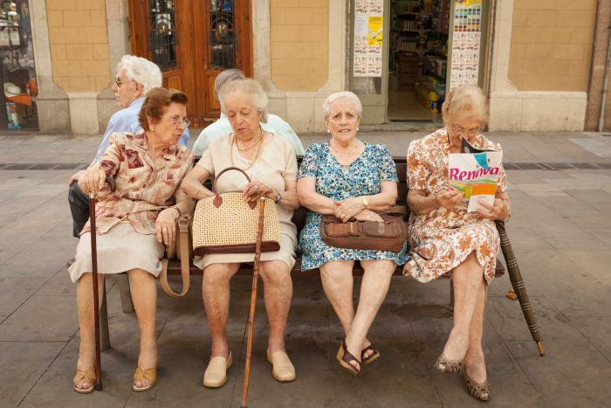

Most empirical and theoretical studies on grief in the elderly get assessed within the idea of therapeutic involvement. The act of losing a loved can have severe physical, spiritual, behavioural, social, and cultural impacts on the health of old age persons.

Researchers have shown old age bereavement starts at the age of 65. At this time, 10% of the married individuals experience the loss of their spouses. These rates keep on rising and by the age of 85, the older adults experience a 40% loss of their loved ones (Hatch, 2018).

Psychologists have come up with different theories that are there to help the elderly adjust positively to this loss.

Section 3: Theories of Aging

Theories of Aging
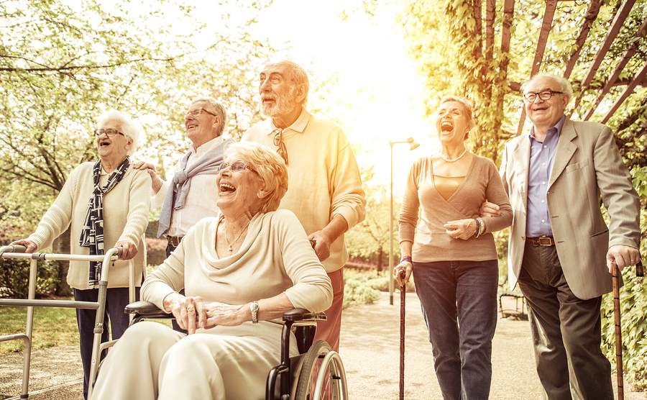
Activity theory, successful aging happens when older adults maintain social interactions and remain active (DeLiema & Bengtson, 2017). Therefore, there is an estimation of the general method of adjusting, which is the theory of mental incompatibility.
The activity theory suggests that it’s important for older individuals to remain mentally active to limit the risk of disengagement. Being both mentally and physically active in older adults can assist with helping individuals with the problems they may encounter when losing a loved one (Richardson, & Balaswamy, 2001).
There are many reasons for the importance of older individuals to stay active later in life , Bowling, (2008) believed that providing facilities for older individuals would not be sufficient enough, and that guidance and understanding would be needed to support and encouragement the bereaved individual to leave behind fixed habits.
However, critics of the activity theory suggest that elder individuals may be unable to participate in such activities due to emotional or physical health, or simply do not wish to participate. Therefore, this theory overlooks some of the differences in personalities types and the possibility of loss of an individual’s physical and mental skills (Bengtson, Coleman, & Kirkwood, 2005).
Psychological inconsistency theory, there is the aspect of cognitive motivation. According to Boerner and Jopp, (2015), a mental discrepancy is a theory that connects between desires and experiences.

Section 3: Theories of Aging

Cognitive motivational theory, inconsistency is a term used to describe an imbalance in the psychological system when conditions of change, such as support and income, are not favourable. It explains;
- Solitude experienced by the bereaved elders as a result of a mismatch in their relationships.
- Upon death, an older person is likely to feel discrepancy between the relationship they wanted and what they have.
- Upon old age, individuals may crave a lot of affection from their spouse. Therefore, if they lose their spouse, they
are likely to feel emptiness.
The theory suggests social support for bereaved individuals.
- Considers the reasonable aging theory that views aging as a normal process that is enhanced by social interaction.
- Counters the disengagement theory (Wahl, Siebert, & Tauber, 2017).
Disengagement theory states that a person withdraws their involvement with society as they age. It was first proposed by two authors Cumming and Henry in 1961. They thought it was a natural process for the elderly individual to abandon their involvement with people due to limited opportunities (Lanre, Omosefe, Oduyoye, & Moturayo (2019).
Many reasons exist that can limit the elderly’s interaction with others like mobility and ill health. The disadvantages of the disengagement theory are that due to the variation and diversity process in which we age, an individual’s class, culture and gender also play a part in how the individual deals with disengagement theory (Moore, 2015).
Furthermore, the activity theory disagrees with the disengagement theory by suggesting the importance that elderly individuals that keep active and socially engaged in life will be at an advantage to those that disengage. Furthermore, that it’s only the biological aspects that separate young from old and not social needs and desires (Schulz, 2006).
Researchers have discovered that the involvement of disengagement theory after bereavement leaves the elder at a critical position, prone to chronic stress. Leaving elderly people to deal with the loneliness that results from the loss of a loved one.

Section 3: Theories of Aging
Theory of relational isolation, attention is on the death and recovery process. Therefore, social and psychological processes focus on the adjustment phase of bereavement.
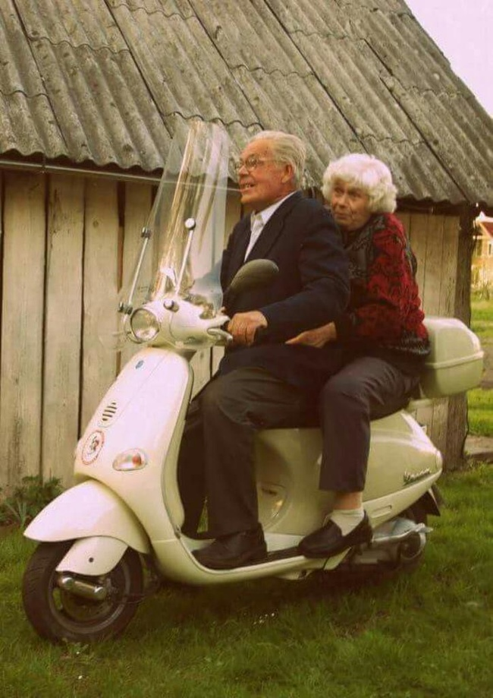
- Loneliness can be caused by social and emotional isolation.
- Lack social interaction platforms which help to forget their loss.
- Suffer loneliness from lacking a strong attachment character like a
partner.
- Failure to have an attachment causes identity impairment.
- Intimate and close bonds get introduced to the bereaved elder (Cleiren, 2019).
- Getting another partner is part of the adjustment process.
Therefore, there is a need to consider the social exchange theory (SET). Even though aging can be associated with moral disengagement, SET encourages the study of the elderly's social performance in the relations of two parties (Boerner, Stroebe, Schut, & Wortman, 2017). That allows family members to perform a cost-benefit assessment to determine the benefits and risks deprivation could have on their health.
In SET, consideration is on romantic relationships, professional relationships, temporary, and even friendships. If the costs presented by the relationships are more significant than rewards, it can have a direct impact on the individual's health.
In attachment theory, focus is on the aftermath of mourning, the grieving elder will retain some attachment to the
deceased for a considerable period.
- Might experience hallucinations and sense the presence of the dead.
- They can rely on the proximity seeking actions e.g. visiting the gravesite or having inner conversations with the
deceased.
- All these behaviours are associated with favourable grieving results (Son & Byun, 2015).
Even though there is a continued bond presented in the grieving process, the individual portrays traits of coping with the loss. In the early months of mourning, the person exhibits high levels of negative emotions that fade away as time passes.

Section 4: Theories and Research Findings of Dealing
with Bereavement in the Elderly

Theories and Research Findings of Dealing with Bereavement in the Elderly

In the field of bereavement, there are many views on how loss is processed.
Grief was assumed to be a systematic process; beginning with denial and shock, moving to protest, depression, and anger before acceptance and recovery.
Questions arise to this presumed research; emotional indicators contradict the sequence in old age bereavement. In the elderly, grief acceptance predominates as denial and anger occur in the first two to three years of readjustment.
These results have driven psychologists to explore theories to deal with old age grief.
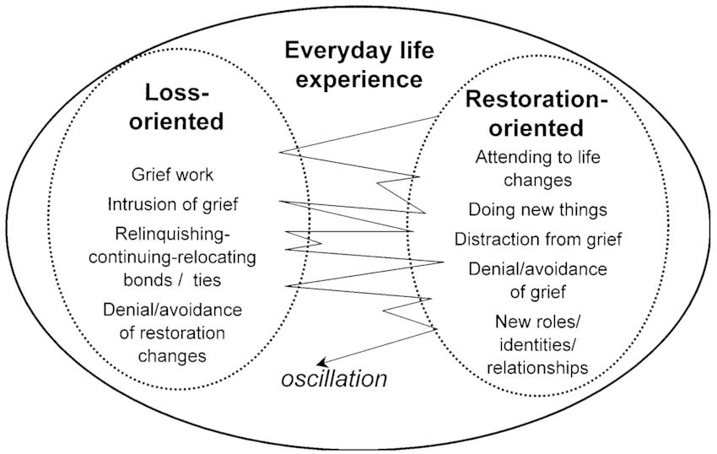
Focus has been laid on self-esteem in adjusting to death and society's role in readjustment to loss. From a theoretical perspective, psychologists have found a connection between social interaction and aging.

Section 4: Theories and Research Findings of Dealing
with Bereavement in the Elderly

According to the attachment theory, signs of mourning are only short term. The theory is backed up by the Two-Track Model of Bereavement (TTMB), which views grief occurring in two concurrent processes.
- Disruption of the biopsychosocial functioning of the person (Neimeyer & Holland, 2015). Characterized by their social behaviour, mood disorders, capacity to work, and physical health.
- A focus on the relationship between the deceased and the bereaved, before death and ongoing.
Another process in support of the attachment theory is the Dual Process Model (DPM) of dealing with grief, which distinguishes between, and normatively alternates, (whether dignified in hours, minutes, days, weeks or years) between;
- loss-oriented behaviours; the mourner experiences pain as they strive to reposition the loss in their ongoing lives (Zheng, Lawson, & Anderson Head, 2017). Often traits exhibited are avoiding interactions to review the loss and struggling to accommodate it more privately.
- restoration-oriented behaviours; involves re-engaging in social, family and workplace demands to distract one from grief.
At this point, the bereaved tries to get workable alternatives that accommodate the physical lack of the deceased.
In Theory, a pendulum swing can be used to explain the pace between the two orientation phases as one restores their life over the loss.
The dual-process model to grief is common with some individuals, especially in males. Here, a person avoids pain. Avoiding pain can be both detrimental and helpful, depending on the present situation.
The dual-process model can cause severe mental and psychological issues in elderly individuals as they live in denial.
In this model, two stressors get identified in coping behaviour. First, there is the restoration and loss-oriented stressor and a dynamic way to deal with fluctuation (Richardson, 2016). The grieving process gets presented as a dynamic process with alternation between confronting the loss of a person (loss orientation) and restricting oneself from having that focus (restoration orientation).
Section 4: Theories and Research Findings of Dealing
with Bereavement in the Elderly

In loss orientation, there is grieving, and the restoration process encompasses handling the secondary losses that come as a result of death. E.g. an old widow might have to manage finances, in the case that her husband dealt with all the bills.
The model assumes that involving oneself in secondary activities helps to overcome the pain of grief (Stroebe & Schut, 2010).


Finally, there is the cognitive-affective-behavioural model that explains grief as an attempt to reconstruct or reaffirm a world with meaning that was challenged by death (Carr & Utz, 2011).
In most aged persons, loss shatters the world that they had built. Therefore, the mourner gets anguished and looks for meaning in death and life afterward. It is called acute grieving.
Several evidence-based studies support this model as there is the concept of processing the death, evaluating the back story, and reaffirming attachment security.

Section 5: Poster NB: Please zoom to enlarge.
Section 6: References
References
Bengtson, V. L., Coleman, P. G., & Kirkwood, T. B. (2005). The Cambridge handbook of age and ageing. Cambridge University Press.

Benkel, I., Wijk, H., & Molander, U. (2009). Family and friends provide most social support for the bereaved. Palliative medicine, 23(2), 141-149.

Boerner, K., & Jopp, D. S. (2015). Adaptation to loss. The encyclopedia of adulthood and aging, 1-6.

Boerner, K., Stroebe, M., Schut, H. A. W., & Wortman, C. B. (2017). Grief and bereavement: Theoretical Perspectives. Encyclopedia of geropsychology, 979-986.

Bowling, A. (2008). Enhancing later life: how older people perceive active ageing? Aging and mental health, 12(3), 293-301.

Bratt, A. S., Stenström, U., & Rennemark, M. (2017). Effects on life satisfaction of older adults after child and spouse bereavement. Aging & mental health, 21(6), 602-608.

Carr, D., & Utz, R. (2011). Late-life widowhood in the United States: New directions in research and theory. Ageing international, 27(1), 65-88.

Cleiren, M. (2019). Bereavement and adaptation: A comparative study of the aftermath of death. New York: Taylor & Francis.

Corden, A., Hirst, M., & Nice, K. (2010). Death of a partner: Financial implications and experience of loss. Bereavement Care, 29(1), 23-28.

De Jong Gierveld, J. (2014). Remarriage, unmarried cohabitation, living apart together: Partner relationships following bereavement or divorce. Journal of marriage and family, 66(1), 236-243.

DeLiema, M., & Bengtson, V. L. (2017). Activity theory, disengagement theory, and successful aging. Encyclopedia of geropsychology, 15-20.
Detering, K. M., Hancock, A. D., Reade, M. C., & Silvester, W. (2010). The impact of advance care planning on end of life care in elderly patients: randomised controlled trial. Bmj, 340, c1345.

DiGiacomo, M., Hatano, Y., Phillips, J., Lewis, J., Abernethy, A. P., & Currow, D. C. (2017). Caregiver characteristics and bereavement needs: Findings from a population study. Palliative medicine, 31(5), 465-474.

Fernández-Ballesteros, R., Benetos, A., & Robine, J. M. (Eds.). (2019). The Cambridge handbook of successful aging. Cambridge: Cambridge University Press.

Hatch, L. R. (2018). Beyond gender differences: Adaptation to aging in life course perspective. New York: Routledge.

Holtslander, L., Duggleby, W., Teucher, U., Cooper, D., Bally, J. M., Solar, J., & Steeves, M. (2016). Developing and pilot-testing a finding balance intervention for older adult bereaved family caregivers: A randomized feasibility trial. European journal of oncology nursing, 21, 66-74.

Huisman, M., Klokgieters, S. S., & Beekman, A. T. F. (2017). Successful ageing, depression and resilience research; a call for a priori approaches to investigations of resilience. Epidemiology and psychiatric sciences, 26(6), 574.

Ingham, C. F., Eccles, F. J., Armitage, J. R., & Murray, C. D. (2017). Same-sex partner bereavement in older women: an interpretative phenomenological analysis. Aging & mental health, 21(9), 917-925.

John, M. D. (2018). Ethical issues in the care of the dying and bereaved aged. New York: Routledge.

Lanre, A. O., Omosefe, O. M., Oduyoye, O. O., & Moturayo, A. O. (2019). Psychosocial factors as predictors of social wellbeing of the elderly in Geriatric Centers in Lagos State. IFE PsychologIA: An International Journal, 27(1), 173-186.

Moore, C. (2015). Moral disengagement. Current Opinion in Psychology, 6, 199-204.

Neimeyer, R. A., & Holland, J. M. (2015). Bereavement in later life: Theory, assessment, and intervention. In APA handbook of clinical geropsychology, Vol. 2: Assessment, treatment, and issues of later life. (pp. 645-666). American Psychological Association.

Richardson, V. E. (2016). A dual process model of grief counselling: Findings from the changing lives of older couples (CLOC) study. Journal of gerontological social work, 48(3-4), 311-329.

Richardson, V. E., & Balaswamy, S. (2001). Coping with bereavement among elderly widowers. OMEGA-journal of death and dying, 43(2), 129-144.

Rook, K. S., & Charles, S. T. (2017). Close social ties and health in later life: Strengths and vulnerabilities. American psychologist, 72(6), 567.

Schulz, R. (2006). The Encyclopedia of Aging: 2-Volume Set. Springer Publishing Company.

Son, J. M., & Byun, S. H. (2015). Effects of spouse bereavement in old age on emotion and social interaction. The journal of the Korea contents association, 15(9), 233-242.

Stroebe, M., & Schut, H. (2010). The dual process model of coping with bereavement: A decade on. OMEGA-journal of death and dying, 61(4), 273-289.

Wahl, H. W., Siebert, J. S., & Tauber, B. (2017). Psychological theories of successful aging. Encyclopedia of geropsychology, 1931-1940.

Zheng, Y., Lawson, T. R., & Anderson Head, B. (2017). “Our only child has died”—a study of bereaved older Chinese parents. OMEGA-journal of death and dying, 74(4), 410-425.

