An exploration into an individual’s thoughts and feelings about compulsory physical education within secondary education; analysing questionnaires.
University of Wales Trinity Saint David

Abstract
Compulsory physical education (PE) was introduced in the 19th century to promote fitness and health and is considered important for overall well-being, therefore, has become an integral part of school curriculums. This study aimed to explore the individual experiences of two participants regarding their participation in compulsory PE during secondary education. A non-experimental qualitative approach was taken, thematic analysis was used to identify major themes in the participants' experiences. Three themes emerged: self-efficacy, student experiences and equality, and the interconnectedness of health and wellbeing. These themes provide insight into how compulsory PE may affect students' sense of self-efficacy, their experiences in school, and their overall health and wellbeing. The results offer a personal insight into lived experience of compulsory PE, additionally, the study highlights the need for a more comprehensive approach to PE that considers the interconnected nature of health and wellbeing, promotes empathy and equity, and addresses the potential for psychological harm.

Introduction
Physical education (PE) has long been a required topic in secondary education in the United Kingdom (UK) (Santiago & Morrow, 2020), the Education Act of 1870 was a significant piece of legislation in the UK that established a framework for universal education, this marked a significant shift towards recognising the importance of compulsory PE in schools. (Graber, 2012). PE has been defined as a discipline that teaches physical skills, promotes fitness and health knowledge, and encourages positive attitudes towards physical activity (PA). Its aim is to foster lifelong participation in PA and enable individuals to maintain healthy lifestyles (Ennis, 2015). The emphasis placed on PE in schools has shifted over time, currently, with more focus now being displayed on the advantages of regular exercise, its role in promoting general health and wellbeing, as well as providing a model for this behaviour in adulthood (Rhodes & Kates, 2015). Currently, PE is an important part of the curriculum in schools across the UK in helping students establish lasting healthy habits (Hulteen et al., 2018), as of 2020, 83% of students attending government secondary schools took at least one PE GCSE (General Certificate of Secondary Education) test, and 54% of them passed with a grade of C or higher. During the academic year 2018–2019, 82% of secondary schools offered at least one team sport, 61% offered individual sports, and 46% provided fitness or exercise classes (Norris et al., 2020). It has been advocated that all adolescents be encouraged and assisted to engage in continuing activities that support their own health, fitness, and wellbeing through PE (Griggs & Fleet, 2021).
Furthermore, understanding the effects of compulsory PE in secondary education is pertinent because adolescence is a pivotal point for physical, cognitive, and social development (Shlafer et al., 2014). Research on secondary school PE has been shown to identify effective ways to promote PA and health among adolescents, Lynch et al. (2016) compared the effectiveness of two school-based interventions on PA levels among adolescent boys. The interventions consisted of either traditional PE lessons or a modified PE program that included more student choice and autonomy. The results showed that the modified PE program resulted in significantly higher PA levels and improved psychological outcomes, such as self-efficacy and enjoyment of PA (Lynch et al., 2020). Nonetheless, this study limited participation to boys, therefore results can’t be generalised for all pupils.
However, the debate over whether pupils in secondary schools should be required to take part in PE has centred on whether or not it is essential for their physical and mental health (Cale et al., 2020). Requiring students who don't meet fitness standards to participate in PE can harm their self-perception and self-worth (Barker et al., 2022), literature suggests that experiences in compulsory PE may cause individuals to appear anxious because of their physical appearance (Vani et al., 2021). Tiggemann & Slater (2014) aimed to investigate the impact of the PE environment on body image dissatisfaction and self-esteem in adolescent girls. (n=191) completed questionnaires that assessed their experiences in PE classes, body image dissatisfaction, and self-esteem. The results found that girls who reported negative experiences in PE, such as feeling embarrassed or uncomfortable in front of their peers, were more likely to have body image dissatisfaction and lower self-esteem (Tiggemann & Slater, 2014). The study had some limitations; due to the study's reliance on self-reported data, which could be biased by social desirability, and given that only adolescent females were involved, the findings may not be generalizable to boys or to older or younger age groups.
Moving on, the Cognitive Development Theory (CDT), supports the positive impact of PA on cognitive development, such as memory, attention, and problem-solving skills, suggesting PE can enhance academic performance and cognitive functioning (White et al., 2018). Additionally, Self-Determination Theory (SDT) contends that to foster wellbeing, Individuals must be able to meet their fundamental psychological requirements for autonomy, competence, and connection. fulfilled (White et al., 2018). PE is suggested to help satisfy these needs by providing opportunities for students to take control of their own physical health, develop competence in PA, and build positive relationships with peers (Sun et al., 2017). To explain further, Teixeira et al, (2020) investigated the role of SDT in PA behaviour change, aimed to determine whether self-determined motivation could predict PA behaviour change over six-month (Teixeira et al., 2020), (n=423) adolescents were divided randomly to one of two groups: a control group or a behavioural intervention group. The behavioural intervention group received a PA intervention that was designed to increase their self-determined motivation, the control group received no intervention. The study's results showed that self-determined motivation strongly predicted the change in PA behaviour over a six-month period, supporting SDT (Teixeira et al., 2020b). However, the study's limited duration (six months) means that longer-term follow-up is necessary to assess the sustainability of PA behaviour change.
In summary, while compulsory PE in secondary education has benefits, it is pertinent to consider individual experiences and feelings towards PE, some individuals may have negative experiences or perceive compulsory PE as discriminatory, while other thrived on PE, it is essential to understand all individuals’ views. The rationale of this study is to contribute to the body of qualitative research by using thematic analysis to explore potential effects which might impact someone who engages in compulsory PE. The aim of the study is to explore a person's individual thoughts and feelings, and to produce a thorough awareness and comprehension of the effects of compulsory PE on a person's wellbeing by analysing questionnaires. Thematic analysis is a valuable method for exploring personal emotions, feelings, and individual case studies in depth. It offers a flexible and reflective tool for this purpose, however, it is important to use a structured approach to ensure effective results, as outlined by Braun and Clarke (2006) (Braun & Clarke, 2006).

Method
Design
Thematic analysis was conducted on interviews with two female students using a non-experimental, qualitative approach, following the six steps outlined by Braun and Clarke (Smith, 2015). The data collected from the interviews were analysed using Microsoft Word and coding techniques were employed to identify themes.
Participants
Two female second year BSC Applied Psychology students (Interview A and Interview B) were interviewed face-to-face by two other second-year BSC Applied Psychology students. The purpose of the interviews was to gather data for a thematic analysis on individual experiences of compulsory PE during secondary education. The participants were referred to as Participant A (Jane) and Participant B (Sally) for anonymity purposes in the results and discussion. The analysis was performed by one second year BSC Applied Psychology student.
Materials
In conducting the research, several materials and tools were utilised, including consent and debrief forms (as seen in appendix 1), ethical considerations were taken into account to ensure that the participants were treated with respect, ethics form provided (as seen in appendix 2), a printer for the purpose of printing the stimuli in the form of questionnaires, to gain the data for the thematic analysis on the topic of compulsory PE within secondary education, printed on white A4 paper with black ink in Arial font size 11 (as seen in appendix 3), a Dictaphone to record participant answers, and a computer with Windows 11 to examine and analyse the data. The research process involved various stages such as transcribing interview answers, familiarization phase, coding and defining themes, and the final write-up of results and discussion. For these stages, Microsoft Word was used (as seen in appendix 5-9). The utilisation of these materials and tools allowed for a systematic and organized approach to the research process.
Procedure
(See appendix 4).

Results/Discussion

Familiarisation phase (See appendix 5)

Table 1 and Figure 1 show the primary themes and subthemes.

Table 1
Main themes with examples in text
Theme | Quote Keyword | Page/Line number
Self-efficacy | I felt happy, I loved being good at something  I liked the challenge of competing with the boys | Page 1; line 19  Page 1; line 55
Student experiences & Equity | I think that there should be choice to make PE as inclusive as possible.  If there was a choice of which activity we got to do, I think I would have enjoyed it more. | Page 2; line 67&68  Page 1; line 14&15
Interconnected nature of health and wellbeing | With the growing obesity rates, I think it is more important now than ever  PE was a positive impact on me and something that has passed on to my children also with their love of the outdoors. | Page 1; line 9  Page 3; line 74&75
Note. Table 1 shows the three main themes found in the text.

Figure 1
Representation of themes and sub-themes graphically
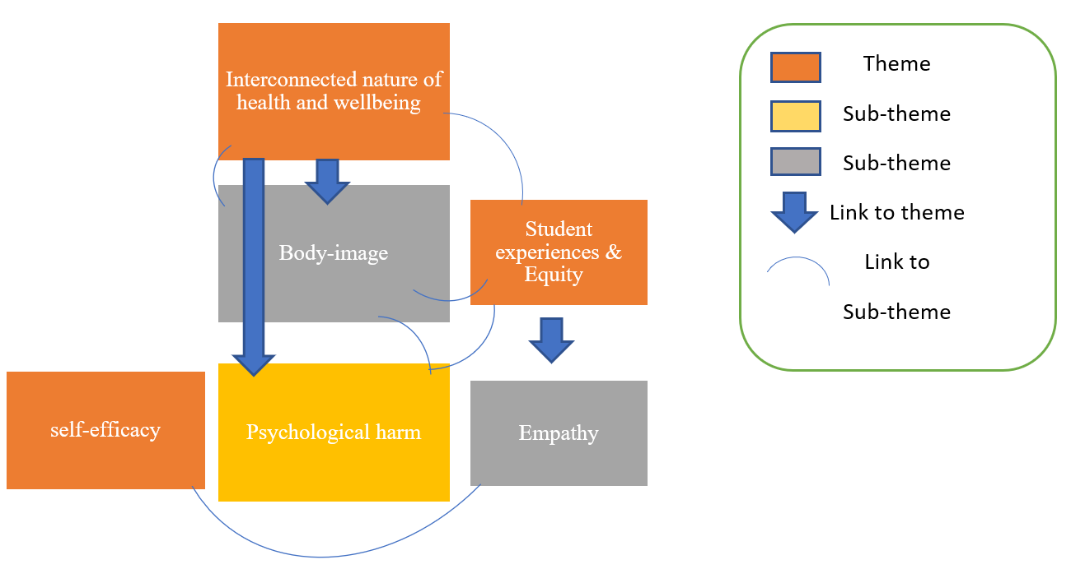
Self-efficacy
The first obvious theme discovered was self-efficacy, which can be defined as an individual's belief in their ability to complete a particular activity, self-confidence, and accomplish a desired outcome (Bandura, 1997). Numerous examples were provided in the information gathered from the interviews that indicated connections to the theme of "Self-efficacy", Jane and Sally both expressed confidence and a desire to compete, Jane quoted;
I loved PE!! (line 9)
I liked the challenge of competing with the boys (line 55)
Similarly, Sally quoted;
I loved learning new skills and I felt excited trying new things I hadn't done before (line 21&22)
These quotes reflect an elevated level of self-efficacy, which, in accordance with Banduras SCT (1986), is essential for motivation, behaviour, and achievement (Oyelekan et al., 2019), implying these individuals have inspiration to continue searching for fresh challenges and opportunities for personal growth. Similarly, the information reinforces how essential it is to give both sexes equal chances to develop and display their physical ability, Sally quoted;
Both girls and boys should be offered the same level of physical activity because both genders are equally as capable (line 63&64)
This advocates an individual that supports and fosters healthy self-efficacy views. It is said that individuals of all genders can develop their physical capabilities and improve their self-efficacy by having equal access to PA (Chang & Suttikun, 2017) Further quotes highlighted this theme and Jane’s confidence in health benefits related to PE;
PE was a positive impact on me (line 74)
I still like being active and find walking can give me both mental and physical support (line 31&32)
Jane expresses a positive experience with PE and an ongoing enjoyment of being active, which suggests a belief in Jane’s abilities to engage in PA and derive benefits from it, supporting literature related to promoting PA and self-efficacy among students, enjoyable experiences, and appropriate support, foster self-efficacy, a key predictor of academic success (Hamilton et al., 2017). Similarly, the quotes reflect the concept of SDT (Ryan & Deci, 2017), asserting that individual are more inclined to act in ways that satisfy their requirements for relatedness, competence, and psychological needs (Vansteenkiste et al., 2020).
Furthermore, an awareness of happy recollections appeared during the analyses of Jane’s data, for example;
I remember the school playing fields with the smell of fresh cut grass (line 18)
This quote exemplifies classical conditioning, Pavlov (1927), where a neutral stimulus becomes associated with a meaningful stimulus and elicits a similar response. Jane associates the smell of fresh cut grass with playing on a school field, resulting in a positive emotional response (Pavlov & Anrep, 1927) Positive experiences with PA have increased both participants' self-efficacy beliefs, particularly Jane's, promoting continued engagement in healthy behaviors.
Student experiences & Equity
Another theme that emerged was student experiences and equity, both Jane and Sally discussed individual experiences with inclusion, equitable opportunity, and freedom of choice; Sally emphasised the significance of both choice and inclusion:
I think that there should be choice to make PE as inclusive as possible (line67&68)
If there was a choice of which activity we got to do, I think I would have enjoyed it more (line 14&15)
Illustrating that if given the possibility to choose activities, and further inclusion, Sally would have been more inclined to enjoy and engage in PE. Similarly, Jane displayed feelings of being excluded from certain activities, as quoted;
although I was always really disappointed that I was not allowed to play football or rugby (line 56)
Inclusion in PE lessons promotes fairness, equity, and diversity, ensuring equal opportunities for all students to participate and succeed (Guerrero & Guerrero Puerta, 2023). Giving students a voice and choice in their education can increase their sense of responsibility and ownership in their PE class (Lynch et al., 2020).
Similarly, empathy, showed as an important part of lived experiences for Jane and Sally, as quoted;
Even those who are not athletic can take part in some forms of PE (line 26&27)
And no one feels excluded or embarrassed when taking part (line 5)
I think that there should be more support and encouragement for peers (line
46)
forcing them to take part in something they were not comfortable with (line 51)
Jane and Sally's empathy in PE classes demonstrate an understanding of their classmates' feelings, promoting physical literacy, which includes empathetic attitudes, resilience against discrimination, and a commitment to fair and meaningful participation in PE (Farias et al., 2020).
Sally shared conflicting feelings and expressed a negative attitude toward PE as a result of bad memories;
Many of the sports I was forced to take part in (line 77)
I hated and would never participate in now (line77&78)
These insights support earlier research which raises concerns regarding negative impacts in engagement in PE as an adolescent, as suggested by Griggs & Fleet (2021) all students should be encouraged and supported by high quality physical education to become lifelong participants in a way that maintains their own health, fitness, and well-being (Griggs & Fleet, 2021). According to Godbout (2021) forced participation in activities that students do not enjoy can perpetuate inequalities (Godbout, 2021). Teachers should give students options and chances to explore a variety of physical activities that fit students interests and abilities to foster equity and long-term health.
Interconnected nature of health and wellbeing
A further theme emerged, identified as Interconnected nature of health and wellbeing, literature discusses the importance of wellbeing during adolescent developmental phases in addition to the detrimental effects on self-esteem and self-image (Sawyer et al., 2018). The analysis revealed that Jane and Sally shared a similar opinion about compulsory PE relating to health benefits, but also conflicted feelings for Sally, the below quotes explain the findings further, Sally quotes;
I think physical activity should be compulsory because it is beneficial for children and adolescents to participate in some form of physical activity, with the growing obesity rates, I think it is more important now than ever (lines 6-9)
I enjoy light exercise now as it clears my mind (line 33)
Jane quoted;
I believe that physical activity is a great way of keeping fit and healthy both body and mind (line 3 & 4)
PE was a positive impact on me and something that has passed on to my children also with their love of the outdoors (line 74&75)
Psychological theory highlights the importance of modelling healthy behaviour and fostering a lifetime of PA for best health and wellbeing, according to SCT, Bandura (1877) suggests individuals learn by observing the behaviour of others which can have positive or negative outcomes (Bandura & Walters, 1977). Jane has demonstrated how modelling healthy behaviour has impacted her children's attitudes and beliefs about physical exercise, increasing motivation to support healthy habits into adulthood.
Sally; on the other hand, quotes;
I have mixed feelings about PE in secondary school (line 13)
I don’t think that secondary PE has made much of an impact in my adult life (line 76)
Overall, by analysing Sally's responses, the negative effects of compulsory PE were seen to have influenced Sally's adult years, for example;
I hated and would never participate in now (line77&78)
Many of the sports I was forced to take part in (line 77)
Similarly, a pertinent point came across of negative body image, this was evident in Sally’s experiences;
people would always make comments about my body, they would say I looked anorexic (line 41&42)
I was very tiny, and people would always make comments about my body (line 40&41)
That used to make me really uncomfortable and upset (line 42)
Negative experiences and beliefs, as asserted by CBT (1967), can lead to negative emotions and behaviours (Putwain et al., 2022). Sally's exposure to negative comments about her body seemed to result in body dissatisfaction and negative beliefs about her appearance. Additionally, Sally was seen to experience psychological harm during PE lessons, as quoted;
I found this very stressful as everyone else could see how far you got and if you didn’t make it very far you would feel very embarrassed (line 27 & 28)
threatened with punishment such as detention or a phone call home (line 50)
felt very intimidated (line 62)
Skinner's operant conditioning theory (1938) warns against using punishment as a motivator for physical exercise. Punishing individuals for not exercising can lead to psychological harm, including shame, lower self-esteem, reduced motivation, and long-term negative attitudes towards physical activity (Rachlin, 2018). Sally's case illustrates the potential negative consequences of using punishment as a motivator for exercise
Conclusion
In conclusion, this study analysed two interviews relating to experiences of taking part in compulsory PE in secondary education, the data was analysed following Braun & Clarke’s (2006) six steps of thematic analysis which found three key themes of Self-efficacy, Student experiences & Equity, and Interconnected nature of health and wellbeing, with sub-themes of empathy, body-image, and psychological harm. It is still important to be mindful of the study's limitations, the small sample size of two female participants and lack of diversity limits the generalizability of findings to other populations or contexts, this study may not reflect the experiences of males or individuals who identify outside of the gender binary. This thematic research highlights the importance of individual experiences in identifying how individuals view PE. While using punishment and threat to motivate PA may result in a negative psychological impact, self-efficacy, empathy, and equity are seen to be important in fostering favourable attitudes toward PE. Both participants in this study agreed that compulsory PE should be a part of the curriculum despite any possible negative consequences. This indicates that even though there may be room for improvements to the way PE is provided, it remains an important aspect of education that supports students' well-being both mentally and physically, and serve as a model for healthy behaviour in adulthood,
In addition to the insights provided by this thematic research, future research in compulsory PE should aim to increase sample size and diversity to gain a comprehensive understanding of the experiences of a wider range of students. This would allow the identification of barriers to participation and factors that promote inclusivity, such research would help develop more effective and fair PE programs that better serve the needs of all students.

References
Bandura, A., & Walters, R. H. (1977). Social learning theory. Englewood cliffs Prentice Hall.
Barker, D., Varea, V., Bergentoft, H., & Schubring, A. (2022). Body image in physical education: a narrative review. Sport, Education and Society, , 1-18. https://10.1080/13573322.2022.2076665
Braun, V., & Clarke, V. (2006). Using thematic analysis in psychology. Qualitative Research in Psychology, 3(2), 77-101.
Cale, L., Harris, J., & Hooper, O. (2020). Debating health knowledge and health pedagogies in physical education. Debates in Physical Education, 2, 256-277.
Chang, H. J., & Suttikun, C. (2017). The examination of psychological factors and social norms affecting body satisfaction and self‐esteem for college students. Family and Consumer Sciences Research Journal, 45(4), 422-437.

Ennis, C. D. (2015). Knowledge, transfer, and innovation in physical literacy curricula. Journal of Sport and Health Science, 4(2), 119-124.
Farias, C., Wallhead, T., & Mesquita, I. (2020). “The project changed my life”: Sport education’s transformative potential on student physical literacy. Research Quarterly for Exercise and Sport, 91(2), 263-278.
Godbout, P. (2021). Emergence of physical literacy in physical education: Some curricular repercussions. Physical Education and Sport Pedagogy, , 1-14.
Graber, K. C. (2012). Feature: PE Metrics: Valid and Reliable Physical Education Assessments. Journal of Physical Education, Recreation & Dance, 83(5), 15-34.
Griggs, G., & Fleet, M. (2021). Most people hate physical education and most drop out of physical activity: In search of credible curriculum alternatives. Education Sciences, 11(11), 701.
Guerrero, M. A., & Guerrero Puerta, L. (2023). Advancing Gender Equality in Schools through Inclusive Physical Education and Teaching Training: A Systematic Review. Societies, 13(3), 64.
Hamilton, K., Warner, L. M., & Schwarzer, R. (2017). The role of self-efficacy and friend support on adolescent vigorous physical activity. Health Education & Behavior, 44(1), 175-181.
Hulteen, R. M., Morgan, P. J., Barnett, L. M., Stodden, D. F., & Lubans, D. R. (2018). Development of foundational movement skills: A conceptual model for physical activity across the lifespan. Sports Medicine, 48, 1533-1540.
Lynch, S., Sutherland, S., & Walton-Fisette, J. (2020). The A–Z of social justice physical education: Part 1. Journal of Physical Education, Recreation & Dance, 91(4), 8-13.
Norris, E., van Steen, T., Direito, A., & Stamatakis, E. (2020). Physically active lessons in schools and their impact on physical activity, educational, health and cognition outcomes: a systematic review and meta-analysis. British Journal of Sports Medicine, 54(14), 826-838.
Oyelekan, O. S., Jolayemi, S. S., & Upahi, J. E. (2019). Relationships among Senior School Students' Self-Efficacy, Metacognition and Their Achievement in Chemistry. Cypriot Journal of Educational Sciences, 14(2), 208-221.
Pavlov, I. P., & Anrep, G. V. (1927). Conditioned reflexes; an investigation of the physiological activity of the cerebral cortex. London: Oxford University Press. Humphrey Milford, 15, 430.
Putwain, D. W., Pekrun, R., Rainbird, E., & Roberts, C. (2022). Cognitive-Behavioural Intervention for Test Anxiety: Could Teachers Deliver the STEPS Program and What Training Would They Require? Handbook of Stress and Academic Anxiety: Psychological Processes and Interventions with Students and Teachers (pp. 381-399). Springer.
Rachlin, H. (2018). Skinner (1938) and Skinner (1945). Behavior and Philosophy, 46, 100-113.
Rhodes, R. E., & Kates, A. (2015). Can the affective response to exercise predict future motives and physical activity behavior? A systematic review of published evidence. Annals of Behavioral Medicine, 49(5), 715-731.
Ryan, R. M., & Deci, E. L. (2017). Self-determination theory. Basic Psychological Needs in Motivation, Development, and Wellness,
Santiago, J. A., & Morrow, J. R. (2020). A study of preservice physical education teachers’ content knowledge of health-related fitness. Journal of Teaching in Physical Education, 40(1), 118-125.
Sawyer, S. M., Azzopardi, P. S., Wickremarathne, D., & Patton, G. C. (2018). The age of adolescence. The Lancet Child & Adolescent Health, 2(3), 223-228.
Shlafer, R., Hergenroeder, A. C., Jean Emans, S., Rickert, V. I., Adger, H., Spear, B., Irwin, C. E., Kreipe, R. E., Walker, L. R., & Resnick, M. D. (2014). Adolescence as a critical stage in the MCH Life Course Model: commentary for the Leadership Education in Adolescent Health (LEAH) interdisciplinary training program projects. Maternal and Child Health Journal, 18, 462-466.
Smith, J. A. (2015). Qualitative psychology: A practical guide to research methods. Qualitative Psychology, , 1-312.
Sun, H., Li, W., & Shen, B. (2017). Learning in physical education: A self-determination theory perspective. Journal of Teaching in Physical Education, 36(3), 277-291.
Teixeira, P. J., Marques, M. M., Silva, M. N., Brunet, J., Duda, J. L., Haerens, L., La Guardia, J., Lindwall, M., Lonsdale, C., & Markland, D. (2020). A classification of motivation and behavior change techniques used in self-determination theory-based interventions in health contexts. Motivation Science, 6(4), 438.
Tiggemann, M., & Slater, A. (2014). NetTweens: The internet and body image concerns in preteenage girls. The Journal of Early Adolescence, 34(5), 606-620.
Vani, M. F., Pila, E., deJonge, M., Solomon-Krakus, S., & Sabiston, C. M. (2021). ‘Can you move your fat ass off the baseline?’Exploring the sport experiences of adolescent girls with body image concerns. Qualitative Research in Sport, Exercise and Health, 13(4), 671-689.
Vansteenkiste, M., Ryan, R. M., & Soenens, B. (2020). Basic psychological need theory: Advancements, critical themes, and future directions. Motivation and Emotion, 44, 1-31.
White, R. L., Olson, R., Parker, P. D., Astell-Burt, T., & Lonsdale, C. (2018). A qualitative investigation of the perceived influence of adolescents’ motivation on relationships between domain-specific physical activity and positive and negative affect. Mental Health and Physical Activity, 14, 113-120.

Appendix
1) Study Consent & debrief form
2) Ethics form
3) Stimuli- Interview questions & Interviews with answers
4) Procedure
5) Step 1 Familiarisation phase
6) Step 2 Coding
7) Step 3 Search for themes
8) Step 4 Review of themes
9) Step 5 Define and name themes
10) Results- Themes & codes represented graphically

Appendix 1 Study Consent & Debrief form


Study Consent Form

I understand that this research is being carried out by a 2nd year Psychology Student for a study assessment and that taking part in this study will involve a thematic analysis of two interviews of an individual's experiences and feelings towards compulsory PE in secondary education.

This study will take approximately 30 minutes to complete.
I understand that participation in this study is voluntary, and I am free to withdraw participation during or at the end of the study without giving a reason. I understand that once I leave the study, I will not be able to withdraw my data, as it will be anonymised. I am aware that if I have concerns about the study, I can discuss these concerns with the researcher at any time during or after the study. I understand that I will be provided with the contact details of the research supervisor at the end of the study, should I have any concerns.
I understand that the information provided by me will be held confidentially, with a code assigned in place of my name. This data will be stored indefinitely in accordance with the Data Protection Act.
I also understand that at the end of the study I will be provided with a debrief form and the opportunity to discuss any issues with the researcher.

I, ___________________________________(NAME) consent to participate in the study conducted by ………… Centre for Psychology and Counselling, University of Wales Trinity Saint David, under the supervision of Module leader Stuart Jones

Participant Signature: ________________________________________________
Date: ___________________
Name and signature of researcher taking consent
__________________________________________________________________

Debrief Sheet

Study Debrief Sheet
Study to explore the impacts of compulsory PE on an individual's wellbeing.

Thank you for taking part in the study.

The aim of this study was to explore comprehensive awareness and understanding of the impacts of compulsory PE on an individual's wellbeing, specifically identifying key themes of lived experiences.

If you wish to withdraw your data from the study, you must tell the researcher now. After this point, all of your data will be anonymised and we will not be able to trace it back to you.

If taking part in this study has raised any questions, please speak to the researcher on ……………………. or contact the academic supervisor Stuart Jones, S.A.Jones@uwtsd.ac.uk

Thank you once again for taking time to participate in this study.

Put your name here

BSc Applied Psychology

University of Wales Trinity Saint David

Appendix 2 Ethics Form

APPLICATION FOR ETHICAL APPROVAL

In order for research to result in benefit and minimise risk of harm, it must be conducted ethically. A researcher may not be covered by the University’s insurance if ethical approval has not been obtained prior to commencement.

The University follows the OECD Frascati manual definition of research activity: “creative work undertaken on a systematic basis in order to increase the stock of knowledge, including knowledge of man, culture and society, and the use of this stock of knowledge to devise new applications”. As such this covers activities undertaken by members of staff, postgraduate research students, and both taught postgraduate and undergraduate students working on dissertations/projects.
The individual undertaking the research activity is known as the “principal researcher”.
Ethical approval is not required for routine audits, performance reviews, quality assurance studies, testing within normal educational requirements, and literary or artistic criticism.
Please read the notes for guidance before completing ALL sections of the form.
This form must be completed and approved prior to undertaking any research activity. Please see Checklist for details of process for different categories of application.

SECTION A: About You (Principal Researcher)
1 | Full Name: |  | Emma Williams & Claudia Varallo
2 | Tick all boxes that apply: |  | Member of staff: | ☐ | Honorary research fellow: | ☐
 | Undergraduate Student | ☒ | Taught Postgraduate Student | ☐ | Postgraduate Research Student | ☐

3 | Institute/Academic Discipline/Centre: | Psychology and Counselling
4 | Campus: | Carmarthen
5 | E-mail address: | 2100048@student.uwtsd.ac.uk  2107833@student.uwtsd.ac.uk
6 | Contact Telephone Number: | 07391614083 & 07368393837
 | For students:
7 | Student Number: | 2100048 & 2107833
8 | Programme of Study: | BSC Applied Psychology
9 | Director of Studies/Supervisor: | Dr Stuart Jones

SECTION B: Approval for Research Activity
1 | Has the research activity received approval in principle?  (please check the Guidance Notes as to the appropriate approval process for different levels of research by different categories of individual) |  | YES | ☒ | NO | ☐
 |  |  |  |  | Date
2 | If Yes, please indicate source of approval (and date where known): Approval in principle must be obtained from the relevant source prior to seeking ethical approval | Research Degrees Committee |  | ☐
2 |  | Institute Research Committee |  | ☐
2 |  | Dr Stuart Jones |  | ☒ | 02.02.2023

SECTION C: Internal and External Ethical Guidance Materials
 | Please list the core ethical guidance documents that have been referred to during the completion of this form (including any discipline-specific codes of research ethics, location-specific codes of research ethics, and also any specific ethical guidance relating to the proposed methodology). Please tick to confirm that your research proposal adheres to these codes and guidelines. You may add rows to this table if needed.
1 | UWTSD Research Ethics & Integrity Code of Practice | ☒
2 | UWTSD Research Data Management Policy | ☒
3 | BPS Code of Human Research Ethics (2014) | ☒
4 | BPS Code of Ethics and Conduct (2018) | ☒
5 | BPS Ethics for Internet-Mediated Research (2017) | ☒
6 | UWTSD Student Code of Conduct 2020-2021 | ☒
SECTION D: External Collaborative Research Activity
If there are external collaborators then you should gain consent from the contact persons to share their personal data with the university. If there are no external collaborators then leave this section blank and continue to section E.
1 | Institution
2 | Contact person name
3 | Contact person e-mail address
4 | Is your research externally funded? |  | YES | ☐ | NO |  | ☐
5 | Are you in receipt of a KESS scholarship? |  | YES | ☐ | NO |  | ☐
6 | Are you specifically employed to undertake this research in either a paid or voluntary capacity? | Voluntary | YES | ☐ | NO | ☐
7 |  | Employed | YES | ☐ | NO | ☐
8 | Is the research being undertaken within an existing UWTSD Athrofa Professional Learning Partnership (APLP)? | If YES then the permission question below does not need to be answered. | YES | ☐ | NO |  | ☐
9 | Has permission to undertake the research has been provided by the partner organisation? | (If YES attach copy)  If NO the application cannot continue | YES | ☐ | NO |  | ☐
Where research activity is carried out in collaboration with an external organisation
10 | Does this organisation have its own ethics approval system? | YES | ☐ | NO | ☐
 | If Yes, please attach a copy of any final approval (or interim approval) from the organisation (this may be a copy of an email if appropriate).
SECTION E: Details of Research Activity
1 | Indicative title: | Exploration into an individual’s experiences and impact of engaging with PE classes in secondary education
2 | Proposed start date: | 02.02.23 | Proposed end date: | 21.03.23
Introduction to the Research (maximum 300 words per section)
Ensure that you write for a Non-Specialist Audience when outlining your response to the points below:
- Purpose of Research Activity
- Proposed Research Question
- Aims of Research Activity
- Objectives of Research Activity
Demonstrate, briefly, how Existing Research has informed the proposed activity and explain.
- What the research activity will add to the body of knowledge
- How it addresses an area of importance.

3 | Purpose of Research Activity  To engage with and complete a level five qualitative report. This will include holding two recorded interviews and performing a thematic analysis (Braun & Clark) 2006 on the qualitative data gathered through the interviews, followed by a write up of the results following the APA report writing format.  This study will be utilising literature by Griggs and Fleet (2021) that discusses that all students should be encouraged and supported by high quality physical education to become lifelong participants in a way that supports their own health, fitness, and well-being. However, a growing percentage of children stop taking part in physical activities at the first chance they have, which results in a rise in sedentary lifestyles and a rise in childhood obesity (Griggs & Fleet, 2021). Furthermore, daily stressors have a significant impact on students' educational outcomes. However, research on students perceived and common contextual stressors in physical education (PE) lessons is limited. Increased physical activity among young people and support of public health goals are two objectives of compulsory PE in secondary education (Norwegian Directorate for Education Training, 2015). Additionally, the impact of physical education (PE) on how young people view their bodies and those of others is important. Barker et al. (2022) suggested this has not always been achieved in a positive way, and some research suggests that experiences in physical education may have contributed to young people's dissatisfaction with their physical appearance (Barker et al., 2022). Further research is needed to explore this topic area further.  Consequently, the aim of the research is for students to participate in (as members of a group) and independently analyse the group data set that explores an individual’s experiences and impact of engaging with PE classes in secondary education.  Barker, D., Varea, V., Bergentoft, H., & Schubring, A. (2022). Body image in physical education: a narrative review. Sport, Education and Society, 1-18. https://10.1080/13573322.2022.2076665  Braun, V., & Clarke, V. (2006). Using thematic analysis in psychology. Qualitative Research in Psychology, 3(2), 77-101.  Griggs, G., & Fleet, M. (2021). Most People Hate Physical Education and Most Drop Out of Physical Activity: In Search of Credible Curriculum Alternatives. Education Sciences, 11(11), 701. https://doi.org/10.3390/educsci11110701  Norwegian Directorate for Education and Training (2015). Curriculum for Physical Education (KRO1-04). Oslo: Norwegian Directorate for Education and Training.
4 | Research Question  Whether participants experience within PE whilst in secondary education has had an impact, whether psychological or physical, in their adult lives and whether PE should be compulsory in secondary education or a choice?
5 | Aims of Research Activity  To carry out interviews with other Level 5 UWTSD Psychology Students with the aim to examine the experiences and impact of engaging with physical education in secondary education using Thematic Analysis (Braun & Clark, 2006) on the data collected during the interviews. Aiming to explore the lasting impacts of PE in secondary school and the further impacts in adult life and whether PE should in fact be compulsory or a choice in concerns to mental health.
6 | Objectives of Research Activity  Students must complete a 2,500-word qualitative report using thematic analysis as part of assessment 1 for the ECAP5006. To do this, they must conduct individual interviews with at least two members of the BSC Applied Psychology Level 5 cohort, either alone or in pairs. The data set will then be individually analysed using the thematic analysis method.
Proposed methods (maximum 600 words)
Provide a brief summary of all the methods that may be used in the research activity, making it clear what specific techniques may be used. If methods other than those listed in this section are deemed appropriate later, additional ethical approval for those methods will be needed. You do not need to justify the methods here, but should instead describe how you intend to collect the data necessary for you to complete your project.
7 | Due to the nature of the study participants ID will be anonymised – Researchers will interview participant A and B with regards to their experiences participating within compulsory physical education in secondary education. The researchers will work on the analysis of the data set independently from each other. Therefore, this will be an individual assessment. The data set will be used in Thematic analysis (Braun & Clark) 2006, to identify key themes in relation to experiences and impacts of physical education in secondary education. The materials needed to participate in this study are laptop / computer with Microsoft teams and Word Doc for the use of recording the interviews and any transcribing materials completing the research. As this is a Level five psychology assessment in which the students are participants, the researcher will explain the nature of the research and explain the rights of the participant. Initially, there will be consent gained, there will be a brief surrounding the nature of the interview with instructions to withdraw at any time and refrain from taking part with no consequences. Students will have the right to withdraw their data and told that this will have no bearing on their studies as participation is voluntary. There will be a full debrief at the end of the study along with directions of how to contact relevant mental health groups if so required.
Location of research activity
Identify all locations where research activity will take place.
8 | Data collection will take place in a quiet and private environment on Campus. Due to the nature of the data collection only students who are present in these sessions will participate in the study.
Research activity outside of the UK
If research activity will take place overseas, you are responsible for ensuring that local ethical considerations are complied with and that the relevant permissions are sought. Specify any local guidelines (e.g. from local professional associations/learned societies/universities) that exist and whether these involve any ethical stipulations beyond those usual in the UK (provide details of any licenses or permissions required). Also specify whether there are any specific ethical issues raised by the local context in which the research activity is taking place, for example, particular cultural and/or legal sensitivities or vulnerabilities of participants. If you live in the country where you will do the research then please state this.
9 | (this box should expand as you type)

10 | Use of documentation not in the public domain: Are any documents NOT publicly available? | NO | ☒
10 |  | YES | ☐
11 | If Yes, please provide details here of how you will gain access to specific documentation that is not in the public domain and that this is in accordance with the current data protection law of the country in question and that of England and Wales.

 | Does your research relate to one or more of the seven aims of the Well-being of Future Generations (Wales) Act 2015? | YES | NO
12 | A prosperous Wales | ☒ | ☐
13 | A resilient Wales | ☒ | ☐
14 | A healthier Wales | ☒ | ☐
15 | A more equal Wales | ☒ | ☐
16 | A Wales of cohesive communities | ☐ | ☒
17 | A Wales of vibrant culture and thriving Welsh language | ☐ | ☒
18 | A globally responsible Wales | ☐ | ☒
19 | If YES to any of the above, please give details:
 | Due to the nature of the study, the potential impact on finding out the impact of experiences and impact of physical education in secondary schools could link to a healthier Wales, a Resilient Wales, prosperous Wales and a more equal Wales.
SECTION F: Scope of Research Activity
 | Will the research activity include: | YES | NO
1 | Use of a questionnaire or similar research instrument? | ☐ | ☒
2 | Use of interviews? | ☒ | ☐
3 | Use of focus groups? | ☐ | ☒
4 | Use of participant diaries? | ☐ | ☒
5 | Use of video or audio recording? | ☒ | ☐
6 | Use of computer-generated log files? | ☐ | ☒
7 | Participant observation with their knowledge? | ☐ | ☒
8 | Participant observation without their knowledge? | ☐ | ☒
9 | Access to personal or confidential information without the participants’ specific consent? | ☐ | ☒
10 | Administration of any questions, test stimuli, presentation that may be experienced as physically, mentally or emotionally harmful / offensive? | ☐ | ☒
11 | Performance of any acts which may cause embarrassment or affect self-esteem? | ☐ | ☒
12 | Investigation of participants involved in illegal activities? | ☐ | ☒
13 | Use of procedures that involve deception? | ☐ | ☒
14 | Administration of any substance, agent or placebo? | ☐ | ☒
15 | Working with live vertebrate animals? | ☐ | ☒
16 | Procedures that may have a negative impact on the environment? | ☐ | ☒
17 | Other primary data collection methods. Please indicate the type of data collection method(s) below. | ☐ | ☒
 | Details of any other primary data collection method: | ☐ | ☒
If NO to every question, then the research activity is (ethically) low risk and may be exempt from some of the following sections (please refer to Guidance Notes).
If YES to any question, then no research activity should be undertaken until full ethical approval has been obtained.
SECTION G: Intended Participants
If there are no participants then do not complete this section, but go directly to section H.
 | Who are the intended participants: | YES | NO
1 | Students or staff at the University? | ☒ | ☐
2 | Adults (over the age of 18 and competent to give consent)? | ☒ | ☐
3 | Vulnerable adults? | ☐ | ☒
4 | Children and Young People under the age of 18? (Consent from Parent, Carer or Guardian will be required) | ☐ | ☒
5 | Prisoners? | ☐ | ☒
6 | Young offenders? | ☐ | ☒
7 | Those who could be considered to have a particularly dependent relationship with the investigator or a gatekeeper? | ☐ | ☒
8 | People engaged in illegal activities? | ☐ | ☒
9 | Others. Please indicate the participants below, and specifically any group who may be unable to give consent. | ☐ | ☐
 | Details of any other participant groups: | ☐ | ☐

Participant numbers and source
Provide an estimate of the expected number of participants. How will you identify participants and how will they be recruited?
10 | How many participants are expected? | Individual interviews with a minimum of two participants.
11 | Who will the participants be? | The participants will be Level 5 BSC Applied psychology students.
12 | How will you identify the participants? | The participant will be identified as Interviewee A and interviewee B.

 | Information for participants: | YES | NO | N/A
13 | Will you describe the main research procedures to participants in advance, so that they are informed about what to expect? | ☒ | ☐ | ☐
14 | Will you tell participants that their participation is voluntary? | ☒ | ☐ | ☐
15 | Will you obtain written consent for participation? | ☒ | ☐ | ☐
16 | Will you explain to participants that refusal to participate in the research will not affect their treatment or education (if relevant)? | ☒ | ☐ | ☐
17 | If the research is observational, will you ask participants for their consent to being observed? | ☐ | ☐ | ☒
18 | Will you tell participants that they may withdraw from the research at any time and for any reason? | ☒ | ☐ | ☐
19 | With questionnaires, will you give participants the option of omitting questions they do not want to answer? | ☐ | ☐ | ☒
20 | Will you tell participants that their data will be treated with full confidentiality and that, if published, it will not be identifiable as theirs? | ☒ | ☐ | ☐
21 | Will you debrief participants at the end of their participation, in a way appropriate to the type of research undertaken? | ☒ | ☐ | ☐
22 | If NO to any of above questions, please give an explanation
 | (this box should expand as you type)

 | Information for participants: | YES | NO | N/A
24 | Will participants be paid? | ☐ | ☒ | ☐
25 | Is specialist electrical or other equipment to be used with participants? | ☐ | ☒ | ☐
26 | Are there any financial or other interests to the investigator or University arising from this study? | ☐ | ☒ | ☐
27 | Will the research activity involve deliberately misleading participants in any way, or the partial or full concealment of the specific study aims? | ☐ | ☒ | ☐
28 | If YES to any question, please provide full details
 | (this box should expand as you type)

SECTION H: Anticipated Risks

Outline any anticipated risks that may adversely affect any of the participants, the researchers and/or the University, and the steps that will be taken to address them.

If you have completed a full risk assessment (for example as required by a laboratory, or external research collaborator) you may append that to this form.
1 | Full risk assessment completed and appended? |  | Yes | ☐
1 |  |  | No | ☒
2 | Risks to participants  For example: sector-specific health & safety, emotional distress, financial disclosure, physical harm, transfer of personal data, sensitive organisational information
 | Risk to participants:  1.Due to the personal nature of the topic area being discussed within the questionnaire, some aspects may be upsetting or uncomfortable for some participants.  2. Some participants may be concerned about feeling judged because they will be asked how involved they are in physical education sessions.  3. Due to the nature of the task (interviews and personal questions in experiences) participants may experience the feeling of being uncomfortable due to disclosing personal/sensitive information which can bring up psychological issues with body image. | How you will mitigate the risk to participants:  - In line with UWTSD and BPS research guidelines (2018), participants will be made aware of the nature of the study and that it involves completing a questionnaire to establish their thoughts and feelings towards compulsory PE in secondary education and the impacts this may of have on their psychological and physical wellbeing in adult life. prior to agreeing to participate in the study. The researcher will disclose that if participants do not feel comfortable disclosing this type of information, then they are advised not to take part in the study. They will also be provided with the contact details of the researcher should they wish to ask any questions or raise any concerns. Data collected from participants will be anonymised so that no identifying features regarding the participant are linked to the data stored for analysis purposes. Participants will be fully briefed at the beginning of the interview and will have the right to withdraw at any time and be debriefed at the end of the interview.  - As point 1 and in line with BPS ethical guidelines (2018), participants will be made aware of the nature of the study and that it involves answering multiple questions regarding their experience and the impacts of PE in secondary education prior to consenting into the study. The researcher will disclose if the participants do not feel comfortable disclosing this type of information then they are advised not to take part in the study. They will also be informed of their right to withdraw at any point before or during the study without penalty if they felt they would prefer not to continue. They will also be provided with the contact details of both researchers should they wish to ask any questions or raise any concerns. Data collected from participants will be anonymised so that no identifying features regarding the participant are linked to the data stored for analysis purposes.  - The researcher will clearly verbalise information prior to the collection of the data to reassure that if at any time the participant is feeling self-conscious providing information which may bring up psychological issues relating to their body image and self-esteem, they are entitled to either take a break or chooses to withdraw from the study. Each student will be informed of their rights as potential participants and the verbalised information will highlight that participation in the study will have no impact on their academic progress and their student experience. They will also be informed that there is no right or wrong answer in completing the questionnaire. Participants will be fully debriefed (verbally) following completing the questionnaire which will highlight the aim of the study, their rights as the participant including the right to
3 | If research activity may include sensitive, embarrassing or upsetting topics (e.g. sexual activity, drug use) or issues likely to disclose information requiring further action (e.g. criminal activity), give details of the procedures to deal with these issues, including any support/advice (e.g. helpline numbers) to be offered to participants. Note that where applicable, consent procedures should make it clear that if something potentially or actually illegal is discovered in the course of a project, it may need to be disclosed to the proper authorities
Due to the personal nature of the topic area being discussed within the questionnaire, some aspects may be upsetting or uncomfortable for some participants.
If at any time a participant feels that participating in the study effects their mental health in regard to body image that the can contact mental health awareness team on 0808 801 0677 or email help@beateatingdisorders.org.uk.
A contact also will be provided for the Samaritans helpline in regard to mental health: Samaritans 116 123 jo@samaritans.org
SANEline. If you're experiencing a mental health problem or supporting someone else, you can call SANEline on 0300 304 7000
Shout. If you would prefer not to talk but want some mental health support, you could text SHOUT to 85258.

4 | Risks to the investigator  For example: personal health & safety, physical harm, emotional distress, risk of accusation of harm/impropriety, conflict of interest
 | - The risks to the investigator are minimal as this is an interview with students that the researcher already knows. A potential risk to the researcher is unwelcomed/unkind communications from participants.  - Researcher bias or risk of accusation of  harm/impropriety. | - To minimise this risk, the interview will be recorded providing a safety net for the researcher and students will be reminded that they should follow the UWTSD Student Code of Conduct throughout their participation, communications, and conduct on the module.  - As the students will be writing up their own qualitative reports, this should not be an issue in the interpretation of results. The researcher will be compassionate, respect and value the dignity and worth of each participant to discourage accusation of harm/impropriety. The researcher will follow all ethical procedures as set out,  by the UWTSD and BPS ethics guidelines. In addition, the researcher will clearly verbalise information prior to the collection of the data to reassure participants that no coercion is involved. Each student will be informed of their rights as potential participants and the verbalised information will highlight that participation in the study will have no impact on their academic progress and their student experience. They will also be informed that there is no right or wrong answers when participating in the interview. Participants will be fully debriefed (verbally) following completing the questionnaire which will highlight the aim of the study, their rights as the participant including the right to withdraw their data. It will be noted also in the debrief that participation in the study will not have an impact on their progress on their module or their student experience.
5 | University/institutional risks  For example: adverse publicity, financial loss, data protection
 | Risk to the University:  - The reputation and integrity of UWTSD and the discipline of Psychology and Counselling could be endangered if the researcher do not adhere to codes of ethics and research protocols.  - Data could be exposed, leaked or used for other purposes | How you will mitigate the risk to university:  - Both the researcher and the students who will participate in the study as participants and use the data collected for analysis in order to write up their report for a module assessment will adhere to the University Ethics and Integrity Code of Practice, the BPS Code of Ethics and Conduct, and the Code of Human Research Ethics at all times. These moral norms will be adhered to in order to reduce any potential threats to the institution. The module lead and students involved in the module must always act professionally.  - The collected data will be stored in an anonymised format in accordance with UWTSD Research Data Management (RDM) rules and only used for the intended purpose, in compliance with ethical guidelines set out by UWTSD Research Ethics and Integrity Code of Practice policy and the British Psychological Society’s(BPS) Code of Human Research Ethics. To minimise any risk to UWTSD and the psychology department, all collected data will be stored securely by the researcher. Paper copies of the raw data will be stored by the researcher securely and held in line with UWTSD and GDPR policy. Students on the module will also be expected to follow all UWTSD and BPS ethical and data management rules and procedures when given access to the anonymised data generated from this research study. Students using the generated data must ensure to keep that data safe, secure, and confidential, and only use it for its intended purpose of completing a module report assessment.
6 | Environmental risks  For example: accidental spillage of pollutants, damage to local ecosystems
 | Risk to the environment:  N/A | How you will mitigate the risk to environment:  N/A

 | Disclosure and Barring Service
 | If the research activity involves children or vulnerable adults, a Disclosure and Barring Service (DBS) certificate must be obtained before any contact with such participants. | YES | NO | N/A
7 | Does your research require you to hold a current DBS Certificate? | ☐ | ☒ | ☐
8 | If YES, please give the certificate number. If the certificate number is not available please write “Pending”; in this case any ethical approval will be subject to providing the appropriate certificate number.
SECTION I: Feedback, Consent and Confidentiality
1 | Feedback  What de-briefing and feedback will be provided to participants, how will this be done and when?
In line with BPS ethics guidelines, students will be verbally debriefed at the end of the study.
The debriefing will provide participants with further information about the study, including information on the aims and research question. The researchers contact details along with mental health helplines will be provided should any participants wish to contact with any questions or concerns after they have completed the study. To further highlight their understanding of the study, the students will be required to write a debrief sheet about the study. This will be reviewed by the module lead as part of their assessment (placed in the report appendices).

2 | Informed consent  Describe the arrangements to inform potential participants, before providing consent, of what is involved in participating. Describe the arrangements for participants to provide full consent before data collection begins. If gaining consent in this way is inappropriate, explain how consent will be obtained and recorded in accordance with prevailing data protection legislation.
Consent will be gained from the participants; no personal information will be collected.
Students will be provided with verbal information on the nature of the study and if they feel that they do not want to participate, they have the right not to do so. They will also be told of the option to stop completing the interview and withdraw their data following the interview (without penalty). The verbal information provided by the researcher is to ensure participants are aware of what the study will involve and offers them the right to not participate without it impacting on their studies. The verbal information provided will also document key ethical considerations, including information on how the data will be collected and stored. It will also remind participants of their right to withdraw from the study at any point without penalty, up until the end of the study when they submit their responses. An individual participant ID will be provided in the form of A and B during the interviews and within the report and the student participants have the rights to inform the researcher (using that ID code) if they do not wish for their data to be included in the research. However, due to the nature of the study and the time constraints, students will have 24 hours in which to contact the research requesting for their information to be withdrawn after completing the study.

3 | Confidentiality / Anonymity  Set out how anonymity of participants and confidentiality will be ensured in any outputs. If anonymity is not being offered, explain why this is the case.
 | As participation is anonymous no participants will be required to provide their name. Therefore, participants will remain anonymous. A code will be assigned to participant data. Therefore, no data can be linked to a particular individual. The collected data will be kept confidential and stored securely by the researcher, only the researcher will have access to the data.

SECTION J: Data Protection and Storage
 | Does the research activity involve personal data (as defined by the General Data Protection Regulation 2016 “GDPR” and the Data Protection Act 2018 “DPA”)? | YES | NO
1 | “Personal data” means any information relating to an identified or identifiable natural person (‘data subject’). An identifiable natural person is one who can be identified, directly or indirectly, in particular by reference to an identifier such as a name, an identification number, location data, an online identifier or to one or more factors specific to the physical, physiological, genetic, mental, economic, cultural or social identity of that natural person. Any video or audio recordings of participants is considered to be personal data. | ☒ | ☐
 | If YES, provide a description of the data and explain why this data needs to be collected:
2 | A video recording will be used during the interview so the researcher will be able to transcribe the interview and decode the transcript for the purpose of the report. This is needed to be able to complete the report.
 | Does it involve special category data (as defined by the GDPR)? | YES | NO
3 | “Special category data” means sensitive personal data consisting of information as to the data subjects’ –  (a) racial or ethnic origin,  (b) political opinions,  (c ) religious beliefs or other beliefs of a similar nature,  (d) membership of a trade union (within the meaning of the Trade Union and Labour Relations (Consolidation) Act 1992),  (e) physical or mental health or condition,  (f) sexual life,  (g) genetics,  (h) biometric data (as used for ID purposes), | ☒ | ☐
 | If YES, provide a description of the special category data and explain why this data needs to be collected:
4 | Participants will be required to speak about the physical side of PE within the interview, this will aid the researcher in determining whether PE should be compulsory in secondary education.  (this box should expand as you type)

 | Will data from the research activity (collected data, drafts of the thesis, or materials for publication) be stored in any of the following ways? | YES | NO
5 | Manual files (i.e. in paper form)? | ☐ | ☒
6 | University computers? | ☐ | ☒
7 | Private company computers? | ☐ | ☒
8 | Home or other personal computers? | ☐ | ☒
9 | Laptop computers/ CDs/ Portable disk-drives/ memory sticks? | ☐ | ☐
10 | “Cloud” storage or websites? | ☒ | ☐
11 | Other – specify: | ☐ | ☒
12 | For all stored data, explain the measures in place to ensure the security of the data collected, data confidentiality, including details of backup procedures, password protection, encryption, anonymisation and pseudonymisation:
A video recording of collected data during the interview will be uploaded to the university one drive for both researchers to transcribe. Participants will remain anonymous to anyone outside of the interview room and once transcribe the recording will be deleted.

Collected data will be kept confidential and will be stored securely by the researcher under lock and key in which only the researcher will have access to. The interview will be kept safe under the stored securely by the researcher under lock and key to which only the researcher will have access and stored securely by the researcher under lock and key to which only the researcher will have access to stored securely by the researcher under lock and key to which only the researcher will have access stored securely by the researcher under lock and key to which only the researcher will have access UWTSD policy and GDPR. Upon student completion of this study, the raw data will be destroyed. The data will be anonymous and there will be no identifying feature as a participant’s ID number will be utilised which only the researcher and the individual participant will be aware of.

 | Data Protection
 | Will the research activity involve any of the following activities: | YES | NO
13 | Electronic transfer of data in any form? | ☐ ☒
14 | Sharing of data with others at the University outside of the immediate research team? | ☐ | ☒
15 | Sharing of data with other organisations? | ☐ | ☒
16 | Export of data outside the UK or importing of data from outside the UK? | ☐ | ☒
17 | Use of personal addresses, postcodes, faxes, emails or telephone numbers? | ☐ | ☒
18 | Publication of data that might allow identification of individuals? | ☐ | ☒
19 | Use of data management system? | ☐ | ☒
20 | Data archiving? | ☐ | ☒
21 | If YES to any question, please provide full details, explaining how this will be conducted in accordance with the GDPR and Data Protection Act (2018) (and any international equivalents, where appropriate):
 | (this box should expand as you type)
22 | List all who will have access to the data generated by the research activity:
Researchers Emma Williams and Claudia Varallo.
Module Leader (leader Stuart Jones.)

23 | List who will have control of, and act as custodian(s) for, data generated by the research activity:
 | Emma Williams & Claudia Varallo
24 | Give details of data storage arrangements, including security measures in place to protect the data, where data will be stored, how long for, and in what form. Will data be archived – if so how and if not why not.
Data will be stored securely by the researcher under lock and key and only the researchers can gain access to this. The interview recording will be securely uploaded on the researchers academic OneDrive on a password protected laptop that only the researchers can use. Data will be transcribed on a MS Word document and then placed onto the report which will be securely uploaded to Turnitin to be accessed by module leader and a second marker. All data collected will not contain any participant identifiable information. As this is a module research study that is not expected to produce publishable standard data, it does not require archiving for public use, nor does it require to be maintained for a period required for data in the public domain. Therefore, after review of the research reports produced by each student at the appropriate examination board, the data will be destroyed (in all but exceptional circumstances this will then mean within 10 months of
data collection).

25 | Please indicate if your data will be stored in the UWTSD Research Data Repository (see https://researchdata.uwtsd.ac.uk/ ). If so please explain. (Most relevant to academic staff)
 | (this box should expand as you type)
26 | Confirm that you have read the UWTSD guidance on data management (see https://www.uwtsd.ac.uk/library/research-data-management/) | YES | ☒
27 | Confirm that you are aware that you need to keep all data until after your research has completed or the end of your funding | YES | ☒

SECTION K: Declaration
The information which I have provided is correct and complete to the best of my knowledge. I have attempted to identify any risks and issues related to the research activity and acknowledge my obligations and the rights of the participants.

In submitting this application I hereby confirm that I undertake to ensure that the above named research activity will meet the University’s Research Ethics and Integrity Code of Practice which is published on the website: https://www.uwtsd.ac.uk/research/research-ethics/
1 | Signature of applicant: | C.J. Varallo & E.J. Williams | Date: 16/02/2023
For STUDENT Submissions:
2 | Director of Studies/Supervisor: |  | Date:
3 | Signature: |  | Date:
For STAFF Submissions:
4 | Academic Director/ Assistant Dean: |  | Date:
5 | Signature: |  | Date:
Checklist: Please complete the checklist below to ensure that you have completed the form according to the guidelines and attached any required documentation:
☐ | ☒ | I have read the guidance notes supplied before completing the form.
☐ | ☒ | I have completed ALL RELEVANT sections of the form in full.
☐ | ☒ | I confirm that the research activity has received approval in principle
☐ | ☒ | I have attached a copy of final/interim approval from external organisation (where appropriate)
☐ | ☒ | I have attached a full risk assessment (where appropriate) ONLY TICK IF YOU HAVE ATTACHED A FULL RISK ASSESSMENT
☐ | ☒ | I understand that it is my responsibility to ensure that the above named research activity will meet the University’s Research Ethics and Integrity Code of Practice.
☐ | ☒ | I understand that before commencing data collection all documents aimed at respondents (including information sheets, consent forms, questionnaires, interview schedules etc.) must be confirmed by the DoS/Supervisor, module tutor or Academic Director.

RESEARCH STUDENTS AND STAFF ONLY
All communications relating to this application during its processing must be in writing and emailed to pgresearch@uwtsd.ac.uk , with the title ‘Ethical Approval’ followed by your name.
You will be informed of the outcome of your claim by email; therefore it is important that you check your University and personal email accounts regularly.
STUDENTS ON UNDERGRADUATE OR TAUGHT MASTERS PROGRAMMES should submit this form (and receive the outcome) via systems explained to you by the supervisor/module leader.

This form is available electronically from the Academic Office web pages: https://www.uwtsd.ac.uk/academic-office/appendices-and-forms/

Appendix 3 Stimuli - Interview questions

1.Do you think physical education should be compulsory in secondary school and why?

2.Did you enjoy PE in secondary education? And why or why not?

3.Can you tell me the first memory that comes to mind when you think about PE in secondary education and what emotions or feelings you had at the time?

4.At any time during a PE lesson did you feel overwhelmed, stressed, pressured or unsupported by peers or teachers? And why?

5.What lasting effects have you experienced since leaving secondary school due to PE, mentally or physically?

6.Has or was there a time when, because or during PE, you have had negative psychological feelings towards yourself, whether that be towards your body image or your mental wellbeing? Please explain your answer.

7.Do you believe there is a lot of pressure on adolescents in secondary education to participate in PE even when they struggle with self-confidence, anxiety or physical ability? Please explain.

8.Whilst in secondary did you have mix gender PE lessons? If so how did that make you feel? And do you believe boys and girls should be doing the same level of physical activity?

9.Do you think that secondary pupils should be allowed the choice to participate in certain activities and not in others? Please explain why.

10.What have you taken from your time in secondary school, due to PE, into your adult life and has it truly impacted you in a positive way?

11.After considering everything you have said, has your opinion changed on whether physical education should be compulsory in education and why or why not?

Stimuli - Interview questions with answers

1.Do you think physical education should be compulsory in secondary school and why?
PARTICIPANT A: I do. I believe that physical activity is a great way of keeping fit and healthy both body and mind, that said, such activities should be suitable to all abilities, so no one feels excluded or embarrassed when taking part.
PARTICIPANT B: Yes, I think physical activity should be compulsory because it is beneficial for children and adolescents to participate in some form of physical activity throughout the week because they may not have the opportunity to exercise at home or out of school. Especially with the growing obesity rates, I think it is more important now than ever.

2.Did you enjoy PE in secondary education? And why or why not?
PARTICIPANT A: I loved PE!! It was the only thing I was any good at in school and I loved being out doing things other than book work.
PARTICIPANT B: I have mixed feelings about PE in secondary school, depending on the sport, I sometimes loved it and other times I hated it. If there was a choice of which activity we got to do, I think I would have enjoyed it more.

3.Can you tell me the first memory that comes to mind when you think about PE in secondary education and what emotions or feelings you had at the time?
PARTICIPANT A: The school playing fields with the smell of fresh cut grass and the sun shining. Life was good and easy, and I felt happy. I loved being good at something.
PARTICIPANT B: Our school had a new gymnasium built and I remember doing gymnastics in there during my first year at the school. I loved learning new skills and I felt excited trying new things I hadn't done before.

4.At any time during a PE lesson did you feel overwhelmed, stressed, pressured or unsupported by peers or teachers? And why?
PARTICIPANT A: No, I can’t say I ever remember feeling like that.
PARTICIPANT B: Yes, we had to take part in something called the bleep test which we had to perform alongside our peers. I found this very stressful as everyone else could see how far you got and if you didn’t make it very far you would feel very embarrassed.

5.What lasting effects have you experienced since leaving secondary school due to PE, mentally or physically?
PARTICIPANT A: I still like being active and find walking can give me both mental and physical support.
PARTICIPANT B: I enjoy light exercise now as it clears my mind, however I no longer enjoy the sports that I used to enjoy in school.

6.Has or was there a time when, because or during PE, you have had negative psychological feelings towards yourself, whether that be towards your body image or your mental wellbeing? Please explain your answer.
PARTICIPANT A: No. I only ever remember positive feelings. I was only tiny in school and used to be able to take part in everything, although I always hated long distance.
PARTICIPANT B: I used to hate having to get changed for the PE lessons, I was very tiny, and people would always make comments about my body, they would say I looked anorexic. That used to make me really uncomfortable and upset.

7.Do you believe there is a lot of pressure on adolescents in secondary education to participate in PE even when they struggle with self-confidence, anxiety or physical ability? Please explain.
PARTICIPANT A: No. I think that there should be more support and encouragement to get adolescents to take part in PE. Even those who are not athletic can take part in some forms of PE without the need for embarrassment.
PARTICIPANT B: Yes, other teenagers who didn’t want to take part for these reasons were always threatened with punishment such as detention or a phone call home. Instead of forcing them to take part in something they were not comfortable with, adaptations should have been made to make the lessons more inclusive.

8.Whilst in secondary did you have mix gender PE lessons? If so how did that make you feel? And do you believe boys and girls should be doing the same level of physical activity?
PARTICIPANT A: Yes, we did. I liked the challenge of competing with the boys, although I was always really disappointed that I was not allowed to play football or rugby. I do not remember feeling that I was less able because I was female and I do not remember being made to feel less capable because of that either. I never felt that I was expected to be the same as the boys or vice versa.
PARTICIPANT B: No, we did not have mixed gender PE lessons. I liked being separated from the boys because I was very petite, and the boys were much bigger than me.i If we had to take part in PE together, I would have felt very intimidated. I do think however, that both girls and boys should be offered the same level of physical activity because both genders are equally as capable.

9.Do you think that secondary pupils should be allowed the choice to participate in certain activities and not in others? Please explain why.
PARTICIPANT A: Yes, I think that there should be choice to make PE as inclusive as possible.
PARTICIPANT B: Yes, I think giving them this choice would make PE lessons much more enjoyable and it may encourage them more to take part if it was a sport that they chose.

10.What have you taken from your time in secondary school, due to PE, into your adult life and has it truly impacted you in a positive way?
PARTICIPANT A: I loved and still love sport and keeping active. I am not as active as I would like to be, but I totally believe that PE was a positive impact on me and something that has passed on to my children also with their love of the outdoors.
PARTICIPANT B: In all honesty, I don’t think that secondary PE has made much of an impact in my adult life. Many of the sports I was forced to take part in, I hated and would never participate in now.

11.After considering everything you have said, has your opinion changed on whether physical education should be compulsory in education and why or why not?
PARTICIPANT A: No. I still believe it should be made compulsory.
PARTICIPANT B: I still think PE should be compulsory because it does encourage some form of physical activity which is important for a healthy lifestyle. However, there should be a choice of which sports to participate in.

Appendix 4 Procedure

This study analysed 2 interviews of individual experiences of compulsory PE in secondary education, using the data, thematic analysis was carried out. The transcripts were analysed in accordance with the thematic analysis method suggested for identifying, analysing, and reporting patterns and themes within data (Braun & Clarke, 2006).
Thematic analysis steps Description
Using Braun & Clarke’s 6 step guide (Smith, 2015):
Step 1- Become familiar with the data by reading the memoir extract a few times. Notes were made about first impressions. Step 2 – Generate initial codes, create initial codes for meaningful chunks to organise the material. Each line was assigned a number to accomplish this. To summarise key meaning components, notes were made using Microsoft Word's "comments" feature. After that, the notes were copied over to another Word document, where the line numbers and codes were written as a summary. There were no pre-established codes; instead, codes were made and altered as work was done. Step 3 – Search for themes, examine the codes and try to classify them into groups or patterns to begin identifying themes. At the conclusion of this phase, several overarching themes were determined, along with examples from the interviews and their associated line numbers. Step 4 – Review the themes, the following step involved going over and revising the main themes to make sure they made logic, to ensure that the facts backed up the themes, and to try to be more succinct. To further group and identify subthemes within main themes if any overlaps were discovered. Step 5 - Define themes, refining the themes and identifying any connections or interactions between them as well as any significant overarching themes that frequently appear in the stimuli are the last steps in the analysis of themes. Step 6 – Write up, finally, the thematic analysis was then written up into a qualitative report using the APA format, which included tables of themes and a diagram of the data set.

Appendix 5 – Step1 Familiarisation stage
The initial views
Confidence
Happy recollection of PE
Importance of inclusivity
Strong personality
Modelling behaviour
Impact of health in adulthood
Empathy toward peers
Negative body-image
Fear
Punishment
Options for choice
Overall health and wellbeing

The data was analysed during the familiarisation phase, and important findings emerged, including increases in confidence, feelings of inclusivity, the likely influence of classical conditioning, modelling physical activity in behaviour, health and well-being, as well as peer empathy. There were also indications of themes concerning traumas such as bullying, negative body-image, punishment, and psychological harm, on students' attitudes towards physical education. A deeper knowledge of the experiences of secondary school students in compulsory PE classes was developed by identifying these patterns in the familiarisation phase, and subsequent codes were then applied to create phases of the thematic analysis.

Appendix 6 Step 2 Coding

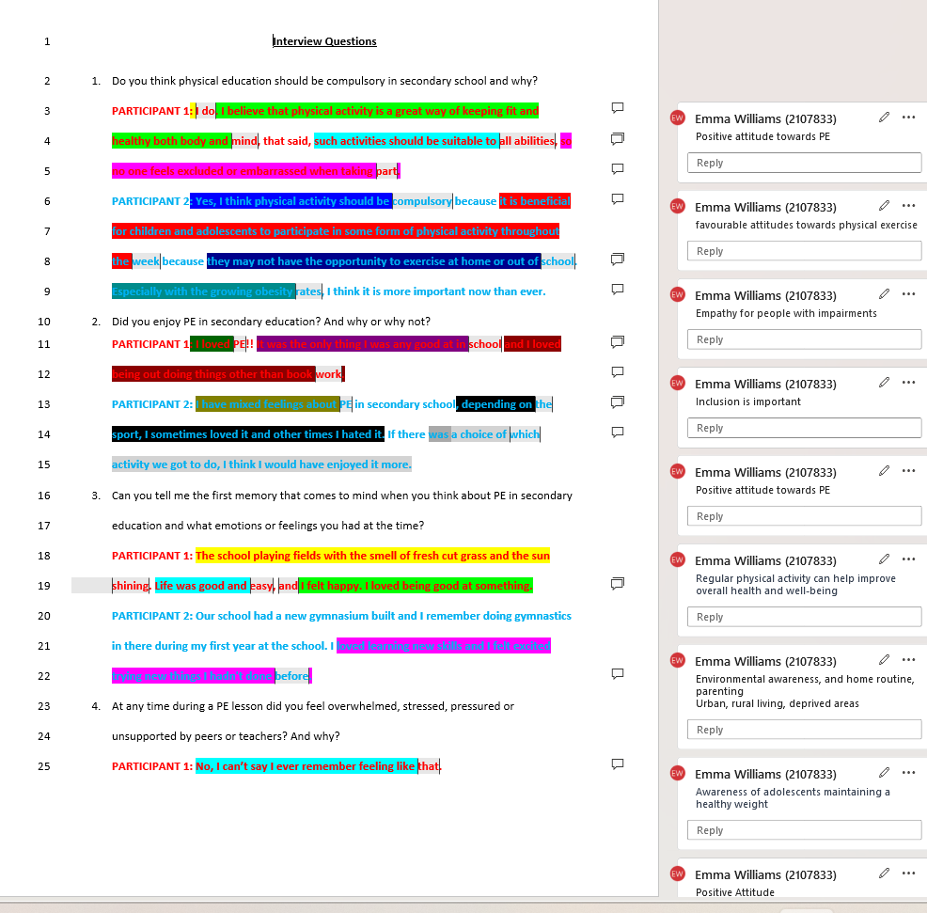

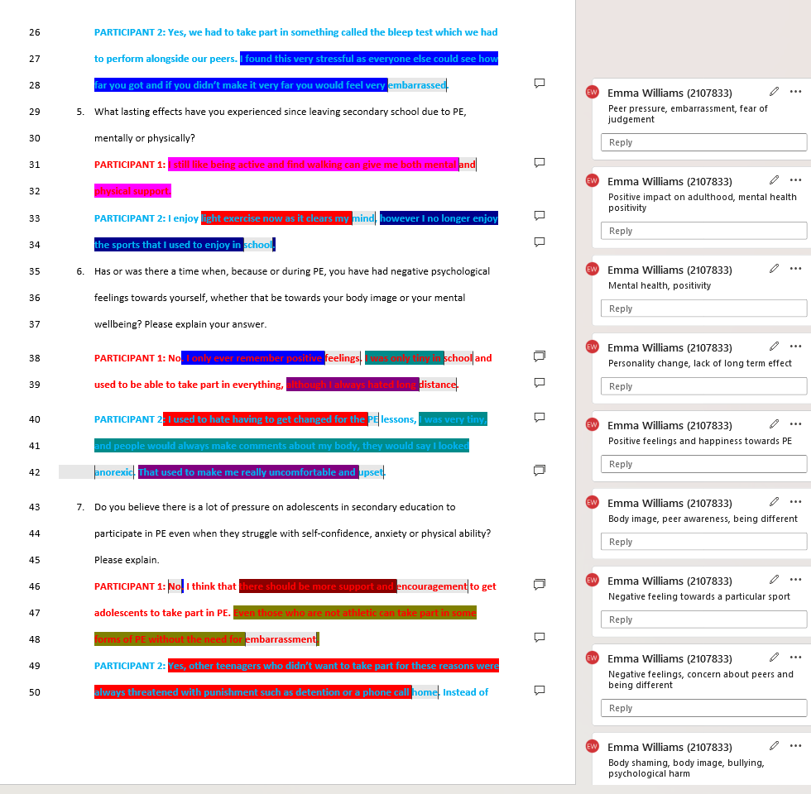
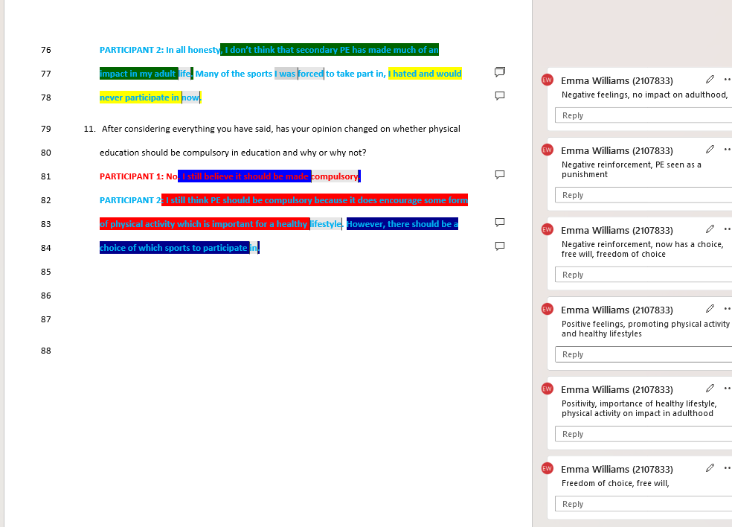

Codes with line numbers

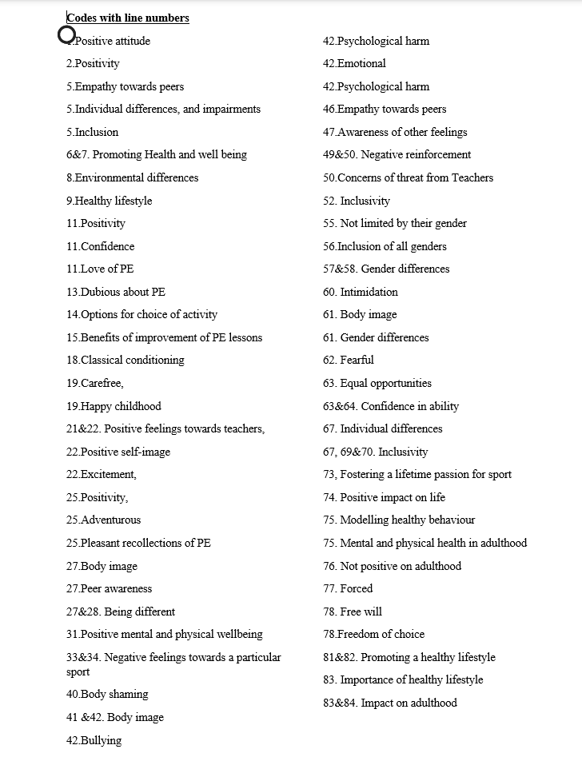

Appendix 7 Step 3 Search for themes



Appendix 8 Step 4 Review of themes

Code | Line number | Quote
Positive attitude-personality
Self-efficacy
Positive attitude | 1 | I do.
Positivity | 2 | I believe that physical activity is a great way of keeping fit and healthy both body and mind,
Carefree | 19 | Life was good and easy
Happy childhood | 19 | I felt happy. I loved being good at something.
Positivity | 11 | I loved PE
Positive feelings towards PE | 21&22 | I loved learning new skills and I felt excited trying new things I hadn't done before.
Confidence in ability | 63&64 | Both girls and boys should be offered the same level of physical activity because both genders are equally as capable.
Excitement | 22 | I loved learning new skills and I felt excited trying new things I hadn't done before.
Positive recollection of PE | 25 | No, I can’t say I ever remember feeling like that.
Classical conditioning, positive recollection | 18 | The school playing fields with the smell of fresh cut grass
Positive PE | 11 | I loved PE!!
Positive impact on life | 74 | that PE was a positive impact on me
Positive mental and physical wellbeing | 31&32 | I still like being active and find walking can give me both mental and physical support.
No limited by gender | 55 | I liked the challenge of competing with the boys
Psychological Harm-sub-theme

Negative reinforcement | 49&50 | : Yes, other teenagers who didn’t want to take part for these reasons were always threatened with punishment such as detention or a phone call home
Concerns of threat from teachers | 50 | threatened with punishment
Intimidation | 60&61 | I liked being separated from the boys because I was very petite, and the boys were much bigger than me.
Forced | 77 | I was forced to take part
Psychological harm | 42 | That used to make me really uncomfortable and upset.
Negative feelings towards a sport | 33&34 | however I no longer enjoy the sports that I used to enjoy in school.
Fearful | 62 | the boys were much bigger than me.
Empathy-Sub-theme

Empathy towards others | 5 | no one feels excluded or embarrassed when taking part.
Individual differences, impairments | 6 | such activities should be suitable to all abilities
Empathy towards peers | 46 | I think that there should be more support and encouragement
Awareness of others feelings | 47&48 | Even those who are not athletic can take part in some forms of PE
Peer awareness | 26&27 | we had to take part in something called the bleep test which we had to perform alongside our peers
Inclusivity
Student experiences & Equity

Options for choice | 14&15 | If there was a choice of which activity we got to do, I think I would have enjoyed it more.
Inclusivity | 51&52 | , adaptations should have been made to make the lessons more inclusive.
Inclusivity | 69&70 | and it may encourage them more to take part if it was a sport that they chose
Free Will | 77&78 | I hated and would never participate in now.
Freedom of choice | 77 | Many of the sports I was forced to take part in
Equal opportunities | 63 | girls and boys should be offered the same level of physical activity
Individual differences | 67&68 | I think that there should be choice to make PE as inclusive as possible.
Inclusion | 4&5 | so no one feels excluded or embarrassed when taking part.
Inclusion of all genders | 56 | was always really disappointed that I was not allowed to play football or rugby
Gender differences | 57&58 | I do not remember being made to feel less capable because of that either. I never felt that I was expected to be the same as the boys or vice versa.
Health & wellbeing

Interconnected nature of health and wellbeing
Promoting health & well-being | 6&7 | , I think physical activity should be compulsory because it is beneficial for children and adolescents to participate in some form of physical activity
Healthy lifestyle | 9 | with the growing obesity rates, I think it is more important now than ever
Promoting a healthy lifestyle | 81&82 | : I still think PE should be compulsory because it does encourage some form of physical activity
Importance of healthy lifestyle | 83 | which is important for a healthy lifestyle
Fostering a lifetime of passion for sport | 73 | : I loved and still love sport and keeping active
Modelling healthy behaviour | 74&75 | PE was a positive impact on me and something that has passed on to my children also with their love of the outdoors.
Not positive impact in adulthood | 76 | , I don’t think that secondary PE has made much of an impact in my adult life
Body image- sub-them

Positive - confident | 22 | I loved learning new skills and I felt excited trying new things I hadn't done before.
Negative body image | 61 | I was very petite, and the boys were much bigger than me
Body shaming | 41&42 | people would always make comments about my body, they would say I looked anorexic.
Body image | 40&41 | , I was very tiny, and people would always make comments about my body,
Bullying | 42 | That used to make me really uncomfortable and upset
Negative cognitive | 27 | . I found this very stressful as everyone else could see how far you got and if you didn’t make it very far you would feel very embarrassed
Gender differences | 60&61 | I liked being separated from the boys because I was very petite, and the boys were much bigger than me.
Miscellaneous

Environmental differences | 8 | they may not have the opportunity to exercise at home or out of school.
Dubious about PE | 13 | I have mixed feelings about PE

Appendix 9 – Step 5 Define and name themes

THEMES
Self-efficacy
DEFINITION:
The theme of self-efficacy was evident. The participants demonstrated belief in their own ability to achieve goals and overcome challenges. The feeling that the participants had a positive outlook on life and not being intimidated by gender difference. One participant in particular shown positive recollections of PE in the form of Classical conditioning.
Student experiences & Equity
Sub-theme
Empathy
DEFINITION:
The theme of Student experiences & Equity was clear, Participants demonstrated how essential it is for all students to have equal access to resources and opportunities within PE, regardless of their backgrounds or abilities, in order to demonstrate the theme of student experiences and equity. Participants also indicated how students perceive inclusivity in PE, including their sense of involvement, empathy, belonging, gender and peer awareness.
Interconnected nature of health and wellbeing
Sub-themes
Body-image
Psychological harm
DEFINITION:
Throughout the analysis, the interconnection of health and wellbeing was evident. Participants provided experienced views of the connections between various concepts and how they affected the obligation for secondary school students to participate in PE. It became clear that experiences in physical education classes were associated often with psychological harm and body-image and one participant particularly showcased confidence issues.

Results section
Representation of themes and codes graphically

