MoveOS
Software Artefact
Cloud-Based Logistics Management Platform for Courier and Removal Businesses

Student | Stefan-Leonard Bitu
Student ID | 2125335
Programme | BSc (Hons) Cloud Computing
Supervisor | Renuga Jayakumar
University | University of Wales Trinity Saint David
Submission | Independent Project - Software Artefact
Current prototype: React + Vite + Local Storage
Prepared from the current MoveOS project source and working application screenshots

Document Purpose
This document presents the MoveOS software artefact as a single submission file. It explains what has been built, how the prototype is structured and how the main user journeys operate. Screenshots from the working application are included alongside selected source code extracts from the submitted MoveOS project.
The document does not reproduce every source file line by line. Instead, it provides enough technical evidence to demonstrate the architecture, key functions and working features while keeping the artefact readable for assessment.

Artefact Snapshot
Area | Current implementation
Frontend | React, JavaScript, React Router and custom CSS
Development environment | Vite running on localhost
Data persistence | Browser Local Storage
User roles | Administrator, Customer and Driver
Core workflow | Quote request - quotation - deposit - booking - calendar - job - driver assignment
Cloud direction | Firebase Authentication and Firestore planned for a future production version

Current Scope Note
MoveOS is currently a localhost prototype. This is intentional. The priority has been to build and test the complete business workflow before introducing production hosting, cloud authentication, external payment processing, mapping services and other integrations that add cost and additional complexity.

Contents
1. Project and Artefact Overview
2. How to Run MoveOS
3. System Architecture and Project Structure
4. Authentication and Role-Based Access
5. Administrator Portal
6. Customer Portal
7. Quote Management
8. Deposit, Booking and Calendar Flow
9. Job Management
10. Driver Registration and Administration
11. Notifications, Archive and Data Safety
12. Data Storage
13. Selected Source Code Evidence
14. Testing and Iterative Development
15. Current Limitations and Known Issues
16. Future Development
17. Conclusion

1. Project and Artefact Overview
MoveOS is a logistics management platform designed around the day-to-day workflow of a small courier or removal business. The system brings together customer enquiries, quotation handling, bookings, calendar scheduling, job management and driver administration.
The project was inspired by practical experience of running removal operations where information can be spread across phone calls, messaging apps, spreadsheets and calendars. The aim of MoveOS is to reduce this fragmentation by providing one system with separate views for customers, administrators and drivers.
- Customers can register, log in and request quotations through a structured form.
- Administrators can review quotes, manage customers and drivers, monitor bookings and create jobs.
- Drivers register separately and require administrator approval before they can access driver functionality.
- Confirmed quotations can move through deposit payment, booking creation and calendar scheduling.
- Jobs can be created from confirmed bookings and assigned to approved drivers.
- Records such as users, quotes and jobs use soft-delete or archive patterns so data can be restored rather than immediately lost.

Business Workflow
Customer Registration -> Quote Request -> Admin Review -> Quotation -> Deposit -> Booking -> Calendar -> Job -> Driver Assignment -> Completion

2. How to Run MoveOS
The current artefact is a React application created with Vite. The prototype runs locally and does not require a remote database or production server.
- Open the MoveOS project folder in Visual Studio Code.
- Open a terminal in the project directory.
- Run npm install if dependencies are not already installed.
- Run npm run dev.
- Open the localhost address shown by Vite, normally http://localhost:5173.
- Use an Administrator, Customer or approved Driver test account to access the appropriate portal.
Local development commands
npm install
npm run dev

The application uses BrowserRouter, so routes such as /admin, /customer and /driver are handled through React Router. Protected routes check the role of the currently logged-in user before the requested page is displayed.
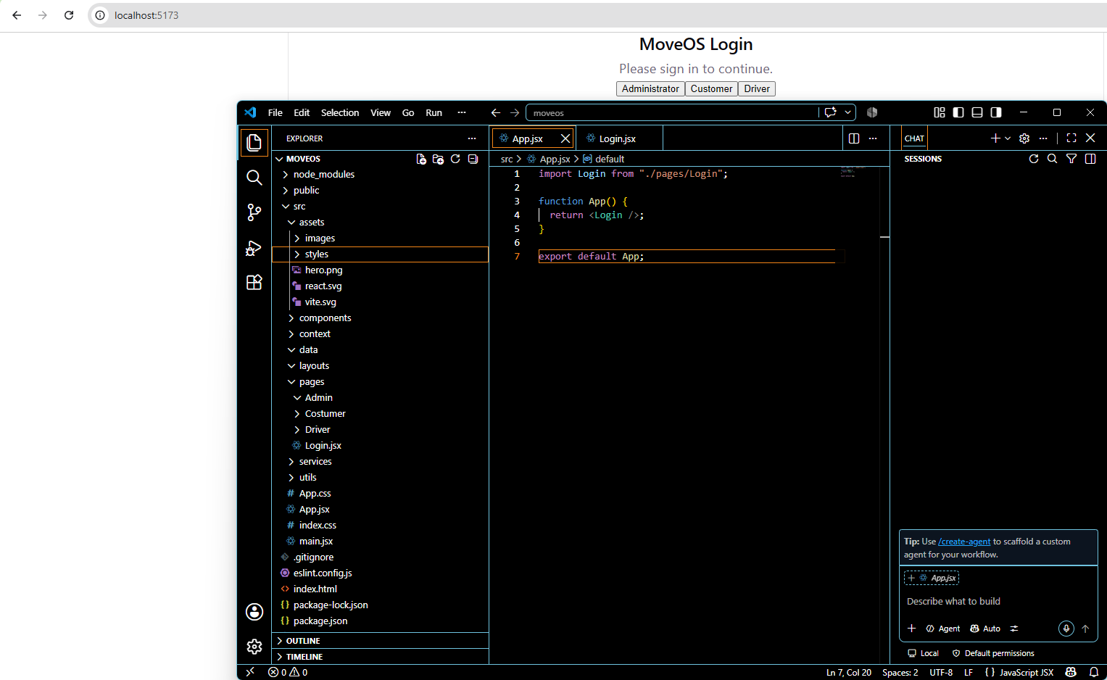
Figure 1. MoveOS login and role entry point

3. System Architecture and Project Structure
The project is separated into pages, layouts, shared components, services and utilities. This makes the UI easier to maintain and keeps storage and business logic away from individual page components where possible.
Current project structure
src/
assets/
components/common/ProtectedRoute.jsx
data/users.js
layouts/AdminLayout.jsx
pages/
Admin/
Customer/
Driver/
Register/
services/
authService.js
bookingService.js
jobService.js
notificationService.js
quoteService.js
storageService.js
userService.js
utils/
constants.js
idGenerator.js
validators.js
App.jsx
main.jsx

Logical Architecture
Layer | Responsibility
React pages and layouts | Display forms, dashboards, tables and role-specific screens
Service layer | Authentication, users, quotes, bookings, jobs, notifications and storage operations
Utilities | Shared statuses, identifiers and validation helpers
Persistence | Local Storage keys managed through storageService.js
This separation is important for future cloud migration because the current Local Storage functions can be replaced by database operations without redesigning every screen.

4. Authentication and Role-Based Access
MoveOS contains three main roles: Administrator, Customer and Driver. The current prototype stores the logged-in user in Local Storage and ProtectedRoute checks the role before allowing access to protected pages.
Extract - ProtectedRoute.jsx
function ProtectedRoute({
children,
allowedRole,
}) {
const location = useLocation();
const user = getCurrentUser();
if (!user) {
return (
<Navigate
to="/login"
replace
state={{
from: location.pathname,
}}
/>
);
}
const userRole = String(
user.role || ""
)
.trim()
.toLowerCase();
const requiredRole = String(
allowedRole || ""
)
.trim()
.toLowerCase();
if (
requiredRole &&
userRole !== requiredRole
) {
if (userRole === "administrator") {
return (
<Navigate
to="/admin"
replace
/>
);
}
if (userRole === "customer") {
return (
<Navigate
to="/customer"
replace
/>
);
}
if (userRole === "driver") {
return (
<Navigate
to="/driver"
replace
/>
);
}
return (
<Navigate
to="/login"
replace
/>
);
}
return children;
}

Driver Access Rules
- Pending drivers are prevented from logging in until an administrator approves the account.
- Suspended drivers are blocked from driver access.
- Archived managed users are treated as inactive.
- Users who try to access the wrong role area are redirected to their own portal.
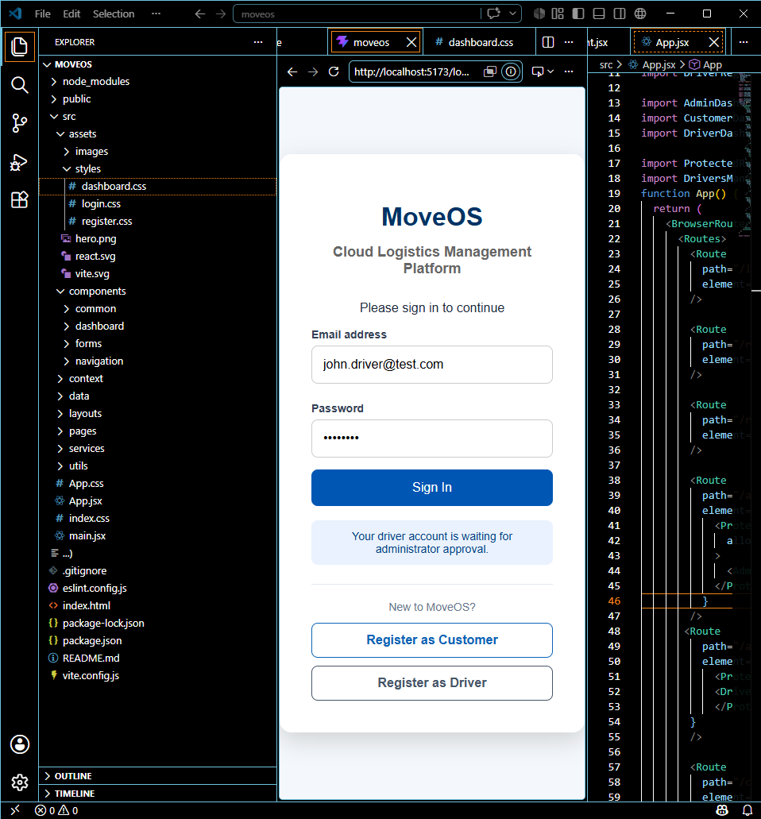
Figure 2. Driver account waiting for administrator approval

5. Administrator Portal
The Administrator Portal is the main operational area. It provides links to customers, drivers, quotes, bookings, the calendar and jobs. The dashboard is designed to show the most useful current information without requiring the administrator to open every section.
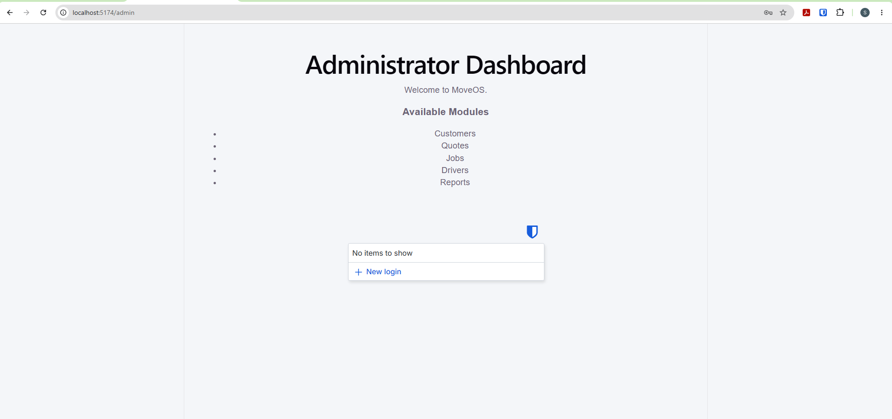
Figure 3. Administrator Dashboard showing operational statistics and upcoming work

Dashboard Statistics
- Today's Jobs are calculated from jobs and calendar bookings scheduled for the current date.
- Pending Quotes are calculated from quote records with Pending or Changes Requested status.
- Active Drivers are drivers with Approved status.
- Estimated Revenue is calculated from confirmed booking values.
- Upcoming work is taken from future confirmed bookings and displayed in date order.

6. Customer Portal
The Customer Portal gives customers a simpler route into the removal process. A customer can access their dashboard, start a quotation request and later review the status of their quotation and booking.
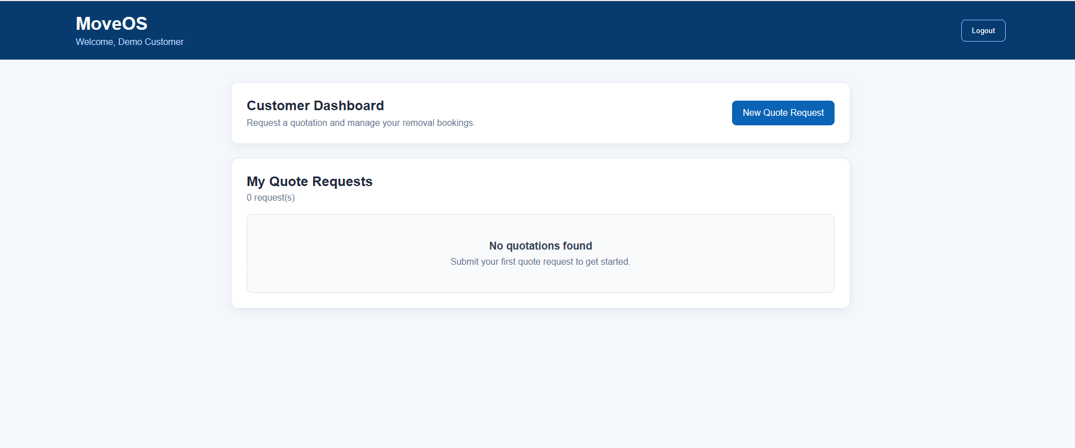
Figure 4. Customer Dashboard
The dashboard reads quotation records by customer ID. When a quotation is priced, the customer can continue to the payment step. When a booking is confirmed, the dashboard reflects the booking state.

Customer Registration - Current Development Iteration
The customer registration screen has been built. During the latest testing, the original form was found to display correctly but its submission logic needed to be connected to the managed-user service and customer-registration notifications. This issue has been identified as part of the iterative testing cycle and the registration handler is being updated to use the same managed-user pattern as the driver registration flow.

7. Quote Management
A key part of MoveOS is replacing unstructured quote enquiries with a consistent digital form. The customer provides the information needed for the administrator to understand the move and prepare a quotation.
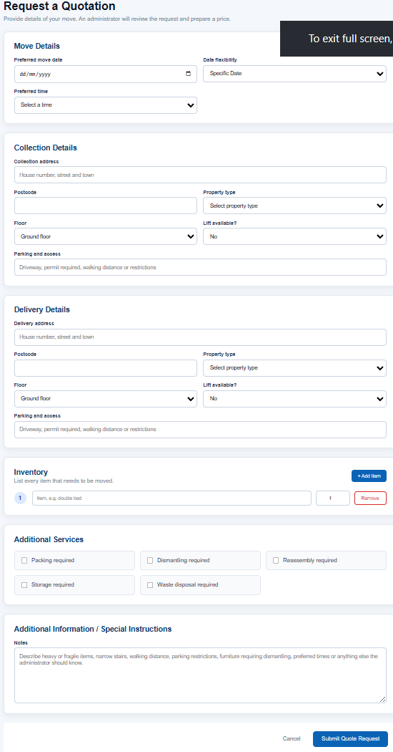
Figure 5. Customer quote request form with move details, access information, inventory and services
The quotation request captures the preferred move date, time flexibility, collection and delivery addresses, property details, floors, lift availability, parking/access information, inventory, optional services and additional notes.

Admin Quote Management
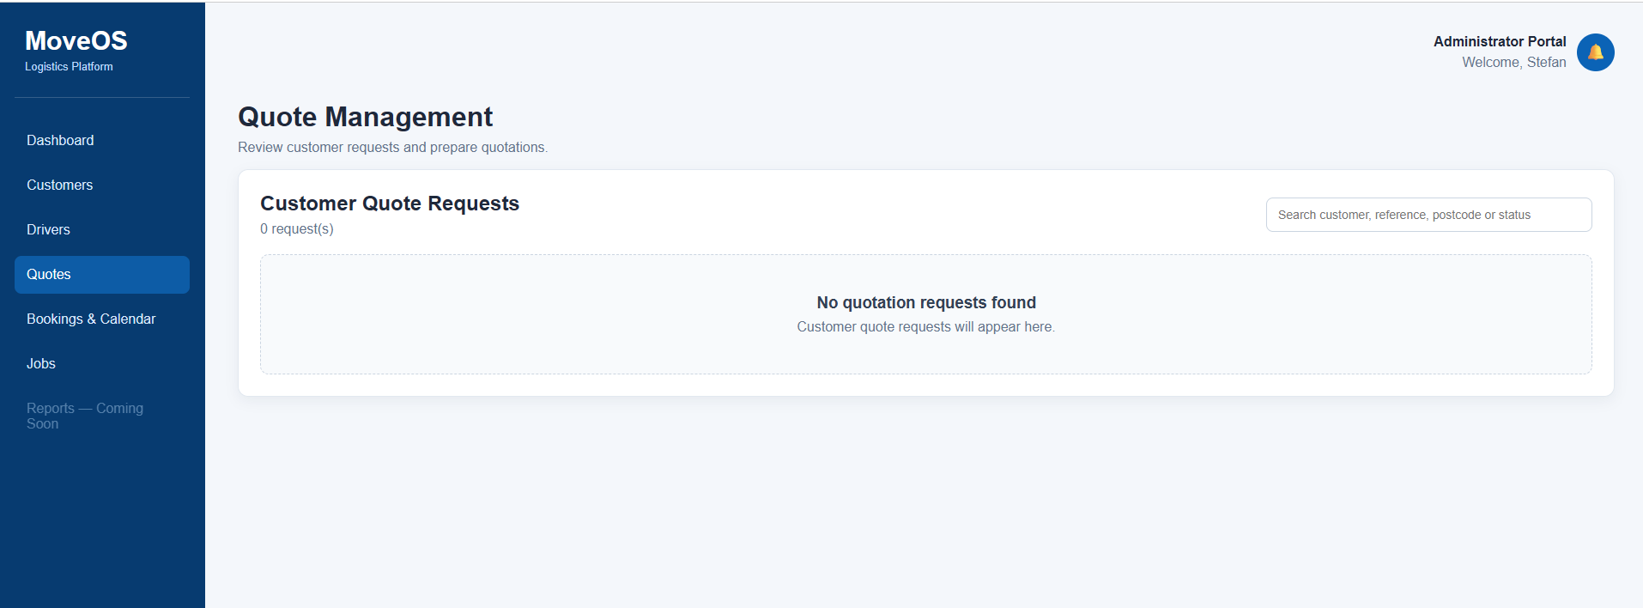
Figure 6. Administrator Quote Management page
The admin page is designed to list customer quote requests with search, reference, route, price, status and actions. The screenshot above shows the empty state that is displayed when there are no active quote requests in the current browser data.
Extract - quoteService.js: creating a quote and administrator notification
export function createQuoteRequest(
quoteInformation
) {
const quotes =
getStoredQuotes();
const newQuote = {
...quoteInformation,
id:
generateId("MOV"),
reference:
generateId("QTE"),
status:
QUOTE_STATUS.PENDING,
quotedPrice: "",
deposit: "",
estimatedDuration: "",
crewSize: "",
vehicleType: "",
adminNotes: "",
customerResponseNotes: "",
isDeleted: false,
deletedAt: null,
restoredAt: null,
createdAt:
new Date().toISOString(),
updatedAt:
new Date().toISOString(),
};
const saved =
saveQuotes([
...quotes,
newQuote,
]);
if (!saved) {
return {
success: false,
message:
"The quotation request could not be saved.",
};
}
createNotification({
type: "quote",
title:
"New Quote Request",
message:
`${
newQuote.customerName ||
"A customer"
} submitted a quotation request.`,
link:
"/admin/quotes",
});
return {
success: true,
quote: newQuote,
};
}

8. Deposit, Booking and Calendar Flow
Once an administrator has prepared a quotation, the customer can continue through the payment stage. The prototype records the payment step locally and then creates both a booking record and a calendar event.
Extract - bookingService.js: booking creation after deposit
export function confirmBookingAfterDeposit(
quoteId,
paymentInformation
) {
const quote = getQuoteById(quoteId);
if (!quote) {
return {
success: false,
message: "Quotation not found.",
};
}
const existingBooking =
getBookingByQuoteId(quoteId);
if (existingBooking) {
return {
success: false,
message:
"A booking has already been created for this quotation.",
};
}
if (quote.status !== QUOTE_STATUS.QUOTED) {
return {
success: false,
message:
"This quotation is not currently available for payment.",
};
}
const depositAmount = Number(
quote.deposit || quote.quotedPrice
);
if (depositAmount <= 0) {
return {
success: false,
message:
"The quotation does not contain a valid payment amount.",
};
}
const paymentReference =
generateId("PAY");
const booking = {
id: generateId("BKG"),
quoteId: quote.id,
quoteReference: quote.reference,
customerId: quote.customerId,
customerName: quote.customerName,
customerEmail: quote.customerEmail,
customerPhone: quote.customerPhone,
collectionAddress:
quote.collectionAddress,
collectionPostcode:
quote.collectionPostcode,
deliveryAddress:
quote.deliveryAddress,
deliveryPostcode:
quote.deliveryPostcode,
moveDate: quote.moveDate,
preferredTime: quote.preferredTime,
quotedPrice:
Number(quote.quotedPrice),
depositPaid: depositAmount,
outstandingBalance:
Math.max(
Number(quote.quotedPrice) -
depositAmount,
0
),
paymentStatus: PAYMENT_STATUS.PAID,
paymentReference,
paymentMethod:
paymentInformation.paymentMethod ||
"Card",
cardLastFour:

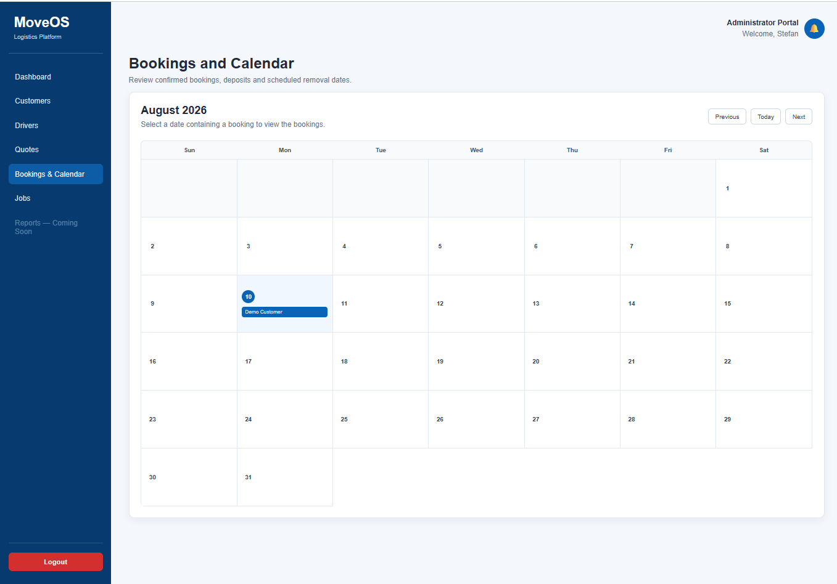
Figure 7. Administrator Booking Calendar
The calendar provides a visual overview of confirmed work. Booking information includes the customer, move date, route, quoted price, deposit paid, outstanding balance, payment status and booking status. This data is then available when an administrator creates an operational job.

9. Job Management
The Jobs area converts confirmed bookings into operational jobs. This separates the commercial booking stage from the actual work that needs to be carried out.
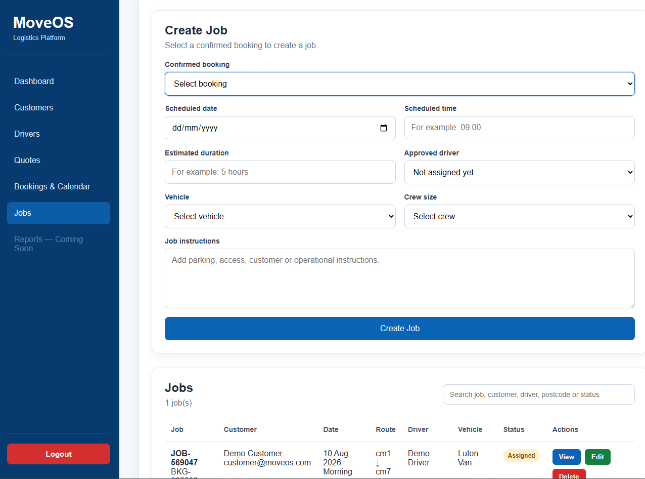
Figure 8. Create Job form
- Confirmed booking selection
- Scheduled date and time
- Estimated duration
- Approved driver assignment
- Vehicle selection
- Crew size
- Job instructions for access, parking and operational information
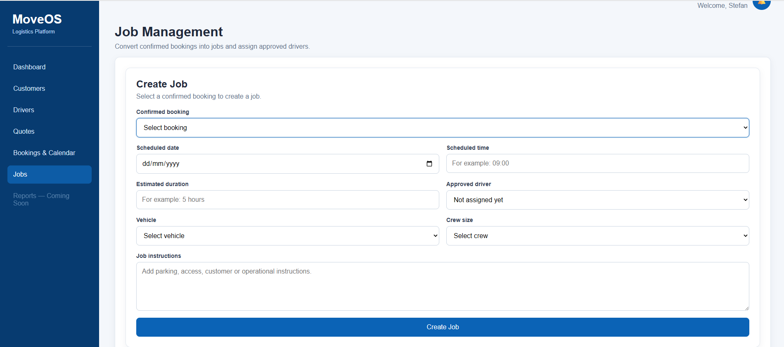
Figure 9. Administrator Jobs page with an assigned job
Extract - jobService.js: creating a job from a confirmed booking
export function createJobFromBooking(
booking,
jobInformation
) {
const jobs =
getStoredJobs();
const existingJob =
jobs.find(
(job) =>
job.bookingId ===
booking.id &&
job.isDeleted !== true
);
if (existingJob) {
return {
success: false,
message:
"A job has already been created for this booking.",
};
}
const driverAssigned =
Boolean(
jobInformation.driverId
);
const now =
new Date().toISOString();
const newJob = {
id:
generateId("JOB"),
bookingId:
booking.id,
quoteId:
booking.quoteId,
quoteReference:
booking.quoteReference,
customerId:
booking.customerId,
customerName:
booking.customerName,
customerEmail:
booking.customerEmail,
customerPhone:
booking.customerPhone ||
"",
collectionAddress:
booking.collectionAddress,
collectionPostcode:
booking.collectionPostcode,
deliveryAddress:
booking.deliveryAddress,
deliveryPostcode:
booking.deliveryPostcode,
scheduledDate:
jobInformation
.scheduledDate ||
booking.moveDate,
scheduledTime:
jobInformation
.scheduledTime ||
booking.preferredTime ||
"Flexible",
estimatedDuration:
jobInformation
.estimatedDuration ||
booking.estimatedDuration ||
"",
driverId:
jobInformation.driverId ||
"",
driverName:
jobInformation.driverName ||
"",
vehicleType:
jobInformation.vehicleType ||
booking.vehicleType ||
"",
crewSize:
jobInformation.crewSize ||
booking.crewSize ||
"",
adminNotes:
jobInformation.adminNotes ||
"",

9.1 Job Status Tracking
Job records contain a status that can change as the work progresses. The current constants support a full operational status sequence.
Status | Purpose
Scheduled | Job exists but may not yet have a driver.
Assigned | An approved driver is allocated.
In Progress | The job has started.
Collected | Collection has been completed.
Delivered | Delivery has been completed.
Completed | The operational job is finished.
Cancelled | The job has been cancelled.
Extract - jobService.js: status update logic
export function updateJobStatus(
jobId,
newStatus
) {
const job =
getJobById(jobId);
if (!job) {
return {
success: false,
message:
"Job not found.",
};
}
const statusDates = {};
const now =
new Date().toISOString();
if (
newStatus ===
JOB_STATUS.IN_PROGRESS
) {
if (!job.driverId) {
return {
success: false,
message:
"A driver must be assigned before starting the job.",
};
}
statusDates.startedAt =
now;
}
if (
newStatus ===
JOB_STATUS.COLLECTED
) {
statusDates.collectedAt =
now;
}
if (
newStatus ===
JOB_STATUS.DELIVERED
) {
statusDates.deliveredAt =
now;
}
if (
newStatus ===
JOB_STATUS.COMPLETED
) {
statusDates.completedAt =
now;
}
if (
newStatus ===
JOB_STATUS.CANCELLED
) {
statusDates.cancelledAt =
now;
}
return updateJob(
jobId,
{
status:
newStatus,
...statusDates,
}
);
}

The service also contains logic to unassign a driver from non-finished jobs when the driver becomes unavailable. Completed and cancelled jobs retain the historic driver information.

10. Driver Registration and Administration
Drivers use a separate registration form. Unlike a customer, a new driver does not receive immediate access. The registration is created with Pending status and must be approved by an administrator.
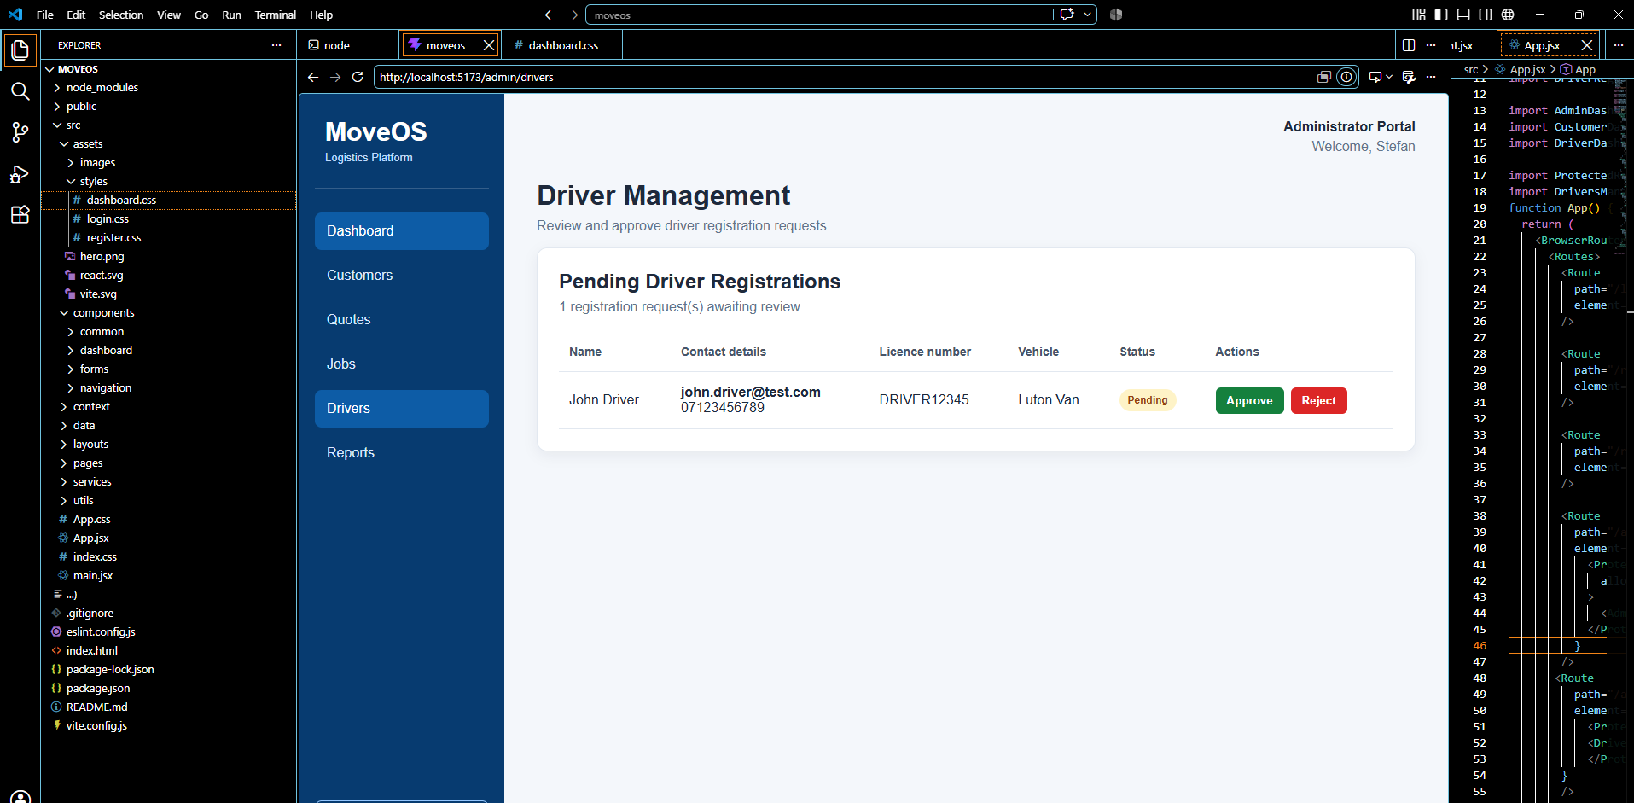
Figure 10. Driver Management and approval screen
- Pending registrations can be approved or rejected.
- Approved drivers appear in the active driver list.
- Drivers can be suspended and later reactivated.
- The system includes an Archived Drivers area for soft-deleted accounts.
- Driver details include name, contact information, licence number, vehicle type and status.

Driver Lifecycle
Pending -> Approved -> Suspended / Reactivated -> Archived / Restored
Recent testing found that the driver archive action needs to be kept independent from job de-allocation to avoid an undefined service reference. This is a useful example of how the service layer has been refined during development.

11. Notifications, Archive and Data Safety
The notification service stores notifications separately and supports unread counts, individual read state, mark-all-read and clearing notifications. Quote creation already generates a New Quote Request notification for the administrator.
Extract - notificationService.js
export function createNotification({
type,
title,
message,
link,
}) {
const notifications =
getStoredNotifications();
const newNotification = {
id: `NOT-${Date.now()}`,
type:
type || "general",
title:
title || "Notification",
message:
message || "",
link:
link || "/admin",
read: false,
createdAt:
new Date().toISOString(),
};
saveNotifications([
newNotification,
...notifications,
]);
return newNotification;
}

Archive Instead of Immediate Deletion
For users, quotes and jobs, the project uses archive or soft-delete concepts so records can be hidden from normal lists but still remain in storage for restoration. This is safer than immediately removing business records and supports a more realistic administration workflow.
Record | Soft-delete / archive approach
Users | archived and archivedAt fields
Quotes | isDeleted, deletedAt and restoredAt fields
Jobs | isDeleted, deletedAt and restoredAt fields
The UI keeps the action name Delete where required, but the intention is to move the record into an archive rather than permanently destroy it. Permanent deletion is kept as a separate service operation.

12. Data Storage
MoveOS currently stores its data in the browser using Local Storage. This was chosen to keep the prototype lightweight while the core business logic and user journeys were still being developed and tested.
Extract - storageService.js: application storage keys
export const STORAGE_KEYS = {
USERS: "moveosUsers",
LEGACY_USERS: "moveosRegisteredUsers",
QUOTES: "moveosQuotes",
LEGACY_QUOTES: "moveosQuoteRequests",
BOOKINGS: "moveosBookings",
CALENDAR_EVENTS: "moveosCalendarEvents",
JOBS: "moveosJobs",
VEHICLES: "moveosVehicles",
NOTIFICATIONS: "moveosNotifications",
CURRENT_USER: "moveosUser",
};

Local Storage key | Data
moveosUsers | Customer and driver managed user accounts
moveosQuotes | Quotation requests and quotation details
moveosBookings | Confirmed bookings
moveosCalendarEvents | Calendar entries created from bookings
moveosJobs | Operational job records
moveosVehicles | Vehicle records / future vehicle management
moveosNotifications | Administrator notifications
moveosUser | Currently logged-in user
Local Storage is suitable for a prototype but it is not a production multi-user database. Data is tied to the browser/device and can be cleared by the user. The future cloud version will move persistence and authentication to managed cloud services.

13. Selected Source Code Evidence
The following extracts show the main technical patterns used across the project. The complete project contains separate files for authentication, users, quotes, bookings, jobs, notifications and storage.
13.1 Authentication and driver account checks
export function authenticateUser(
email,
password
) {
const normalisedEmail = String(
email || ""
)
.trim()
.toLowerCase();
/*
Administrator accounts are currently stored
in src/data/users.js
*/
const administrator = users.find(
(user) =>
String(user.email)
.toLowerCase() ===
normalisedEmail &&
user.password === password
);
if (administrator) {
return {
success: true,
user: administrator,
};
}
/*
Customer and Driver accounts
*/
const managedUser =
findManagedUserByEmail(
normalisedEmail
);
if (!managedUser) {
return {
success: false,
message:
"Invalid email address or password.",
};
}
if (
managedUser.password !== password
) {
return {
success: false,
message:
"Invalid email address or password.",
};
}
/*
Archived accounts cannot log in.
*/
if (managedUser.archived) {
return {
success: false,
message:
"This account is no longer active.",
};
}
/*
Pending drivers must wait for approval.
*/
if (
managedUser.role ===
USER_ROLES.DRIVER &&
managedUser.status ===
DRIVER_STATUS.PENDING
) {
return {
success: false,
message:
"Your driver registration is awaiting administrator approval.",
};
}
/*
Suspended drivers cannot log in.
*/
if (
managedUser.role ===
USER_ROLES.DRIVER &&
managedUser.status ===
DRIVER_STATUS.SUSPENDED
) {
return {
success: false,
message:
"Your driver account is currently suspended.",
};
}
return {
success: true,
user: managedUser,
};
}
/*
Lo

13.2 React Router and protected role routes
function App() {
return (
<BrowserRouter>
<Routes>
{/* Public routes */}
<Route path="/login" element={<Login />} />
<Route
path="/register/customer"
element={<CustomerRegister />}
/>
<Route
path="/register/driver"
element={<DriverRegister />}
/>
{/* Administrator routes */}
<Route
path="/admin"
element={
<ProtectedRoute allowedRole="Administrator">
<AdminDashboard />
</ProtectedRoute>
}
/>
<Route
path="/admin/customers"
element={
<ProtectedRoute allowedRole="Administrator">
<CustomersManagement />
</ProtectedRoute>
}
/>
<Route
path="/admin/drivers"
element={
<ProtectedRoute allowedRole="Administrator">
<DriversManagement />
</ProtectedRoute>
}
/>
<Route
path="/admin/quotes"
element={
<ProtectedRoute allowedRole="Administrator">
<QuotesManagement />
</ProtectedRoute>
}
/>
<Route
path="/admin/bookings"
element={
<ProtectedRoute allowedRole="Administrator">
<BookingsCalendar />
</ProtectedRoute>
}
/>
<Route
path="/admin/jobs"
element={
<ProtectedRoute allowedRole="Administrator">
<JobsManagement />
</ProtectedRoute>
}
/>
{/* Customer routes */}
<Route
path="/customer"
element={
<ProtectedRoute allowedRole="Customer">
<CustomerDashboard />
</ProtectedRoute>
}
/>
<Route
path="/customer/request-quote"
element={

13.3 User Management Service
Managed user creation
export function createManagedUser(
newUser
) {
const users = getStoredUsers();
const normalisedEmail = String(
newUser.email || ""
)
.trim()
.toLowerCase();
if (!normalisedEmail) {
return {
success: false,
message:
"An email address is required.",
};
}
const emailExists = users.some(
(user) =>
String(user.email || "")
.toLowerCase() ===
normalisedEmail
);
if (emailExists) {
return {
success: false,
message:
"An account with this email already exists.",
};
}
const prefix =
newUser.role === USER_ROLES.DRIVER
? "DRV"
: "CUS";
const defaultStatus =
newUser.role === USER_ROLES.DRIVER
? DRIVER_STATUS.PENDING
: "Active";
const userToSave = {
...newUser,
id: generateId(prefix),
email: normalisedEmail,
status:
newUser.status ||
defaultStatus,
archived: false,
archivedAt: null,
registeredAt:
new Date().toISOString(),
updatedAt:
new Date().toISOString(),
};
saveUsers([
...users,
userToSave,
]);
return {
success: true,
user: userToSave,
};
}

The service normalises email addresses, prevents duplicate accounts, generates role-specific IDs and sets a default Pending status for drivers and Active status for customers.

13.4 Dashboard Data Derived from Live Records
Administrator dashboard calculations
const activeJobsToday = jobs.filter(
(job) =>
job.scheduledDate === todayDate &&
job.status !== JOB_STATUS.CANCELLED
);
const jobBookingIds = new Set(
activeJobsToday.map(
(job) => job.bookingId
)
);
const calendarBookingsToday =
bookings.filter(
(booking) =>
booking.moveDate === todayDate &&
booking.bookingStatus !==
"Cancelled" &&
!jobBookingIds.has(
booking.id
)
);
const todayJobsCount =
activeJobsToday.length +
calendarBookingsToday.length;
const pendingQuotesCount =
quotes.filter(
(quote) =>
quote.status ===
QUOTE_STATUS.PENDING ||
quote.status ===
QUOTE_STATUS.CHANGES_REQUESTED
).length;
const activeDriversCount =
drivers.filter(
(driver) =>
driver.status ===
DRIVER_STATUS.APPROVED
).length;
const estimatedRevenue =
bookings.reduce(
(total, booking) =>
total +
Number(
booking.quotedPrice || 0
),
0
);
const upcomingBookings = bookings
.filter(
(booking) =>
booking.moveDate &&
booking.moveDate >= todayDate &&
booking.bookingStatus !==
"Cancelled"
)
.sort((a, b) =>
a.moveDate.localeCompare(
b.moveDate
)
)
.slice(0, 5);

The dashboard values are calculated from stored jobs, bookings, quotes and drivers rather than being hard-coded. This was an important improvement during development because earlier placeholder values did not reflect the actual system state.

14. Testing and Iterative Development
MoveOS has been developed using an iterative Agile approach. Features were added in stages, tested through the browser and then adjusted when problems were identified. Testing has therefore included both feature verification and regression testing after service changes.
Test area | Expected result | Current evidence / status
Role routing | Only the correct role portal is accessible | ProtectedRoute implemented and login flows demonstrated
Driver registration | New driver remains Pending | Demonstrated in application screenshot
Driver approval | Admin can approve Pending driver | Demonstrated in Driver Management
Driver suspension | Suspended driver cannot log in | Implemented in authService and tested during development
Quote request | Customer request is stored and admin notified | Implemented in quoteService - requires final regression re-test after recent service changes
Booking after deposit | Booking and calendar event are created | Implemented in bookingService and calendar demonstrated
Job creation | Confirmed booking can become a job | Create Job form and job list demonstrated
Dashboard metrics | Values reflect stored system data | Implemented in AdminDashboard
Archive / restore | Delete should preserve records for recovery | Implemented as soft-delete pattern - driver archive action currently being re-tested

Examples of Problems Found During Testing
- Routes that accidentally redirected users back to Login.
- Notification dropdown behaviour that did not close as expected.
- Jobs and booking details expanding in the wrong place in the UI.
- Dashboard statistics originally using placeholder values instead of stored data.
- Suspended drivers remaining allocated to jobs.
- Driver archive behaviour breaking after service-level de-allocation changes.
- Customer registration UI existing without a complete submission handler in one project snapshot.
- Quote and notification flows requiring re-testing after changes to shared services.
These issues are included because they show the development process rather than only the finished screens. Each issue led to changes in the component or service design and helped improve the separation of responsibilities in the project.

15. Current Limitations and Known Issues
The current version should be considered a functional academic prototype rather than a production logistics platform. The main limitations are listed below.
- Local Storage is browser-specific and does not provide true multi-user synchronisation.
- Administrator credentials are still stored in project data rather than a production authentication provider.
- The deposit flow is a prototype payment workflow and does not process a real bank/card transaction.
- The Driver Dashboard is still basic compared with the Administrator and Customer areas.
- Reporting is marked as Coming Soon.
- Customer registration persistence and customer-registration notifications were identified for correction in the latest iteration.
- Driver archive behaviour is being re-tested after changes intended to keep job allocation data consistent.
- Cloud deployment and Firebase integration are not yet live.

Cost and Scope
Keeping the prototype on localhost also controlled project cost. Firebase usage, cloud hosting, payment processing, mapping, SMS and other external services can introduce monthly or usage-based charges. Building the core workflow locally first allowed more time to be spent on functionality, testing and the dissertation before committing to production services.

16. Future Development
- Migrate user authentication to Firebase Authentication.
- Move operational data from Local Storage to Cloud Firestore.
- Deploy the React application to a production cloud environment.
- Integrate a real secure payment provider for deposits and balances.
- Add Google Maps or another mapping service for route and distance calculations.
- Add live driver location and GPS tracking where appropriate.
- Add email and SMS notifications for customers and drivers.
- Expand the Driver Dashboard with assigned jobs, job detail views and status updates.
- Complete reporting and business analytics.
- Add multi-company support so the platform can be used by other small removal and courier businesses.

Planned Cloud Direction
React Client -> Firebase Authentication -> Cloud Firestore -> Cloud Hosting / Production Domain

Figure 11. MoveOS QR code prepared for future public access

17. Conclusion
The MoveOS artefact demonstrates the core structure of a logistics management platform designed for a small removal or courier business. The project now includes role-based access, customer quote requests, administrator quotation handling, bookings, a calendar, job creation, driver administration, notifications and archive concepts.
The most important result is that the different stages of a removal job are no longer treated as separate screens or spreadsheets. The prototype connects the customer request to the administrator workflow and then to the operational booking and job process.
The current implementation remains deliberately local so the business logic can be tested and corrected before cloud migration. The next stage is to move authentication and data persistence to Firebase, complete the remaining regression testing and deploy the application to a production environment.

Submission Details
Item | Detail
Project | MoveOS
Student | Stefan-Leonard Bitu
Student ID | 2125335
Programme | BSc (Hons) Cloud Computing
Supervisor | Renuga Jayakumar
Artefact type | React/Vite localhost prototype
Source reviewed for this document | moveos.zip project snapshot and working application screenshots
MoveOS - bringing quotes, bookings, drivers and jobs into one system.

