Professional career development
Naeem Ahmed 1712832
June 14, 2019
University of Wales Trinity Saint David

Table of Contents
Introduction 2
Findings 3
Part 1 3
Part 2 3
Conclusion 4
Bibliography/Reference List 5

Introduction

In this part I will be talking about what professional career development is and why it is important when a person undertakes a professional career development they learn new skills to step up in the career ladder. Nearly every industry does some sort of review of its staff to see how well they are performing and what needs to be improved and also whether someone should have the chance to move up or down in there role. They would go through tests to see if they are ready for the role or not. Professional career development is important because there are new rules and techniques are always being introduced so to move up to a management role you would be required to learn these new skills as you would be expected to teach people below you. The main skills are communication skills, speaking confidently in front of a audience and also good leadership skills also being able to communicate with new people. Professional career development is also important because you have a better understanding of what a successful career is and have a better chance of staying in a job role for a long period of time. professional career development helps employees build a sustainable career. Enrolling into courses will also help gain on your knowledge and skills. Being able to conduct a presentation in front of a group of people and being able to speak confidently about what you are saying because this shows that you are trying to motivate the audience and have a impact on them from what you are saying. To be able to work in a management role you would need to know how different departments are run in the company so that you would be able to direct someone else on what to do. Also attending training sessions will help you gain skills. You should be able to set guidelines so that when you staff work remotely everything runs efficiently and there is support when needed available.

Findings

Part 1
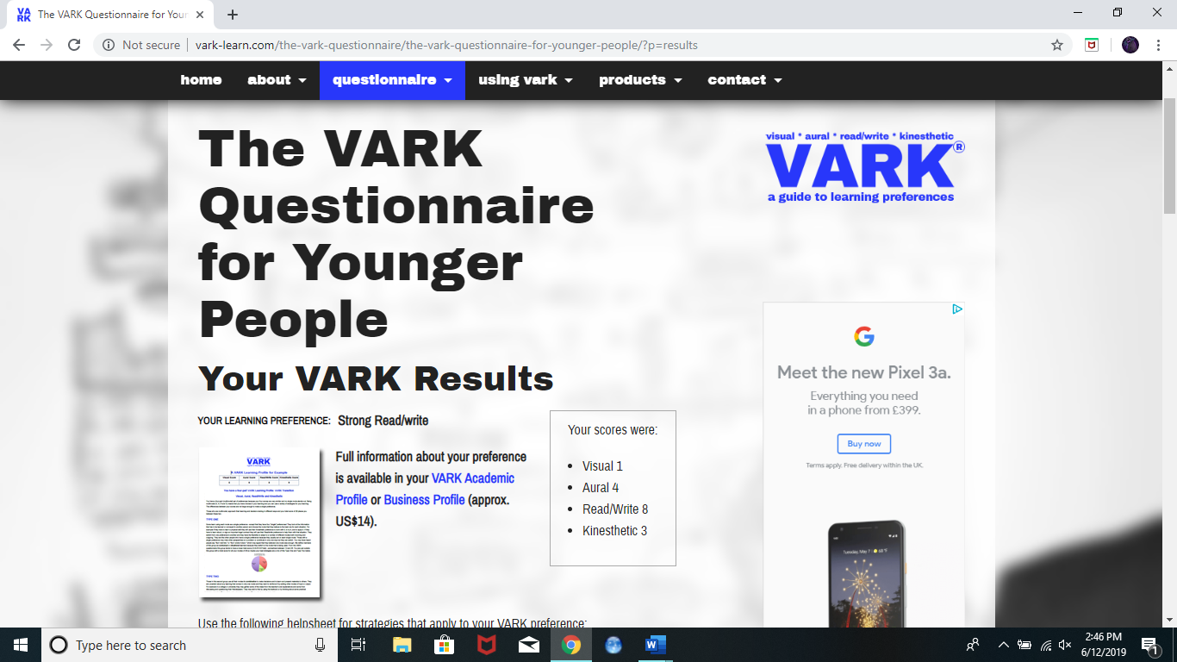
I have done a vark questionnaire online and the results have shown that I am a reading and writing type of learner so this shows that I am good with reading and writing skills and this will help with my job role in management because reading and writing skills are vital in any type of job role especially in a management role.

Part 2

The key development areas are speaking in front of a audience and also good leadership skills I have chosen these two skills because they are my biggest weak point and I feel if I can improve on these 2 skills then I would be more confident to go for a management role. Also I would need to work on my teamworking skills as I am not very good at that and also struggle to make friends with people I have never seen before so in order for me to be working in a management role I would need to be able to work with all types of people as I would need to show others that I am easy to get on with and also committed to learn as well with them. If I set myself a goal to be in the management role then the things I would need to work on mainly are being able to forward plan so I should be able to plan things for the future such as hosting meetings and setting priorities for the company and I need to work on my mentoring skills so I have to be able to pass knowledge onto staff and help them gain there confidence skills also it would be good if I can come up with new productive ideas to pass on to colleagues to make the company run better and improve. Also another skill I would need to work on is my persuading skills because as a manager you are need to be persuasive and need to be able to get peoples attention. A manager should know what is going on and if someone is not co operating it is the managers duty to make sure that everything is working as expected or if there are a short of resources then that is also the mangers responsibility to correct that. Also they would need to adapt with different people
Some of the things that are stopping me is that I am always busy with work and family and also I need to put my mind to more important things that need to be done if I watch videos as well on how people do presentations it would give me a better idea of how they address themselves what type of body language they use and also in general how they connect with the audience. The support would be from my family and friends as when I do presentations in front of them after I have finished I would ask them for feedback on what I need to improve on and what I am doing right. The way I would monitor if I am developing my skills is to just keep practising and if I feel I am getting more and more confident over time then I know it is working for me. Also another point is if I can make myself a timetable to follow as I am not very organised so I am usually late and that would stop me from improving my job role as I would be seen as not punctual I would improve on this by taking a extra day off work and and change my shifts as I work till late so if I took a extra day off this would mean that I have more time to myself to work on other things as well as work.

Swot analysis
Strengths  - I am a quick learner  - I am good at teamworking  - I have good reading skills  - Good listener  - Hard working  - I am confident  - I am an organised person  - I am well disciplined  - I like to learn new skills  - I am considerate  - I have a ambition to learn and improve on my skills  - I am honest  - I am friendly and helpful I try to help others about things I know  - I am responsible | Weaknesses  - Self-discipline  - Qualifications  - I need employability skills  - Took time off education  - I was easily distracted when I had the chance to study I wasn’t focusing on what I should have been.
Opportunities  - Take advantage of the course  - Get a better job in the future  - Ask the tutors for help  - Gain employability skills  - Understand what is required for a management job role  - Buy a house  - Start up my own business in the future | Threats  - I have work commitments which are getting in the way of my studies  - Financial responsibilities  - I need to take extra time off work to focus on my assignments and other university work  - If I started my own business then I would have competition with other companies
I want to be able to move forward with my course that I am doing and hopefully get a degree in this course so I can get a better job and also be able to say to employers that I have a degree in a certain course so I am educated and this gives them a good first impression of me and I will be more likely to get a chance to have a better role and I would be able to gain trust from my employer

Go mad

I will be getting support from my family and friends and I will ask them for feedback on what I am doing well on and what needs to I need to improve on I am more confident around family and friends so I can rely on there suggestions
I need to focus on my assignments and try complete them in the given time frame so that I am not late and not lose marks then this way I am not trying to rush them so I have time after to read over them before submission to ensure that they are to the best of standards
I want to be able to set goals for myself and then think about how I would go ahead on achieving them. And be as successful as I can be

I want to succeed in my course and put it to use by applying for jobs that relate to the course I am doing so this way if I get a job I am already educated in the role so I wont have to learn as I go along also I will be able to move forward quicker if I already have the skills required this way when I go for interviews aswell I will have a better chance then most people applying for the same role.

Obtain a degree from my course so it would look good on my cv and I have a better chance of getting a better job in the future that I know is secured for as long as I want to be in it. And hopefully in the future set up my own business I would have the knowledge and skills as I would gain experience from where I would be working.
I want to be able to provide for my family with a stable job and good income so I can do things that I’m not able to do as of now such as buy nice things and go on holidays more often and hopefully in the future buy my own house.

Conclusion
In this report I have gathered information about importance of professional career development and what is needed for me to gain a role in the management role. I have outlined my strengths and weaknesses and the things I need to work on. I have got information from the internet which has also educated me I have also gained knowledge on what is required from me to be in a management role. Also the classes I have attended have given me more information on skills for the workplace and I will be doing presentations which will help with my confidence. I have also included information on what companies look for in a individual for a management role and what i as a manager would need to teach colleagues as I am above them so I would need to have a high amount of knowledge on the company and also have a backup so in case of a personal emergency I would have someone to cover my role.

Bibliography/Reference List
https://www.wisegeek.com/what-is-professional-career-development.htm
https://blog.impraise.com/360-feedback/7-examples-for-setting-professional-development-goals-at-work-performance-review
https://www.prospects.ac.uk/jobs-and-work-experience/job-sectors/business-consulting-and-management/7-skills-for-a-successful-management-career
https://www.thebalancecareers.com/management-skills-list-2062427

