
Skills for the Workplace
Module Assignment Submission
Student Name: | Alyson Downes
Student Number: | 2024912
Module No: | BMSK5002
Module Title: | Developing Relationships and Workplace Achievement

Statement of Confirmation of Authenticity
By the act of making this submission, the student declares that this is the work of the student named above. The work has not, in whole or in part, been knowingly presented elsewhere for assessment, or where assessment has been built on a previous assessment, this has been identified. Where materials have been used from other sources it has been properly acknowledged. If this statement is untrue, the student acknowledges that an assessment offence has been committed.
Attention is drawn to the plagiarism and unfair practice policies of both the University and of ILM.
Table of Contents
Critically assess the potential benefits to the organisation of developing individuals in the workplace 4
Increased Staff Retention 4
Herzberg’s Two Factor Theory 5
Empirical Research 5
Staff Empowerment 5
Kanter’s Theory of Structural Empowerment 6
Empirical Evidence 6
The Risks 6
Summary 7
Manage an individual’s expectations in respect of personal development 7
The Personal Development Cycle 8
SMART Goals 9
Organisational Structure 9
Critically evaluate development vehicles available to an organisation appropriate to the development needs of the individual 9
Performance Appraisals 10
The importance of feedback 11
Criticisms 11
Summary 12
Generate a detailed plan to meet the identified development needs of an individual in the workplace and the management of performance 12
Performance management cycle 12
Development and performance management plan 13
References 15
Appendix A 19
Appendix B 20
Appendix C 21
Appendix D 22
Appendix E 23
Appendix F 24
Appendix G 25
Appendix H 26
Appendix I 27
Appendix J 30

Introduction
This report will aim to critically assess the benefits and importance of offering training and development opportunities to employees, for both the individual and organisation.
The report will also examine the importance of expectation management, as well as provide a critical evaluation of the variety of development vehicles available to an organisation.
Finally, an appropriate personal development and performance management plan will be created and evaluated for an individual, based on their specific circumstances.

Critically assess the potential benefits to the organisation of developing individuals in the workplace

Investment in the training and development of employees creates as many benefits for an organisation as it does for the employees themselves. Whilst initial training is irrefutably important, it is the ongoing training and development of staff that produces the best results, and improves a business’ success (Staff Training Solutions, 2017).
The Driver Vehicle Standards Agency (DVSA), and in fact the civil service as a whole, recognise the importance of investing in people. As well as offering funding for a variety of qualifications, DVSA employees are entitled to five paid ‘study days’ per year, used for training and development purposes. There are also coaching and mentoring schemes in place, and the civil service learning website has a wide range of online courses available to all civil servants (Government Communication Service, 2021).

Increased Staff Retention
Companies that invest in their employees have better staff retention rates than competitors who do not offer the same benefits, with 86% of individuals admitting they would change companies if they were offered better development opportunities elsewhere (Keswin, 2022).
Recruiting staff is expensive, which is why retaining them is important. A lower employee turnover rate reduces costs, improves both morale and productivity, provides an improved experience for customers and retains expertise. Retaining staff also results in an improved workplace culture and higher engagement from employees (Paulsen, 2021).

Herzberg’s Two Factor Theory
The Two-Factor Theory (Herzberg et al, 1959), asserts that there are two sets of factors responsible for employee satisfaction and motivation (Appendix A). Satisfiers are factors that increase job satisfaction and inspire employees to work harder, such as advancement opportunities and the possibility of growth. Hygiene factors are elements that cause job dissatisfaction if they are not up to standard. These include being paid a fair salary, company policies and relationships with supervisors.
Herzberg postulates that a person’s likelihood of remaining in their existing role is dependent on satisfiers outweighing dissatisfiers (Nickerson, 2021). An organisation’s retention strategy should focus on improving both sets of factors (Merin, 2022). Investing in the training and development of employees, is an effective way to do this. Better training opportunities result in additional advancement prospects, and a higher sense of achievement, satisfying the motivation factors. Development opportunity also leads to staff feeling valued by their employer, thus improving both relationships with management and workplace culture, and therefore satisfying hygiene factors.

Empirical Research
Research supports the theory that investing in employees results in a lower staff turnover. A 2019 survey found that organisations that offer development opportunities have 34% higher staff retention rates than those that don’t, as well as employees who are 15% more engaged. Additionally, a different study found that 60% of workers would opt for a job with strong development opportunities, over one with regular salary increases (University of Massachussets, 2019).

Staff Empowerment
Staff empowerment is a management philosophy that gives greater autonomy to employees and better equips them to work independently and make their own decisions (Hirsch, 2021).
Offering continuous learning and development to employees is an extremely effective means to ensuring they feel empowered (Andriotis, 2017). A feeling of empowerment has a positive impact on job satisfaction and productivity. It increases motivation, results in staff having greater trust in an organisation, improves creativity and leads to an increase in results and profit. Companies that promote staff empowerment, are shown to perform better than those that do not (Wong, 2020).

Kanter’s Theory of Structural Empowerment
Kanter’s theory (Kanter, 1977), is a management theory that focuses on organisational structure, rather than the qualities of an individual. Kanter believes that when leaders share power through empowering their staff, they will increase their organisation’s performance. Furthermore, Kanter asserts that empowerment is promoted in organisations that provide its employees with opportunities to learn and develop, offer resource, support and access to information (Larkin et al, 2008).
Kanter’s theory has proven to have a measurable impact on job satisfaction, commitment, staff retention and a significant decrease in job burnout (Peek, 2022).

Empirical Evidence
There are numerous workplace case studies and research to support Kanter’s theory. A 2015 study found a significant increase in job satisfaction when employees were provided with training and development opportunities and a feeling of empowerment (Hanaysha & Tahir, 2016). The same study also found the same factors had a positive impact on employee commitment (Hanaysha, 2016). Although it is important to note that the study used a small number of participants, so caution should be taken when evaluating the results, another study conducted in 2017 added weight to the theory, when it found a substantial positive effect on performance when staff felt empowered and valued (Ahmad & Manzoor, 2017).

The Risks
Although there are undoubtedly benefits to investing in staff development, it is important to consider the disadvantages, such as time and cost. Training and development does not come cheap, and there are no guarantees that the investment will produce a high return. Arguably the biggest risk when investing in employee development, is the possibility of an employee leaving the organisation soon after and seeking opportunity elsewhere. The result of this is a loss of both time and money, as well as the additional cost of recruiting and training a replacement.
These concerns are not unfounded. While workers from previous generations were likely to stay at an organisation for their entire career, this is no longer the case, with the average tenure now being as little as two years (Doyle, 2021).
DVSA is an organisation dedicated to investment in staff development, however research is emerging which shows the civil service staff retention rates are on the decline (Institute for Government, 2019) (Appendix B), which may indicate that the investment is no longer producing the desired result.

Summary
In summary, research suggests that the benefits significantly outweigh the risks when investing in staff development. Whilst there is a definite risk of losing employees after investing time and money in their development, staff turnover is undeniably higher in companies that do not offer these opportunities. Additionally, employees in companies that invest in them feel valued, and therefore work harder, have increased motivation and therefore produce better results.
There are also ways to avoid the risks of losing staff after investment, and DVSA is an organisation that does this well. They offer an allowance to staff with certain qualifications that are relevant to their role, so there is not only an incentive to work towards the qualification itself, there is an incentive to remain at the agency once it has been achieved. There are also generous annual retention payments paid to qualified staff in certain departments, that have to be repaid if the employee leaves during the six months that follow.
Although the declining staff turnover in the civil service should not be dismissed, civil service turnover is still lower than the vast majority of private sector companies (Institute for Government, 2022). It is also important to acknowledge that the turnover figures include internal turnover, individuals that leave one civil service organisation and transfer to another. In these cases, knowledge is not being lost, it is simply being utilised elsewhere. Furthermore, a survey found that the majority of civil servants do not intend to leave the civil service within the next three years (Appendix C).
Civil service organisations are able to retain their staff at a better rate than their private sector counterparts due to the benefits they provide their employees. Their belief and willingness to invest in their staff being one of the most significant.

Manage an individual’s expectations in respect of personal development

For organisations to develop employees successfully, it is vital that expectations are managed correctly. A study found that 48% of people have left a role because it did not meet up to expectations. Managing expectations will ensure employees feel more fulfilled and are happier overall, as well as improving retention rates and the organisation’s performance (Iancu, 2021).
To be able to manage expectations properly, the first step should be determining what the employee’s expectations are, and comparing them to what the organisation can realistically offer. If these elements are not in alignment then this should be discussed honestly and openly by both parties (Lynn, 2020).
DVSA manage expectations well, and they do this through quarterly performance reviews, and annual development planning for each of their employees (Appendix D).
Every quarter, employees have a discussion with their line manager in which their performance for the previous quarter is reviewed, weaknesses or areas for development are addressed and solutions discussed, and objectives are set for the next quarter. There is also the opportunity for the employee to raise any concerns, request additional training and development, and discuss their goals and aspirations for the coming quarter. At the end of these reviews, the line manager will grade the employee and decide whether they are exceeding expectations, achieving them, or if further development is required.
Additionally, employees have an annual development planning discussion, in which they are asked if there are qualification or courses they are interested in completing. If the line manager is in agreement that these would be beneficial and the budget allows, they will arrange for these to be undertaken. Managers are also able to recommend or request the employee complete any necessary training, and training goals for the upcoming year are discussed and agreed.

The Personal Development Cycle
The personal development cycle (Appendix E) is a useful tool for both employers and employees that can assist in both managing expectations and forming a realistic personal development plan (PDP). The cycle has five stages that can assist the employee in assessing themselves honestly. Where they are currently, where they want to be, how they can get there, what actions they need to take, and a reflection on the process once complete. This can then be discussed with their employer, and if their goals are achievable and align with the organisation’s goals, a PDP can be developed.
A PDP (Appendix F) is a plan that outlines these goals and the steps they need to take to reach them. It is a continuous process and helps an employee to not only set their goals, but to track their progress, review and adapt when necessary, and stay accountable for their own growth (Putter, 2022).

SMART Goals
Development goals should always be specific, measurable, attainable, realistic and time-bound (SMART) (Appendix G). It is essential to use SMART goals when developing a PDP, to ensure that objectives are credible and there is an acceptable timescale in which to achieve them.
SMART goals help with motivation, direction and keep employees focused on end results (Kristenson, 2022). They are also essential for managing expectations (Odato Markeint, 2022).

Organisational Structure
To be able to effectively manage an employee’s expectations and develop realistic goals, it is important to consider the organisational structure. For example, in a hierarchical structured company, a line manger may not be the person best equipped to develop a personal development plan with an employee, as they do not have the authority to authorise budgets for training purposes. Likewise, a flat structured company that has less tiers of management, would not be the optimal kind of company for a person that required regular promotional opportunities (Green, 2022).
DVSA has a grading system in place that gives employees a realistic view of the next available advancement opportunities they can work towards. Additionally, their success profiles document outlines the expected behaviours for each grade, ensuring the organisation’s expectations are transparent from the outset. (Appendix H) (Institute for Government, 2019).

Critically evaluate development vehicles available to an organisation appropriate to the development needs of the individual

Performance management is the process of maximising employee value within an organisation. The goal is to ensure the employee performance aligns with organisational objectives. It is a way to monitor progress and assist staff in achieving their goals. It is not a single activity, but a group of practices that should be utilised based on individual needs (Gifford, 2022).
There are a variety of vehicles that can be used to manage an individual’s performance and development needs, such as performance appraisals, PDPs, coaching and mentoring, completing qualifications, and the continuing professional development (CPD) cycle (indeed, 2021).
To successfully manage performance, there are 5 elements that should be fulfilled:
- Planning and goal setting, preferably using SMART goals.
- Management and employee engagement. It should not be treated as a simply box-ticking exercise.
- Monitoring and feedback along the way.
- Development and improvement. Set targets and give encouragement so they’re met and even exceeded.
- Reward and compensation. Offer incentives (Clover HR, 2020)
DVSA manage performance in much the same way as they manage expectations. With regular reviews in which line mangers can give honest feedback and recommendations, and employees are encouraged to discuss their goals, both short and long term. The organisation is also committed to investing in training opportunities for staff, is willing to fund professional courses and covers the cost of subscription fees to professional bodies so employees are able to take advantage of the benefits. For example, the payroll team are encouraged to become members of the Chartered Institute of Payroll Professionals (CIPP). They offer regular seminars to members which ensures the team are kept up to date with all current legislation and upcoming changes (CIPP, n.d). DVSA cover the annual cost of £160 for every team member.

Performance Appraisals
Performance appraisals, or performance reviews, are the most frequently used tools by organisations for performance management purposes. They involve a formal meeting between an employee and their line manager, and the aim of using them is to identify areas for growth and improvement and discuss goals and objectives. They can also have an effect on administrative decisions, such as pay reviews, bonuses and even redundancy outcomes (Gifford, 2020). Whilst in the past they were typically conducted annually, it has since been found that they are more useful when performed more regularly.
Performance appraisals have benefits for both employees and organisations. They can increase employee engagement, resulting in more motivated and higher performing staff. Aligning priorities and having open discussions can strengthen relationships between managers and employees and can give both parties a new sense of focus (Indeed, 2021).
Studies have found that appraisals have a positive effect of job satisfaction, performance and retention (Cravens et al, 2015). However it should be noted, these results were found in workplaces that were specifically assessed as having a positive workplace culture that encouraged development, which is not applicable to every workplace.

The importance of feedback
Employee feedback is the process of giving or receiving advice or information based on workplace performance, skills and behaviours (HR Central, 2018).
Receiving regular feedback, both positive and negative, is vital for growth. Utilising feedback can help break bad habits, ensure mistakes are learned from, and enable employees to work towards their goals more effectively. There is also evidence to suggest it increases self-awareness and empathy (Collier, 2022).
However for feedback to be effective, it must be constructive. It is best delivered regularly rather than solely in formal reviews and should preferably be delivered face-to-face. It should also be specific and come with advice that is actionable (Himelstein, 2018). Receiving feedback is not always easy and recipients will often feel defensive. It is important to be considerate of this when delivering difficult feedback to employees and be prepared to actively listen to their response.

Criticisms
Performance appraisals are not without their critics. Some common criticisms tend to be that they aren’t performed frequently enough to be useful, they’re too focussed on past performance rather than future learning and development, they are usually only ever conducted by one person, the line manager, so give one perspective rather than a wider viewpoint, and the process can be time-consuming and demotivating (Gifford, 2020).
There are also concerns that appraising and delivering feedback are skills that are not often taught. For them to be an effective, positive experience, it is vital they are carried out well, so training in this area should prioritised by organisations if they want their performance management strategy to work (Fernandes, 2020).
Furthermore, some neurological studies suggest that delivering negative feedback and drawing attention to weakness, can actually impair growth, rather than accelerate it (Buckingham & Goodall, 2022).

Summary
Whist there are certainly drawbacks to most performance management tools, they are also quite easily overcome.
Reviews should ideally be undertaken quarterly rather than annually to have the best effect, and they should not be used as a tool to criticise or dwell on past mistakes. Employees should be encouraged to assess themselves honestly, and formally record their goals. Managers should encourage this and help formulate a plan for them to be achieved. If the employee has concerns with only receiving feedback from one person, then 360 degree appraisals, a system that enables staff to receive feedback from several people, in different roles and departments, or even customers, could be an effective way to overcome this (Gifford, 2020).
Good leaders should be able to assess the most appropriate tool to use for employees on an individual basis, depending on the person’s personality and learning style to enable them to get the most from them. They should also have an open-door policy so that concerns or ideas can be discussed as and when they come up, and not just during planned meetings.
Interestingly, research suggests that it is a positive attitude towards performance management reviews, from both the manager and the employee, that is the determining factor of how beneficial they will be. If both are open to honest discussion and view it as an opportunity for growth instead of a box-ticking exercise, then that is exactly what it will be.

Generate a detailed plan to meet the identified development needs of an individual in the workplace and the management of performance

DVSA recently recruited a new member of the payroll team, Harry. (CV Appendix I). Harry is an experienced payroll professional and has experience of leading a team. During an initial meeting with Harry, arranged during his first week, a performance management plan will be mutually agreed and put in to place.
Harry is keen to develop his skills and has aspirations of becoming a manager.

Performance management cycle
The performance management cycle (Appendix J) is a tool that leaders can use for performance management, and has four continuous stages:
- Planning. This is where expectations are outlined, and goals set.
- Monitoring. Tracking progress and helping to overcome any obstacles met.
- Reviewing. Evaluate process and results.
- Rewarding. Give recognition and reward good performance (Valamis, 2019).
The performance management plan for Harry will be created using this cycle as a guide.

Development and performance management plan
The first stage in developing a suitable PDP for Harry, is to complete a skills gap analysis. This will determine the stage Harry is at now and the skills he already has, and a comparison can be made against where he wants to be, and the skills he’ll require to get there. Gaps in skills and knowledge can then be identified, and a plan to address them can be implemented (Verlinden, 2022).
Although Harry has payroll experience, the gap analysis highlighted that he does not hold a qualification in the field. Every other payroll team member at DVSA has completed the payroll technician certificate delivered by CIPP (CIPP, n.d). This ensures all team members are trained equally, are knowledgeable and comply with all relevant legislation. DVSA will offer to fund the course and Harry is eager for the chance to gain a formal qualification. The course takes six months to complete, so is added to his PDP as a short term goal.
In the longer term Harry wishes to utilise his previous leadership skills and experience and become a team leader. Promotions can never be guaranteed so cannot be promised, and certainly not in a timeframe requested by the employee. It is suggested that once Harry has established himself as a part of the team, completed his qualification and workplace training, a performance review can be arranged. More concrete SMART goals regarding his long term aspirations can then be established when this is complete.
Whilst this may be a little discouraging, it ensures that Harry’s expectations are not unrealistic. He is also informed of the poor performance measures that may be implemented if his first review does not go as well as he would like. On the other hand, it is agreed that if his first review goes well, after completing his qualification, he will be put forward for the coaching and mentoring programme at DVSA, which enables staff to shadow senior managers, who can offer advice and share their knowledge.
There will also be regular weekly check-ins arranged where performance can be tracked, feedback given, and Harry is able to ask any questions, raise any concerns or ask for additional support if he feels he needs it. Additionally, DVSA leaders have an open-door policy, so Harry will be able to communicate with management outside of planned meetings and reviews, should he wish to do so.
Finally, an important stage of performance management, is reward and incentive. Incentives do not always need to be monetary, although they can be. DVSA offer a bonus scheme whereby line managers can nominate staff for a bonus when they go above and beyond their usual duties. Offering funding for qualifications is also a way to incentivise staff, and in Harry’s case, the promise of being enrolled on the coaching and mentoring programme if his performance allows, is an incentive based on his personal goals. On the other hand, employees who are under poor performance measures, are not eligible to the receive annual pay increase. Their salary will remain at the same level until their performance reaches an acceptable level.
Finally, it is important to remember that performance management is an ongoing process, and development plans should be reviewed, reflected upon, and updated whenever appropriate to ensure continuous improvement.

References

Ahmad, I., & Manzoor, S. R. (2017). Effect of Teamwork, Employee Empowerment and Training on Employee Performance. International Journal of Academic Research in Business and Social Sciences, 7(11). https://doi.org/10.6007/ijarbss/v7-i11/3472 (Accessed 28th August 2022)

Andriotis, B. N. (2017). 4 Ways To Empower Your Employees Through Learning. eFront Blog. https://www.efrontlearning.com/blog/2017/11/ways-empower-employees-workplace.html (Accessed 28th August 2022)

Buckingham, M., & Goodall, A. (2022, June 23). Why Feedback Rarely Does What It’s Meant To. Harvard Business Review. https://hbr.org/2019/03/the-feedback-fallacy (Accessed 1st September 2022)

CIPP. (n.d.). CIPP membership. Www.cipp.org.uk. https://www.cipp.org.uk/membership.html (Accessed 31st August 2022)

CIPP. (n.d.). Payroll Technician Certificate Online Course. Www.cipp.org.uk. Retrieved September 1, 2022, from https://www.cipp.org.uk/course/payroll-technician-certificate.html (Accessed 1st September 2022)

‌ Clover HR. (2020). Top 7 Performance Management Tips and Techniques. https://www.cloverhr.co.uk/performance-management-tips/ (Accessed 31st August 2022)

Collier, E. (2022). How to Deliver Effective Feedback in the Workplace. The Hub | High Speed Training. https://www.highspeedtraining.co.uk/hub/feedback-in-the-workplace/ (Accessed 31st August 2022)

Cravens, K. S., Oliver, E. G., Oishi, S., & Stewart, J. S. (2015). Workplace Culture Mediates Performance Appraisal Effectiveness and Employee Outcomes: A Study in a Retail Setting. Journal of Management Accounting Research, 27(2), 1–34. https://doi.org/10.2308/jmar-51169 (Accessed 31st August 2022)

Doyle, A. (2021, August 12). Have You Stayed Too Long at Your Job? The Balance Careers. https://www.thebalancecareers.com/how-long-should-an-employee-stay-at-a-job-2059796 (Accessed 28th August 2022)

Fernandes, J. (2020, April 28). 10 Common Problems With Performance Appraisals. CMI. https://www.managers.org.uk/knowledge-and-insights/listicle/10-common-problems-with-performance-appraisals/ (Accessed 1st September 2022)

Gifford, J. (2020). Performance Reviews | Factsheets. CIPD. https://www.cipd.co.uk/knowledge/fundamentals/people/performance/appraisals-factsheet (Accessed 31st August 2022)

Gifford, J. (2022). Performance Management | Factsheets. CIPD. https://www.cipd.co.uk/knowledge/fundamentals/people/performance/factsheet#gref (Accessed 31st August 2022)

Government Communication Service. (2021). Civil Service Learning. GCS. https://gcs.civilservice.gov.uk/external-resources/civil-service-learning/ (Accessed 27th August 2022)

Green, N. (2022). What are the different types of organisational structure? Unbiased.Co.Uk. https://www.unbiased.co.uk/life/small-business/which-organisational-structure (Accessed 30th August 2022)

Hanaysha, J., & Tahir, P. R. (2016). Examining the Effects of Employee Empowerment, Teamwork, and Employee Training on Job Satisfaction. Procedia - Social and Behavioral Sciences, 219, 272–282. https://doi.org/10.1016/j.sbspro.2016.05.016 (Accessed 28th August 2022)

Hanaysha, J. (2016). Examining the Effects of Employee Empowerment, Teamwork, and Employee Training on Organizational Commitment. Procedia - Social and Behavioral Sciences, 229, 298–306. https://doi.org/10.1016/j.sbspro.2016.07.140 (Accessed 28th August 2022)

Herzberg, F., Mausner, B., & Snyderman, B. B. (1959). The Motivation to Work (2nd ed.). John Wiley & Sons. (Accessed 28th August 2022)

Himelstein, C. (2018). The Importance Of The Employee Feedback Loop. Forbes. https://www.forbes.com/sites/forbescommunicationscouncil/2018/08/01/the-importance-of-the-employee-feedback-loop/?sh=77674a692026 (Accessed 1st September 2022)

Hirsch, A. S. (2021)). Empowering Employees Before, During and After the Pandemic. SHRM. https://www.shrm.org/resourcesandtools/hr-topics/employee-relations/pages/empowering-employees-before-during-and-after-the-pandemic.aspx (Accessed 28th August 2022)

HR Central. (2018). The Importance of Feedback in the Workplace – HR Central. https://hrcentral.com.au/blog/feedback/ (Accessed 1st September 2022)

Iancu, S. (2021). 7 Tips on How to Manage Employee Expectations at Your Organization. AIHR. https://www.aihr.com/blog/employee-expectations/#:%7E:text=All%20in%20all%2C%20managing%20employee,impact%20on%20the%20bottom%20line. (Accessed 29th August 2022)

Indeed. (2021). 12 Benefits of Performance Appraisals. Indeed Career Guide. https://www.indeed.com/career-advice/career-development/benefit-of-performance-appraisal (Accessed 1st September 2022)

Institute for Government. (2019). Grade Structures of the Civil Service. https://www.instituteforgovernment.org.uk/explainers/grade-structures-civil-service (Accessed 30th August 2022)

Institute for Government. (2022). Staff turnover in the civil service. https://www.instituteforgovernment.org.uk/explainers/civil-service-turnover#:%7E:text=Internal%20turnover%20remained%20consistent%20at,of%20the%20civil%20service%20workforce. (Accessed 28th August 2022)

Institute for Government. (2019). Staff turnover is weakening the civil service. https://www.instituteforgovernment.org.uk/news/latest/staff-turnover-weakening-civil-service (Accessed 28th August 2022)

Kanter, R. M. (1993). Men and Women of the Corporation: New Edition (New ed.). Basic Books. (Accessed 28th August 2022)

Keswin, E. (2022). 3 Ways to Boost Retention Through Professional Development. Harvard Business Review. https://hbr.org/2022/04/3-ways-to-boost-retention-through-professional-development (Accessed 27th August 2022)

Kristenson, S. (2022). 7 Benefits of Setting & Achieving SMART Goals. Develop Good Habits. https://www.developgoodhabits.com/benefits-smart-goals/ (Accessed 30th August 2022)

Larkin, Cierpial, Stack, Morrison, & Griffith. (2008). Empowerment Theory in Action: The Wisdom of Collaborative Governance. OJIN. http://ojin.nursingworld.org/MainMenuCategories/ANAMarketplace/ANAPeriodicals/OJIN/TableofContents/vol132008/No2May08/ArticlePreviousTopic/EmpowermentTheory.html#:%7E:text=Kanter’s%20(1993)%20theory%20of%20structural,opportunity%20to%20learn%20and%20develop. (Accessed 28th August 2022)

Lynn, L. (2020). How to take the frustration out of managing expectations. Core Impact Coaching. https://www.coreimpactcoaching.com/managing-expectations-a-simple-process/ (Accessed 30th August 2022)

Malec, M. (2022). Your Foolproof PDP Template & Checklist for 2022. Learnably. https://www.learnerbly.com/articles/personal-development-plan-template (Accessed 1st September 2022)

Merin, M. (2022). Employee Retention Theories - Analysis & Implementation | HR Shelf. HRShelf. https://hrshelf.com/employee-retention-theories/#:%7E:text=One%20of%20a%20major%20employee,their%20position%2C%20and%20their%20company. (Accessed 27th August 2022)

Nickerson, C. (2021). Herzberg’s Motivation Theory (Two-Factor Theory) - Simply Psychology. Simply Psychology. https://www.simplypsychology.org/herzbergs-two-factor-theory.html (Accessed 28th August 2022)

Odato Marketing. (2021). A Guide to Managing Your Business Expectations with SMART Goals. https://odatomarketing.com/a-guide-to-managing-your-business-expectations-with-smart-goals/#:%7E:text=Setting%20SMART%20goals%20is%20a,business%20growth%20in%20the%20process. (Accessed 30th August 2022)

Paulsen, E. (2021). Why Employee Retention is Important. Quantum Workplace. https://www.quantumworkplace.com/future-of-work/why-employee-retention-is-important (Accessed 28th August 2022)

Peek, S. (2022). Management Theory of Rosabeth Moss Kanter. Business.Com. https://www.business.com/articles/management-theory-of-rosabeth-moss-kanter/ (Accessed 28th August 2022)

Putter, M. (2022). What is a personal development plan? CPD Online College. https://cpdonline.co.uk/knowledge-base/business/what-are-personal-development-plans/ (Accessed 30th August 2022)

Staff Training Solutions. (2017). Benefits of Training to Employees and Employers | benefits of training and development in an organisation. https://www.stafftrainingsolutions.co.uk/sts-blog/benefits-of-training-to-employees#:%7E:text=As%20an%20employee%2C%20taking%20part,opportunity%20to%20outperform%20its%20competitors (Accessed 28th August 2022)

University of Massachusetts. (2019). Business leaders explain how professional development benefits help with employee retention. Www.Umassglobal.Edu. https://www.umassglobal.edu/news-and-events/blog/professional-development-benefits#:%7E:text=A%20recent%20survey%20of%20more,don’t%20offer%20similar%20opportunities. (Accessed 28th August 2022)

Valamis. (2021). What is the Performance Management Cycle? It’s Model and Stages. https://www.valamis.com/hub/performance-management-cycle (Accessed 1st September 2022)

Wong, B. K. (2020). Employee Empowerment: Definition, Benefits, and Factors. Achievers. https://www.achievers.com/blog/employee-empowerment/ (Accessed 28th August 2022)

Appendix A

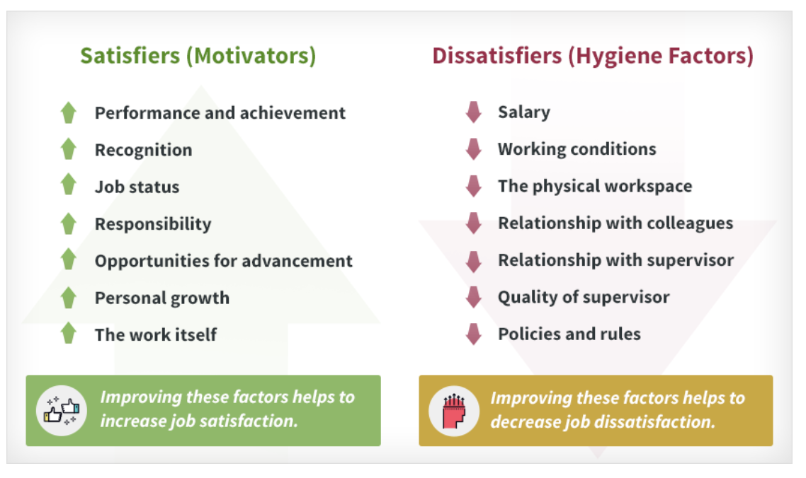
(Herzberg, 1959)

Appendix B

Evidence of increasing staff turnover rates within the civil service.

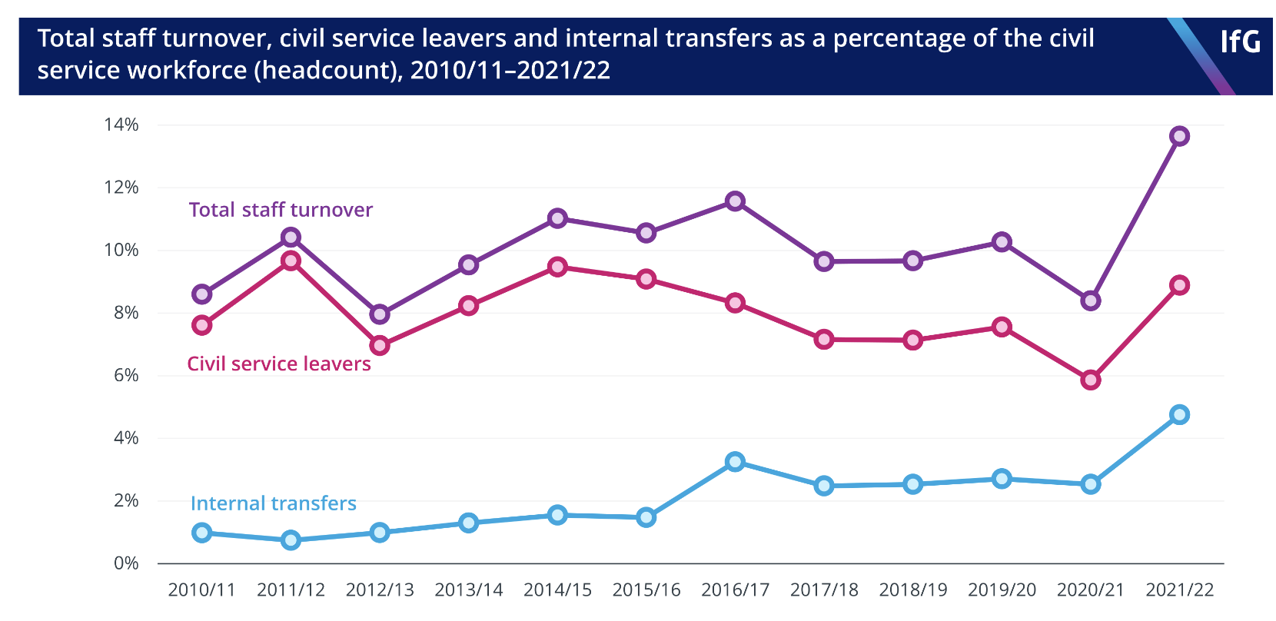
(Institute for Government, 2022)

Appendix C

Civil servants’ intention to leave the civil service.
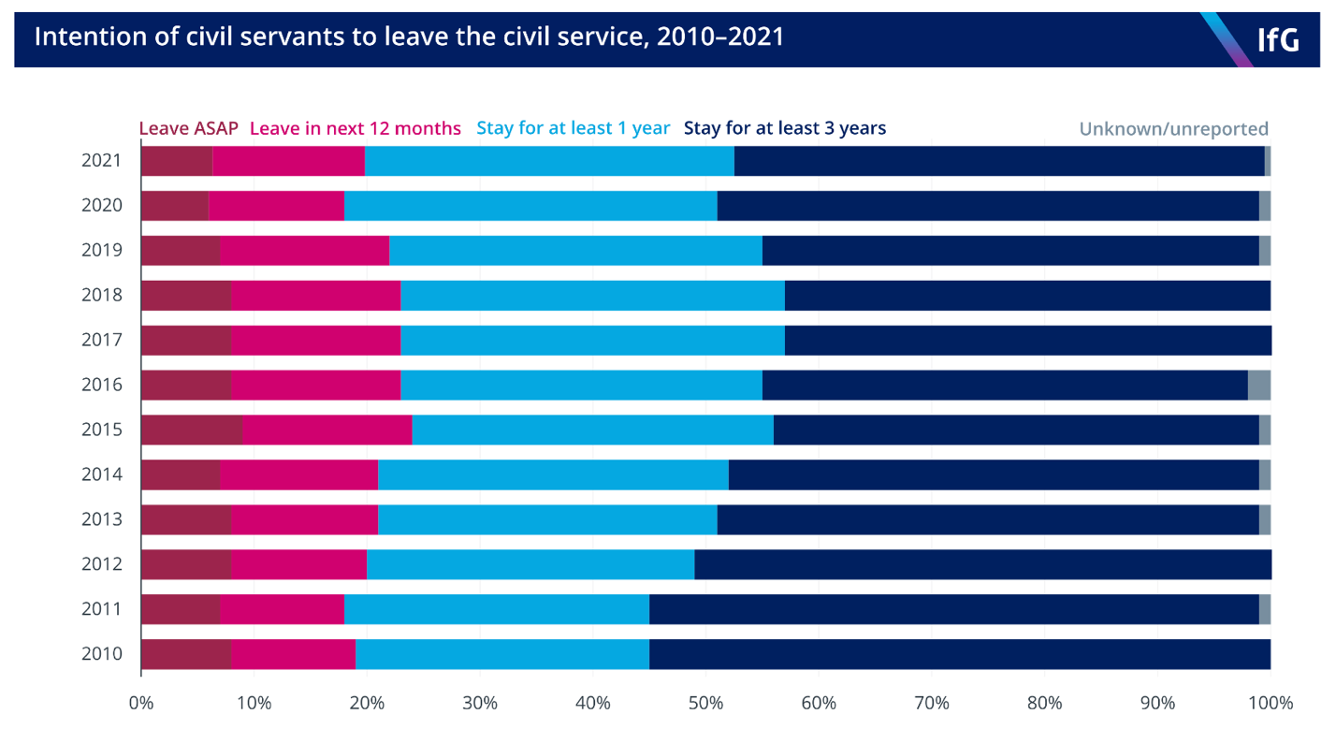
(Institute for Government, 2022)

Appendix D

The civil service performance management documents:

https://assets.publishing.service.gov.uk/government/uploads/system/uploads/attachment_data/file/1080684/SCS-PM-UpdatedGuidance-APRIL-2022-V.2.pdf

https://assets.publishing.service.gov.uk/government/uploads/system/uploads/attachment_data/file/446672/PM_Arrangements_SCS_May15_v.22_fv_.pdf

Appendix E

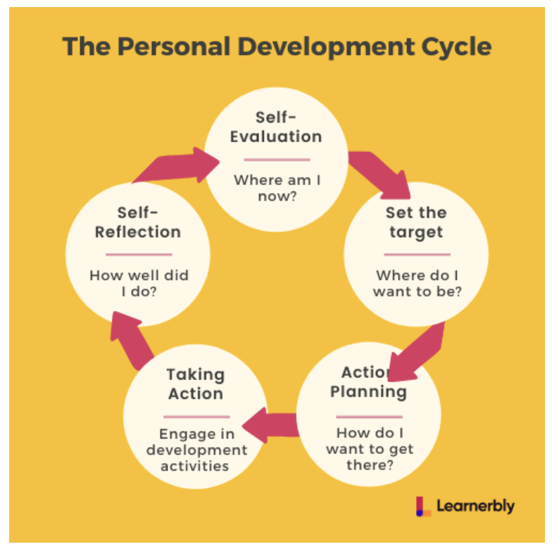
(Malec, 2022)

Appendix F

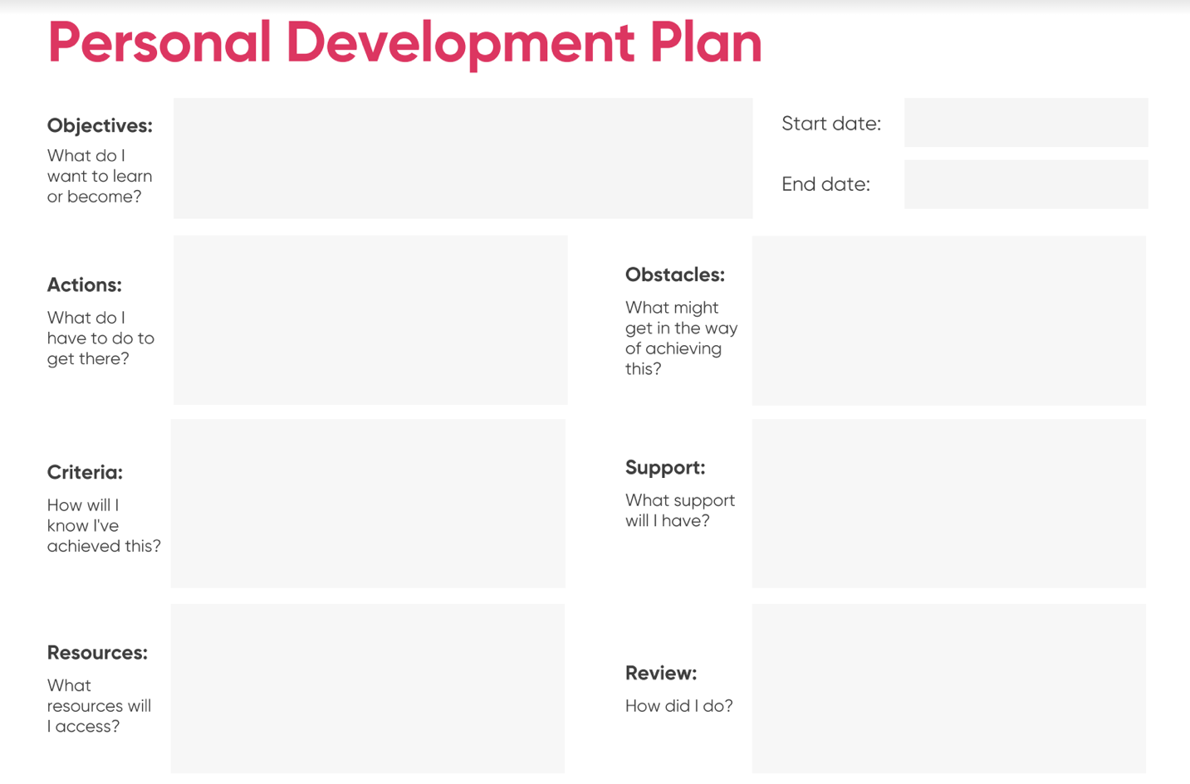

Appendix G

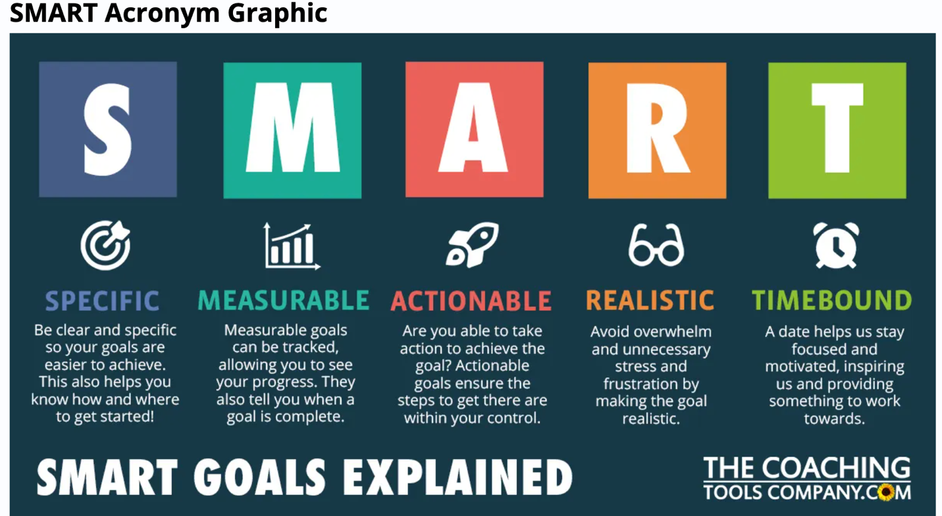

Appendix H

Civil service success profiles:
https://assets.publishing.service.gov.uk/government/uploads/system/uploads/attachment_data/file/717275/CS_Behaviours_2018.pdf

Appendix I

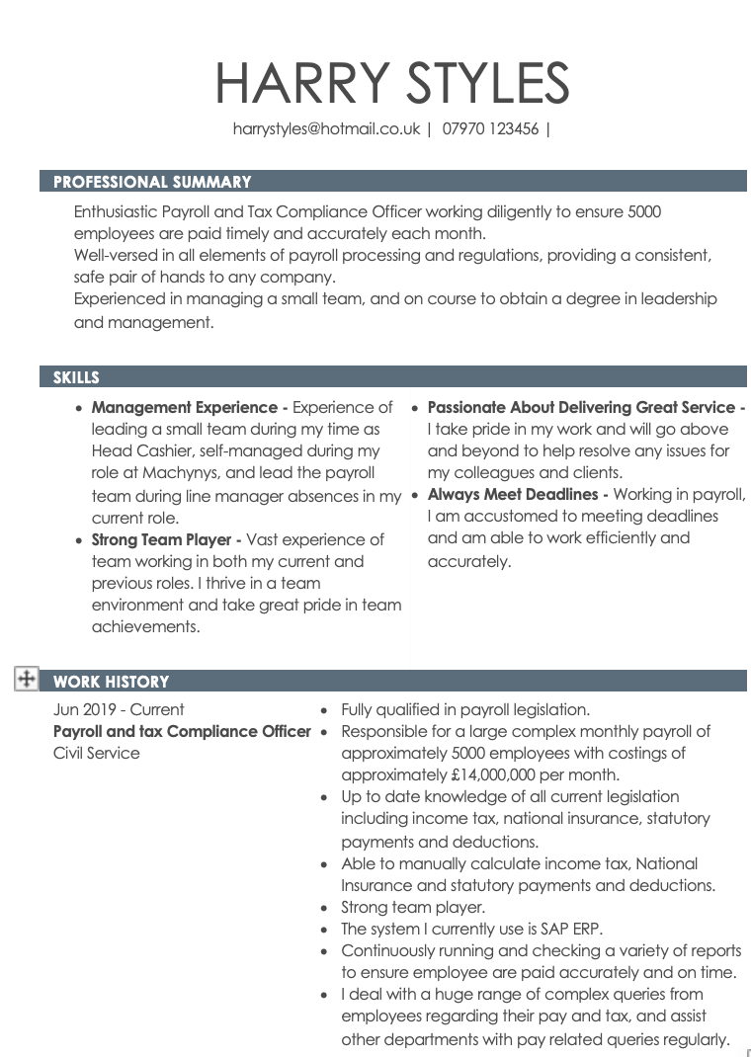

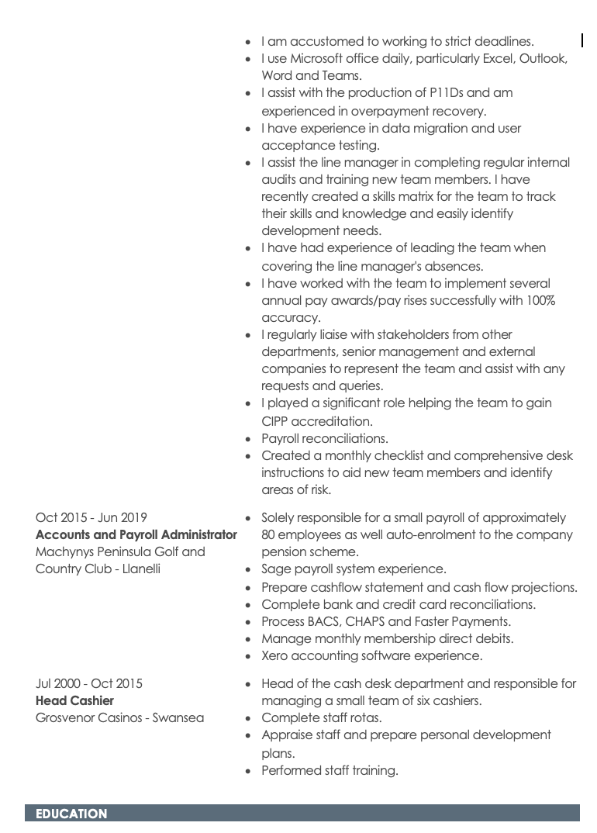
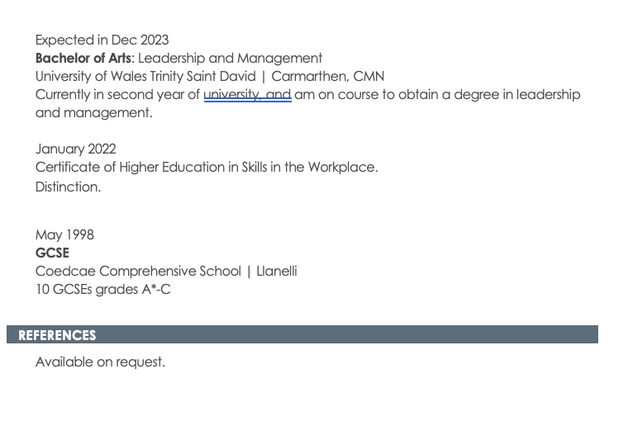

Appendix J

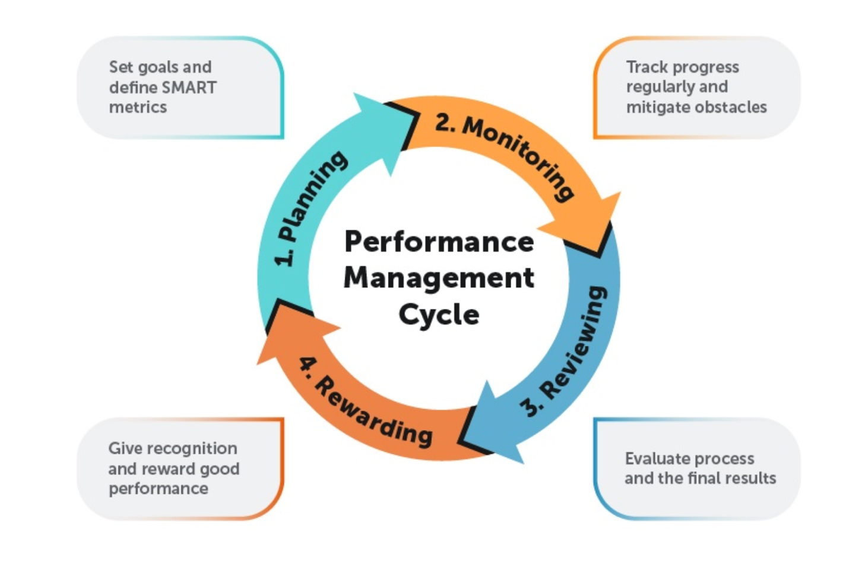
(Valamis, 2021)

