Financial Management for the Hotel Industry
Assignment no1
BMIH5007
Student name: Andreea Marin
Student number: 2206723
Lecturer name: Tristan Hawkins

Executive Summary

The report has covered the financial practices and management strategies of two hotels Corinthia Hotel and Ibis Hotel. The report has explored the aspects of revenue such as its source, trend and factors lead to growth or decline within the revenue. Different marketing aspects has been focused on the report which includes strategies, opportunities and potential threat in the growth. The report has also described the different ethical and sustainable practices of the both hotels.

Table of Contents
Introduction 5
Analysis and Comparison of total revenue generated by Corinthia Hotels and Ibis Hotels using different aspects 6
Sources and revenue trends of Corinthia Hotels 6
Sources and revenue trends of Ibis Hotels 7
Factors driving the revenue growth and decline 8
Assessment of market positioning of both hotel groups 9
Market share of Corinthia Hotels 9
Market share of Ibis Hotels 9
Customer Demographics of Corinthia Hotels 10
Customer Demographics of Ibis Hotels 10
Brand perception of Corinthia Hotels 11
Brand perception of Ibis Hotels 11
Indicating the growth potential of the Corinthia Hotel Group and Ibis Hotels business 12
Showing the growth potential of Corinthia Hotel Group in terms of expansion strategies, market opportunities, and potential barriers to growth 12
Representing the growth potential of Ibis Hotels in terms of expansion strategies, market opportunities, and potential barriers to growth 13
Indicating the financial commitment towards the activities of CSR of Corinthia Hotel Group and Ibis Hotels 14
The financial commitment of each organisation to CSR initiatives in terms of sustainability practices, community engagement, and ethical business practices of Corinthia Hotel Group 14
The financial commitment of each organisation to CSR initiatives in terms of sustainability practices, community engagement, and ethical business practices of Ibis Hotels 15
Recommendation 16
Conclusion 17
References 18

Introduction
Revenue refers to the money that is generated by the company by selling its goods and services The report will highlight the financial practices and management strategies followed by both hotels to generate revenue. The report will also explore the market position of both companies based on the share covered by both companies, customer demographics and brand perception within the hospitality market and industry. The report will focus on the potential growth of the company by examining their expansion strategies, opportunities within the market and barriers faced by them. The report will also present the aspects of social responsibility of both companies.

Analysis and Comparison of total revenue generated by Corinthia Hotels and Ibis Hotels using different aspects

Sources and revenue trends of Corinthia Hotels
Years | Revenue earned by Corinthia Hotel Group
2019 | 5119
2020 | 75649
2021 | 30328

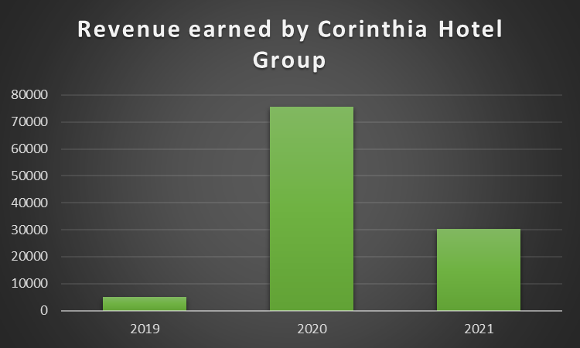
Figure: Revenue Trend of Corinthia Hotels
Self-created
Corinthia Hotels generated the highest revenue in the year 2020 which is reflected in the bar diagram. This generation of huge revenue occurred due to indulgence in various activities such as access to 800 luxury room accommodations, dining, spa and meeting facilities. They also offer complimentary Wi-Fi services to its customers (Corinthiagroup.com, 2023). The high-quality services provided by Corinthia Hotels resulted in the growth of revenue. The firm faced a shaft downfall in 2021 after the arrival of the pandemic scenario which resulted in a huge gap in the revenue between two years.

Sources and revenue trends of Ibis Hotels
Years | Revenue earned by Ibis Group
2019 | 6491
2020 | 84322
2021 | 43983

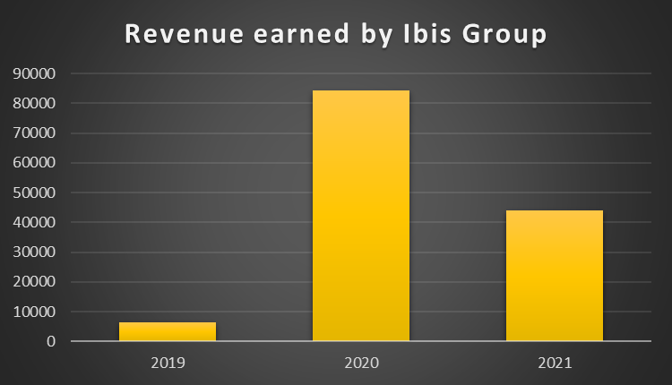
Figure: Revenue Trend of Ibis Hotels
(Self-created)
The revenue of Ibis Hotels is reflected to be more than that of Corinthia Hotels. This firm has also earned the highest revenue in the year 2020. The firm offers guarantees on its pricing policy which attracted a large base of customers in the year 2020. The firm offers premium and luxurious services to its customers along with different amenities such as parking and spa services. These extra facilities provided a major contribution to the growth and source of revenue.

Factors driving the revenue growth and decline
The revenue of both hotels is majorly generated from the common operations such as renting rooms and providing luxurious and premium services to the customers. The firms such as Corinthia Hotel Groups and Ibis Hotels also focused on providing additional services to its customers which resulted in the growth of the firm during 2020. Corinthia Hotels has changed its low-rated services into lucrative services to sustain itself within the competitive market. Ibis Hotel targets premium customers to sustain itself in the market. The rise of the pandemic has resulted in the downfall of the Hotels as they remained shut down for successive months (Spanaki et al., 2021).

Assessment of market positioning of both hotel groups

Market share of Corinthia Hotels
The existence of Corinthia Hotel in London reflects its presence in different regions of the country and its brand awareness is spread from Thames to Buckingham Palace. The firm has a 25% share in the secondary market which helped the firm to rise 250 million shares to mitigate the issues caused by the coronavirus pandemic and sustain its business within the competitive market. There are 800 hotels across the globe which reflects its global share of 1 to 2%.

Market share of Ibis Hotels
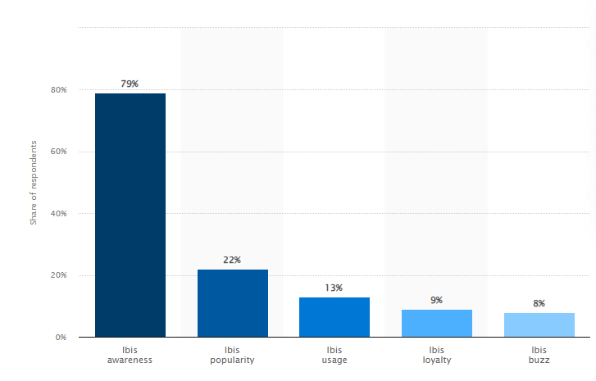
Figure: Market share of Ibis Hotels in the UK
Source: (Statista, 2023)
The market share of the Ibis Hotels reflects 79% of brand awareness across the UK. The premium services offered by the firm reflect its popularity among the population of the UK which is 22%. Among 100 people 13 people have used the services provided by Ibis Hotel and among them, nine people are ready to avail the services again and again (Statista, 2023). This reflects that 9% of the people in the market show loyalty towards the brand. The remaining population has the buzz of Ibis Hotel's existence in the UK and its premium services song with beneficial amenities such as parking and spa facilities.

Customer Demographics of Corinthia Hotels
The firm provides luxurious services to its customers; thus, its major segment comprises the people who avail luxury over the economy. The customer segment includes the upper-class and upper-middle-class section of the society. The majority of the customers belong to the age group between 25 to 35 to attend different events. The prime location of the hotel in London attracts customers belonging to different segments such as booking for meetings, dining or get-togethers or any important events such as conferences. After the age group of 25 to 25, the age group of above 40 can be seen in the hotels to attend conferences and meetings of the hosting companies or as elite business individuals.

Customer Demographics of Ibis Hotels
Ibis Hotel includes the premium segment of customers who enjoy the comfortable services provided by the staff members of the company. The comfort of the hotel majorly attracts family visits and recreational visits to the hotel. The hotel also includes different scaled people such as upscale, midscale and economically scaled people. This segment is attracted towards the services of Ibis Hotel due to its personalised services offered to its customers.

Brand perception of Corinthia Hotels
The popularity among the people has been rated 5 on the 1 to 5 scale. More than 3000 people have reviewed the presence and functioning of Corinthia Hotels and presented that the firm has outstanding services in the UK market. The brand awareness of the firm among the people can be developed with the use of digitalisation.

Brand perception of Ibis Hotels
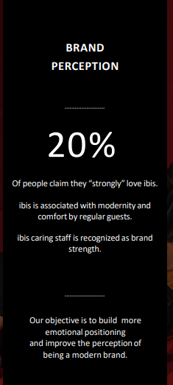
Figure: Brand perception of Ibis Hotels
Source: (Hendriyatmoko and Poernomo, 2023)
The brand perception of Ibis Hotels reflects 20% perception among the people as it reflects a strong comfort within its services. The firm also includes modern technology in its services to meet the requirements of its customers (Hendriyatmoko and Poernomo, 2023). The primary task of the firm is to build a strong position among the people and get emotionally connected to them.

Indicating the growth potential of the Corinthia Hotel Group and Ibis Hotels business

Showing the growth potential of Corinthia Hotel Group in terms of expansion strategies, market opportunities, and potential barriers to growth
Expansion strategies
Corinthia Hotel Group has an outstanding opportunity for development by making deliberate activities to increase and availing into deliberation fresh income promises. The business devotion to comfortable hotels puts the situation in an ideal location to exploit the increasing claim for first-rate housing around the sphere. By exploiting a merger of controlling assemblies along with management arrangements, Corinthians Hotel Group expects to increase its discernibility in indispensable worldwide locations (Fuchs et al., 2024).
Market opportunities
Possible accomplishments are sufficient as the luxurious tourism subdivision keeps growing due to the growing demand for excellent amenities plus more income. Corinthia’s Hotel Group’s focus on the contribution of exceptional provision to its patrons is in possession of embryonic tastes among clientele, giving them an advantage over the rivalry (Bolt and Homer, 2024).
Potential barriers to growth
Some steeplechases to growth include ferocious rivalry in the fashionable hotel industries, qualms in the budget that might impression vacation monotonous, and lawmaking problems in different parts. Ensuring supportable expansion will mean circumnavigating ambassadorial adverse belongings along with submitting to local commandments.

Representing the growth potential of Ibis Hotels in terms of expansion strategies, market opportunities, and potential barriers to growth
Expansion strategies
Ibis Hotels, segments of the Accor group, indicates substantial growth likelihood finished employing a speckled operation policy. Ibis Hotels pursues to take advantage of growing market potentials in both industrialised and new countries by organising its robust licences model with tactical businesses. The business’s promise of low-priced lodging cascades well with the increasing demand of economical tourists who request high-quality lodgings.
Market opportunities
As a greater quantity of persons journey on controlled funds around the world, there has been an increasing demand for greater, cheaper housing. This has transported about promises for markets. Ibis Hotel acclimatises to the ever-changing tastes of current-day tourists by improving the guest experience via the use of technical advancements and absorbing customers’ strategies.
Potential barriers to growth
Significant barricades to growth include fierce competition in the affordable hotel market, vicissitudes in the reduced that impact portable patterns, counting having to regulate various unconventionalities of culture in dissimilar nations. Ibis Hotels must direct regulatory difficulties and balance calibration with localisation to guarantee sustained accomplishment (Huang et al., 2024).

Indicating the financial commitment towards the activities of CSR of Corinthia Hotel Group and Ibis Hotels

The financial commitment of each organisation to CSR initiatives in terms of sustainability practices, community engagement, and ethical business practices of Corinthia Hotel Group
Sustainability practices
The Corinthia Hotel Group dedicates a siseable helping of its yearly revenue to CSR fundraising, it is not readily accessible as corporation monetary matters are unceasing. Unpredictably, sustainable systems receive approximately all of this backing speculation. With a normal per year duty outstanding 5% of the business’s allocated funds, Corinthia Hotel Group makes labourers in waste removal, energy-actual technology, and environmentally mindful operating approaches (corinthia, 2023).
Community engagement
Regarding outreach to the communal, Corinthia Hotel Group goes well outside the call of responsibility with admiration to of finances; a precise fund gives out around 3% of the corporation’s yearly revenue for humanitarian schemes, enlightening efforts, and counting associations with non-profit societies. This validates how dedicated the Complete is to emerging productive communal effects in the societies where it conducts business.
Ethical business practices
Ethical business activities are reinforced by Corinthia Hotel Group’s investment in worker training and upholding a comprehensive work setting. The pledge to ethical performs is proven through reliable financial sustenance, on behalf of about 2% of the yearly budget for exercise agendas and creativities promoting see-through business performance.

The financial commitment of each organisation to CSR initiatives in terms of sustainability practices, community engagement, and ethical business practices of Ibis Hotels
Sustainability practices
Ibis Hotels, as a segment of the Accor group, donates a substantial share of their properties to generous projects. The yearly revenue selected for environmental schemes is around 4% which includes spending on maintainable working regulations like trash removal, and thermal competence improvement for all of the commerce’s places (accor, 2023).
Community engagement
Addressing its participation in public affairs, Ibis Hotels exhibitions an inexpensive dedication of about 2.5 % about its general spending near philanthropic activities, educational efforts, and collaboration with charitable groups. The pledge proves how dedicated the business is to having a hopeful social effect through every field in that the business behaviours commercial (Vaughan et al., 2024).
Ethical business practices
The backing available for accountable business events amounts to everywhere 3% of the annual budget. The incomes go into subsidiary open company processes across the complete supply chain, as long as a varied and welcoming factory, and sponsoring exercise for workers exertions.

Recommendation
Basically, two respective hotel businesses have suggested enhancing their performance by focusing on internal activity as this is useful for allocating the resources to the right task and utilising this to get the most benefits. Along with this, the more intention over the system of gaining control over the cost drivers can lead to a situation where any kind of misuse of the resources can be completely reduced ultimately enhancing their performance.

Conclusion
This report has been on the functional activity of Corinthia Hotel Group and Ibis Hotels in a specific period with the motive of generating sufficient returns with its daily tasks. The level of the gained income as well as market position after offering their services to the consumers has been represented by the help of the Excel chart and graphs. Based on that, the higher management has been capable of making effective business decisions that are useful to accomplish the determined target in a precise manner. Along with that, CSR activities of this well-known hotel business for the development of the environment as this is another primary goal of running their operation without any kind of burden.

References
accor, (2023). VIBRANT HOTELS, CARING PEOPLE.. [Online] Available at: https://all.accor.com/brands/ibis.en.shtml [Accessed 1 February 2023].
Bolt, E.E.T. and Homer, S.T., (2024). Employee corporate social responsibility and well-being: the role of work, family and culture spillover. Employee Relations: The International Journal.
corinthia, (2023). ELEGANT SURROUNDINGS. [Online] Available at: https://www.corinthia.com/ [Accessed 1 February 2023].
Corinthiagroup.com, (2023). Annual Repot and Financial statement 2022. [Online] Available at: https://www.corinthiagroup.com/wp-content/uploads/2023/06/37547-CORINTHIA-ANNUAL-REPORT-2022_WEB-min.pdf [Accessed 31 January 2024].
Fuchs, K., Prideaux, B. and Konar, R., (2024). An exploratory study on tourist perception of green hotels: Empirical evidence from UK. Journal of Vacation Marketing, p.13567667231225475.
Hendriyatmoko, D. and Poernomo, M.I., (2023). Communication Of The Crisis Of Hotel Ibis Budget Daan Mogot Jakarta In Facing The Covid-19 Pandemic. International Journal Of Humanities Education and Social Sciences, 3(2).
Huang, M., Geng, S., Yang, W., Law, K.M. and He, Y., (2024). Going beyond the role: How employees’ perception of corporate social responsibility fuels proactive customer service performance. Journal of Retailing and Consumer Services, 76, p.103565.
Spanaki, M.Z., Papatheodorou, A. and Pappas, N., (2021). Tourism in the post COVID-19 era: evidence from hotels in the North East of England. Worldwide Hospitality and Tourism Themes, 13(3), pp.357-368.
Statista, (2023). Ibis brand awareness, usage, popularity, loyalty, and buzz among hotel customers in the UK in 2022. [Online] Available at: https://www.statista.com/forecasts/1335566/ibis-hotels-brand-profile-in-the-uk#:~:text=All%20in%20all%2C%2013%25%20of,in%20the%20UK%20use%20Ibis. [Accessed 31 January 2024].
Vaughan, Y., (2024). Preventing Modern Slavery Through Corporate Social Responsibility Disclosure: An Analysis of the US Hospitality and Tourism Industry. Cornell Hospitality Quarterly, 65(1), pp.120-135.

