

Programme: Master of Business Administration
Module: Marketing Management
Module code: LCMB7024

Marketing Management: Brand Development Portfolio
Samsung EcoLife: A Sustainable Brand Extension

Student name: Bhaveshkumar Arashibhai Odedara
Student id: 2536676
Lecturer name: Tushara Balendran
Word count: 2578
Submission date: 14th August 2026

Table of Contents
Element 2: Segmentation, Targeting, Differentiation and Positioning (STDP) Analysis 3
2.1 Segmentation 3
2.2 Targeting 4
2.3 Differentiation 4
2.4 Positioning 5
Element 3: Marketing Mix (7Ps) 6
3.1 Product 6
3.2 Price 7
3.3 Place 8
3.4 Promotion 8
3.5 People 8
3.6 Process 9
3.7 Physical Evidence 10
Element 4: Reflection 10
References 12
Appendix- Element 1-Sustainable Brand Extension Poster Presentation 15

Element 2: Segmentation, Targeting, Differentiation and Positioning (STDP) Analysis

2.1 Segmentation
Sustainable-segmentation research of the 21st century (Jaiswal et al., 2021) resonates with the effective market segmentation of Samsung EcoLife which incorporates geographic, demographic, psychographic and behavioural aspects. Geographically, launch should focus on high digital and environmental regulatory maturity markets (the UK, wider EU and South Korea), where there is already WEEE-style extended producer responsibility legislation and established recycling infrastructure, before going to higher growth but less mature markets like India and Southeast Asia, where this is not the case yet (Abdelmeguid and Corsini, 2026).
The primary segment is the urban, high median household income, above-median HHI, 25-44 age group, who already own Samsung Galaxy devices and have been shown to be willing to buy into the Samsung Galaxy Ecosystem throughout the lifecycle of the extension. The secondary segment is Gen Z (18-24), with disproportionately high expectations around sustainability, and who are likely to have a greater purchasing power over the life of the extension (Thomas and George, 2021). In terms of psychographic profile, the target is the “conscious-technology” consumer, which is defined as those who value pro-environmental values but who are not willing to compromise on functionality, design or brand prestige, as opposed to price-conscious mainstream consumers, and deep-green minimalists who are averse to branded, mass-produced electronics altogether.
Behaviorally, high engagement, low acquisition cost, and natural integration are distinct among current SmartThings/Galaxy users, which are different from prospective switchers who need to be actively dissuaded from Apple or third-party eco-accessory brands. Both groups are “sceptical-sustainable” (Rahman and Nguyen-Viet, 2023; Tu et al., 2024; Rinaldi et al., 2026) as consumers are now skeptical about sustainability claims and see them as a tool to discourage purchases if they are not substantiated or are not clear. These bases of segmentation are summarised in Table 1.
Table 1: STDP Segmentation Bases for Samsung EcoLife
Basis | Variable | Description for Samsung EcoLife
Geographic | Primary markets | UK, wider EU and South Korea, mature environmental regulation (e.g. WEEE Directive) and recycling infrastructure
Geographic | Secondary markets | India and Southeast Asia, phased entry once repair/recycling logistics scale
Demographic | Age / income | 25-44, urban professionals, above-median income, existing Samsung Galaxy owners
Demographic | Secondary cohort | Gen Z (18-24) high and growing sustainability expectations
Psychographic | Values | “Conscious-technology” consumers: pro-environmental but unwilling to sacrifice functionality or design
Behavioural | Ecosystem status | Existing SmartThings/Galaxy users (low acquisition cost) vs. prospective switchers
Behavioural | Attitude to claims | “Sceptical-sustainable”: evidence-seeking, greenwashing-aware

2.2 Targeting
Samsung EcoLife follows a differentiated and selective targeting strategy to two priority markets instead of a mass market approach, as is supported by the growing body of evidence that sustainability motivation is not homogeneous among a brand's customers and that undifferentiated green marketing is less effective than segment-specific approaches (Kaur, Gangwar & Dash, 2022). The primary target is the current Galaxy and SmartThings ecosystem user and bringing sustainable values to accessories that are already required, like chargers and cases, and that are most likely to convert to the cross-sell.The primary target is the existing Galaxy and SmartThings ecosystem user and the sustainable values are pushed to accessories that are already required, like chargers and cases, and that are most likely to convert to the cross-sell, where the acquisition cost is low. The second objective is to attract the wider sustainability-minded tech-savvy consumer, primarily from Gen Z and younger millennials, through sustainable marketing and then convert them to the wider ecosystem. These two segments can be targeted with credible and well-substantiated messaging, while the price-sensitive mainstream can be targeted after production scale brings down the unit cost (da Costa Fernandes and Rozenfeld, 2024).

2.3 Differentiation
Samsung EcoLife stands out on three defensible bases that smaller specialist eco-accessory players and larger non-specialist players will not easily be able to duplicate. The first is verified manufacturing sustainability: Samsung's pledge to become RE100 and its demonstrated progress toward net-zero manufacturing lend verified credibility that start-up eco-brands, typically with unverified supply chains, cannot claim at scale. Samsung's collection and reverse logistics system is more about an advantage, not a marketing claim, as only 22.3 per cent of the sixty-two million tonnes of e-waste generated worldwide in 2022 was formally recycled (ITU/UNITAR, 2024). Secondly, technology-driven transparency: Brands outside Samsung's ecosystem lack the ability to track carbon and material-recovery in real time on an individual basis, as is possible with SmartThings integration, which could be considered a new “digital product passport” (Heeß et al., 2024). Thirdly, the implementation of a genuinely circular approach with repairable design and a well-designed trade-in and recycling programme, demonstrating that EcoLife is not a “one-use” eco-product but rather a genuine product-service system (da Costa Fernandes and Rozenfeld, 2024). These bases directly challenge the greenwashing scepticism which, in the context of sustainable electronics, has been measured to affect buy intention across the board (Qayyum, Jamil and Sehar, 2023).

2.4 Positioning
Samsung EcoLife is the smart and eco-friendly accessory that is verifiable, connected and circular not just an eco-product that's attached to the Samsung device for the Samsung ecosystem user who doesn't want to sacrifice smart function for eco-consciousness.
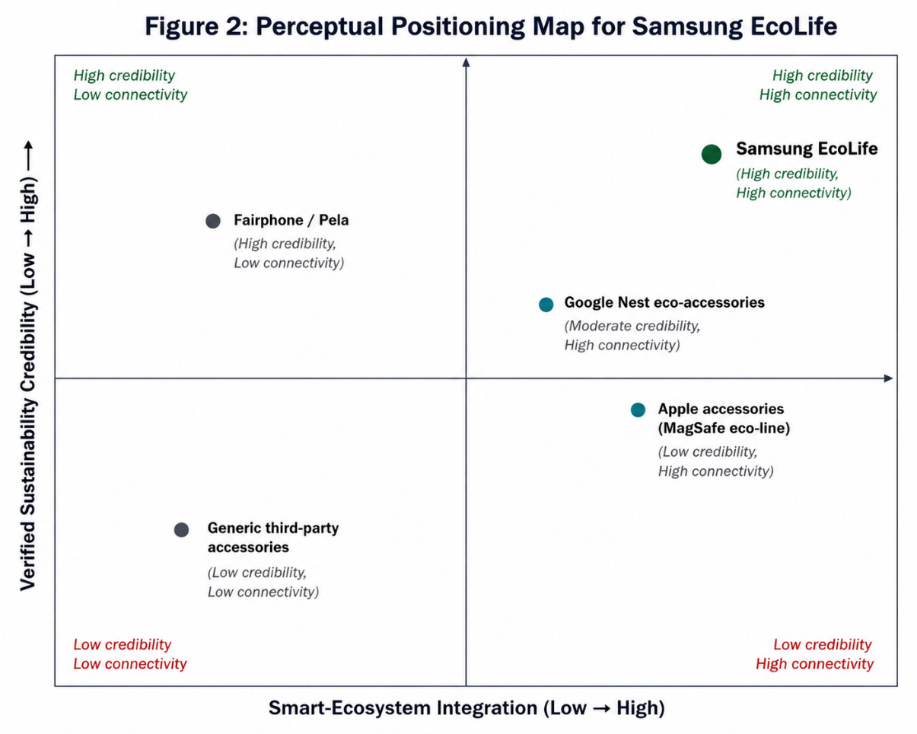
Figure 1: Perceptual Positioning Map for Samsung EcoLife
Source: Author
In Figure 1, EcoLife is plotted with other key players along sustainability credibility and ecosystem integration, and positioned in the quadrant of credible, but less integrated brands like Fairphone or Pela, and the quadrant of mainstream accessory brands which are less credible and less integrated. This is done to encourage customers to buy, seeing the tangible results of impact, and investors to have a clear revenue stream.

Element 3: Marketing Mix (7Ps)

3.1 Product
Samsung EcoLife's flagship collection includes a smart home line of accessories such as phone cases, chargers and modular lights made from recycled ocean-bound plastic and reclaimed aluminium. The actual product is the physical accessory, designed for durability and ease of disassembly; the core benefit is protection and functional utility; and the augmented product is the sustainability ecosystem surrounding it, which includes RE100-produced parts, a structured trade-in and recycling initiative and SmartThings carbon-tracking. The augmented layer is the most critical part of the offer, as recent branding research shows that sustainable attributes that have been substantiated and verified, and not functional claims, are today the most effective drivers for brand extension acceptance in mature technology categories (Hesse et al., 2022; Golob et al., 2022). Repairability is built into the product architecture, rather than added on, in line with the principles of circular product-services systems, as opposed to a traditional linear buy-and-discard approach (da Costa Fernandes and Rozenfeld, 2024; Abdelmeguid and Corsini, 2026). Furthermore, the smart-home adoption study consistently found interoperability and perceived usefulness as key barriers or enablers to smart-home adoption (Basarir-Ozel, Turker and Nasir, 2022; Strzelecki, Kolny and Kucia, 2024), and the ease with which EcoLife accessories connect to an ecosystem of millions of Galaxy owners who use it daily means that the product avoids the 'standalone-adoption friction' that independent smart-home accessory start-ups experience.
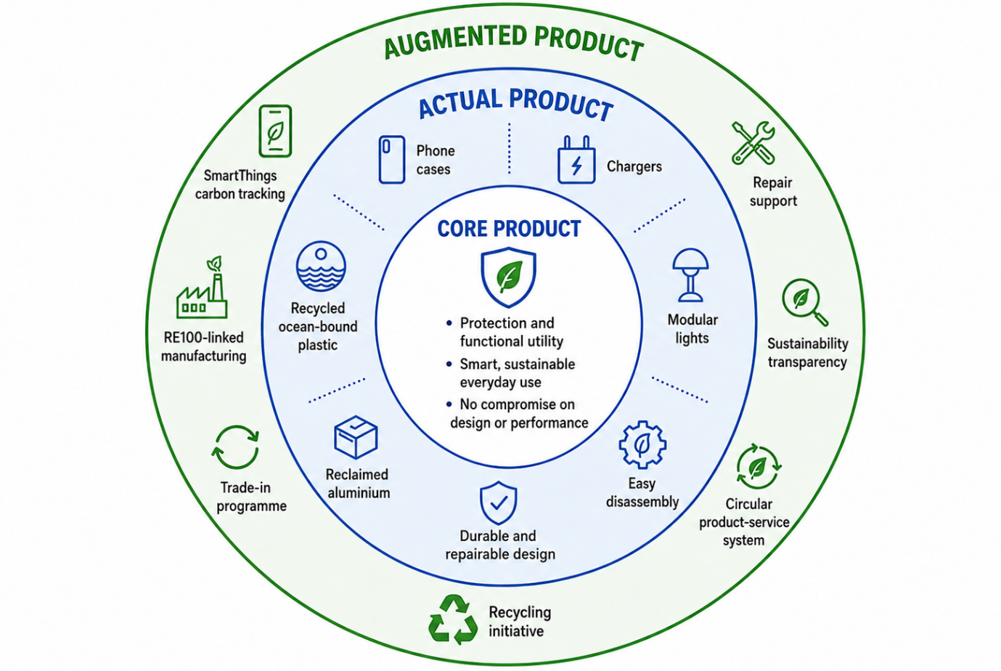
Figure 2: Samsung EcoLife Three Levels of Product

3.2 Price
The value-based premium pricing strategy is recommended, where the sustainability credentials of the product are substantiated and not just claimed. Evidence suggests that consumers are willing to pay a real premium for verifiably sustainable products, especially when social reference groups endorse the purchasing decision (Shi and Jiang, 2023), and PwC's (2024) worldwide consumer survey revealed that 9.7 per cent on average was their willingness to pay for sustainability premiums. This pricing of EcoLife accessories which are around ten to fifteen per cent higher than the corresponding non-sustainable Samsung lines, is therefore commercially defensible, as long as the added value is transparently represented, such as itemising the cost of sourcing recycled materials and reverse logistics infrastructure. This transparency is necessary as unexplained green premiums have been found to be a driver of greenwashing scepticism and can reduce purchase intention (Rahman and Nguyen-Viet, 2023; Tu et al., 2024). If the claims are believable, however, the result is positive brand attitude, a desire to pay a premium and positive word of mouth (Fatemi et al., 2023), and genuine environmental marketing has been proven to directly lead to purchase decisions and not just be a stated preference (Baca and Reshidi, 2025). The pricing should therefore go hand-in-hand with the evidence-based promotional approach listed below, not as a stand-alone decision.

3.3 Place
The distribution strategy includes Samsung's own digital storefront and flagship Experience Stores along with in-app purchasing through SmartThings, which will enhance the convenience of the main ecosystem-users and reinforce the positioning of the technology. Most importantly, place also works in reverse: retail and online collection points are also the take-back channel for the trade-in and recycling programme, closing the loop that sets EcoLife apart from its competitors, which offer sustainable products through conventional, one-way retail channels (da Costa Fernandes and Rozenfeld, 2024).

3.4 Promotion
Emotive statements in promotion should be avoided as there is a lot of research that shows consumers are sceptical about unsupported environmental claims (Qayyum, Jamil and Sehar, 2023; Rinaldi et al., 2026). The SmartThings carbon-tracking dashboard is the main selling element itself, which lets customers see, not just hear, their personal footprint, as an unofficial digital product passport (Heeß et al., 2024). This evidence-based messaging can be directed efficiently to the psychographically defined segment of the conscious technology market with the help of partnerships with credible voices of sustainability, and not through broad celebrity endorsements, which research has correlated with lower perceived authenticity in green marketing communications (Kaur, Gangwar and Dash, 2022). That green brand positioning has a significant effect on purchase intention, which is mediated by attitude toward the brand and green trust (Wang, Zaman and Alvi, 2022), and that eco-brand positioning is more effective to increase sustainable consumption than novelty alone, when supported by brand familiarity (Jian and Zhong, 2025), Samsung's current brand familiarity is thus a promotional advantage that newer eco-accessory brand entrants may not possess.

3.5 People
Front-line Samsung Experience Store personnel and customer service staff need to be trained on the sustainability aspects of EcoLife, as well as how the trade-in program works, as it is known that inconsistent and unclear messaging from front line staff reduces green brand equity (Qayyum, Jamil and Sehar, 2023). Inside companies, there is a need to coordinate internal marketing, supply chain, and sustainability teams to ensure that promotional claims are true despite changes in manufacturing and recycled content data over time.
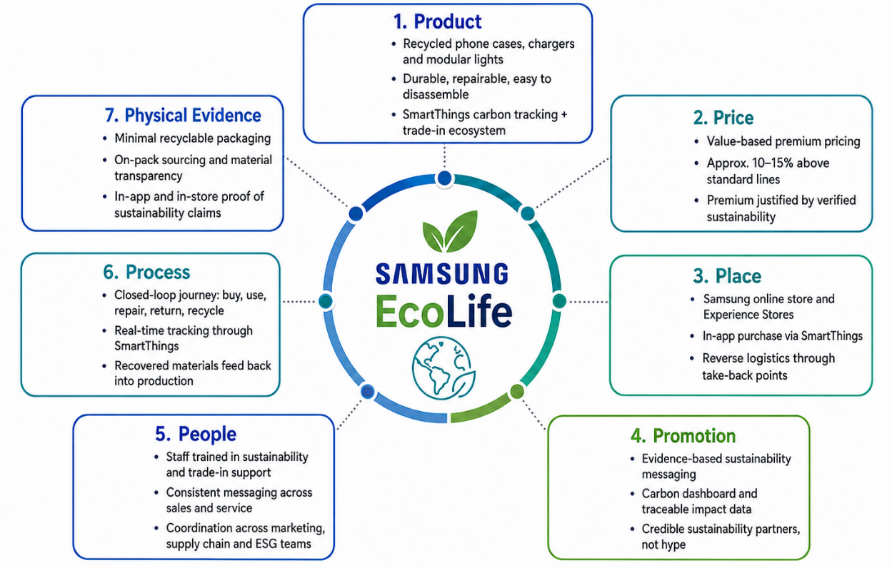
Figure 3: Samsung EcoLife Marketing Mix (7Ps).
Source: Author

3.6 Process
The customer process is closed loop from purchase to end of life, and is managed with real-time carbon tracking through Samsung's SmartThings to be traded in or repaired, recovered materials are returned to Samsung's recycled-input supply chain.
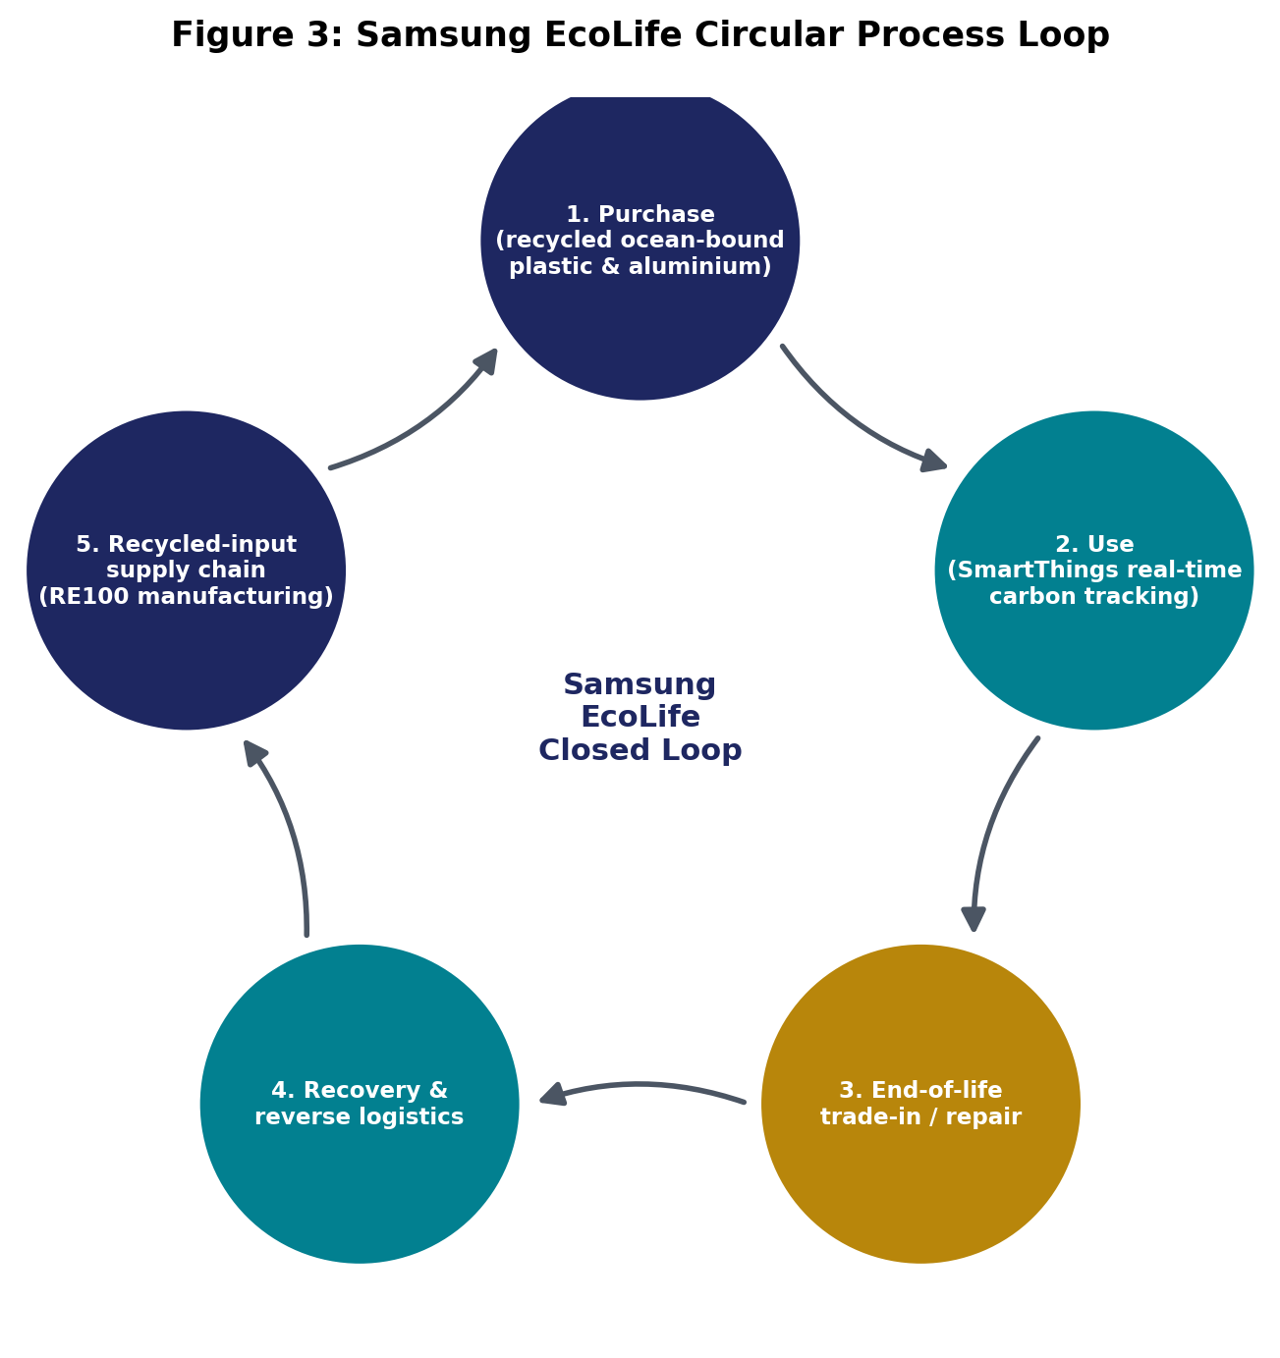
Figure 4: Samsung EcoLife Circular Process Loop
It concretises the product-service system logic that is more and more advocated for circular electronics business models (da Costa Fernandes, Rozenfeld, 2024) and tackles directly some structural barriers to electronics circularity found in the recent systematic reviews, such as reverse logistics complexity (Abdelmeguid, Corsini, 2026) and the inconsistency of consumers in take-back schemes.

3.7 Physical Evidence
Minimal, recyclable, labelled packaging (Branca, Resciniti and Babin, 2024); transparent material-sourcing information on-pack and in-store and the SmartThings application interface as continuous digital physical evidence of the sustainability claim which extends beyond the point of sale. Corporate-level evidence, for example, externally reported evidence of Samsung's own sustainability progress (Samsung Electronics, 2025), should also be available to customers as third party verified evidence, and not be limited to investor-facing reporting. Together, they create a cohesive, unified experience for the customer, both in the physical and digital world, that supports and validates the EcoLife sustainability promise.

Element 4: Reflection
The challenge in creating the Samsung EcoLife brand extension strategy was to shift from one register to the other from the persuasive, benefit-led language of a poster pitch for potential investors and customers, to the more sceptical, evidence-testing register of academic marketing analysis. The most challenging part of the process was to apply the STDP framework. I didn't have any problems describing segments in the abstract; defence of why certain segments were prioritised over others based on evidence as opposed to assumption was much harder and the greenwashing-scepticism literature I came across repeatedly required me to question my own claims of Samsung EcoLife the same way that I would question a competitor's claims.
I have come to a better understanding that a sustainable brand extension is not just a ‘green' product added to an existing brand, but a coordinated system where the pricing, distribution, people and process should all back up the same sustainability message. One weak point, for example, poor pricing transparency or poorly trained retail employees is enough to destroy consumer confidence in the entire offer. This relates directly to the marketing emphasis of the module as a cross functional organisational activity as opposed to a marketing activity alone, which directly influenced my critical thinking around sustainability marketing in this assignment as well as when I am a consumer.
The process of creating a poster presentation introduced a unique set of skills. In fact, the challenge of presenting a complex, literature-based argument in a three-to-five minute, visual presentation required a ruthless prioritisation of evidence and a more critical eye on the evidence that a non-specialist audience (including potential investors) needed to be convinced of, rather than an academic reader. The time limit also helped me with verbal delivery, and I was confident in presenting a strategic recommendation in a timely manner, which is a skill I will need in future client-facing consulting or management positions.
It also revealed some gaps I plan to fill in the process. My positioning analysis was done using secondary data and industry data and not primary consumer data, which would have been helpful in future projects to confirm some of my segment assumptions rather than assuming them from literature. I would also make the financial argument for premium pricing more explicit by modelling the unit-economics earlier in the design process than the poster was finished, and get feedback from peers earlier on the visual hierarchy than the close of the design process. In general, describing, evaluating and critically analysing this experience has revealed that I will be more evidence-based skeptical of my own strategic claims in the future, and in a regular manner, not just when I'm asked to reflect.

References
Abdelmeguid, A. and Corsini, L. (2026) 'Barriers and enablers of circular economy in electrical and electronic equipment: a systematic literature review', Business Strategy and the Environment. Available at: https://doi.org/10.1002/bse.70559 (Accessed: 9 August 2026).
Baca, G. and Reshidi, N. (2025) 'Green branding and consumer behavior, unveiling the impact of environmental marketing strategies on purchase decisions', Business Strategy and the Environment, 34(3), pp. 3701-3713. Available at: https://doi.org/10.1002/bse.4172.
Basarir-Ozel, B., Turker, H.B. and Nasir, V.A. (2022) 'Identifying the key drivers and barriers of smart home adoption: a thematic analysis from the business perspective', Sustainability, 14(15), article 9053. Available at: https://doi.org/10.3390/su14159053 (Accessed: 9 August 2026).
Branca, G., Resciniti, R. and Babin, B.J. (2024) 'Sustainable packaging design and the consumer perspective: a systematic literature review', Italian Journal of Marketing, 2024(1), pp. 77-111. Available at: https://doi.org/10.1007/s43039-023-00084-1
da Costa Fernandes, S. and Rozenfeld, H. (2024) 'Business model innovation through the design of circular product-service system value propositions: a method proposal', Business Strategy and the Environment, 33(6), pp. 5325-5345. Available at: https://doi.org/10.1002/bse.3759.
Fatemi, H., Leijerholt, U., Rezvani, Z. and Schnittka, O. (2023) 'Consumer responses to sustainable product branding strategies: a literature review and future research agenda', Baltic Journal of Management, 18(4), pp. 525-542. Available at: https://doi.org/10.1108/BJM-11-2022-0412.
Golob, U., Burghausen, M., Kernstock, J. and Davies, M.A.P. (2022) 'Brand management and sustainability: exploring potential for the transformative power of brands', Journal of Brand Management, 29(6), pp. 513-519. Available at: https://doi.org/10.1057/s41262-022-00293-7.
Heeß, P., Rockstuhl, J., Körner, M.-F. and Strüker, J. (2024) 'Enhancing trust in global supply chains: conceptualizing Digital Product Passports for a low-carbon hydrogen market', Electronic Markets, 34(1), article 10. Available at: https://doi.org/10.1007/s12525-024-00690-7 (Accessed: 9 August 2026).
Hesse, A., Bündgen, K., Claren, S. and Frank, S. (2022) 'Practices of brand extensions and how consumers respond to FMCG giants' greening attempts', Journal of Brand Management, 29(6), pp. 520-537. Available at: https://doi.org/10.1057/s41262-022-00274-w
International Telecommunication Union and United Nations Institute for Training and Research [ITU/UNITAR] (2024) The Global E-waste Monitor 2024. Geneva/Bonn: ITU/UNITAR. Available at: https://ewastemonitor.info/the-global-e-waste-monitor-2024/ (Accessed: 9 August 2026).
Jaiswal, D., Kaushal, V., Singh, P.K. and Biswas, A. (2021) 'Green market segmentation and consumer profiling: a cluster approach to an emerging consumer market', Benchmarking: An International Journal, 28(3), pp. 792-812. Available at: https://doi.org/10.1108/BIJ-05-2020-0247
Jian, W. and Zhong, Z. (2025) 'Eco positioning drives sustainable fashion consumption through process related strategies and brand familiarity', Scientific Reports, 15, article 17600. Available at: https://doi.org/10.1038/s41598-025-02233-2 (Accessed: 9 August 2026).
Kaur, B., Gangwar, V.P. and Dash, G. (2022) 'Green marketing strategies, environmental attitude, and green buying intention: a multi-group analysis in an emerging economy context', Sustainability, 14(10), article 6107. Available at: https://doi.org/10.3390/su14106107 (Accessed: 9 August 2026).
Kotler, P., Armstrong, G. and Balasubramanian, S. (2024) Principles of Marketing. 19th global edn. Harlow: Pearson Education.
Labib, E. (2024) 'Artificial intelligence in marketing: exploring current and future trends', Cogent Business & Management, 11(1), article 2348728. Available at: https://doi.org/10.1080/23311975.2024.2348728 (Accessed: 9 August 2026).
PwC (2024) PwC's 2024 Voice of the Consumer Survey. Available at: https://www.pwc.com/gx/en/news-room/press-releases/2024/pwc-2024-voice-of-consumer-survey.html (Accessed: 9 August 2026).
Qayyum, A., Jamil, R.A. and Sehar, A. (2023) 'Impact of green marketing, greenwashing and green confusion on green brand equity', Spanish Journal of Marketing - ESIC, 27(3), pp. 286-305. Available at: https://doi.org/10.1108/SJME-03-2022-0032
Rahman, S.u. and Nguyen-Viet, B. (2023) 'Towards sustainable development: coupling green marketing strategies and consumer perceptions in addressing greenwashing', Business Strategy and the Environment, 32(4), pp. 2420-2433. Available at: https://doi.org/10.1002/bse.3256
Rinaldi, F.R., Khatami, F., Cagno, E. and Ferraris, A. (2026) 'Perceived greenwashing: where does scepticism come from?', Journal of Cleaner Production, 554, article 148077. Available at: https://doi.org/10.1016/j.jclepro.2026.148077 (Accessed: 9 August 2026).
Samsung Electronics (2025) Samsung Electronics Sustainability Report 2025. Available at: https://www.samsung.com/global/sustainability/media/pdf/Samsung_Electronics_Sustainability_Report_2025_ENG.pdf (Accessed: 9 August 2026).
Shi, J. and Jiang, Z. (2023) 'Willingness to pay a premium price for green products: does a reference group matter?', Environment, Development and Sustainability, 25(8), pp. 8699-8727. Available at: https://doi.org/10.1007/s10668-022-02419-y
Strzelecki, A., Kolny, B. and Kucia, M. (2024) 'Smart homes as catalysts for sustainable consumption: a digital economy perspective', Sustainability, 16(11), article 4676. Available at: https://doi.org/10.3390/su16114676 (Accessed: 9 August 2026).
Thomas, M.R. and George, G. (2021) 'Segmenting, targeting, and positioning (STP) of generational cohorts Y, Z and Alpha', IIMS Journal of Management Science, 12(2), pp. 115-129. Available at: https://doi.org/10.5958/0976-173X.2021.00008.7
Tu, J.-C., Cui, Y., Liu, L. and Yang, C. (2024) 'Perceived greenwashing and its impact on the green image of brands', Sustainability, 16(20), article 9009. Available at: https://doi.org/10.3390/su16209009 (Accessed: 9 August 2026).
Wang, Y.M., Zaman, H.M.F. and Alvi, A.K. (2022) 'Linkage of green brand positioning and green customer value with green purchase intention: the mediating and moderating role of attitude toward green brand and green trust', SAGE Open, 12(2). Available at: https://doi.org/10.1177/21582440221102441 (Accessed: 9 August 2026).

Appendix- Element 1-Sustainable Brand Extension Poster Presentation



