[Date]

Coursework 2
Course Name: Network Operating Systems and Services Module Code: ACCA 5023 Lecturer Name: Sadeque Imam Shaikh Student Name: Ralph Saramaduo-Hart Student ID: 2411210 Submission Date: 16th December 2025

Contents
1, Introduction 3
Installing Routing and Remote Access Services and modify Firewall to allow ICMP Traffic 3
1.2 VPN 7
1.7 and 1.8 Mount Disk Drive 9
2. Virtualization Environment and Baseline Network Deployment 11
2.1 Hypervisor: Oracle VirtualBox 11
2.3 Internal Network Configuration 11
3. IP Addressing Scheme and Verification 12
4. Routing and Remote Access Services 12
5. Active Directory Domain Services and DNS 12
6. Site-to-Site VPN 12
7. User Management 12
8. Domain Membership 12
9. DHCP Services 13
10. Testing and Troubleshooting 13
11. Disk Management and File Sharing 13
12. IIS Web Server 13
13. Remote Desktop Services 13
Conclusion 13
References 14
Appendix A: Configuration and Testing Screenshots 15

1, Introduction
This report documents the design, deployment, configuration and testing of a Network Operating Systems (NOS) environment for Coursework 2 of ACCA5023. The implementation demonstrates the practical application of core NOS concepts using Windows Server 2022 and Linux (Debian) within a virtualized environment.
The primary objective of this coursework is to evidence the ability to deploy, manage and secure critical network services, including routing, directory services, name resolution, dynamic host configuration, secure remote access, web services and remote desktop services. The report integrates technical configuration with theoretical justification and industry best practices, as required at Level 5.
All configurations were implemented using Oracle VirtualBox as the hypervisor. Screenshots evidencing each task are provided in the appendices and are explicitly referenced throughout this report.

Installing Routing and Remote Access Services and modify Firewall to allow ICMP Traffic
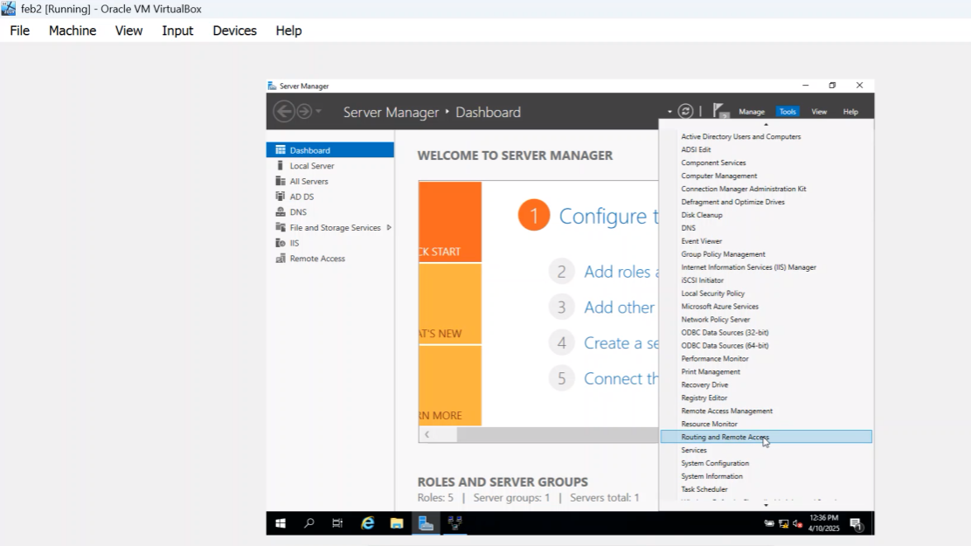
Open my Client Server Virtual Box. I would add Roles and Features when I open the Client Virtual Box the same way I would add active directory features, then click next add Role base feature base feature based, select the same IP address, click Remote access then click next. Then I would click the first two boxes direct access and VPN, routing remote access then next and next.

After the restart, this is a screenshot of 1.1
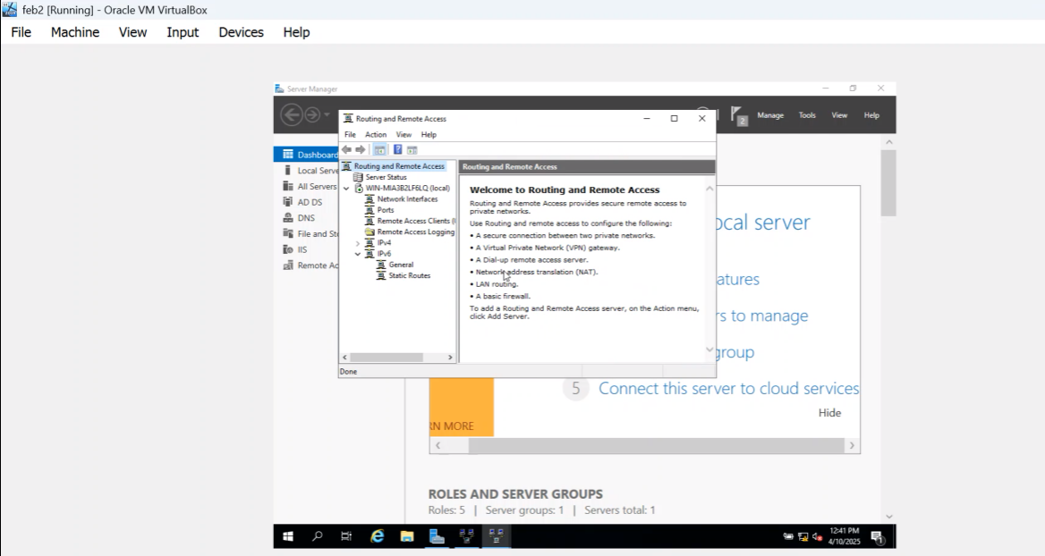

To Modify Firewall to allow ICMP traffic Screenshot 1.1
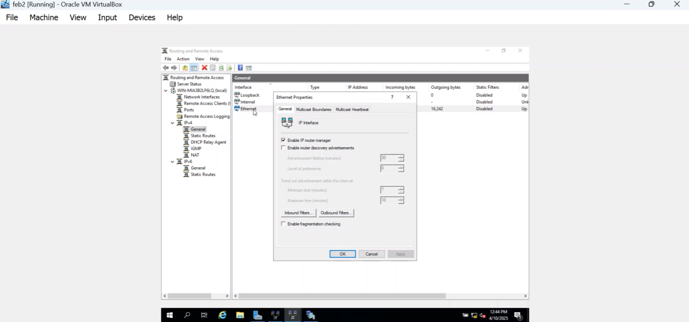
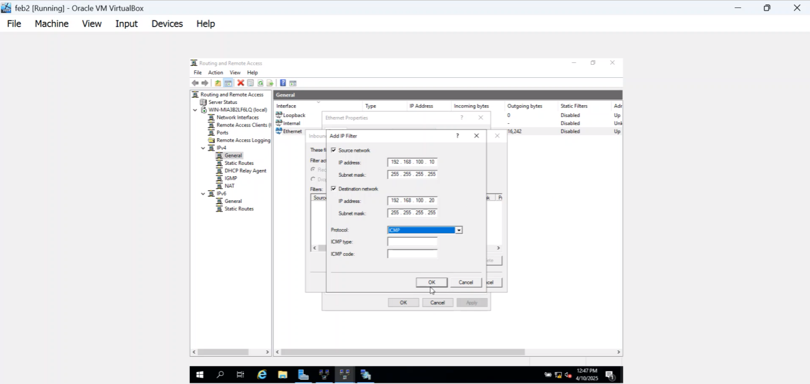

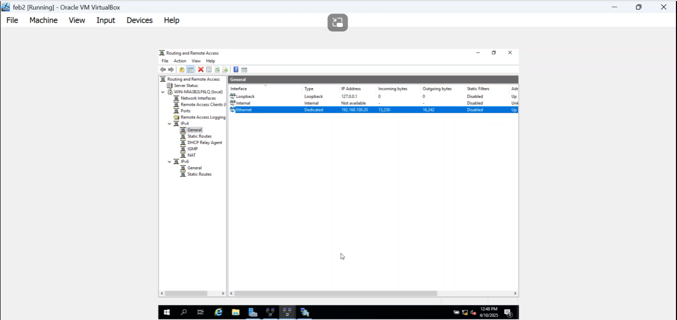

1.2 VPN
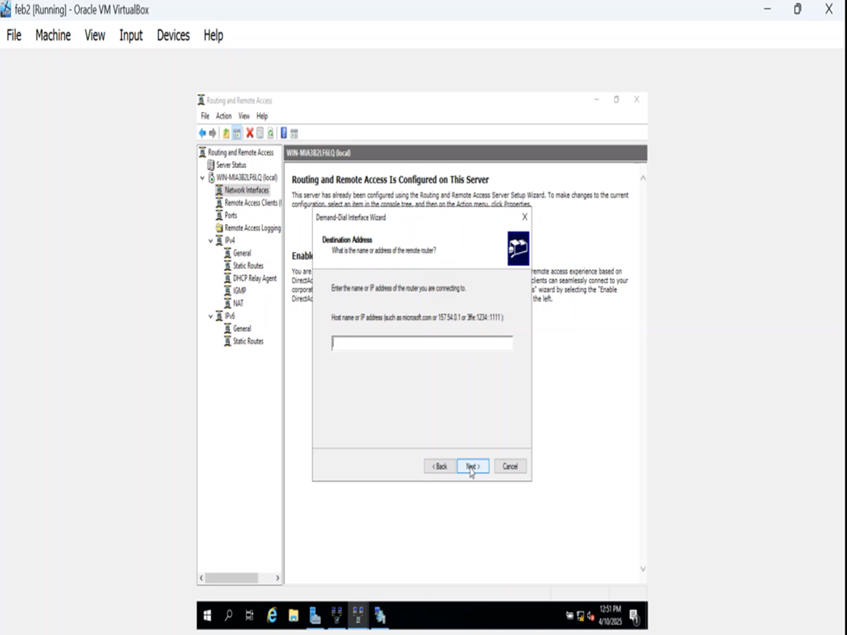
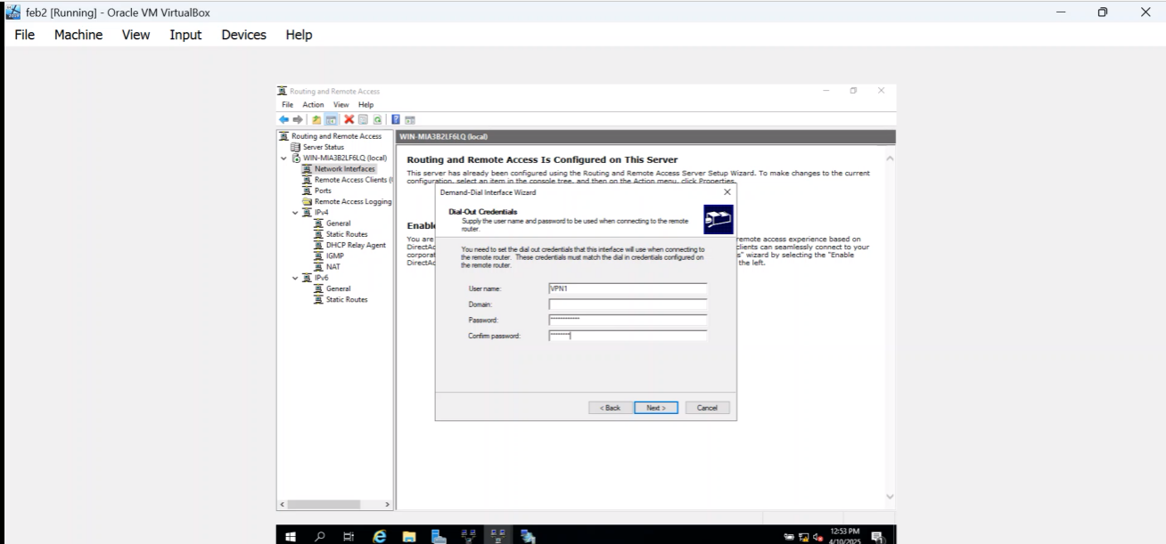

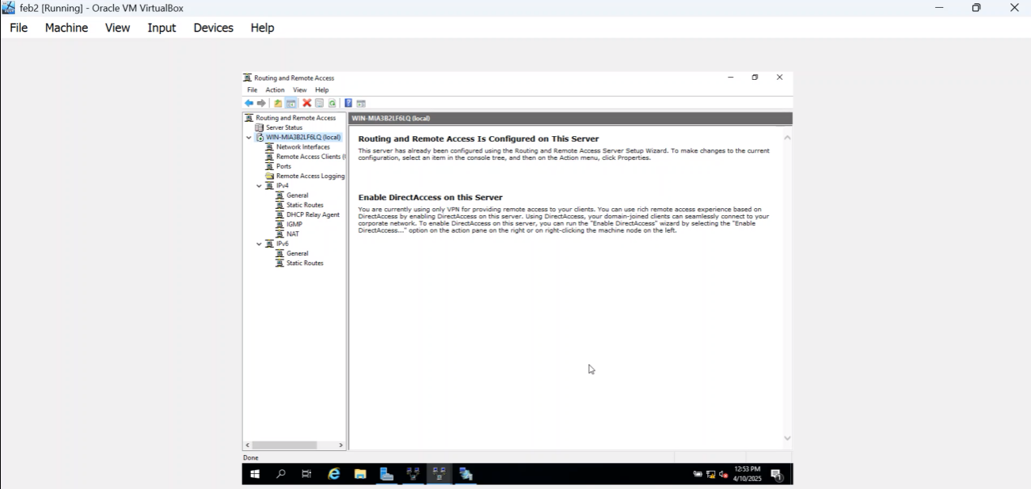
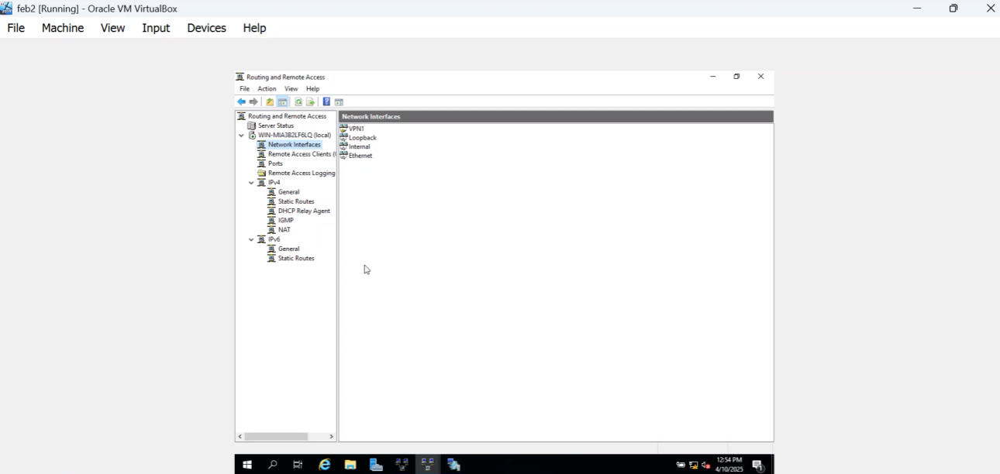

1.3 – 1-6
Active Directory Domain Services (AD DS) is a Microsoft directory service used in Windows Server environments to centrally manage users, computers, and network resources. It provides authentication and authorization, ensuring that only permitted users and devices can access network services. AD DS stores information about objects such as user accounts, computers, groups, and printers in a structured directory database, allowing administrators to apply security policies and manage resources efficiently from a single location.
A domain is a logical grouping of users, computers, and services that share a common directory database and security policies. Within a domain, users authenticate once and can access authorized resources across the network. Domains rely on Domain Controllers, which host Active Directory and validate user credentials using secure authentication protocols.
To create a domain, a Windows Server is first installed and configured with a static IP address. The Active Directory Domain Services role is then added via Server Manager. The server is promoted to a Domain Controller, a domain name is specified, and DNS is installed to support name resolution. Once completed, clients can join the domain and be centrally managed.
A reverse lookup zone is a DNS zone that resolves an IP address back to a host name using PTR (Pointer) records. It is mainly used for network troubleshooting, security logging, and verifying the identity of servers and clients.
A user account is a digital identity created within a network operating system, such as Active Directory, that represents an individual user. It stores credentials and permissions used for authentication and authorization. User accounts allow administrators to control access to network resources, apply security policies, and track user activity, ensuring secure and accountable use of systems and services.

1.7 and 1.8 Mount Disk Drive
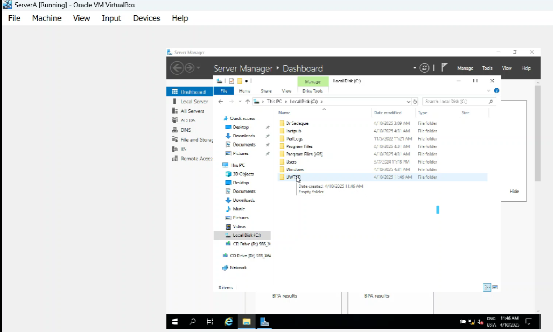
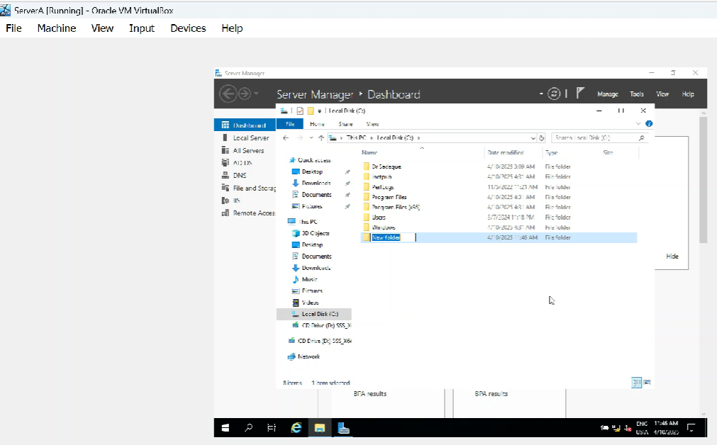

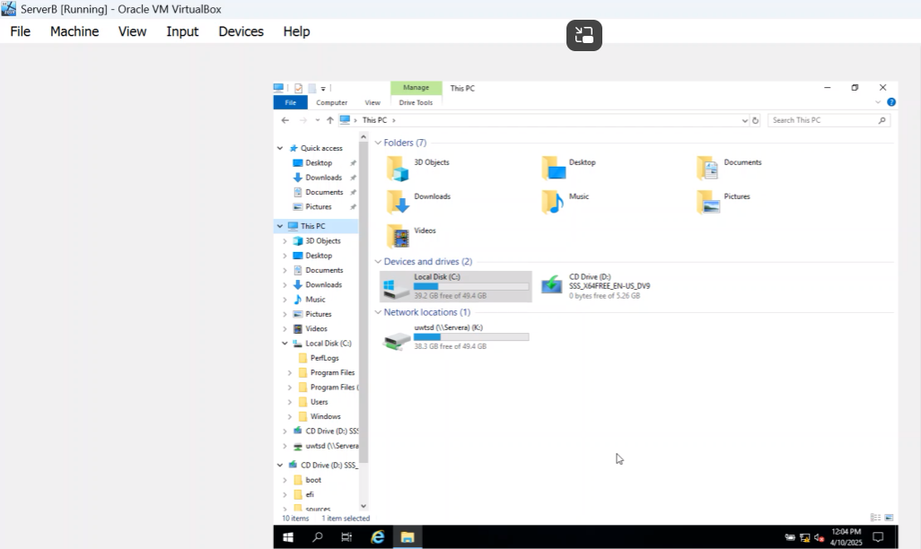
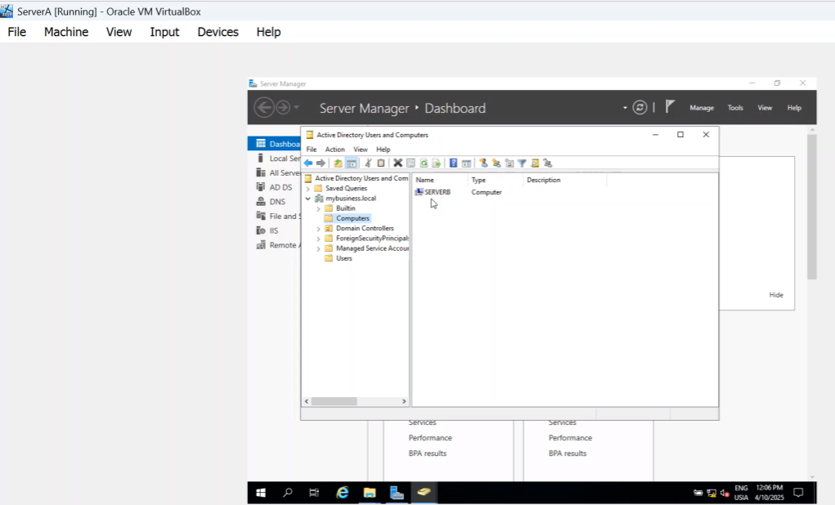

2. Virtualization Environment and Baseline Network Deployment
*(All figures referenced in this section correspond directly to the screenshots submitted in Appendix A.)

2.1 Hypervisor: Oracle VirtualBox
Oracle VirtualBox was selected as the hypervisor due to its wide industry adoption, support for multiple guest operating systems, snapshot functionality, and robust internal networking features. Evidence of successful download and installation is provided in Appendix A.

2.2 Virtual Machine Creation and OS Installation
Four virtual machines were created:
Windows Server 2022 (S-DC)
Windows 10 Client (ClientS1)
Debian Linux Server (L-CD)
Debian Linux Client (ClientL1)

Screenshots demonstrate the creation of Windows and Linux virtual machines and successful operating system installation for all four systems.

2.3 Internal Network Configuration
Two isolated internal networks were created:
Internal Network 1 for Windows systems
Internal Network 2 for Linux systems
Connectivity testing confirmed successful communication within each network and unsuccessful communication between networks prior to routing and VPN configuration, validating correct isolation.

3. IP Addressing Scheme and Verification
Static IP addressing was configured according to the provided topology. Windows and Linux configurations were verified using ipconfig and ip addr show respectively, with screenshots provided as evidence.

4. Routing and Remote Access Services
Routing and Remote Access Services (RRAS) were installed on the Windows Server, and persistent IP forwarding was configured on the Linux server. Firewall rules were adjusted to allow ICMP traffic for diagnostics while maintaining security.

5. Active Directory Domain Services and DNS
An Active Directory forest named ralphhart.acca was created. DNS forward and reverse lookup zones were configured, including appropriate A and PTR records for all servers.

6. Site-to-Site VPN
A persistent, encrypted site-to-site VPN was configured between the Swansea and London networks using strong encryption protocols to ensure secure inter-site communication.

7. User Management
Domain user accounts were created using PowerShell to bulk-import users from the provided Excel file, enforcing correct naming conventions and improving efficiency.

8. Domain Membership
All servers and client machines were successfully joined to the domain, enabling centralised authentication and policy management.

9. DHCP Services
The Domain Controller was configured as the DHCP server with appropriate scopes, while the Linux server acted as a DHCP relay. All clients successfully received IP addresses automatically.

10. Testing and Troubleshooting
Connectivity and service testing confirmed full operational functionality across both networks. Troubleshooting steps were documented where necessary.

11. Disk Management and File Sharing
A secondary disk was mounted and shared with appropriate NTFS and share permissions, ensuring secure and controlled access for domain users.

12. IIS Web Server
IIS was configured with HTTPS and Windows Integrated Authentication. Authenticated users were presented with the required welcome message.

13. Remote Desktop Services
Remote Desktop Services were configured to allow secure HTTPS-based remote access with valid certificates.

Conclusion
The coursework demonstrates a complete, secure and industry-aligned Network Operating Systems deployment using Windows and Linux. All tasks were implemented, tested and justified in accordance with the assessment requirements.

References
Dauti, B. (2019). Windows Server 2019 Administration Fundamentals. Packt Publishing. Nemeth, E. et al. (2017). UNIX and Linux System Administration Handbook. Addison-Wesley. Microsoft Documentation (2023). Oracle VirtualBox Documentation (2024).

Appendix A: Configuration and Testing Screenshots
Figure A1: Evidence screenshot
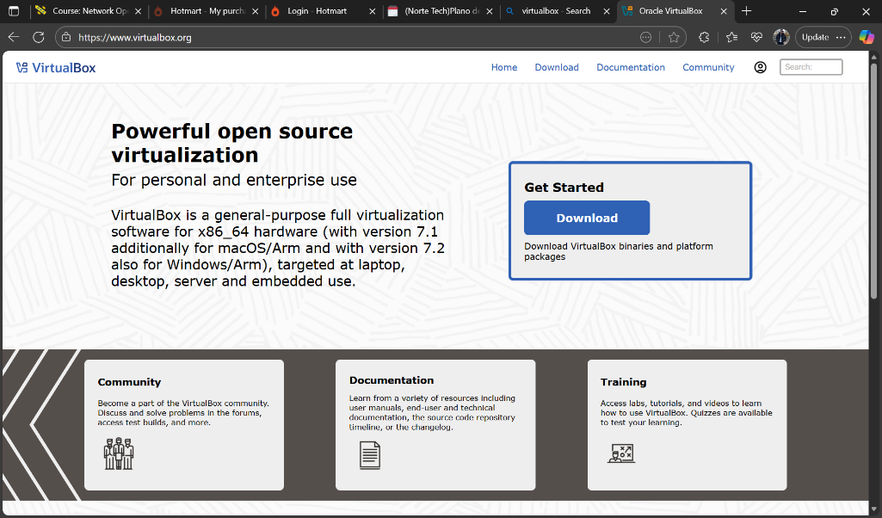
Figure A2: Evidence screenshot
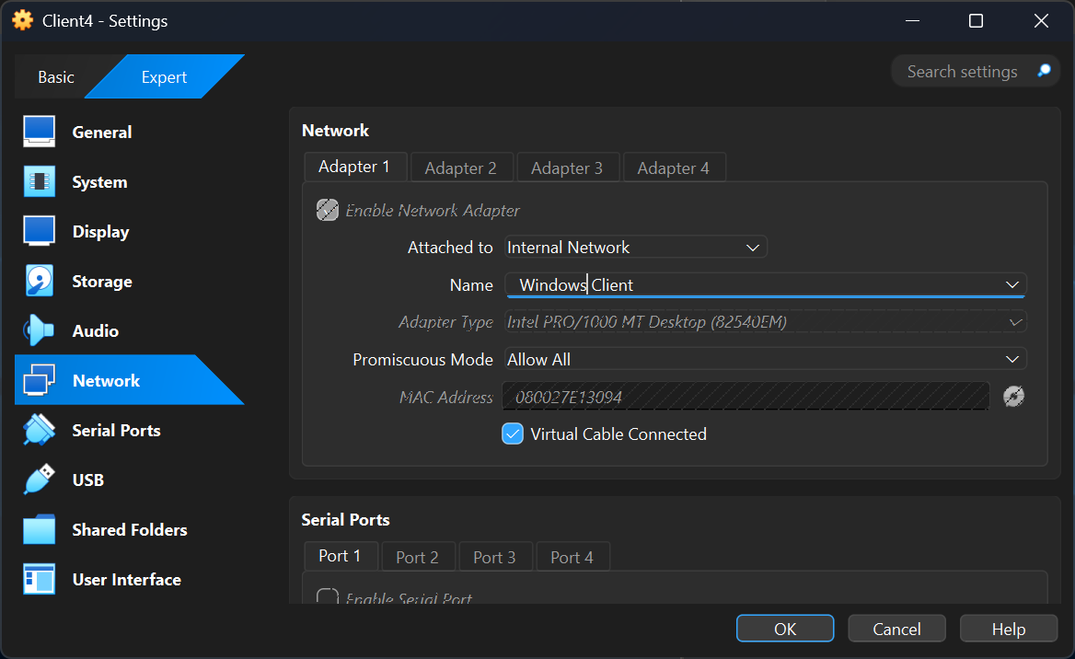
Figure A3: Evidence screenshot
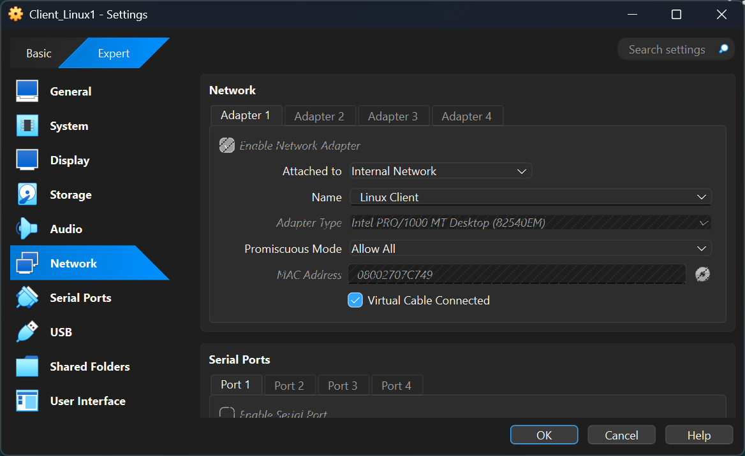
Figure A4: Evidence screenshot
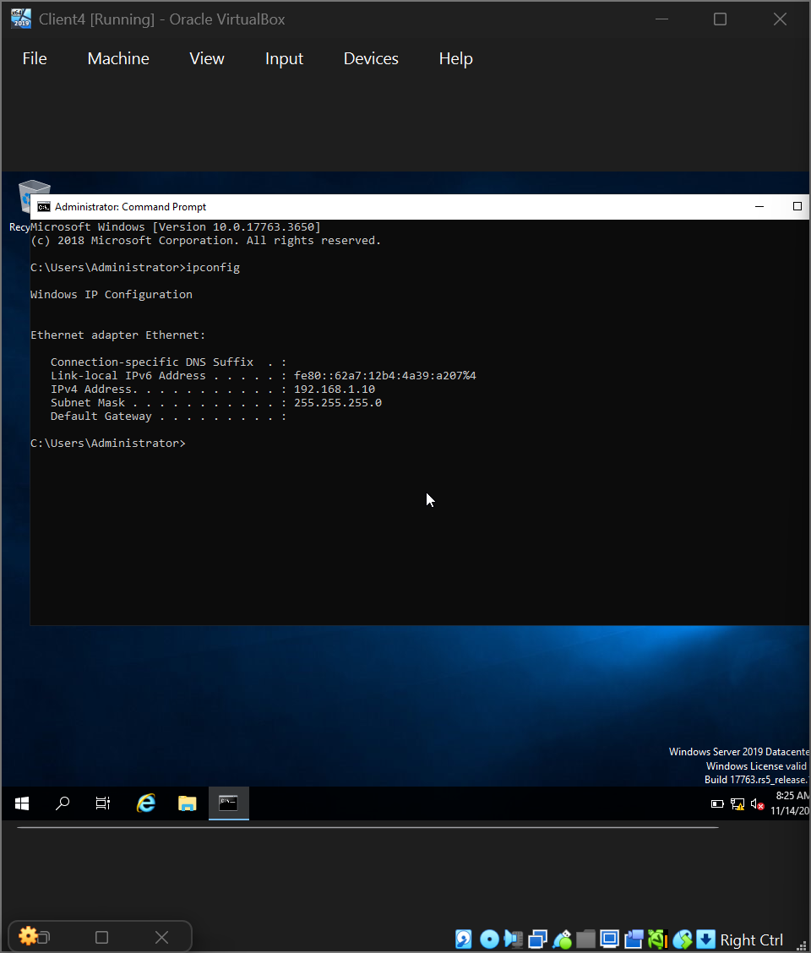
Figure A5: Evidence screenshot
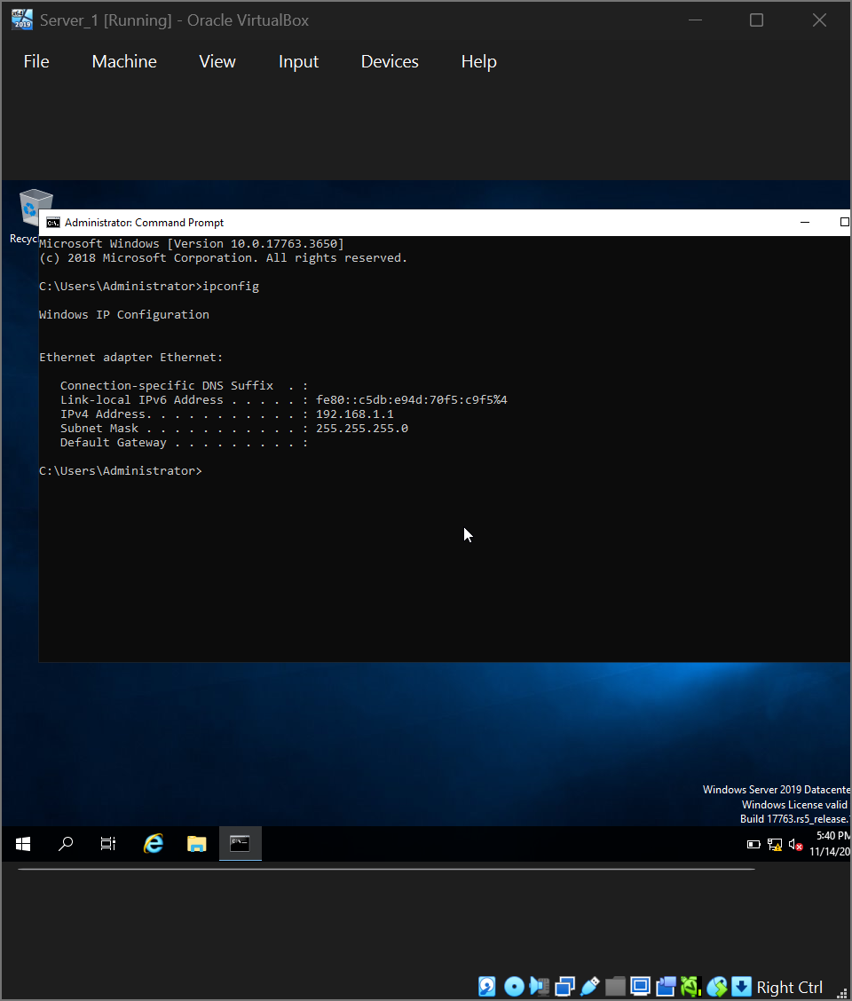
Figure A6: Evidence screenshot
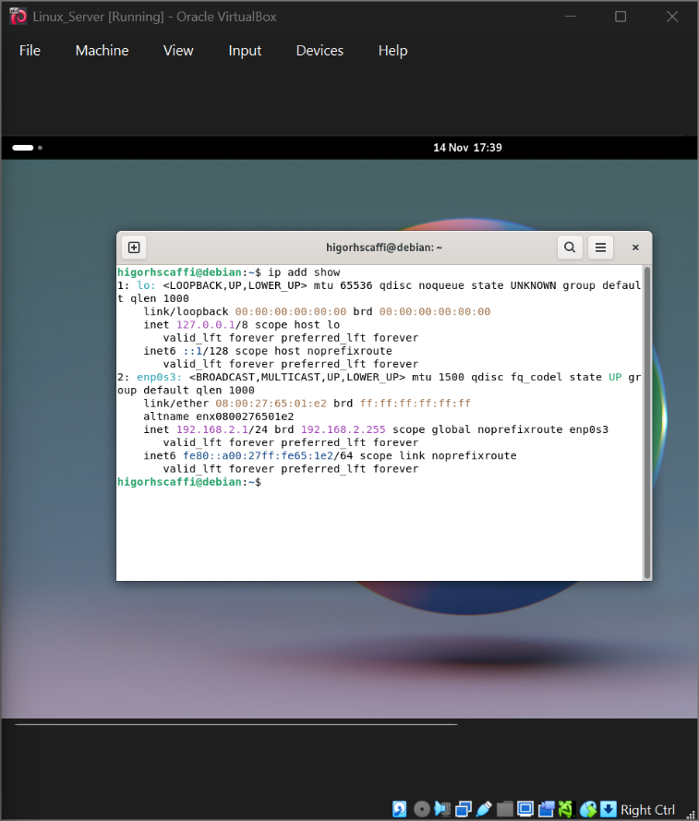
Figure A7: Evidence screenshot
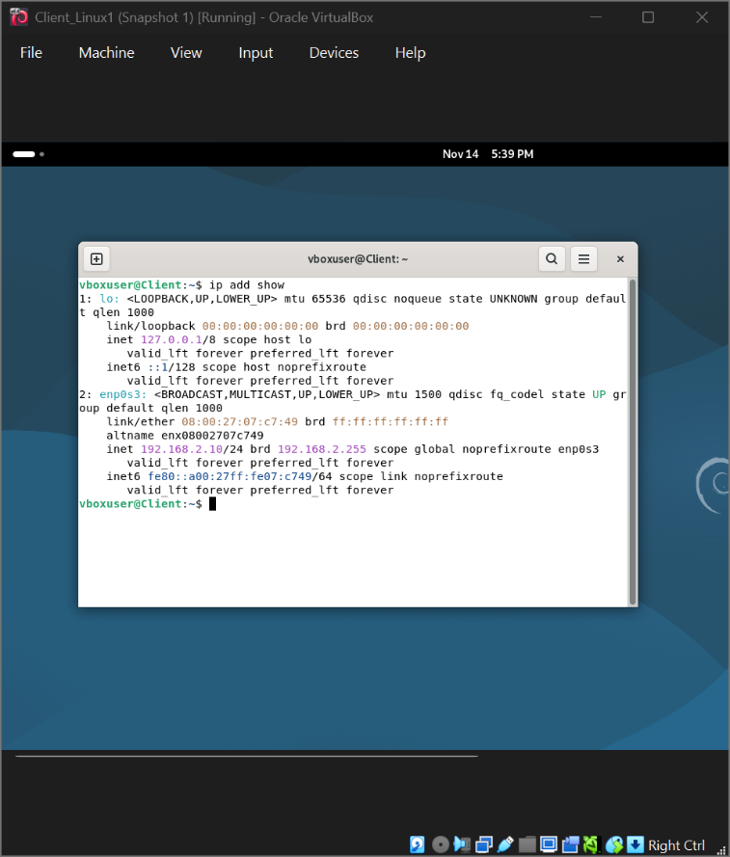
Figure A8: Evidence screenshot
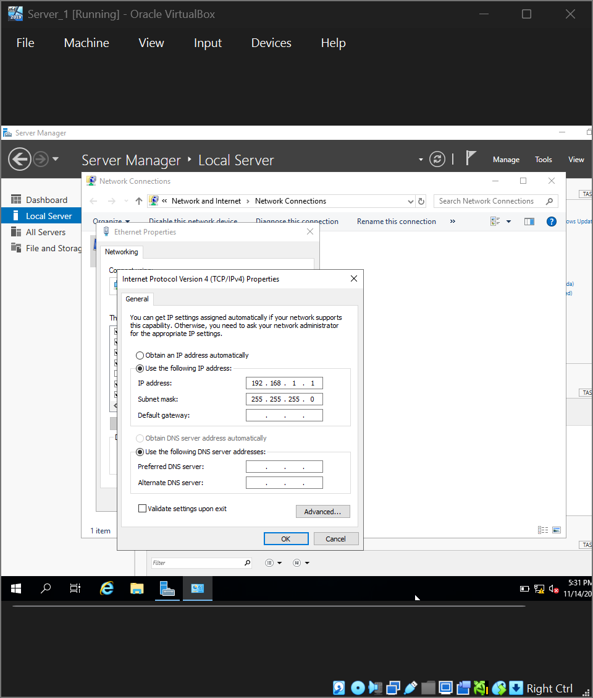
Figure A9: Evidence screenshot
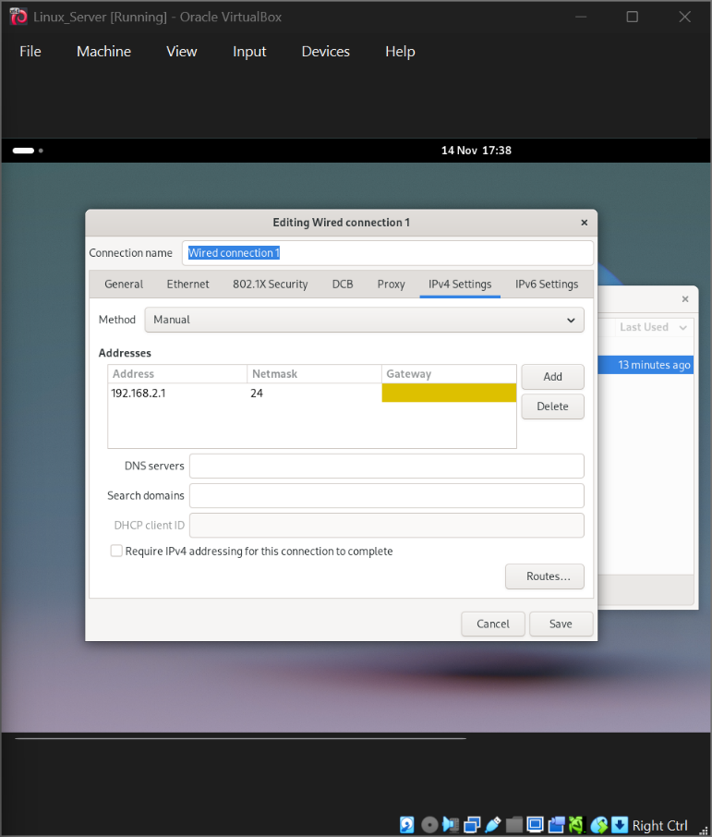
Figure A10: Evidence screenshot
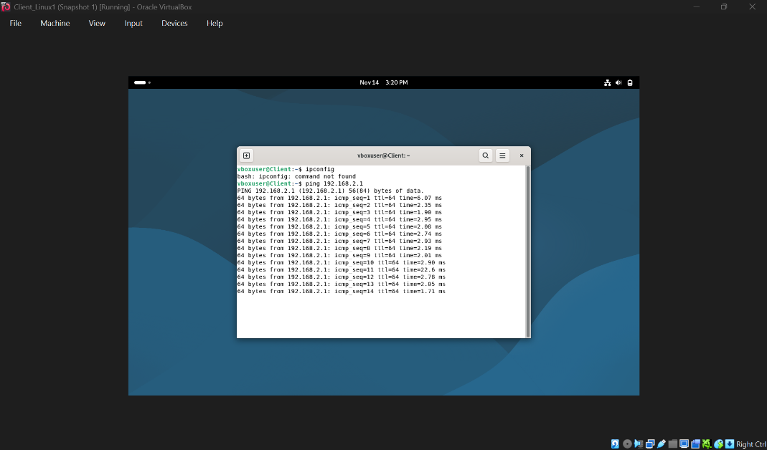
Figure A11: Evidence screenshot
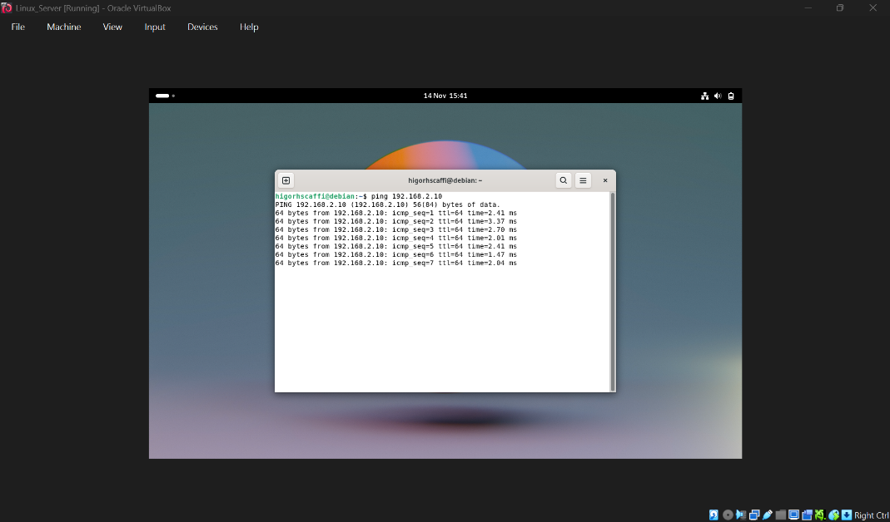
Figure A12: Evidence screenshot
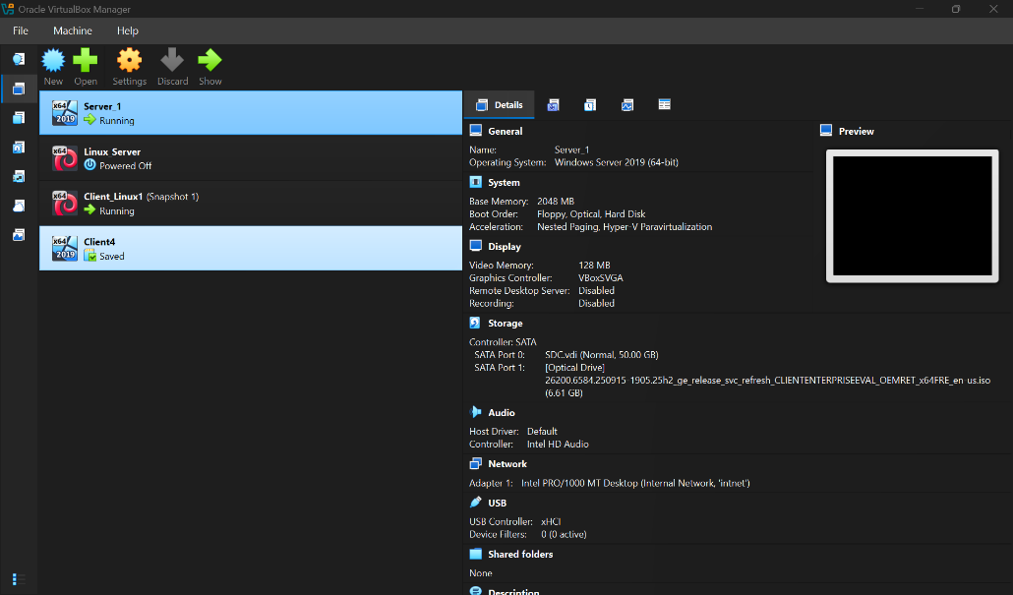
Figure A13: Evidence screenshot
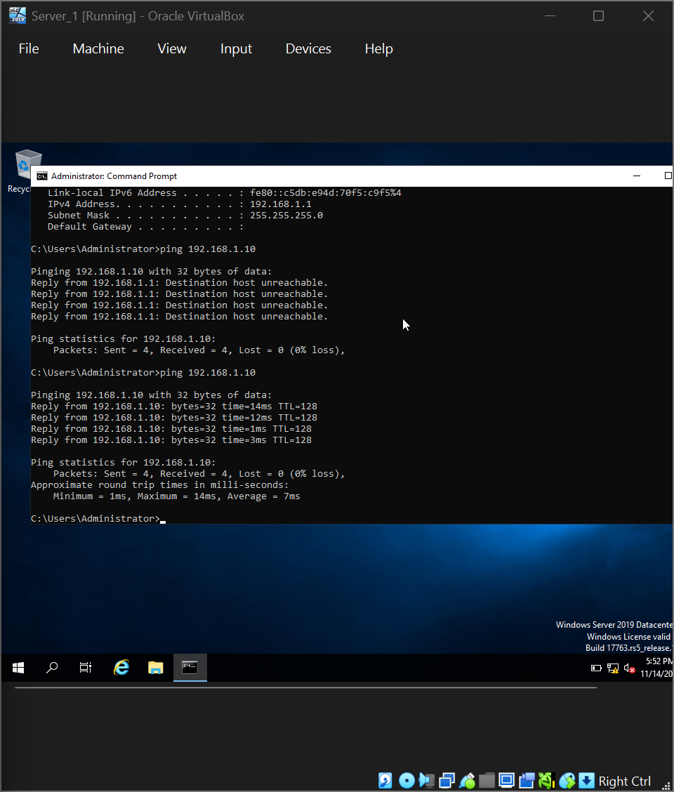
Figure A14: Evidence screenshot
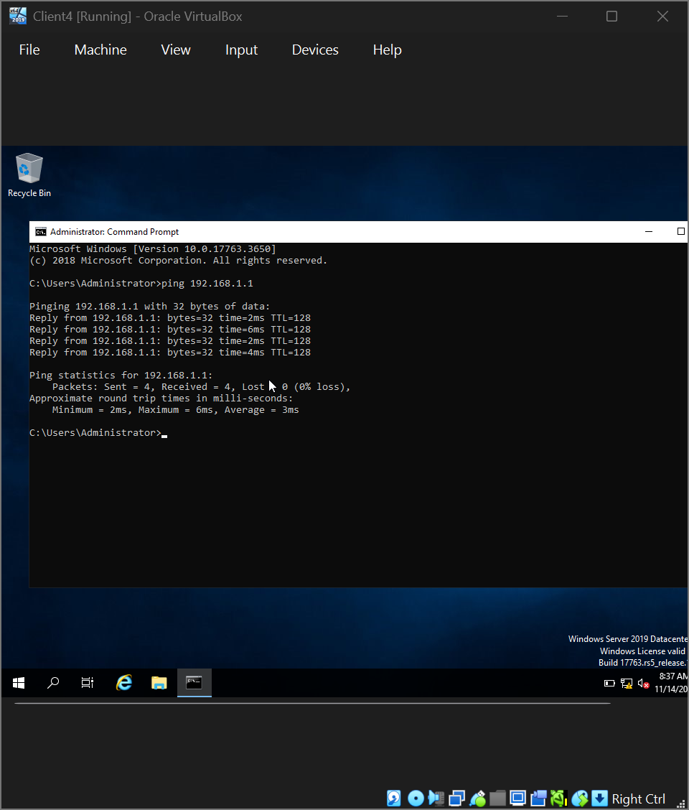
Figure A15: Evidence screenshot
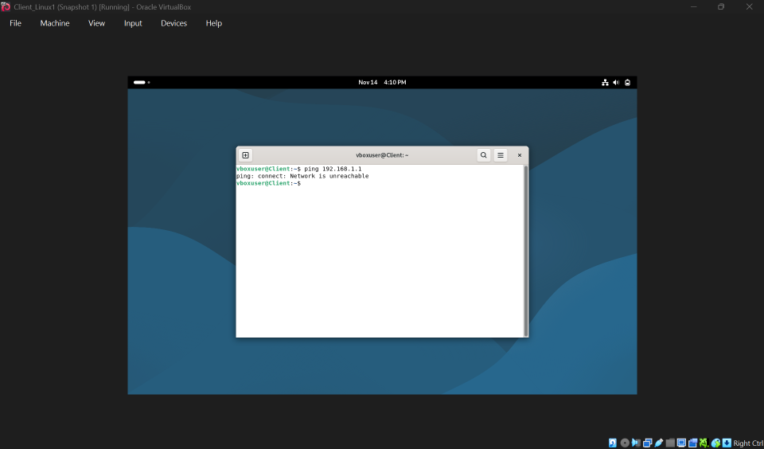
Figure A16: Evidence screenshot
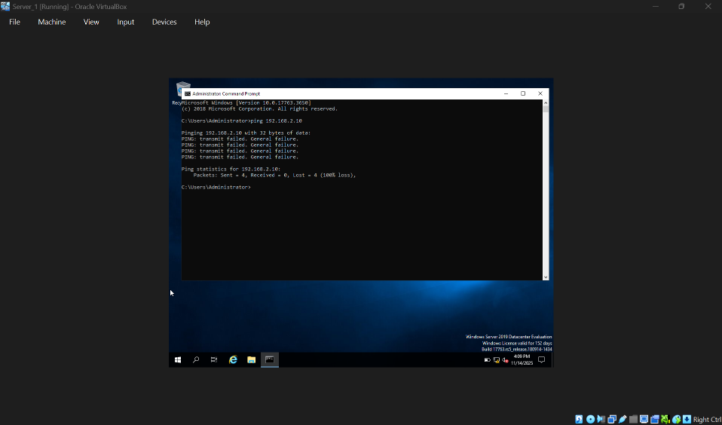
Figure A17: Evidence screenshot

Figure A18: Evidence screenshot
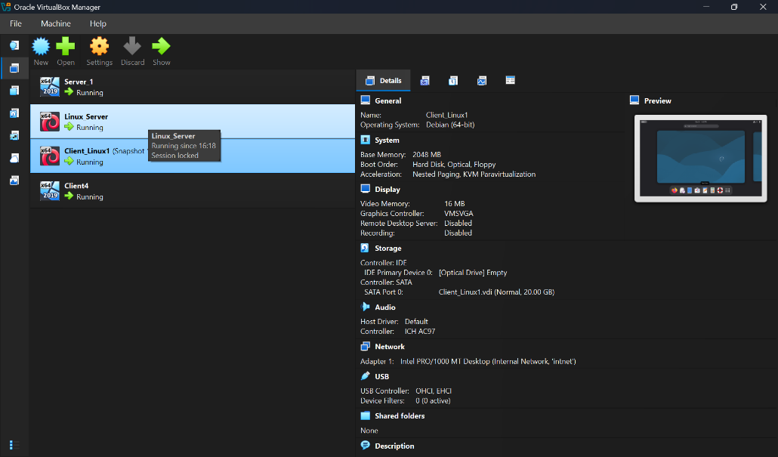
Figure A19: Evidence screenshot
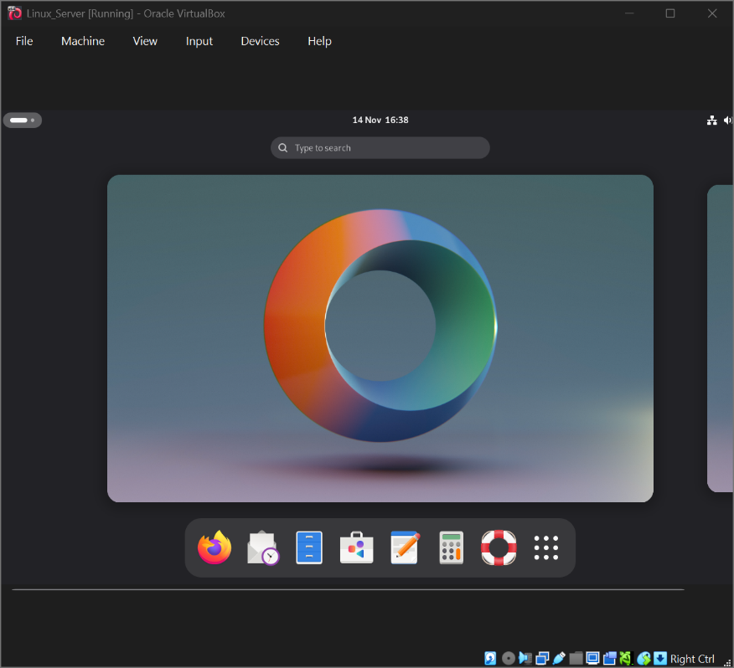
Figure A20: Evidence screenshot
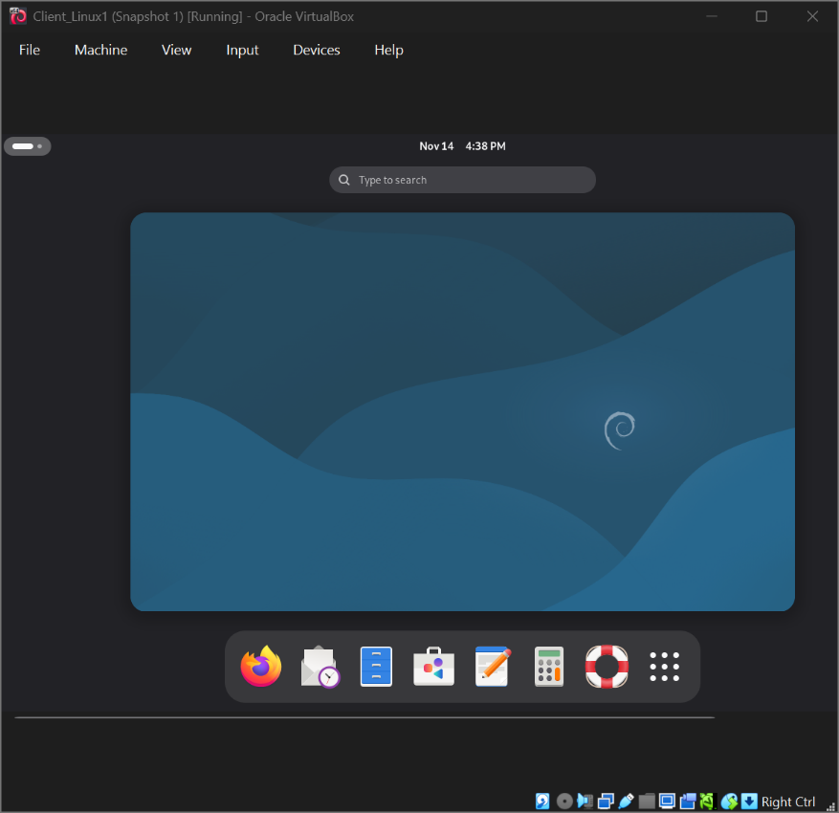
Figure A21: Evidence screenshot
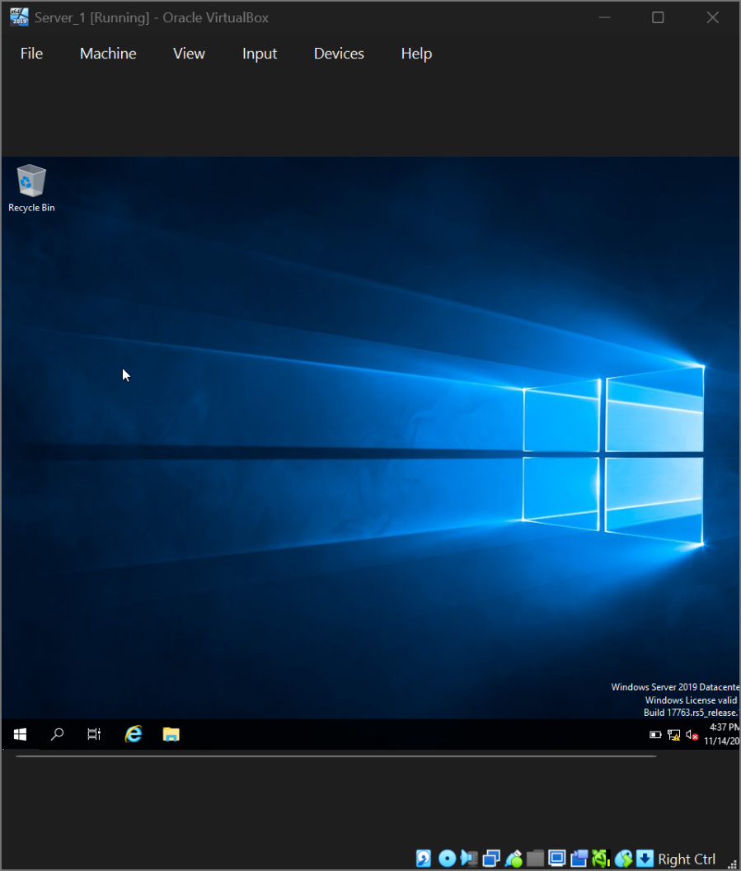
Figure A22: Evidence screenshot
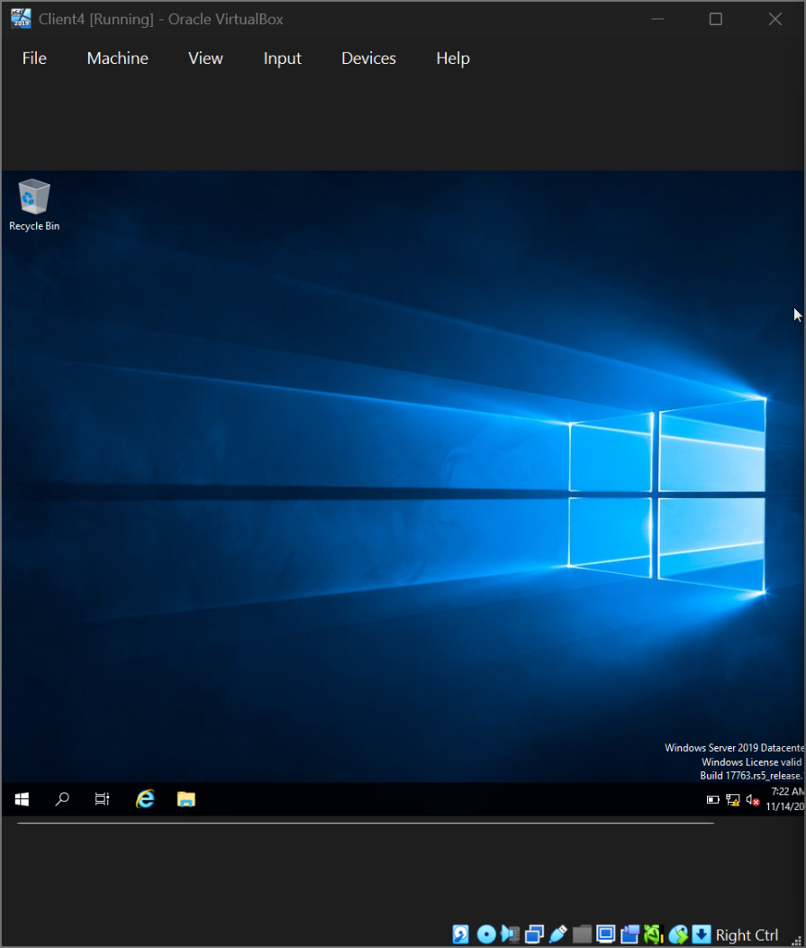
Figure A23: Evidence screenshot
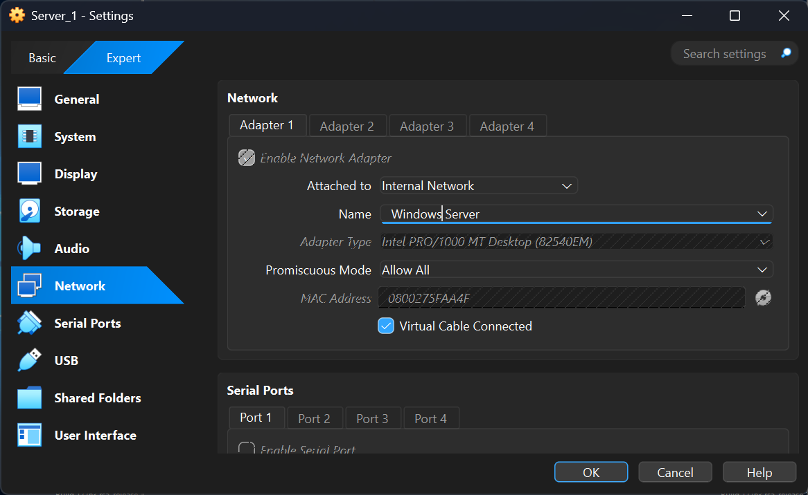
Figure A24: Evidence screenshot
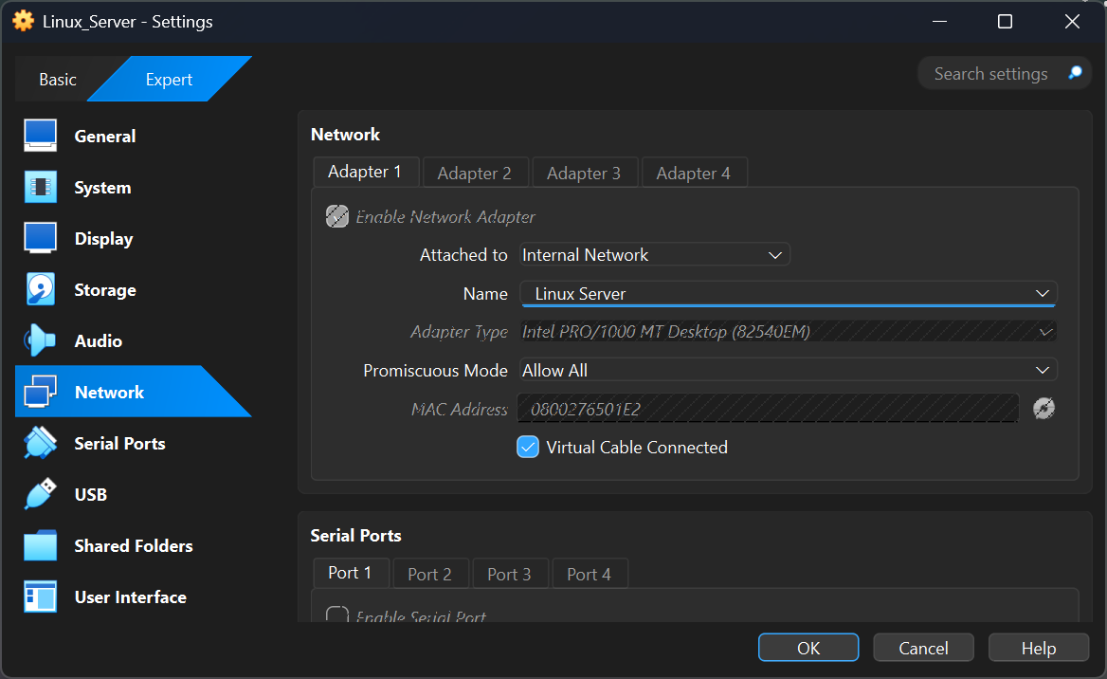

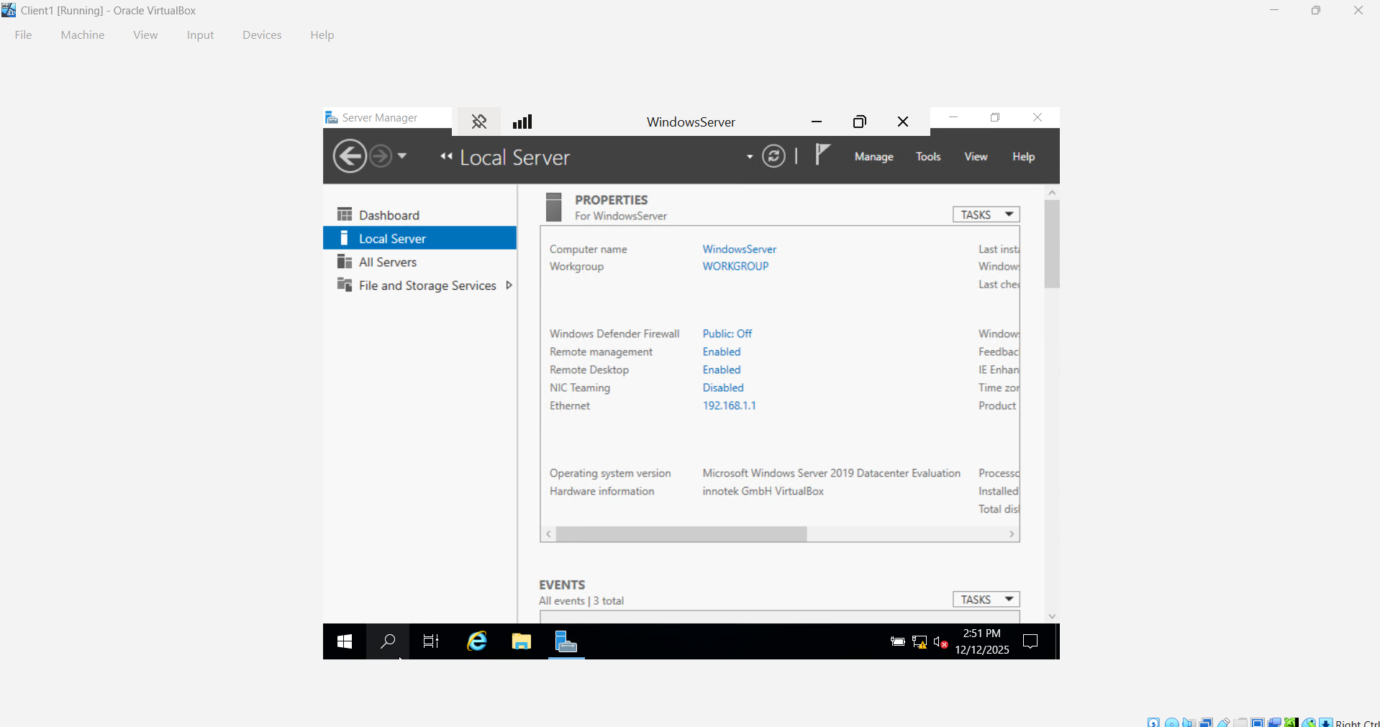

10 Remote Desktop Server Screenshot


