

Name: Lucy Pugh
Student Number: 2247367
Module Code: BMPF7018
Module Title: Managing Work-based Projects
Word Count: 4928

Assignment Brief (Assessment Component 1): -

Discuss and critically evaluate project management process and assess the suitability in the context of the workplace.

Table of Contents

Table of Figures 3
1 Introduction 4
2 Project Management and its Role in the Workplace 5
2.1 What is a Project? 5
2.2 What is Project Management? 5
2.3 The Workplace – Local Government 5
2.4 Role of Project Management in Local Government 6
3 Project Management Process vs Methodology 7
3.1 Project Management Process 7
3.2 Project Management Methodology 7
3.3 Summary 7
4 Project Management Processes 8
4.1 Processes 8
4.2 Process Groups 8
4.2.1 Initiating 8
4.2.2 Planning 9
4.2.3 Executing 9
4.2.4 Monitoring and Controlling 9
4.2.5 Closing 9
4.3 Summary 10
5 Project Management Methodologies 11
5.1 Introduction 11
5.1.1 Key Components of a Methodology 11
5.1.2 Predictive (Traditional), Adaptive (Agile), or Hybrid? 11
5.2 Methodologies and Approaches 12
5.2.1 Waterfall Methodology (Predictive) 12
5.2.2 PRINCE2 Methodology (Predictive) 14
5.2.3 Agile Approach (Adaptive) 16
5.2.4 Scrum (Adaptive) 19
5.2.5 PRINCE2 Agile (Hybrid) 21
5.3 Hybrid Project Management 23
5.4 Tailoring 25
5.5 Summary 26
6 Process/Methodology Suitability for the Workplace 28
7 Conclusion 32
8 References 33

Table of Figures

Figure 1 – Example Process: Inputs, Tools & Techniques, and Outputs 8
Figure 2 – How process groups can overlap on a project 9
Figure 3 – Waterfall Methodology 13
Figure 4 – PRINCE2 7th Edition Quick Reference Card 15
Figure 5 – 12 Agile Principles 17
Figure 6 – Agile Method 17
Figure 7 – The Agile Umbrella 18
Figure 8 – Scrum Methodology 20
Figure 9 – Tailoring PRINCE2 by blending in the agile ingredients 22
Figure 10 – Waterfall + Agile 24
Figure 11 – Waterfall vs Agile 26
Figure 12 – The Stacey Model 29
Figure 13 – Suitability Assessment Radar Chart 30

1 Introduction
1.1 This report details the findings of an investigation into the different project management processes and methodologies and assesses their suitability in the context of my workplace; a large local authority employing some 8,300 staff.

1.2 The report comprises:
- Introduction to Project Management and its role in the local authority.
- Discussion of what is meant by the following terms:
  - Project management process.
  - Project management methodology.
- Introduction to project management processes and discussion of the five main process groups.
- Introduction to, and evaluation of, the following project management methodologies:
  - Waterfall Methodology.
  - Agile approach.
  - PRINCE2 and PRINCE2 agile.
  - Scrum Framework.
- Discussion of hybrid and tailoring approaches.
- Assessment of the processes and methodologies that would be most appropriate in my workplace.

2 Project Management and its Role in the Workplace

2.1 What is a Project?
To understand project management, we first need to ascertain what is meant by a “project”. Project Management Institute (2021, p. 245) define a project as “a temporary endeavour undertaken to create a unique product, service, or result.”

Wrike (2024) emphasises the importance of noting the following:
- The word “temporary”, meaning that all projects must have a beginning and an end (as opposed to “operations”, which are ongoing).
- That the purpose of the project is to “create a unique product, service, or result”, again alluding to the fact that a project aims to accomplish a goal that is outside of normal operations.

2.2 What is Project Management?
Project management can be described as “the practice of using knowledge, skills, tools, and techniques to complete a series of tasks to deliver value and achieve a desired outcome.” (Project Management Institute, 2024)

It plays a pivotal role in ensuring the successful delivery of projects, enabling organisations to efficiently allocate resources, manage risks, and meet objectives.

2.3 The Workplace – Local Government
I work for local government, in a large local authority (county council) which provides a range of services including education, planning, transport, social services, and public safety.

More specifically, my job role is that of a Digital Transformation Project Officer, based within the IT Department. Our division (Business Transformation) manages or assists with projects raised within the authority that have an ICT element to them, and provides guidance and governance to those projects.

2.4 Role of Project Management in Local Government
Managing projects within local government presents a unique set of challenges, from navigating complex bureaucratic structures to balancing diverse stakeholder interests. The need to adhere to strict regulations and guidelines, coupled with limited resources and funding constraints, often adds layers of complexity to project management initiatives.

Effective project management plays a crucial role in enabling local governments to address these challenges and efficiently deliver projects in line with community expectations. It provides a structured framework to promote clear communication, active stakeholder engagement, and strategic planning. Through the application of appropriate project management principles and methodologies, local authorities can navigate obstacles, improve decision-making, mitigate risks, and ultimately achieve successful project outcomes, thereby contributing to the enhancement of their communities within the public sector landscape.

3 Project Management Process vs Methodology

The terms "project management process" and "project management methodology" are often used interchangeably, but they have distinct meanings within the field of project management.

3.1 Project Management Process
A project management process refers to a specific sequence of activities and tasks that guide a project. Processes produce the outputs needed to move a project from initiation to completion, ensuring that tasks are organised, resources are allocated, and goals are achieved.

3.2 Project Management Methodology
As noted by Aston (2024), a project management methodology, on the other hand, is a framework that outlines the way that work is completed throughout a project by providing procedures, rules, and practices. It provides a structured approach and can incorporate various processes, techniques, tools, and templates to achieve consistent project success.

For example, Waterfall, Scrum, PRINCE2, and Six Sigma are examples of project management methodologies. These methodologies provide not only specific processes for managing projects but also guidelines for project governance, communication, risk management, and other aspects of project management.

3.3 Summary
In essence, the distinction between "project management process" and "project management methodology" lies in their scope and purpose. While a project management process refers to a specific set of sequential activities within a project, a project management methodology is a comprehensive framework that guides how projects are managed.

4 Project Management Processes

4.1 Processes
Project management processes refer to the specific activities and tasks that are carried out to achieve the goals of a project. Each process contributes to the overall success of the project by addressing specific aspects of project management, such as scope definition, time scheduling, cost control, risk mitigation, and stakeholder engagement.

Project Management Institute (2017) describe a total of 49 processes applicable to project management. Each process takes one or more inputs and uses a project management tool or technique to turn it into one or more outputs, as can be seen in Figure 1:

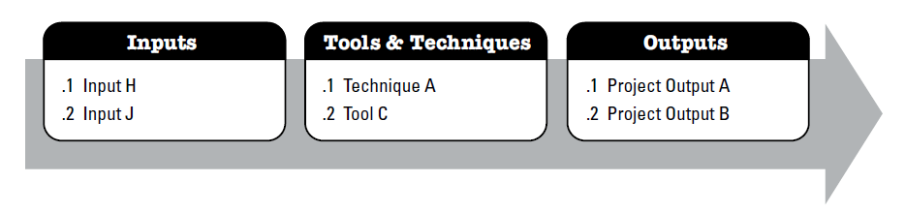
Figure 1 – Example Process: Inputs, Tools & Techniques, and Outputs
(PMI, 2017a, p.22)

Some examples of the 49 processes outlined by PMI include:
- Develop Project Charter
- Identify Stakeholders
- Monitor Risks

4.2 Process Groups
The processes referred to above can be grouped into the following five categories, or universally accepted stages of a project:

4.2.1 Initiating
The initiation process marks the beginning of a project and involves defining its purpose, scope, and objectives. It sets the stage for project planning and establishes initial alignment among stakeholders.

4.2.2 Planning
Planning is the process of creating a detailed roadmap for the project, outlining tasks, resources, timelines, and potential risks. It ensures a comprehensive approach to project execution.

4.2.3 Executing
Execution involves carrying out the tasks and activities outlined in the project plan. It's where the actual work happens, and progress is tracked against the plan.

4.2.4 Monitoring and Controlling
This process involves tracking project performance, comparing it to the plan, and making necessary adjustments to ensure project objectives are met.

4.2.5 Closing
The closing process signifies the end of the project. It involves finalising deliverables, obtaining stakeholder acceptance, and closing out contracts and agreements.

It should be noted that project management process groups can overlap to some extent, especially in larger and more complex projects where multiple activities are occurring simultaneously or in close succession. Figure 2 below shows how the process groups may coincide:
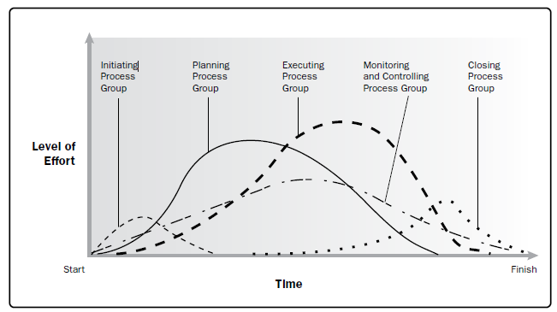
Figure 2 – How process groups can overlap on a project
(PMI, 2017a, p.555)

4.3 Summary
Having an appreciation of the above Process Groups and the associated individual processes has numerous benefits for individuals involved in project management:
- Comprehensive understanding of the various components involved in managing projects effectively.
- Common language, allowing effective communication with all interested parties.
- Best practices, using proven tools and techniques.
- Improved project performance from effective management.

It should be noted that the above processes are not specific to any particular methodology, but instead should be viewed as best practice resources and knowledge that can be utilised in whichever methodology is chosen for the project in question.

5 Project Management Methodologies

5.1 Introduction
A project management methodology is a structured and systematic approach that outlines the processes, practices, and guidelines for managing projects from start to finish. It provides a framework for how project teams should work together to achieve project goals and deliverables efficiently and effectively.

Using a recognised methodology can help ensure consistency, reduce risks, enhance communication, and increase the likelihood of project success. Different methodologies can be applied depending on the nature of the project, its complexity, the organisation's culture, and the industry context.

5.1.1 Key Components of a Methodology
Project management methodologies will normally include guidance on the following:
- Process framework.
- Roles and responsibilities.
- Tools and techniques.
- Documentation.
- Communication.
- Quality assurance.
- Change management.

5.1.2 Predictive (Traditional), Adaptive (Agile), or Hybrid?
Project management methodologies may be predictive (also referred to as traditional or linear), adaptive (also called Agile), or a blend of both - hybrid.

Predictive/traditional project management methodologies:
- Assume that the project’s requirements, scope, and objectives can be fully defined at the beginning of the project and will not change.
- Require detailed planning and documentation at the very start of the project.
- Progress through the project phases in a linear fashion, with little scope for change.
- Are suitable for highly predictable projects with stable requirements.

Adaptive project management methodologies:
- Recognise that requirements, scope and objectives may change during the project.
- Encourages adaptive planning and frequent reassessment of priorities.
- Break the project down into smaller iterations, where requirements can be adjusted based on changing needs.
- Are suitable for projects with evolving or uncertain requirements, and those requiring incremental delivery.

Hybrid project management methodologies:
- Combine elements of both predictive and adaptive approaches.
- Adjust the project management approach to suit the specific needs and characteristics of the project.
- Allow for flexibility and adaptability while also providing structure and control where needed.
- May involve using predictive methodologies for certain aspects of the project, such as upfront planning and documentation, while adopting adaptive practices for other areas, such as iterative development and frequent stakeholder engagement.
- Provide a middle ground between the rigidity of predictive methodologies and the fluidity of adaptive methodologies, offering a balanced approach that can accommodate a variety of project requirements and constraints.

In summary, predictive project management methodologies follow a structured, linear approach, adaptive methodologies prioritise flexibility and incremental delivery, and hybrid methodologies combine elements of both approaches to customise the project management approach to the specific needs of the project. The choice between these methodologies depends on factors such as project requirements, complexity, uncertainty, and stakeholder preferences.

5.2 Methodologies and Approaches
Below, we will look at some of the different types of project methodologies and approaches.

5.2.1 Waterfall Methodology (Predictive)
The Waterfall methodology is a traditional, predictive project management approach characterised by a linear and sequential structure. It was defined by Winston Royce in the 1970s, but since then the terminology has been used to describe phase-driven approaches in general. In this method, projects progress through a series of predefined phases, with each phase building upon the completion of the previous one. Waterfall follows a rigid sequence, where each phase must be completed before the next one begins. The key phases of the Waterfall methodology that are typically included are shown in Figure 3 below:
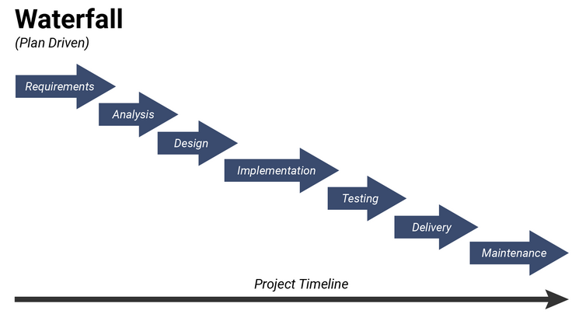
Figure 3 – Waterfall Methodology
(Actitime, 2022)

Advantages:
- Clear structure: provides a clear framework, suitable for local government projects with defined goals.
- Enhanced accountability: emphasis on documentation promotes transparency, crucial for government compliance.
- Predictable planning: allows better upfront cost and schedule estimation, helpful for government projects with strict budgets.

Disadvantages:
- Limited adaptability: linear approach may struggle to accommodate evolving government project requirements.
- Late stakeholder engagement: stakeholder feedback comes late, risking misalignment with expectations.
- Risk of incomplete requirements: relying on upfront documentation may lead to misaligned project deliverables.

Best suited to:
Projects with well-defined requirements and stable environments such as:
- Infrastructure development, e.g. roads or bridges.
- Regulatory compliance initiatives, e.g. implementing new policies.

5.2.2 PRINCE2 Methodology (Predictive)
PRINCE2 (PRojects IN Controlled Environments) is a structured, predictive project management methodology that divides projects into manageable stages and emphasises controlled governance, clear roles, and responsibilities, and thorough documentation.

PRINCE2 is part of the best practice guidance that came out of the UK Office of Government Commerce, and Harrin outlines its history:

It started life as the PROMPT methodology, created in a private UK company back in the 1970s. A British government agency, the Central Computer and Telecommunications Agency, licensed it for use in government IT projects back in 1979. It was renamed PRINCE.

PRINCE2® was released in 1996 and had major updates in 2009 and 2017. The most recent major update came in 2023.
(Harrin, 2023)

PRINCE2 is now maintained by Axelos, and the 2023 update referred to above took it from the 6th edition to the 7th edition, keeping it abreast of current project management practices and enabling it to be more easily tailored to projects.

As outlined by Buehring (2023), PRINCE2 comprises five integrated elements:
- Principles.
- People (new for the 7th edition).
- Practices (formerly known as Themes).
- Processes.
- Project context.

ILX Group (2024) outline the seven basic principles, or core values, that guide the way project managers work, make decisions, and prioritise tasks in a PRINCE2 project as follows:
- Ensure continued business justification.
- Learn from experience.
- Define roles, responsibilities, and relationships.
- Manage by stages.
- Manage by exception.
- Focus on products.
- Tailor to suit the project.

As seen from the extract from Portman’s Quick Reference Card in Figure 4 below, the full PRINCE2 methodology is complicated and official accreditation is seen as advantageous if not essential for a project manager following this framework.
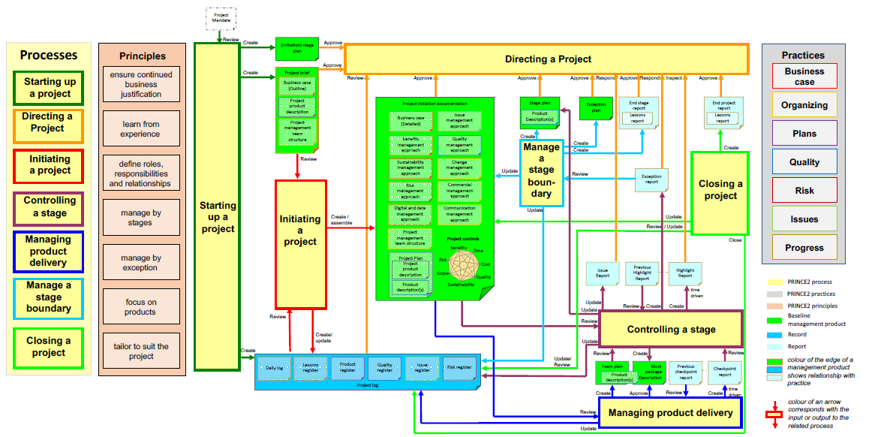
Figure 4 – PRINCE2 7th Edition Quick Reference Card
(Portman, 2023)

Advantages:
- Structured approach: offers a clear framework for local government projects, ensuring organisation and efficiency.
- Governance emphasis: prioritises governance, aligning projects with government strategies and regulations.
- Risk management: includes robust risk management processes, reducing the chances of project delays or failures.

Disadvantages:
- Complexity and dependency on skills: PRINCE2 is a complicated methodology, requiring skilled project managers, or extensive training and resources, which can increase project costs.
- Documentation overhead: while documentation ensures accountability, it can also create administrative burdens, particularly in large projects.

Best suited to:
Projects that involve significant complexity, multiple stakeholders, and a need for governance and risk management, such as:
- Large scale infrastructure development, e.g. roads, bridges, or public facilities.
- Public service improvements, such as upgrading public transportation systems.

5.2.3 Agile Approach (Adaptive)
Agile is an adaptive project management approach that was formalised in 2001 by “The Agile Alliance” with the publication of the Manifesto for Agile Software Development.

Rather than being a methodology in its own right, “’Agile’ is an umbrella term for all the methods and methodologies that follow the values and principles described in the Agile Manifesto” (PM Vidya, 2022).

The Manifesto states:
We are uncovering better ways of developing software by doing it and helping others do it. Through this work we have come to value:

Individuals and interactions over processes and tools
Working software over comprehensive documentation
Customer collaboration over contract negotiation
Responding to change over following a plan

That is, while there is value in the items on the right, we value the items on the left more.

(Beck et al., 2001)

Behind the Agile Manifesto are 12 principles, which can be read in full on the agilemanifesto.org/principles webpage, but can be summarised as shown in Figure 5 below:
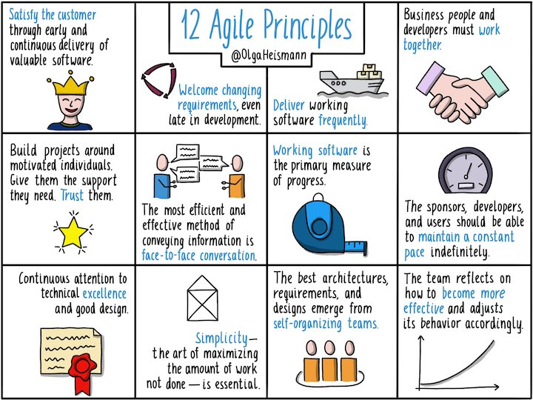
Figure 5 – 12 Agile Principles
(Lamborn, 2022)

Agile frameworks prioritise customer satisfaction by delivering working solutions in short iterations, incorporating feedback from stakeholders to refine requirements and improve the product incrementally.

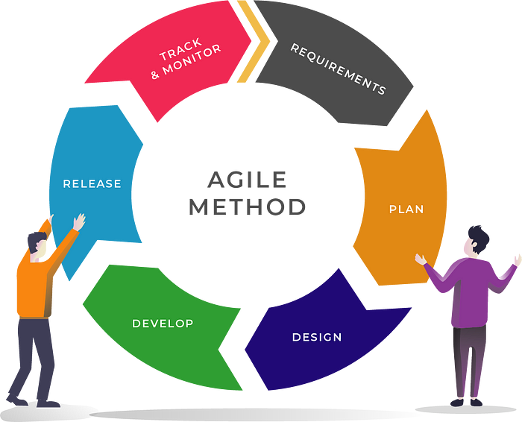
Figure 6 – Agile Method
(Tan, 2019)

Although Agile was initially developed for software development, as Wrike (2024a) notes, it has evolved and now encompasses many types of projects:

The tenets of Agile are more suited to projects that result in concrete deliverables rather than services. However, since Agile uses an iterative and incremental approach to product development, you can structure any project to be more flexible and adaptive to changes.
(Wrike, 2024a)

Some of the methodologies that come under the Agile umbrella are shown in the diagram below:

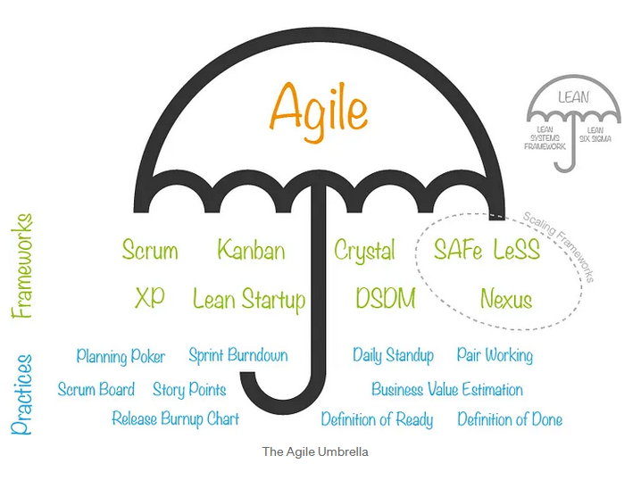
Figure 7 – The Agile Umbrella
(Schuurman, 2017)

One of the above frameworks/methodologies (Scrum) will be discussed in more detail in the next section.

Advantages:
- Flexibility: allows for adaptability to changing requirements.
- Iterative delivery: enables frequent delivery of project increments, facilitating early feedback and continuous improvement.
- Transparency: regular updates and demonstrations increase visibility into project progress, promoting accountability in local government projects.

Disadvantages:
- Cultural change: adoption may require significant cultural shifts within local government organisations.
- Resource requirements: implementation demands skilled practitioners and resources, which can be challenging for departments with limited budgets and expertise.
- Documentation challenges: balancing Agile's focus on working solutions with regulatory documentation requirements may pose difficulties for compliance.

Best suited to:
Projects that involve dynamic requirements, frequent stakeholder interactions, and a need for rapid delivery of value, such as:
- Digital Transformation projects, e.g. developing public facing apps or digitising administrative processes.
- Community engagement initiatives, e.g. partnership working.

5.2.4 Scrum (Adaptive)
The Scrum framework is an Agile project management methodology that emphasises iterative and incremental development, collaboration, and adaptability. It was initially designed for software development but has found application across various industries due to its flexible and dynamic nature. Scrum divides projects into time-boxed iterations called "sprints," each typically lasting two to four weeks. It emphasises transparency, inspection, and adaptation through regular meetings such as daily stand-ups, sprint planning, sprint review, and sprint retrospective. One of the key roles within Scrum is that of the Scrum Master, who facilitates the team and ensures adherence to Scrum principles.

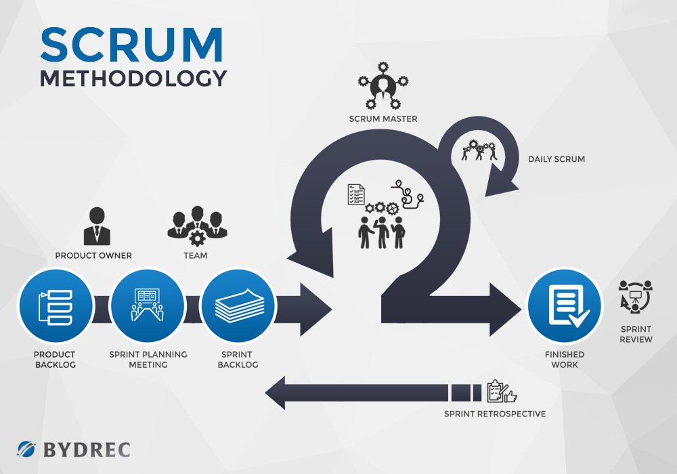
Figure 8 – Scrum Methodology
(Bydrec, 2024)

Evaluation:
Scrum offers a lightweight framework for managing complex projects, fostering self-organisation and continuous improvement. However, Scrum's success depends on strong team collaboration and adherence to its practices. Organisations may struggle with Scrum's lack of detailed guidance, requiring experienced practitioners and ongoing training to implement effectively.

Advantages:
- Flexibility: allows for adaptability to changing requirements.
- Iterative delivery: enables frequent delivery of project increments, facilitating early feedback and continuous improvement.
- Transparency: regular updates and demonstrations increase visibility into project progress, promoting accountability in local government projects.

Disadvantages:
- Cultural change: adoption may require significant cultural shifts within local government organisations.
- Resource requirements: implementation demands skilled practitioners and resources, which can be challenging for departments with limited budgets and expertise.
- Documentation challenges: balancing Agile’s focus on working solutions with regulatory documentation requirements may pose difficulties for compliance.

Best suited to:
Projects that involve dynamic requirements, frequent stakeholder interactions, and a need for rapid delivery of value, such as:
- Digital Transformation projects, e.g. developing public facing apps or digitising administrative processes.
- Community engagement initiatives, e.g. partnership working.

5.2.5 PRINCE2 Agile (Hybrid)
In the words of its developer, Axelos, “PRINCE2 Agile® blends the flexibility and responsiveness of agile with the defined governance of PRINCE2®” (Axelos, 2024).

Axelos considers that PRINCE2 Agile is a methodology aimed at facilitating the delivery of agile projects by combining PRINCE2 management controls with various agile behaviours, concepts, frameworks, and techniques.

The approach requires a thorough understanding of PRINCE2 governance requirements and adds a wide range of agile concepts and techniques such as Scrum, Kanban, Lean Start-up, and Cynefin, integrating the PRINCE2 and agile methodologies to provide governance coupled with working practices that deliver business value early and often.

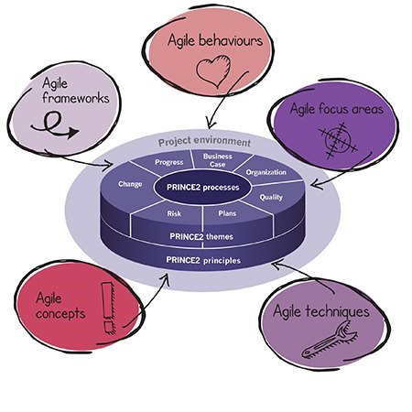
Figure 9 – Tailoring PRINCE2 by blending in the agile ingredients
(Axelos, 2021)

Axelos aims this methodology and certification particularly towards professionals involved in integrating project management with product delivery, as well as individuals with governance responsibilities for projects using agile approaches.

Evaluation:
PRINCE2 Agile aims to bridge the gap between predictive and adaptive project management, offering organisations the benefits of both approaches. However, integrating PRINCE2 and Agile can be complicated, requiring an in-depth understanding of both methodologies.

Advantages:
- Integrated approach: combines structured project management with Agile flexibility, making it suitable for dynamic local government projects.
- Tailored delivery: allows customisation based on project needs, ensuring adaptability to local government requirements.
- Stakeholder engagement: emphasises collaboration, ensuring active involvement of stakeholders throughout the project.

Disadvantages:
- Complexity: integrating PRINCE2 and Agile may be challenging and require significant resources and training.
- Cultural change: requires shifts in mindset and practices, potentially facing resistance within local government agencies.
- Documentation overhead: balancing Agile flexibility with PRINCE2 documentation needs may pose challenges, especially in highly regulated environments.

Best suited to:
Projects that require a combination of structured project management and Agile flexibility, such as:
- Digital transformation initiatives, e.g. implementing a new waste management program.
- Infrastructure development, e.g. modernising a transportation system.

5.3 Hybrid Project Management
As described earlier and exemplified by PRINCE2 Agile above, it is possible to combine elements of both predictive and adaptive approaches. Hybrid project management combines elements of different methodologies, allowing organisations to adapt their approach to the specific needs of the project.

In the words of PMI:

Those elements of the project that are well known or have fixed requirements follow a predictive development life cycle, and those elements that are still evolving follow an adaptive development life cycle.
(Project Management Institute, 2017a)

An example of this is put forward by Tan (2019), who promotes a hybrid method using the Waterfall framework as the overarching structure to the engagement, but an Agile approach to the implementation (execution) stage, drawing from both Scrum and Kanban methodologies:

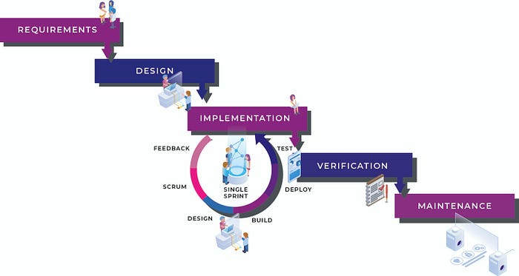
Figure 10 – Waterfall + Agile
(Tan, 2019)

Advantages:
- Flexibility: allows project management to fit local government projects' unique needs.
- Customisation: adaptable to projects' size, complexity, and requirements for efficient delivery.
- Stakeholder satisfaction: balances responsiveness to change with meeting stakeholder expectations.

Disadvantages:
- Complexity: managing a hybrid approach can be challenging due to its complexity and integration of different methodologies.
- Communication challenges: coordinating between teams following different methodologies can pose communication hurdles.
- Integration issues: ensuring seamless integration of agile and waterfall practices may present technical and organisational obstacles.

Best suited to:
Similar to PRINCE2 Agile above, a hybrid methodology is best suited to projects that require a balance between structure and adaptability, such as:
- Environmental sustainability initiatives, e.g. projects that balance long term goals with adapting to emerging technologies, community needs, and unforeseen environmental challenges.
- IT projects, e.g. implementing a new system to monitor Internet of Things sensors.

5.4 Tailoring
A related concept to hybrid project management is “tailoring”. While hybrid approaches combine elements from different existing elements, tailoring involves modifying an existing approach.

Project Management Institute (2021, p.131) define tailoring as: “the deliberate adaptation of the project management approach, governance, and processes to make them more suitable for the given environment and the work at hand.”

However, it should be cautioned that:

Tailoring is an advanced topic that should be undertaken by experienced practitioners who have been successful using agile approaches as originally
described in multiple environments before they consider tailoring them. In
other words, gain experience and be successful with one approach before
attempting to tailor the approach.
Project Management Institute (2017b, p119)

Tailoring can be done on a per-project basis, or it can be developed as a bespoke project management methodology for use within an organisation:

The alternative to an off the shelf methodology is to instead spend the time and money set aside for licensing and accreditation fees to develop your own tailored project management methodology. The results will be better suited to your organization and longer lasting because you developed it yourself, using your own language and creating your own champions.
Whitaker (2012)

Advantages:
- Alignment with needs: allows the alignment of project processes and practices with the unique requirements of each project or organisation.
- Improved efficiency: eliminates unnecessary processes and focusses resources on activities that add value to project outcomes.

Disadvantages:
- Complexity: developing and implementing a tailored project management methodology can be complex and time-consuming.
- Consistency and standardisation: may lack consistency and standardisation across projects.
- Risk of over-customisation: may lead to overly complex processes or practices that hinder project delivery.

Best suited to:
Organisations that wish to develop a bespoke version of a recognised methodology, or, in the hands of an experienced practitioner, projects that require a modified version of an existing methodology, such as:
- Small-scale, one-time projects, e.g. organising a community event.
- Proof-of-concept initiatives, e.g. piloting a new recycling program in a specific area.

5.5 Summary
We have seen in the discussion above that Project Management methodologies tend to be predictive (aka waterfall), adaptive (aka Agile), or a combination of both (hybrid).

The difference between the approaches and their output can be show below:

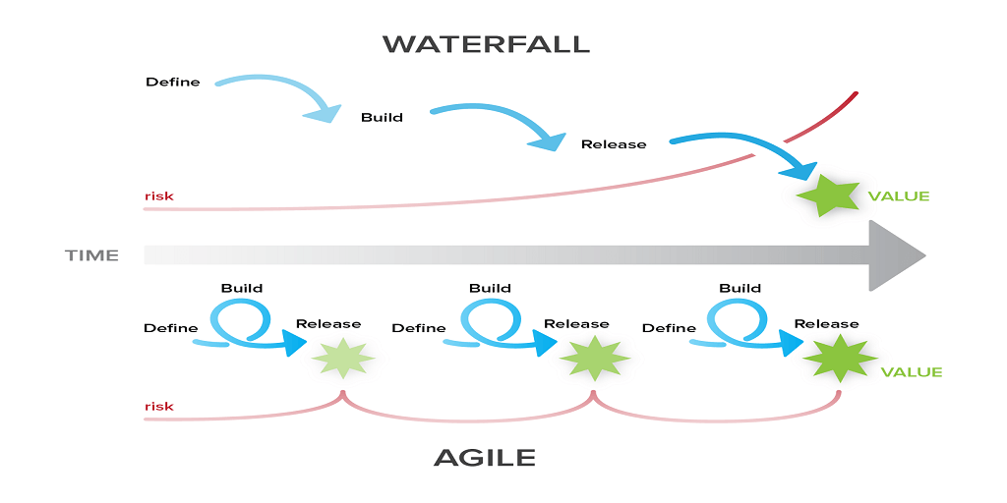
Figure 11 – Waterfall vs Agile
(Robins, 2016)

With the waterfall approach, the product is presented at the end, a grand finale that does not allow for adjustments to the product if it is not as expected, or if requirements have changed. With the Agile approach, on the other hand, the product is presented at regular intervals, allowing for modifications as necessary.

However, combining the two approaches in a hybrid manner can offer the best of both worlds, and is becoming increasingly popular. As Wachira (2024) notes: “Agile sprints within a Waterfall framework, for example, can provide structured guidance while allowing for iterative refinement.”

Further options for customisation are offered by tailoring, enabling existing methodologies to be adapted to better suit the organisation or project.

6 Process/Methodology Suitability for the Workplace

Having discussed and critically evaluated project management processes and methodologies, let’s now assess the suitability in the context of the workplace.

We discussed how project management processes can generally be grouped into five process groups that are used in most projects, most of the time:
• Initiating
• Planning
• Executing
• Monitoring and Controlling
• Closing
We opine that understanding these processes and groups and using them as best practice resources and knowledge will assist with effective implementation of the workplace project, no matter which methodology is used.

We then discussed how different methodologies can be applied depending on the nature of the project, its complexity, the organisation's culture, and the industry context.

We put forward that:
- Predictive methodologies are suited where requirements are clear and will not change.
- Adaptive methodologies are suited where requirements may change and/or incremental delivery is required.
- Hybrid methodologies allow for flexibility and adaptability while also providing structure and control where needed.
- Tailoring enables the above approaches to be customised to suit the organisation or specific project needs.
We then went on to outline the types of projects that are suited to each approach.

Projects within local government can be diverse, and it would be impossible to recommend a one-size-fits-all methodology. Instead, it is proposed that a methodology should be chosen that suits the type of project under consideration.

The Stacy Model, put forward by Wachira (2024), suggests using the following matrix to help decide on the most suitable approach:
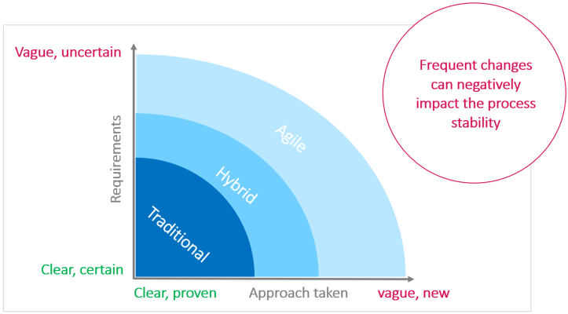
Figure 12 – The Stacey Model
(Wachira, 2024)

Using the above model, a project with:
- Clear requirements and proven technology, such as building a bridge, would be well managed using a traditional methodology.
- Vague requirements and untested approach, such as developing a revolutionary medical device, would be more suited to an agile approach.

PMI takes this a step further with their Suitability Assessment Radar Chart, shown in Figure 13 below:

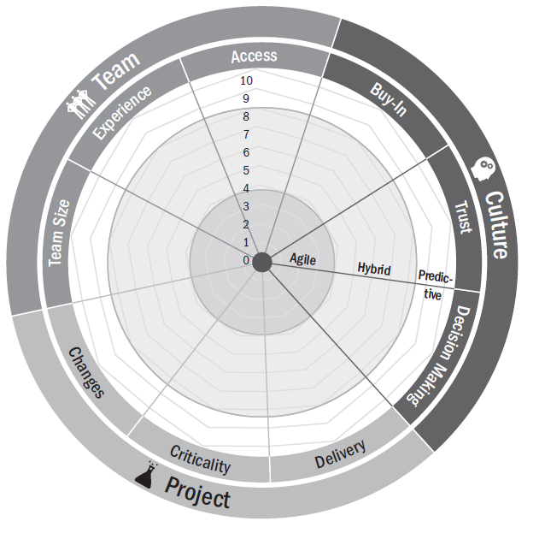
Figure 13 – Suitability Assessment Radar Chart
(Project Management Institute, 2017b)

In the above assessment, a number of guided questions are posed to the project team, with the results plotted on the chart indicating which is likely to be the best approach.

It should be noted that whilst the above decision-support tools may provide guidance on the likely best approach, a skilled and experienced project manager would be able to add their knowledge and judgement to assist with the decision-making process.

In local government, governance and compliance requirements are generally high, and culture change can be slow to implement, meaning that predictive approaches are often favoured even where an agile approach may seem a better fit. In these circumstances, Project Management Institute (2017a) suggests that a gradual transition can be implemented, using a hybrid approach to add agile techniques slowly to gain acceptance.

Within Digital Transformation, the requirement is often to follow a prescribed process to ultimately deliver a digital solution. Compliance with existing frameworks and protocols demands a linear approach, yet incremental delivery of the digital solution enables effective collaboration with the customer, early delivery of value and opportunity for improvement and hence increased satisfaction. It is therefore proposed that a hybrid methodology is generally used for Digital Transformation projects, whereby a predictive approach is largely followed, but with iterative cycles during the delivery phase, similar to the method shown in Figure 12 earlier.

This is a common, tried and tested approach; LGA state that “in local government it is typical for transformation initiatives to adopt the most relevant elements of each methodology and use them in combination to achieve outcomes” (Local Government Association, 2024).

A recurring theme throughout the discussion in this report is that whilst using a hybrid approach can offer the ideal combination of methodologies for a project, it can be challenging to manage. It is therefore essential that project managers are selected appropriately and given the necessary resources to do the job.

7 Conclusion

This report has discussed and critically evaluated project management processes and methodologies. Suitability in the context of the workplace has been assessed, and the recommendations given can be summarised as follows:

Knowledge of processes and process groups:
It is recommended that the best-practice processes and process groups as outlined in the PMBOK Guides (and discussed on pages 8 and 9 of this assignment) are understood and utilised as resources when undertaking projects.

Best methodology for local government projects in general:
There can be no correct answer here due to the diverse nature of local government projects. Instead, it is recommended that an assessment of the project attributes is undertaken using a recognised tool such as PMI’s Suitability Assessment Radar Chart to determine which is likely to be the best approach. Corporate directives are also likely to play a role in the decision of which approach should be used.

Best methodology for Digital Transformation projects:
A hybrid approach is likely to offer the best fit for these types of projects within a local government setting. This method will allow for compliance with the governance framework including any necessary legal and regulatory requirements, whilst also allowing for flexibility and adaptability, and delivery of working solutions incrementally, thus benefitting from early stakeholder feedback.

It is crucial that a competent project manager is employed, who has the skills, knowledge, and experience to manage the project effectively using the most suitable methodology (or methodologies), and that the necessary resources are made available in order to ensure the overall success of the project.

8 References

Actitime (2022) Waterfall Model: What Is It, When and How To Use It? Available at: https://www.actitime.com/project-management/what-is-waterfall-model (Accessed: 29 February 2024).
Aston, B. (2024) 9 Project Management Methodologies Made Simple. Available at: https://thedigitalprojectmanager.com/projects/pm-methodology/project-management-methodologies-made-simple/ (Accessed: 14 February 2024).
Axelos (2021) PRINCE2 Agile in 1000 words | Axelos. Available at: https://www.axelos.com/resource-hub/white-paper/prince2-agile-in-one-thousand-words (Accessed: 1 March 2024).
Axelos (2024) PRINCE2 Agile Certification | Agile Project Management | Axelos. Available at: https://www.axelos.com/certifications/propath/prince2-agile-project-management (Accessed: 29 February 2024).
Beck, K. et al. (2001) Manifesto for Agile Software Development. Available at: https://agilemanifesto.org/ (Accessed: 15 February 2024).
Buehring, S. (2023) PRINCE2 Principles. Available at: https://www.knowledgetrain.co.uk/project-management/prince2/prince2-course/prince2-principles (Accessed: 28 February 2024).
Bydrec (2024) Full Comparison - Agile vs. Scrum vs. Waterfall Methodology. Available at: https://blog.bydrec.com/a-comprehensive-comparison-between-the-agile-scrum-and-waterfall-methodology (Accessed: 1 March 2024).
Harrin, E. (2023) PRINCE2: The Project Management Method Explained. Available at: https://rebelsguidetopm.com/prince2/ (Accessed: 28 February 2024).
ILX Group (2024) What Is PRINCE2? The Definition, History & Benefits. Available at: https://www.prince2.com/uk/what-is-prince2 (Accessed: 28 February 2024).
Lamborn, J. (2022) Agile explained: The 4 Agile Manifesto values and 12 principles - LogRocket Blog. Available at: https://blog.logrocket.com/product-management/agile-manifesto-4-values-12-principles-explained/ (Accessed: 1 March 2024).
Local Government Association (2024) Governance and Control: Apply appropriate delivery methodology | Local Government Association. Available at: https://www.local.gov.uk/our-support/transformation/transformation-capability-framework/governance-methodology (Accessed: 3 March 2024).
PM Vidya (2022) Agile & Agile Methodologies (Agile Umbrella). Available at: https://pmvidya.com/blog/agile-agile-methodologies-agile-umbrella/ (Accessed: 17 February 2024).
Portman, H. (2023) PRINCE2 7th edition | Henny Portman’s Blog. Available at: https://hennyportman.wordpress.com/2023/08/08/prince2-7th-edition/ (Accessed: 28 February 2024).
Project Management Institute (2017a) A Guide to the Project Management Body of Knowledge (PMBOK® Guide). 6th edn. Newtown Square, PA: Project Management Institute.
Project Management Institute (2017b) Agile Practice Guide. Newtown Square: Project Management Institute, Inc.
Project Management Institute (2021) A Guide to the Project Management Body of Knowledge (PMBOK® Guide). 7th edn. Newtown Square, Pennsylvania: Project Management Institute, Inc.
Project Management Institute (2024) What is Project Management. Available at: https://www.pmi.org/about/learn-about-pmi/what-is-project-management (Accessed: 14 February 2024).
Robins, D. (2016) Agile vs Waterfall - which one is right? - Binfire. Available at: https://www.binfire.com/blog/agile-vs-waterfall/ (Accessed: 17 February 2024).
Schuurman, R. (2017) What is Agile? And is it Agile or is it Scrum? Or is it Agile-Scrum? | by Robbin Schuurman | The Value Maximizers | Medium. Available at: https://medium.com/the-value-maximizers/what-is-agile-ac19f79de430 (Accessed: 1 March 2024).
Tan, B. (2019) Effective Agile + Waterfall Hybrid Project Management. Available at: https://medium.com/2359media/effective-agile-waterfall-hybrid-project-management-25af260aaa6d (Accessed: 17 February 2024).
Wachira, D. (2024) Choosing Agile, hybrid and Waterfall project management methodologies. Available at: https://www.linkedin.com/pulse/agile-vs-predictive-hybrid-navigating-uncertainty-stacey-wachira-0pjjf?trk=article-ssr-frontend-pulse_more-articles_related-content-card (Accessed: 17 February 2024).
Whitaker, S. (2012) Art of Tailoring - Making Project Methodology Fit. Available at: https://www.pmi.org/learning/library/making-project-methodology-fit-guide-6085 (Accessed: 3 March 2024).
Wrike (2024a) Is Agile Project Management Only for Software? Available at: https://www.wrike.com/project-management-guide/faq/is-agile-project-management-only-for-software/ (Accessed: 17 February 2024).
Wrike (2024b) Project Management Basics. Available at: https://www.wrike.com/project-management-guide/project-management-basics/ (Accessed: 14 February 2024).

