“
Name: Fabio Candiza
Student name:2118054
Module code BMSW4004
Module Title: Problem Solving and Decision Making
Lectures name: Nicholas Worthington
Assignment Title: Problem Solving and
Decision making

Contents
Task 2 3
Introduction 3
Problem statement 3
SWOT Analysis 4
The NHS PESTLE Analysis 5
Ishikawa Fishbone Diagram 6
Alternative solutions 7
Grid analysis 8
SMART Goals 9
References 10

Task 2

Introduction
Proper Care, a UK provider of adult care, is presently facing the greatest danger from workforce issues, which are already having substantial effects on patients and employees. Further, NHS hospitals, mental health facilities, and community providers are now experiencing a staffing deficit of more than 100,000 full-time equivalents (FTEs). There are 41,000 nursing vacancies, one of the major obstacles. Still, there are problems in medicine, notably in certain specialities and geographic regions, as well as in other allied health professions. Adult Social Care has a 12% vacancy rate for registered nurses, which translates to around 5,000 nursing openings. The present vacancy rate seems to be on the verge of worsening. Concerns over Brexit seem to have exacerbated both short- and medium-term threats. As of July 2017, and July 2018, there were 1,584 fewer EU nurses, and health visitors in the NHS than EU nurses and health visitors were entering the NHS. The problem of inadequate training among employees is something that has to be addressed as quickly as possible in order to improve performance. In order to address this problem, the hospital administration will need certain operational methods and techniques.

Problem statement
High-quality care can only be given effect and for a long time if the people who work in the field are skilled and have the support they need. Research from the Health Foundation on the workforce in 2016 states that the primary care staffing paradigm is shifting. The number of full-time equivalents (FTE) GPs has decreased by 1.6% over the last year. Over the last years, the number of nurses and other direct patient care personnel working, in general, in practice has increased. There has been a minor but significant rise in the number of pharmacists and advanced practice nurses in general rule. According to the Buchan, (2019) FTE registered nurses and health visitors employed by NHS England expanded by less than half a percentage point (1,000 FTE) between July 2017 and July 2018, while activity demands increased significantly. Although there has only been a very slight increase in the total number of registered employees, there is clear evidence of underlying staffing shortages in the form of high vacancy rates across the NHS. One in ten nursing positions in the NHS is now unfilled in England, with more than 41,000 registered nurse positions listed as empty. According to the Buchan, (2017) report primary care and learning disabilities are two sectors where the NHS has seen a minor rise in the number of nurses working. There has been a long-term drop in the number of nurses and health visitors working in community health services, with a decrease of 1.2 percent (538 FTE). Trends in the NHS workforce (Beech et al., 2019) show a reduction in the number of health visitors but a minor increase in community nurses. The number of mental health nurses, another area of emphasis, grew by less than 0.5% (172 FTE) between July 2017 and July 2018.

SWOT Analysis
Table 1: Nursing and Health Care: SWOT Analysis (Ladd et al., 2020)
Strengths  - There is a great emphasis in the clinic on transparency, sharing, and building patient trust. | Weaknesses  - Planned activities are not possible because of a lack of staff time.  - A lack of availability of nurses in terms of interacting with patients  - Economic and political slowdown  - Dissatisfied NSH staff and patients  - Employees are unsure about their place in the patient-physician connection.  - A narrow emphasis on open events rather than collaboration activities
Opportunities  - Patients who are participating in the Patient Participation Project at the clinic may have their thoughts and ideas solicited from them at any time.  - New goals can be set with the help of advanced technology | Threats  - Security breaches  - High competition  - The number of volunteers participating in open days is also not rising.

The NHS PESTLE Analysis
Table 1: shows the PESTLE Analysis of NHS (De Val et al., 2021)
Political Factors  uncertainty about Brexit: In terms of the important notion of medicines and medical equipment from the European Union, there are several questions. Concerns over the NHS's workforce, which includes many medical professionals from other European nations, have been raised due to Brexit, which might lead to tighter or less attractive living circumstances for foreigners working in the NHS. | Economic Factors  Measures of austerity: The United Kingdom's government implemented a broad range of austerity measures to reduce public expenditure in response to the current economic slump. Austerity policies may have indirectly impacted the NHS's finances and contributed to the organisation’s financial difficulties. However, the NHS was never directly harmed by austerity measures
Social factors  Patient expectations: Patients' expectations have never been greater than they are now, thanks to advancements in medical technology, social media, and education. In industrialised nations like the United Kingdom, patients have a greater understanding of the therapeutic alternatives accessible to them and expect government entities to spare no money. Even though this is a wonderful development, the NHS faces new hurdles since they are now required to deliver better treatment. | Technological Factors  Enhancing medical care: Healthcare is gradually improving as new technologies are introduced daily. Affordability has made scanning technologies a need in hospitals and clinics. Many pumps and other devices are being created to treat or manage various illnesses, decreasing morbidity due to recent advancements in healthcare technology, all stakeholders benefit. The NHS can streamline and automate more healthcare procedures for both patients and the government.
Legal Factors  Improved training: Better healthcare education is now possible because of technological advancements. Both patients and practitioners are educated through the internet s and high-quality content sources. However, technology has been underutilised since it is so simple to deliver accurate information into the hands of everyone. It should be more straightforward for the NHS to attract qualified staff and offer high-quality treatment if clinical experts are given more excellent training. | Environmental Factor  NHS places trees across their campus and surrounding area to offer a healthy environment for hospital patients and nearby residents. Patients will be treated for their health concerns, and the background will be taken care of to prevent undesired infections.

Ishikawa Fishbone Diagram
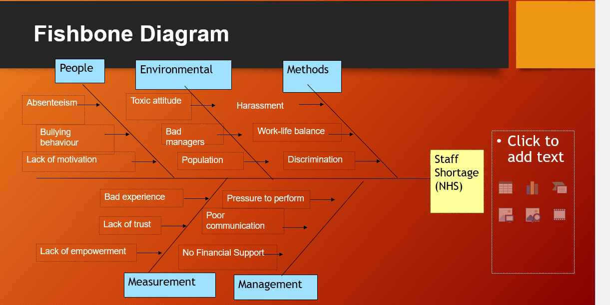
Figure 1: Fishbone Diagram of NHS problem

Alternative solutions
Nurses play an essential role in providing health and social care services. They may work in various settings, including hospitals, care homes, community services, and primary care. The few strategies given below can help to improve the number of nurses in NSH.
“Creating A Motivating Climate”
The organisation has such a significant effect on elements that intrinsically inspire individuals, it is critical to evaluate organisational climates or attitudes that have a direct impact on employee morale and motivation. Many firms, according to (Waters, 2022), promote the idea that each and every person is replaceable in some manner, and that a high level of individual recognition is detrimental to the individual as well as the productivity of that individual inside the company. Nurse supervisors should strive for excellence while also setting realistic objectives and rewarding their employees when they achieve them. These are the cornerstones of a nursing organization's incentive and reward system.
“Managing Career Development in nursing”
Nursing has been influenced by certain theories on the role of nurses in their own professional growth. Nurses need to take on more responsibility for their own career planning and advancement. Continuing professional development (CPD) has long been recognised in the UK as an important factor in nurses' individual career advancement and retention. It improves patient care as well. Local health care employers have been debating for a long time whether or not CPD programmes with adequate controls are valuable in recruiting, motivating, and maintaining high-quality workers.
“Working Condition"
Nursing job satisfaction and workplace stress research has shown that nurses can be influenced in a variety of ways, influencing their career choices and retention rates. Positively, it has long been recognised that nursing is a difficult job to do on both a physical and cerebral level. Emotional support for patients and loved ones who are dealing with death and dying can be an equally important and demanding aspect of nursing. Success can be a source of satisfaction when a person's demanding emotional elements rise to meet a challenge. Nursing professionals who are under-supported and under-resourced, especially in terms of staffing, may suffer from poor morale and job stress (Waters, 2022).

“Job Security”
Salary and advancement are not as crucial as job stability, a basic human need to sustain many people. Unionism is a significant factor in many of these factors, such as a lack of trust in one's supervisor or fear of change. An employee's union assures that they will not be dismissed unlawfully via an objection procedure. Most non-union companies should also have a grievance mechanism, so workers do not worry about being wrongfully dismissed. According to (Waters, 2022), the patient returned to Aintree University Hospitals NHS Foundation Trust after routine eye surgery to express gratitude to medics who discovered he had a significant cardiac problem.
“Good Pay”
Even though employee dissatisfaction with pay has long been recognised as a significant reason for low retention, a research revision conducted before the start of the current upgrade programme indicated that the relationship between payment and retention is complicated and is the most significant of various variables that may influence behaviour on the labour market. Nurses' wages were shameful. In many cases, they were paid less than an office cleaner. Women, who make up most of the nursing workforce, have seen their career options expand recently, resulting in lower wages for nurses as a group compared to the rest of the crew (Waters, 2022). Consequently, the awareness that others may be receiving more money for the same or less obligation may influence the choice to quit nursing for high-paying occupations. Nurses report making less than a quarter of their household's income from their work. Beech, (2019) reports that a new, higher-paying plan for the vast majority of NHS employees is in the works and might be implemented as soon as the next two years. The three components of NHS nurses' compensation have changed over the last several years.
Pay renewal has been suggested, according to (Xu et al., 2020) as a more transparent approach to rewarding and developing employees. It has long been established that certain locations of the United Kingdom, particularly London and the South-East, have very high housing prices. Those who work in the public sector for low wages, such as nurses, are forced to look for employment elsewhere. Even though the results of these and other similar suggestions have yet to be thoroughly evaluated for a better retention strategy, this has led to the development of much low-cost housing proposals

Grid analysis
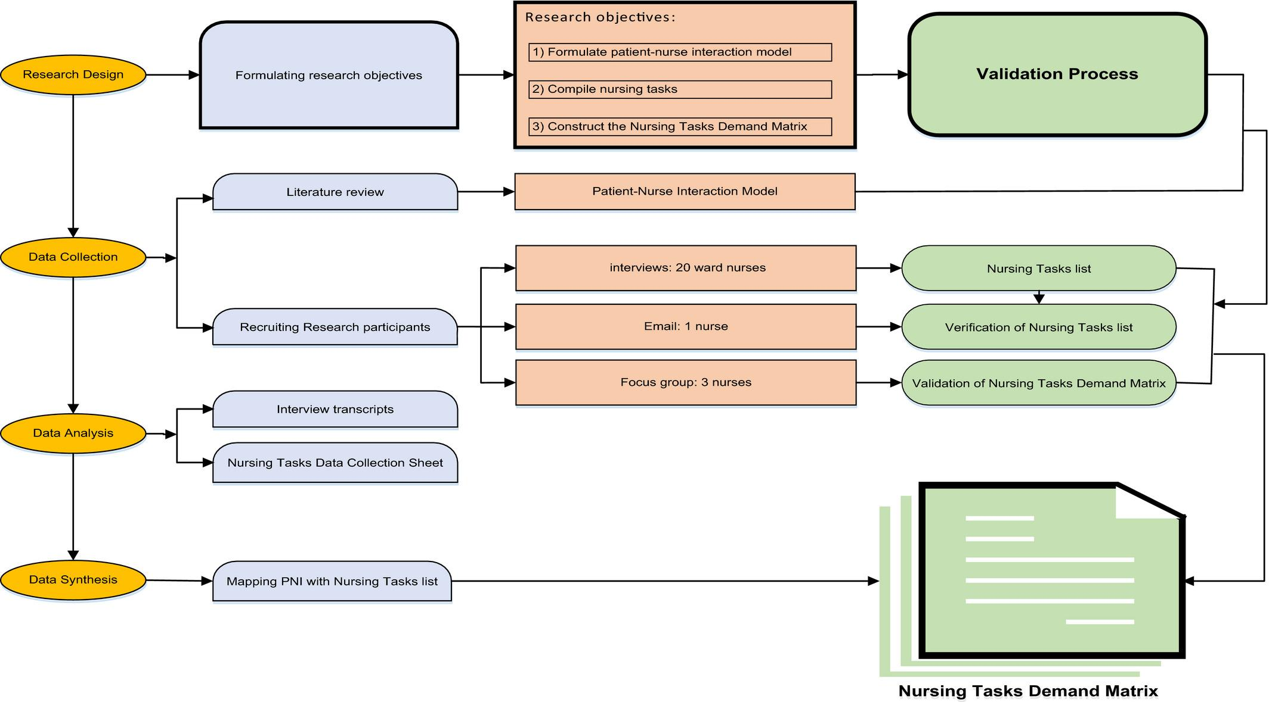
Figure 2: a qualitative assessment matrix of professional nursing practice (Riley et al., 2021)

SMART Goals
The key areas focus on when setting SMART goals in nursing are training, funding of government, the role of HR and measuring the targets:
Training
In today's NHS, training opportunities for clinical nursing professionals are a problem of rising relevance. First, if they regularly update their clinical nursing abilities, they will be more likely to continue providing high-quality patient care.
Measure the targets
Out of 11 high-income nations, the NHS in the United Kingdom has dropped to fourth place, behind only Norway, the Netherlands, and Australia systems. To retain healthcare employees and prevent recurrent staff shortages, more emphasis must be devoted to working conditions, especially regarding health and well-being.
Role of HR
Human resource operations within healthcare providers must adopt a strategic stance, focusing on investments with precision to maximise workforce performance.
Funding of government
As a practice discipline, nursing scholarship informs research, improves clinical practice, affects policy, and influences the best methods for training nurses as clinicians, scholars, and leaders.

”

References

Beech, J., Bottery, S., Charlesworth, A., Evans, H., Gershlick, B., Hemmings, N., Imison, C., Kahtan, P., McKenna, H., Murray, R. and Palmer, B., 2019. Closing the gap. Key Areas for Action on the Health and Care Workforce.
Buchan, J., Charlesworth, A., Gershlick, B. and Seccombe, I., 2019. A critical moment: NHS staffing trends, retention and attrition. London: The Health Foundation.
Buchan, J., Charlesworth, A., Gershlick, B. and Seccombe, I., 2017. Rising pressure: the NHS workforce challenge. Workforce Profile and Trends of the NHS in England. London: The Health Foundation.
De Val, J., Sohal, G., Sarwar, A., Ahmed, H., Singh, I. and Coleman, J.J., 2021. Investigating the challenges and opportunities for medicines management in an NHS field hospital during the COVID-19 pandemic. European Journal of Hospital Pharmacy, 28(1), pp.10-15.
Ladd, E., Miller, M., Wheeler, K., Wainaina, S., Aguirre, F., McGrath, H., Lee, S., Nashwan, A., Neary, A. and Core, K., 2020. A Global SWOT Analysis of Advanced Practice Nursing: Policy, Regulation, and Practice.
Riley, Y., Stitt, J., Hill, C.M., Stutzman, S.E., Venkatachalam, A.M., Aguilera, V. and Ifejika, N.L., 2021. Implementation of the MATRIX staffing grid improves nurse satisfaction with rehabilitation unit staffing. Journal of Neuroscience Nursing, 53(4), pp.183-187.
Waters, A., 2022. NHS staff survey underlines need for national workforce strategy. BMJ: British Medical Journal (Online), 377.
Xu, H., Intrator, O. and Bowblis, J.R., 2020. Shortages of staff in nursing homes during the COVID-19 pandemic: what are the driving factors?. Journal of the American Medical Directors Association, 21(10), pp.1371-1377.

