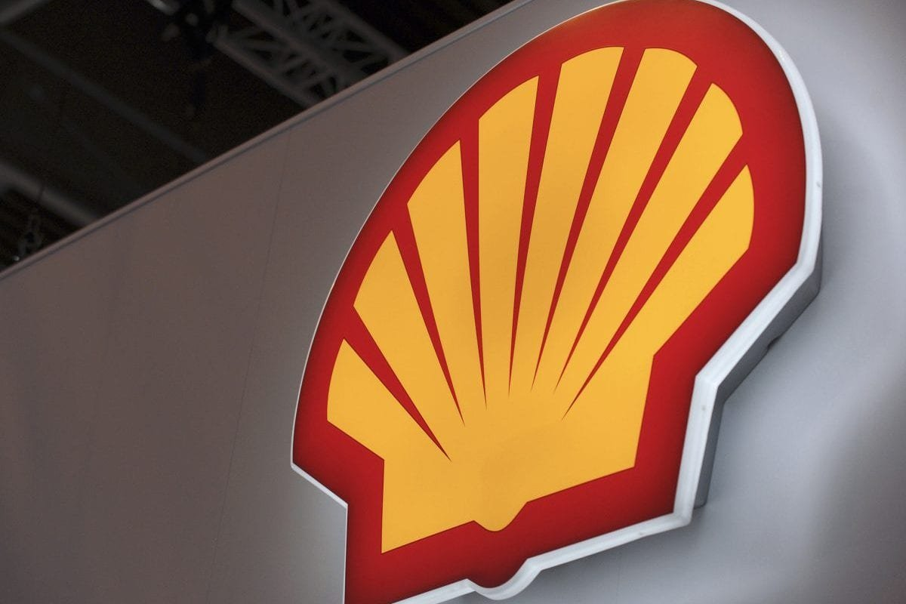

Strategic Management and Sustainability

(LCBB6004)
University of Wales Trinity Saint David (London)
BA (Hons) Business Management

Student name: Anca Mirela Dula (2112863)
Lecturer name: Dr Hossein Shokri
Submissions Date: 24/04/2024
Table of Contents

Introduction 2
Company background 2
MAIN BODY 3
1.1: Identifying Key Business and Corporate Strategies 3
1.2: Porter's Generic Strategies 3
1.3: Applying the Ansoff Matrix 3
1.3.1: Market Penetration: 4
1.3.2: Development of the Market: 4
1.3.3: Product Development: 4
1.3.4: Diversification: 4
2.1: Analysing Resources and Capabilities 4
2.1.1: Resources and Capabilities 4
2.1.2: Allocation of Resources and Capabilities 5
2.3: Value Chain and Value System analysis 5
3.1: VRIO Analysis 6
4.1: Evaluating Strategy in Action: SAF (Suitability, Acceptability and Feasibility) 7
4.1.1: Suitability 7
4.1.2: Acceptability 7
4.1.3: Feasibility 7
5.1: Provide evidence and examples of how the company has executed its strategies successfully or faced challenges. 8
5.1.1: Successes 8
5.1.2: Challenges 8
6.1: Evaluating Sustainability Efforts 8
6.1.1: Sustainability 8
6.1.2: Coordination with Corporate Strategy 8
6.1.3: Action Taken 9
7.1: Conclusion 9
References 11

Introduction
Shell PLC is one of the most important companies in the world of energy, which is changing quickly. It faces many obstacles and possibilities. As a strategic planner whose job it is to thoroughly review, analyse, and rate Shell's business and corporate strategies, this report aims to give you information about the company's strategic choices and how well they were put into action. With this backdrop, the research will examine Shell's business and goals. This will include examining the company's strategic choices to evaluate how well they fit together, operate, and can be adjusted to accommodate internal and external changes. After that, the report will examine how these plans were implemented, including resource utilisation, organisation performance, and outcomes. This strategic assessment aims to assist Shell PLC's board make informed choices and enhance their strategy for long-term development and value generation (Shell PLC, 2023)

Company background
Shell is a British-Dutch multinational energy business based in The Hague, Netherlands, with a registered office in London. Shell is one of the biggest integrated oil and gas businesses in the world, founded in 1907. Shell explores, produces, refines, distributes, and markets oil, gas, and renewable energy in over 70 countries and territories.
From oil exploration to LNG technology, Shell has innovated and expanded strategically. The corporation has been adapting to market changes and trends by emphasising sustainability, technology, and ethical business. Shell PLC, a London Stock Exchange-listed firm, helps the global energy transition by providing dependable, cheap energy while addressing environmental issues and promoting socio-economic development. Shell shapes the energy sector and delivers value to stakeholders via operational excellence and strategic investment (Shell PLC, 2023).

MAIN BODY

1.1: Identifying Key Business and Corporate Strategies

1.2: Porter's Generic Strategies
According to Porter (1979), strategic analysts continue to make use of Porter's five-force strategic analysis model to conduct an examination of the competitive environment of an industry. Porter's Generic techniques are methods that businesses may use to get a competitive edge in the market. These strategies were established by Michael Porter from the beginning. The three primary tactics are as follows:
1. Cost leadership: Which means being the most cost-effective producer in the business. The company has the potential to undercut competitors and attract customers who are price-conscious if it reduces its expenditures.
3. Differentiation: Considering that consumers place a high value on unique products and services, this strategy places a focus on distinctiveness. A differentiation may occur in areas like as design, brand image, technology, and customer service.
3.Focus: This strategy focuses on a certain market and adapt products and services to meet the requirements of that market. By doing so, the company can better serve its target market than its competitors.

Differentiation is the primary focus of Shell PLC's global energy business. In addition to providing high-quality energy goods and services, the company has a strong emphasis on new product development, environmental responsibility, and sustainability. Shell invests a significant amount of money in research and development to find more effective energy alternatives and reduce its carbon footprint. Shell has been able to develop a strong brand and the loyalty of its customers by conducting operations that are safe, dependable, and honest. Shell can differentiate itself from its competitors, which allows it to demand premium prices and attract a diverse customers base (MarketLine, 2021) .

1.3: Applying the Ansoff Matrix
The Ansoff Matrix is a strategy tool that gives an examination of future growth possibilities. It examines four possible strategic orientations: market entry, market development, product development, and diversity. These are the four possible strategic orientations that are analysed by the Ansoff Matrix (Whittington et al., 2020).
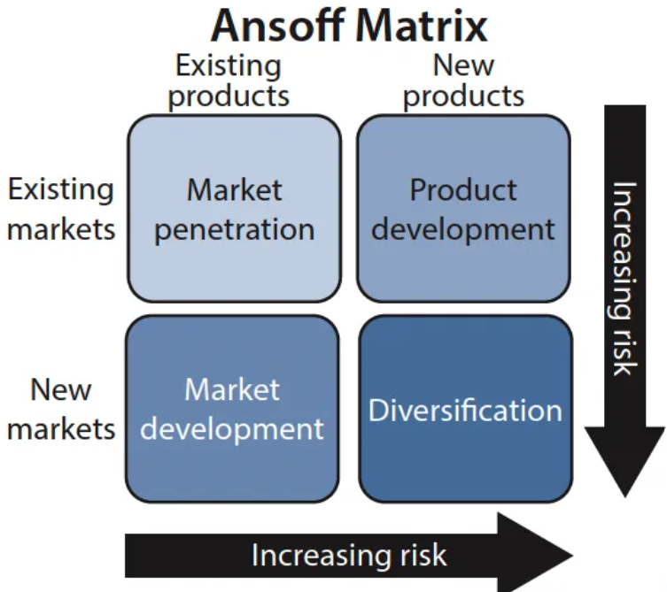

1.3.1: Market Penetration:
Shell tries to get into new markets by making its position stronger in current ones. It does this through bold marketing efforts, customer reward programmes, and pricing strategies. To get a bigger share of the market, this could mean opening more stores, making delivery routes better, or giving better customer service (Shell, 2023a)

1.3.2: Development of the Market:
Shell looks for ways to grow its markets by joining new areas or groups of people. This could mean going into new markets where energy needs are rising, teaming up with local providers, or going after specific groups of people with tailored energy solutions.

1.3.3: Product Development:
Shell works on product development to come up with new energy solutions and services that add value. One way to do this is to introduce new fuels that work better, work on creating green energy technologies, or provide complete energy management options for business and industry clients.

1.3.4: Diversification:
Oil and gas are Shell's main business, but the company also uses diversification tactics to grow into other industries, some of which are connected and some of which are not. This could mean putting money into green energy projects, buying up new tech companies, or forming smart relationships to look for new business possibilities that don't involve standard energy sources based on hydrocarbons (Shell, 2023a).

2.1: Analysing Resources and Capabilities

2.1.1: Resources and Capabilities
- According to Shell (2023a) Capabilities are a company's ability to use its physical and intangible assets to fulfil its strategic goals.
- Financial Resources: Shell has cash reserves, capital market access, and worldwide revenue.
- Physical Resources: The corporation runs a global network of oil and gas reserves, refineries, pipelines, terminals, and distribution facilities.
- Human Capital: Shell employs experienced engineers, geologists, financiers, and marketers. Companies engage in training and development to improve employee skills and expertise.
- Shell has new method of: Energy exploration, production, refining, and distribution technology. The firm funds R&D to produce greener energy and operational efficiency technology.
- Quality goods, innovation, and sustainability and social responsibility have earned Shell a solid brand name over decades.

2.1.2: Allocation of Resources and Capabilities
Research by Shell PLC (2023) has invested in its strategic position as a leading global energy corporation focused on sustainability and innovation.
- Exploration and Production: Shell invests heavily in global oil and gas exploration. This helps its objective of diversifying and securing energy supplies to satisfy global demand.
- Research: The firm invests in research and development to create greener energy technologies such renewable energy, biofuels, and carbon capture and storage.
- Sustainability: Shell invests in renewable energy, energy efficiency, and greenhouse gas reduction. The strategic position as a responsible and sustainable energy supplier is strengthened.

2.3: Value Chain and Value System analysis
From development to distribution, a value chain is a set of actions that create a final product. The chain highlights value-added steps including sourcing, manufacturing, and marketing. The precise methods of each business phase are examined in a value-chain analysis. Value-chain analysis improves manufacturing efficiency so a firm may maximise value at the lowest cost (Whittington et al., 2020).
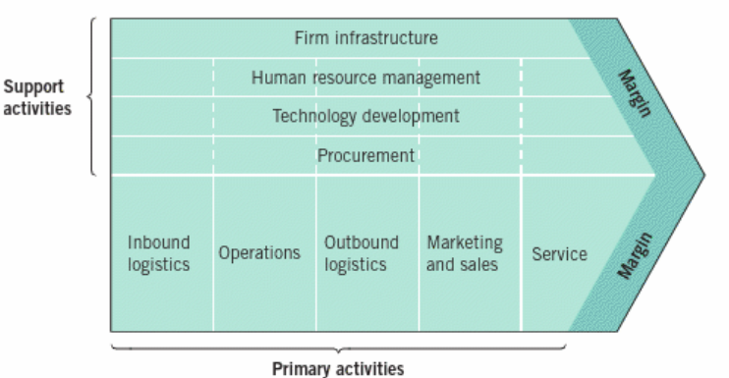
Shell plc's value chain is made up of transportation, supply chain management, and the success of the organisation. Some of the biggest oil and gas companies in the world are Shell. It is also a world leader in logistics and supply chain management. The company wants to know how logistics affects the success of the organisation and find ways to cut costs and time while also adding value along the supply chain. Shell can make its supply chain work better by keeping costs down, planning and risk under control, and keeping good ties with owners and suppliers. The value chain method helps Shell come up with a plan, find ways to enhance customer satisfaction, and make money. It also lets the business look at its actions, prices, and resources to gain a competitive edge and find its best strategy position. Overall, Shell's value chain is all about improving performance and giving people good services by making the best use of its supply chain management (MarketLine, 2021)

3.1: VRIO Analysis
VRIO Analysis is a tool for internal analysis that companies use to sort their own resources into groups based on whether they meet certain criteria listed in the framework. After putting things into these groups, businesses can find the tools that give them a competitive edge. Another type of analysis tool is the VRIO Analysis (Lynch, 2018).
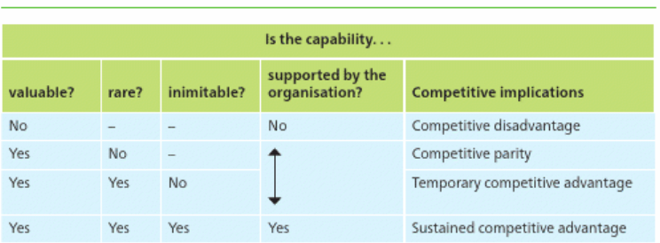

From the VRIO Analysis of Shell PLC (2023) are the following:

- Valuable: Shell values a resource or capacity that helps it to capitalise on micro business opportunities or prevent macro business hazards. A resource doesn't help Shell develop a lasting competitive advantage if it doesn't minimise risks or exploit opportunities.
- Rare: Many rivals have considerable resources in Shell's sector. Therefore, valuable resources don't provide a sustained competitive edge. Shell needs unusual resources to succeed. Shell won't prosper in the market without unusual resources. Second, Shell may acquire an advantage over competitors by retaining rare resources.
- Inimitable: Shell may get a temporary advantage from a rare and precious resource since rivals will strive to copy it. If the resource is hard to copy, it gives an extended competitive advantage. Shell may generate inimitability by inventing products, decreasing service delivery pain spots, and having a good post-sales plan.
- Organization: Shell's scarce and hard-to-copy resources won't guarantee a permanent advantage over rivals. Building a lasting competitive advantage requires organisational skills, knowledge, and structure to utilise resources. Shell cannot maximise its resources if it is not organised around its strengths.

4.1: Evaluating Strategy in Action: SAF (Suitability, Acceptability and Feasibility)
With the SAF framework approach, you can be sure that your organisation will follow a plan. You use the SAF framework approach to help you decide which of the confrontation's options are best. To use this information to help you pick a better plan for your business (Lynch, 2018)
.
According to Shell (2023) there are using below strategies:

4.1.1: Suitability
- Market Alignment: Shell's portfolio diversification, technical innovation, environmental efforts, and market positioning are fit for the changing energy landscape and customer preferences for cleaner energy sources.
- Adaptability and Flexibility: Shell invested in wind and solar electricity to diversify its portfolio and support the global low-carbon economy. However, growing these projects quickly to make a difference is difficult.

4.1.2: Acceptability
- Stakeholders Perception: Investors, consumers, and regulators have supported Shell's sustainability and environmental efforts. However, environmental, and social responsibility concerns in certain locations have caused criticism and controversy.
- Financial Performance: Despite oil price volatility, regulatory restrictions, and geopolitical uncertainty, Shell has maintained consistent revenues and profitability. The company's financial indicators may not satisfy investor expectations, causing stock price volatility.

4.1.3: Feasibility
- Resource Allocation: Shell invests heavily in R&D, infrastructure, and environmental efforts. Technology, regulation, and economic viability determine the feasibility of these investments.
- Organizational Capabilities: Shell has great organisational strengths in project management, technical innovation, and operational excellence. Complexity of business, legal obstacles, and cultural variations between regions make global strategy execution difficult.

5.1: Provide evidence and examples of how the company has executed its strategies successfully or faced challenges.

5.1.1: Successes
When Shell bought BG Group in 2016, it improved its standing in the LNG (liquefied natural gas) industry and added large natural gas sources to its holdings. Focusing on LNG has paid off for the company. Shell is now one of the biggest LNG makers in the world, thanks to its technology know-how and market presence (Shell PLC, 2023).

5.1.2: Challenges
Shell has had problems with its efforts to use green energy. It has been slower than some rivals to increase investments in wind and solar power. Regulatory problems, high start-up costs, and technical problems have made it harder to grow green energy projects more quickly (Shell, 2023b)

6.1: Evaluating Sustainability Efforts

6.1.1: Sustainability
- Net-Zero Emissions Target: Shell's aim of net-zero emissions by 2050 aligns with the Paris Agreement's target to keep global warming below 2 degrees Celsius. These ambitious goals include Scope 1, 2, and 3 emissions from the company's activities, products, and value chain.
- Renewable Energy Investments: Shell plans to spend heavily in wind, solar, and biofuels to diversify its low-carbon portfolio and cut fossil fuel use. The corporation plans to spend billions in renewable energy and sustainable technology yearly.
- Energy Efficiency Improvements: Shell uses energy-saving methods, sophisticated technology, and process optimisation to reduce energy consumption and greenhouse gas emissions.

6.1.2: Coordination with Corporate Strategy
- Portfolio Diversification: Shell's environmental objectives support its portfolio diversification and greener energy transition. Shell invests in green power and low-carbon technology to future-proof its company and leverage energy market changes.
- Risk Management: Shell's risk management plan includes climate change and sustainable business practices. Climate change poses operational, financial, and reputational concerns, which the corporation seeks to manage via sustainable programmes.
- Stakeholder Engagement: Shell's sustainability aims emphasise stakeholder interaction and corporate citizenship. Shell wants to develop stakeholder trust,
improve its brand name and preserve its social licence to operate internationally by tackling environmental and social issues.

6.1.3: Action Taken
- Investments in Renewable Energy: Shell has invested heavily in offshore wind farms, solar power plants, and biofuels. Shell is extending its low-carbon portfolio and switching to greener energy with these investments.
- Carbon Capture and Storage (CCS): Shell is participating in CCS projects to capture and store industrial and power production CO2 emissions. CCS expertise makes the firm a pioneer in carbon capture and storage, helping combat climate change globally.
- Partnerships and Collaborations: Shell works with governments, academics, and industry partners to encourage renewable energy, energy efficiency, and carbon capture innovation. These relationships enable information exchange, technology transfer, and sustainable collaboration.

Shell PLC has set up lofty sustainability objectives that are in line with its business strategy, which focuses on portfolio diversification, risk management, and stakeholder involvement. Shell is adopting preventative measures to minimise the risks associated with climate change, limit the negative consequences on the environment, and contribute to a sustainable energy future. These measures include investments in renewable energy, improvements in energy efficiency, and collaborations with important stakeholders (Shell, 2023b).

7.1: Conclusion
In conclusion, the strategic assessment of Shell PLC demonstrates the proactive approach that the firm takes to handling the difficulties and possibilities that are present in the global energy market. Some of the most important results from the research include Shell's strategic decisions, implementation efforts, and the impact of these choices in the market.
In general, Shell PLC's strategy decisions and implementation efforts are reflective of the company's dedication to responsible business practices, sustainable growth, and innovation. Shell is well-positioned to manage the changing energy environment and to achieve long-term value creation for its stakeholders because the company continually evaluates the dynamics of the market, takes advantage of technical improvements, and embraces sustainability initiatives. However, to maintain a competitive edge in the years to come, proactive adaptation and strategic agility are required to deal with continuous problems such as the transition to a new energy source, changes in regulatory policies, and geopolitical concerns.

References
- Lynch, R. (201)8. Strategic Management. 8th ed. Harlow: Pearson.
- MarketLine (2021). Chemicals in the United Kingdom, Uk: Primary NAICS: 3251.
- PLC, Shell (2023). SHELL WEBSITE. [Online]
Available at: https://www.shell.co.uk/about-us.html
[Accessed 08 04 2024].
- Richard Whittington et al (2020). Exploring Strategy. 12th ed. Harlow: Pearson.
- Shell Annual Report ( 2022). Principles of Marketing: Ansoff Matrix Application to Shell PLC., s.l.: Pearson Education.
- Shell Suistainability Report (2023). Sustainability at Shell, s.l.: s.n.
- Grant, R. M. (2016). "Contemporary Strategy Analysis: Text and Cases Edition." Wiley.
- Hitt, M. A., Ireland, R. D., & Hoskisson, R. E. (2016). "Strategic Management: Concepts and Cases: Competitiveness and Globalization." Cengage Learning.

Appendix

Shell plc. is an oil and gas corporation. The company's strengths include market position, R&D, and global presence, but insufficient liquidity is a worry. US liquid fuel consumption, energy demand, and partnerships and agreements might boost the corporation. However, price volatility, severe rivalry, and greenhouse gas legislation would pressure the company's profitability (MarketLine, 2021).



