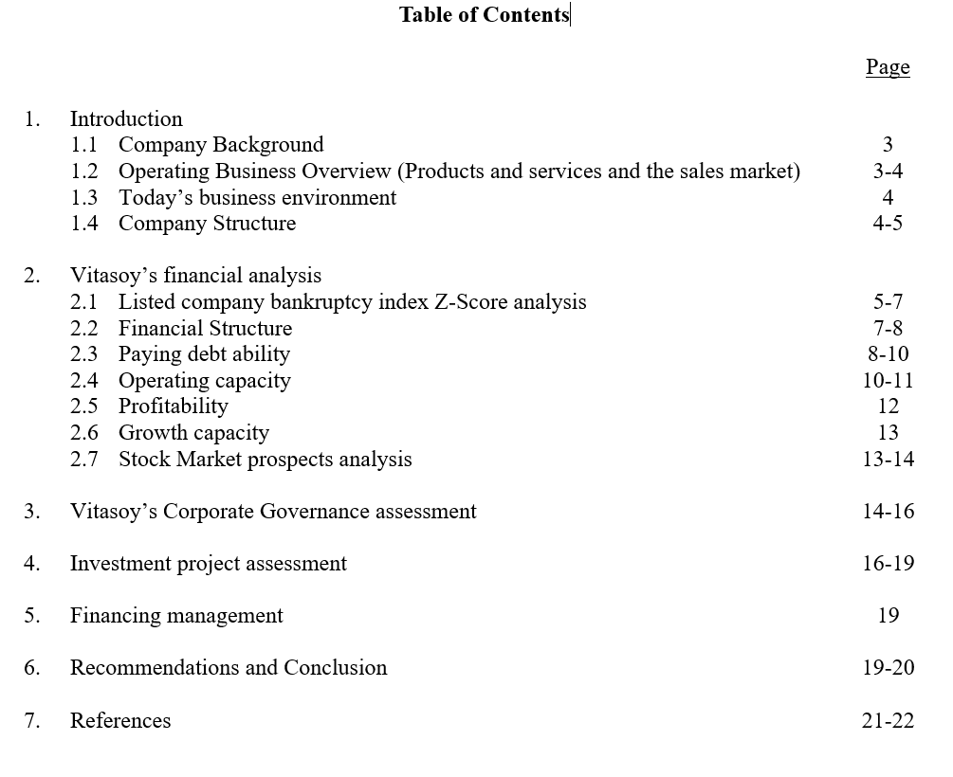

1.1 Company Background
Vitasoy International Holdings Ltd. was founded in 1940 by Dr. Lo Kwee-seong in Hong Kong with a mission to provide affordable and nutritious soy milk to the local population, particularly in the challenging post-war era. The company quickly established itself as a staple in Hong Kong households, with its flagship product, Vitasoy soy milk, gaining widespread popularity due to its nutritional value and affordability. Over the decades, Vitasoy has expanded its product portfolio to include a variety of plant-based beverages and foods, such as tofu, teas, and fruit juices, to meet the growing demand for healthier and more sustainable food options. The company’s dedication to quality, innovation, and sustainability has been a driving force behind its transformation from a local business into a global brand (Vitasoy Annual Report 2023, pp. 10-12; Vitasoy Official Website, 2024).
Today, Vitasoy operates in over 40 markets worldwide, including key regions such as Mainland China, Australia, New Zealand, Singapore, and the Philippines. The company has strategically positioned itself as a leader in the plant-based food and beverage industry, focusing on promoting sustainable nutrition and maintaining a strong commitment to environmental stewardship. Vitasoy’s growth has been marked by significant milestones, such as establishing production facilities in China and Australia, and its successful listing on the Hong Kong Stock Exchange in 1994. Despite its international expansion, Vitasoy continues to uphold its founding principles of providing high-quality, nutritious, and environmentally friendly products, consistently innovating to meet the evolving needs of consumers globally (Vitasoy Official Website, 2024).

1.2 Operating Business Overview (Products and Services and the Sales Market)
Vitasoy’s operations center around a diverse portfolio of plant-based beverages and food products, with soy milk being the cornerstone of its offerings. The company has expanded its product line over the years to include various plant-based drinks, such as almond milk, oat milk, and teas, as well as food products like tofu and yogurt alternatives. Vitasoy's ability to innovate and adapt its product offerings has been key to its success in different markets. For instance, the introduction of the Vitasoy Plant+ range, which includes high-quality fresh plant-based milks like oat and almond milk, has helped the company tap into the growing market of health-conscious consumers looking for premium and sustainable beverage options (Vitasoy Annual Report 2023, pp. 15-18).
The company's sales markets are primarily concentrated in the Asia-Pacific region, with Mainland China, Hong Kong, and Macau being the largest contributors to its revenue. In Mainland China, Vitasoy has seen significant growth, driven by the increasing consumer demand for healthy and sustainable food options. The company’s strategy in China includes expanding its distribution channels and investing in localized marketing to enhance brand recognition. Vitasoy has also maintained a strong presence in Australia and New Zealand, where its soy and almond milk products have gained significant market share due to the rising popularity of plant-based diets. In Singapore and the Philippines, Vitasoy’s products are well-received, further solidifying the company’s market presence in the Asia-Pacific region (Vitasoy Annual Report 2022, pp. 20-22).

1.3 Today’s Business Environment
The business environment in which Vitasoy operates is shaped by several macroeconomic factors, including changing consumer preferences, heightened competition, and economic uncertainties. The global trend towards plant-based diets has provided a significant boost to Vitasoy’s growth, as more consumers seek healthier and more sustainable food options. However, this growth has also led to increased competition in the plant-based food and beverage sector, with numerous new entrants and established companies vying for market share. To maintain its competitive edge, Vitasoy has focused on continuous innovation, launching new products like the Vitasoy Plant+ range to meet evolving consumer demands (Vitasoy Annual Report 2023, pp. 18-20).
In addition to competition, Vitasoy faces challenges related to supply chain management and raw material costs, particularly in the context of the COVID-19 pandemic. The pandemic has disrupted global supply chains and led to fluctuations in the prices of key ingredients like soybeans, which have impacted the company’s margins. To mitigate these challenges, Vitasoy has implemented strategies such as diversifying its supplier base and optimizing its production processes. The company has also enhanced its digital presence to better engage with consumers and expand its market reach. Despite these challenges, Vitasoy remains optimistic about its future growth prospects, supported by its strong brand equity and continued investments in innovation and sustainability (Vitasoy Annual Report 2021, pp. 22-24).

1.4 Company Structure
Vitasoy’s corporate structure is designed to support its global operations while maintaining strong governance and operational efficiency. The company is led by a Board of Directors, which includes both executive and non-executive members who bring a diverse range of expertise and experience. The Board is responsible for setting the company’s strategic direction and overseeing its implementation, supported by several key committees, including the Audit Committee, the Remuneration Committee, and the Nomination Committee. These committees ensure that Vitasoy operates with high standards of corporate governance, focusing on transparency, accountability, and ethical conduct (Vitasoy Annual Report 2023, pp. 88-90).
Operationally, Vitasoy is structured around its key markets, with regional management teams responsible for the day-to-day operations in Mainland China, Hong Kong, Australia, New Zealand, and Singapore. This decentralized structure allows the company to respond more effectively to local market conditions while maintaining a consistent brand and product offering globally. The company also places a strong emphasis on sustainability and corporate social responsibility, with dedicated teams focused on these areas to ensure that Vitasoy’s growth is aligned with its environmental and social commitments. The company’s governance structure is further strengthened by its adherence to the Corporate Governance Code of the Hong Kong Stock Exchange (Vitasoy Annual Report 2022, pp. 90-92).

2. Vitasoy’s financial analysis
2.1 Listed company bankruptcy index Z-Score analysis
When analyzing the financial health of Vitasoy and comparing it with two other companies from 2021 to 2023, I’ve chosen to use the Altman Z-Score as a key evaluation tool. This decision is based on the Z-Score’s well-established reputation for accurately assessing a company’s financial stability. Originally developed by Edward Altman back in 1968, the Z-Score is a widely recognized method for predicting a company’s bankruptcy risk. It works by combining several important financial ratios, such as working capital, retained earnings, EBIT, market value of equity, and sales, to provide a comprehensive view of a company’s overall financial condition (Altman, 1968).

In this study, the Z-Score will be particularly useful in helping us gauge Vitasoy’s financial health over the past three years. By comparing Vitasoy’s Z-Score to the average scores of the two other companies, we can better understand where Vitasoy stands in terms of financial stability and its competitive position within the industry.

Here’s how the Z-Score is typically interpreted:

- A Z-Score above 2.99 suggests that the company is financially sound with a low risk of bankruptcy.
- A Z-Score between 1.81 and 2.99 indicates that the company is in a somewhat uncertain position, with some level of financial risk.
- A Z-Score below 1.81 signals that the company may be in financial distress and facing a high risk of bankruptcy.

Using the Z-Score in this way allows for a systematic comparison of Vitasoy’s financial health against the other companies, giving us a clearer picture of its potential risks and strengths in the market.

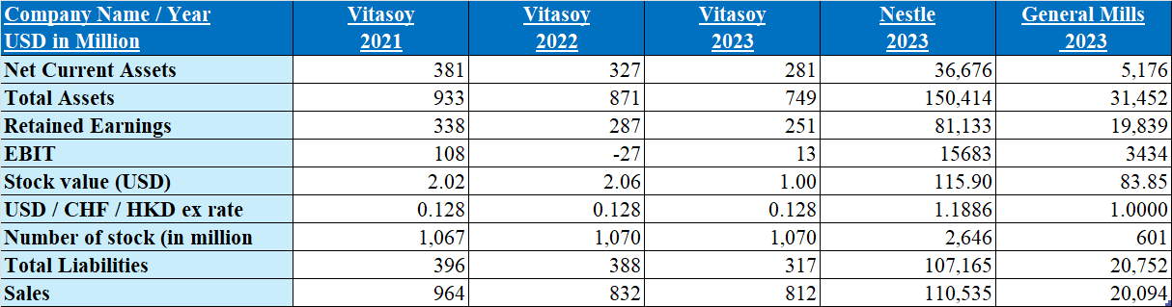
Z-Score Formula: Z=1.2A+1.4B+3.3C+0.6D+0.999E
Components: A: Working Capital / Total Assets Ratio; B: Retained Earnings / Total Assets Ratio; C: EBIT / Total Assets Ratio; D: Market Value of Equity / Total Liabilities Ratio; E: Sales / Total Assets Ratio

Vitasoy Financial Analysis (2021-2023):
From 2021 to 2023, Vitasoy's financial health exhibited a gradual decline. In 2021, Vitasoy's Z-Score was a strong 5.17, indicating robust financial stability, high asset utilization efficiency, and strong market valuation. However, by 2022, the Z-Score dropped to 4.62, primarily due to deteriorating working capital (A value declining from -0.02 to -0.07) and operational losses (C value falling from 0.12 to -0.03). This decline reflected increasing liquidity pressures and operational challenges.

In 2023, the Z-Score further decreased to 3.80, signaling continued weakening of Vitasoy's financial health. Although there was a slight recovery in the EBIT/Total Assets ratio (C value improving to 0.02), the market valuation (D value decreasing from 5.66 to 3.74) and sales efficiency (E value slightly improving to 1.08) did not significantly improve the overall financial situation. The persistent negative working capital ratio indicates ongoing short-term liquidity issues.

Comparison with Nestle and General Mills (2023):
Compared to Nestle and General Mills in 2023, Vitasoy’s Z-Score, despite its downward trend, was still higher than those of the other two companies. Nestle had a Z-Score of 3.49, while General Mills had 3.25, suggesting that Vitasoy maintained relative financial stability compared to its peers. However, Nestle and General Mills demonstrated stronger long-term profitability through higher retained earnings and EBIT ratios.

Conclusion and Bankruptcy Risk Assessment:
Overall, while Vitasoy’s Z-Score has been declining year over year from 2021 to 2023, reflecting increasing financial challenges, particularly in liquidity and market valuation, its 2023 Z-Score of 3.80 still remains above the critical threshold of 2.99. This indicates that Vitasoy is not currently at immediate risk of bankruptcy. However, if the current trends are not addressed, Vitasoy may face higher financial risks in the future. The company needs to take proactive measures to improve its liquidity and operational efficiency to reverse this negative trend and avoid falling into the high-risk category for bankruptcy.

2.2 Financial Structure
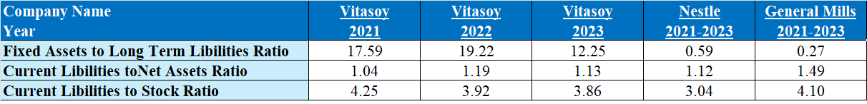
Fixed Assets to Long Term Liabilities Ratio
The Fixed Assets to Long Term Liabilities Ratio reflects a company's ability to finance fixed assets through long-term debt. For Vitasoy, this ratio stood at 17.59 in 2021 and increased to 19.22 in 2022, indicating enhanced investment in fixed assets during this period, possibly linked to expansion or infrastructure upgrades. By 2023, the ratio dropped to 12.25, likely due to asset depreciation or an increase in long-term liabilities. In contrast, Nestle and General Mills had average ratios of 0.59 and 0.27 from 2021 to 2023, indicating more conservative approaches to balancing fixed assets and long-term liabilities. Vitasoy’s higher ratio demonstrates its emphasis on capital expenditure and future growth, even though it fell in 2023, reflecting a more aggressive capital strategy overall.

Current Liabilities to Net Assets Ratio
The Current Liabilities to Net Assets Ratio measures the proportion of a company's short-term debt relative to its net assets. A higher ratio suggests greater short-term debt pressure. Vitasoy’s ratio increased from 1.04 in 2021 to 1.19 in 2022, indicating that the company faced heightened short-term debt pressure during this period. However, by 2023, the ratio declined to 1.13, showing some improvement in managing current liabilities. In comparison, Nestle’s average ratio was 1.12, while General Mills had a higher ratio of 1.49. This shows that Vitasoy manages its short-term liabilities more effectively, especially compared to General Mills, and its ratio aligns more closely with the industry average, demonstrating solid liquidity management.

Current Liabilities to Stock Ratio
The Current Liabilities to Stock Ratio measures a company's ability to cover its current liabilities with its inventory. For Vitasoy, the ratio decreased from 4.25 in 2021 to 3.86 in 2023, reflecting gradual improvements in inventory management and reduced pressure from current liabilities. Compared to Nestle’s ratio of 3.04 and General Mills’ 4.10, Vitasoy’s performance lies between the two, demonstrating a good balance between inventory management and current liabilities. This suggests that Vitasoy has implemented an active strategy for inventory turnover, reducing the risk of excess inventory while improving financial stability.

2.3 Paying debt ability
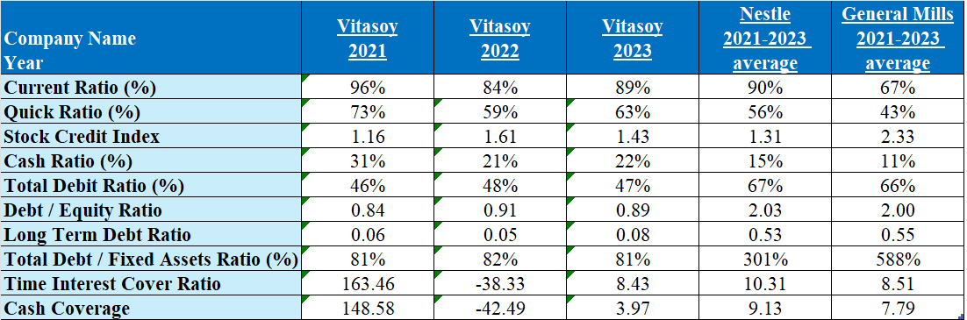

Current Ratio
The Current Ratio measures whether a company can meet its short-term liabilities with its current assets. Vitasoy’s current ratio was 96% in 2021, dropped to 84% in 2022, and then rebounded to 89% in 2023. This indicates the company faced liquidity challenges in 2022 but improved its position in 2023. Compared to Nestle's 90% and General Mills' 67%, Vitasoy's ratio is moderate, suggesting a solid ability to cover short-term liabilities, though slightly weaker in 2022.

Quick Ratio
The Quick Ratio assesses whether a company's liquid assets can cover short-term liabilities. Vitasoy's quick ratio decreased from 73% in 2021 to 59% in 2022, but recovered to 63% in 2023. This indicates liquidity pressures in 2022, possibly due to slower accounts receivable collection or excess inventory. By 2023, the situation improved. Compared to Nestle's 56% and General Mills' 43%, Vitasoy's quick ratio demonstrates stronger short-term debt management, especially in handling unexpected liquidity needs.

Stock Credit Index
Vitasoy's Stock Credit Index rose from 1.16 in 2021 to 1.61 in 2022, indicating enhanced market confidence in the company. However, in 2023, the index slightly declined to 1.43, suggesting a small dip in market sentiment. Compared to Nestle's 1.31 and General Mills' 2.33, Vitasoy’s index is mid-range, reflecting steady market stability and relatively strong investment value, despite a slight drop in 2023.

Cash Ratio
The Cash Ratio reflects a company’s ability to pay off short-term liabilities using cash. Vitasoy’s cash ratio dropped from 31% in 2021 to 21% in 2022, then slightly improved to 22% in 2023. This indicates cash flow pressures in 2022, possibly due to rising liabilities or reduced cash inflows. The slight recovery in 2023 shows improvement in cash flow management. Compared to Nestle's 15% and General Mills' 11%, Vitasoy demonstrates higher flexibility in managing cash for short-term liabilities.

Total Debt Ratio
The Total Debt Ratio measures the proportion of a company’s assets financed by debt. Vitasoy's total debt ratio was 46% in 2021, rose to 48% in 2022, and slightly decreased to 47% in 2023. This suggests stable debt management, with minor fluctuations. Compared to Nestle's 67% and General Mills' 66%, Vitasoy's debt ratio is lower, indicating a more conservative capital structure with less reliance on external financing, showing stronger risk control.

Debt to Equity Ratio
The Debt to Equity Ratio measures a company's debt relative to its equity, reflecting the stability of its capital structure. Vitasoy’s ratio rose from 0.84 in 2021 to 0.91 in 2022, before slightly falling to 0.89 in 2023. This indicates the company expanded its debt financing in 2022 but made adjustments in 2023. Compared to Nestle's 2.03 and General Mills' 2.00, Vitasoy's ratio is lower, demonstrating a more conservative capital structure with lower debt levels and reduced risk, reflecting strong financial stability.

Long Term Debt Ratio
Vitasoy's Long Term Debt Ratio was 0.06 in 2021, decreased to 0.05 in 2022, and rose slightly to 0.08 in 2023, indicating conservative long-term debt management. This low ratio suggests a reliance on short-term financing and internal funds rather than long-term debt. Compared to Nestle's 0.53 and General Mills' 0.55, Vitasoy’s long-term debt ratio is significantly lower, showing a focus on flexibility and risk control in its funding structure.

Total Debt to Fixed Assets Ratio
Vitasoy’s Total Debt to Fixed Assets Ratio was 81% in 2021, slightly increased to 82% in 2022, and returned to 81% in 2023. This indicates stable use of debt to finance fixed assets without excessive dependence. In comparison, Nestle's ratio of 301% and General Mills' 588% suggest they heavily rely on fixed assets for debt financing. Vitasoy’s more conservative approach highlights lower risk in financing fixed assets, preferring other methods of capital acquisition.

Time Interest Cover Ratio
Vitasoy's Time Interest Cover Ratio was 163.46 in 2021 but dropped significantly to -38.33 in 2022, likely due to a sharp decline in profits or increased interest expenses. By 2023, the ratio recovered to 8.43, indicating improvements in profitability and the ability to cover interest payments. Compared to Nestle's 10.31 and General Mills' 8.51, Vitasoy’s 2023 figure is slightly lower but shows signs of steady recovery.

Cash Coverage
Vitasoy's Cash Coverage Ratio dropped dramatically from 148.58 in 2021 to -42.49 in 2022, reflecting severe cash flow pressures. However, in 2023, the ratio recovered to 3.97, indicating improvements in cash flow management. Compared to Nestle's 9.13 and General Mills' 7.79, Vitasoy's cash coverage is still weaker in 2023, but the recovery from 2022 suggests a positive trend towards healthier cash flow management.

2.4 Operating capacity
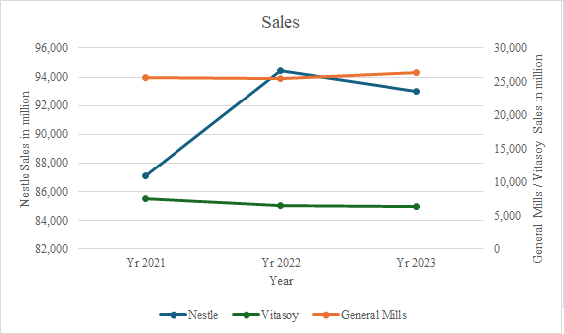
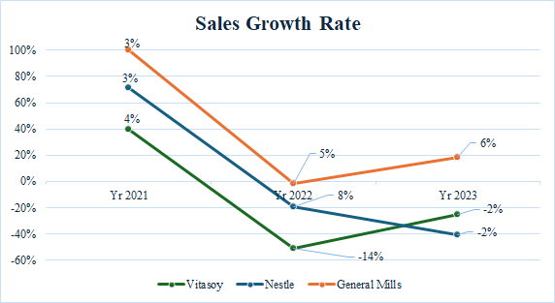

From the sales growth rate chart, Vitasoy had a 4% growth in 2019, but it dropped sharply to -10% in 2020, and slightly recovered to -2% in 2021. This decline is likely influenced by the COVID-19 pandemic, which disrupted markets, caused consumer demand volatility, and affected operations. In contrast, Nestle and General Mills showed more stability, with Nestle also experiencing some fluctuations in 2020 but recovering to a 6% growth in 2021. In terms of sales, Nestle’s sales increased from 86,000 million in 2019 to 94,000 million in 2020, before slightly declining in 2021. General Mills' sales remained stable throughout, while Vitasoy showed a continuous downward trend, indicating it was more significantly impacted by the pandemic.

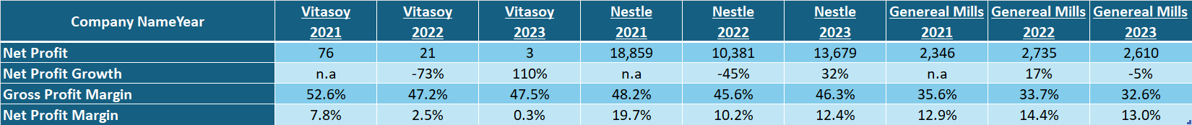

Employee Costs
Vitasoy’s employee costs were 20.3% in 2021, rising to 24.9% in 2022, and slightly decreasing to 23.5% in 2023. The three-year average is 22.9%, indicating relatively stable labor cost management. In comparison, Nestle’s employee costs average 15.8%, while General Mills’ costs are significantly lower at 0.9%. This suggests that Vitasoy relies more heavily on labor in its operations, possibly due to manual production processes, while Nestle and General Mills may use more automation or outsourcing to reduce labor expenses.

Operating Expenses
Vitasoy’s operating expenses were only 3.0% in 2021, but surged to 34.1% in 2022 and slightly declined to 31.9% in 2023. This significant rise in 2022 likely reflects increased operational costs, potentially due to market expansion or rising material costs. The three-year average for operating expenses is 23.0%, which is lower than Nestle’s 32.7% but higher than General Mills’ 17.0%. This suggests that Vitasoy has managed to maintain stable business operations despite fluctuating market conditions.

Depreciation and Amortization
Vitasoy’s depreciation and amortization costs increased from 6.5% in 2021 to 8.6% in 2022, and slightly decreased to 8.4% in 2023. The three-year average is 7.8%. In comparison, Nestle’s average is 3.8% and General Mills’ is 3.0%, indicating that Vitasoy has made more significant investments in fixed assets and equipment. This likely relates to expanding production capacity or upgrading facilities, and higher depreciation costs reflect greater capital expenditure, which positively impacts the company’s long-term operating capacity.

2.5 Profitability

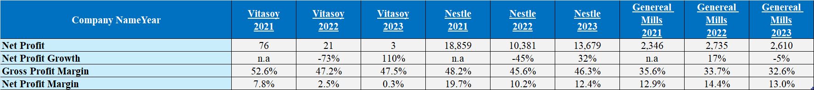

Over the past three years, Vitasoy’s profitability has shown significant volatility. Net profit was 76 million in 2021, but dropped to 21 million in 2022 and further down to 3 million in 2023, highlighting the market challenges and cost pressures the company faces. In contrast, Nestle and General Mills had more stable profits, with Nestle reaching 13,679 million in 2023. For gross profit margin, Vitasoy’s margin decreased from 52.6% to 47.5%, but it remains higher than General Mills’ 32%-36%. This indicates that Vitasoy has some strength in controlling production costs, maintaining a competitive margin despite the decline. However, Vitasoy’s net profit margin reveals profitability pressure, dropping to 0.3% in 2023, far below Nestle’s 12.4% and General Mills’ 13.0%. This suggests that Vitasoy needs to improve operational efficiency and cost management.

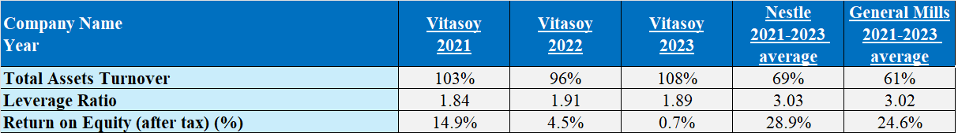

Vitasoy's total assets turnover was 103% in 2021, decreased to 96% in 2022, but recovered to 108% in 2023, indicating improved asset utilization. Compared to Nestle's 69% and General Mills' 61%, Vitasoy demonstrates significantly better asset utilization, reflecting strong operational efficiency. For leverage ratio, Vitasoy remained stable over the three years, increasing from 1.84 in 2021 to 1.91 in 2022, before slightly dropping to 1.89 in 2023. In contrast, Nestle and General Mills have much higher leverage ratios of 3.03 and 3.02, showing Vitasoy's more conservative capital structure. For equity (ROE) shows weak performance, dropping from 14.9% in 2021 to 4.5% in 2022 and further down to 0.7% in 2023. In comparison, Nestle and General Mills have higher average ROEs of 28.9% and 24.6%, highlighting Vitasoy's need for significant improvements in profitability and capital efficiency.

2.6 Growth capacity
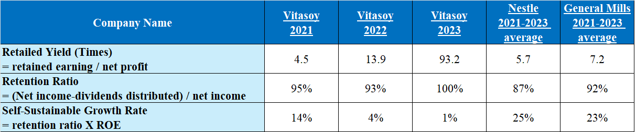

Vitasoy’s Retailed Yield fluctuated significantly over the three-year period, from 4.5 times in 2021 to 13.9 times in 2022, and dramatically increased to 93.2 times in 2023, indicating a substantial growth in retained earnings. Compared to Nestle's 5.7 times and General Mills' 7.2 times, Vitasoy’s 2023 yield is notably higher, reflecting significant potential for internal capital accumulation. Similarly, Vitasoy’s Retention Ratio showed annual growth, rising from 95% in 2021 to 93% in 2022, and reaching 100% in 2023. This means the company retained all its net income for internal operations in 2023 without distributing dividends. In comparison, Nestle's average retention ratio was 87%, and General Mills' was 92%, showing Vitasoy's stronger inclination toward capital retention for reinvestment. In Self-Sustainable Growth Rate reveals challenges in its internal growth capacity. The rate was 14% in 2021 but dropped to 4% in 2022 and further declined to just 1% in 2023. Compared to Nestle’s 25% and General Mills’ 23%, Vitasoy’s performance is weaker, indicating a need to improve profitability and capital efficiency to enhance sustainable growth potential.

2.7 Stock Market prospects analysis
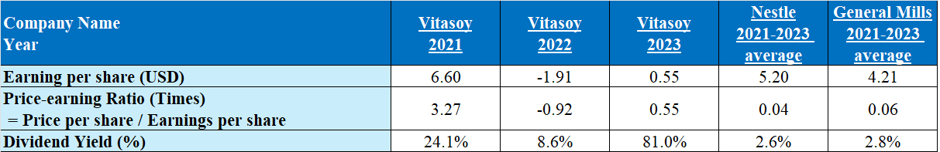

Vitasoy’s earnings per share (EPS) was USD 6.60 in 2021, turned negative in 2022 (-USD 1.91), but recovered to USD 0.55 in 2023, reflecting volatile performance. In contrast, Nestle and General Mills showed more stable earnings, averaging USD 5.20 and USD 4.21 respectively, indicating stronger market stability. For price-earnings ratio (P/E), Vitasoy recorded a negative P/E of -0.92 in 2022 but rebounded to 0.55 in 2023, indicating a market reevaluation of the company’s profitability. By comparison, Nestle and General Mills had lower P/E ratios of 0.04 and 0.06, showing their stocks are cheaper relative to their earnings. And for dividend yield, Vitasoy saw a significant increase from 8.6% in 2022 to 81.0% in 2023. In contrast, Nestle and General Mills had dividend yields of 2.6% and 2.8%. Vitasoy’s high dividend yield in 2023 likely reflects a substantial drop in its stock price, despite its large dividend distribution.

3.1 Corporate Governance Assessment
Vitasoy International Holdings Ltd. has developed a robust corporate governance framework that emphasizes transparency, accountability, and ethical practices. The company adheres closely to the Corporate Governance Code of the Hong Kong Stock Exchange, ensuring that its operations align with best governance practices. The Board of Directors plays a pivotal role in the governance structure, overseeing the company’s strategic direction and key decision-making processes. The board comprises both executive and non-executive directors, a composition that helps maintain independent judgment and a diversity of perspectives in decision-making. In addition to the board, Vitasoy has established several key committees, including the Audit Committee, the Remuneration Committee, and the Nomination Committee. These committees operate independently and are tasked with specific oversight responsibilities, thereby enhancing the transparency and accountability of the company's governance framework (Vitasoy Annual Report 2023, p. 88; Vitasoy Annual Report 2022, p. 78).

Internal controls and risk management are integral components of Vitasoy's corporate governance. The company has implemented a comprehensive internal control system designed to identify, assess, and manage various risks across its global operations, including financial, operational, and compliance risks. These controls are regularly reviewed by the internal audit department to ensure their effectiveness. Any identified deficiencies are promptly addressed. Additionally, Vitasoy upholds stringent ethical standards, requiring all directors, management, and employees to adhere to a strict code of conduct. This code covers critical areas such as conflicts of interest, insider trading, and asset protection, ensuring that all business activities are conducted with the highest level of integrity (Vitasoy Annual Report 2023, p. 90).

3.2 Corporate Governance of Business Organization and Its Impact and Importance
Corporate governance is crucial to Vitasoy’s business operations, laying the foundation for sustainable growth and long-term success. Effective corporate governance ensures that the company operates with transparency, accountability, and fairness, thereby maintaining the trust of shareholders, customers, employees, and the wider community. This trust is fundamental to the company’s ability to attract investment, retain talent, and sustain its competitive edge in the marketplace (Vitasoy Annual Report 2023, p. 88).

The impact of strong corporate governance at Vitasoy is particularly evident in the company’s approach to risk management and compliance. Operating in a complex global environment, Vitasoy faces various regulatory landscapes, supply chain challenges, and market dynamics. Through robust governance practices, the company is able to anticipate and mitigate these risks, ensuring resilience in the face of external pressures. The governance framework includes rigorous oversight of financial reporting processes, which helps prevent errors and ensures accuracy in the company’s financial statements. This not only protects the company’s assets but also enhances its reputation among investors and regulators. Moreover, effective corporate governance enables Vitasoy to align its business operations with its corporate social responsibility (CSR) objectives, further strengthening the company’s commitment to sustainable and ethical business practices (Vitasoy Annual Report 2022, p. 80).

3.3 Existing Corporate Governance (Including Analysis of Weaknesses)
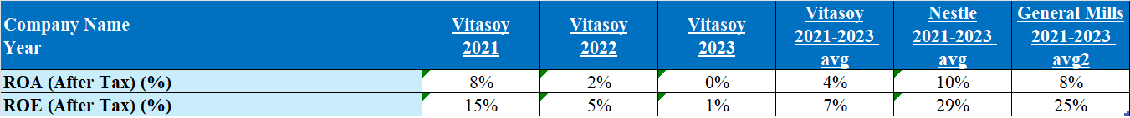
Vitasoy’s return on assets (ROA) has steadily declined from 8% in 2021 to 0% in 2023, with a three-year average of just 4%. In contrast, Nestle and General Mills maintain stronger ROAs of 10% and 8%. Vitasoy’s return on equity (ROE) dropped from 15% in 2021 to just 1% in 2023, with a three-year average of 7%, far below Nestle’s 29% and General Mills’ 25%. Overall, Vitasoy’s lower ROA and ROE highlight inefficiencies in asset and capital utilization, indicating room for improvement in financial performance and operational strategies to match industry leaders.

While Vitasoy’s corporate governance structure is comprehensive and aligns with international best practices, there are areas that could benefit from further enhancement. One potential area of concern is the long tenure of some of the company’s independent directors. While these directors bring valuable experience and continuity to the Board, their extended service may limit the introduction of fresh perspectives and innovative ideas. This could be particularly challenging in the rapidly evolving food and beverage industry, where staying ahead of market trends and consumer preferences is critical to maintaining a competitive advantage (Vitasoy Annual Report 2023, p. 88).

Another area that could benefit from improvement is the transparency and structure of executive compensation. While Vitasoy provides detailed disclosures regarding the remuneration of its directors and senior executives, the linkage between compensation and company performance could be made more explicit. This would help ensure that compensation packages are directly tied to the achievement of strategic objectives and the creation of shareholder value. Additionally, while Vitasoy’s stakeholder engagement practices are generally strong, the company could further enhance its efforts in this area by implementing more regular and direct feedback mechanisms. This would allow Vitasoy to better understand the concerns and expectations of its stakeholders, leading to more informed decision-making and improved governance practices (Vitasoy Annual Report 2023, p. 90).

3.4 Suggestions for Improvement
For further strengthen its corporate governance framework, Vitasoy could consider several key improvements. First, the company might introduce a policy that encourages periodic board refreshment. This could include setting tenure limits for independent directors or increasing the frequency of board evaluations to ensure that the Board remains dynamic and open to new ideas. Bringing in directors with diverse backgrounds and experiences could provide the fresh perspectives needed to drive innovation and adaptability in a rapidly changing industry (Vitasoy Annual Report 2023, p. 88).

In executive compensation, Vitasoy could enhance the alignment between pay and performance by tying a larger portion of executive remuneration to specific, measurable performance metrics. These could include financial targets, sustainability goals, and shareholder returns. By making these connections more transparent, the company would not only strengthen its governance practices but also increase investor confidence. Furthermore, Vitasoy could improve its stakeholder engagement by implementing more frequent and structured feedback mechanisms, such as surveys, focus groups, and town hall meetings. These initiatives would allow the company to gather valuable insights from its stakeholders and make more informed decisions that reflect the interests of all parties involved (Vitasoy Annual Report 2023, p. 90).

4. Investment Project Appraisal
This investment project aims to open a specialty store in Mongkok (Hong Kong, dedicated to selling Vitasoy products. The store will adopt a business model similar to Hung Fook Tong, focusing on offering a diverse range of Vitasoy beverages and related products to meet consumer demands and increase market exposure. The initial phase of the plan is set for five years, during which the store's performance and market response will be evaluated. If successful, there are plans to expand this concept to other bustling commercial areas to further enhance Vitasoy's brand influence and market share. This project aims not only to increase Vitasoy's sales but also to boost brand loyalty and overall market performance.

4.1 Project items basic information
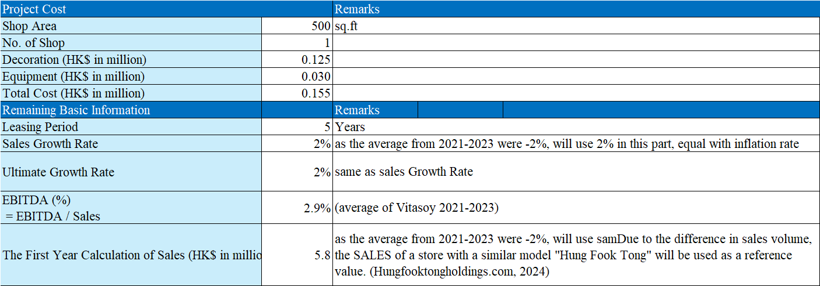

4.2 Computing Tax Cost
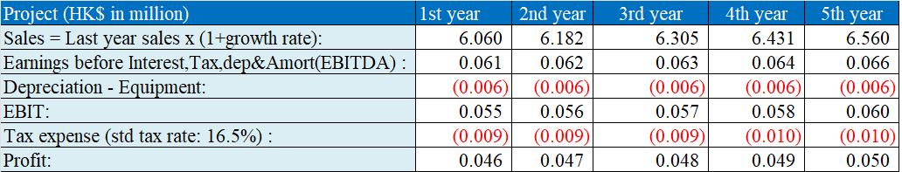
4.3 Cashflow calculation
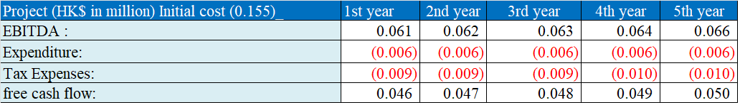
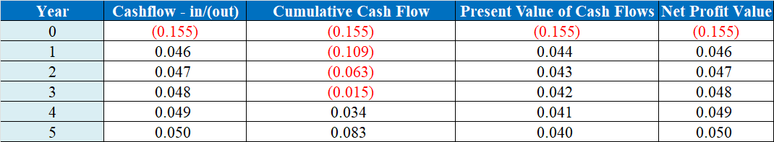

4.4 Other information
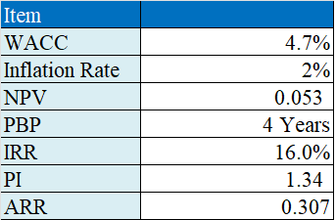

4.5 Investment Appraisal
An in-depth analysis of the proposed specialty store project reveals a payback period of four years with a positive Net Present Value (NPV) of HKD 0.053 million. This positive financial indicator suggests the project is a viable investment that promises to enhance the group's sales network. It is advisable to pursue this initiative, aiming for a broader market reach and enhanced market penetration.

4.6 Analysis of New Project Appraisal Methods
Investment Returns: Initial forecasts predict a modest 4% return on investment in the first year. As the Vitasoy brand continues to establish itself, these returns are expected to improve progressively. The simplicity and straightforwardness of this return calculation method are beneficial, although it falls short by not accounting for the time value of money.

Average Rate of Return (ARR): At 30.97%, the ARR surpasses the current return on assets, underscoring the project's substantial investment appeal. The ARR is particularly insightful as it averages the yearly returns, providing a window into the project's long-term profitability.

Net Present Value (NPV): Calculated with a discount rate of 4.7% Gurufocus.com, 2023)
, the project's NPV is firmly in the positive territory, affirming its financial viability against anticipated costs and returns.

Internal Rate of Return (IRR): The project's IRR stands at 16.0%, signifying a commendable return that justifies the investment. IRR offers a direct reflection of the financial benefits across the project's lifecycle, although it's sensitive to the assumptions employed in its calculation, which might introduce variability.

4.7 Recommendations for Cash Flow Management in the New Project
Given the project's reliance on specialty store sales, which may pose liquidity challenges, there will be a substantial initial cash flow requirement of approximately HKD 0.155 million. It's feasible to meet these liquidity needs through strategic reallocation of internal resources.

Strategic Initiatives for Enhanced Financial Stability and Success:
- Establish an Emergency Fund: It is prudent to set aside a contingency fund at the outset to cushion against unexpected financial discrepancies or shortfalls. This proactive measure will ensure operational stability during the critical early phase when cash flows are often less predictable.
- Optimize Cash Flow Management: Implementing a regimen of regular reviews and adjustments to the working capital management strategies—including better inventory control, and more efficient handling of receivables and payables—will optimize cash flow. This approach enhances capital utilization, accelerates cash inflows, and moderates outflows.

5. Financing management
Financing Options
- Internal Retained Earnings/Cash Payments
  - Utilizing company's own retained earnings or cash reserves to fund the investment, avoiding additional debt and interest expenses.
- Bank Loan
  - Securing a term loan from a bank provides necessary funds with relatively stable interest rates and predictable financial costs.

Bank loans thus provide a cost-effective and minimally disruptive financing route.

6. Recommendations and Conclusion
Recommendations
- Cost Control and Efficiency Enhancement:
  - After analyzing the decline in net profit margins, I recommend that the company further optimize its production processes and supply chain management to reduce unnecessary expenditures, thereby enhancing overall operational efficiency.
- Capital Investment:
  - Noticing fluctuations in the fixed asset and long-term liabilities ratio, I suggest that the company should make judicious investments in production facilities and technological upgrades, under the premise of ensuring financial stability, to support future business expansion and innovation.

- Liquidity Management:
  - Given the performance of the Z-Score analysis and liquidity ratios, I believe Vitasoy needs to strengthen its liquidity management. I recommend the company enhance its control over working capital to cope with potential market fluctuations or economic uncertainties.
- Market Expansion and Brand Building:
  - The analysis indicates that Vitasoy has the potential to further penetrate new markets, especially internationally. Therefore, I suggest the company should increase its investment in overseas markets, particularly in promoting its plant-based products, to attract more health-conscious consumers.
Conclusion
In this report, after conducting a comprehensive analysis of Vitasoy's financial performance and market performance, and considering the company's future investment plan, although the company faces market competition and cost pressures, it still shows good financial stability and growth potential. By implementing the strategies suggested above and actively pursuing the investment plan, I believe Vitasoy can further enhance its market competitiveness and achieve sustainable growth.

Also, the company should actively explore new markets and strengthen brand promotion efforts to enhance its market position and shareholder value. This will help Vitasoy consolidate its leadership in the global plant-based beverage market and lay a solid foundation for future success. The analysis and recommendations provided in this report will guide the company in taking actions over the next few years to address industry challenges and seize market opportunities, thereby achieving long-term sustainable growth and profitability.

‌

‌
‌

‌

