Measuring biodiversity at Parc-Le-Breos with barn owl pellets
  - Rowan Kenney
Contents
Introduction 1
Methodology 2
Results 4
Discussion 5
Conclusion 6
Bibliography 7

Introduction
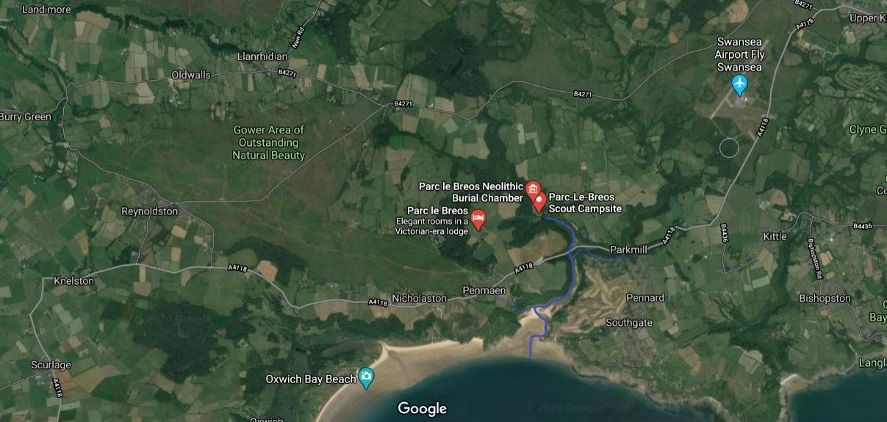
Barn owls (Tyto alba) are a species found on every continent except Antarctica (The Barn Owl Trust, 2014), with the UK populations experiencing an historic decline with the advent of industrialised farming methods (The Barn Owl Trust, 2018).Owl pellets, the partially digested mass of bones, fur and other indigestible products expelled from the gizzard as a solid form, are often found near nest boxes, and contain useful biological evidence of what organisms the owls have been predating on. As many species are too small or evasive to effectively survey a wide area, owl pellets can be a useful tool, in particular the barn owl (Agnelli & De Marinis, 1993) as many bones are left intact.
Figure 1, Parc-Le-Breos shown via satellite (Google Maps, 2020), with the Ilston river shown in blue
Pellets were gathered from a barn owl nest in Parc-Le-Breos, in the Gower area of Outstanding Natural Beauty from 2007-2011, and made available to the University of Wales Trinity Saint David in Swansea. A team of 4 first year bSc Environmental Conservation students, along with their lecturer, were tasked with dissecting the pellets, identifying remains within, and recording the species found. The area around Parc-Le-Breos, while not particularly known for its barn owls, is an area fairly well suited for the birds, as they prefer areas by water thanks to the increased bounty of prey (Animals Network, 2010), so being situated by the Ilston river in an area of meadows and fields, interspersed with forested areas (see figure 1), provides an adequate habitat.

Methodology
Equipment:
- Disposable gloves
- Petri dish
- Lab coat
- Hand lens/microscope
- Tweezers (x 2)
- Owl pellets
- Identification sheet
- Scales
- Recording sheet
- Calipers
Barn owl’s prey in the UK is numerous, and as their scope is rather large, one can examine owl pellets to establish ideas of species spread and density over an area, essentially using the owl’s diet as a sampling technique. 10 species were singled out for identification: the field vole (Microtus agrestis), bank vole (Myodes glareolus), common shrew (Sorex araneus), pygmy shrew (Sorex minutus), water shrew (Neomys fodiens), rat (Rattus genus), harvest mouse (Micromys minutus), wood mouse (Apodemus sylvaticus), house mouse (Mus musculus), and birds (Aves class), with another category for ‘others’. As the owl pellets were poorly preserved, approximate ‘pellets’ were weighed out from a box of matter, about 5g with a >10%< leeway, into a petri dish. As clothes moth grubs are commonly found in owl pellets and can cause damage to fabrics, lab coats had to be worn alongside disposable gloves to protect against the risk of illnesses such as salmonella (as the regurgitation mechanism is also used to protect owls from pathogens ingested). The pellets were teased apart using the tweezers and gentle scraping, then skulls and jaws primarily used for identification, often removing teeth from the sockets and examining with a lens as tooth roots are an effective, simple method to differentiate species based on number and shape. Calipers may also be used to measure the size of the skull for other identification like between common shrews and pygmy shrews, but some size differences are far clearer like that of the water shrew or the rat, which are characteristically large. Once a specimen was identified, it was added to the recording sheet as a tally, then later totalled up. Each participant dissected a minimum of 30 ‘pellets’, but these findings will be combined for this report, to a final sample of 123 ‘pellets’.
The sampling of small mammals for broad studies can be difficult, with the common field technique of mark-recapture via live-trapping being suggested by the NHBS (Peacock, 2019), with a variety of commercial traps such as Longworth and Sherman traps being placed, based on target species, numbers of which can then be extrapolated. Removal trapping is another technique, this time of kill-trapping where animals are lured into pitfall or snap traps, and again this small sample is applied to a general area. Removal trapping has been found to be markedly less accurate in estimating abundance than mark-recapture, for a number of reasons, primarily that small mammal communities are more susceptible to collapse or restructure when members of the community are removed, with many immigrating from the removal site (Sullivan & Sullivan, 2013). As a result, when small mammals are sampled in this way, it only allows for a static measurement to be taken, as population after removal-trapping is typically significantly lower. For this reason, this method would be inadequate for this investigation. Live-trapping, similarly, has its issues, with various forms of trapping often providing inaccurate readings for certain species, either undersampling or oversampling (Torre, et al., 2011), and while combining multiple forms of traps may provide a more accurate sample, the cost-effectiveness of this is very low.
Owl pellets however, are very cost effective when compared to typical trapping methods, with broader spatiotemporal scales as one nest’s collected pellets can accumulate over years, whereas funds normally only allow trapping over periods of 3-7 days (Heisler, et al., 2015). Owls are also known to be opportunistic feeders, hunting whatever is available, and although some have preferred prey (voles and shrews here), studies suggest that thanks to their ability to capture greater species richness, the biases of owl pellets wouldn’t seriously skew estimates of small mammal populations across landscapes (Heisler, et al., 2015) (Jaksić & Yáñez, 1979). Shrews and water voles are also protected in the UK by the Wildlife and Countryside Act 1981, so any sampling method that would endanger them would be prohibited, so it’s hard to assess these populations. Harvest mice are listed as a priority species in the UK’s biodiversity action plan (BAP), so care also needs to be taken around them.
It should be expected that the pellets would mostly be made up of field voles, with a significant number of bank voles, alongside primarily shrews and wood mice, thanks to the area around the nest. As small rodents are relatively prevalent in meadow and woodland, the numbers of birds found in the pellets should be rather low, as they’re typically taken when there’s a lack of other prey.

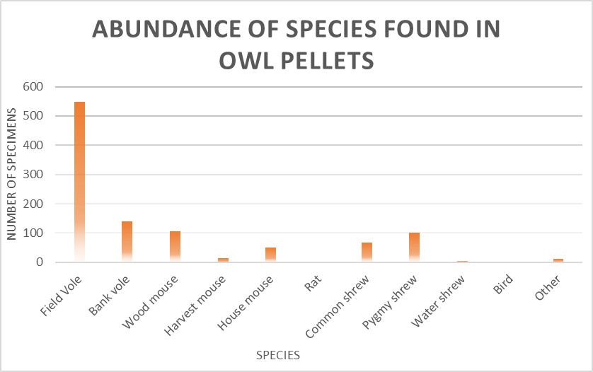
Results
Figure 2, a bar chart to show the number of species found overall in the sample
Overall, 1045 specimens were recovered across 123 ‘pellets’ and of this, 548 specimens were identified as field voles, 139 bank voles, 106 wood mice, 15 harvest mice, 50 house mice, 2 rats, 66 common shrews, 102 pygmy shrews, 4 water shrews, 2 birds and 11 ‘others’ (shown in figure 2). Of this last bracket, two pieces of reptile skulls were recovered, but due to the fragility of reptile bones, it’s difficult to establish what species they belonged to. The remaining 9 specimens were difficult to identify, but generally rodents or insectivores that didn’t align to the field guide, and/or were too degraded to clearly identify them.
Figure 3 showing the mean average species found per pellet

Figure 4, a pie chart to show the average percentages of species in an owl pellet
Overall, the owl pellets averaged out to have 8.5 identifiable specimens each, and as figure 3 and 4 show, over half of each pellet’s remains were composed of field voles, at a mean average of 4.59. The second most common species found in pellets were bank voles at 1.14, and least common that of the rat, followed by birds and water shrews, which as figure 4 shows, are relatively insignificant.

Discussion
There are some limitations to this experiment, however, firstly in the quality of the pellets. Owl pellets should be either dried or frozen, then stored in airtight containers, otherwise they tend to disintegrate into a congealed mess (The Barn Owl Trust, 2014), as the pellets in this experiment had. The matter had degraded to such an extent that insect cases and furs were in too poor a quality to use for identification, and as they were simply kept in a large tub, fragile bones may have been lost under the weight. Furthermore thanks to the state of decay, there were no formed pellets to use, meaning estimated amounts of around 5g had to be used, which can explain the abnormalities in numbers of organisms found per pellet. The 8 mammals per pellet average is far higher than the 4-5 typical of the barn owl (The Barn Owl Trust, 2014), which could be explained by the loose matter encouraging larger bones (like the skulls and jaws used for identification) to rise to the surface and thus be sampled, or organic matter rotting down so the remains were more compacted, thus leading to oversampling.
Another criticism of the method itself is that as each identifiable specimen must be registered as a separate organism (unless the separation of parts was witnessed), up to three different pieces could have originated from one animal- the upper jaw, the left lower jaw, and the right lower jaw. This would give a falsely high score for both overall number of organisms, and breakdown within a species. Similarly, many bones were found that couldn’t be used for a sure identification, but were clearly large femur bones, implying the presence of rats in the pellets, but until the skulls or jaws were found, they couldn’t be counted.
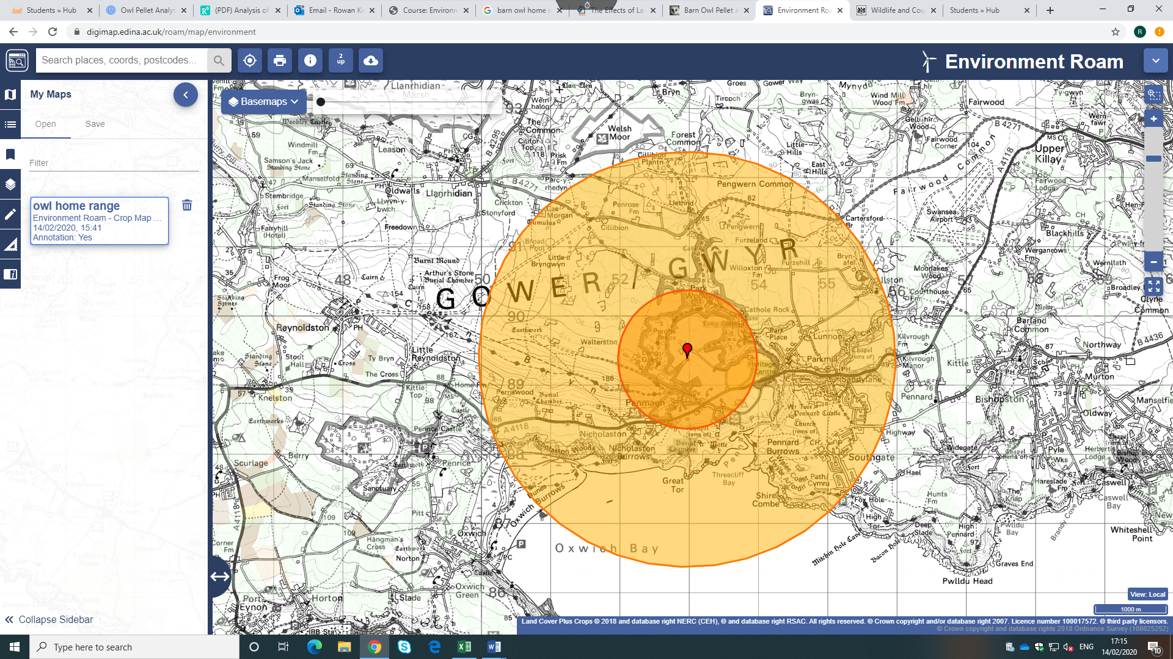
Furthermore, the students weren’t well-practiced in small mammal identification, armed primarily with a field identification guide, so there could potentially be false recordings where IDs are trickier, such as between pygmy shrews and very young common shrews. However, this was mitigated by difficult specimens being isolated until the experimenters could establish an identification
Figure 5 showing the estimated range of the barn owls in question
The home range of a barn owl is typically about 1km radius in the breeding season, but 3km radius in the winter as prey becomes scarcer (The Barn Owl Trust, 2014), meaning that these species would be taken over a rather large area, with figure 5 demonstrating an estimate of a home range for them. It should be noted however, that barn owls seldom have a circular or even elliptical range (The Barn Owl Trust, 2010), so this map can simply give a suggestion of areas covered by them. Furthermore, as the pellet collector refused to disclose precise details about the nest beyond being in the Parc-Le-Breos area, a certain leeway must be allowed for accuracy. From the results of this report, it is relatively clear that the area has a high quantity of field voles and an unusually high number of pygmy shrews in comparison to common shrews, but most interestingly there was a reasonably high number of harvest mice found in the pellets, a species found on the UK Biodiversity Action Plan. The species is considered to be in decline, so actions should be taken to preserve and encourage favourable habitat- areas of tall grass kept long, alongside preservation of hedgerows and reedbeds. Shrews are protected from killed or being taken by certain methods, so these areas, with their high concentration of shrews, should be kept well-informed about the population to avoid breaking the Wildlife and Countryside Act 1981.

Conclusion
From this study of owl pellets, it is clear that the area of Gower between Forest common, Southgate and Oxwich contains a diverse wealth of species, with a high abundance of both field voles and bank voles, along with reasonable numbers of pygmy and common shrews. Only a handful of water shrews were found, typical for the species as they typically aren’t very abundant, and the low number of birds found in the sample suggests the number of insectivores and rodents is adequately high, as the owls didn’t need to predate on them. A potential cause for concern however, is the reasonable presence of harvest mice, a protected species under the UK BAP, so information should be dispersed among farmers particularly, but also residents of the area that they may maintain their lands in a way preferential to the small rodents- long tufts of grass along hedgerows and such. This could boost most of the populations of species investigated in this report, as all of the mammals listed would benefit from improved hedgerow maintenance, since that is a primary habitat for them.

Bibliography
Agnelli, P. & De Marinis, A., 1993. Comparison between barn owl pellet and fox scat analysis in small mammal survey / Analisi di borre di barbagianni e di feci di volpe: confronto tra due metodologie per il rilevamento di piccoli mammiferi. Hystrix, the Italian Journal of Mammalology, 4(2), pp. 1-3.
Animals Network, 2010. Barn Owl. [Online]
Available at: https://animals.net/barn-owl/
[Accessed 12 February 2020].
Google Maps, 2020. Parc-Le-Breos (satellite). [Online]
Available at: https://www.google.com/maps/search/parc+le+breos/@51.5896609,-4.1365444,7198m/data=!3m1!1e3
[Accessed 10 January 2020].
Heisler, L. M., Somers, C. M. & Poulin, R. G., 2015. Owl pellets: a more effective alternative to conventional trapping for broad‐scale studies of small mammal communities. Methods in Ecology and Evolution, 7(DOI:10.1111/2041-210X.12454), pp. 96-103.
Jaksić, F. M. & Yáñez, J. L., 1979. The diet of the Barn Owl in central Chile and its relation to the availability of prey. The Auk, 96(3), pp. 619-621.
Peacock, A., 2019. NHBS Guide to small mammal survey equipment. [Online]
Available at: https://blog.nhbs.com/how-to-guides/nhbs-guide-to-small-mammal-survey-equipment/
[Accessed 12 February 2020].
Sullivan, T. P. & Sullivan, D. S., 2013. Influence of removal sampling of small mammals on abundance and diversity attributes: scientific implications. Human-Wildlife Interactions, 7(1), pp. 85-98.
The Barn Owl Trust, 2014. About the Barn Owl. [Online]
Available at: http://witham-1st-idb.gov.uk/wp-content/uploads/2013/03/barn-owl-factsheet.pdf
[Accessed 14 February 2020].
The Barn Owl Trust, 2014. Barn Owl pellet analysis. [Online]
Available at: https://www.barnowltrust.org.uk/barn-owl-facts/barn-owl-pellet-analysis/
[Accessed 14 February 2020].
The Barn Owl Trust, 2018. Past UK Barn Owl population. [Online]
Available at: https://www.barnowltrust.org.uk/barn-owl-facts/current-uk-barn-owl-population/past-barn-owl-population/
[Accessed 10 February 2020].
Torre, I., Guixé , D. & Sort, F., 2011. Comparing three Live trapping methods for small mammal sampling in cultivated areas of NE Spain. Hystrix, the Italian Journal of Mammalogy, 21(2), pp. 72-73.

Kenney, R, 2020 "A map to show the estimated home range of a Gower barn owl nest" [JPG map], Scale 1:50,000, [object HTMLSelectElement] [geospatial data], Updated: 2018, Centre for Ecology & Hydrology, Using: EDINA Environment Digimap Service, <http://digimap.edina.ac.uk/>, Created: 14 February 2020

