

Module Name: Digital skills for Personal Development and Business Growth
Module Code:(BMSW4008_SWAN)
Assignment Name:(E-Portfolio)
Student Name: Salma Farache
Student Number:2408621
Lecturer: Philippa Fitzgerald
Deadline: 20/06/2026

I confirm that I have not presented any AI generated materials as my own work.
I confirm that I have copies of my drafts, notes, and other resources I used, which I may be asked to provide in evidence.

Word count :1692

Table of Contents

ChocoBalance: Using Market Research to Build a Healthy Dessert Brand 4
Introduction 4
1. Purpose of the Research 4
2. Key Findings from the Questionnaire 5
3. Application of Research to Business Development 8
A) Brand Identity . 8
B) Website Design…………………………………………………………….9
C) SEO Strategy 16
E) Audience Segmentation 19
4. Use of Digital Tools 19
5. Conclusion 20
6. Spreadsheet Hyperlink ………………………………………………………………………………21
7. Essay 2: The Importance of Excel in the Digital Era: A Case Study on SweetBalance …………………………………………………………………………….22
8.References: 25

ChocoBalance: Using Market Research to Build a Healthy Dessert Brand

  - Introduction
This report explains how the student used digital market research to develop the dessert business, ChocoBalance. The business concept focuses on creating and selling healthy handmade chocolate and Arabic sweets using natural ingredients such as dates and figs. Feedback was collected through a digital questionnaire, which informed the design of the website, product selection, and marketing materials. The research provided valuable insights into consumer preferences, strengthening the overall business plan.

  - 1. Purpose of the Research
To develop a viable business, it was essential to understand customer preferences, purchasing habits, and dessert types they enjoy. A 17-question digital questionnaire was created using Microsoft Forms. Participants were asked about age, gender, shopping routines, favourite desserts, and preferences for healthy or low-sugar options. The data gathered enabled the development of products aligned with customer interests. Reedy and Parker (2017) argue that digital tools like surveys offer valuable data that support better decision-making.

  - 2. Key Findings from the Questionnaire

A) Frequency of Dessert Purchases:(Figure 1)
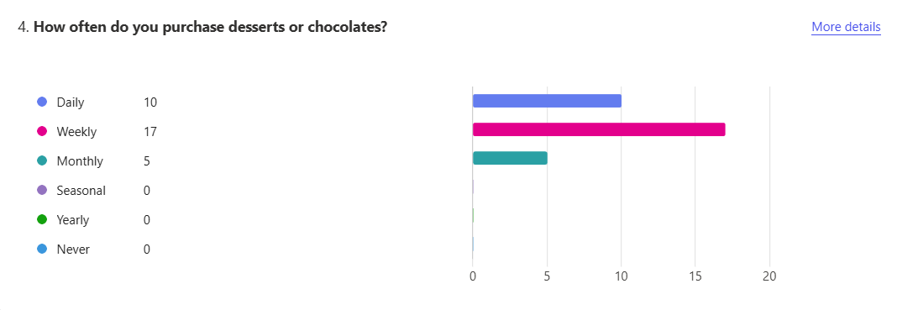Figure 1: Purchase Frequency of Desserts or Chocolates (Microsoft forms,2025)
According to figure1, the questionnaire revealed that 27 out of 32 respondents purchase desserts or chocolate either daily or weekly. This indicates a strong demand for sweet products, suggesting a promising market for the business. Pinto and Guarda (2020) highlight the importance of understanding customer behaviour to deliver timely and suitable products.

  - B) Preferred Types of Sweets:( Figure 2)
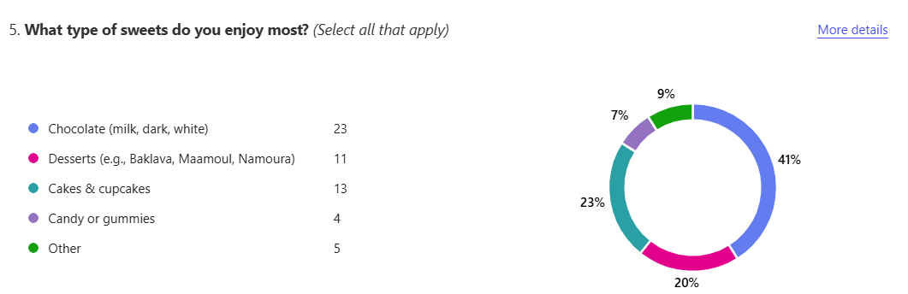Figure 2: Preferred Type of Sweets (Microsoft forms,2025)
Figure 2 shows that respondents identified chocolate as the most preferred sweet, followed by cakes and Arabic treats such as Baklava. This insight influenced the product line, focusing on chocolate truffles infused with traditional Arabic flavours like fig and hazelnut. Soltanifar et al. (2021) stress that startups must align their offerings with customer preferences.

C) Importance of Natural Ingredients:( Figure3,4 and 5)
The responses showed strong interest in health-conscious options:
- 90% were interested in handmade desserts.
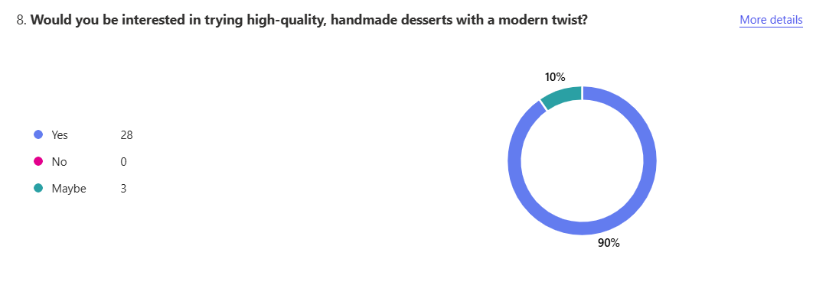
Figure 3: Interest in Handmade, High-Quality Desserts (Microsoft forms,2025)

- 71% preferred healthy or low-sugar versions.
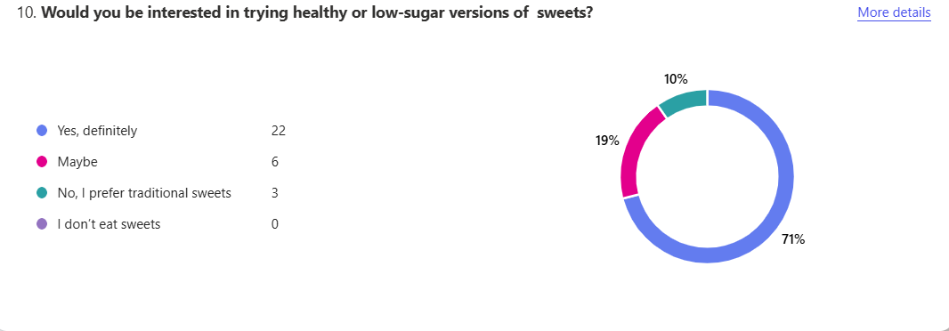 Figure 4: Interest in Healthy or Low-Sugar Sweets (Microsoft forms,2025)

- 58% supported using natural sweeteners like dates or figs.
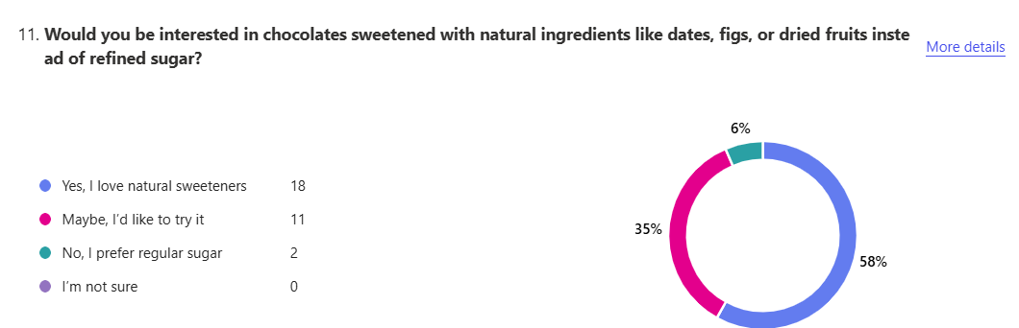
Figure 5: Openness to Natural Sweeteners (Microsoft forms,2025)

  - These results led to the decision to promote ChocoBalance as a diabetic-friendly and guilt-free brand. According to Sandhu (2020), today’s consumers value ingredients transparency and wellness.

  - D) Purchasing Locations:(Figure 6)
  - in figure 6, most respondents reported buying desserts from supermarkets. This finding influenced the promotional strategy by incorporating supermarkets in flyer messaging. Dadwal (2020) explains that marketing is more effective when aligned with customers' everyday shopping habits.

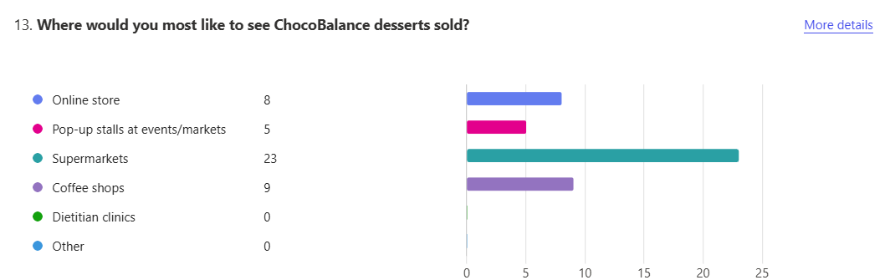Figure 6: Preferred Purchase Locations for ChocoBalance Desserts (Microsoft forms,2025)

E) Attention Check:(Figure 7)
Figure 7 shows that an attention-check question was included to validate engagement. Participants were asked to select 'Coffee' from a list, and 83% answered correctly, indicating reliable data. Chaffey and Ellis-Chadwick (2019) support using such measures to ensure data quality.
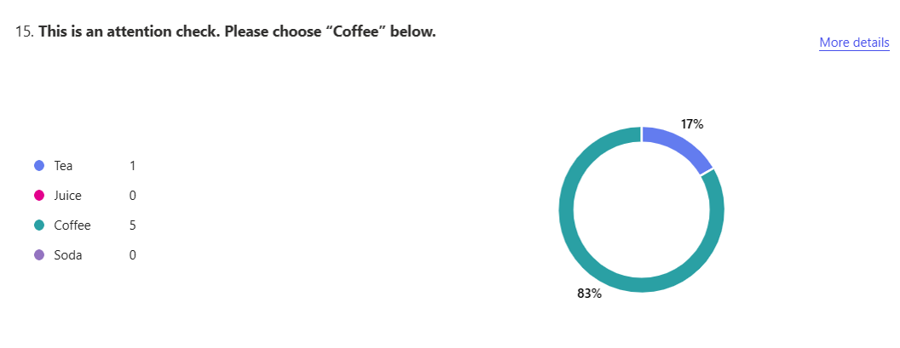
Figure 7: Attention Check Question Response (Microsoft forms,2025)

  - 3. Application of Research to Business Development
  - A) Brand Identity: (Image 1)
The brand name ‘ChocoBalance’ was selected to reflect the mix of indulgence and health in image 1. Given the survey demographics, mostly women aged 25–44, and the brand tone was developed to be warm and professional. Byrd (2021) notes that market research helps entrepreneurs craft stronger brand narratives.
Image 1: Business Card Design for SweetBalance (Canva,2025)

B) Website Design (Images 1-13)
A two-page website was developed using Weebly. The homepage describes the brand’s origin and focuses on dates and figs. The product page includes images and order information. SEO keywords such as 'low sugar desserts', 'diabetic-friendly', and 'date-sweetened chocolate' were selected based on survey responses. Reedy and Parker (2017) state that search-optimised content improves visibility.

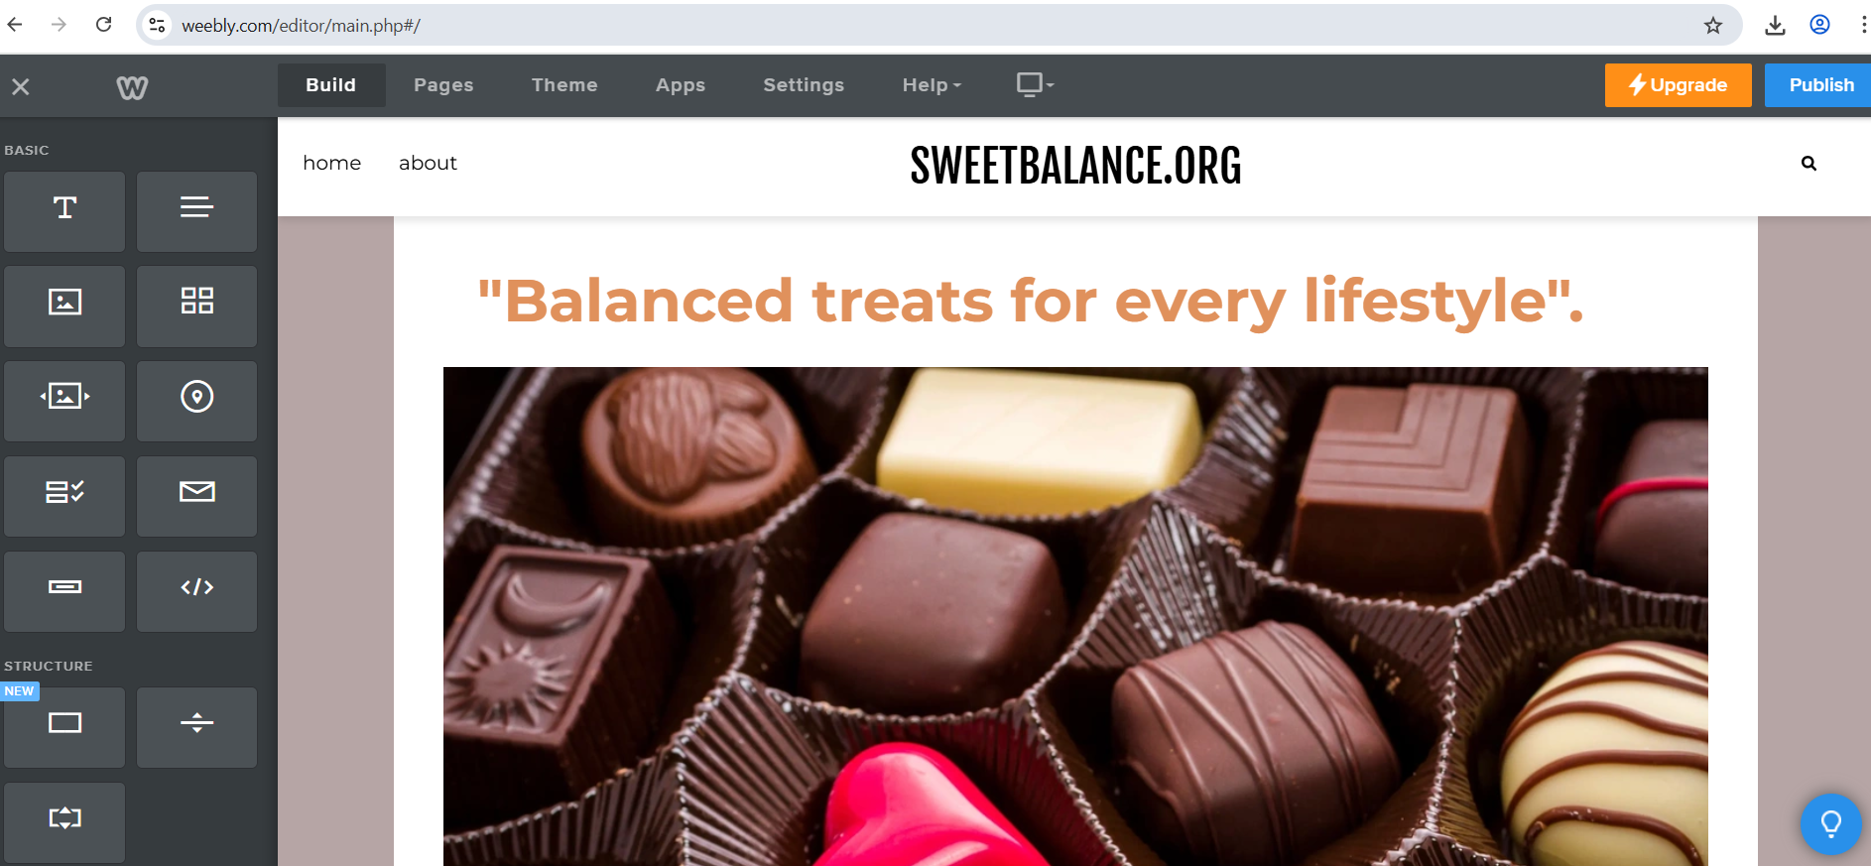Image 2: SweetBalance Website Homepage (Weebly,2025)
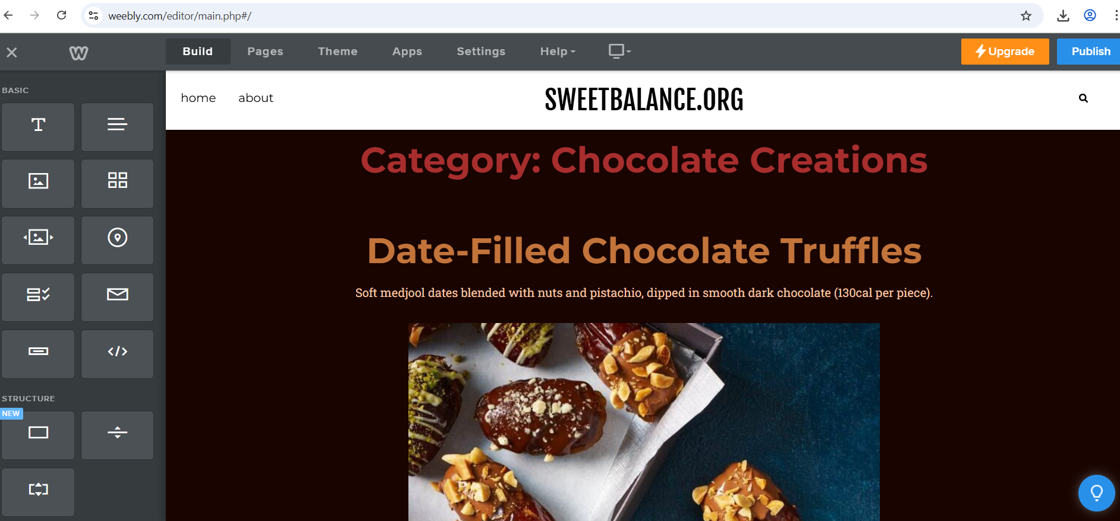Image 3: Product Page: Date-Filled Chocolate Truffles (Weebly,2025)

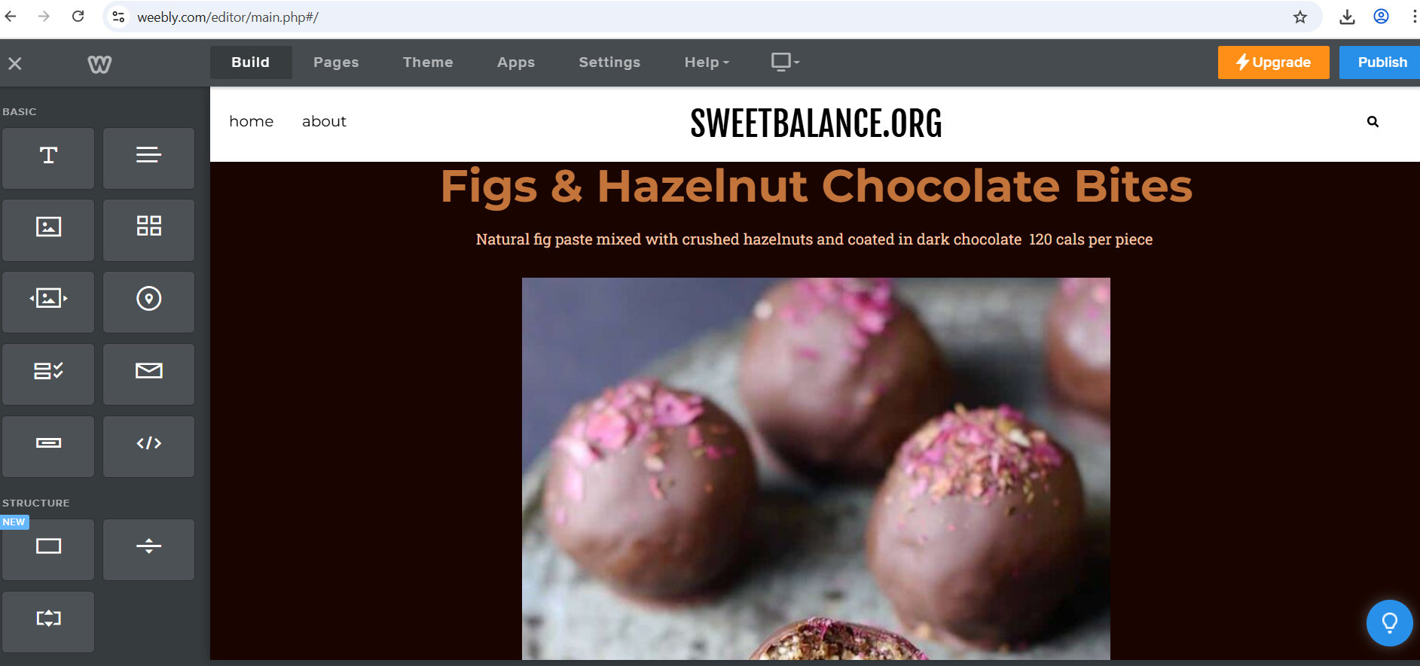Image 4: Product Page: Figs & Hazelnut Chocolate Bites (Weebly,2025)

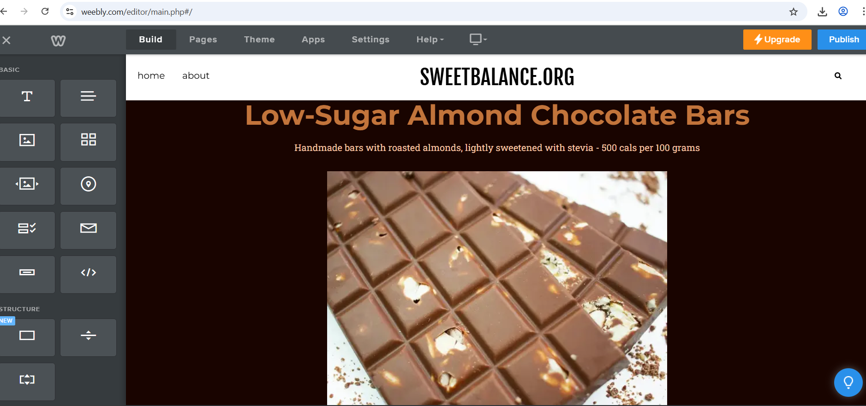Image 5: Product Page: Low-Sugar Almond Chocolate Bars (Weebly,2025)

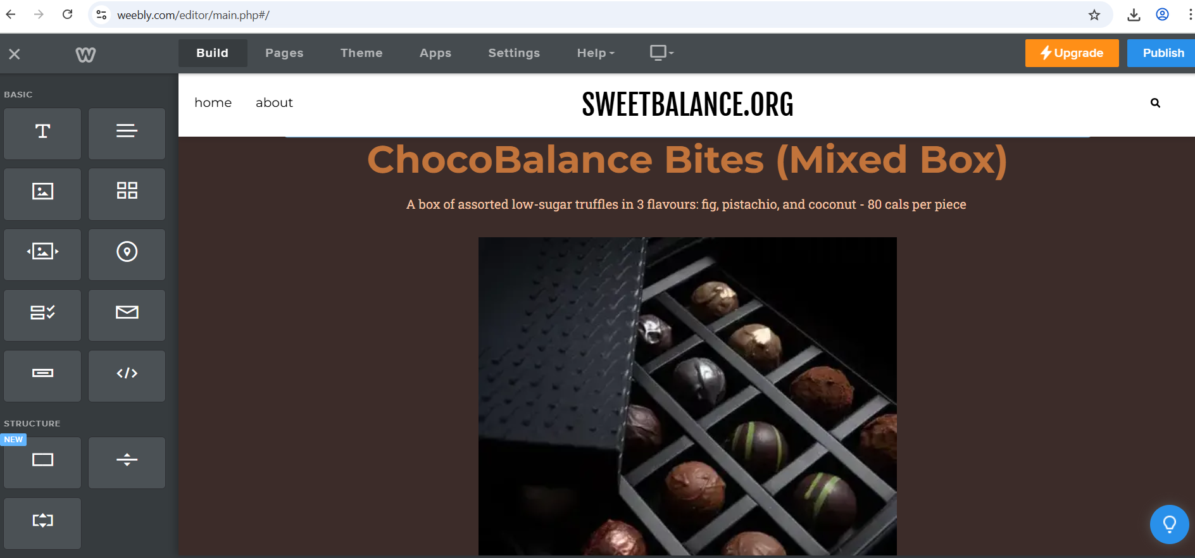Image 6: Product Page: ChocoBalance Mixed Box (Weebly,2025)

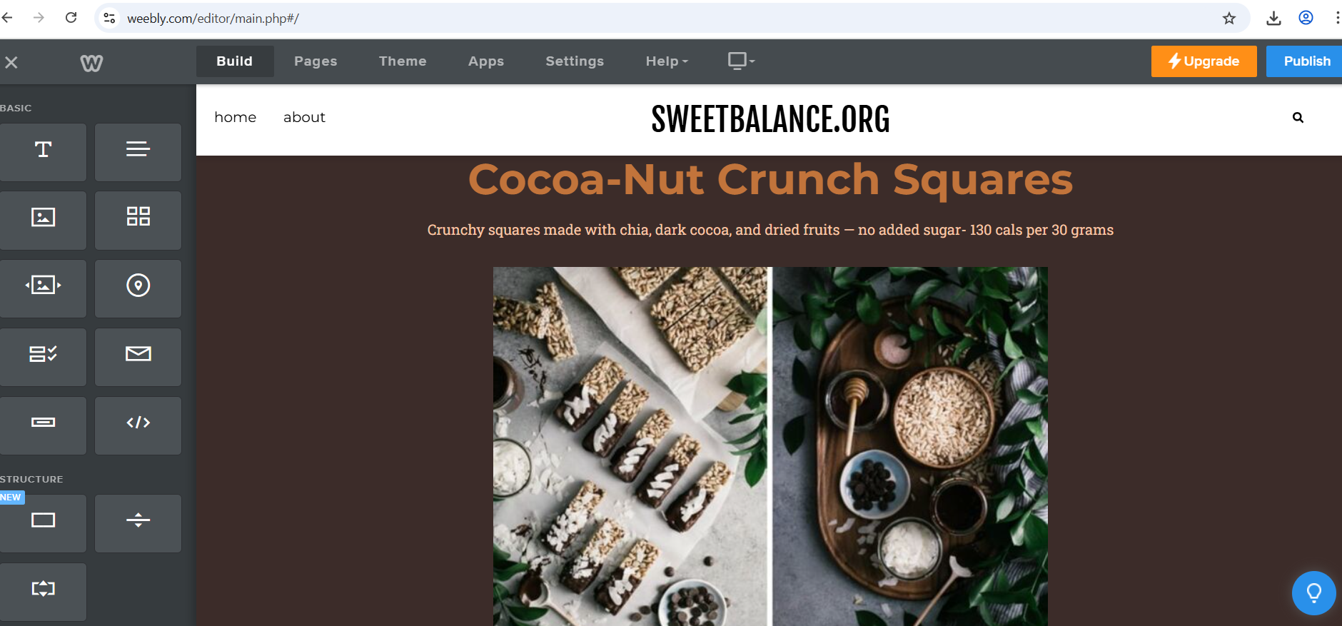Image 7: Product Page: Cocoa-Nut Crunch Squares (Weebly,2025)

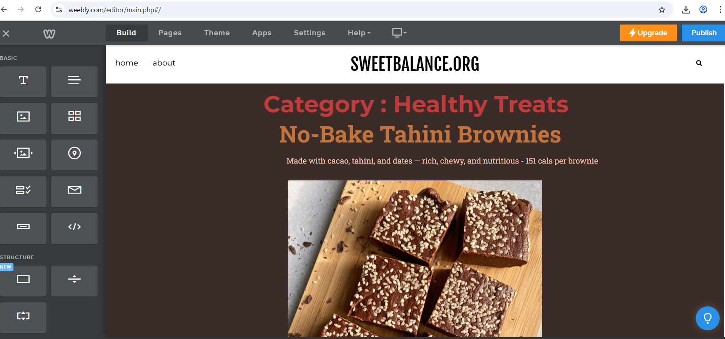Image 8: Product Page: No-Bake Tahini Brownies (Weebly,2025)

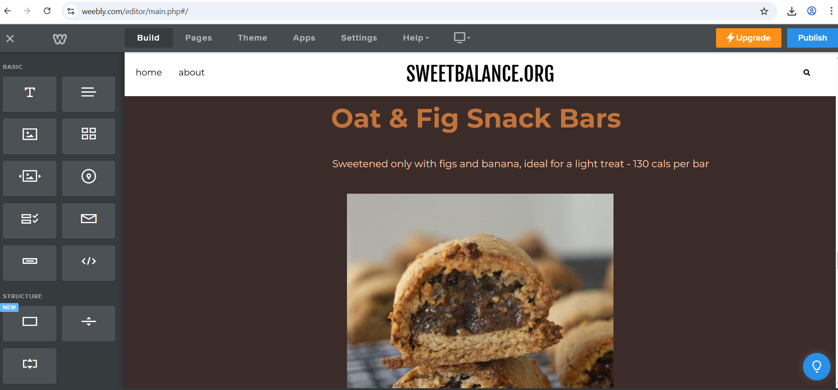Image 9: Product Page: Oat & Fig Snack Bars (Weebly,2025)

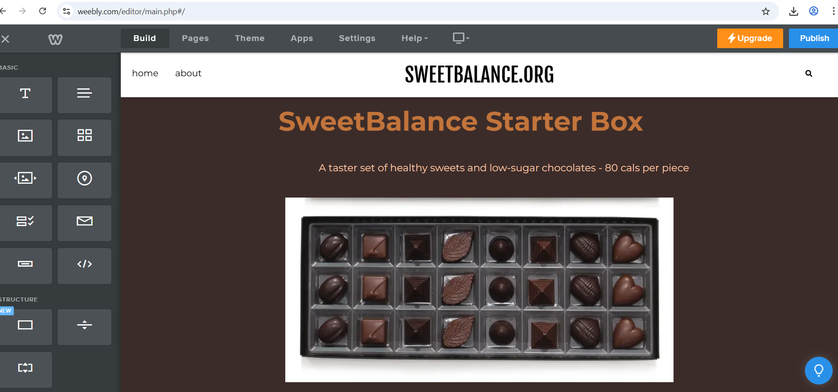Image 10: Product Page: SweetBalance Starter Box (Weebly,2025)

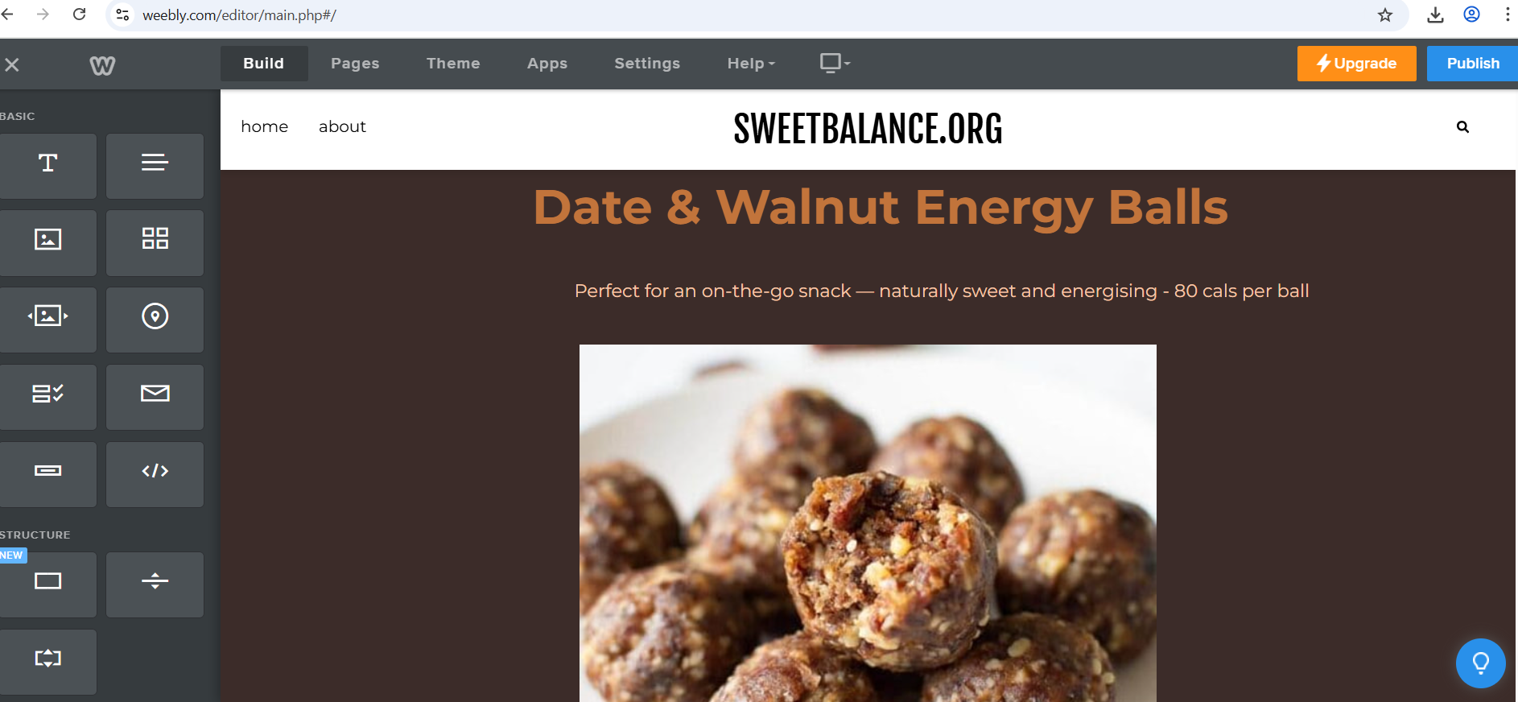Image 11: Product Page: Date & Walnut Energy Balls (Weebly,2025)

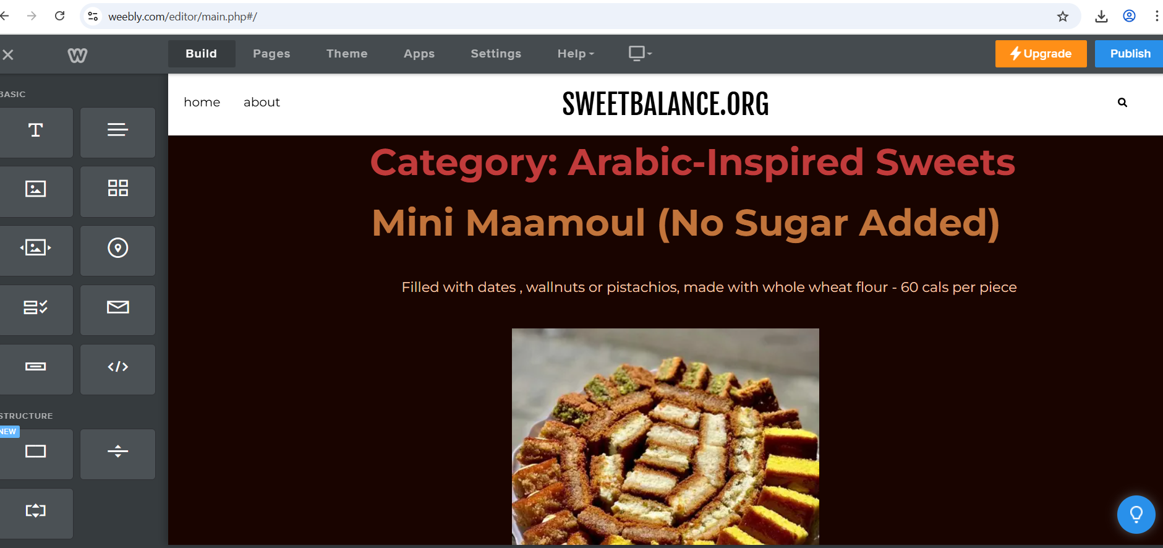Image 12: Product Page: Mini Maamoul (No Sugar Added ) (Weebly,2025)

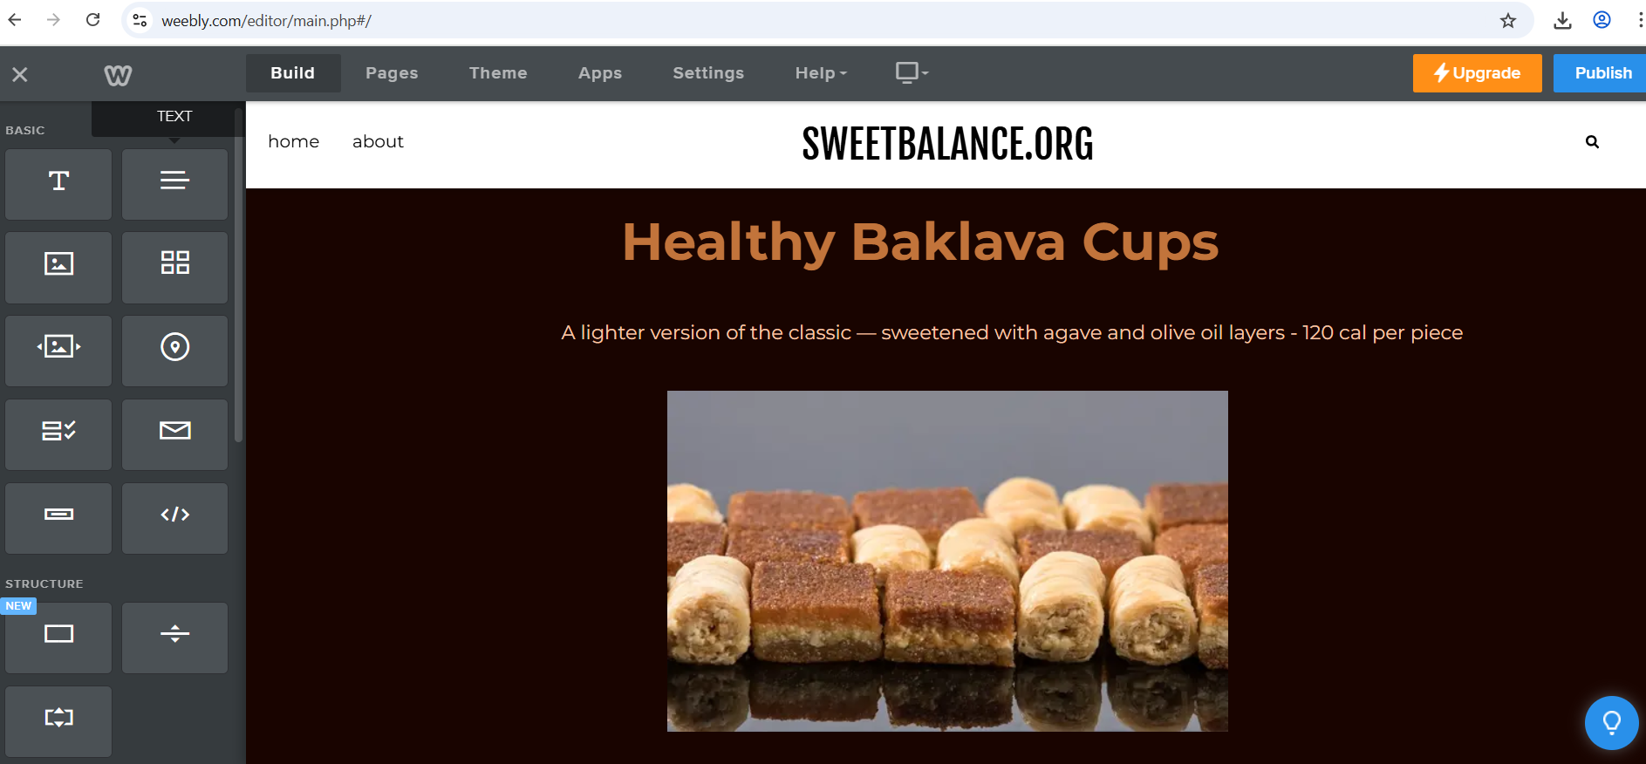Image 13: Product Page: Healthy Baklava Cups (Weebly,2025)

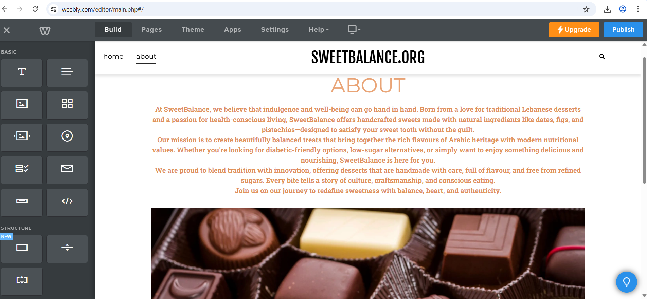Image 14: Website 'About' Page (Weebly,2025)

  - C) SEO Strategy: (Image 15)
In addition to using keywords in page titles and headings, SEO was also applied to the images on the website as shown in image 15. Each image file was saved with relevant names such as "low-sugar-baklava-truffles.jpg" and "date-sweetened-chocolate-box.jpg". These keywords reflect common search terms and were chosen based on the questionnaire responses. Alt-text descriptions were added on Weebly, such as "Diabetic-friendly Arabic chocolate with fig and hazelnut filling". This not only improves accessibility for users but also helps search engines recognise what the image is about, improving the site’s visibility on Google (Reedy & Parker, 2017).
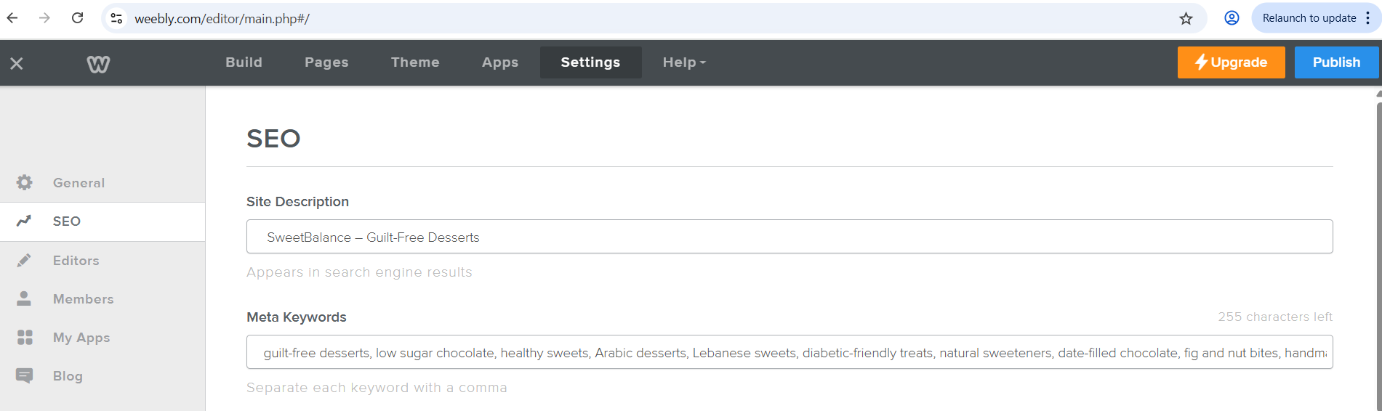Image 15: SEO Settings Panel on Weebly for SweetBalance Website (Weebly,2025)

D) Marketing Flyers (Images 16,17)
Flyers were created using Canva, one styled like an Instagram post and the other designed for printed promotion as shown in images 16 and 17. Both featured messaging influenced by the research:
- “Shaping the Future of Guilt-Free Desserts”
- “Made with love, using dates and figs”
- “Diabetic-friendly and natural”

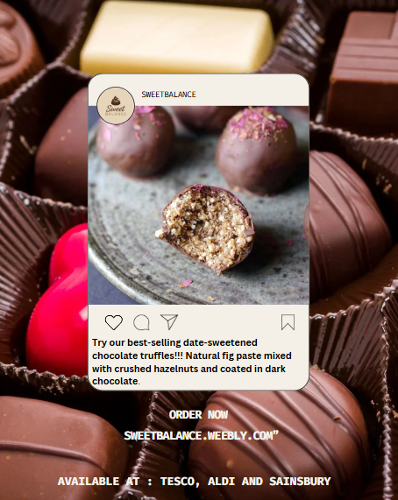 Image16: Instagram Product Post (Canva,2025)

Flyers also included a QR code to link to the website. Burgess et al. (2018) emphasise that well-designed digital materials help new businesses grow online.
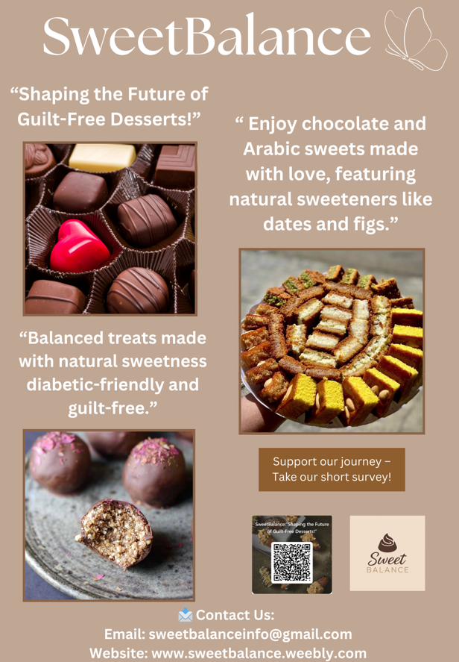 Image 17: Promotional Poster for SweetBalance (Canva,2025)

  - E) Audience Segmentation

The market research also helped define the target audience for ChocoBalance. Figure 8 shows that the majority of survey respondents were women aged 25 to 44 who expressed strong interest in health, low-sugar products, and cultural flavours. This group values both taste and nutrition and is likely to share product experiences on social media. Understanding this allowed the business to tailor its tone, visuals, and messages to match audience expectations. According to Burgess et al. (2018), successful digital branding begins by clearly identifying and designing for the needs of a specific customer group.
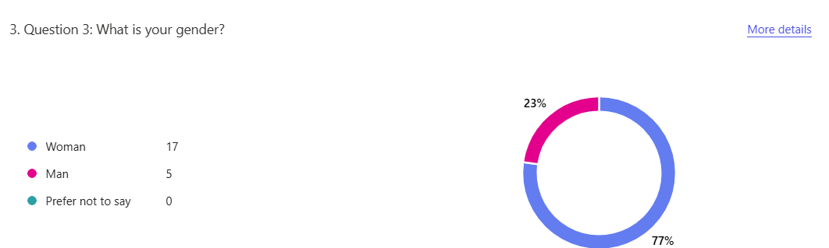
Figure 8: Gender Pie Chart (Microsoft forms,2025)
  - 4. Use of Digital Tools
Various free tools were used throughout the project:
- Google Forms: for questionnaire creation and distribution
- Microsoft Excel: for analysing responses
- Canva: for designing marketing materials
- Weebly: for building the website
These tools enabled efficient, cost-effective progress. Soltanifar et al. (2021) argue that digital tools empower small entrepreneurs to test ideas with minimal risk.

  - 5. Conclusion
This project demonstrated the value of combining digital market research with practical business tools. Survey insights shaped ChocoBalance’s branding, product choices, and marketing strategy. Consumer demand for chocolate, healthy ingredients, and accessible shopping locations informed every decision.
The use of digital tools like Microsoft Forms, Excel, and Canva allowed the project to be completed efficiently. ChocoBalance is now positioned as a healthy dessert brand offering handmade chocolate using natural, culturally inspired ingredients.

TASK 2:
  - 6. Spreadsheet Excel:

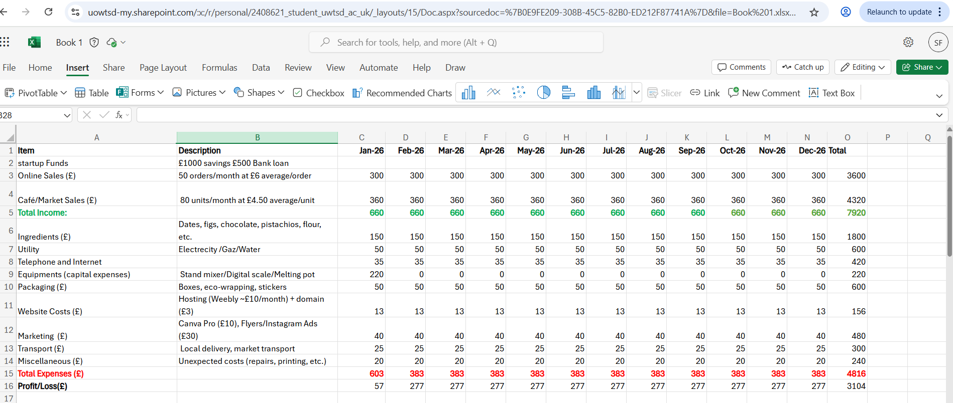Image 1: Excel Financial Table (Excel,2025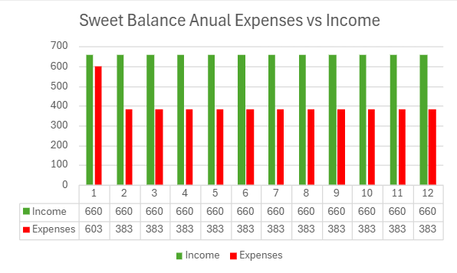 Image 2 :Bar Chart: Income vs Expenses (Excel,2025)

7. Essay: The Importance of Excel in the Digital Era: A Case Study on SweetBalance
  - Introduction
In today's fast-moving digital age, Microsoft Excel continues to be one of the most powerful and versatile tools for managing small businesses. It plays a critical role in tasks from tracking expenses and managing stock to visualising growth. Excel enables entrepreneurs to analyse operations efficiently, make informed decisions, and present financial plans professionally. This essay explores the role of Excel in driving business success, with a focus on SweetBalance, a Swansea-based dessert brand offering handmade, health-conscious sweets inspired by Lebanese culture.

  - Excel in Business Operations
Excel is widely recognised across industries as a vital tool for data analysis, budgeting, forecasting, and performance tracking. Its structure, which supports tables, graphs, and formulas, allows users to manage datasets with ease (Reedy & Parker, 2017). For small business owners or aspiring entrepreneurs, especially those with limited resources, Excel provides a cost-effective solution for daily and strategic tasks. As part of the Managing Enterprise module, learners are introduced to Excel not just as a spreadsheet, but as a tool for simulating real-world business environments.

  - Financial Planning for SweetBalance
In the context of SweetBalance, Excel was used to prepare a 12-month financial projection. Monthly income was divided into online sales and physical sales through cafés and local markets. Expenses included raw materials, packaging, website subscriptions, equipment, utilities, social media marketing and transportation. Basic Excel formulas such as =SUM and =O4-O15 were applied to calculate income, expenses, and monthly profit. This enabled the business to monitor financial health and assess sustainability. Additionally, bar and line charts made financial trends easier to interpret. These visuals supported the business owner in recognising seasonal patterns and adjusting stock and promotions accordingly (Chaffey & Ellis-Chadwick, 2019).

  - Supporting Data-Driven Decisions
One of Excel’s key benefits is its contribution to data-driven decision-making. As Sandhu (2020) highlights, modern business strategies require tools that support evidence-based planning. Excel empowers entrepreneurs to explore 'what-if' scenarios, test pricing models, plan for budget adjustments, and see how changes in cost affect profit.

  - Transparency and Accountability
Furthermore, Excel plays a role in transparency and accountability. Keeping all data in one workbook allows small businesses to present financial summaries clearly to banks, grant providers, or potential investors. Excel simplifies income and expenditure reporting, which is useful when applying for funding. In line with the Managing Enterprise module’s goals, Excel helps learners build responsible financial habits and confidence with business documentation (Dadwal, 2020).

  - Developing Digital Competence
In education, Excel is also valued for developing digital competence. Students gain experience in financial planning and analysis. As Byrd (2021) suggests, fostering entrepreneurial thinkers requires combining creative problem-solving with digital skills. Through projects like SweetBalance, learners practice calculating revenue, building budgets, and analysing customer and sales data, preparing them for business challenges.

  - Business Intelligence and Marketing Insights
Beyond projections, SweetBalance has been searching how to use excel for inventory management, order tracking, and marketing evaluation in the future. Customer survey feedback can be analysed in Excel to identify top product choices. Pivot tables help segment customers by age or health interest, improving marketing focus. Conditional formatting reveal trends, such as which products sold best in certain months (Pinto & Guarda, 2020). These functions turn Excel from a basic spreadsheet into a business intelligence tool.

  - Critical Reflection on Excel’s Limitations
While Excel is widely praised for its flexibility, it’s important to critically assess whether it fully meets the complex needs of modern digital businesses. For small enterprises like SweetBalance, Excel is excellent for early-stage planning and tracking. However, as the business grows, manual data entry and lack of automation may lead to errors or inefficiencies. This raises the question of whether relying on Excel might delay the shift to more scalable, cloud-based systems. Therefore, entrepreneurs must not only master Excel but also know when to adopt integrated digital platforms that support real-time insights and teamwork.

  - Conclusion
In conclusion, Microsoft Excel continues to be a key part of entrepreneurial success in the digital age. For SweetBalance, it has supported financial forecasting, operational planning, and digital literacy. These functions align closely with the Managing Enterprise module’s goals, helping learners plan strategically, solve problems, and confidently use business tools. In Swansea’s small business community, Excel serves as a bridge between ambition and action, helping businesses like SweetBalance move from idea to reality with accuracy and control.

  - 8. References:
Albaba Sweets (n.d.) Ice cream, pastry & chocolate products – Lebanon. Available at: https://albaba-sweets.com/pages/ice-cream-pastry-chocolate-products-lebanon (Accessed 7 June 2025).
Bake It Paleo (n.d.) No-bake tahini brownies. Available at: https://bakeitpaleo.com/no-bake-tahini-brownies/ (Accessed 5 June 2025).
Burgess, J., Marwick, A. and Poell, T. (2018) The SAGE Handbook of Social Media. London: SAGE Publications Ltd. Available at: https://doi.org/10.4135/9781473984066 [Accessed 4 June 2025].
Byrd, L. S. (ed.) (2021) Cultivating Entrepreneurial Changemakers Through Digital Media Education. IGI Global.
Chaffey, D. and Ellis-Chadwick, F. (2019) Digital Marketing. 7th edn. Harlow: Pearson Education.
Cocoa Black (n.d.) Chocolate truffle tasting collection. Available at: https://www.cocoablack.com/product/chocolate-truffle-tasting-collection/ (Accessed 5 June 2025).
Dadwal, S.S. (ed.) (2020) Handbook of Research on Innovations in Technology and Marketing for the Connected Consumer. Hershey, PA: IGI Global.
Delicious Magazine (n.d.) Chocolate-dipped stuffed dates. Available at: https://www.deliciousmagazine.co.uk/recipes/chocolate-dipped-stuffed-dates/ (Accessed 5 June 2025).
Etsy (2024) Lebanese Sfouf SweetFamous Arabic cake – listing 1210255312. Available at: https://www.etsy.com/uk/listing/1210255312/lebanese-sfouf-sweetfamous-arabic (Accessed 3 June 2025).
Friars (n.d.) No-added-sugar chocolate. Available at: https://www.friars.co.uk/collections/no-added-sugar-chocolate (Accessed 5 June 2025).
Hint of Healthy (n.d.) Date walnut balls. Available at: https://www.hintofhealthy.com/date-walnut-balls/ (Accessed 5 June 2025).
Kotler, P., Armstrong, G., Harris, L. and He, H. (2021) Principles of Marketing. 8th edn. Harlow: Pearson.
New Atlas (2024) Chocolate can now be made from cocoa jelly: new type of chocolate explained. Available at: https://newatlas.com/good-thinking/chocolate-new-type-cocoa-jelly/ (Accessed 7 June 2025).
Pinto, F.M. and Guarda, T. (eds.) (2020) Digital Marketing Strategies and Models for Competitive Business. Hershey, PA: IGI Global.
POD Chocolates (n.d.) Sugar-free milk chocolate almond nutty bar. Available at: https://thepodchocolates.co.uk/products/sugar-free-milk-chocolate-almond-nutty-bar (Accessed 7 June 2025).
Reedy, K. and Parker, J. (eds.) (2017) Digital Literacy Unpacked. London: Facet Publishing.
Rowles, D. (2017) Digital Branding: A Complete Step-by-Step Guide. 2nd edn. London: Kogan Page.
Ryan, D. (2016) Understanding Digital Marketing: Marketing Strategies for Engaging the Digital Generation. 4th edn. London: Kogan Page.

Sandhu, K. (ed.) (2020) Digital Transformation and Innovative Services for Business and Learning. Hershey, PA: IGI Global
Soltanifar, M., Hughes, M. and Gocke, L. (2021) Digital Entrepreneurship. Springer. Available at: https://doi.org/10.1007/978-3-030-53914-6 [Accessed 5 June 2025].
The Kitchen McCabe (2016) Chocolate chunk coconut chia macadamia crunch bars. Available at: https://thekitchenmccabe.com/2016/03/01/chocolate-chunk-coconut-chia-macadamia-crunch-bars/ (Accessed 7 June 2025).
The Tasty Spoonful (n.d.) Healthy fig and banana rolls. Available at: https://thetastyspoonful.com/healthy-fig-and-banana-rolls/ (Accessed 5 June 2025).
Unconventional Baker (2023) Vegan chocolate hazelnut bites. Available at: https://www.unconventionalbaker.com/vegan-chocolate-hazelnut-bites/ (Accessed 7 June 2025).

