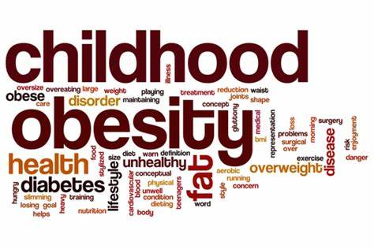

DIGITAL SKILLS AND RESEARCH METHODS

Executive Summary
This report has been focused on childhood obesity and determining contributing factors leading to it. These factors include environmental, parental, socio-cultural, genetic and psychological factors. Genetics has been found to be one of the major contributing factors for obesity among children. This report further emphasised on role of parents in adopting a healthy lifestyle and in turn influencing their children in doing so. The children are needed to engage into physical activities for minimising the risk of obesity among them.
Table of Contents
1.0 Introduction 3
2.0 Background 3
3.0 Aims and Objectives 5
4.0 Primary Research Method 5
5.0 Results 6
6.0 Discussion 9
7.0 Conclusion 10
Reference List 11

1.0 Introduction
Obesity has been considered as a serious medical condition which impacts children as well as adolescents. The obese children are having a greater body weight as compared to children of same age and height. Obesity among children has been troubling them as it might result in the emergence of several health problems like high cholesterol, blood pressure and diabetes. The obesity has been prevalent among children, particularly in the United Kingdom and recent studies revealed that one out of three children in the country are obese. Nearly 20 percent of teenagers were found to be obese and further 15 percent were overweight and girls are at a greater risk of getting overweight as compared to boys. The rates of obesity among children has been found to be highest in Northern Ireland (40 %), followed by Wales (38 %) and 35% in both England and Scotland (digital.nhs.uk, 2019). It has been evident that obesity and overweight has been associated with psychological problems like depression and self-esteem. The increasing rates of obesity have been a public health concern within the country.

2.0 Background
Causes of Childhood Obesity
Childhood obesity has been resulting from imbalance in expenditure and energy intake and increase in positive balance of energy has been related closely with their preferences in adopted lifestyle and dietary intake. However, it has been evident in various literatures that genetic background of an individual has been a key factor in determining risk of obesity. As opined by Roy et al. (2016), risk factor which contributes towards obesity among children includes daily exercise, intake of foods and sedentary behaviour. The family factors involves lifestyles of parents and parenting style and environmental factors includes demographics, policies existing in schools and work related demands of parents further influences activity and eating behaviours among children.
Genetics has been found to be one of the major contributing factors for obesity among children. It has been evident in various studies that 25-40% of genes are heritable. However, it has been argued by Simmonds et al. (2016) that genetic susceptibility are often needed to be coupled with contributing behavioural and environmental factors for accessing its impact on weight. Genetics has accounted to merely 5% of obesity cases among children. Hence, it can be stated that genetics might play a major role in obesity among children; however it is not a reason behind the rapid rise of obesity.

Environmental Factors
With the emergence of digital technology, children are spending most of their time in viewing television and using other forms of electronic media. These factors have contributed towards their sedentary lifestyles, along with other factors have minimised their opportunities for physical activity. In accordance to Baidal et al. (2016), recent years have observed reduced opportunities to children towards engaging in physical activities. A study conducted by NHS England revealed that 53% of children were driven to school by their parents and 66% of them reported that they did so because their homes are located far away from schools. Other reasons given by parents included fear of child predators, unavailability of safe route for walking and inconvenience for the child.
Family Factors
Family factors have also been found to be associated with increased obesity cases. The foods preferred by parents and food types which are available can influence eating preferences of children. Moreover, mealtimes of family can also influence the amount and types of foods consumed. It has been revealed in several researches that overweight parents are associated with childhood obesity and obesity.
Obesity- A growing epidemic in the UK
Obesity has been characterised as a worldwide problem and its rates have been found to be prevalent in the United Kingdom for children belonging in the age group of 7 to 10. From the recent reports, it has been found out that rates of obesity have been on the rise. As per the data released by Health Survey of England and CDC, it has been found out that rates of obesity among boys was nearly 11% in 2000 and 16% in 2009 and it has been predicted to be nearly 25% in 2020 (digital.nhs.uk, 2019). Moreover, the data revealed that obesity among children has not been found to be equal for every section of society and children residing in lower income households are at twice at risk as compared to those within higher income households. The amount of funds spent by the government towards obesity has been estimated at £4.2 billion annually. It has been predicted that by 2050, more than 50% of children will be overweight.
Social Cognitive Theory
Social Cognitive Theory reveals that an individual’s behaviour is shaped by their ability to reform their environment and regulate their own behaviour. As per the views put forward by Llewellyn et al. (2016), it has been evident that the interaction between environment, behaviour and personal factors of an individual and there exists an interrelationship among these factors. Therefore, it can be stated that behaviours of an individual can be altered by the environment and can alter daily exercise and healthy eating habits (Kumar and Kelly, 2017). environment. By altering the environment at home and parental behaviour, it is possible to change Ideally, this theory can be implemented for developing an intervention of home food in child behaviours which can place a positive impact on their health.

3.0 Aims and Objectives
Aims
This research has been aimed towards conducting an in depth research regarding factors which contribute towards childhood obesity and its impact on children.
Objectives
- To identify the contributing factors of childhood obesity
- To determine the prevalence of obesity in the United Kingdom
- To identify the health issues faced by children due to obesity
- To emphasise on the importance of health eating habits and physical activities for children.

4.0 Primary Research Method
Sampling Method
Sampling is referred as a way of selecting a particular group from a population group to be studied and a sample is a group of individuals who participates within a research. Probability and Non-probability sampling are the two types of sampling methods. As opined by Braun (2017), in probability sampling, samples are selected from a large amount of population and are chosen on the basis of probability theory and the participants are chosen on a random basis. However, in non-probability sampling method, a researcher selects a population group in a specific manner. The researcher has opted to choose probability sampling method for gathering data for the research. A set of questionnaires has been prepared which were distributed among 51 parents of obese children and data has been gathered.
Ethical Consideration
Ethical considerations are considered as one of the key aspects within a research. A research can get doomed if a researcher fails to take into consideration any factors. A range of guidelines exists, which can be used by a researcher for maintaining ethical considerations within their research. As highlighted by Wang et al. (2015), it is essential for a researcher to maintain confidentiality of their gathered data. The researcher has made sure that information which has been provided by participants has been stored in a password protected form, such that others are unable to access the information. The researcher has obtained consent from participants before collecting data from them. Moreover, the individual has ensured that participants have provided information on the basis of their experience and findings.

5.0 Results
Q1: Out of the following options, what do you think are major contributing factors for childhood obesity?
Options | Percentage of Respondents | Count of Respondents | Overall number of respondents
Environmental | 25.49% | 13 | 51
Socio-Cultural | 11.76% | 6 | 51
Family | 29.41% | 15 | 51
Psychological | 29.41% | 15 | 51
Genetic | 3.92% | 2 | 51
Table 1: Major contributing factors for childhood obesity
(Source: Created by the researcher)

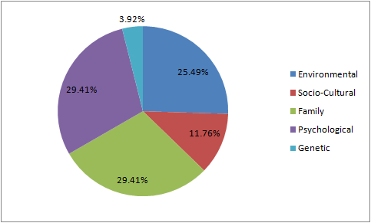
Figure 1: Major contributing factors for childhood obesity
(Source: Created by the researcher)

The results revealed that Family and psychological factors are the major contributors of obesity among children.

Q2: What are the major health issues faced by children due to obesity?
Options | Percentage of Respondents | Count of Respondents | Overall number of respondents
Low Self esteem | 31.37% | 16 | 51
Depression and anxiety | 9.80% | 5 | 51
Breathing problems | 9.80% | 5 | 51
Increased joint problems | 23.52% | 12 | 51
Social problems | 25.49% | 13 | 51

Table 2: Major health issues faced by children due to obesity
(Source: Created by the researcher)

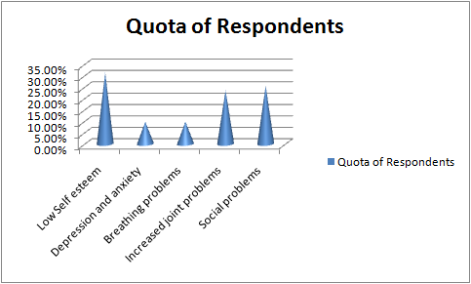
Figure 2: Major health issues faced by children due to obesity
(Source: Created by the researcher)

It can be established that, obesity has lead to lack of self esteem among most of the children.

Q3: Out of these options, what recommendations would you make for children in adopting a healthy lifestyle?
Options | Percentage of Respondents | Count of Respondents | Overall number of respondents
Involvement of parents at home and school | 23.52% | 12 | 51
Eating foods at appropriate time | 15.68% | 8 | 51
Physical activity | 35.29% | 18 | 51
Intake of nutritious foods | 25.49% | 13 | 51

Table 3: Recommendations for children in adopting a healthy lifestyle
(Source: Created by the researcher)

c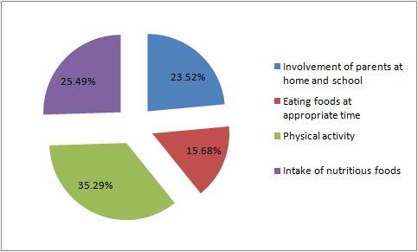
Figure 3: Recommendations for children in adopting a healthy lifestyle
(Source: Created by the researcher)

The parents are required to empower their children for engaging in physical activities for integrating a healthy lifestyle.

6.0 Discussion
Associated factors of obesity
Overweight occurs mainly when amount calorie intake exceeds the physical activities performed by an individual. It has been observed that 24% of children in the United Kingdom are having food with a higher amount of calories and sweetened beverages. As opined by Gurnami et al. (2015), children are spending a sedentary lifestyle and spending most of their time sitting in front of the television. Other contributing factors of obesity include parental factors. A survey recently conducted by NHS England revealed that if one or both parents are overweight, it increases the risk of children getting overweight by 50%. Moreover, children belonging to low income families have been found to be at a greater risk of getting overweight as they are unable to afford healthy foods.
Health consequences of obesity among children
Obesity among children can have major health consequences in various ways. Rankin et al. (2016) stated that, Heart disease, diabetes and asthma are among the most serious health risks faced by children. Moreover, it has been evident that obese children lack in self esteem. Self esteem is used for explaining the balance between aspirations and achievements of an individual and is correlated with a range of psychological symptoms like depression, anxiety and somatisation (Roy et al. 2016). A recent survey conducted by the University of Minnesota revealed that children who are bullied for being obese tend to have depression, lower self esteem and poor body image. It has been found that, 26% of children who were bullied reported to consider suicide and 9% of them committed it.
Promoting healthy lifestyles for preventing children in getting overweight
With increased prevalence of obesity, it has been important for parents to change eating habits of their children. It has been stated by Brown et al. (2015) that, parents play a key role in influencing their children to shape their eating habits. The children tend to have food which are purchased by their parents and hence are required to vary their eating habits. Moreover, children are needed to engage into physical activities for enabling them to shed their weight safely.
Limitations of the study
The major limitation which has been observed in this research is lack of funds and time. Due to lack of time, the researcher is unable to study important books and journals which could have enabled him to gain a deeper insight about the topic. Moreover, more information were available regarding contributing factors of obesity and less information was obtained regarding risks of obesity.

7.0 Conclusion
From assessment of this study, it can be concluded that the rates of obesity have been prevalent among children in the United Kingdom. Contributing factors which are associated with obesity are family, social, environmental, genetic and psychological. The children have been found to lead a sedentary lifestyle which has increased risk of obesity among them. Hence, the parents are needed to change their eating habits and in turn influencing their children in adopting the same. Moreover, they must empower their children to engage in physical activities and leading a healthy lifestyle.

Reference List
Baidal, J.A.W., Locks, L.M., Cheng, E.R., Blake-Lamb, T.L., Perkins, M.E. and Taveras, E.M., (2016). Risk factors for childhood obesity in the first 1,000 days: a systematic review. American journal of preventive medicine, 50(6), pp.761-779.
Braun, J.M., (2017). Early-life exposure to EDCs: role in childhood obesity and neurodevelopment. Nature Reviews Endocrinology, 13(3), p.161.
Brown, C.L., Halvorson, E.E., Cohen, G.M., Lazorick, S. and Skelton, J.A., (2015). Addressing childhood obesity: opportunities for prevention. Pediatric Clinics, 62(5), pp.1241-1261.
Digital.nhs.uk (2019). Statistics of Obesity. Available at: https://digital.nhs.uk/data-and-information/publications/statistical/statistics-on-obesity-physical-activity-and-diet/statistics-on-obesity-physical-activity-and-diet-england-2019. [Accessed on: 23rd June 2019]
Gurnani, M., Birken, C. and Hamilton, J., (2015). Childhood obesity: causes, consequences, and management. Pediatric Clinics, 62(4), pp.821-840.
Kumar, S. and Kelly, A.S., (2017), February. Review of childhood obesity: from epidemiology, etiology, and comorbidities to clinical assessment and treatment. In Mayo Clinic Proceedings, 92(2), pp. 251-265
Llewellyn, A., Simmonds, M., Owen, C.G. and Woolacott, N., (2016). Childhood obesity as a predictor of morbidity in adulthood: a systematic review and meta‐analysis. Obesity reviews, 17(1), pp.56-67.
Rankin, J., Matthews, L., Cobley, S., Han, A., Sanders, R., Wiltshire, H.D. and Baker, J.S., (2016). Psychological consequences of childhood obesity: psychiatric comorbidity and prevention. Adolescent health, medicine and therapeutics, 7, p.125.
Roy, S.M., Spivack, J.G., Faith, M.S., Chesi, A., Mitchell, J.A., Kelly, A., Grant, S.F., McCormack, S.E. and Zemel, B.S., (2016). Infant BMI or weight-for-length and obesity risk in early childhood. Pediatrics, 137(5), p.e20153492.
Simmonds, M., Llewellyn, A., Owen, C.G. and Woolacott, N., (2016). Predicting adult obesity from childhood obesity: a systematic review and meta‐analysis. Obesity reviews, 17(2), pp.95-107.
Wang, Y., Cai, L., Wu, Y., Wilson, R.F., Weston, C., Fawole, O., Bleich, S.N., Cheskin, L.J., Showell, N.N., Lau, B.D. and Chiu, D.T., (2015). What childhood obesity prevention programmes work? A systematic review and meta‐analysis. Obesity reviews, 16(7), pp.547-565.

