MARKETING ESSENTILS
Marketing Plan HILON HOTEL
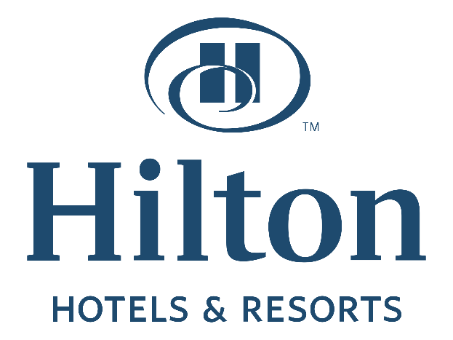
Student Name:Andreea Maria Crozolo
Student ID:2226837
Lecturer’s name:Ruth Taylor-Davies
Words count: 1504.

TABLE OF CONTENTS
1. Introduction 1
2. Situation Analysis (5Cs) 2
2.1 Company: SWOT Analysis 2
2.2 Customers: Segmentation & Targeting 2
2.3 Competitors: Porter’s Five Force 3
2.4 Collaborators 3
2.5 Climate: PESTLE Analysis 3
3. Objectives: 5
3.1 SMART Target: 5
4. Strategy 5
4.1 Value Proposition & Bowmans Strategy Clock 5
5. Tactics: 350 5
5.1 Marketing Mix 5
6. Action 6
6.1 Gantt Chart of Marketing Activities 6
7. Control 6
8. Conclusion 7
9. References: 8

Introduction

Sharma (2019) stated that a detailed marketing plan helps a business to attract new customers and retain existing customers which contribute to the sustainable growth of a business. This report aims to develop a marketing plan for Hilton Hotel to explore the market opportunity in India, one of the emerging economies in the world, and communicate the strategy with the decision-makers of the company. At first, a situation analysis will be presented containing the microenvironment analysis, customer analysis, macro environment analysis, industry competitiveness analysis and so on. Strategic tools such as SWOT analysis, STP, PESTLE analysis, Porter’s five forces etc. will be applied here. Furthermore, SMART objectives will be defined considering the SMART factors and strategy will be explored using Bowman's strategy clock model. Then, the marketing mix for the opportunity will be explored which will be followed by the action plan and control measures for the marketing plan.

2. Situation Analysis (5Cs)

2.1 Company: SWOT Analysis
Campbell (2020) referred to the SWOT analysis as a microenvironment analysis tool using which internal strengths and weaknesses of a business and external threats and opportunities can be identified. The SWOT analysis of Hilton in the context of the Indian market is presented below:

2.2 Customers: Segmentation & Targeting
According to Walker and Stanton (2019), segmentation allows grouping the potential customers into multiple groups based on similarities in their characteristics and targeting assists to target the customers to market and position the products and services. As SWOT analysis revealed, the demand for destination weddings is high in India and the company has 25 hotels in 25 attractive locations, suitable for a destination wedding (Hilton.com, 2023). In 2021, 28.7% growth has been recorded in this segment with a rapid growth forecast for coming years (Futuremarketinsights.com, 2022). Therefore, the company will target the customers who belong to the high-income category from the income-based segmentation. The typical target customers of the company will be rich people with marriage plans.

2.3 Competitors: Porter’s Five Force
According to Cornelis (2021) the Porter’s five forces analysis help to evaluate the competitive environment of an industry. The following segment will illustrate the competitive position of Hilton in the Indian market:
- The threat of new entrants-Low: Roh (2020) highlighted that the hotel industry requires a substantial initial investment which acts as an entry barrier in the industry. Therefore, the threat of new entrants is low for Hilton considering its gigantic size.
- The threat of substitutes-Low: The demand for hotel accommodations is less likely to be met by substitutes and hotel accommodation is a prerequisite for destination weddings causing the threat to be at the lower end.
- Bargaining Power of Suppliers-Low: Hilton is a large hotel chain that has a strong hold on the suppliers and since there are a lot of suppliers in the hotel industry, the bargaining power is low for the suppliers.
- Bargaining Power of Customers-Moderate: The geographical location and quality service give an upper hand to Hilton in India but since there are many hotels offering destination wedding venues, the customers have moderate bargaining power.
- Competitive Rivalry-High: There are numerous competitors of Hilton in the existing hotel segment which causes the industry competition to be at the higher end.

2.4 Collaborators
Saraogi (2020) highlighted that Hilton’s business model is standing on its franchisee model and in India the company has 25 franchisees playing important role in the company’s success. However, since the company aims to expand its offerings in the destination wedding segment, it will require to collaborate with the event management companies to acquire customers and carry out the business in this segment.

2.5 Climate: PESTLE Analysis
Campbell and Stonehouse (2021) stated that PESTLE analysis helps to evaluate the macroenvironmental influence on a business. The PESTLE analysis of Hilton in the Indian market is presented below:
- Political: The political environment in India remains stable for several years in a row causing an influx of foreign investment in the country (Trade.gov, 2022). Thus, it will have a positive impact on the business of Hilton in India.
- Economic: According to Taborda (2022), India is set to overtake Chain in terms of economic development within the next 5 years which will increase the income level of the people. Thus, this will create a great opportunity for Hilton to market its destination wedding services.
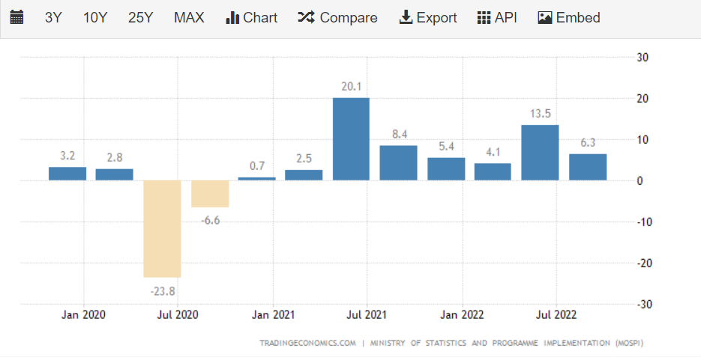
Figure 1 GDP Growth of India
Source: (Taborda, 2022)
- Social: The social trend is showing a high growth rate in the destination wedding demand among the rich people of the country (Bwhotelier.businessworld.in, 2022).
- Technological: Technological development has made it easier for businesses to reach their target customers and the Indian tech environment is business friendly as well.
- Legal & Ecological: The legal environment for foreign business is simple in India and the government has taken the initiative to make it business-friendly for foreign investors. The ecological environment also is in favour of Hilton with favourable weather conditions for a destination wedding.

3. Objectives:

3.1 SMART Target
This marketing plan aims to identify the target customers for the company’s destination wedding service category and develop an effective value proposition strategy and define the marketing mix to attract the target customers for the services of the company.

4. Strategy

4.1 Value Proposition & Bowmans Strategy Clock
Hilton has developed its value proposition in high-quality services at a reasonable cost. The company has achieved this via the cost leadership strategy (Kotler and Armstrong, 2021). Through this strategy, the company has differentiated itself from other hotel service providers (Saraogi, 2020). The value proposition for the destination wedding services of the company will also follow a similar strategy i.e., cost leadership to deliver high-quality services at a reasonable cost to position itself in the market. Since the target customers belong to the rich category, high-quality services will help to develop the brand value and strengthen the positioning of the company in the market.

5. Tactics: 350

5.1 Marketing Mix
- Product/Services: The company’s service offering will be designed focusing on the destination wedding across all of its 25 locations in India where the services will include night stays, dine-in, restaurants, bars, entertainment i.e., musicals, dance etc., venue management, program coordination and so on.
- Place: The destination wedding services of the company will be offered from all of its 25 locations in India. The customers will be able to secure their reservations using the website, and mobile app as well as being physically present at the hotels. The company will also utilise approved event management partners to sell its services to customers.
- Price: According to Engelson (2019), the cost-plus pricing helps to offer high-quality services at a reasonable cost while securing a desired profit margin. Therefore, the company being a cost leader will follow the cost-plus pricing strategy where a target profit will be added to the cost to reach the pricing.
- Promotion: According to Horner (2019), the communication mix includes advertising, personal selling, sales promotion, public relations, direct/internet marketing and packaging. To promote the services of the company, it will primarily focus on direct/internet marketing to reach the customers. Mediums such as social media platforms, target advertising, websites etc. will be used. Advertising on TV and Webpages will be used also. The sales promotions such as early booking discounts will be provided to attract customers as well.

6. Action

6.1 Gantt Chart of Marketing Activities
Figure 2 Gantt Chart for Marketing Activities
Source: Developed by Author
The above Gantt chart is showing the schedule for marketing activities of the plan. As noticeable, the TV advertisement will be run initially from February to June to create initial awareness of the brand. The Web-advertisement will be run from January to November whereas the personal selling will be pursued throughout the year with the help of the room service and hotel staff. Early booking discounts will be offered from January to September and referral discounts will be provided from March to December. Direct marketing will be run mostly throughout the year.

7. Control
The unique selling point (USP) of the Hilton’s wedding destination offerings will be the attractive geographical location of the hotels. Moreover, the company’s high-quality services at a reasonable cost will also complement the above USP of the company. To measure the success of the marketing plan, the company will use the following metrics:
- Growth is the revenue from the destination wedding segment.
- The flow of online traffic on the company’s website
- Number of clicks in the advertisement
- Number of coupon codes used.
- Number of referrals
- Feedback from the customers

8. Conclusion
The above report has outlined the marketing plan for the destination wedding services of Hilton in the Indian market. The situation analysis has revealed a great opportunity for the company to expand its businesses in the destination wedding segment. The company has targeted the rich people of the country to market the services. The company will adopt a cost leadership strategy and offer high-quality services at a reasonable price. The marketing mix has outlined the communication strategy in detail and the Gantt chart has summarised the schedule of marketing activities to implement the communication strategy.

9. References
Bwhotelier.businessworld.in (2022). 62% increase in demand for destination weddings, says WeddingWire India Report. [online] BW Hotelier. Available at: https://bwhotelier.businessworld.in/article/62-increase-in-demand-for-destination-weddings-says-WeddingWire-India-Report/23-06-2021-394171 [Accessed 29 Jan. 2023].
Campbell, D. (2020). Business Strategy. 7th ed. London: Pearson.
Campbell, D.J. and Stonehouse, G. (2021). Business strategy : an introduction. 8th ed. Houndsmills, Basingstoke, Hampshire ; New York: Palgrave Macmillan.
Cornelis (2021). Strategic thinking : an executive perspective. 8th ed. Upper Saddle River, N.J.: Prentice Hall.
Engelson, M. (2019). Pricing strategy : an interdisciplinary approach. 12th ed. Portland, Or: Joint Management Strategy.
Futuremarketinsights.com (2022). Destination Wedding Market. [online] www.futuremarketinsights.com. Available at: https://www.futuremarketinsights.com/reports/destination-wedding-market#:~:text=According%20to%20Future%20Market%20Insights [Accessed 29 Jan. 2023].
Hilton.com (2023). Hilton Hotels in India - Find Hotels. [online] Hilton. Available at: https://www.hilton.com/en/locations/india/hilton/ [Accessed 29 Jan. 2023].
Horner, S. (2019). The promotional mix. 10th ed. Sheffield: Sheffield Hallam University, School Of Leisure And Food Management.
Kotler, P. and Armstrong, G. (2021). Principles of marketing : an Asian perspective. 15th ed. Singapore: Pearson/Prentice-Hall.
Roh, Y. (2020). An Analysis of Japanese Investment in the U.S. Hotel Industry. The Journal of Hospitality Financial Management, 1(1), pp.55–63. doi:10.1080/10913211.1991.10653615.
Saraogi, A. (2020). Exploring Franchisor Franchisee Relationship: Building a Predictive Model of Franchisee Performance. Vision: The Journal of Business Perspective, 13(1), pp.31–58. doi:10.1177/097226290901300104.
Sharma, S. (2019). Principle of marketing. 4th ed. Jaipur, India: Oxford Book.
Taborda, J. (2022). India GDP Grows Less than Expected in Q4. [online] Tradingeconomics.com. Available at: https://tradingeconomics.com/india/gdp-growth-annual [Accessed 30 Jan. 2023].
Trade.gov (2022). India - Political Environment. [online] www.trade.gov. Available at: https://www.trade.gov/country-commercial-guides/india-political-environment [Accessed 30 Jan. 2023].
Walker, B.J. and Stanton, W.J. (2019). Marketing. 2nd ed. Maidenhead: Mcgraw-Hill Education.



