

Cameron Lane

Study Skills Assessment

Ordnance, Munitions and Explosives Apprenticeship

Academic Year: 2024-2025

Supervisor: Jenni Steen
January 2025

This assessment is submitted in partial fulfilment of the requirements for the degree of Ordnance, Munitions and Explosives BEng
(NB. Remove if the degree award is based solely on examination of the thesis)

© UWTSD 2025. All rights reserved. No part of this publication may be reproduced without the written permission of the copyright owner
Contents
1 Presentation 4
1.1 Key Points Learnt 6
1.2 Areas of Improvement 7
2 Skills Evaluation 7
3 Data Storage 11
3.1 Data storage 11
3.1.1 The 3-2-1 Rule 11
3.1.2 My Data Storage 11
3.1.3 The Flaws of My Data Storage 11
3.2 Time Management and Self Organisation 12
3.2.1 Time Management 12
3.2.2 Organisation 14
3.3 Independent Study- Torpex – a powerful underwater explosive 15
3.3.1 The Development of Torpex 15
3.3.2 Torpex in Service 16
3.3.3 The Replacement of Torpex 17
4 Conclusions and Evaluation 18
4.1 Appendix 19
5 Bibliography 22

Table of Figures
Figure 1- Family 4
Figure 2- Life 5
Figure 3- Sports and hobbies of the student 6
Figure 4- Examples of Time Management on Fridays 13
Figure 5- Time Management during University 14
Figure 6- Organisation in My Previous Degree 15
Figure 7- Organisation in My Current Degree 15

Presentation
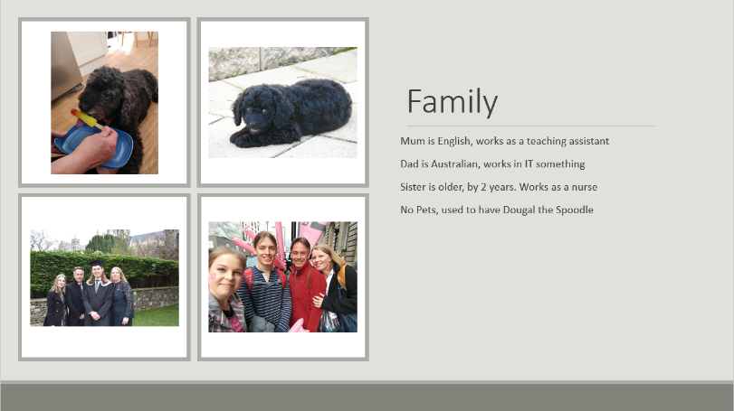
I was asked to produce and present an icebreaker presentation on their life. This was intended to provide an overview of my life, family, interesting facts etc. as an introduction for the rest of the class. I started this off by giving an overview of my family, seen in figure 1. This consisted of a brief introduction to each of the members of the family, father, mother, and sister respectively. This covered their nationality, jobs etc. Also included was my pet, for the extra marks.
Figure 1- Family

Following on from this was an introduction to my life, seen in figure 2. This covered a wide variety of information on me, including where I was born, my early life growing up in Australia, moving to England, studying in university, and working for Tesco. This was backed up with images to highlight key points I was making in my presentation. This showed me with my sister and mum in Australia, the leaving party for when we left Australia, my graduation from university, and working for Tesco.
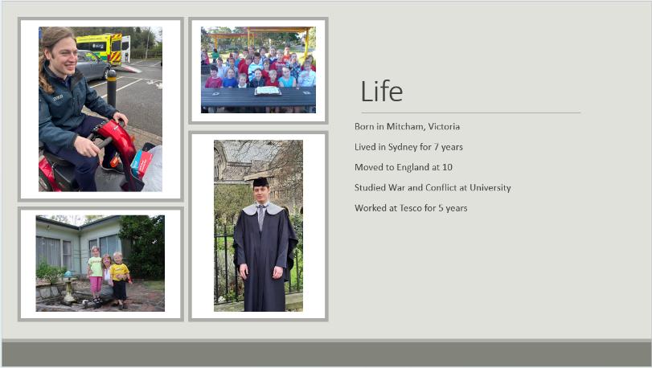
Figure 2- Life
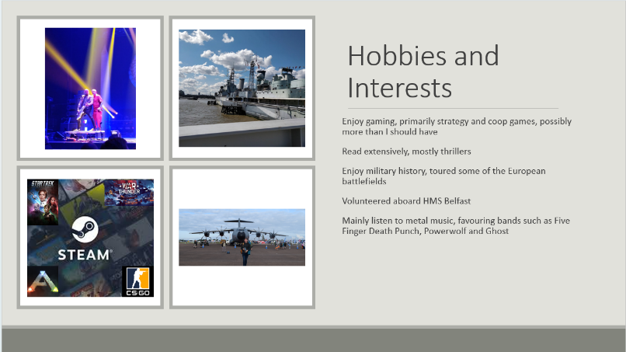
Figure 3 goes on to introduce the hobbies and interests of the student. This again featured a number of bulletpoints on the slide to use as reference points when presenting. For this slide, I covered a number of areas. Firstly, my interesting in gaming, showing a few of the games I enjoy playing. I then went into how I enjoy reading, listing a few of my favourite authors and series. I then went into military history, with images showing my volunteering for the Imperial war museum aboard HMS Belfast, and attending the Royal International Air Tattoo. This section was concluded with my taste in music, with the final picture from the Five Finger Death Punch concert I attended last year.
Figure 3- Hobbies and Interests

Finally, I covered sports and travel. I started this looking at sports, describing the loosing streak in football leading to me taking up archery and fencing, with a picture of archery to illustrate. I followed this into my enjoyment of skiing, with pictures from one of my first and my latest ski trip. This lead me into discussing my travel, where I highlighted some of the countries I had been to and experience I had had abroad.
Figure 3- Sports and hobbies of the student

Key Points Learnt
This project highlighted a number of key learning points that were vital to the delivery of a successful presentation. Firstly, the importance of well-designed slides. When designing these slides, I wanted to keep the number of slides low whilst also including a significant amount of information. I had to arrange the slides in the way that best allowed for this, hence grouping sports with travel, and hobbies with interests. This allowed for topics to flow together, with skiing linking sport to travel, and military history the main theme of hobbies and interests. By having these slides joined together, it allowed for more condensed slides, information did not have to be repeated multiple times, giving space for other information.
Alongside arranging the slides and topics correctly, I also found it key during this project to consider the information included in the slides. I wanted to ensure that the audience was listening to me presenting, not just reading off the slides. For this purpose, I sought while making my presentation to keep the writing to bullet points, ideally just single lines. These were mainly designed as references for me to recall what needed to be covered. It gave an overview for the audience, but still directed attention back to myself as I expanded upon each point.

Areas of Improvement
I identified one significant area for improvement as a result of my self evaluation. This point of improvement is decreasing the amount of filler words being used during my presentation. I found that while I knew what point I was meant to be making next, and had the information on the slides as reminders for my points, I was utilising filling words far too much between them. This lead to a more stilted presentation that I wanted. To improve this, I will seek to prepare more, revising what I plan to say so it flows better. This will result in me stopping less while I consider the next point that I plan on saying.
There were also a number of areas identified through peer review of my presentation, primarily around my presenting style rather than the presentation itself. Firstly, the need for more eye contact when presenting. This helps me to engage more with the audience, judge the level of understanding to see if there is the need for further explanation, and so they feel more interested in what I am presenting. Secondly, it was identified that I need to face the audience more. This is in the same vein as the first point of improvement identified. While this was somewhat limited by the need to turn to change the slides, better facing the audience allows me to engage better with them, improving the information given. Finally, it was identified that I needed to improve my projection and confidence whilst speaking. Succeeding in this helps to properly present information to the audience, and keep them engaged.

Skills Evaluation
There are numerous skills required to succeed in higher education. Commonly suggested skills include written and verbal communication, listening, teamwork and leadership [1] [2]. These are all skills that a highly important on a purely academic point of view. With content being delivered through lectures and seminars, listening skills are highly important. Strong writing skills are vital as the majority of assignments will be written work. This requires a higher level of work than required for secondary education, with the ability to be able to reference and to write professionally the most important improvements [3]. Assignments that aren’t written will often be in the form of presentations or group work, where strong verbal communication skills will provide the most benefit. Strong presentation skills are often something not overly well developed in secondary education, where essays are most common. It is important to make the most of presentation opportunities at university, especially since final year projects will require presentations about dissertations, making up a significant portion of grades.
While academic skills are highly important in higher education, there are also numerous others that have a significant impact on success at university. Whilst at university, you are largely self-sufficient. A significant portion of module content is self-taught, and you are also often living on your own, responsible for far more than in secondary education. As such, the skills required for this are also highly beneficial. These include time management, organisation, budgeting, and cooking [4] [5]. These skills will be directly beneficial to both the academic side of higher education and the non-academic side. Time management is important for studying, to ensure adequate time dedicated to revision, and to make sure that assignments are started and completed on time, however it also benefits the non-academic parts, planning life around university. Budgeting and cooking are naturally important for university life, you are often living alone, so having the skills for self sufficiency are highly beneficial [6].
Many of these skills are transferable skills relevant to employment. Skills such as written and verbal communication are as useful in the workplace as they are in higher education. In many industries, professional writing skills are essential, OME included, and it is important that candidates for jobs are able to write and read these sorts of technical documents. In the same vein, verbal skills are important to be able to perform well in meetings and conferences and conversations throughout the work day. Time management and organisational skills are equally important, for the same reasons as in higher education. A candidate needs to be able to mange their work-load, as there will constantly be deadlines in employment that must be met. For this reason it is a skill that will be highly prized by employers.
As part of this module, I completed a number of online exercises to research my learning style and see what would work best for my studies. The first test completed identified me as a visual learner, who would work best with flashcards and diagrams. The second test identified that I fitted better as a Kinesthetic learner, who would learn better based on a hands on, trial and error based approach. The final test identified me as a multimodal learner, that favoured kinesthetic and aural learning, and disfavoured reading/writing and visual learning. The results from these three tests are listed in the appendix, appendices 1, 2 and 3 respectively. I believe these latter two tests fit in with my preconceived ideas about my learning style. I have found from previous experience that a hands on approach has lead to better results, and I retain the information far better when doing something than just when being shown how to do it. To improve in my studies I need to work with my style of learning. To reinforce other methods of learning I will complete exercises and examples of work that has been taught, as this is shown to help me retain information.
I have a number of goals surrounding this course. My main goal for the foreseeable future is to pass my degree and get a job following on from this. As such, there are a number of other short term targets that I have that contribute towards this. These consist of succeeding in each individual module for this year, maths, chemistry and physics, as well as doing well in my employment. To achieve these goals it is important to have SMART targets. This is why my main goal of passing my degree has been broken down into smaller goals, to make it easily measurable and achievable.
I have a target to pass each module taken this year, maths, physics and chemistry, achieving at least a 2:1 in each of these. These are specific, I want to achieve at least a 2:1. It is measurable, based on the grade achieved. It is achievable, I received a 2:1 grade in my previous degree and believe it to be possible for me to achieve it again. And it is relevant. Each of these modules is responsible in part for the overall grade of my degree, so are relevant to my main target in my life. To ensure these goals are met, I will be ensuring that I am adequately managing my time, so that assignments and revision are started and completed on time, so that the maximum effort can be put into my work, hopefully resulting in a better outcome. I will be ensuring that I complete additional exercises in my weaker topics in line with my learning style as this will be the most productive for me.
These separate goals all feed into my main goal, and make it a SMART Goal. It is specific, I want to pass my degree. It is measurable, I have to pass all my modules to pass my degree. It is achievable, I am capable of completing all of the modules that are required for this degree. And finally, it is relevant, my degree is the main focus in my life at the moment. To achieve this goal, I will have to ensure that all the contributing factors towards my degree are being completed to the highest standard I can. This is mostly being controlled by the goals I mentioned previously, where each individual module is an individual target.

Data Storage

Data storage

The 3-2-1 Rule
With the importance of technology on the modern world, the safe storage of data is vital. The 3-2-1 rule is often used to describe the most common ways to ensure data safety. Firstly, have three copies of your data saved, to ensure there are copies of the data in case one fails. Secondly, have these 3 copies of the data spread across at least two different storage devices, ensuring redundancy if one device fails. And finally, have at least one of these storage devices kept in a secondary location, safety in case something happens to the storage location. Following these rules should offer a simple, robust data backup to prevent the loss of data.

My Data Storage
To prevent my loss of data, I ensure that everything is saved to the device it is being worked/used upon. This is the first copy, on the first device. Secondly, through the use of cloud storage services, in my case Microsoft OneDrive, data that is changed across my devices is backed up to the cloud, through the use of incremental data storage. This covers my documents, pictures, videos and downloads, while leaving the majority of program files. This ensures that more important data, harder/ impossible to replace data, is being stored on a second device, off site from my primary devices. The use of incremental saving means that backups are quick and simple, at any time I have access to a copy of the most up to date version of my work. For University work, I also have data stored on a USB drive, the third storage device. This is mostly for ease of access, it can be quicker to access files on a USB device than data stored on the cloud, with numerous logins and security authentications required.

The Flaws of My Data Storage
There are a couple of flaws in my data storage methods. Firstly, besides university work, my data is only being backed up in two locations. This does go against the 3-2-1 rule, however it is not as big of an issue as it may seem. OneDrive, my cloud storage system, has significant redundance in it, and the vast majority of files that are only on these locations are not of such value that requires further backups to be made.
Secondly, the majority of data isn’t being backed up. There is roughly 5 terabytes of storage space in use on my main computer, further being used on laptops. My OneDrive however only cover 56 gigabytes of data across all devices. This is not the major problem that it seems however. The vast majority of this data is program files which are very easily replaced, with the work associated with them stored as part of my documents that get backed up. Were there to be a loss of data, these program files can be replaced within a day or two through reinstallation. Having them backed up would most likely take longer to recover, and slow the recovery of other more important data.

Time Management and Self Organisation

Time Management
Time management is something that I found I struggled with significantly during my past degree, and have continued to since then. I often left assignments later than they should have been, resulting in more rushed work that could have had more time and attention paid to it. With the balancing of work and study during this degree, proper management of time will be even more important for success at university this time.
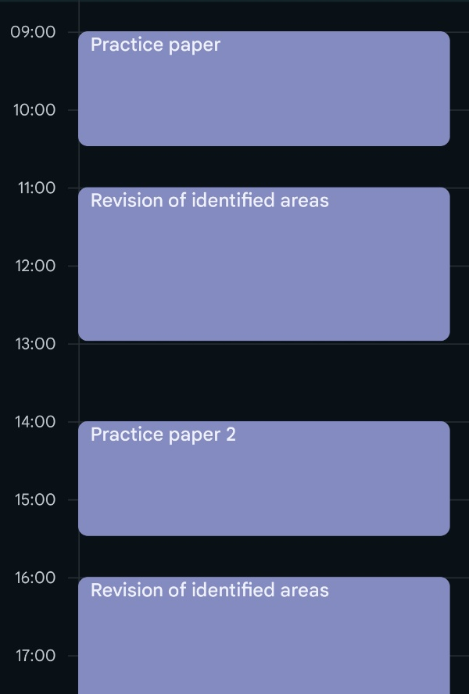
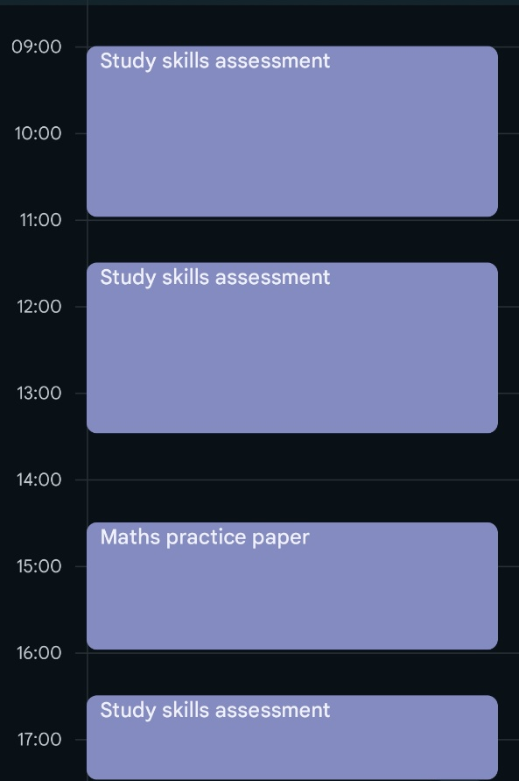
The primary method of managing my time will be the correct use of my Fridays. My work has given me these days to be dedicated for university work, rather than my Monday-Thursday role. To ensure these days are being used properly I will be splitting them into sections covering the work that needs to be completed. Shown below are two examples of how my Fridays will be divided up. The first shows how a day with assignments will be set up. In this, the majority of the time is being dedicated to the assignment, as it is the more pressing piece of work due. Some time is also dedicated to the other module as revision time, to break things up from a whole day of assignments, however as it is not as pressing it is not being prioritised. The second example shows the following Friday. The assignment that was being worked on in the first example has been completed, there are no other piece of work due or revision to be done, so the day is dedicated to the module.
Figure 4- Examples of Time Management on Fridays
This approach to time management is not however dedicated to just Fridays. Some university days do not have lectures covering the whole day, leaving time for self study. These times are also planned for, as shown in the example below. The day shows starts with double chemistry lectures in the morning. It then allows for lunch, to give time to relax from learning for a period. Lunch is then followed by time dedicated to more maths revision, as it is the piece of work most pressing at that day. Other days could see this time used for revision for subjects, writing of assignments, or time dedicated to research to prepare for writing.

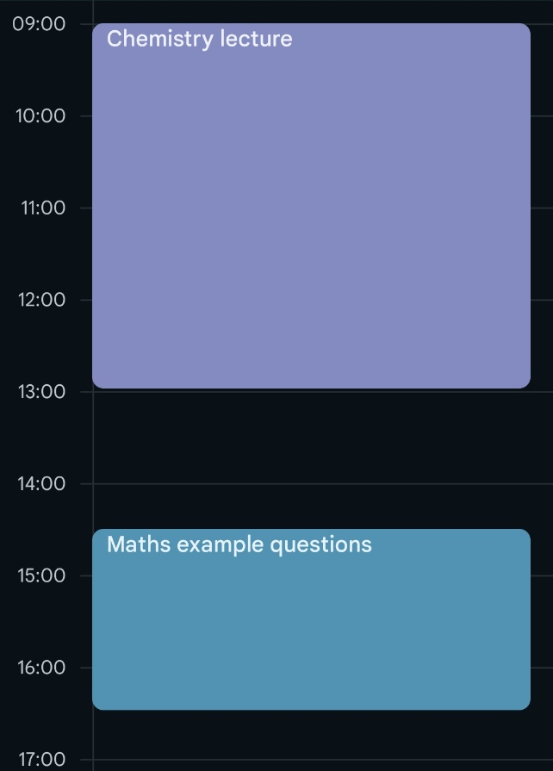
Organisation
Figure 5- Time Management during University
To ensure that I am adequately organised for my learning, my file storage systems have been organised ahead of time to ensure that relevant work is easily accessible and storable. Two figures can be seen below. The first shows my file storage for my previous degree. While in some cases work is labelled according to module, one folder contains three years’ worth of work, covering over a dozen different modules. Work such as my dissertation is not easily recognisable, with multiple different notations used to identify different versions of the piece. The second picture shows the file set up for my current degree. Folders have been created for each year, and inside these for each module. This allows for assignments to have a dedicated place they will be saved to, allowing me to easily find them again. It also gives a location that I am easily able to gather sources for work when conducting research prior to writing. This enhanced method for storing my university work will prevent the issues I faced before in find assignments I had started, eliminating the stress of endlessly searching for work you know should be around here somewhere, but has vanished.
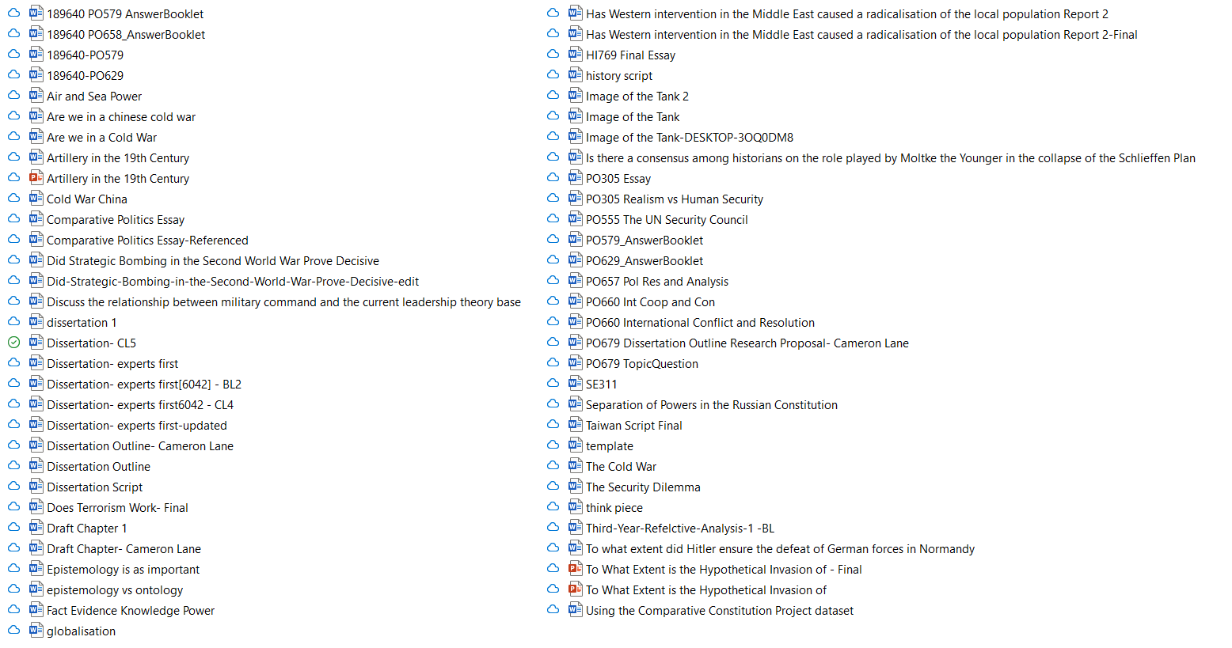
Figure 6- Organisation in My Previous Degree
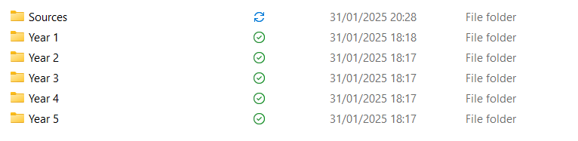
Figure 7- Organisation in My Current Degree

Independent Study- Torpex – a powerful underwater explosive

The Development of Torpex
“This is the most powerful explosive in use today”, the words of D. P. MAC DOUGALL and N. M. NEWMARK in 1946 [7]. World War Two saw the massive expansion in munitions production, with countries seeking new more effective weapons, including new forms of explosives. The twenty years of peace had seen very little progress made on this technological front, with countries entering the war much the same way they had finished the last. Countries were still largely relying on explosives such as TNT and Amatol [8].
Aluminium first saw use in pyrotechnics in the tail end of the 19th century, with its use in explosives first patented in 1897 by Deissler [8]. The oxidation of aluminium is a highly exothermic reaction, producing a significant amount of heat [9]. By mixing aluminium into explosives, the overall heat produced in the blast is increased. This increased heat also increases the pressure produced by the blast, an effect highly useful in airbursts and underwater explosions [20]. Aluminium was added to TNT during the First World War, creating the explosive Tritonal, boasting 35% greater power than TNT, and was also added to Amatol to create Ammonal, which was roughly 40% stronger than TNT [10] [7]. Research after the war sought to develop a new explosive, increased explosive power, but as stable as TNT. This eventually led to the development of RDX, which was first patented in 1920. The British finally developed a manufacturing process suitable for large scale production of RDX in 1939, allowing for its use in explosives for service [8]. While RDX achieved its first aim of increasing blast power, it was far more sensitive that TNT. For use as an explosive, it had to be mixed to make it stable enough for use. Initially it was mixed with TNT, in the form of Composite B, more explosive than TNT, but more stable than RDX. Composite B was used on its own as an explosive, but it was also mixed with aluminium to gain the benefits for underwater explosions. Multiple formulas were attempted, mixing differing levels of explosives and aluminium together, ultimately settling upon Topex, 42% RDX, 40% TNT and 18% Aluminium. This results in an explosive that has 60% greater blast damage than TNT alone, and 30% greater than Composite B [8] [7] [10].

Torpex in Service
Torpex saw widespread usage in British and American service during the Second World War. The initial lack of production capability severely hampered the introduction of Torpex into service, with both RAF Coastal Command and Bomber Command spending years asking for greater quantities [11]. The use of torpex filled weaponry was notably credited with contributing to the 6-fold increase in success of depth charges against U-Boats in the Atlantic, through the greatly increased kill radius provided over earlier explosives [11]. Torpex filled weapons were also responsible for other notable successes, initially through raids such as Operation Chastise, the Dambusters raid, and the sinking of the battleship Tirpitz in 1944 [12]. By the end of the war, increases in industrial output of explosives had enabled the use of Torpex in a wide variety of allied weapons, from depth charges and torpedoes as first used, to the general-purpose high capacity bombs, to Barnes Wallis’s famous earthquake bombs, the Tallboy and Grand Slam [7] [11] [12]. The end of the war did not see the end of Torpex. Safety concerns surrounding the development of new explosives saw the continued use of Torpex in the West. Torpex had been used in the Mk VIII torpedoes of World War 2, continued to be used in their replacement, the MK 24 torpedo in the 1960s, and was even used during the development of the MK 24 replacement, the Spearfish, introduced in 1992.

The Replacement of Torpex
It was not until the 1960s and 70s that development of explosives looked to replace Torpex, however this replacement was hampered by the caution surrounding the introduction of new explosives into service. While more stable than many explosives, Torpex was still sensitive to impact and battle damage, an undesirable aspect for a weapon. A series of incidents at ammunition depots and aircraft carriers spurred the development of insensitive munitions in the US, with other western countries beginning development around the similar time [8]. In British service, Torpex was not replaced in torpedoes until the introduction of the Spearfish torpedoes in 1992, with warheads made with PBXN-105 [10]. Similarly, it was not until the 1990s in US service that Torpex was replaced in the Mk80 series of general-purpose bombs, with PBXN-109, as a less sensitive munition to carry about carriers [13] [14].
The legacy of Torpex has not completely gone, however. Similarly to the development of Torpex, a mixture of RDX, an explosive, and TNT, acting as binder and explosive, with aluminium added to enhance the blast effects, some of the explosives that replaced Torpex are formulated in much the same way [15] [8]. PBXN-109 for example, the replacement for Torpex in the Mk 80 series of bombs, is composed of RDX, aluminium and a number of binders. The conflict in Russia is seeing numerous explosive compositions in use. In some cases, munitions are using compositions similar to Torpex, such as TGAF, found in the FAB-500 series of Russian bombs, while others such as Kornet ATGMs and IGLA MANPADS uses aluminium and RDX based plastic explosives [16] [17]. Such is the power of this formula. Over 7 years since it was first developed, and it is still in production and seeing combat usage across the world.

Conclusions and Evaluation
This module highlighted numerous areas of importance that need to be considered during the course of my studies for this degree. It showed the importance of adequate time management, leading to the improvements covered in the sections above to properly plan out my time. It also highlighted the importance of organisation in my university work, storing my files in the way that they had been for my previous degree was not productive for good quality work. This has been reorganised to greatly ease storing files and retrieving them when needed and allow for a far easier time completing university work. This course also showed new methods for referencing. Previously, I used Harvard referencing during my degree, with numerous footnotes and references littered throughout in a mishmash of styles. This module had cleared things up on how referencing should be done, to allow for clearer, more refined work, as shown in the literature review above.

Appendix


Learning Test 1

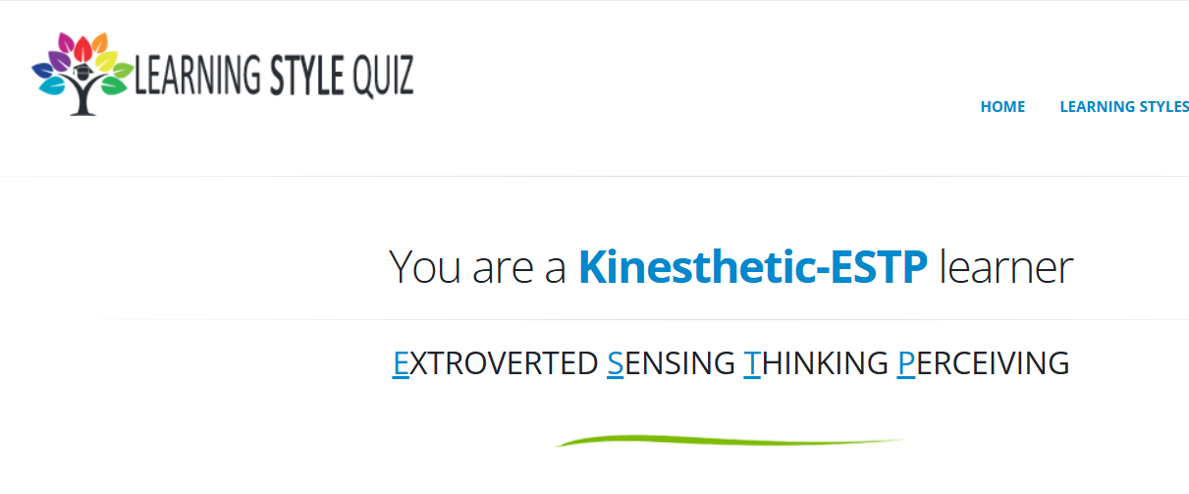
Learning Test 2

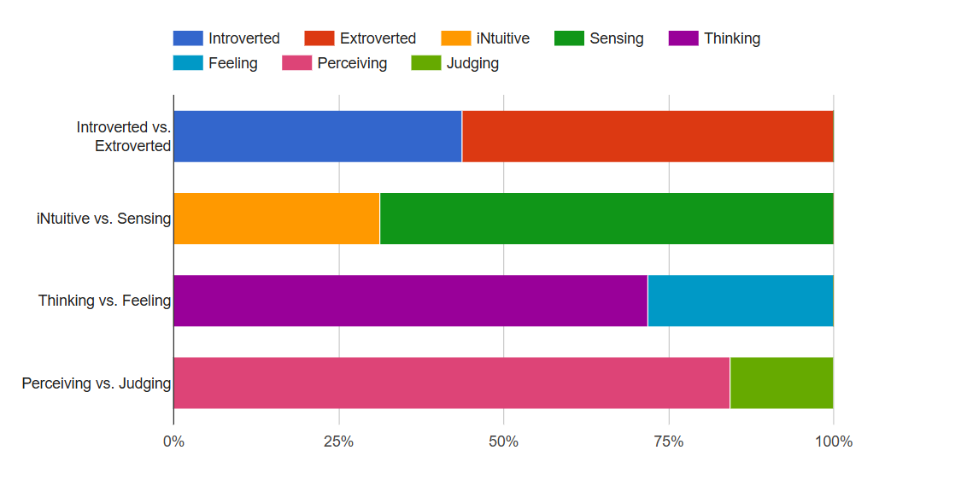
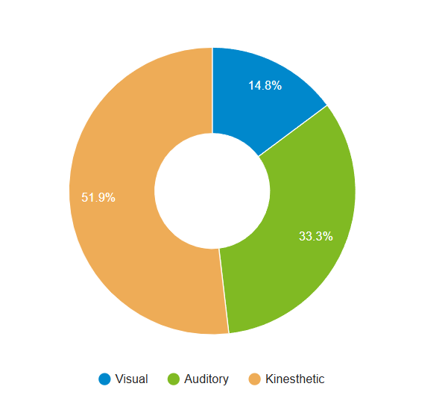

Learning Test 3

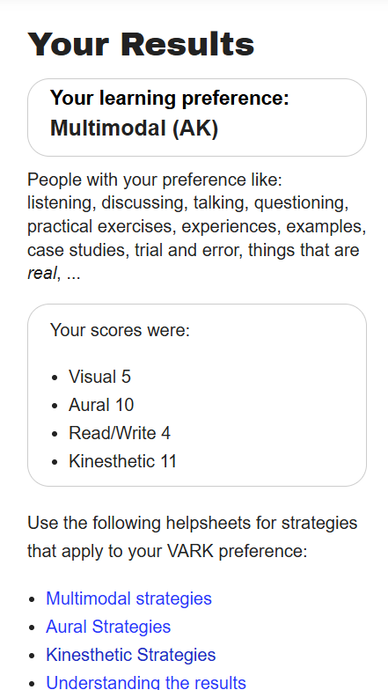

Bibliography

[1] | R. Needleman, “What Are The 6 Essential Skills For University Students?,” UniAdmissions, 11 December 2024. [Online]. Available: https://www.uniadmissions.co.uk/application-guides/6-essential-skills-for-university-students/. [Accessed January 2025].
[2] | University of Chester, “Academic Skills,” N/A. [Online]. Available: https://www.chester.ac.uk/student-life/student-support/academic-skills/. [Accessed January 2025].
[3] | University of Manchester, “Student life at university,” [Online]. Available: https://sites.manchester.ac.uk/gatewaysresources/home/year-11/understanding-he-life-11/student-life-at-university/. [Accessed January 2025].
[4] | UCAS, “Money and Student Life,” [Online]. Available: https://www.ucas.com/money-and-student-life. [Accessed January 2025].
[5] | J. Smith, “7 life skills you'll learn at university,” Prospects, November 2023. [Online]. Available: https://www.prospects.ac.uk/applying-for-university/university-life/7-life-skills-youll-learn-at-university. [Accessed january 2025].
[6] | University of Essex, “10 Essential Life Skills for University Life,” 26 august 2021. [Online]. Available: https://www.essex.ac.uk/blog/posts/2021/08/26/10-essential-life-skills-for-university-life. [Accessed January 2025].
[7] | N. M. N. D. P. MAC DOUGALL, “Explosives and Terminal Balistics,” Air Force Material Command, Dayton, 1946.
[8] | S. G. Murray, JSP 333 Service Textbook of Explosives, DE&S, 2020.
[9] | J. Akhavan, The Chemistry of Explosives, 4th ed., London: Royal Society of Chemistry, 2022.
[10] | B. C. R. HOWE, “TORPEDO WARHEAD DESIGN,” Journal of Naval Engineering, vol. 34, no. 2, 1993.
[11] | C. F. Baxter, “Torpex and the Atlantic Victory,” International Journal of Naval History, vol. 16, no. 1, 2021.
[12] | C. F. BAXTER, The Secret History of RDX: The Super-Explosive that Helped Win World War II, University Press of Kentucky, 2018.
[13] | GICHD, “Mk 82 Aircraft Bomb,” [Online]. Available: http://characterisationexplosiveweapons.org/studies/annex-e-mk82-aircraft-bombs/. [Accessed January 2025].
[14] | E. Kowal, Progress continues on safer, 500-pound bomb, Wharton, New Jersey: US Army, 2014.
[15] | S. S. K. T. D. E. B. Dr. Brian Fuchs, “INSENSITIVE MUNITIONS (IM) TECHNOLOGIES AND IMPLEMENTATION OF,” Picatinny Arsenal, New Jersey, 2022.
[16] | M. MISZCZAK, “TECHNOLOGY AND PROPERTIES OF EXPLOSIVE TGAF COMPOSITIONS ON THE BASIS OF RUSSIAN INVENTIONS,” Problemy Techniki Uzbrojenia, vol. 161, no. 3, pp. 77-90, 29 November 2022.
[17] | B. S. Roly Evans, “Explosive Ordanance Guide for Ukraine,” GICHD, 2022.
[18] | S. J. LOWELL, “Properties of Desensitised Torpex-Type Bomb Fillers,” PICATINNY ARSENAL, Dover, 1956.
[19] | U. S. ARMY MATERIEL COMMAND, “Engineering Design Handbook. Warheads-General,” U. S. ARMY MATERIEL COMMAND, Washington D.C, 1964.
[20] | J. E. A. O. H. E. Labeur, “Development of Explosives - Metallized Explosives,” Picatinny Arsenal, Dover, 1957.

