Taraneh Adibmehr (2005918)

Architecture BSc
History and Theory (M4X01975)

An Exemplar of Modern Architecture

Fallingwater – Frank Lloyd Wright

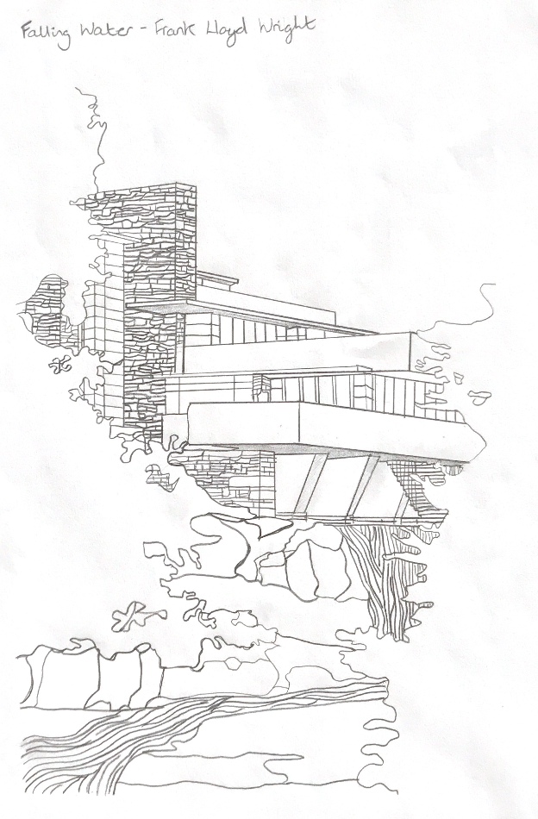
Frank Lloyd Wright’s most famous building; Fallingwater is the epitome of modern organic architecture due to its Japanese-inspired cantilevered design and harmonious bonds with its surroundings in the way it mimics nature (Allen 2016). The basis of what he called organic architecture was Wright's belief that humans, nature, and the built environment should all function together to help one another (Designcurial.com 2018). Fallingwater is also considered a modernist architecture icon thanks to its revolutionary building technologies.

Situated in the mountains of Southwestern Pennsylvania, also known as the Laurel Highlands in Mill Run (Fallingwater.org 2021) American architect Frank Lloyd Wright designed this remarkable weekend home in 1935 and completed it in 1937 for Mr.Edgar Kaufmann, (the owner of a large department store in Pittsburgh) and his wife and son (Zelazko 2019).

The family wanted to be able to admire the view of their favourite waterfall which had been in their family retreat for fifteen years, and therefore requested that the house be built across from it.
Figure 1: Taraneh Adibmehr (2021) Fallingwater drawing
Wright on the other hand, had a different vision for the house, and against the Kaufmanns' wishes, he planned the structure to rise above the waterfall, allowing it to blend into the home's design. According to Wright, the waterfall, should become a part of their lives, enabling them to experience and be conscious of its presence rather than only being in their view (Perez 2010). This unique design of his resulted in Fallingwater becoming one of the twentieth century's most iconic buildings. Years later in 1963 the house was open to the public for tours after Edger Kaufmann Jr. gave his home to the Western Pennsylvania Conservancy following his parents’ deaths (Zelazko 2019).
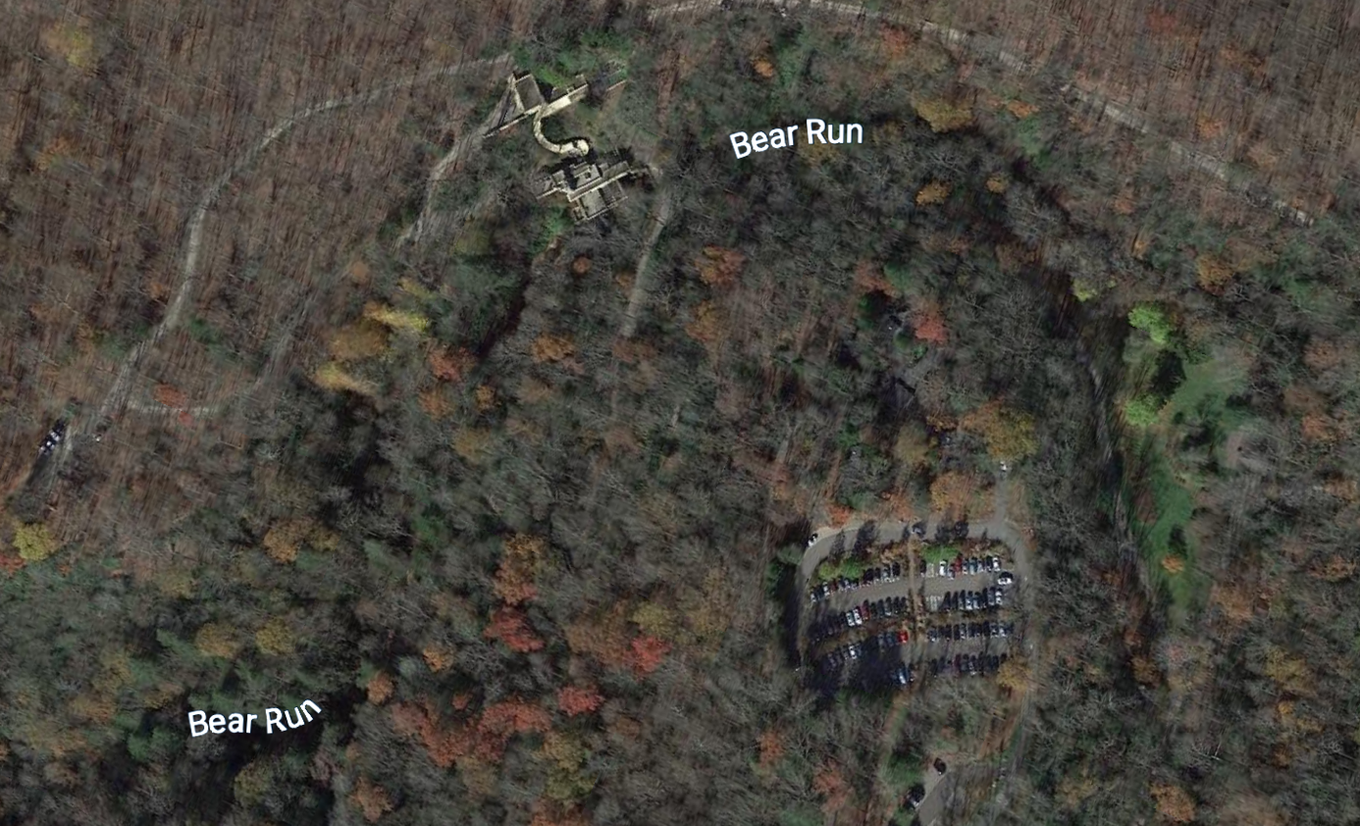
The building itself is in a remote location (Fig 2) and although there are roads and carparks nearby where visitors can park their vehicles anyone seeking entry to the house will have to walk through a meandering pedestrian path leading through the woods at a downward incline, which can be confusing for first time guests.
Figure 2: Google maps (2021) Fallingwater aerial view

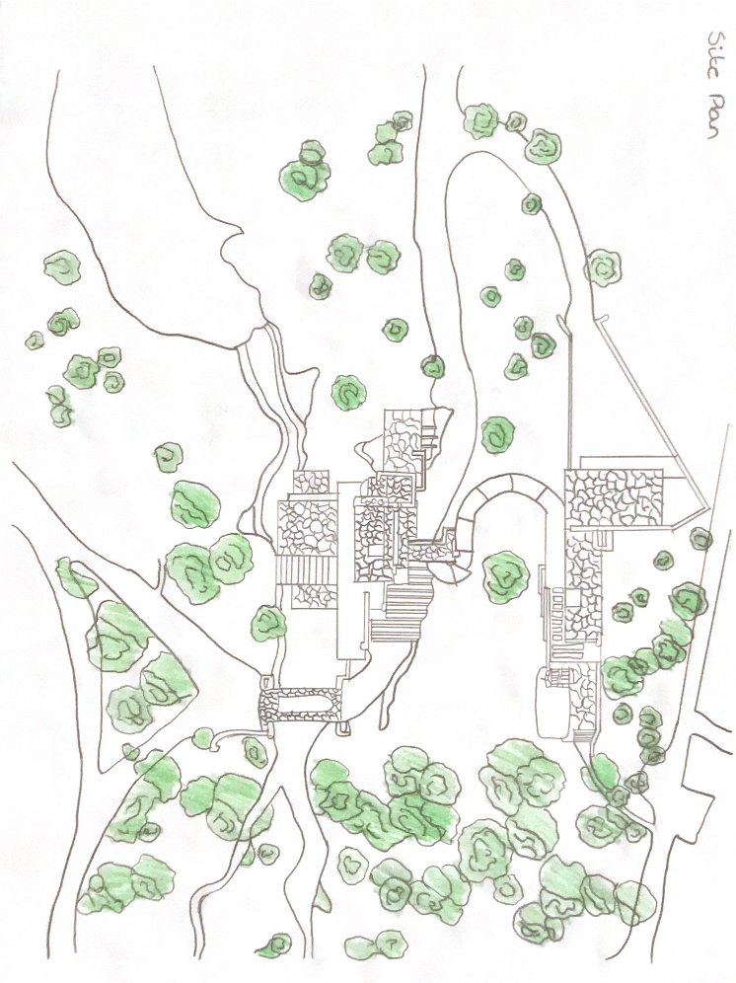

Figure 3: Taraneh Adibmehr (2021) Fallingwater site view

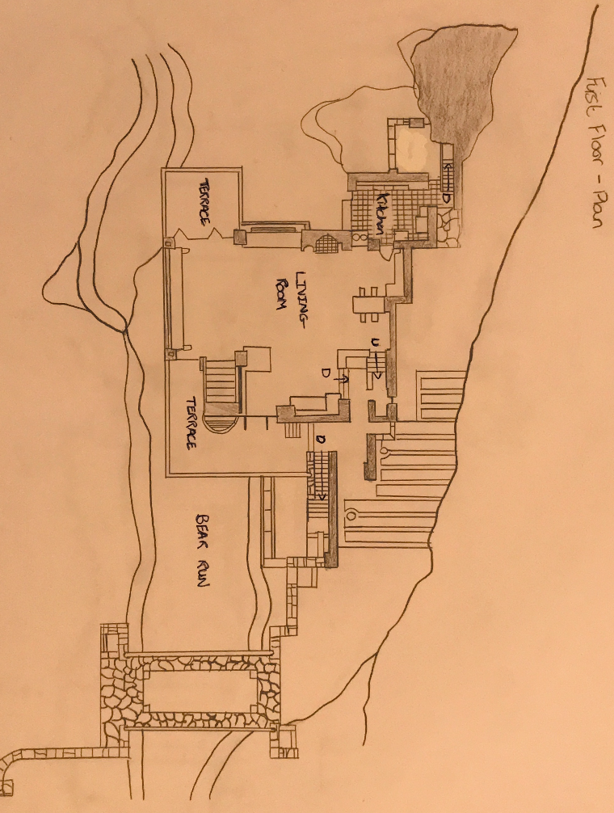
Figure 4: Taraneh Adibmehr (2021) Fallingwater first floor plan drawing.

Wright was all about the concept of breaking down walls that divided space so that they could be united into one open plan, this was the fundamental of modernism, which can be seen mainly in the first-floor plan where the large living area is (Fig 4). In contrast to the open layout of the living area, circulation is condense nearer to the back of the house where the kitchen, corridors and staircases are. Surprisingly, this was intended this way to draw people closer to the outdoors where they can experience feelings of expansion rather than compression. This is also done with the short ceiling heights, reaching as low as 6'4” in some areas in order to draw the eye horizontally to the windows and outside (Perez 2010). This technique is also done in the second (Fig 5) and third floor (Fig 6) where Wright has created small, sheltered and cave like interiors that open up to expansive terraces that dominate the majority of the building (Perez 2010).

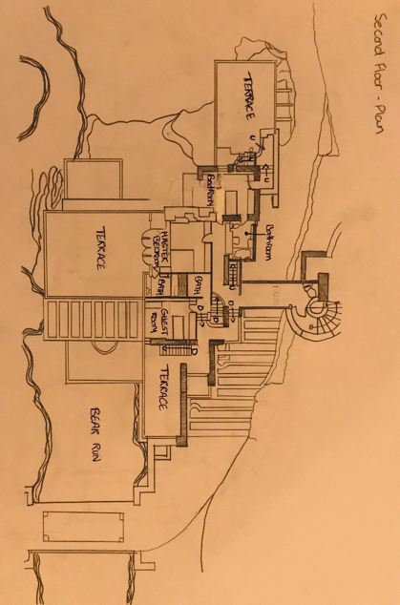
Figure 5: Taraneh Adibmehr (2021) Fallingwater second floor plan drawing.

For instance the second floor has three small bedrooms, each with a large terrace, one of which the terrace is boldly stretching out 6 feet over the living room below with an open pergola next to it overpowering the interior space (Charles 2014). A few years later, as another stage Wright added a guest wing around the back of the house with a bridge leading to it. Finally, on the third floor there is a study, gallery, bathroom, and Edgar Jr. Kaufmann's bedroom. This floor is the smallest level of the house, aside from the basement.
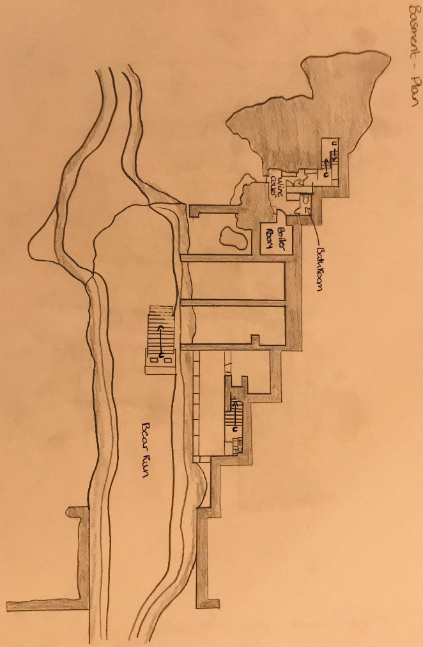
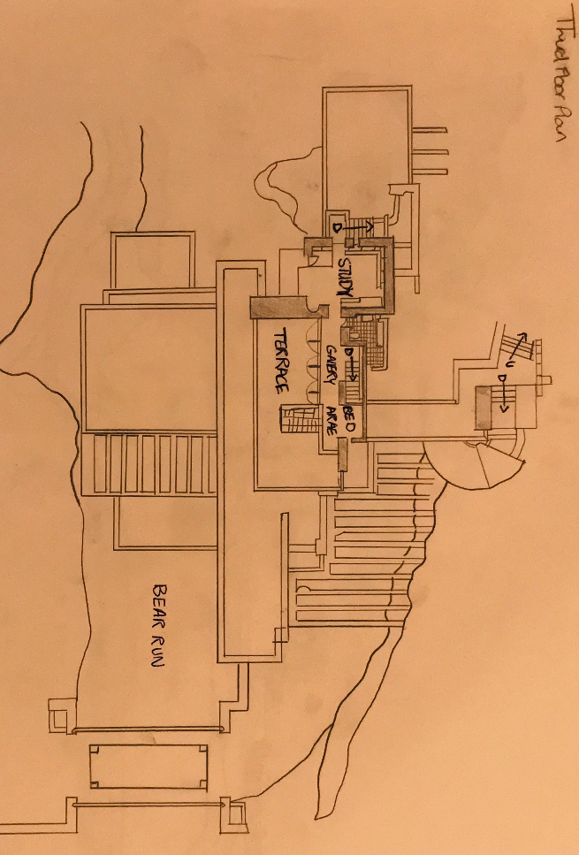
Figure 6: Taraneh Adibmehr (2021) Fallingwater third floor plan drawing.

Figure 7: Taraneh Adibmehr (2021) Fallingwater basement floor plan drawing.

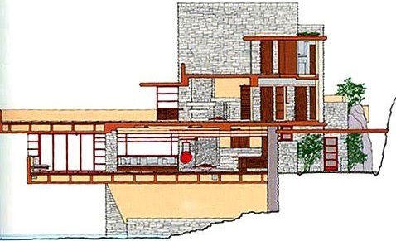

Figure 8: Fallingwater: A Frank Lloyd Wright Country House (1987 book)

Since the site was not large enough to accommodate the entire floor area, Wright had to anchor the structure to a boulder and then install a series of extensive concrete cantilevers that stretched outwards like arms around the building. This is connected by a vertical stone section that rises upwards to become the building's highest point; this contrasting feature balances the building's horizontality (Midcenturyhomes.com 2019) while also serving as a fireplace in the centre of the house. Wright’s houses are known for having a central focal point because he considered it to be the heart of a home (Zelazko 2019) (Fig 8).

The 16-foot cantilever is supported by wide buttresses under the elevated parts of the house and when the blueprints for the building were sent to engineers, they found the ground unstable and recommended that he should not proceed with this plan (Dana 2016). Even though Wright disagreed with this and moved forward with his decision, he did increase the number and diameter of the structure's steel reinforcements however they were still under-reinforced. Cracks began appearing anyway due to the lack of proper support and they have had to be repaired repeatedly ever since because of the continuous sagging. By 2001 the main terrace where the problem was; had sagged more than 7-inches and had to be repaired by adding steel cables (Charles 2014).
The building's connections to its surroundings are maintained even inside of the home, thanks to a staircase in the living room that leads directly to the water and also acts as a ventilation system (Midcenturyhomes.com 2019). The numerous windows in the house often assist in ventilating and allowing light inside while also serving to break up the boxy appearance. This is due to Wright's glass-to-glass corner connections, which help to link the house to the outside. The window frames are made of steel, which were common in the 1930s and there is no frame at the end of each window where it meets the wall instead there is a glass-to-wall connection (Wright-house.com 2021).

The harmonious links to nature and the buildings structure are carried on in the furniture that were also designed by Wright. He created cantilevered sofas that fit into the walls, as well as low seats and tables with extending edges, to match the house's low ceilings and terraces. The colours used in the furniture and all around the house are simple warm earth tones that mirror the colours of the surrounding forest in different seasons (Midcenturyhomes.com 2019).

The main material used in Fallingwater is reinforced concrete which Wright was hesitant about using at the beginning, however it gave him the opportunity to really experiment with this material, which is a wonderful modern material that was used for a lot of different things such as the cantilevers, canopy walkway, stairs, eaves, and ceilings throughout the building (Fallingwater.org 2021).

Wright's concept of putting the outside and inside together was aided by the use of sand stone, which was sourced from a nearby quarry and used in the building walls. They were stacked in an irregular manner to mimic the natural stone ledges found around Bear Run, and they also suited the horizontal theme of the house. The aim of using this stone was to help blend the house and the site, making it appear as if the building was rising out of the earth. They fit perfectly against the living room hearth's boulder, and when used on the interior, they're waxed to look wet like the riverbed at Bear Run (Fallingwater.org 2021).

With the exception of Louis Sullivan, who he credited as a significant influence, Wright's designs were very original, and he denies being inspired by any other architects. Sullivan was the first recognized modern architect in the nineteenth century, and his concept was that all modern architecture should be based on function (Muscato 2021) which Wright adopted as he started a new approach to architecture known as the Prairie style (Freundt 2017). Some of his other major influences came from nature, the geometry of some of his childhood toys and Japanese art and architecture which he praised Japan for; being a nature-inspired country that he looked up to (KCP International (2019).

Both of Wright's previous expertise and experience came together to create Fallingwater; his inspiration for both of these elements, as well as many others, can be seen in the construction. For example, his preference for clear horizontal and vertical lines was influenced by the De Stijl movement which is a modern art movement. Wright's theories arose as a result of his desire to break away from the conventional and traditional forms that were prevalent at the time.

The Fallingwater project ultimately did satisfy Wright’s main goals which were for the building to blend into its surroundings. Even though he hadn't worked in a few years before taking on the Kaufmanns as a client, Fallingwater was able to demonstrate that he wasn't an out-of-date architect (Zelazko 2019). Even if certain elements of Fallingwater did not work due to structural problems, it is still a significant building that is a National Historic Landmark.

References:

Allen, E. (2016) 5 Examples Of Iconic Modern Architecture That Have Serious Flaws Accessed 13/04/2021 https://www.architecturaldigest.com/story/modern-architecture-that-have-serious-flaws

Fallingwater.org (2021) What is Fallingwater? Accessed 12/04/2021 https://fallingwater.org/what-is-fallingwater/

Zelazko, A. (2019) "Fallingwater". Encyclopedia Britannica Accessed 13/04/2021 https://www.britannica.com/place/Fallingwater

Perez, A. (2010) "AD Classics: Fallingwater House / Frank Lloyd Wright" ArchDaily. Accessed 12/04/2021 https://www.archdaily.com/60022/ad-classics-fallingwater-frank-lloyd-wright

Designcurial.com (2018) Organic Architecture – 11 Best Buildings Accessed 11/04/2021 http://www.designcurial.com/news/organic-architecture---11-best-buildings-4540983/

Midcenturyhomes.com (2019) ‘’Frank Lloyd Wright’s Masterpiece, Falingwater’’ Accessed 12/04/2021 https://www.midcenturyhome.com/frank-lloyd-wright-fallingwater/

Charles Wiebe (2014) ‘’Frank Lloyd Wright, Fallingwater’’ khanacademy.org Accessed 12/04/2021https://www.khanacademy.org/humanities/ap-art-history/later-europe-and-americas/modernity-ap/a/frank-lloyd-wright-fallingwater

Kaufmann, E Jr. (1987) Fallingwater: A Frank Lloyd Wright Country House.

Wright-house.com (2021) ‘’Fallingwater pictures: Window set directly in stone’’ Accessed 12/04/21 http://www.wright-house.com/frank-lloyd-wright/fallingwater-pictures/c8-window-in-stone-no-frame.html

Fallingwater.org ( 2021) ‘’Preservation History’’ Accessed 12/04/2021 https://fallingwater.org/history/preservationcollections/preservation-history/

Dana Varinsky (2016) ‘’7 things Frank Lloyd Wright, a great American architect, got wrong about design’’ Accessed 14/04/2021 https://www.insider.com/what-frank-lloyd-wright-got-wrong-2016-8#his-roofs-werent-properly-supported-1

Christopher Muscato (2021) ‘’Frank Lloyd Wright’s Influences’’ Accessed 14/04/2021 https://study.com/academy/lesson/frank-lloyd-wrights-influences.html

Rachel Freundt (2017) ‘’How Louis Sullivan’s Organic Architecture Inspired Frank Lloyd Wright’s Prairie School’’ Accessed 14/04/2021 https://chicago.curbed.com/2017/6/8/15744072/frank-lloyd-wright-louis-sullivan-prairie-school

KCP International (2019) ‘’Japanese influence in the work of Frank Lloyd Wright’’ Accessed 14/04/2021 https://www.kcpinternational.com/2019/09/japanese-influence-works-frank-lloyd-wright/

Figure 2: Google maps (2021) Accessed 12/04/2021 https://www.google.com/maps/place/Fallingwater/@39.9057419,-79.4671977,443m/data=!3m1!1e3!4m5!3m4!1s0x883533f74d79e731:0x6e162bd3790a9ab8!8m2!3d39.9062551!4d-79.4678413

Figure 8: Kaufmann, E Jr. (1987) Fallingwater: A Frank Lloyd Wright Country House.

