

RESEARCH PROPOSAL

NAME OF STUDENT: VANSHIKA

STUDENT ID: 2224637

NAME OF LECTURER: OGOCHUKWU AGUNENYE

MODULE NAME: DISSERTATION

MODULE CODE: LCMB7020

SUBMISSION DATE: 31st DECEMBER 2023

EVALUATE THE IMPACT OF INFLUENCER MARKETING ON CONSUMER PURCHASING DECISIONS AND BRAND PERCEPTION ACROSS DIFFERENT SOCIAL MEDIA PLATFORMS

Table of Contents
Introduction 2
Background 2
Research rationale 5
Research significance 6
Main Body 7
Methodology 7
Aims and Objectives 8
Aim 8
Objectives 8
Research questions 8
Literature review 8
Limitations 11
Ethical Considerations 11
Timeframe 12
Mini conclusion 12
References 13

Introduction
Influencer marketing through social media platforms has become an important form of digital marketing. The current trends in marketing and collaboration with influencers have helped in the growth of fast fashion brands exponentially. Social media inferences often get involved in different controversies, and they directly affect the image of the brand that they are promoting, which creates problems in business. It is a critical challenge that different brands face. Additionally, finding the right inferences on social media is also a challenge for brands. It is because various influences on social media use AI power boats to boost their social media following and continent (Jin et al. 2019). Various brands are facing these two challenges in the current scenario to promote their products on different social media platforms.
Influencer marketing has emerged as the most popular form of social media marketing. It provides brands to promote their products to the followers of different social media influences in an indirect way. Fashion brands that have implemented the influencer marketing method have been able to increase sales and profit margins (Lou and Yuan, 2019). This research is significant because it provides a comparison between the business performance of the brands that have adopted influencer marketing and the brands that have not adopted this marketing method.

Background
Influencer marketing is a powerful social media strategy adopted by brands by employing leads along with niche content creators to increase brand perception. As opined by Zak and Hasprova (2020), influencer marketing has become a trend among brands to connect with the target audiences. In this regard, brands associated with the fashion sector collaborate with influencers or content characters to expand their reach among buyers (Malik et al. 2020). Businesses in India or the UK consider influencer marketing to endorse the products and create positive interactions with potential audiences.

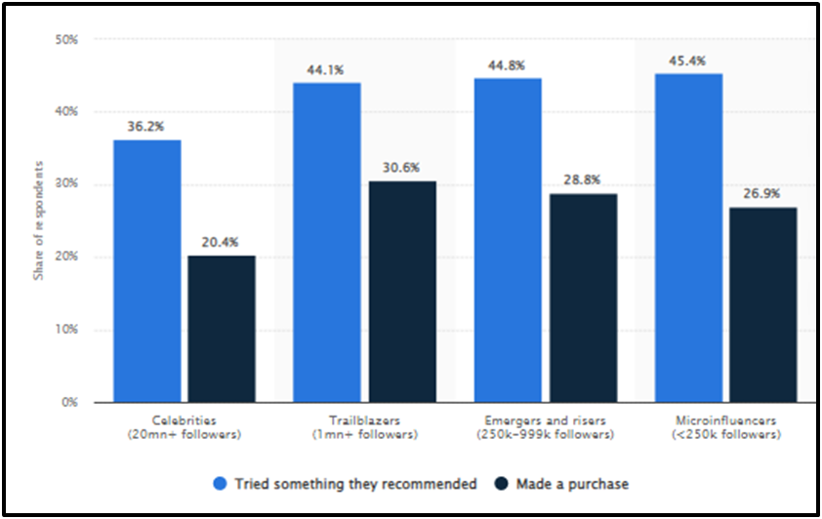
Figure 1.1: Impact of the Influencer’s post on the purchasing decisions
(Source: Dencheva, 2023)
Figure 1.1 shows that the posts of the influencers on the social media platforms have a significant influence on purchasing decisions (Dencheva, 2023). The image highlights that nearly 45.4% of the micro followers agreed that customers tried the products recommended by the influencers and 26.9% purchased the product.
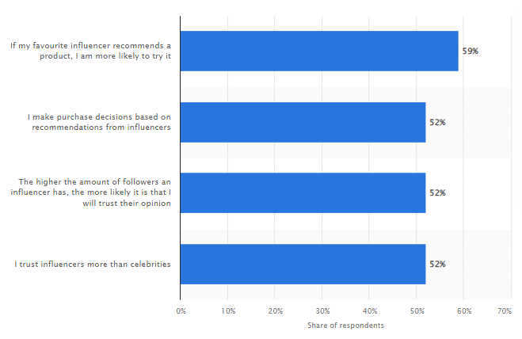
Figure 1.2: Customers' attitude toward influencers in India in 2022
(Source: Basuroy, 2023)
Figure 1.2 illustrates that, in India, influencers have a strong influence on the purchase decisions of customers. Over 59% of respondents reported having tried products based on their favourite influencer and 52% purchased products based on the recommendations (Basuroy, 2023). Therefore, across India, fashion brands using influencer marketers can increase brand image and sales.

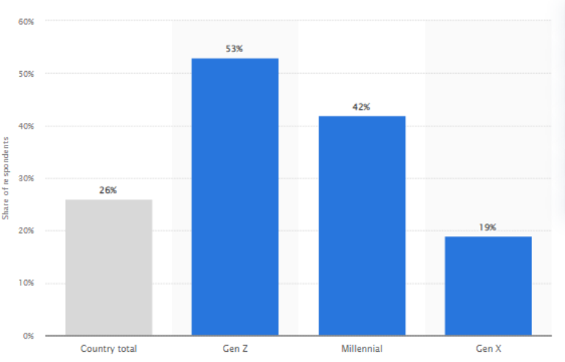Figure 1.3: Customers influenced by social media influencers in the UK in 2022
(Source: Chevalier, 2023)
Figure 1.3 shows that approximately one-fourth of the customers in the UK have influenced buying decisions. 53% of Generation Z customers are more likely to be influenced by influences than Gen X shoppers (Chevalier, 2023). Therefore, fashion stores in the UK can target Generation Z and millennials through influencer marketing.

Research rationale
Fashion brands face challenges with social media influencers and aligning the concept of fashion with influencer marketing. Business in the UK or India faces Influencer marketing due to its complicated nature. The issue is that blends face challenges due to the lack of transparency of the influencers and the determining cost of collaborating with the influencers (Davies, 2023).
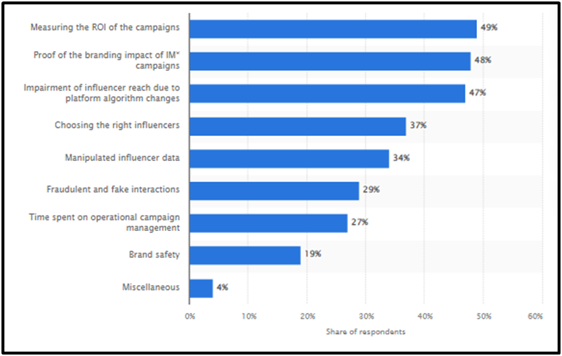
Figure 1.4: Challenges with influencer marketing globally in the year 2023
(Source: Dencheva, 2023)
Figure 1.4 sheds light on the challenges associated with influencer marketing in the global business environment. The issue now is that 49% of the marketer’s face challenges with measuring the ROI of campaigns and 34% of the marketer’s face issues manipulating influencer data (Dencheva, 2023). Nearly 28% of social media marketers encountered challenges with keeping up with the trends and managing the time carte social media campaigns (Davies, 2023). The issue can be mitigated by selecting the right influencers and creating unique content that highlights the concept of fast fashion to emotionally connect with the customers.

Research significance
The research is significant as it provides a comparison between the fashion brands that have adopted fast fashion models and use influencer marketing to resonate with the customers. Fashion brands operating in India, or the UK have developed a fast fashion business model to create a positive impact on society and increase profits. This research is significant as it helps in understanding the strategies taken by fashion brands in the UK or India to collaborate with the influencers to highlight sustainable strategies.

Main Body

Methodology
Implementation of the research onion will help in creating guidelines associated with the research philosophy, research approach, research design, data collection, data analysis and time horizon. The study will be conducted based on positivism research philosophy to develop a hypothesis from the theories. Positivism research philosophy allows a researcher to use a quantitative approach and focus on statistical data to answer the research questions (Junjie and Yingxin, 2022). The research will be conducted based on a deductive approach to justify the influence of social media influencers and the purchase intention of customers based on research objectives.
The research will focus on descriptive research design to determine the role of influencers in promoting the fast fashion concept. Primary research methods will be instrumental in collecting information regarding the concept of fast fashion within the fashion sector of the UK and India. Primary data collection consists of collecting data from first-hand sources that include surveys and interviews (Sileyew, 2019). The study will neglect secondary data collection due to its reliance on predetermined information and mixed methods, which are time-consuming. Surveys are beneficial for easy administration, cost-effectiveness, and shorter time periods (Nayak and Narayan, 2019). Data will be collected using the primary quantitative method through a survey of 51 customers in both UK and Indian markets using Google Forms.
Collecting information from the customers will help in gaining insights about the role of influencers and the ability to shape purchase intentions. Google Forms will be an instrument for this research and the 51 participants will be questioned through the forms. A simple random sampling method will be implemented in the research to collect information for analysing the challenges of fashion brands in the UK and India associated with influencer marketing. Probability sampling deals with the random selection of research participants required for any research (Ames et al. 2019). In this regard, the participants that will be selected for this research will be social media users and customers of different fashion brands in the UK and India.

Aims and Objectives

Aim
The aim of the research is to evaluate the impact of influencer marketing on consumer purchase decisions and brand perception in the UK and India across different social media platforms.

Objectives
- To identify the significance of influencer marketing in consumer purchasing decisions and brand perception across different social media platforms.
- To evaluate the influence of influencer marketing on consumer purchasing decisions and brand perception across different social media platforms in India and the UK.
- To investigate the challenges faced by businesses in India and the UK associated in the fashion industry with influencer marketing to influence buyers.
- To recommend strategies to the brands in India and the UK in the fashion industry to improve effective influencer marketing strategies for influencing purchase decisions.

Research questions
- What is the significance of influencer marketing in consumer purchasing decisions and brand perception across different social media platforms?
- What is the impact of influencer marketing on consumer purchasing decisions and brand perception across different social media platforms in India and the UK?
- Why are the challenges faced by businesses in India and the UK associated in the fashion industry with influencer marketing to influence buyers?
- How can the challenges be mitigated by the brands in India and the UK in the fashion industry to improve effective influencer marketing strategies for influencing purchase decisions?

Literature review
Significance of influencer marketing
Increase social media following
Recieve feedback on product
Tap into new markets
Develop new content to audience
Increase brand awareness
Increase sales and repeat orders
Gain credibility and trust
Figure 2.1: Influencer marketing benefits
(Source: Influenced by the views of Saini et al. 2021)
The increasing popularity of social media platforms such as Instagram, Facebook or TikTok has helped in the rise of social media influencers. As opined by Saini et al. (2021), influencer marketing campaigns are crucial for businesses to build brand loyalty and convince customers to make purchases and repeat purchases. Brands using influencer marketing tactics help to provide a tarot customer base appropriate for selling products (Dwivedi et al. 2021). Businesses associated with the fashion industry intend to improve brand awareness, brand perception and target marketing by using social media influencers to increase customer attention towards the offerings.
Concept of Fast Fashion and its Impact on Consumer Purchasing Decisions and brand perception through Influencer Marketing
Fast fashion is considered a business concept that helps fashion brands create high fashion designs, identify trends and mass production at low cost to meet the demands of customers. Fashion brands that have adopted the fast fashion model use influencer marketing to create innovative content and highlight sustainable initiatives. Social media can help fast fashion brands gain knowledge about clothing customization patterns (Gayathri and Anwar, 2021). Fashion influencers can challenge sustainability and ethical practices in the fashion industry and create content related to it. Social media influences can help customers to encourage re-wearing outfits and encourage quality over quantity through recommendations and reviews, thereby improving brand perception.
Theoretical perspective
Social influence theory
Thoughts

Attitudes

Behaviours

Social pressure
Figure 2.2: Social influence theory
(Source: Influenced by the views of Yang et al. 2021)
The Social influence theory can be applied by fashion brands to analyse the social interaction of potential audiences who support green initiatives on social media platforms through interactions. The Social influence theory illustrates the impact of social influences on the needs, preferences, and behaviours of individuals (Yang et al. 21). Businesses associated with the fashion sector of India, or the UK can apply the theory to describe the behavioural aspects of the buyers on popular social media platforms to increase their brand image.

Triple bottom line approach
People
Profit
Planet
Figure2.3: Triple bottom line approach
(Source: Self-created)
The triple bottom line theory can be beneficial for fashion brands to achieve CSR by considering the people, planet, and profit approach. As stated by Ahmad et al. (2020), businesses can analyse the needs of customers and gain insight into the purchasing behaviour towards the products or services. Fashion brands can apply the triple bottom line theory to managing ethical business and create transparent influencer advertising campaigns. Applying the theory while creating influencer marketing campaigns can help brands create content that matches the concept of fast fashion and highlights sustainable management programs.

Limitations
Despite having rich sources of information about the notion of influencer marketing, the article by Saini et al. (2021) does not provide information about the concept of fashion or brand perception. The gap can be mitigated in this study by providing meaningful insight into the topic of interest.

Ethical Considerations
The research will be presented by maintaining an ethical code of conduct to ensure ethical standards are practiced throughout the research. The “Data Protection Act of 2018” will be followed to maintain the privacy of the respondents (Gov. uk, 2023). The collected data will be stored in a password-protected device to mitigate the chances of data loss. In addition to this, the “Human Rights Act 1998” will be implemented to maintain the rights of the participants (Legislation.gov.uk, 2023). A consent form will be sent to the participants that will act as a guide to the verbal explanation of this research. The participants will have to fill out the form before selecting the responses through email. This research will be completed using University guidelines and without any paraphrasing tools such as ChatGPT to meet the ethical considerations.

Timeframe
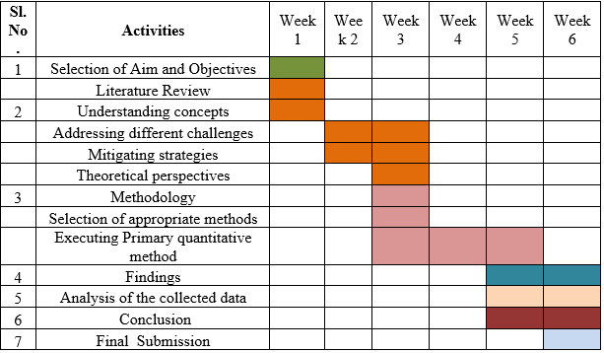
Figure 2.4: Timeline
(Source: Self-created)

Mini conclusion
The probable outcome that can be achieved is that influence can gain insight into the purchasing decisions of the customers. Fast fashion brands can improve their market reputation and brand perception by creating effective influencer marketing campaigns. It can be stated that fashion brands in the UK and India need to carefully influencer marketing strategies to mitigate the challenges and create a positive impact on the customers.

References
Ahmad, S., Miskon, S., Alabdan, R. and Tlili, I., (2020). Towards sustainable textile and apparel industry: Exploring the role of business intelligence systems in the era of industry 4.0. Sustainability, 12(7), p.2632.
Basuroy, T., (2023). Impact of influencers on consumer behavior in India as of 2022. Available at: https://www.statista.com/statistics/1359453/india-influencer-impact-on-consumer-behavior/#:~:text=A%20survey%20conducted%20across%20India,recommended%20by%20their%20favorite%20influencer. [Accessed on: 17/11/2023]
Chevalier, S., (2023). Share of consumers whose buying decisions were influenced by social media influencers in the United Kingdom (UK) in 2022, by generational cohort. Available at: https://www.statista.com/statistics/1395249/social-media-influence-purchase-uk-age/#:~:text=In%202022%2C%20approximately%20one%2Dfourth,content%20creators%2C%20followed%20by%20millennials. [Accessed on: 17/11/2023]
Davies, K., (2023). What do you see as the biggest challenge for influencer marketing in 2023? Available at: https://www.statista.com/statistics/1415804/influencer-marketing-challenges-gsa-region/#:~:text=In%202023%2C%20around%2049%20percent,was%20choosing%20the%20right%20influencer. [Accessed on: 17/11/2023]
Dencheva, V., (2023). Impact of influencer posts on purchasing decisions among influencer marketing audiences worldwide as of February 2018, by influencer tier. Available at: https://www.statista.com/statistics/956197/influencer-impact-on-purchasing-decisions/ [Accessed on: 17/11/2023]
Dencheva, V., (2023). Leading challenges among influencer marketers worldwide as of January 2023. Available at: https://www.statista.com/statistics/1372264/leading-challenges-influencer-marketers-worldwide/ [Accessed on: 17/11/2023]
Dwivedi, Y.K., Ismagilova, E., Hughes, D.L., Carlson, J., Filieri, R., Jacobson, J., Jain, V., Karjaluoto, H., Kefi, H., Krishen, A.S. and Kumar, V., (2021). Setting the future of digital and social media marketing research: Perspectives and research propositions. International Journal of Information Management, 59, p.102168.
Gayathri, A. and Anwar, H., (2021). Consumers’ Perception of the Credibility of Social Media Influencers and Its Impact on Purchase Intention. Adalya, 8, pp.1-8.
Gov.uk (2023). The Data Protection Act. Available at: https://www.legislation.gov.uk/ukpga/1998/42/contents on 25/10/2023[Accessed on 28/10/2023]
Jin, S.V., Muqaddam, A. and Ryu, E., (2019). Instafamous and social media influencer marketing. Marketing Intelligence & Planning, 37(5), pp.567-579.
Junjie, M. and Yingxin, M., (2022). The Discussions of Positivism and Interpretivism. Online Submission, 4(1), pp.10-14.
Legislation.gov.uk (2023). Human Rights Act 1998. Available at: https://www.legislation.gov.uk/ukpga/1998/42/contents [Accessed on 28/10/2023]
Lou, C. and Yuan, S., (2019). Influencer marketing: How message value and credibility affect consumer trust of branded content on social media. Journal of interactive advertising, 19(1), pp.58-73.
Malik, M.F., Akhtar, M., ur Rehman, Z., Mehmood, K. and Hafeez, M., (2022). Factors Affecting the Consumer Satisfaction with the Role of Social Media Influencers in Ready to Wear Clothing Brands. Journal of Policy Research, 8(3), pp.71-80.
Nayak, M. S. D. P., and Narayan, K. A. (2019). Strengths and weaknesses of online surveys. technology, 6(7), 0837-2405053138.
Saini, D., Sharma, M., Gupta, S. and Verma, H., (2021). Effect of social media influencers and celebrity endorsers on brand loyalty through brand image. Empirical Economics Letters, 20, pp.161-170.
Yang, X., Tseng, Y. and Lee, B., (2021). Merging the social influence theory and the goal-framing theory to understand consumers’ green purchasing behaviour: does the level of sensitivity to climate change really matter? Frontiers in Psychology, 12, p.766754.
Zak, S. and Hasprova, M., (2020). The role of influencers in the consumer decision-making process. In SHS web of conferences (Vol. 74, p. 03014). EDP Sciences.

