A study on the perception of Tasers as a type of force used by police.

By Travis Challener-Morgan
Student Number: 2029567

BSc (Hons) Professional Policing Practice

Acknowledgments

First and foremost, I'd want to thank my dissertation tutor, Jonathan Edwards, for all his help and support throughout this process. As well as Sgt Tayler and Inspector Tovey who have supported me through my final submission.

In addition, I would like to thank all of the university staff and police staff from my time at training who have helped me throughout this process. I would also like to thank my colleagues who have been very supportive and a great sounding board when I have needed them.

Declaration

This work has not previously been accepted in substance for any degree and is not being concurrently submitted in candidature for any degree.
Signed: Travis Challener-Morgan. Date: 04/01/2024

STATEMENT 1
This dissertation is being submitted in partial fulfilment of the requirements for the degree of BA.
Signed: Travis Challener-Morgan. Date: 04/01/2024
STATEMENT 2
This dissertation is the result of my own independent work/investigation, except where otherwise stated.
Other sources are acknowledged by footnotes giving explicit references. A bibliography is appended.
Signed: Travis Challener-Morgan. Date: 04/01/2024

STATEMENT 3
I hereby give consent for my dissertation, if accepted, to be available for photocopying and for interlibrary loan, and for the title and summary to be made available to outside organisations.
Signed: Travis Challener-Morgan. Date: 04/01/2024

STATEMENT 4
I hereby give consent for my dissertation, if accepted, to be available on the university’s IT system to those who have consent to use the system.
Signed: Travis Challener-Morgan. Date: 04/01/2024

Abstract

Although there is a large number of articles in the media and research from charities into the UK Police force’s use of Tasers it is safe to say that the majority of these pieces of literature are heavily anti-Taser.

The aim of this dissertation was to explore an alternative viewpoint and compare this to the more often than not standard negative viewpoint on Taser usage. The researcher of this dissertation wanted to take the opinion of serving Police officers and give them a voice when it comes to this topic.

Too often do we see negativity in the media surrounding police officers especially when it comes to Taser usage. The researcher specifically wanted to understand how it feels to be a police officer under scrutiny and how being equipped with a Taser can potentially be the difference in a positive outcome.

The researcher began by looking at relevant literature and academia surrounding the topic of Taser usage and then completed a breakdown of these pieces to establish what the current viewpoint was from the media and the public. The researcher conducted a survey with police officers where they received answers that were subsequently critically analysed through in-depth reflection of the results. The goal is to show the opinion of police officers on Taser usage, offer an alternative view from mainstream media, and attempt to produce empathy from public in why officers feel as though this is something they need.

Contents
Acknowledgments……………………………………………………………………………………………………………2
Declaration………………………………………………………………………………………………………………………3
Abstract…………………………………………………………………………………………………………………………..4
Chapter 1: Introduction…………………………………………………………………………………………………….6
1.1 – Background……………………………………………………………………………………………………………...6
1.2 – Choice of Study…………………………………………………………………………………………………………6
Chapter 2: Literature review…………………………………………………………………………………………….7
2.1 – Introduction…………………………………………………………………………………………………………....7
2.2 – Lethal or Non-lethal………………………………………………………………………………………………….7
2.3 – Portrayal of Tasers in media………………………………………………………………………………….….8
2.4 – Racial bias and Taser usage……………………………………………………………………………………….9
2.5 – Conclusion……………………………………………………………………………………………………………..11
Chapter 3: Research methodology………………………………………………………………………………….12
3.1 – Introduction……………………………………………………………………………………………………………12
3.2 – Research Strategy……………………………………………………………………………………………..……12
3.3 – Data Collection……………………………………………………………………………………………………….13
3.4 – Data Analysis..………………………………………………………………………………………………….…….13
Chapter 4: Analysis of results………………………………………………………………………………………….14
4.1 – Introduction……………………………………………………………………………………………………………14
4.2 – Data Analysis……………………………………………………………………………………………….…………14
Chapter 5: Findings and conclusion…………..…………………………………………………………………….23
5.1 – Findings…….…………………………………………………………………………………………………………...23
5.2 – Conclusion……………………….………………………………………………………………………………….…24
5.3 – Limitations and further research…….……………………………………………………………………….25
Chapter 6: Recommendations…………………………………………………………………………………………26
6.1 – Recommendations………………………………………………………………………………………………....26
References………………………………………………………………………………………………………………….....30
Appendix A…………………………………………………………………………………………………………………….35
Chapter 1 – Introduction
  - Background

The topic for this dissertation was decided due to the growing number of news and media articles surrounding Police Taser usage, the majority of this coverage being negative. It was decided that by conducting a study into perception on Taser usage it could be decided if the UK mainstream media is simply exaggerating feelings towards Tasers or does everyone truly have a negative view on them.
Taser usage in the UK has increased one article talks about how the usage is increasing year on year and is now more than double what it was some years ago, (BBC News, 2019). This article highlights the increase in the use of Tasers by Police officers however, it does not discuss why this may be the case such as an increase in criminals carrying weapons such as knives. One local paper highlights the issue in one UK area where there was an increase of 267 incidences of people carrying knives, (Eastern daily press, 2023). This gives an indication as to why Tasers are being used increasingly. In addition to this another article discusses how between 2016 and 2017 knife crime in the UK rose by 22% and as of 2018 the admission to hospitals for knife related injuries was the highest it had been for 7 years, (Straw et al, 2018).

1.2 Choice of Study

The decision to look at the perception of Tasers was with the aim of offering an alternative view at them, instead of seeing Tasers as some sort of deadly weapon, seeing them as a critical piece of equipment for Police Officers in times of danger. An article from one UK media outlet includes phrases such as “Disturbing statistic” and “Alarming rise in overuse” (The Guardian, 2019). These types of phrases are specifically used to cause concern to the reader and that is exactly why this article in particular was doing.

The influence from the media with negative views on Taser use by Police Officers and the Police in general is impactful to public perception of UK Police forces. It is thought that when the public are exposed to negative news regarding Police Officers this does impact their feelings and attitude about the Police. One study from Australia that looked at predicting negative impactors on research done in nursing showed that when 74% of media around a topic was negative the views on that topic were also likely to be negative, (Ramjan et al, 2016) Also when a news article talking poorly about one or a small group of officers, the public will generalise and view all Police Officers under this negative light, (The Cummings foundation, 2022). This is often how service Police Officers feel and so the choice of study topic for this dissertation was to allow Police Officers a voice in the hope that the public could relate to them more.

Chapter 2 – Literature Review
2.1 Introduction

The purpose of this chapter of the dissertation provide an overview and analysis of the current literature on the topic of Tasers, perception of Tasers, and Taser usage across the UK.

In addition to analysing this research, this chapter of the dissertation will help with breaking down and supporting a discussion surrounding the two research objectives of the dissertation which are to find out Police perception of Taser as a use of force, and to break down potential issues with Taser as a use of force. By providing an analysis of research selected within this dissertation, it will help to break down these objectives and provide some insight into them prior to my own personal research.

In order to gather the information used to cover the topic of ‘Perception of Taser as a use of force’ some search terms used are: “Taser usage UK”, “Taser less lethal”, “Are Tasers beneficial?”, “What issues are there with Tasers?”.

2.2 Lethal or Non-lethal

Controversy surrounding Taser use in the UK is not a new topic, since their introduction to UK police forces in 2003, after two whole decades of use they are still a hot topic of discussion. There are organisations within the UK that understand Taser usage but still feel as though the Taser is not a critical piece of policing equipment. Amnesty international discusses the use of Taser by police forces and notes that Tasers have been linked with at least two deaths following police contact within the UK but are likely to have been involved in a much higher number than that (Amnesty International, 2018). While considering the risk posed by Tasers, it should be considered if the possibility of injury is higher to someone who is subject to Taser use. One case study discusses how a male, 42-years-old, was holding a knife to his chest and when tasered his muscles contracted in such a way that it is believed this has caused him to plunge the knife into his chest, (The Royal College of Surgeons of England, 2009) This highlights how an increase in Taser usage may demonstrate and increase in injury or Taser related deaths and not always by more obvious causes, such as injuries following a fall. This is supported by the work of Mangus et al (2008) which looks at an incident of a 25-year-old male who when fleeing the police was Tasered in the back, the subsequent fall caused a 2cm laceration to his scalp and a forehead hematoma, (Mangus et al, 2008). These pieces of work highlights that no matter the intention, the deployment of Taser can go from low-level to severe. In terms of risks posed by deploying Taser in such situations it also demonstrates that, while regarded as a non-lethal weapon, can cause injuries and even death in certain circumstances.

If Taser usage is linked to deaths then it is clear to understand why people may be against the use of them, however, when Tasers were introduced they were not described as non-lethal but instead as a less lethal alternative to things such as firearms. A Taser is a less lethal use of force with the intention to incapacitate a subject, but this does not mean they are without risks, (College of Policing, 2022). Tasers are designed by an American company called Axon and they are specifically marketed as a less-lethal alternative due to police officers in the United States carry firearms this means that if a firearm is drawn the chance of a lifechanging injury or possibly death is significantly higher, one study used data to calculate the rate of lives saved they estimated it would reach over 76,000 lives by August 2011, (Brewer and Kroll, 2009). If this calculation is correct then the statement of ‘less lethal’ would prove accurate.

What do the references and the evidence above really suggest? The use of Tasers as a non-lethal police tactics, while regarded as an effective and safer alternative to firearms, (Manhas et al, 2021). Tasers continue to receive opposition as it has been proven that Tasers do cause injury and on occasion can result in death. One study discusses how between 2005 and 2008 11% of suspects that ended up in hospital following police contact in America were as result of being subject of Taser, (Haileyesus, T. 2011).

2.3 Portrayal of Tasers in media

Police usage of Tasers in the news is criticised for many reasons such as, criticising the necessity of the usage as well as if the usage is having the desired effect. According to media, if police forces across the UK do not address concerns over Taser usage then they may end up losing trust in the communities they serve, (Express and Star, 2021). This is supported by another article that discusses how in America, although Tasers are seen as more humane than firearms, repeated media reports of officers using Tasers in situations with no immediate threat causes there to be some controversy (De Angelis and Wolf, 2015). This can create a negative association with Tasers as it suggests that the public may not trust them as a safe use of force.

There are multiple news and media sources that outline problems with Tasers the above example is not alone in this, and it is not just UK news. Sometimes incidences from other areas of the globe can have an impact on the portrayal of Taser usage here in the UK. More high-profile cases draw the spotlight on Taser usage and highlight statistics such as five hundred deaths have occurred as a result of Taser usage since 2001 in the United States, (The New York times, 2021). This statistic looks bad when it is highlighted like this and can causes concern amongst human rights groups and the public alike however, this statistic fails to mention how many times since 2001 Tasers have been used in the United States it also does not speak of the type of incidences they were used at. This portrayal of Tasers in the media which highlights the negative aspects of Taser usage could prove harmful to public perception of this particular use of force.

There are also high-profile cases in the UK that cause concern for the public when it comes to Taser usage. An incident where a man who was shot by a Taser and has ended up falling into the river Thames was a very high-profile incident in the UK. Although an investigation by the Independent Office of Police Conduct (IOPC) has yet to clarify if the usage was appropriate and necessary or not, the media has already begun to sway the narrative in the direction that it was not appropriate. It was reported that the male was tasered and as a result had fallen into the river Thames, leaving him in critical condition, (BBC News, 2022). It could be argued that this type of reporting is misleading and suggestive, this particular sentence suggests that the male was on the edge and was Tasered causing him to fall into the river which is not the case. In this example the male involved was Tasered on the bridge once the Taser cycle has ended the male has then thrown himself off the bridge and his subsequent fall is not therefore related to the deployment of the Taser during this incident.

The main issue when it comes to how Taser usage is represented in the media is that there is few if any positive stories it is asserted that, this is because the media, whether intentionally, or not, omit important pieces of information and do not tell a full story. The purpose of this dissertation is to aim to highlight policing perspective and policing issues when it comes to Taser usage to offer a more balanced view on this use of force.

2.4 Racial bias and Taser usage

Unfortunately, like with most topics in regards to policing, there is evidence that there is a disparity against Black, Asian Minority Ethnic (BAME) groups when it comes to Taser usage. One study conducted in America by Gau et al (2010) between White people and Hispanic people found that Hispanic people were twice as likely to be Tasered on their first encounter with police, (Gau et al, 2010). As already discussed the media uses negative connotations when discussing use of Tasers, the unbalanced use of Tasers against ethnic minorities provides the media another opportunity to create a negative view of Tasers as a use of force. Tasers are disproportionally used against Black people compared to white people, but it was noted by the Independent Office of Police Conduct (IOPC) that Black people were Tasered for longer than the standard 5 second cycle 31% more of the time, (Dodd, 2021). This statistic is isolated when it comes to the difference in treatment for BAME groups against white people in regards to Taser usage however, when these statistics are published in media they are not often coupled with information to show why this may be the case. Regardless the suggestion is that BAME groups are more likely to be subject to Taser than white people, this information is likely to cause concern in communities throughout the UK especially those communities that fit in the BAME category.

There is a concern amongst groups that this type of racial bias is not specific to adults within the BAME community. One article talks about a report that was published where it was shown that children of an ethnic minority are approximately three times as likely to be subjected to Taser than their white counterparts, (The Mirror, 2020). Use of Taser against children is not an ideal solution in any scenario and can strike concern within communities, with the addition of being three times more at risk of having a Taser discharged on your child BAME communities are likely to be incredibly cautious of Taser carrying police officers. The concern also increases due to the possibility of ethnic minorities miscommunicating with police officers which could result in them being subject to Taser as the police are unable to communicate and resort to force. An article Mandel (2013) discusses the case of a male Robert Dziekanski, this male was at an airport and, as he was unable to speak English, he could not effectively communicate what he wanted this resulted in him getting frustrated and during his rage he was shot multiple times with a Taser resulting in his death, (Mandel, 2013). These types of incidences combined with some concerning statistics do no good with trust from communities and support for police forces across the UK and do even more harm for police forces that aim to justify why more of their officers should carry Tasers.

The importance of reviewing the disparity in the use of Taser amongst BAME groups is to get an idea of how these communities may perceive Tasers. This is critically important as the population of BAME groups continues to increase between 2011 and 2021 the population of the UK that identified as white British went down from 80.5% to 74.4% this shows a steady increase in BAME groups throughout the UK (Office for National Statistics, 2023). This shows that with the UK population growing increasingly diverse the views from these groups become increasingly important. Therefore if statistics show that BAME groups are more likely to be subjected to Taser or are more likely to be Tasered for longer the perception of this use of force within the police is going to be affected negatively. Over time as diversity increases if things are not changed then the negative views of Taser will naturally increase with diversity.

2.5 Conclusion

Although Tasers were first introduced to UK police forces back in 2003, after two decades they are still not fully supported or trusted as a standard part of policing. This cautious approach to Tasers is not without justification, there have been a number of cases of misconduct involving Tasers that create a cause for concern. One such case that raises concerns is one of a police officer who has discharged a Taser at a 10-year-old girl this incident took place in the Metropolitan police area where a report of a 10-year-old girl was threatening someone with a hammer, this case was referred to the Independent Office for Police Conduct (IOPC), who found this officer should face misconduct charges, (The independent, 2022). This is a prime example of why there may be a negative public perception.

This research aims to highlight these issues while also highlighting concerns from police officers and reasons why they may be supportive of Tasers. Unfortunately, the public are very often exposed to negative media stories that likely make up a small amount of the total uses of Taser throughout the UK. This can skew public perception as seen from the evidence in this chapter.

Issues and disparity when it comes to policing BAME groups unfortunately is likely to continue to be an issue in the near future however, by opening a discussion on Taser usage and offering a policing perspective hopefully it will show that there are a number of considerations that are made when officers utilise Taser and that the colour of somebody’s skin isn’t and should never be one of them. This should also highlight to police officers how BAME groups could feel persecuted and may react differently to their white counterparts when it comes to being faced with Taser carrying officers.

To conclude, a great amount of research has been reviewed covering several aspects of public view and perception, as well as organisations with differing opinions on the subject matter. By highlighting the issues on whether or not Taser can be considered a less-lethal alternative this builds foundations for where most of the opinions on Tasers comes from. The media appear to err on the side of caution and distrust of Tasers which from the research reviewed is the leading opinion of this particular use of force. It appears as though in the 20 years that police forces across the UK have had Taser trained officers little has been done to reassure the public of the positive points of this use of force. Within this dissertation there are two main objectives that will be considered throughout, these objectives are: to find out Police perception of Taser as a use of force, and to break down potential issues with Taser as a use of force. By undertaking this research these objectives should be provided some answers. A third objective of seeking the public perception was considered however due to time restraints this was not possible. By showing a more balanced view and highlighting police perspectives on this controversial use of force, the aim will be to offer the public some answers to some questions that they may have around Taser usage. This will hopefully result in a more open conversation around the topic as well as a better trust from communities in the use of Tasers.

Chapter 3 – Research methodology
3.1 Introduction
Having explored the literature relating to the use of Taser. In particular the media and public perception of said use as a less lethal use of force, this chapter sets out the primary research conducted in response to the research objectives set out in the previous chapter. This research is going to be conducted to provide a perspective on Taser use that is not as commonly found which is that of the officers who experience Taser usage on possibly a regular basis.

3.2 Research Strategy
The primary research tool used in this thesis was a questionnaire. This selection was made due to the research philosophies as discussed by Saunders et al (2016) considered prior to conducting the data collection. The questionnaire will be used to gather as much information as possible. The questionnaire will have a variety of questions to be answered. The majority of the questions will focus on Taser usage and respondents experience with this if they have any.

A questionnaire has been selected for this dissertation as it will allow the research to be conducted quickly and precisely. This research strategy is easy to disseminate to large groups in a short space of time, this allows for a large sample size to be used which provides a truer result at the end.

A questionnaire was selected as it was considered the most efficient method in which to collect the data. As discussed by one journal on questionnaire design, a questionnaire has the advantage of being completed in the respondents own time, so they can take time to think about the answer. There is also less likely for any social-desirability bias as it is anonymous and therefore respondents answer more honestly (Brace, 2008). As questionnaires are simple to create, are easy to disseminate, and are likely to get a good number of honest responses due to the fact that responses can be quick and anonymous a questionnaire was selected for the research method. It should be noted that other research methods were considered as part of this research. Another research method considered was interviewing however, this was not selected due to questionnaires being a quick and reliable method of gathering data from large sample as stated by Cohen et al (2017).

3.3 Data Collection
To collect the data for this dissertation, a questionnaire was sent out to current serving police officers. The survey was sent out to Sergeants across Gwent Police through email for them to disseminate to their shifts. The survey was out for two months before results were reviewed. A copy of the survey results can be located at appendix A. There was consideration of disseminating a survey to the public however, this was decided against due to time constraints.

This survey consisted of ten questions surrounding current knowledge of Use of force options and views on whether Tasers are a suitable use of force. These questions will vary from more closed ‘yes/no’ questions to more open-ended questions these will give a range of answers for analysis later on in the dissertation. Some example questions that were used will be, “Do you know any alternatives to Tasers? As discussed by one article, open-ended questions allow for exploring topics in more depth, (Weller et al, 2018). The reason for offering a range of different types of questions is to allow for varied responses and to cover as much context and gather as much information surrounding the topic of Tasers as a use of force as possible. Considerations were made for more than ten questions to be asked during this survey however, this was thought to be enough questions to collect enough useful information. It was also thought that this was a low enough number so as to not overwhelm respondents and encourage a higher number of responses.

3.4 Data Analysis
Once the research has taken place the results were reviewed and ultimately analysed. After collecting the data from the questionnaire each question was analysed individual. The questions were analysed and presented in the form of bar charts.

The survey conducted for this dissertation was created using Survey Monkey. Survey Monkey is a large platform that deals with millions of questions and surveys everyday (Survey Monkey, n.d.). The positives of using this site to create the survey for the dissertation are that the website was easy to navigate meaning the survey got sent out in a suitable time, it offers multiple ways of sharing the survey meaning that you can pass it to more people. Survey Monkey also keeps the surveys nice and simple meaning that the answers and findings are clear resulting in an easier process to break these down.

There are a number of disadvantages such as the fact that in order to have a more detailed breakdown from the survey it does cost money. So the break down from the survey is incredibly simplified which unfortunately affects the amount that it can be broken down for the dissertation.

Chapter 4 – Analysis of results

4.1 Introduction
This chapter will present the results and provide a good overview of the key results from the primary research tool, namely a questionnaire. The results have been displayed as bar charts with a narrative under them.

4.2 Data Analysis
A breakdown of the survey question responses:

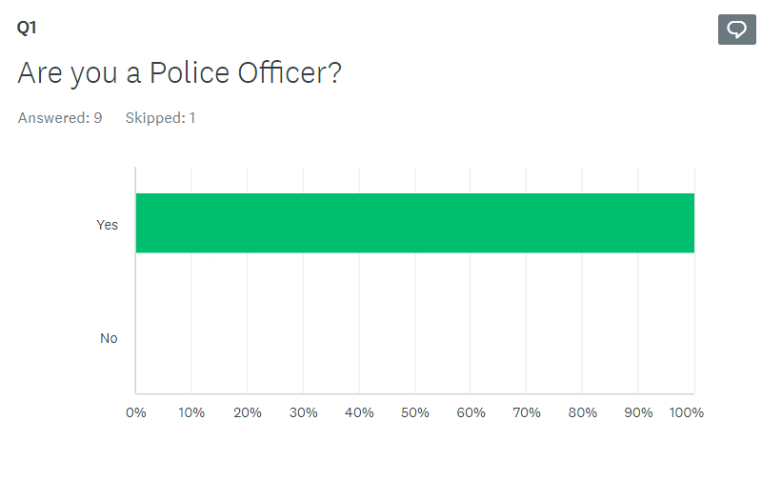

Question 1 of the survey this question was originally put in the survey when there remained a want to also survey members of the public. This question was added so it could be established the separation between respondents, however when the decision was made that this survey would not be sent to members of the public this question remained in, simply to show that police officers were answering it.
It is noted that one of the respondents has skipped this question, the reason for this is unknown although it is noted that it does not affect the results.

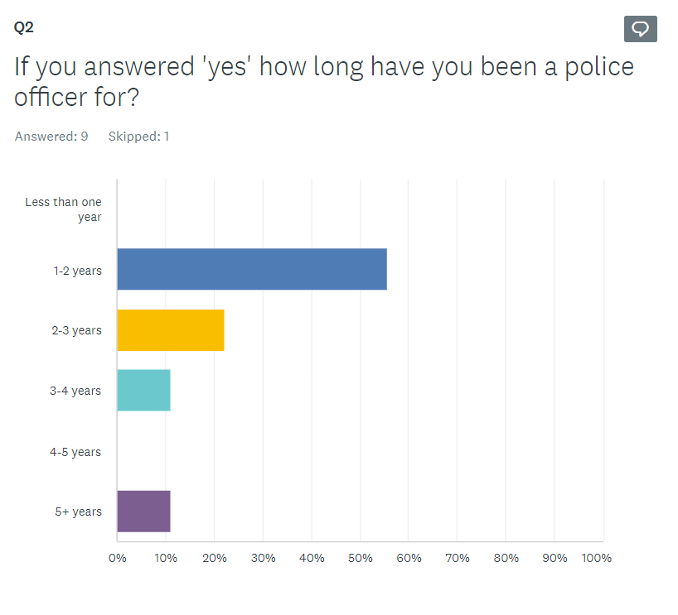

Question 2 was included in the survey so it could highlight the varying years’ experience between respondents. This is a critical question as it acts as a demographic question and allows the opportunity to understand if there is a variance in perception by those with different levels of service. Officers with longer service may be less preferable towards Tasers as they may have experience of service without Taser. Whereas officers who are younger in service and have always been in service when Tasers have been available may be more accepting of them.
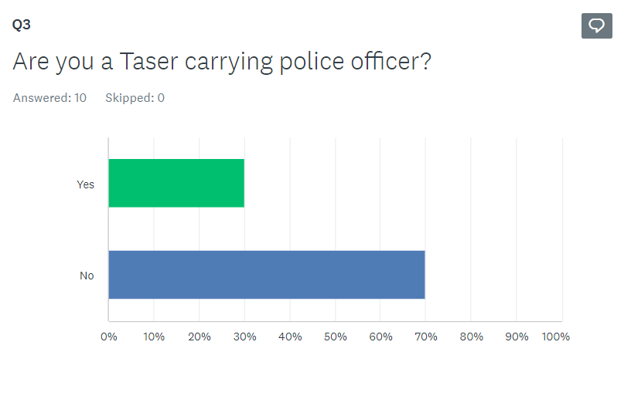
Question 3 “Are you a Taser carrying officer?” This question was used to gain an understanding of the numbers of respondents who are or have been trained to carry Tasers. It was important to have officers who are and are not trained to carry Tasers respond to the questionnaire as this meant the research conducted, offered opposing views as officers who do not carry a Taser may be less supportive of them.
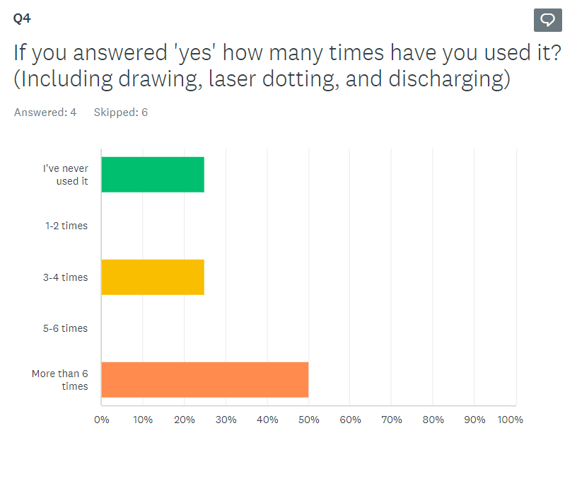
Question four was aimed at police officers who do carry Tasers and it was designed again to reduce the assumption of bias as much as possible. By including this question any views on the results of the survey such police officers are pro Taser as they are Taser trained or they have used it multiple times can be dismissed by the inclusion of questions such as these. This question shows that even those police officers who have answered the survey and do carry Taser have not necessarily used a Taser.

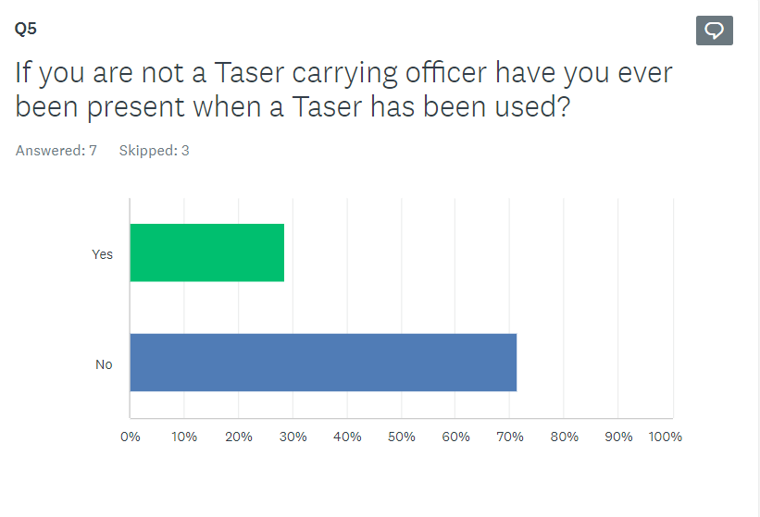
Question 5 is similar but is aimed at the police officers who answered the survey and are not Taser trained. Another assumption of this survey could be that police officers are only in support as they have been in a situation where they wished they had a Taser or where they were assisted by a colleague who had a Taser. This question shows that some of the police officers who answered this survey had not been in a situation where they had seen a Taser get used showing that again a variety of police officers had answered this survey meaning it was done in as fair a way as possible.

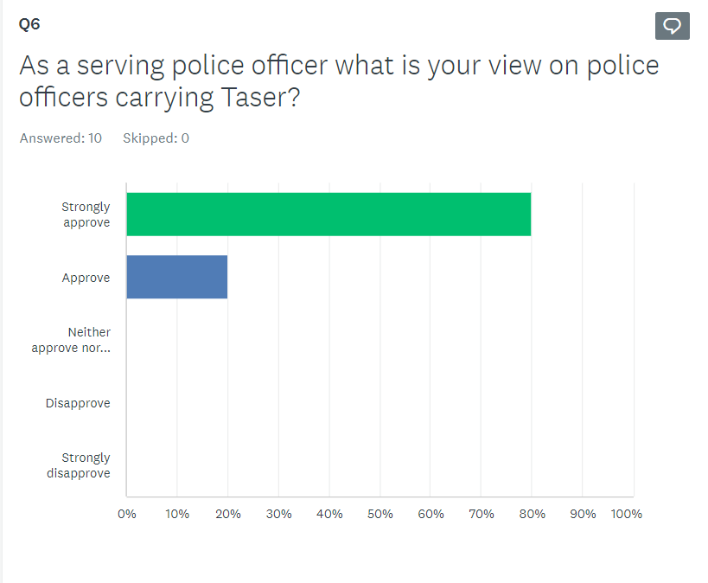
Question 6 is a simple question providing a clear answer do police officers approve or disapprove of Tasers being a valid use of force for police officers. All ten respondents answered this question and all of them approved with 8 out of 10 strongly approving. This shows that police officers feel that Tasers should continue to be a use of force that is available to police officers.

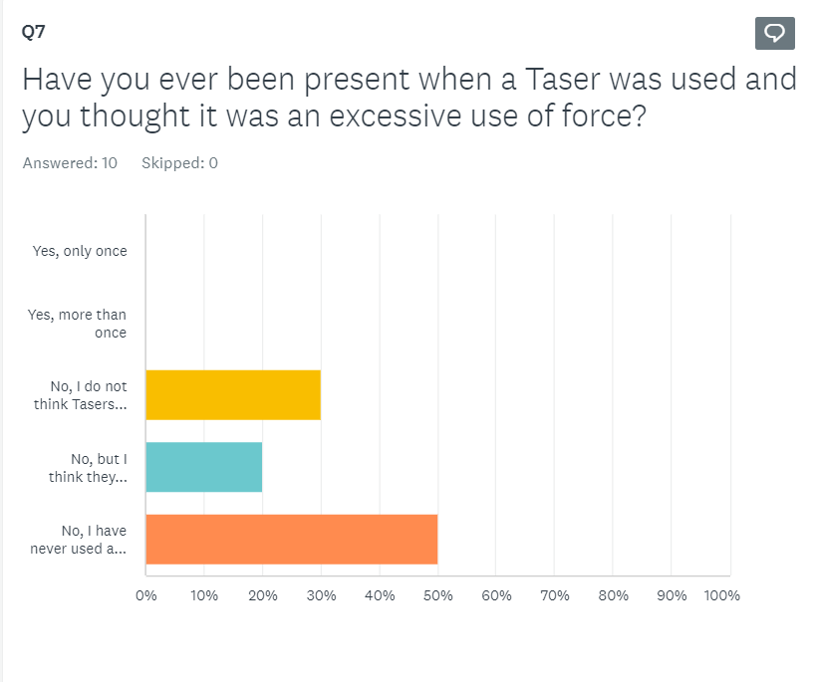
The next question is crucial to the outcome of the research. Question 7 was asked to determine if Police officers ever felt as though a Taser had been used excessively or if they could be used excessively. Again this question was answered by all ten respondents and not a single respondent has answered yes that they have never seen one used excessively.

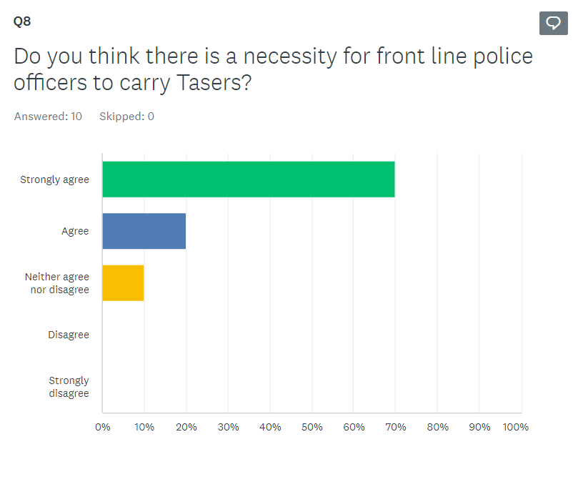

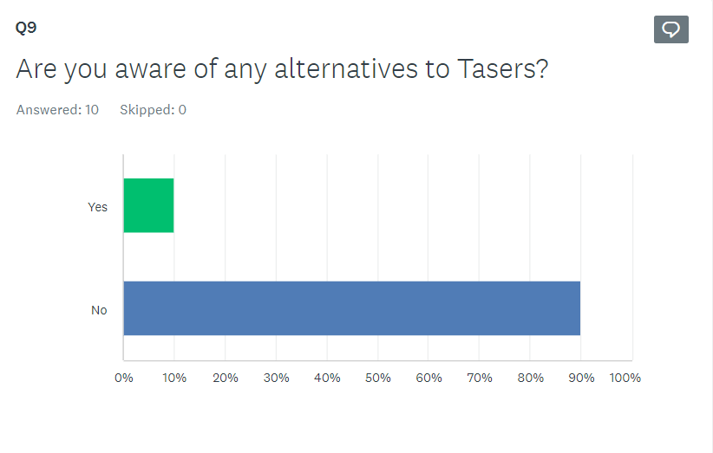

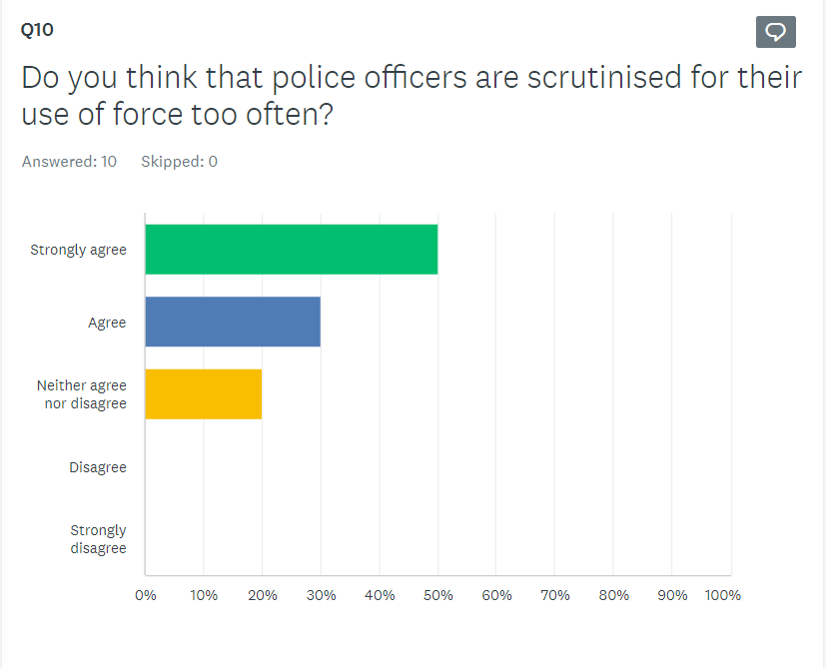

The final three questions 8, 9, and 10 were all based on whether Police Officers should be carrying Tasers, are there any alternatives, and are Police Officers too quickly scrutinised. The answers as shown above show that those who are out there on the frontline agree that Tasers should be carried by officers however there is feeling that this should be optional and training should be required, which implies that although officers agree Tasers should be used, they should be used in a responsible fashion.
Question 9 was about if there are alternatives to Taser, this question allowed for additional comments. All but one respondent answered no and the respondent who answered yes stated that PAVA spray or more commonly called pepper spray was a suitable alternative.

Chapter 5 – Conclusion

5.1 Findings
The questions asked in the survey were targeted at Police Officers. The aim at this research was to identify what police officers’ perspective was on Tasers and if Police officers are supportive.
The survey showed a range in years of service, level of training, and experience of Taser usage. This information is useful when breaking down the results and findings as it can be used to show if there is a difference in opinion from Police officers based on other factors such as years’ experience.

One finding that can be taken from the survey is that Police Officers do feel that they are often over-scrutinised when it comes to their decision making and their use of force. This can be seen as over a number of years public confidence in the Police has seen a decline from 62% in 2017 to 55% in 2020, (Royal United Services Institute, 2022). This is backed up by a publication from the Independent Office for Police Conduct (IOPC) where in it shows that positivity towards one’s local police force was at 45% and remains at an all-time low since January 2020, (IOPC, 2023). Both these publications highlight the lack of public confidence, this is felt by police officers as they feel that more often than not they are heavily scrutinised often unnecessarily.

A second finding from this research that can be identified is that police officers feel that there is a necessity for Tasers in frontline policing. This can be drawn from question eight of the primary research where 90% of respondents either agreed or strongly agreed that Tasers are a necessity with the other 10% stating they neither agreed nor disagreed. As highlight above an article by Straw, et al (2018) discusses the rise in knife crime across the UK, this could be why the majority of respondents feel that Tasers are a necessity. This rise in violent crim is also discussed in the British Dental Journal (2019) where surgeons have reported a 20% increase on the previous year for penetrative trauma injuries.

A third finding that can be inferred from the primary research conducted is that officers are not aware of alternatives to Tasers, although irritant sprays such as PAVA spray are standard pieces of police equipment across the UK. Although this can be used in similar circumstances, PAVA is not guaranteed to work as it is not always effective as some people can experience no effects from PAVA, (Association of Youth Offending Team Managers, 2020). Although there are potential issues with Tasers being ineffective such as getting stuck in clothing however, if a shot is successful Tasers will always be effective.

Another finding that can be seen within this survey is that excessive uses of force are not as common as they are made out in the media, with the survey above showing that not a single respondent had felt as if Taser usage they had seen was excessive. This highlights that as much as it is made out in the media excessive Taser usage is not a regular occurrence. This shows that often at times these articles or reports showing that Tasers are used excessively. One example of this is in an article in USA today where they talk about how Police officers are often accused of using Tasers as a form of torture or punishment by repeatedly firing the 50,000-volt devices when there is not apparent, imminent threat to life (USA Today, 2021). Another article talks about an incident where a person suffering with their mental health was Tasered then once he was in handcuffs he was Tasered again and the Police Officer involved was charged with assault for their actions, (The Standard, 2023). When articles like this are published one thing that is never included is the proportion of uses that are deemed excessive and how many uses are completely justified.
Although it is clear from the research conducted in the literature review that there are occasions such as that discussed by Mandel (2013) where force is used excessively due to lack of information or communication difficulties as highlighted in the literature review and discussed by Manhas et al, (2021) Tasers are considered safer alternatives to firearms. Tasers come under the category of force described as ‘less lethal’ and according to government figures between April 2022 and March 2023 less lethal uses of force were used 34,687 times, (Home Office, 2023). This is a great deal of uses and only the times that it is used excessively is it reported this negatively impacts public perception and could skew feelings towards this type of force turning it from a tool used in high threat situations to protect the public and making it appear as a dangerous weapon.

5.2 Conclusions
In conclusion, this thesis was completed on the topic of the perception of Tasers as a use of force. Existing literature was reviewed in reference to the lethality of Tasers, how Tasers are presented in the media, and how Taser usage differs in regards to race and ethnicity. As a result of the literature review two main research objectives were identified these were as follows: Identify police perception on Taser use and Breakdown any potential problems regarding Taser usage.

Although when conducting initial research into existing literature a good amount was identified there were few pieces of existing literature that focused on police officers’ perspective. This gap in research led to the selection of research topic. A questionnaire was design and distributed to police officers with the aim of answering the research objectives.

The research objective of identifying police perception of Taser as a use of force was accomplished within the survey. The findings from the survey were that the perspective from police officers surrounding Tasers were that they are supportive of Tasers as a use of force.

The second research objective of breaking down any potential issues identified with Taser use has been completed through primary and secondary research. Within the primary research conducted it was established that none of the respondents believe that they have been witness to excessive force being used. It was also identified by one respondent that there are alternatives to Tasers such as irritant spray. Within the secondary research issues involving race and ethnicity were identified and discussed as part of the literature review.

5.3 Limitations and further research
Throughout the research conducted there were several limitations identified which affected the results and subsequently the findings from the primary research.

The first limitation of the research conducted was the number of respondents to the survey. Although the survey was put out for responses for a full two months only 10 officers responded. This was due to the survey being sent only to local police sergeants via email the research relied on these sergeants forwarding this email onto their officers and subsequently those officers responding. This method of distribution limits the research as it relies heavily on the sergeants distributing the survey and if for whatever reason it is forgotten then potentially a number of officers would not have access to the survey.

A second limitation to consider is that during the two-month period that the survey was available for responses it was sent out once via email and no reminder notices were sent out withing the time period. This limitation can affect the number of respondents as some officers may tell themselves that they are going to answer at a later date and due to being busy may forget by sending out reminder notices it is possible that more officers would have responded.

Another limitation of the primary research conducted is that although it included a question surrounding experience within the police force to allow the opportunity to see if experience affected responses. There were no additional questions to allow for identifying different responses. Other questions that could have been included in the survey for example could be a gender-based question to identify if male or female officers had differing views as well as an age range question to identify you there was a difference in views based on age.

As well as the limitation of the types of questions asked the number of questions within the survey could also be considered as a limitation. By having fewer questions within the questionnaire less information can be collected which results in fewer findings being drawn from the primary research.

For any research conducted in the future it is crucial to improve based on these limitations. If this study were to be conducted in the future the survey would contain additional questions such as: Are you male or female? As well as what is your age? This question would include a range to choose from.

Another improvement that would be carried forward were this research to be continued in the future would be to not only send the survey to local police sergeants but to send it directly to officers themselves, the survey would also be posted on the policing intranet site. As well as this change several reminder prompts would be sent, these changes would hopefully see an increase in responses which would allow for further findings to be drawn from the research and additional recommendations to be identified.

Chapter 6 – Recommendations

6.1 Recommendation
Following the research conducted a number of findings were identified and discussed above. As a result of these findings a number of recommendations will be put forward.

Recommendation one is that there is more information provided to officers in regards to what if any alternatives to Taser are available. This would hopefully improve officer confidence if the decision to use Taser is made.

Recommendation two is that there is clearer guidance on what is classed as excessive force. This recommendation comes from the evidence in the literature review that the public are often shown the worst incidences and is also drawn from the primary research where officers feel heavily scrutinised on their use of force. This is recommended with the aim that police and public perception of use of force become more aligned.

The final recommendation is that more frontline police officers should have Taser training. This recommendation comes as a result of the finding that 90% of the respondents from the primary research felt that there was a necessity for frontline officers to carry Taser. As well as information identified within the literature review that violent crime namely crimes involving weapons are on the rise. The ability to carry Taser should be reviewed and should be a standard piece of equipment.

References

Amnesty International (2018) UK: Public should 'resist drum-beat of calls for all police to carry a Taser'.
Available at: https://www.amnesty.org.uk/press-releases/uk-public-should-resist-drum-beat-calls-all-police-carry-taser
(Accessed: 17 July 2023).

Association of Youth Offending Team Managers (2020) The use of PAVA in Public Sector Prison Establishments.
Available at: https://aym.org.uk/wp-content/uploads/2020/09/UoF2-PAVA-Operational-Procedure-and-Practice.pdf#:~:text=It%20is%20not%20universally%20effective%20and%20some%20people,may%20have%20a%20longer%20or%20more%20severe%20reaction.
(Accessed: 29 December 2023).

BBC News (2019) Taser use by police in England and Wales reaches record high.
Available at: https://www.bbc.co.uk/news/uk-50862398
(Accessed: 23 September 2023).

BBC News (2022) Chelsea Bridge: Man Tasered in critical condition after River Thames fall
Available at: https://www.bbc.co.uk/news/uk-england-london-61689308
(Accessed: 27 July 2023).

Brace, I. (2008) Questionnaire design how to plan, structure and write survey material for effective market research. 2nd ed. London; Kogan Page.
Available at: https://r1.vlereader.com/Reader?ean=9780749454999#
(Accessed: 18 January 2024).

Brewer, J. E. Kroll, M. W. (2009) Field statistics overview.
Available at:
https://axon-2.cdn.prismic.io/axon-2%2F680c026c-5981-4ddd-b5d5-0935f8fdb170_taser-life-saving-field-statistics-brewer-study-2009.pdf
(Accessed: 22 January 2024).

British Dental Journal (2019) ‘Maxillofacial surgeons see a rise in violent crime British dental journal, 226(8), pp. 552–552.
Available at: https://www.nature.com/articles/s41415-019-0305-8.pdf
(Accessed 28 January 2024).

Cohen, L., Manion, L. and Morrison, K. (2018) Research methods in education. Eighth edition. London: Routledge.
Available at: https://r2.vlereader.com/EpubReader?ean=1781315456515#
(Accessed: 28 January 2024).

College of Policing (2022) Conducted energy devices (Taser).
Available at: https://www.college.police.uk/app/armed-policing/conducted-energy-devices-taser
(Accessed: 17 July 2023).

De Angelis, J. and Wolf, B. (2015) ‘Tasers and Community Controversy: Investigating Training Officer Perceptions of Public Concern Over Conducted Energy Weapons’, Qualitative report.
Available at: https://doi.org/10.46743/2160-3715/2013.1540.
(Accessed 23 January 2023).

Dodd, V. (2021) The Guardian ‘Black people more likely to be Tasered for longer, police watchdog finds.’
Available at: https://www.theguardian.com/uk-news/2021/aug/25/black-people-more-likely-to-be-tasered-for-longer-police-watchdog-finds
(Accessed: 30 July 2023).

Eastern Daily Press (2023) Police see steep rise in people carrying knives in Norfolk.
Available at: https://www.edp24.co.uk/news/23517115.police-see-steep-rise-people-carrying-knives-norfolk/
(Accessed: 23 September 2023).

Express and Star (2021) Taser use needs to change to avoid losing public’s trust, watchdog warns.
Available at: https://www.expressandstar.com/news/uk-news/2021/08/25/taser-use-needs-to-change-to-avoid-losing-publics-trust-watchdog-warns/
(Accessed: 27 July 2023).

Gau, J.M., Mosher, C., and Pratt, T.C. (2010) ‘An Inquiry into the Impact of Suspect Race on Police Use of Tasers’, Police quarterly, 13(1), pp. 27–48.
Available at: https://doi.org/10.1177/1098611109357332.
(Accessed: 23 January 2024).

Haileyesus, T. Annest, J.L. and Mercy, J.A. (2011) ‘Non-fatal conductive energy device-related injuries treated in US emergency departments, 2005–2008’, Injury prevention, 17(2), pp. 127–130.
Available at: https://doi.org/10.1136/ip.2010.028704.
(Accessed: 22 January 2024).

Home Office (2023) Police use of force statistics, April 2022 to March 2023.
Available at: https://www.gov.uk/government/statistics/police-use-of-force-statistics-april-2022-to-march-2023#documents
(Accessed: 29 December 2023).

IOPC (2023) IOPC Public Perceptions Tracker Summary Report, Waves 6.1 – 6.3.
Available at: https://www.policeconduct.gov.uk/publications/public-perceptions-tracker-summary-report-202223
(Accessed 29 December 2023).

Mandel, D.R. (2013), Gender Differences in Attitudes Toward Police Use of Tasers Following the Dziekanski Case. Analyses of Social Issues and Public Policy, 13: 310-326.
Available at: https://doi-org.ezproxy.uwtsd.ac.uk/10.1111/asap.12022
(Accessed: 17 January 2024).

Mangus, B. E. Et al. 2008) Taser and Taser Associated Injuries: A Case Series. The American Surgeon™ 74:9, 862-863.
Available at: https://journals-sagepub-com.ezproxy.uwtsd.ac.uk/doi/epdf/10.1177/000313480807400920
(Accessed 17 January 2024).

Office for National Statistics (2023) Population of England and Wales.
Available at: https://www.ethnicity-facts-figures.service.gov.uk/uk-population-by-ethnicity/national-and-regional-populations/population-of-england-and-wales/latest
(Accessed: 30 July 2023).

Ramjan, L., Hunt, L. and Salamonson, Y. (2016) ‘Predictors of negative attitudes toward Indigenous Australians and a unit of study among undergraduate nursing students: A mixed-methods study’, Nurse education in practice, 17, pp. 6.
Available at: https://doi.org/10.1016/j.nepr.2015.12.006.
(Accessed: 17 January 2024).

Royal United Services Institute (2022) Public Confidence in the Police: A New Low for the Service.
Available at: https://www.rusi.org/explore-our-research/publications/commentary/public-confidence-police-new-low-service
(Accessed: 18 January 2024).

Saunders, M., Lewis, P. and Thornhill, A. (2016) Research methods for business students.
Seventh edition. Harlow: Pearson Education.
(Accessed: 28 January 2024).

Sharma, A., Theivacumar, N.S. and Souka, H.M. (2009) ‘Tasers--less than lethal’, Annals of the Royal College of Surgeons of England, 91(4), pp. 1.
Available at: https://europepmc.org/backend/ptpmcrender.fcgi?accid=PMC2749399&blobtype=pdf
(Accessed: 17 January 2024).

Straw, I. et al. (2018) ‘Knife crime in London, UK: a youth perspective’, The Lancet (British edition), 392, pp. S85–S85.
Available at: https://doi.org/10.1016/S0140-6736(18)32212-8.
(Accessed: 22 January 2024).

Survey Monkey (n.d.) About us.
Available at: https://www.surveymonkey.com/about/?ut_source=footer
(Accessed: 29 December 2023).

The Cummings foundation (2022) Police and The Media.
Available at: https://cummingscfbh.org/police-and-the-media/
(Accessed: 23 September 2023).

The Independent (2022) Met Police officer who fired taser at girl, 10, should face gross misconduct proceedings, watchdog finds.
Available at: https://www.independent.co.uk/news/uk/crime/met-officer-taser-watchdog-gross-misconduct-b2010767.html
(Accessed: 30 July 2023).

The Mirror (2020) Black or ethnic minority kids three times more likely to have police Taser used on them.
Available at: https://www.mirror.co.uk/news/uk-news/black-ethnic-minority-kids-three-22530618
(Accessed: 30 July 2023).

The New York times (2021) Tasers: Are These Police Tools Effective and Are They Dangerous?
Available at: https://www.nytimes.com/article/police-tasers.html#:~:text=At%20least%20500%20people%20in%20the%20United%20States,in%20California%20%2892%29%2C%20Florida%20%2865%29%20and%20Texas%20%2837%29.
(Accessed: 27 July 2023).

The Standard (2023) Are Tasers Legal in the UK? Manchester police officer sacked for ‘excessive force’.
Available at: https://www.standard.co.uk/news/crime/taser-legal-law-uk-police-use-b1089624.html
(Accessed: 29 December 2023).

USA Today (2021) Lethal force? Tasers are meant to save lives, yet hundreds die after their use by police.
Available at: https://eu.usatoday.com/in-depth/news/investigations/2021/04/23/police-use-tasers-ends-hundreds-deaths-like-daunte-wright/7221153002/
(Accessed: 29 December 2023).

Weller, S.C. et al. (2018) ‘Open-ended interview questions and saturation’, PloS one, 13(6), pp. e0198606–e0198606.
Available at: https://doi.org/10.1371/journal.pone.0198606.
(Accessed: 28 January 2024).

Appendix A

