1702475
Ba Hons Surface Pattern Design
Emily Boyce
DR. Julia Lockheart
(M5X01599)
Word Count:2141
What is the role of the artist/Designer in the 21st century and how may this change in the next ten years?

1702475
Emily Boyce
18th November 2018

What is the role of the artist/ designer in the 21st century and how may this change in the next ten years?

In the 21st century, the role of the artist designer has changed, even within the last ten years. This maybe a direct result of how globalised as a society we have become due to advancements in technology. This has had a direct effect on who we design for ‘The task is no longer to design for a universal audience the task is designed for the individual placed in her/ his immediate context’ (Press, 2003, p. 12) . However, I feel that emphasis has been taken away from the ‘consumer’ or audience and has become focused on the extent that an individual consumes and on how we creatives can uphold our social responsibility through our mass consumption. Brian Smith Says ‘They (designers) should be designing concepts and incorporating … effective implementation of solutions to problems” (1977,p.p112). I believe it’s the role of the designer to dictate and reclaim autonomy on creating more meaningful products that perhaps will pragmatically project the consumer towards sustainability. This may be achieved through making sustainability fashionable.
Sustainable Brands?
When most people think of sustainability, quite often we think of a lack of colour and a hefty price tag. However, there are a small number of brands out there that support the sustainable cause and are looking to make it fashionable. Take Monki for example, they’re a Swedish brand that are held under the H&M group (which historically aren’t so sustainable). Their belief is in ‘The Lazy Loop’ which is the reinvented reduce, reuse, and recycle. Their advice is to ‘support good materials, wash cooler, recycle repeat’ (Monki, 2018). Monki are a good example of the future of design in fashion, not only promoting cheaper prices for their clothing but also not compromising on their social responsibility “our goal to use only recycled or other sustainably sourced materials by 2030” (Monki, 2018). They also reuse their own fabrics, when an item of clothing comes to the end of its life cycle “you can recycle any textiles in any Monki store, anywhere in the world” (Monki, 2018). The way the industry of design will change will be that sustainability will become more accessible for everyday people. This, however, does not question our relationship with how the consumer consumes; we still need to be mindful of our ethical consumerism. Recycling the already made materials and considering its uses is where the industry will have to improve, in the same way Monki has.
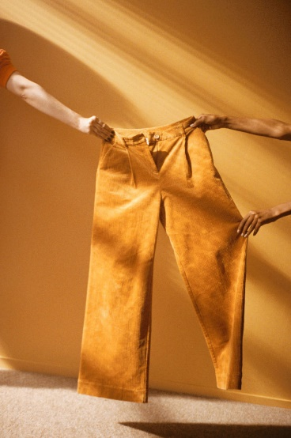
Figure 1. (Monki, 2018) Picture of
Sustainable clothing.

‘Trying’ to be sustainable in industry.
It is important to the hyper aware generation of millennials, as to what subconscious guilt they will be carrying for buying into a brand that’s potentially unethical. Deidre Shaw says “Despite the UK economic downturn over the past five years, the total value of ethical markets has increased from 35.5bn to 47.5bn” (Shaw, 2016, p. 2) .This clearly indicates that ‘ethical consumerism’ is something that there is a market for but how do designers achieve this? Simon Sinek a speaker has a theory of what he calls ‘the golden circle’ “No matter the industry, no matter the product or the service, if we all take responsibility to start with why… together we can change the world” (Sinek, 2011). The problem with the sustainable uprising is that it’s not quite here. There clearly is an interest in sustainability, but for the mean time it is not quite on every brands/ individual’s agenda. “The current system of commerce destroys and depletes natural resources; denigrates the human rights to which workers, consumers, and communities are entitled” (Carbo, 2017, p. 19) This may cause a problem for the designers or artists that have their social responsibilities in line but are hindered by their own industry or employer. The designer may need to uptake entrepreneurship or design for brands that have their principles in line with their own.
However, it is beneficial and, in some cases, complying with law for the designer artist to be socially aware of their impact. This may also be known as “CSR” which means corporate social responsibility. “CSR activities influence costumer’s internal outcomes (i.e. awareness, attitude and trust) and external outcomes (i.e. purchase loyalty and word-of- mouth)” (Narapareddy, 2015, p. 20) .Obviously this can be used to build a brand that is legitimately aware of their responsibilities and some to use the facade of being kind to the environment. This unfortunately in few cases is abused by the corporations because of the principles that are held by the customer and in return the consumer is potentially consuming unethically. So therefore, it’s important to “design(ing) an effective CSR strategy is understanding how to induce customer’s attitudinal and behavioral changes in a positive way” (Narapareddy, 2015, p. 22).The consumers ‘why?’ could be a better sense of wellbeing perhaps, ultimately that is for us designers to decide. But consequently, designers are approaching an age where entrepreneurship isn’t just about working for yourself but also about working a market that the designer themselves will dictate, but responsibly and positively.
I predict that in ten years nearly all industries will require ‘design thinking – those creative problem- solving capabilities that utilize design process methods to define the problem, generate ideas implement solutions- is key” (Vezzoli, 2017, p. 15) .This idea of using the skills of the designer to solve all unethical or non -sustainable problems will soon become realised within industry and when it does the artist or designer will be equipped to do so and the corporations will have no choice but build it into their agenda.
There are organisations that are directly focused on changing the industry, after all “the fashion industry is the world’s second largest polluter” (The True Cost, 2015). Organisations like The Global Fashion Agenda. Their goal states “Influencing leaders – from CEO’s to creative directors – is the most impactful way to drive industry change at large scale, and that has been the core focus of Global Fashion Agenda since the very beginning.” (The Global Fashion Agenda 2018). Designers or artists that support the sustainable cause or organisations such as these, push the fashion/ textile industry to understand that sustainability is vital for the industry itself to sustain and should not be used as a ploy or a marketing tool.
What does the role entail?
In 2028 the world would have hopefully moved forward from harsh chemical use and using vital natural resources in the textile industry. What can the designer do to encourage this? The designer can simply endorse “Slow fashion that comprises less obsolescence through considerate design possibilities” (Inns, 2007, p. p.15) and more “concern for the entire lifecycle of the product” (Inns, 2007, p. 16) this simple ethos and practice is something that is easy to implement using the model of a limited collection or simply creating as and when the designer needs; not as the fast fashion industry runs currently as a “52 season cycle” (The True Cost, 2015) . This would also create an enthusiasm over what is being produced. This in return may help change the mindset of the consumer to what exactly they are purchasing as they simply have more time to consider their purchase.
Furthermore, by potentially opening a niche fashion/ textile market within the UK, the industry could thrive on the idea of individualism and the custom made. “There is an opportunity to address the need of markets related to disability, ageing or much larger consumer segments” (Inns, 2007, p. 17). In doing so, we would be creating a market for the UK that could sustain the idea that ‘home grown’ textiles are overall more ethical and enriching for our own economy and ourselves.
Take Collusion the newest fashion brand that’s held at one of the UK’s largest online stores Asos. They’re fashion agenda is for “the coming age” that is curated by “students, stylists, activists’ image- makers and authors” (Collusion, 2018). By collaborating with individuals that represent the everyday people they are enabling new agendas for their brands to expand and work on principles like inclusiveness. Also, this supports the idea of the individual and therefore has an aura that isn’t seen as mass made. Consequently, their textiles are considered and concise and relies on the individual and not fashion forecasted. In return this will may make the consumer feel their clothing is less trend and more realistic to them, which may leave the consumer to shop less and become more mindful of what they’re purchasing. Their clothing is “animal free” (Collusion, 2018) and the majority of their “cotton is sustainably sourced” (Collusion, 2018). Brands like Collusion I feel represent the new ways in which I think the industry will progress towards; especially the idea of Made in the UK.
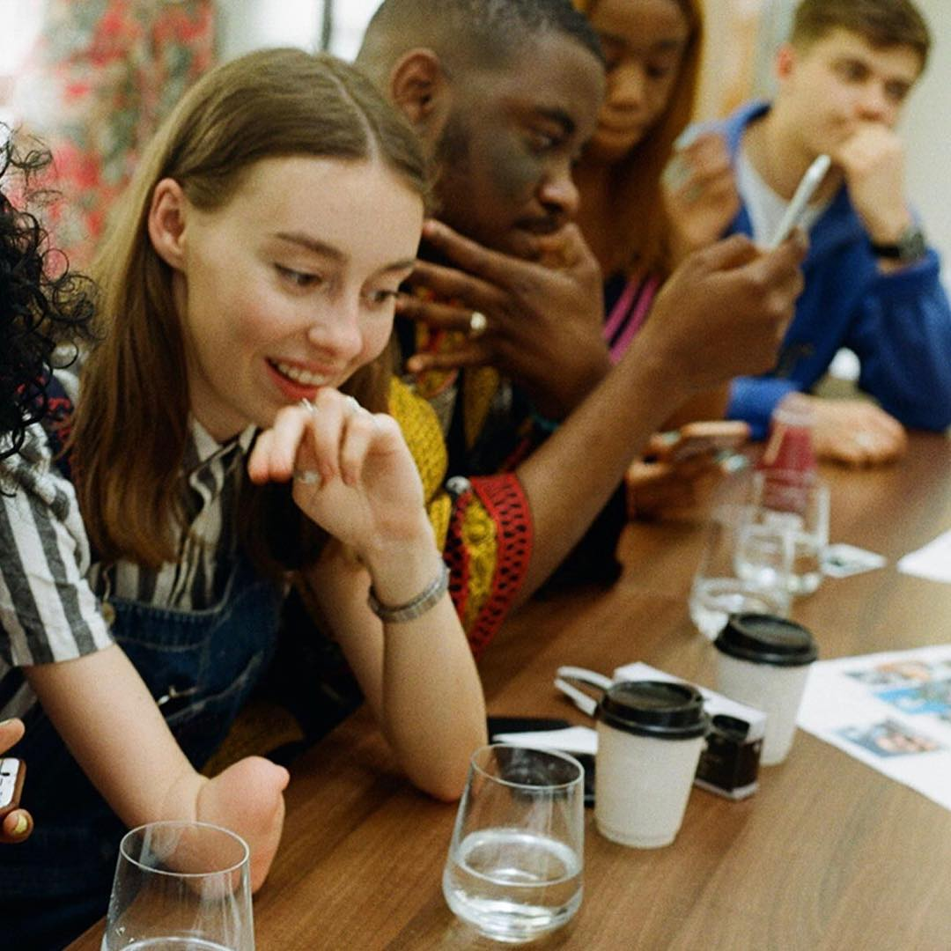
Figure 2. (Collusion, 2018) Picture of the creatives that collaborate with Collusion.
The role of social media
Many brands endorse their products online and I believe they will continue to do so in the next ten years. The sustainable movement must do the same, and brands/ designer/ artists must push their presence online which “encourages discussions of how the community can participate and change their behavior” (Sharma, 2018, p. 20). I believe social media is one of the best forms of globalisation and keeps the world interconnected. Social media is used greatly for marketing purposes that allow the “consumers (to) become knowledgeable about brands and are better able to make consumption decisions” (Ha-Brookshire, 2018, p. 15). I feel that in ten years’ time most of our consumption will be mostly through the online social media world as it is becoming today. The main contributor of this is that social media is far less formal than most other platforms and allows a communication to occur where there may not have been otherwise. This is a great platform where the designer can use their beliefs to curate an idea of what their brand is about. This creating a sense of trust and support.

I have come to believe that in the next ten years the designer would have change their strategy or their CSR dramatically. I believe this will be achieved through practical, cultural and sociological factors. Some of these may include simple recycling, but mainly of our ability to culturally shift our focus to what we as designers need to achieve in order to sustain our own industry.
I believe that practical strategies such as recycling fabrics in the same place where they were purchased is a great way to get the consumer to take responsibility of their waste. This then directly feeds back into the industry to be reused. This is also something that is highly achievable.
I have realised that as designers the main reason we design is to meet a human need. But a human need should not perish the land we live or others. Design should be meaningful and open to warp and change to meet demand of an ever-growing population and meet the loose ends to solve our problems. I have learnt that sustainability is a rather complex issue that will take many creatives to solve. I do believe that the model of a trend can be used in the same way as it is used currently for a more useful cause to influence the consumer to buy into an ethos or product if it is made fashionable in the masses/media. This approach would potentially give people the opportunity to become part of the solution and I believe this will be used in the same way Monki has.
Furthermore, the designer should be responsible and positively create products that promote the consumer to consume ethically. Their CSR should pragmatically project the consumer and not use this ethos as a way of good PR. To do this I feel it is important that the corporations adopt creative problem solving to utilize the design processes to understand the issues and come up with new strategies to combat them.
In the next ten years these corporations will eventually understand that for their own industry to sustain they need to address the problems of the industry and the lack of responsibility on themselves. They also need to address how workers are treated and the lack of Fairtrade.
Mostly I feel it should be an innate desire to better ourselves and our environment. Design/ designer should seek to do so. The root cause of the problem is our ego and the lack of empathy for others and our environment. In ten years time I hope that more people will be sympathetic to how the industry needs to change and will be willing to change too. This cementing our ability to adapt and change for the greater good and put an end to our continuous pollution of our own oneness.

The Global Fashion Agenda (2018) What we do. Available at: https:// www. Globalfashionagenda.com/our-three-pillars/ (Accessed: December 4th 2018)
Carbo, J. A., 2017. Social Sustainability For Buisness. 1 ed. New York: Routledge.p.19.
Collusion, 2018. Collusion.com. [Online] Available at: https://www.collusion.com/about [Accessed 5 December 2018].
Ha-Brookshire, J., 2018. sustainability in luxury fashion buisness. 1 ed. s.l.:Springer,p.15.
Inns, T., 2007. Designing for the 21st century. 1 ed. uk: Gower publishing limited,p.15,16,17.
Monki, 2018. Monki. [Online]
Available at: https://www.monki.com/we-are-monki/monki-cares/
[Accessed 28 November 2018].
Narapareddy, H. a. V., 2015. Sustainability, Social responsibility and innovations in Tourism and hospitality. 1 ed. London: Apple Acedemic press.p.20,22.
Press, M., 2003. The design experience; The role of designers in the twenty first century. 1 ed. London: Routledge.p.12
Sharma, A., 2018. Enviromental awareness and the role of social media. 1 ed. s.l.:IGI Global,p.20.
Shaw, D., 2016. Ethics and morality in consumption: . In: D. S. a. M. Carrington, ed. interdisciplinary perspective. s.l.:Routledge, p. 2.
Sinek, S., 2011. Start with why: how great leaders inspire everyone to take action. 1 ed. s.l.:penguin.
Smith, B., 1977. Concuptual design - A polemic. In: J. Bicknell, ed. London: Elsevier, p. 112.
The True Cost. 2015. [Film] Directed by Andrew Morgan. U.S.A: Untold Creative Life is my movie entertainment.
Vezzoli, C., 2017. Product- service systems design for sustainability. 2 ed. New York: Routlefge. p.15.

