12/9/2025
Kelly Casey
2106451
Ensemble Machine Learning for Intrusion Detection Using NSL-KDD Dataset
ACCA7026

Table of Contents
Abstract 2
1.Introduction 3
1.1 Cybersecurity and Intrusion Detection 3
1.2 Aim and Objectives 3
1.3 Structure of the Report 4
2. literature review 5
2.1 Ensemble Learning for IDS 5
2.2 Random Forest and Gradient Boosting in Cybersecurity 5
2.3 The NSL-KDD Dataset in Recent Research 6
2.4 Feature Importance and Model Interpretability in IDS 6
2.5 literature review summary 7
3.Methodology 8
3.1 Overview of the Methodology 8
3.2 Dataset Description and Exploratory Data Analysis 8
3.2.1 NSL-KDD Dataset Overview 8
3.2.2 Exploratory Data Analysis (EDA) 9
3.3 Data Preprocessing Strategy 12
3.4 Random Forest Model 13
3.5 Gradient Boosting Model 13
3.5.1 Hyperparameter Tuning 14
3.6 Evaluation Strategy 14
4. Results and Discussion 15
Section 4.1 Dataset Overview & EDA Results 15
4.1.1 Attack Category Distribution 17
4.2 Random Forest Baseline Performance 18
4.3 Confusion Matrix Analysis 21
4.4 Gradient Boosting Model Performance 22
4.5 Gradient Boosting Multi-class Evaluation 25
4.6 Comparison of Ensemble Models 28
4.7 discussion 29
5. conclusion 30
6. recommendations 31
Bibliography 32

Abstract
Modern cybersecurity systems increasingly rely on intelligent techniques to detect sophisticated network intrusions in real time. This study evaluates the effectiveness of ensemble machine learning methods, specifically Random Forest and Gradient Boosting, for network intrusion detection using the NSL-KDD dataset. The dataset provides an improved benchmark by addressing redundancy issues present in the original KDD’99 dataset, enabling more reliable model evaluation [1].
Both models were developed within a unified preprocessing pipeline and evaluated using accuracy, precision, recall, F1-score, confusion matrices, and feature importance analysis. Ensemble methods were selected due to their proven robustness and effectiveness in intrusion detection tasks [2]. The results demonstrate strong overall detection performance, with Random Forest showing greater stability under class imbalance. This study highlights the strengths and limitations of ensemble-based intrusion detection systems and provides insight into their practical application.

1.Introduction

Cybersecurity and Intrusion Detection
In today’s highly interconnected digital environment, cybersecurity is a critical concern for national infrastructure, economic stability, and personal data protection. The increasing scale and sophistication of cyber threats require intelligent security mechanisms capable of detecting malicious activity in real time. Intrusion Detection Systems (IDS) play a vital role in this process by identifying unauthorised access, malicious behaviour, and policy violations within computer networks. IDS complement traditional security measures such as firewalls and encryption by detecting threats that may bypass static defences [3].
Despite widespread deployment, effective intrusion detection remains a complex challenge. Modern networks generate large volumes of high-dimensional and diverse data, while attackers continually adapt their techniques through methods such as obfuscation and zero-day exploits. Consequently, IDS must not only detect malicious activity but also accurately classify different types of attacks. This complexity necessitates advanced machine learning approaches capable of learning complex patterns and generalising to previously unseen threats [1].
Traditional machine learning models often suffer from limitations such as overfitting, limited robustness, and sensitivity to noisy data. Ensemble learning techniques, including Random Forest and Gradient Boosting, address these issues by combining multiple learners to improve predictive performance, reduce variance, and enhance model stability. These characteristics make ensemble methods particularly well suited to intrusion detection tasks [2].

Aim and Objectives
The primary aim of this study is to develop and evaluate ensemble-based machine learning models for multi-class network intrusion detection using the NSL-KDD dataset. To achieve this aim, the objectives are to preprocess the dataset, implement Random Forest and Gradient Boosting models, evaluate their performance using appropriate classification metrics, analyse feature importance, and derive insights that support the design of effective intrusion detection systems.

1.3 Structure of the Report
The remainder of this report is organised as follows.
- Section 2 reviews related work on intrusion detection and ensemble learning techniques.
- Section 3 describes the methodology, including dataset selection, preprocessing, model design, and evaluation procedures.
- Section 4 presents and discusses the experimental results, and
- Section 5 concludes the study and provides recommendations for future research and system improvement.

2. literature review
The increasing scale and complexity of cyber threats have driven extensive research into intelligent intrusion detection systems (IDS). Machine learning approaches, particularly ensemble learning techniques, have gained prominence due to their ability to improve detection accuracy and robustness in complex network environments. This section reviews key research on ensemble-based IDS, focusing on Random Forest and Gradient Boosting models, the NSL-KDD dataset, and the role of feature importance in improving model interpretability.

2.1 Ensemble Learning for IDS
Ensemble learning has demonstrated strong performance in intrusion detection by addressing challenges such as overfitting, noisy data, and class imbalance. By combining multiple learners, ensemble models often achieve greater stability and accuracy than individual classifiers. Moustafa and Slay introduced the UNSW-NB15 dataset to address limitations of older benchmarks such as KDD’99 and NSL-KDD, demonstrating that ensemble-based approaches are effective at detecting modern attack patterns [4]. Their work highlights both the advantages of ensemble methods and the importance of evaluating IDS using realistic datasets.
Despite these strengths, ensemble-based IDS have been criticised for limited explainability. In operational cybersecurity environments, analysts must understand why network connections are classified as malicious to support informed decision-making. Ben Asker et al. noted that highly accurate black-box models can reduce trust and usability when decision processes are not transparent [5]. This has motivated increased research into interpretable ensemble models and explainability techniques that balance performance with operational insight.

2.2 Random Forest and Gradient Boosting in Cybersecurity
Random Forest is widely applied in IDS due to its robustness, resistance to overfitting, and ability to handle high-dimensional network traffic data. Farid et al. showed that Random Forest performs well in detecting frequent attack categories such as Denial of Service (DoS) and Probe attacks but struggles with rare classes including User-to-Root (U2R) and Remote-to-Local (R2L) intrusions due to class imbalance [6]. These findings suggest that Random Forest benefits from supplementary strategies such as class weighting or resampling to improve minority-class detection.

Gradient Boosting has also been shown to perform effectively in intrusion detection by modelling complex, non-linear relationships within structured network data. Singh et al. reported that Gradient Boosting outperformed Random Forest and Naïve Bayes in terms of precision and recall in real-time anomaly detection tasks [7]. However, the sequential nature of Gradient Boosting increases computational cost and sensitivity to hyperparameters, which may limit its suitability for large-scale or time-sensitive environments without careful optimisation.

2.3 The NSL-KDD Dataset in Recent Research
The NSL-KDD dataset remains one of the most used benchmarks for evaluating machine learning-based IDS due to its reduced redundancy and improved class balance compared to the original KDD’99 dataset. Almiani et al. noted that NSL-KDD supports fair and repeatable comparison of IDS models, particularly ensemble approaches such as Random Forest and Gradient Boosting [8]. Their review found that models trained on NSL-KDD often achieve high accuracy for known attack types.
Nevertheless, limitations of NSL-KDD have been widely acknowledged. Alshammari and Zincir-Heywood emphasised that the dataset does not fully represent modern attack scenarios and highlighted the importance of multi-class detection for underrepresented categories such as U2R and R2L [9]. While NSL-KDD remains valuable for benchmarking and algorithm development, these studies indicate the need for cautious interpretation and validation against more contemporary datasets.

2.4 Feature Importance and Model Interpretability in IDS
Feature importance analysis plays a critical role in improving both IDS performance and interpretability. Shapoorifard and Shahrabi demonstrated that feature selection can reduce model complexity while maintaining or improving detection accuracy, which is particularly beneficial for large-scale IDS applications [10]. Identifying influential features also reduces noise and computational overhead.
Interpretability has become increasingly important in cybersecurity contexts, where automated decisions must be justified. Guidotti et al. reviewed explainable AI (XAI) techniques such as SHAP and LIME, which provide insight into how individual features influence model predictions [11]. Ensemble models, particularly Random Forest, naturally support feature importance analysis through decision tree structures, enabling better understanding of network behaviour and attack characteristics.

2.5 literature review summary
Overall, existing research demonstrates that ensemble learning methods, particularly Random Forest and Gradient Boosting, are effective for intrusion detection using benchmark datasets such as NSL-KDD. However, challenges remain in detecting rare attack types and ensuring interpretability for real-world deployment. These gaps motivate the present study, which evaluates ensemble-based IDS models while examining feature importance to enhance interpretability and practical relevance

3.Methodology

3.1 Overview of the Methodology
This study follows a structured machine learning pipeline consisting of data preparation, exploratory data analysis, ensemble model development, and performance evaluation, consistent with established intrusion detection research practices [1]. All experiments were implemented in Python using Jupyter Notebook to support reproducibility and iterative experimentation [12][13].

3.2 Dataset Description and Exploratory Data Analysis

3.2.1 NSL-KDD Dataset Overview
The NSL-KDD dataset was used to evaluate ensemble machine learning models for network intrusion detection. It improves upon the original KDD’99 dataset by reducing redundant records and mitigating biased class distributions, enabling more reliable model evaluation [14]. Each record represents a network connection described by traffic-based features and labelled as either normal traffic or a specific attack type. Attacks are grouped into four main categories: Denial of Service (DoS), Probe, Remote-to-Local (R2L), and User-to-Root (U2R), supporting multi-class classification.
The predefined NSL-KDD training and test splits were used to ensure evaluation on unseen data. The training set contains 125,973 records with a mixture of numerical and categorical features describing network traffic behaviour.

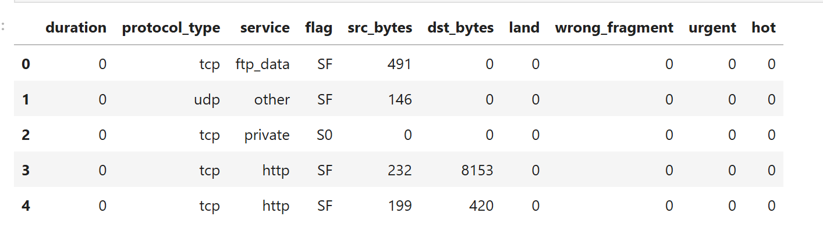
Figure 1: Sample records from the NSL-KDD training dataset illustrating the structure of network connection features used in this study.
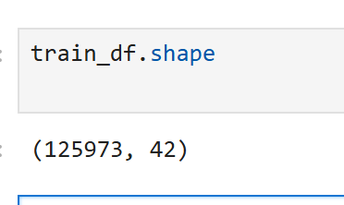
Figure 2: Shape of the NSL-KDD training dataset showing 125,973 network connection records with 42 features.

3.2.2 Exploratory Data Analysis (EDA)
Exploratory Data Analysis (EDA) was conducted to understand dataset structure and identify characteristics influencing model performance. A key finding was severe class imbalance, where normal traffic and a small number of attack types dominate the dataset, while many intrusion categories contain very few samples (Figures 3 and 8). This imbalance is a known challenge in intrusion detection and can negatively impact a model’s ability to learn rare but critical attack patterns [15].
EDA also revealed a mixture of categorical attributes, including protocol type, service, and connection flags, alongside numerical traffic statistics. TCP traffic and HTTP-based services dominate the dataset, with successful connection states occurring most frequently (Figures 4–6). These findings informed preprocessing decisions, feature encoding strategies, model selection, and the use of evaluation metrics robust to class imbalance. Detailed EDA outputs are retained as supporting evidence and referenced throughout this section.

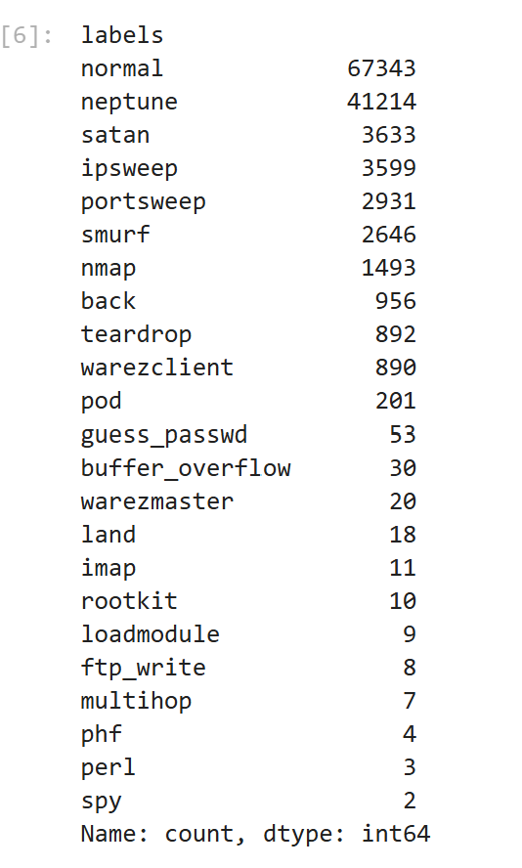
Figure 3Distribution of attack classes in the NSL-KDD training dataset, highlighting severe class imbalance across intrusion categories.
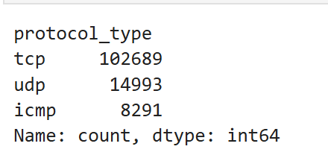
Figure 4 Distributions of protocol types, service types, and connection flags in the NSL-KDD training dataset, illustrating the dominance of TCP traffic, HTTP-based services, and successful connection states.
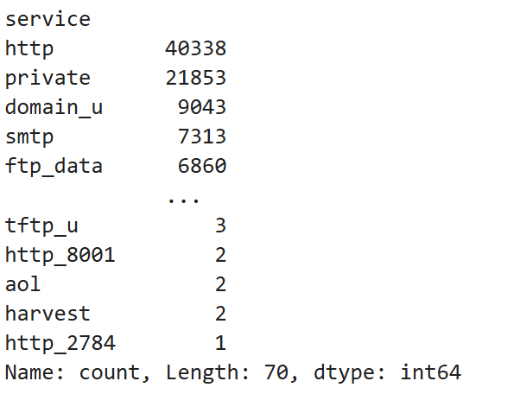
Figure 5 Distributions of protocol types, service types, and connection flags in the NSL-KDD training dataset, illustrating the dominance of TCP traffic, HTTP-based services, and successful connection states.
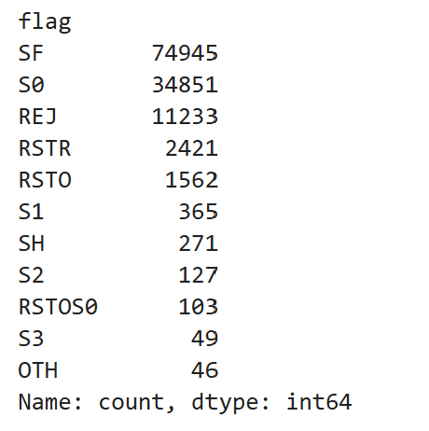
Figure 6 Distributions of protocol types, service types, and connection flags in the NSL-KDD training dataset, illustrating the dominance of TCP traffic, HTTP-based services, and successful connection states.

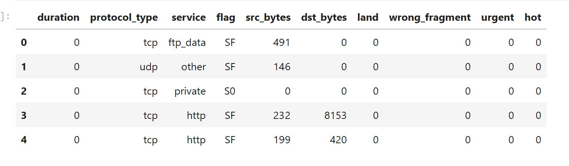
Figure 7 Sample of pre-processed NSL-KDD training data showing the structure of numerical and categorical features used for model training
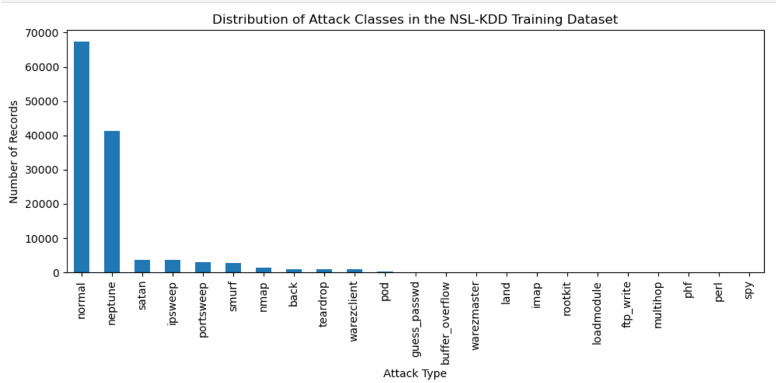
Figure 8 Distribution of attack classes in the NSL-KDD training dataset, illustrating severe class imbalance where normal traffic and a small number of attack types dominate, while many intrusion categories are underrepresented.

3.3 Data Preprocessing Strategy
Prior to model training, the NSL-KDD dataset was pre-processed to ensure compatibility with ensemble learning algorithms. Pre-processing is essential in intrusion detection due to mixed feature types, varying feature scales, and high dimensionality.
Categorical features representing protocol type, service, and connection flags were transformed using one-hot encoding to avoid introducing artificial ordinal relationships. Numerical features representing traffic statistics were standardised to ensure consistent feature magnitudes and prevent individual attributes from disproportionately influencing model learning.
A unified preprocessing pipeline was implemented using a ColumnTransformer [16], enabling separate transformations for categorical and numerical features within a single framework. Embedding preprocessing within the pipeline ensured identical transformations were applied during training and testing, preventing data leakage and supporting fair model evaluation. The resulting pre-processed feature matrix and target vector dimensions were verified programmatically (Figure 9), and the processed data served as input for both ensemble models.

.
Figure 9 Shape of the pre-processed feature matrix (X) and target vector (y) after encoding and scaling, confirming compatibility with ensemble learning models.
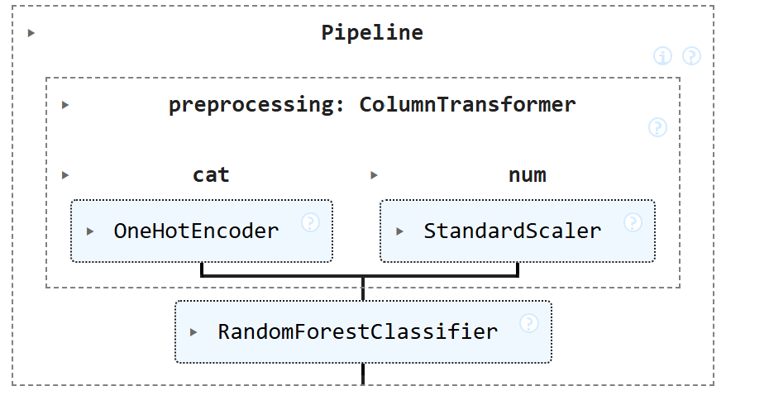
Figure 10 Visual representation of the machine learning pipeline showing integrated preprocessing using a ColumnTransformer with one-hot encoding for categorical features and standard scaling for numerical features, followed by the Random Forest classifier.

3.4 Random Forest Model
Random Forest was selected as the first ensemble model due to its robustness when handling high-dimensional and noisy intrusion detection data, as well as its natural support for multi-class classification [17][18]. Its ability to model complex, non-linear relationships makes it well suited to distinguishing between multiple intrusion categories within the NSL-KDD dataset.
The Random Forest classifier was implemented within the unified preprocessing pipeline described in Section 3.3 to ensure consistent feature handling during training and testing. Following preprocessing, the training feature matrix expanded due to one-hot encoding while retaining the original number of samples (Figure 11). The model was trained using the predefined NSL-KDD training split to establish a stable baseline for comparison.


Figure 11 Shape of the pre-processed training feature matrix (X_train) and target vector (y_train) after encoding and scaling, confirming the final dimensionality used for Random Forest training.
Figure 12 Random Forest classification accuracy on the NSL-KDD test dataset following preprocessing and pipeline integration.

3.5 Gradient Boosting Model
Gradient Boosting was selected as the second ensemble model to enable direct comparison with Random Forest. Unlike bagging-based approaches, Gradient Boosting builds decision trees sequentially, with each new tree focusing on correcting errors made by previous learners. This makes Gradient Boosting effective at modelling complex intrusion patterns, particularly for difficult-to-classify instances.
As with Random Forest, the Gradient Boosting classifier was implemented within the unified preprocessing pipeline to ensure consistent handling of categorical and numerical features. The model was trained using the predefined NSL-KDD training split, with default configuration parameters used to establish a stable baseline rather than extensive hyperparameter tuning.

3.5.1 Hyperparameter Tuning
Hyperparameter tuning was attempted for the Random Forest model using GridSearchCV to explore different model configurations and improve detection performance. Cross-validation was applied with macro-averaged F1-score as the optimisation metric to account for severe class imbalance within the NSL-KDD dataset. However, several attack classes contained fewer samples than the number of cross-validation folds, which prevented reliable splitting during tuning. This limitation reflects a known issue with the NSL-KDD dataset, where rare attack types restrict the applicability of cross-validation-based optimisation. As a result, baseline model parameters were retained for final evaluation. This approach ensures methodological completeness while avoiding unreliable optimisation caused by extreme class sparsity.

3.6 Evaluation Strategy
Evaluating intrusion detection systems requires multiple performance metrics due to class imbalance and the presence of multiple attack categories. Accuracy was used as an initial measure of overall performance but was supplemented with additional metrics to assess detection capability for minority attack classes.
Precision and recall were used to evaluate the trade-off between false positives and false negatives, which is particularly important in intrusion detection where missed attacks can have serious consequences. The F1-score was included as a balanced metric combining precision and recall across uneven class distributions. Confusion matrices were used to provide class-level insight into prediction performance and identify frequently misclassified attack types. All evaluation metrics were applied consistently to both ensemble models using the predefined NSL-KDD test set, ensuring fair comparison. Detailed results are presented in Section 4.

4. Results and Discussion

Section 4.1 Dataset Overview & EDA Results
Exploratory Data Analysis (EDA) revealed significant class imbalance within the NSL-KDD training dataset. As shown in Figures 13 and 14, normal traffic and a small number of attack types dominate the dataset, while many intrusion categories occur very infrequently. This imbalance represents a known challenge for intrusion detection systems, as models may achieve high overall accuracy while failing to detect rare but critical attacks.
High-level attack category analysis further illustrates this imbalance, with normal traffic and Denial of Service (DoS) attacks accounting for most records, while Probe, Remote-to-Local (R2L), and User-to-Root (U2R) attacks are underrepresented. Binary class analysis (Figure 15) shows a more balanced distribution when all attacks are grouped together; however, normal traffic still slightly dominates. These findings provide important context for interpreting model performance in subsequent sections.

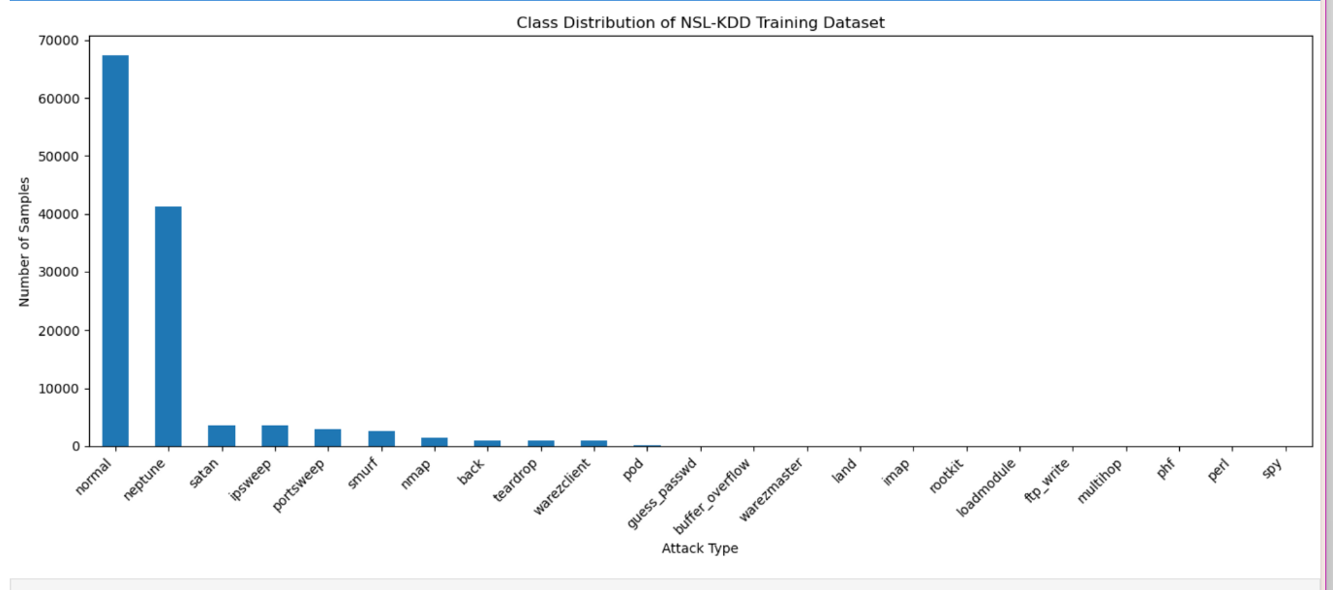
Figure 13 Distribution of individual attack types in the NSL-KDD training dataset, illustrating severe class imbalance across intrusion classes.
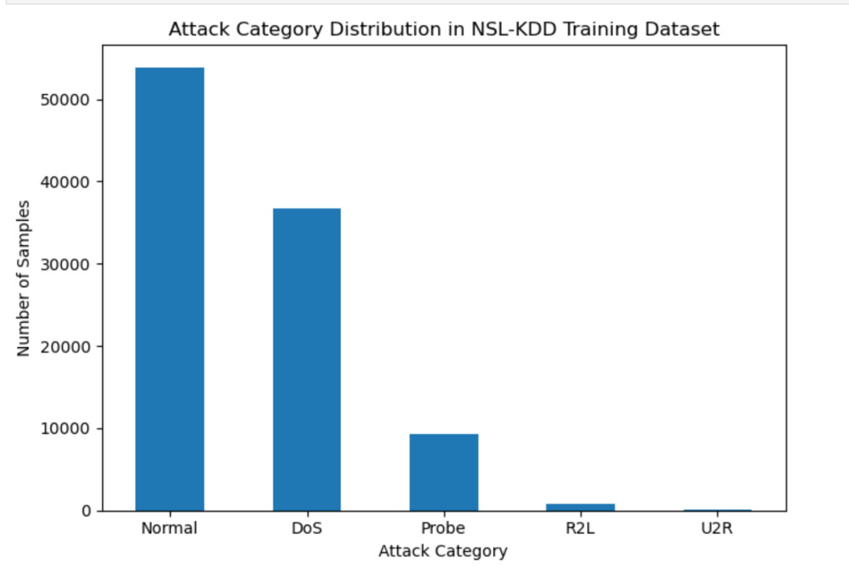
Figure 14 Distribution of high-level attack categories in the NSL-KDD training dataset, showing the dominance of normal traffic and Denial of Service (DoS) attacks and the rarity of R2L and U2R intrusions.
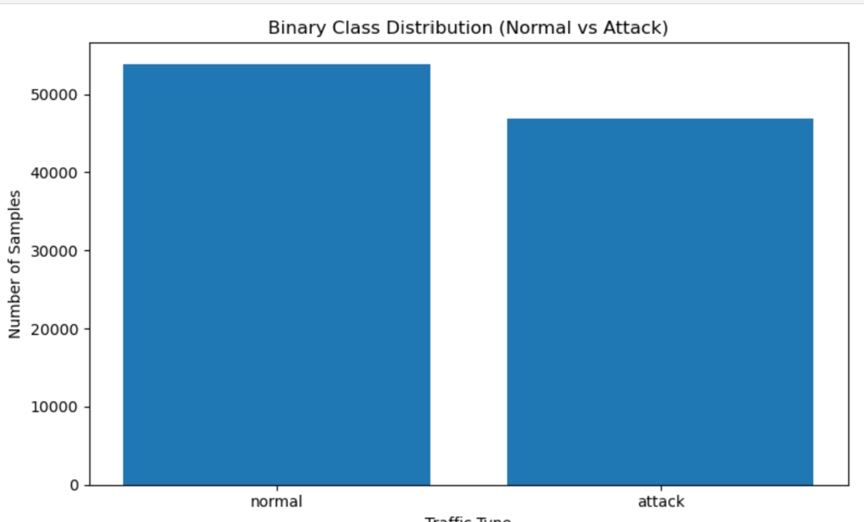
Figure 15 Binary class distribution of normal versus attack traffic in the NSL-KDD training dataset, showing a more balanced split compared to the multi-class distribution.

4.1.1 Attack Category Distribution
Figure 16 shows the distribution of high-level attack categories in the NSL-KDD training dataset. Normal traffic and denial-of-service (DoS) attacks dominate the data, while Probe attacks are much less frequent and R2L and U2R attacks are extremely rare. This severe class imbalance is expected to bias models towards majority classes and negatively impact performance on rare attack categories such as R2L and U2R.

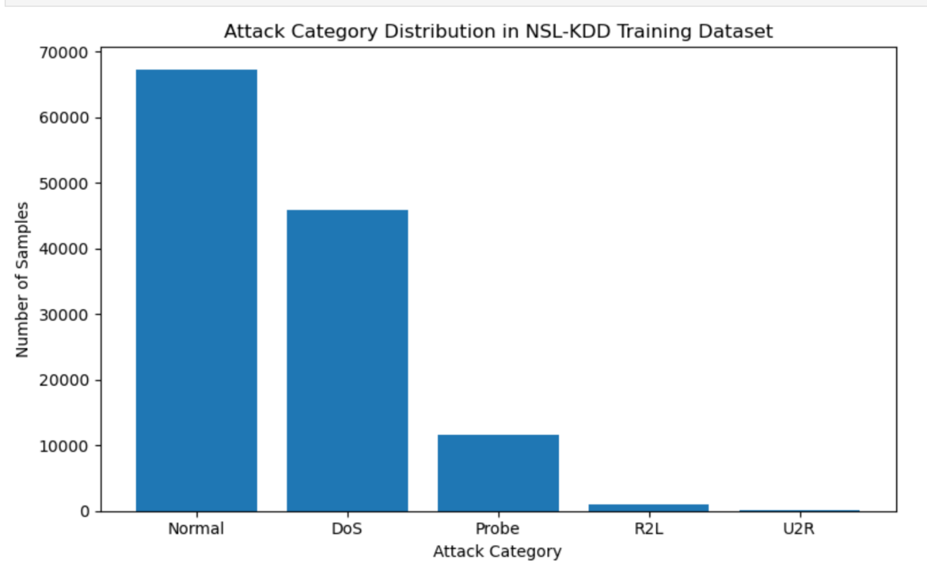
Figure 16 Distribution of high-level attack categories in the NSL-KDD training dataset.
These distributional characteristics provide important context for interpreting the classification results presented in the following sections.

4.2 Random Forest Baseline Performance
The Random Forest model achieved very high overall accuracy on the NSL-KDD test dataset (Figure 17), demonstrating strong capability in distinguishing between normal and malicious traffic. However, accuracy alone is insufficient in imbalanced intrusion detection datasets and must be considered alongside class-level metrics.
The multi-class classification report (Figure 18) shows that Random Forest performs exceptionally well on frequent classes such as normal, neptune, ipsweep, and smurf, achieving high precision and recall. In contrast, rare attack types including phf, rootkit, and ftp_write record zero precision and recall due to extreme class sparsity. This behaviour is typical in IDS applications and highlights the limitations of relying solely on overall accuracy.
Binary evaluation provides further insight into detection capability. The binary confusion matrix (Figure 19) and classification report (Figure 20) show near-perfect detection of attack traffic with very low false negative rates. While this indicates strong general intrusion detection performance, it also masks reduced sensitivity to minority attack classes in the multi-class setting.

Figure 17 Random Forest model accuracy on the NSL-KDD test dataset.

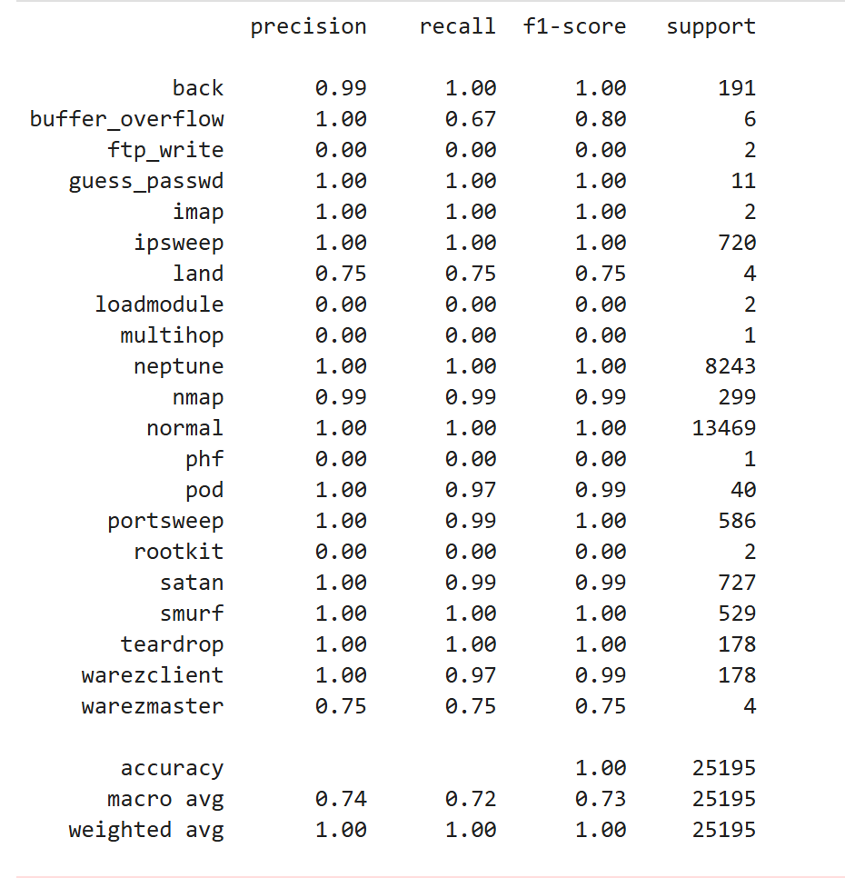
Figure 18 Random Forest classification report on the NSL-KDD test set. 4.2.1 Binary Confusion Matrix (Normal vs Attack)

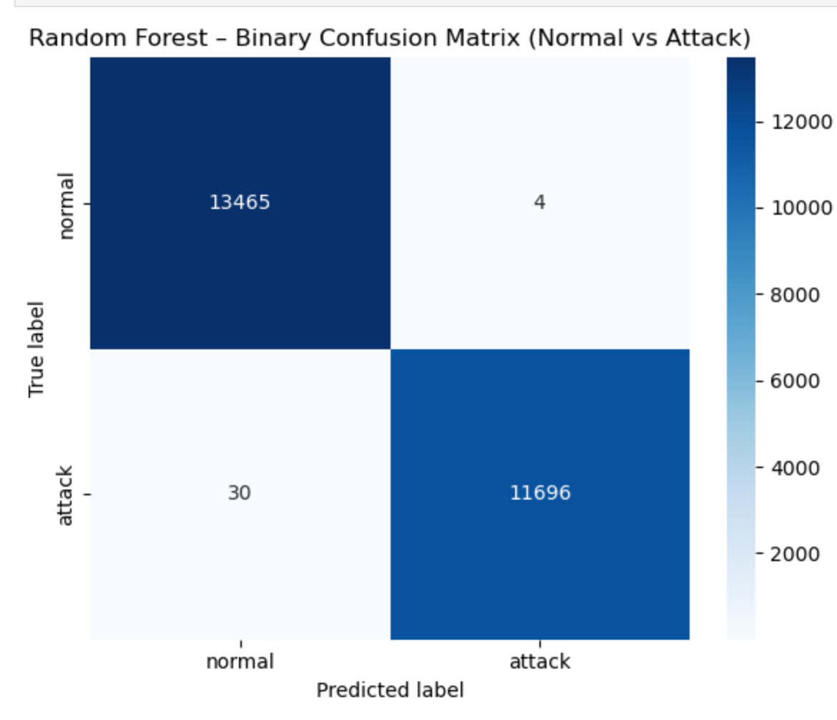
Figure 19 Binary confusion matrix for the Random Forest model on the NSL-KDD test dataset (Normal vs Attack).

evaluation.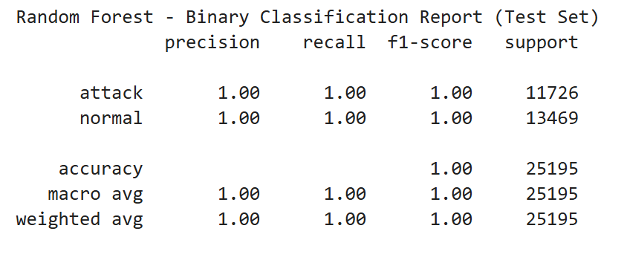
Figure20 Binary classification report for the Random Forest model on the NSL-KDD test dataset (Normal vs Attack).

4.3 Confusion Matrix Analysis
The multi-class confusion matrix for the Random Forest model (Figure 21) further illustrates the impact of class imbalance. The strong diagonal indicates high classification accuracy for dominant attack types, while several rare classes exhibit few or no correct predictions. This confirms that overall performance is driven primarily by majority classes and reinforces the importance of evaluating IDS using per-class metrics rather than accuracy alone.
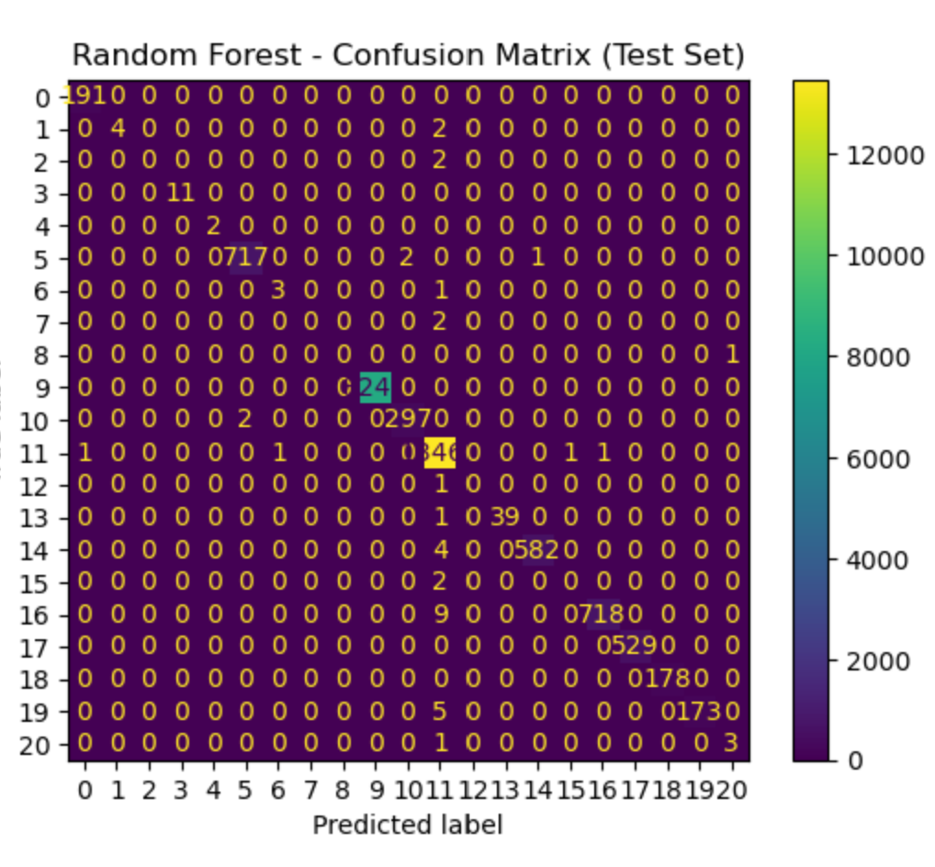
Figure 21 Multi-class confusion matrix for the Random Forest model on the NSL-KDD test dataset.
These results demonstrate that while Random Forest performs well on dominant attack types, its effectiveness decreases substantially for low-frequency intrusions, motivating further analysis using detailed classification metrics.

4.4 Gradient Boosting Model Performance
Gradient Boosting achieved similarly high overall accuracy to Random Forest on the NSL-KDD test dataset (Figure 22). Binary evaluation results, including the confusion matrix and classification report (Figures 23 and 24), demonstrate near-perfect separation between normal and attack traffic, indicating strong performance in simplified intrusion detection scenarios.
Feature importance analysis (Figures 25 and 26) shows that Gradient Boosting relies heavily on a smaller subset of influential features, particularly traffic volume and service-based attributes such as src_bytes and same_srv_rate. While this focus enables strong performance on dominant attack patterns, it also increases sensitivity to class imbalance in the multi-class setting.

Figure22: Gradient Boosting model accuracy on the NSL-KDD test dataset.
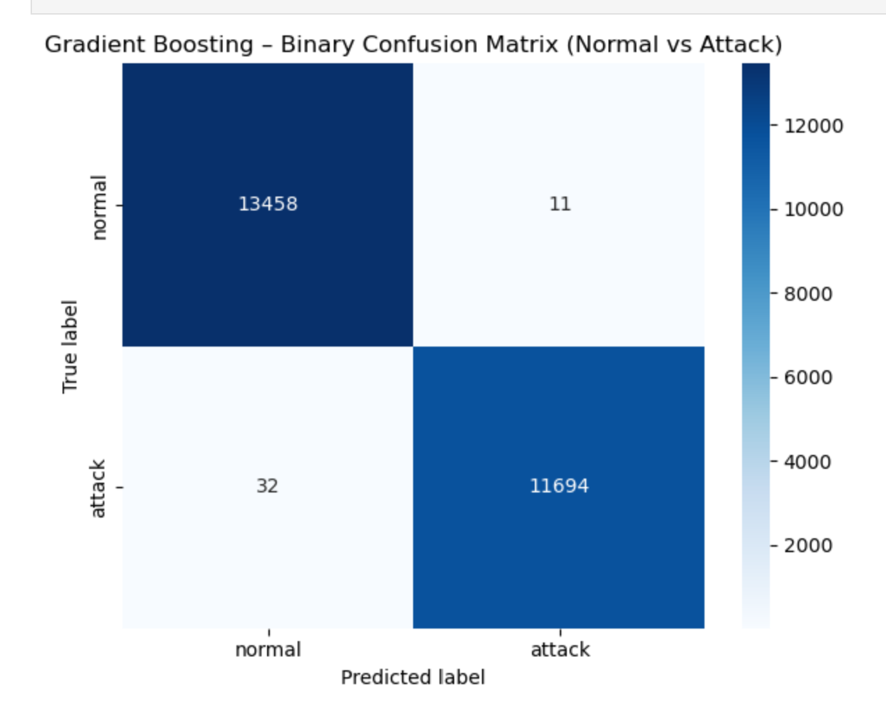
Figure 23 Binary confusion matrix for the Gradient Boosting model on the NSL-KDD test dataset (Normal vs Attack).
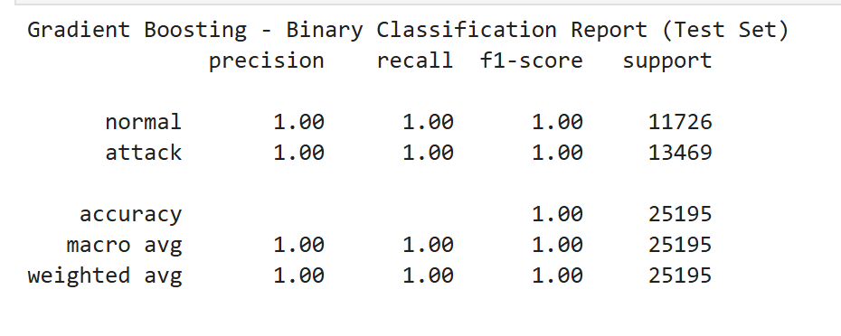
Figure 24 Binary classification report for the Gradient Boosting model on the NSL-KDD test dataset (Normal vs Attack).
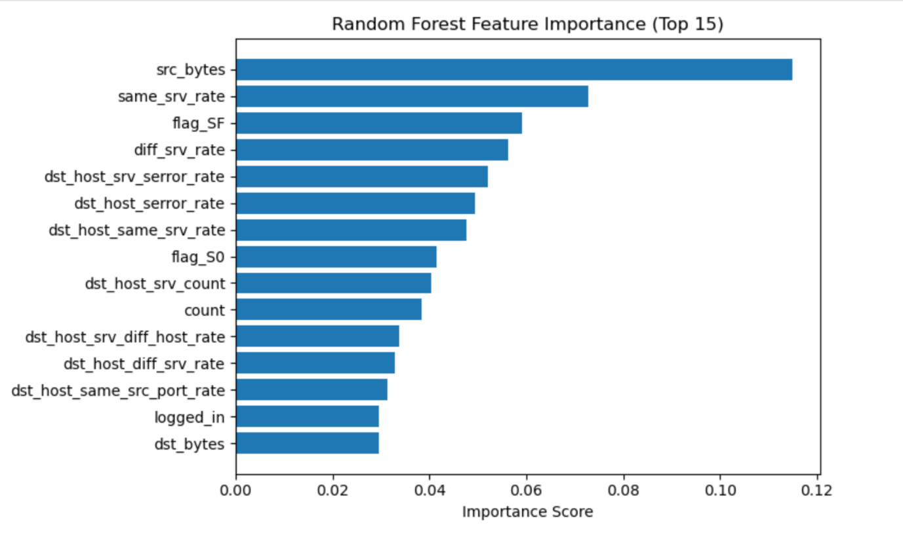
Figure 25 Top 15 most important features identified by the Random Forest classifier on the NSL-KDD dataset. Feature importance scores represent the relative contribution of each feature to the model’s predictions.

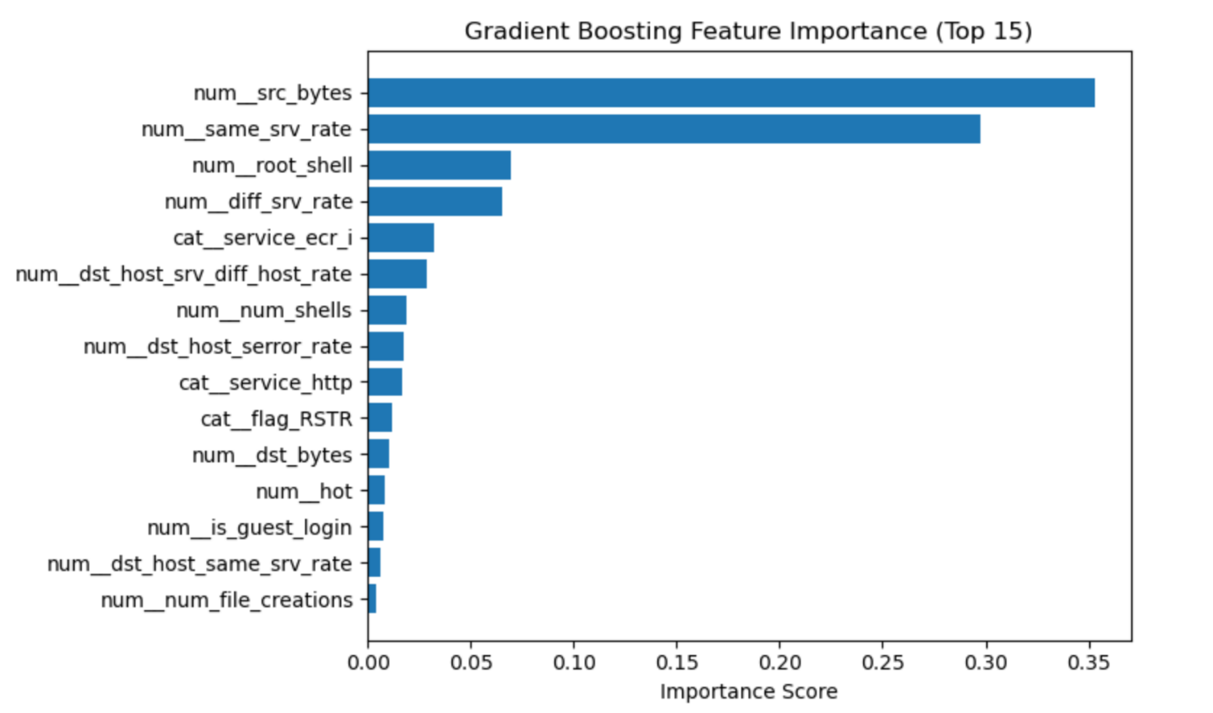
Figure 26:Gradient Boosting Feature Importance (Top 15 Features)

4.5 Gradient Boosting Multi-class Evaluation
The multi-class classification report and confusion matrix for Gradient Boosting (Figures 27–29) reveal performance patterns similar to those observed for Random Forest. Frequent attack classes achieve high precision and recall, while rare attack types such as ftp_write, phf, rootkit, and multihop record near-zero scores due to extremely limited representation. This results in lower macro-average performance, highlighting the limitations of ensemble models when applied to highly imbalanced intrusion detection datasets.

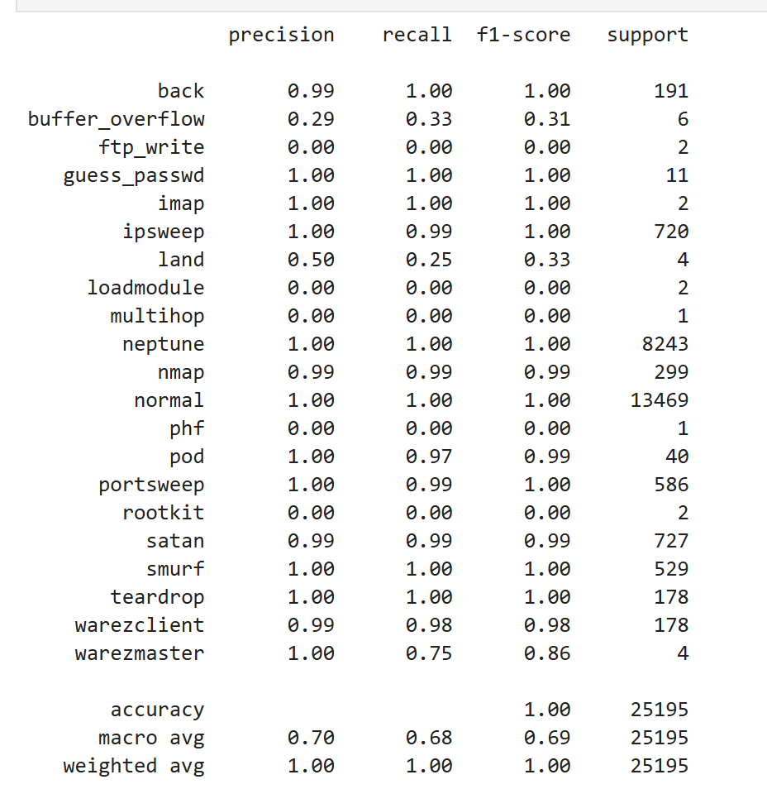
Figure 27 Classification report for the Gradient Boosting model evaluated on the NSL-KDD test dataset.
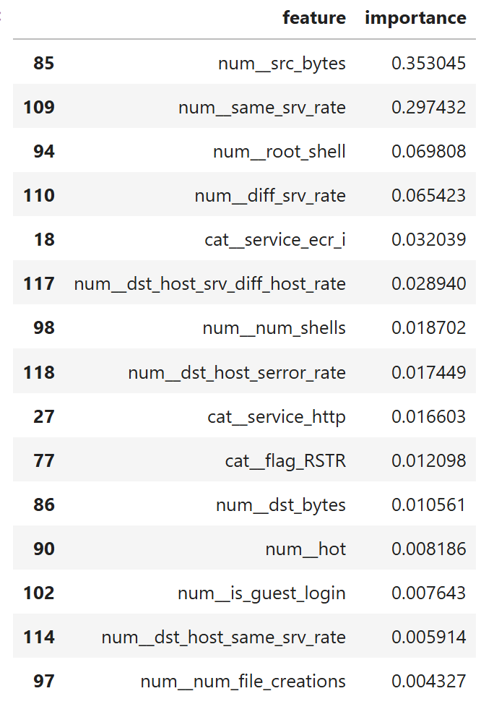
Figure 28 Gradient Boosting Top 15 Features and Importance Scores

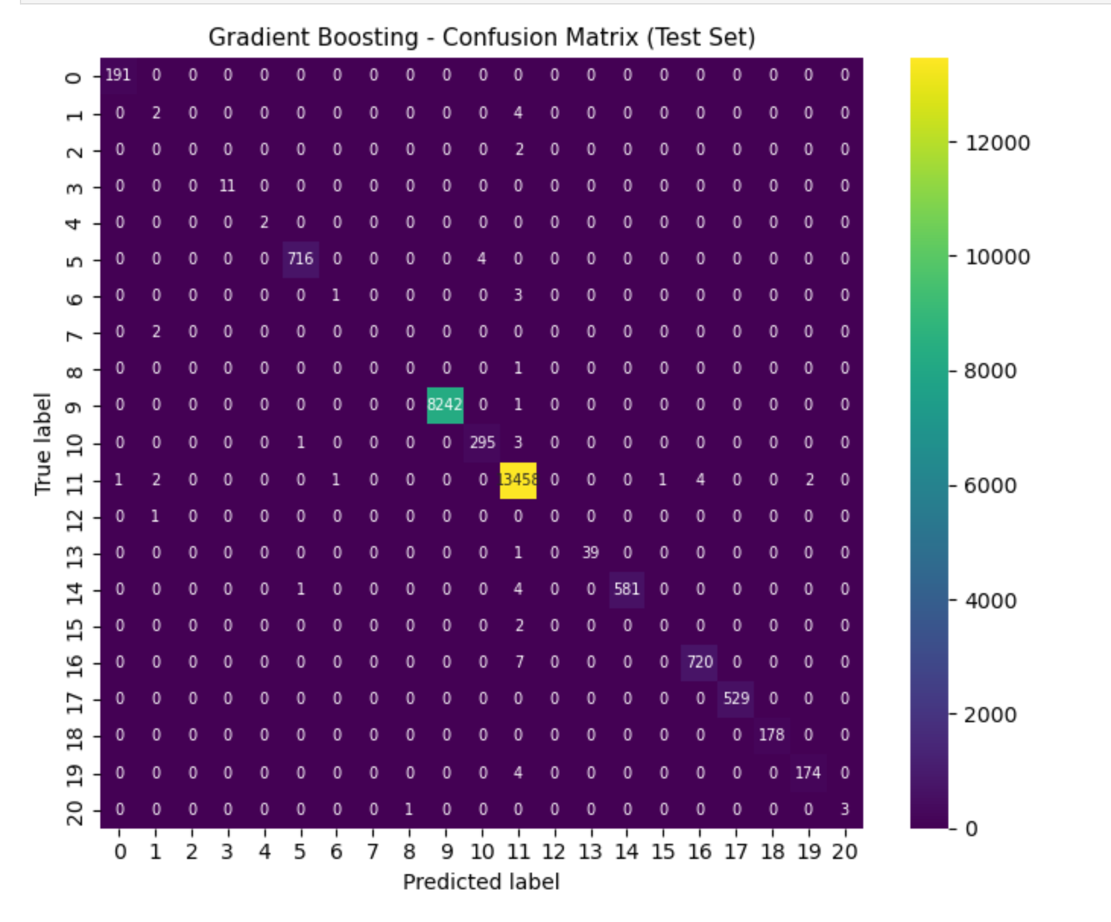
Figure 29 Confusion matrix for the Gradient Boosting model on the NSL-KDD test dataset

4.6 Comparison of Ensemble Models
Both Random Forest and Gradient Boosting demonstrate strong overall performance on the NSL-KDD dataset, achieving accuracy above 99% (Figure 30). Random Forest consistently shows slightly more stable performance across classes, reflecting the robustness of its bagging-based ensemble structure. Gradient Boosting achieves comparable accuracy but is more affected by class imbalance, particularly in multi-class evaluation.
ROC curve comparison (Figure 31) further illustrates that ROC–AUC values underestimate true detection capability in this context due to highly confident predictions in an imbalanced binary setting. Overall, Random Forest provides a more robust baseline for this study, while the results reinforce the importance of using class-level evaluation metrics when assessing IDS performance.


Figure 30 Accuracy comparison between Random Forest and Gradient Boosting models on the NSL-KDD test dataset.

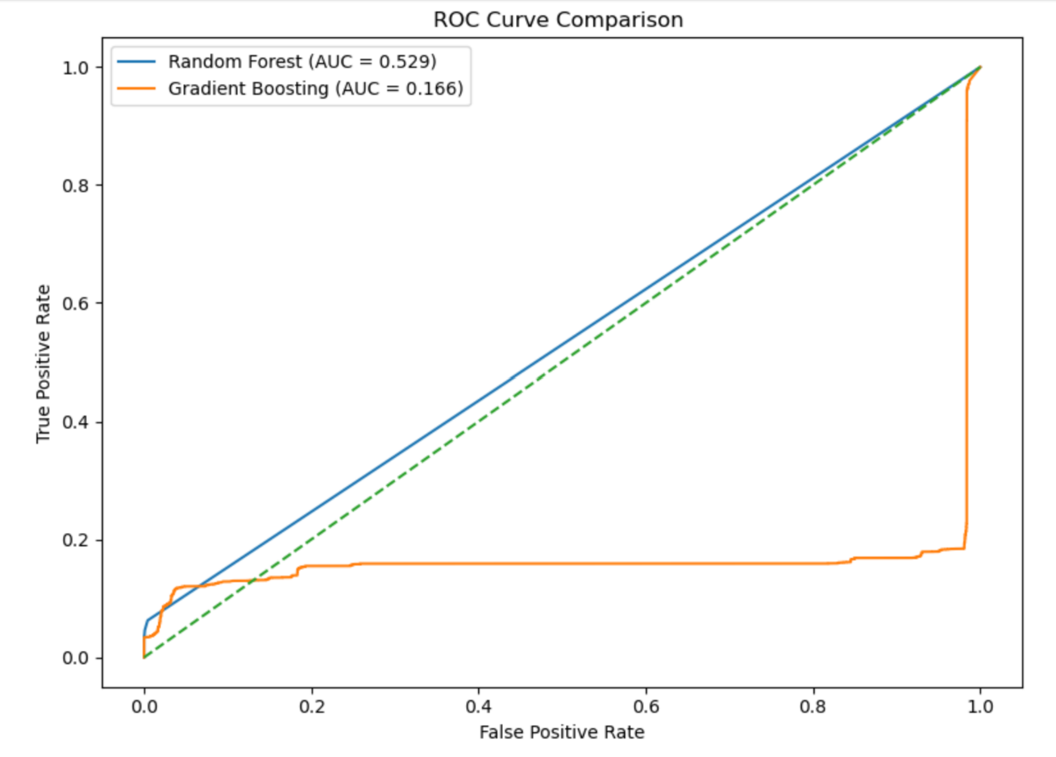

Figure 31 ROC curve comparison for Random Forest and Gradient Boosting classifiers on the NSL-KDD test dataset

4.7 discussion
This section evaluates the performance of Random Forest and Gradient Boosting for intrusion detection on the NSL-KDD dataset, with particular emphasis on class imbalance, robustness, and practical deployment considerations. Although both models achieve very high overall accuracy, class-level evaluation reveals important differences that are critical in intrusion detection contexts.
Random Forest demonstrates consistently strong and stable performance across both binary and multi-class settings. Its bagging-based ensemble structure reduces variance and improves robustness to noisy network traffic, resulting in low false negative rates for attack detection. This stability is particularly valuable in operational IDS deployment, where missed intrusions and excessive false alerts can have serious consequences. In contrast, Gradient Boosting achieves comparable overall accuracy but is more affected by class imbalance, showing reduced sensitivity to rare attack classes unless additional mitigation techniques are applied.
From a practical perspective, Random Forest offers advantages in robustness, interpretability, and computational efficiency, as it is easily parallelised and performs well with minimal tuning. Gradient Boosting remains a powerful alternative but requires careful parameter optimisation and is more sensitive to skewed data distributions. Overall, these findings align with existing IDS literature on the NSL-KDD dataset, confirming the effectiveness of ensemble methods while highlighting class imbalance as a persistent challenge in detecting rare but critical intrusions.

5. conclusion
This study evaluated the effectiveness of ensemble machine learning techniques for network intrusion detection using the NSL-KDD dataset. All research objectives were achieved, including data preprocessing, ensemble model development, performance evaluation, and feature importance analysis.
The results demonstrate that ensemble methods are highly effective for intrusion detection, particularly in the binary normal-versus-attack setting. Both Random Forest and Gradient Boosting achieved strong overall performance; however, Random Forest consistently provided more stable and robust results across classes, making it a stronger baseline model for intrusion detection systems.
Feature importance analysis identified traffic volume, service usage consistency, and host-based error metrics as key indicators of malicious behaviour. While both models relied on these features, Random Forest distributed importance more evenly, supporting greater robustness under class imbalance.
Although ROC–AUC values were limited due to dataset imbalance, confusion matrices and class-level metrics offered more meaningful insight into detection capability. Overall, this study confirms the suitability of ensemble-based approaches for intrusion detection while highlighting the persistent challenge of detecting rare attack types. Future work should explore newer datasets and improved methods for handling class imbalance to enhance real-world applicability.

6. recommendations
Based on the findings of this study, several practical recommendations can be made for improving intrusion detection systems (IDS) using ensemble machine learning techniques. Ensemble models, particularly Random Forest, demonstrated strong and robust performance and should be considered a core component of modern IDS architectures.
In operational environments, ensemble learning should be integrated as part of a layered defence strategy alongside traditional signature-based IDS. Random Forest is especially suitable for deployment due to its robustness to noisy and high-dimensional data, stable performance with minimal tuning, and ease of parallelisation. To maintain detection effectiveness, IDS models should be periodically retrained using updated network traffic to address evolving attack patterns and concept drift.
Future IDS development should prioritise improved data quality and representativeness. While NSL-KDD is useful for benchmarking and comparative evaluation, more recent datasets such as CICIDS2017 or UNSW-NB15 should be used to better reflect modern network behaviour. Class imbalance should be mitigated using techniques such as class weighting, resampling, or hybrid anomaly-based approaches to improve detection of rare but high-impact attacks.
Additional performance gains may be achieved through targeted hyperparameter tuning and hybrid IDS architectures that combine ensemble models with anomaly detection or deep learning techniques. Incorporating explainability methods would further enhance trust, transparency, and operational usability of IDS decisions.
Overall, these recommendations provide practical guidance for deploying ensemble-based IDS that are accurate, robust, and adaptable, while identifying clear directions for future research and system development.

Bibliography

[1] | E. B. L. A. G. Mahbod Tavallaee, “IEEE xplore,” IEEE, 18 12 2009. [Online]. Available: https://ieeexplore.ieee.org/document/5356528. [Accessed 4 12 2025].
[2] | O. O. S.A. Oyewole, “ScienceDirect,” ScienceDirect, 31 07 2018. [Online]. Available: https://www.sciencedirect.com/science/article/pii/S1110866517303225?via%3Dihub. [Accessed 4 12 2025].
[3] | J.-M. P. Animesh Patcha, “ScienceDirect,” scienceDirect, 16 02 2007. [Online]. Available: https://www.sciencedirect.com/science/article/abs/pii/S138912860700062X?via%3Dihub. [Accessed 4 12 2025].
[4] | M. C. a. P. Bedi, “Effective Hybrid Ensemble Model for Network Intrusion Detection,” International Journal of Computers and Applications, vol. 42, p. 164–172, 2022.
[5] | A. A. a. H. A. M. Ben Asker, “Explainable AI in Intrusion Detection: A Review and Future Directions,” PeerJ Computer Science,, vol. 7, p. 598, 2021.
[6] | M. Z. R. a. C. R. D. M. Farid, “A New Supervised Learning Algorithm for Intrusion Detection Based on Support Vector Machines and Decision Tree,” International Journal of Network Security & Its Applications, vol. 4, no. 2, p. 53–63, 2012.
[7] | e. a. Gayathry Sunil, “tutcomat,” 28 04 2021. [Online]. Available: https://turcomat.org/index.php/turkbilmat/article/view/5096. [Accessed 04 12 2025].
[8] | M. A. M. A. A. A. a. Y. K. K. Almiani, “Deep and machine learning approaches for anomaly-based intrusion detection systems: A comprehensive review,” Applied Sciences, vol. 11, no. 5, p. 2077, 2021.
[9] | S. M. R. N. Y. W. François Larrouturou, “cornell university,” 20 09 2016. [Online]. Available: https://arxiv.org/abs/1609.06191. [Accessed 01 12 2025].
[10] | J. Y. O. A. C. Lifeng Cao, “ENHANCING THE WORDPRESS SYSTEM:FROM,” International Journal of Network Security & Its Applications (IJNSA) , vol. 11, no. 3, 2019.
[11] | A. M. S. R. F. T. F. G. D. P. I. &. C. Riccardo Guidotti, “A Survey of Methods for Explaining Black Box Models,” ACM Computing Surveys (CSUR), vol. 51, no. 5, pp. 1 - 42, 2018.
[12] | python, “python,” python, [Online]. Available: https://www.python.org/doc/essays/blurb/. [Accessed 2025 11 28].
[13] | geeksforgeeks, “geeksforgeeks,” 23 07 2025. [Online]. Available: https://www.geeksforgeeks.org/data-science/jupyter-notebook/. [Accessed 29 11 2025].
[14] | UNB, “UNB,” UNB, [Online]. Available: https://www.unb.ca/cic/datasets/nsl.html. [Accessed 12 2025].
[15] | H. Chan, “IEEE,” IEEE, 8 july 2010. [Online]. Available: https://ieeexplore.ieee.org/document/5504792. [Accessed 12 2025].
[16] | “scikit,” scikit, [Online]. Available: https://scikit-learn.org/stable/modules/compose.html. [Accessed 12 2025].
[17] | L. Breiman, “RANDOM FORESTS,” University of California, Berkeley, CA 94720, 2001.
[18] | A. Azfar and K.-K. R. Choo, “IEEE,” IEEE, march 2010. [Online]. Available: https://ieeexplore.ieee.org/document/7427881. [Accessed 12 2025].
[19] | Amir Gandomi, “science direct,” science direct, [Online]. Available: https://www.sciencedirect.com/science/article/pii/S0268401214001066. [Accessed 4 12 2025].

