

STUDENT NAME: GURPREET SINGH
STUDENT ID: 2220408
LCMB7020

TITLE: THE IMPACT OF SOCIAL MEDIA MARKETING ON CONSUMER BEHAVIOR: A CASE STUDY ON TESCO
Table of Contents
Chapter 1: Introduction 3
1.1 Research Background 3
1.2 Research Aim and Objectives 3
1.3 Research Rationale 4
1.4 Research Question 5
1.5 Research Significance 5
Chapter 2: Literature Review 5
2.1 Chapter Introduction 5
2.2 Social Media Marketing Strategies of Modern Brands 5
2.3 Social media marketing positively influencing consumer behaviour 6
2.4 Challenges of consumer behaviour management 6
2.5 Theoretical Underpinning 7
2.6 Literature Gap 8
2.7 Chapter Summary 9
Chapter 3: Methodology 9
References 12

Chapter 1: Introduction

1.1 Research Background
Social media marketing is an essential part of Tesco’s promotional activities, influencing positive consumer behaviour to incite sales. Tesco has removed around 71 billion calories from its own products since 2018, in an effort to improve consumer spending on healthy products to influence positive purchase behaviour (Tescoplc.com, 2023). It indicates that SMM has helped Tesco to develop its promotional activities and develop its efforts on consumer spending.
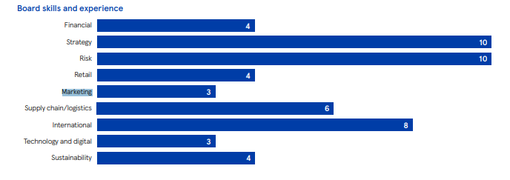
Figure 1: Skill Evaluation of Board members of Tesco
(Source: Tescoplc.com, 2023)
The brand markets its philanthropic efforts and its support of more than 50,000 projects within communities to improve consumer behaviour via consumer loyalty. Tesco marketed discounted offers on social media showing extremely low retail prices to observe an 8.7% rise in sales during the lockdown (Cnbc.com, 2020). Hence, there is a need to assess the elements of consumer behaviour being influenced by the social media strategies of Tesco.

1.2 Research Aim and Objectives
Aim
The aim of the research is to discover the impact of social media marketing of Tesco on influencing consumer behaviour.
Objectives
- To analyse the social media marketing strategies of Tesco
- To determine the impact of social media marketing of Tesco on positively influencing consumer behaviour
- To evaluate the key challenges of consumer behaviour analysis that can impact SMM
- To recommend a number of strategies to improve Tesco’s social media marketing efforts to influence positive consumer behaviour

1.3 Research Rationale
A key issue occurring in the current UK market is the increasing importance of consumer behaviour management, usually ignored by brands. The importance of consumer behaviour in SMM is highlighted by key emerging trends like demand for marketing transparency, omnipresent communication and improving customer interaction (Forbes.com, 2023). Understanding consumer behaviour can help companies like Tesco decipher the needs and wants of consumers, highlighting the importance of the issue respectively. Consumer loyalty is a key aspect of consumer behaviour and effective behaviour management can help develop consumer loyalty for improved sales.
Improving consumer loyalty directly leads to increased market share and increased sales for brands. Food inflation levels increased to 15% in 2022, bringing about a change in consumer behaviour to opt for cheaper products, affecting Tesco’s 27% market share in the UK (reuters.com, 2022). Avoiding loss of profitability and brand image requires extensive efforts of consumer behaviour management in the increasing inflation period of the contemporary UK environment.
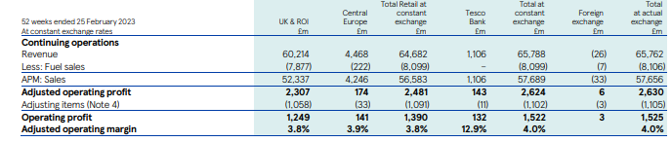
Figure 2: Income Statement of Tesco PLC
(Source: Tescoplc.com, 2023)
The aforementioned figure details the success of Tesco’s SMM efforts highlighted by the adjusted operating profit of 2307 billion pounds in 2023 (Tescoplc.com, 2023). The research focuses on positive consumer buying behaviour via effective social media marketing, showing a way to combat the issue via appropriate SMM methods. Hence, understanding the behaviour of the consumer via the study can help Tesco estimate demand and improve profitability within the current market.

1.4 Research Question
- Why does the impact of the social media marketing of Tesco on positively influence consumer behaviour?
- What are the key challenges of consumer behaviour analysis that can impact SMM?
- How can the social media marketing efforts of Tesco be improved to foster a loyal customer base?

1.5 Research Significance
The proposed research can help detail the importance of targeted social media efforts for brands like Tesco to incite positive consumer behaviours for increased sales. In 2023 around 4.9 billion people worldwide make use of social media with 90% of users following a prominent brand (Forbes.com, 2023). A shift has been denoted in consumer behaviour in favour of direct engagement with the brand, necessitating a strong social media presence for brands such as Tesco.
The research is significant for enhancing customer interaction by using social media marketing in business. A large segment of customers of nearly 44% are shown to be purpose-driven, preferring brands that align with their personal values (Forbes.com, 2022). Hence, the research can help show the methods of understanding consumer behaviour to improve the SMM efforts of Tesco.

Chapter 2: Literature Review

2.1 Chapter Introduction
The literature review is an essential part of a study showing key information from previously published authors on the topic chosen. The Literature review chapter analyses certain key themes related to the topic while also providing relevant theories on the topic to improve the authenticity of the study.

2.2 Social Media Marketing Strategies of Modern Brands
Tesco’s social media strategies are an essential part of its operational strategy as effective brand management on all platforms has enabled the brand to become successful. As an example, Tesco makes use of geo targeted adverts and personalised social media campaigns to target consumer groups, inciting positive consumer behaviour. Customers expect businesses to treat them as important stakeholders and personalised marketing enables customers to feel special. On the contrary, Smith and McElwee (2021) have opined how scandals like the Horsemeat scandal of Tesco lead to negative consumer behaviour like boycotts on social media. Brands focus significantly on improving their customer service experience to incite positive purchase intent in customers

2.3 Social media marketing positively influencing consumer behaviour
Social Media has become a platform for users to share brand/product experiences and brands tend to focus on providing a positive experience to the customer to develop consumer loyalty. As opined by Topaloglu and Dass (2021), consumer decision-making is impacted heavily by online reviews of consumers left on social media due to the application of herd mentality. Fostering trust within a brand is a key measure for improving consumer behaviour applications. The social media marketing for modern brands can help to promote increased retail sales and address the brand’s omnichannel strategy by creating engaging posts and advertisements. Hence, social media marketing has a positive influence on business by developing consumer behaviour.
SMM helps businesses to achieve organisational success by developing interaction with customers. On the contrary, Andalibi and Buss (2020) have opined the intrusive nature of social media advertising in the case of some customers, leads to negative behaviour like seeking alternative options. Consumer behaviour management becomes a necessary element of the management of a business. Social media is also used as a point for researching products and as such marketing efforts of brands like Tesco must positively aim to improve the customer experience. Hence, the development of brand loyalty can be a positive consumer behaviour that can be a key target of SMM strategies of brands like Tesco.

2.4 Challenges of consumer behaviour management
Companies face a number of issues in the effective management of consumer behaviour, leading to decreased ROI from social media marketing efforts. As opined by Safara (2022), biases in consumer behaviour range from price misperception to quality misperception and can affect the market share of companies. Careful consideration of bias during social media marketing efforts is necessary to invoke positive marketing outcomes. Organisations need to be aware of challenges regarding consumer behaviour management to prevent from any kind of losses. Hence, careful consideration of challenges like managing bias and decreased ROI needs to be considered when formulating strategies.

2.5 Theoretical Underpinning
Maslow’s Hierarchy of needs
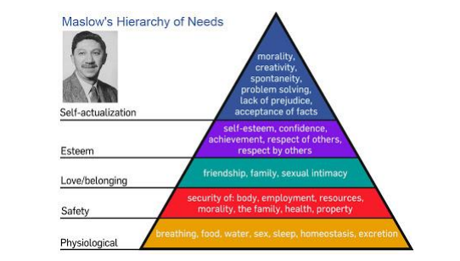
Figure 4: Maslow’s Hierarchy of Needs Pyramid
(Source: Trivedi and Mehta, 2019)
Maslow’s need hierarchy theory is a prominent theory of consumer behaviour that categorises basic human needs into five different categories in the shape of a pyramid. As opined by Trivedi and Mehta (2019), the fundamental needs are portrayed at the bottom and the non-essential ones are stated at the top, highlighting the fulfilment of mental satisfaction. The five types of needs include Physiological, Safety, love and belonging, esteem and self-actualisation needs. The model is used to evaluate customer motivations and give a view on the needs of the consumer to fulfil in order to evoke a positive response. Hence, the model is useful in the study as it can help in the formulation of need-specific strategies in the case of Tesco.
EKB Model of Consumer Behaviour
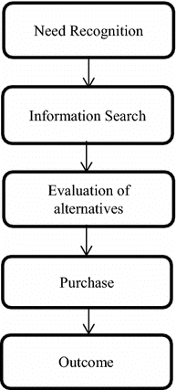
Figure 5: Steps of the EKB model
(Source: self-created)
The Engell-Kollat and Blackwell model of consumer behaviour is a prominent model that helps highlight the key stages that a consumer experiences before the purchase of a product. As opined by Lily and Yazdanifard (2021), the need recognition stage brings about an assessment of needs while the information search stage promotes finding a cause for purchase. The stage of evaluation compares the product with alternatives and the purchase decision stage shows the purchase of a product for the value. This model can be helpful to understand consumer behaviour and enhance growth in business by generating higher ROI. The model is useful for deciphering the key steps that consumers of Tesco will face when interacting with SMM materials of Tesco, influencing positive consumer behaviours.

2.6 Literature Gap
After a detailed understanding of the literature, some key sections of the topic have been avoided. The study leaves out the detailed study of customer biases as no studies have related consumer biases to SMM performance. Hence, the unfinished study of customer biases and their effect on SMM performance can be detailed to be the key gap in the literature.

2.7 Chapter Summary
It can be summarised that the chapter on the Literature review highlights the importance of customer behaviour management for improving the SMM process of Tesco. The theories highlighted including Maslow’s theory and the EKB model are used to improve the literature section by aligning with key theories of behaviour management.

Chapter 3: Methodology
Research methodology will describe the tools and procedures used for the collection and analysis of data to improve the results. Research Philosophy denotes the method of gathering and analysing data, consistent primarily with Positivism and Interprevism. Positivism Research Philosophy will be used for this study as it focuses on detailed observation of the social media marketing behaviour of Tesco (Kirongo and Odoyo, 2020). Research Approach details the procedure of conducting a study by comparing the key hypotheses of the research to either inductive or deductive approaches.
The Deductive Research Approach will be applied this study as it helps in converting the collected primary data into new and specific knowledge (Pearse, 2019). Research Design is described as the key strategy employed to meet the research questions by making use of the collected empirical data. The Descriptive Research Design will be used in the study as it reinforces the use of descriptive methods to describe the approaches to the research question.
The process of data collection is an important procedure of research as it helps in the synthesis of findings to help improve research outcomes. Data collection primarily consists of two methods, those being primary and secondary, with primary data collection as the preferred method in this study. The study will incorporate primary quantitative data collected from the customers of Tesco to improve the quality of analysis by incorporating recent data. The key advantages of primary data collection for the study includes an accurate and reliable result and an in depth analysis of the collected data. The research will consider 30 respondents, including loyal customers of Tesco as a sample size. Tesco’s 30 customers will taken into consideration to gain significant information on impact of social media marketing on customer interaction.
The simple random sampling method will be used to remove bias during the sampling process. The chosen sampling method presents a number of key advantages that help solidify the choice including cheap implementation costs and efficient sampling within the stipulated time. Data analysis is an essential step of the research as it will help in the detailed analysis of the collected data to draw conclusions meeting the research questions. The primary method will make use of a questionnaire containing twelve questions distributed via an in-person survey. The Primary quantitative data that will be collected will be analysed using excel calculations. The questionnaire will constitute of close ended questions and will include questions on the behavioural choices of consumers in regard to Tesco. Primary Quantitative research will be useful for complete elimination of bias and the sampling of Tesco customers will improve the accuracy of the results. (Braun and Clarke, 2023). Hence, the research will make effective use of primary data to analyse the topic in detail and present actionable results.
Ethical Consideration
- The Data Protection Act of 2018 of the UK necessitates the use of data protective measures when conducting research to protect data from data leaks (Gov.uk, 2023). In compliance, the research will protect the used data from any sort of data leak to improve the validity of the study
- The study will not collect any sort of personal demographic information from participants and will incorporate a consent form attached with the online questionnaire. Consent form can help to enhance safety of participants and increase to participations in a research study. (King-Kallimanis et al. 2023). The Consent form will ensure compliance with data protection laws and ensure rational participation.
Project Timeline
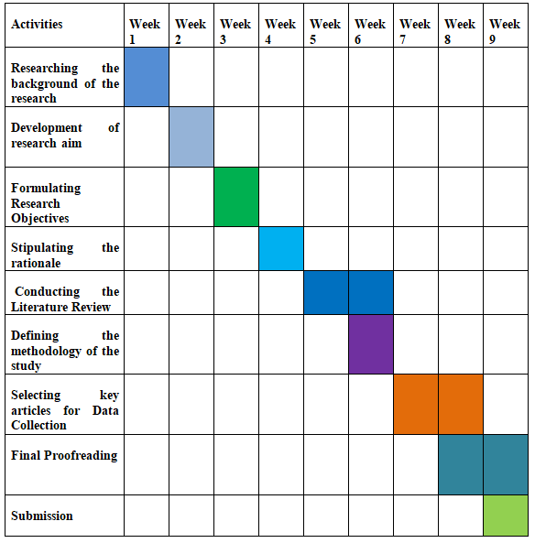
Figure 6: Project Timeline
(Source: self-created)

References
Andalibi, N. and Buss, J., (2020) April. The human in emotion recognition on social media: Attitudes, outcomes, risks. In Proceedings of the 2020 CHI Conference on Human Factors in Computing Systems (pp. 1-16).
Braun, V. and Clarke, V., (2023) Toward good practice in thematic analysis: Avoiding common problems and be (com) ing a knowing researcher. International Journal of Transgender Health, 24(1), pp.1-6.
CNBC.com (2023) Britain’s lockdown drives Tesco’s sales and costs higher [online] Available at: https://www.cnbc.com/2020/10/07/britains-lockdown-drives-tescos-sales-and-costs-higher.html?&qsearchterm=Tesco[Accessed 29 November, 2023]
Forbes.com (2021) 15 Customer Behaviour Trends emerging this year [online] Available at: https://www.forbes.com/sites/forbesbusinesscouncil/2021/03/15/15-customer-behavior-trends-emerging-this-year/?sh=1610aabd14d9[Accessed 29 November, 2023]
Forbes.com (2022) Why Consumer Habits Should Help Determine Your Business Purpose [online] Available at: https://www.forbes.com/sites/forbesbusinesscouncil/2022/05/13/why-consumer-habits-should-help-determine-your-business-purpose/?sh=5d152e5845af [Accessed 29 November, 2023]
Forbes.com (2023) Top Social Media Statistics and Trends of 2023 [online] Available at : https://www.forbes.com/advisor/in/business/social-media-statistics/#:~:text=90%25%20of%20users%20follow%20at%20least%20one%20brand%20on%20social%20media&text=It's%20a%20powerful%20illustration%20of,establish%20and%20maintain%20brand%20loyalty.[Accessed 29 November, 2023]
Gov.uk (2023) Data protection Act [online] Avaliable at: https://www.gov.uk/data-protection[Accessed 29 November, 2023]
King-Kallimanis, B.L., Ferris, A., Dropkin, L., Molina, M., Redway, L., Gerber, D.E., Grant, T.L. and Roy, U.B., (2023). Initial Steps in Creating a Patient-Centric Addendum to Clinical Trial Informed Consent Forms. JTO Clinical and Research Reports, 4(10), p.100575.
Kirongo, A. and Odoyo, C., 2020. Research philosophy design and methodologies: A systematic review of research paradigms in information technology.
Lily, Y. and Yazdanifard, R., (2021) The Impact of Consumer Buying Decision on Malaysian Sports Shoe Market. International Journal of Management, Accounting & Economics, 8(2).
Pearse, N., 2019, June. An illustration of deductive analysis in qualitative research. In 18th European conference on research methodology for business and management studies (p. 264).
Purwanto, A., (2021) Education Management Research Data Analysis: Comparison of Results between Lisrel, Tetrad, GSCA, Amos, SmartPLS, WarpPLS, and SPSS For Small Samples. NidhomulHaq: JurnalManajemenPendidikan Islam, 6(2).
Reuters.com (2022) Tesco says Britons buying less and trading down to navigate inflation [online] Available at: https://www.reuters.com/business/retail-consumer/uks-tesco-sees-early-signs-changing-customer-behaviour-inflation-hits-2022-06-17/[Accessed 29 November, 2023]
Safara, F., (2022) A computational model to predict consumer behaviour during COVID-19 pandemic. Computational Economics, 59(4), pp.1525-1538.
Smith, R. and McElwee, G., (2021) The “horse-meat” scandal: illegal activity in the food supply chain. Supply Chain Management: An International Journal, 26(5), pp.565-578.
Tescoplc.com (2023) Annual Report 2023 [online] Available at: https://www.tescoplc.com/investors/reports-results-and-presentations/annual-report-2023[Accessed 29 November, 2023]
Topaloglu, O. and Dass, M., (2021) The impact of online review content and linguistic style matching on new product sales: The moderating role of review helpfulness. Decision Sciences, 52(3), pp.749-775.
Trivedi, A.J. and Mehta, A., (2019) Maslow's Hierarchy of Needs-Theory of Human Motivation. International Journal of Research in all Subjects in Multi Languages, 7(6), pp.38-41.

