

Assessment 1 – Reading Task Template
PART 1: Upload your photo of your A3 in-class notes here:
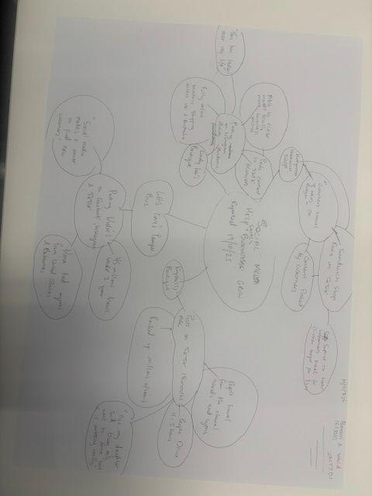

PART 2:
- Answer every question below in 1-3 full sentences.
- Use your own words. Do not use generative AI to answer these questions.
- Include a specific detail from the text when asked.
REMINDER
- The main idea is the overall message of the whole text.
- A key point helps to explain the main idea.
- A specific detail or example from the text shows that the key point is true.

- What is the main idea of the whole text?
The main idea of the text explains how social media platforms like facebook, tiktok and instagram can help small businesses grow and get more customers to shop with them.

- What is one key point that supports the main idea, and which specific example from the text shows this?
One key point that supports the main idea of the text is that of Lindy Loo’s boutique article. Where it states ‘Today she is followed by a combined 320,000 people across facebook and instagram’ from her small stall to gaining a large following on social media this clearly supports the main idea of the text.

- What is a different key point that supports the main idea, and which specific example from the text shows this?
Another key point that supports the main idea is that of Murat Mutlu’s Honywood sandwich shop story. In the text, it says ‘it was a big surprise to me to hear customers had travelled for our chicken burger for three hours’ all because of his local customers posts on social media helping him gain widespread hype for his food.

- Which part of the text do you think is most important, and why?
I believe the most important part of the text is evidently the figures shown. In each part of the text you see a pattern of small businesses using social media to boost attention and create a trend that helps their business explode into something they’ve never seen before showing us as a reader that social media can really have an affect on a businesses success.

Reflection:
- What did you find difficult in this task (including in-class components), and why was it difficult?
I found it difficult to grasp the concept of the mindmap in-class as it was abit confusing at first branching out each idea. But once i got the hang of it and made sense of it i understood why it was necessary to use.

- What helped you with this difficulty, and how did it help you?
Reading, re-reading, and making mistakes before i asked questions really helped me better understand the idea of making a mind map and how each point connects to the other. Mind maps are now very easy for me and help organise information in a clear and simple format.

