

Major Interim Report- M7X01373

Implementation of Innovative Technologies into Altrad Services (mechanical) Quality Management System

Connecting Manufacturing

Author: - Adrian Devonald
MSc Engineering Project Management

Project Supervisor-Andrew Thorn

Content
Chapter 1: -Introductions / Literature Review
1.0-Introduction
1.1-Project aims and overview-
1.1.1-Overview of Altrads current standards/processes,
1.1.2- Integrating management Systems
1.1.3- Connecting manufacturing (industry standards and implementation of innovative technologies
1.2-Introduction to the Altrad Group
1.2.1-Mohed Altrad
1.2.2-Business Background
1.2.3- Altrad Services

Chapter 2: - Literature Review
Current Industry Standards
2.1-ISO 9001-Quality Management
2.2-ISO 14001-Environmental Management
2.3-ISO 45001 (18001)-Occupational Health and Safety
2.4-Standard Integration

Chapter 3-Integration within the Business
3.0- Commonalities within all standards -Table 1
3.1-Integrating standards (Altrad and Industry Standards)
3.1.1-Full Integration Management System
3.1.2-Partial Integrated Management System
3.2- Integration within Altrad Concept (auditing & additional training)
3.3-Integrating 45001 & 14001- Look at areas where commonalities do not exist
3.3.1-Risk Assessment-Common HSE & Environmental Policy
3.3.2-SWOT Analysis
3.4-Cost and resource implications of integration (processes, training, software required)
3.4.1-Quantify the benefits
3.5- Implementation Plan (P6 timescale / GANTT Chart)
3.6-Project Life cycle
Chapter 4-Altrad Quality Management Systems
4.1-Altrads Quality Management System (three different audits/systems)
4.2-Altrads Vison
4.3-Connecting Manufacturing
4.4- ADKAR Model

Chapter 5-Sources of innovations
5.0- Types of innovations
5.1- Impact of Innovations within the organisation (Quality Circle)
5.2-Connecting Manufacturing-New technologies
5.3-Enviromnmental factor- Paperless innovations/ Environmental Factors
5.4- ADKAR Model
5.5-Resistance to change

Chapter 6 -Project Progress / Progression Plan

Chapter 7-References

Please Note: - Chapters highlighted in blue are areas in which require additional research in which will be included in final proposal.

1.0-Introduction
The aim of this report is to critically analyse the current progress of the thesis for the Implementation of Innovative Technologies into Altrad Services (mechanical) Quality Management System. I plan to identify and discuss the reasons for carrying out such research and aim to discuss the project outcomes from these findings.
1.1-Project aims and Overview
The aim of the major project is to examine the current quality management system in which Altrad (mechanical) currently implement within the organisation and explore possible areas that could be improved to enable a more sufficient working system. With the world rapidly evolving and new technologies readily available, I feel Altrad as a whole adopt a dated, manual system into which vast improvements can be made to produce a standalone, integrated quality management system.

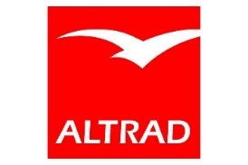
1-(Altrad.com, 2018)

The aim is to explore all the current control measures and accreditations that are currently in place within Altrad. From here I aim to review and compress documentation that Altrad currently distribute throughout the organisation (where possible) and develop a single system in which can be implemented company wide, to allow users full transparency to view a live-system which enables access to all pending, ongoing and complete activities within the organisation, bringing together all aspect of quality, commercial and safety to produce a more efficient system 2-(Zhukov et al., 2019).
In doing this, I am going to examine industry standards, ISO 9001 (Quality Management Systems), ISO 14001(Environmental Management) and 45001 (18001-Occupational Health and Safety) to gain knowledge and further information, making sure the newly proposed system captures all critical aspects to comply with industry standard going forward.
Although aimed at Altrad, I will carry out research on a number of manufacturing organizations and clients who work alongside and with Altrad currently, carrying out questionnaires and interviews into how each organization control all aspects of fabrication and what documentation is used and how, taking note of and any downfalls that may be apparent in which improvements can be made. Using all the information gained from this exercise, will allow me to help navigate the new system taking key aspects from all parties and merging them into one standalone system 3- (Avdeeva et al., 2019).
Alongside this, and as part of IS0 14001, the environmental issues will become apparent in years to come. This system will solely be a digitalised, an online system accessed by computer or tablet (subject to research). This will mitigate the need for constant paper trails allowing all documentation to be recorded and stored digitally allowing full trackability and transparency to all involved.
The overall outcome of this project will be to produce a visual concept in which can be navigated to control all aspects of a new, improved, integrated quality management system. From all stages as noted from contract awarded, design, fabrication, completions and handover within the organisation, 100% transparency for all works undertaken. Benefits of this system will include but not limited to: - transparency of works through the organisation for all levels to track progress, resulting in live date into which can also be presented to clients. Simple but precise information recording tool for all users to input and extract data when required. Interaction with 3rd parties i.e NDT contractors, painting contractors so as all stages of work are requested and recorded accordingly. Paperless, achieving an environmentally friendly system within the organisation. Many businesses have already adapted this approach and feel Altrad need to catch up with current market players to continue their growth in the engineering sector.
The cost to implement this system companywide is something that is currently being researched as a new system (SAP to Navison) has recently been rolled out and implemented within Altrad UK. I have contacted the transition team to get an idea of the process and any implications along the way in which will be fed back and recorded in the interim report going forward.

1.2-Introduction to the Altrad Group
1.2.1-Mohamed Altrad
To get a true understanding of the Altrad Group, I feel it is necessary to understand the personality of the founder, the man who still leads and drives the business to this day. The story of Mohed Altrad is a human story that combines the desire of a child with the courage, competence and intuition of an entrepreneur.

Born into a nomadic tribe in Syria in 1948, his mother died the same day in which he was born, and his Bedouin farther gave him away to his grandparents at age four. He was an orphan from birth. His mother was barely 15 years of age when she had him. She had given birth alone in the village - had no friends and was treated like excess baggage.
4.(Badawi and Altrad, M., 2020)
This little boy's life was put through every obstacle. His grandmother and father did everything they could to hold him back...gave him zero encouragement to succeed - or support to feel proud and worthy of himself... Yet, this little 'man' had a spirit in him that couldn't be stopped.


5-(Get to know me - Mohed Altrad, 2020)

1.2.2-Business Background
Altrad Services organizes multidisciplinary teams with a wealth of knowledge that is unmatched. This deal, the first offer on the industrial market, is customized to each individual customer's unique needs 6-(Lebedeva et al., 2019). This approach to added value and wealth development is the outcome of a variety of unique storeys that brought Altrad Services to life.
- 1985: The Montpellier Altrad group is formed.
- Today, its founder Mohed Altrad still leads the group. It has been a significant player in the manufacture and sale of construction equipment for 30 years.
- By taking over Balliauw, which specializes in services to the industrial sector, the company reached a significant turning point in 2006.
- Purchase of three leading industrial services firms in Europe, Altrad has tripled in size in just two years in 2015-2017: firstly, the Dutch company Hertel, then the French company and finally Cape plc in UK.
- Altrad Services is now an integral element of the competitive inclusion of numerous Altrad enterprises, all leading companies in their respective markets: Altrad Balliaw, Hertel, Prezioso Linjebygg, Cape plc, Altrad Rodisola, Altrad NSG, Poujaud and Comi Operation.
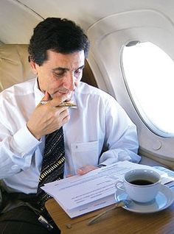

7-(Mohed Altrad Net Worth 2020, 2020)
1.2.1-Altrad Services
Today Altrad Services are a worldwide, multi-disciplined organisation who provide a serve to a range of cliental around the globe, on and offshore. The organization has taken part in many market cycles. Therefore, suffered from substantial declines in margins and activity in the event of a cycle reversal, as in the year 2009, while so many businesses operate in the sector as monocycle. Never lost money in the Altrad group. The Group now proceeds from the maintenance investments of its customers into large industrial units when the industrial cycle is short, particularly in the oil and gas sectors. The group will share its know-how in order to invest in new equipment with consumers when the cycle recovers again.

Chapter 2: -Literature Review
Current Industry Standards
Quality Management
Altrad Services not only fulfils but exceeds within industry in the work they carry out. This leads to continuity in the delivery of projects by building on validated accredited management systems built from industry standards and a culture of learning.
Our dedication to successful control quality, guided by experienced and committed employees, enhances our partnerships while minimizing risk and creating opportunities. Through this dedication, we have developed a reputation for absolute honesty in the industry, where our company is trustworthy. Our activities are central with the Altrad Management System (AMS). The documentation on quality assurance and quality control has been established primarily for projects and facilities, and our methodology is laid down in a project-specific Quality Management Plan 8-(Abenova, 2019).
Background to management systems and their integration: -
2.1-ISO 9001-Quality Management
ISO 9001 is a worldwide recognised Quality management system and has been implemented by over 1 million business worldwide. ISO 9001 is not intended as a detailed prescription for how quality is to be achieved, but rather as what needs to be done in a generic sense. In other words, gaining ISO 9000 certification does not guarantee quality of products and services, but rather it provides an assurance to customers that the organisation has conformed to an international standard ([13] Brunsson et al. , 2000). 9-(Feng, Terziovski and Samson, 2007). This system will help streamline the business processes, reduce errors and free up valuable management time to improve communications.
Benefits of using the ISO 9001 framework:

- Increased efficiency: by following industry best-practice and focusing on quality you can reduce costs and time.
- Increased revenue: through the reputation of ISO 9001 you can win more tenders and contracts, and by being more efficient you will also retain more customers and experience repeat custom.
- Higher levels of customer satisfaction: by understanding your customers’ needs and reducing errors you increase customer confidence in your ability to deliver products and services.
- Improved supplier relationships: ISO 9001 certification ensures best-practice processes are in place which can contribute to more efficient supply chains, certification increases their confidence in your processes.
- Improved employee morale: by improving internal communications you ensure everyone works to one agenda.

10 (ISO 9001 Certification Norwich, 2020)

2.2-ISO 14001-Environmental Management
ISO 14001 is the most popular environmental management standard worldwide, with more than 285,000 companies having adopted it as their main means of dealing with corporate environmental challenges (ISO 2013). The standard has been written in such a way that it includes all types and sizes of organizations and addresses diverse geographical, cultural and social conditions. ISO 14001 is a certifiable environmental management standard, meaning that external auditors, known as certification bodies, are called in by firms to certify their commitment to the standard’s requirements. 10-(Iatridis and Kesidou, 2016)
Altrad withhold the 14001 accreditations across a number of facilities within the business. As per the 9001 accreditations, a periodic audit (twelve months) is carried out at each facility making sure they comply with the standards requirements.
2.3-ISO 45001 (18001)-Occupational Health and Safety
ISO 45001 is a proposed international safety management system standard, the latest in the progression of similar standards over the past 2 decades. It is built from the environmental management systems approach (ISO 14001) to address safety, first with OHSAS 18001 (a British standard), then ANSI Z10 (an American standard). The current proposed ISO 45001 is the product of a project committee (ISO PC 283) representing more than 70 countries (AFNOR Group, 2015; BSI Group, 2014). ISO 45001 provides a structure for building an ergonomic improvement process, whether that is a standalone improvement process or an element of an organization’s safety management system. This practice of leveraging a safety management system model to manage ergonomics is illustrated by several organizations including AIHA (Rostykus, 2008), CSA (2012), NIOSH (Torma-Krajewski, Steiner & BurgessLimerick, 2009) and ILO (1997). 11-(G. Rostykus, Ip and Ann Dustin, 2016)
The purpose of a safety management system is to provide and reduce the risk of occupational injuries, illness and fatalities in which aligns with the work in which Altrad undertake as a business.
2.4-Integration
Though the similarities are important, recognizing the differences between the various management systems is equally consequential. For instance, although both ISO 9000 and ISO 14000 standard series have the same "management systems focus, they greatly differ in their roles, applications, complexity, documentation and most importantly the people they affect - both in their nature (i.e. businesses) and customers/consumers" (Picard, 1998, p. 32).Integration would thus ensure that instead of two or more different standards/systems, only one integrated standard is present within the organization, which could be efficiently and effectively understood, implemented, and maintained, especially by its employees. In the view of White (1999, p. 11) the integration process depends on a number of factors, excluding the costs, expertise and resources availability. These factors include:
- complexity of the company (single/multiple sites; national/multinational);
- how closely environmental issues are related to the company's key processes; and
- whether QMS and EMS issues are included in the same document.
12-(Zutshi and Sohal, 2020)

Chapter 3-Integration within the Business
Definitions
Integrated Management System
An Integrated Management System (IMS) incorporates all elements of the structures, procedures and standards of an organization into one intelligent system. This merger helps an organization to streamline its administration, save time and improve productivity by tackling all facets of the entire management structure 13-(Kenzhaliyev, 2019).
Level of Integration
The level to which an organisation uses one single management system to manage multiple aspects of organisational performance to meet requirements of one or more management system standard/specification.

Full Integration

Partial Integration

3.0- Commonalities within all standards
As the research of the three standards progresses, it has become apparent straight from the onset there are a number of commonalities within all three that could be reviewed and merged to suit a more effective system. ISO 45001 has less commonalities in which may require Occupational Health and Safety to still be a standalone system. Some aspects can be merged but would need to be reviewed further. As the paper evolves and the standards are examined, I will look at merging these areas into a more compressed standard.

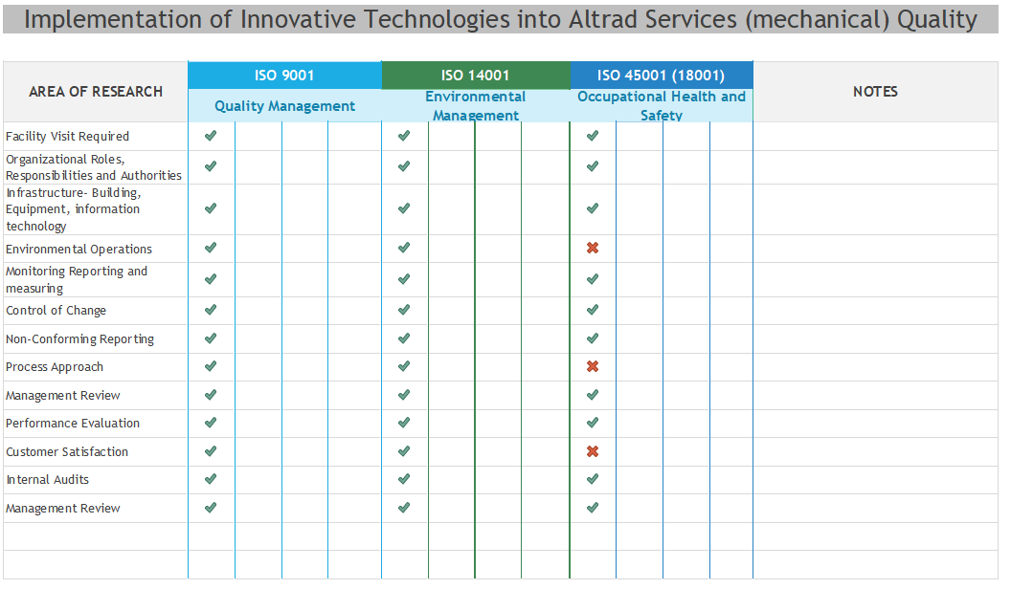
Figure 1.0- Commonalities Within Standards

Going forward and as the project progresses, the results to my finding will provide a clear vision of the commonalties across all three standards, merging certain areas and criteria of Altrads current QMS into one integrated quality management system (IQMS). In additional to this, the way in which it would be delivered and reviewed within the organisation at the Pembroke facility initially and introduced business wide if the concept was successfully implemented.

3.2- Integration within Altrad Concept (auditing & additional training)
Currently within the Altrad Group, with regards to the three standards noted, three different audits take place periodically. Normally, this is carried out over a one, two or three day visit to the facility (depending on standard). Being involved in all three audits, there are a lot of commonalties through in which could be developed into a process in which Altrad could adopt when it comes to audits. I’m planning on re-writing the standards but extracting common factors from all three, merging into one system in which could be utilise for auditing purposes and alike.

3.3-Integrating 9001 and 14001- Look at areas where commonalities do not exist
4.3.1-Risk Assessment-Common Quality & Environmental factors.
As the above Table 1 demonstrates, across 9001 and 14001 standards, there are a number of commonalties in which could be merged across two. To enable this, I aim to examine further each of the areas highlighted and discuss the requirements within.
3.3.2-Risk Assesment-45001
Health and Safety is a much bigger area to research due to the number of different factors that are involved. The initial basis for this standard is within the mechanical sector, this will inevitably be evolved around our facility, training and working practices within offsite workshops and on site processes.
3.3.3-SWOT Analysis
3.4-Cost and resource implications of integration (processes, training, software required)
3.5- Project Implementation Plan
Below is an extract from the project plan that has been produced to log and record progress throughout. The dates/milestones have been noted making sure that all aspects are managed accordingly, and enough time has been allocated for each stage. Some activities may start earlier than planned, overlap and over ruin but the main aim is to manage to in such a way that the deadline is met and all surrounding activities such as budgets are adhered too to complete the project.

Project Implementation Plan

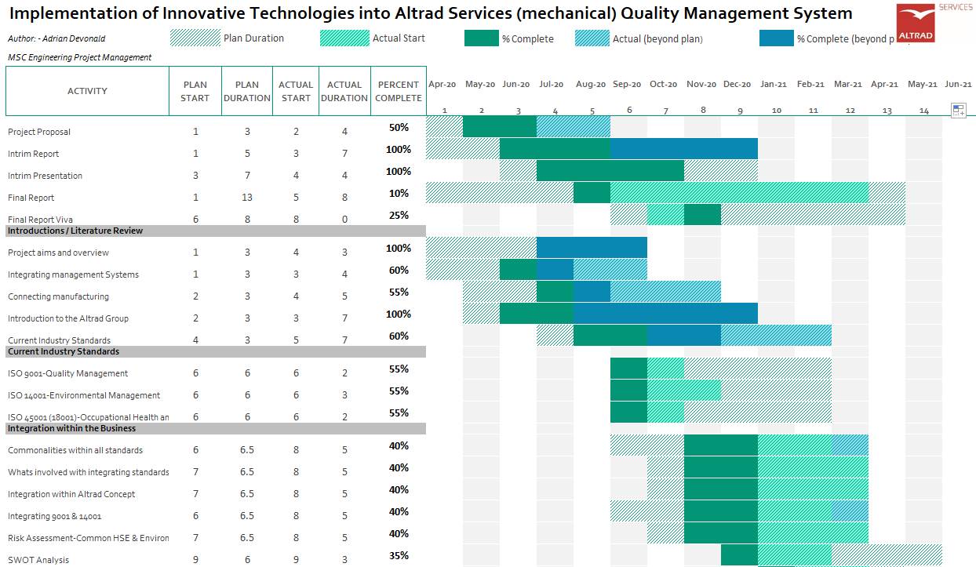

Figure 2 : Project Gantt Chart

3.6-Project Life cycle
Once all aspects of the proposal have been examined, this integrated system could be used for many years to come, adhering to industry and procedural standards. I feel there is definitely a requirement to get up to speed within the organisation and to be able to compete with other manufacturing organisations.

Chapter 4-Altrad Quality Management Systems
4.1-Altrads Quality Management System
One of the main aspects of this paper is to review Altrads current quality management system and how the incorporate the industry standards as noted above. The aim is to combine the commonalties with all three and produce a standalone concept. Implementing key aspects providing a more efficient, stream line system.
As noted above, Altrad bought Cape Engineering Services back in 2017 into which they inherited their quality management system, Cape Management System (CMS). This database was an online system in which could be accessed by authorised personnel in which held industry standards and related documentation.
Prior to the takeover in 2017, Altrad also purchased Hertel Service in 2015 which also held their own quality management system. Due to Altrad wanting to be one entity within industry, it was communicated by the business that there would be a standalone system through the business, extracting key documentation from both organisation and merging into one master database. To date, the transition is still ongoing with a number of documents being reviewed on a regular basis making sure all items are relevant to the industry standard.
4.2-Connecting Manufacturing
Since the start of this paper and researching the current industry standards, the way of working around the world has evolved and changed to suit a more remote way of working. A lot more business are adapting to the changes COVID-19 has presented us with, be it working remotely from home, reduce number of staff required at facilities to operate therefore implementing the use of Microsoft Teams and Skype.
4.3-Altrads Vison
Since the take over, I have learnt that Altrad as an organisation are always striving to be the best at what they do within the industry. They are eager to reach out beyond new boundaries and are willing to explore innovative ways of thinking and working. What we do is therefore not easy: we are entrepreneurs and thus take risks and challenge ourselves permanently. Our objectives is always to achieve the best outcome despite the difficulties 1-(Altrad.com, 2018)
Economical Factor
Altrad are keen to explore all avenues in which will help build the organisation into a more efficient, environmentally friendly business. One of the most recent projects executed is the use of electric vans throughout their fleet of vehicles. In support of our carbon reduction agenda, the first of Altrad’s electric vehicles were recently rolled out at Fawley refinery in support of our client ExxonMobil.
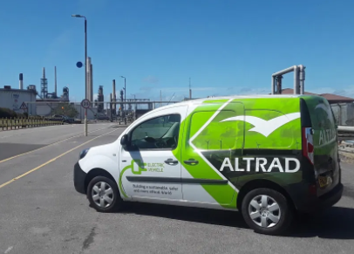
Image-(Altrad.com, 2018)

The arrival of our first electric vehicles marks an exciting milestone in our plan to transfer 10% of the Altrad van fleet to electric power within the next 12 months. 1-(Altrad.com, 2018)
4.4- ADKAR Model
The ADKAR Model is a worldwide management tool in which guides individuals and organisations when change is imminent in their business. ADKAR is an acronym that represents five tangible and concrete outcomes that people and organisations need to achieve for lasting change: awareness, desire, knowledge, ability and change. By setting goals and change within the business, ADKAR Model is an effective way of planning and managing the changes efficiently.
When organization approach changes using this model, they can immediately identify where the process is breaking down and which elements are being overlooked. ADKAR can help organization as individual player on market to plan effectively for a new change or diagnose why a current change is failing. In some cases, corrective action can be taken, and the change successfully implemented. Here are the five elements of ADKAR again. 1. Awareness of the need for change. 2. Desire to make the change happen. 3. Knowledge about how to change. 4. Ability to implement new skills and behaviours. 5. Reinforcement to retain the change once it has been made
Change can be more effectively managed with specific tactics and can be developed for each of the states of change. As people understand why the change is necessary, there is a desire to make this change work also for organization. 14-(Dana Boca, 2013)

Chapter 5-Sources of Innovation
5.0- Types of innovations
Further to my research, I aim to look a new innovation that are available to be adapted and utilise alongside this combined system. Although the aim is to review and compact the standards, the way in which the actual audits on facilities is carried out will be reviewed. From the use and implementation of Microsoft Teams, Skype and alike will be explored further how these can also be adopted to make this system for efficient and economical to the environment.
The Environmental factor down to being paperless and reducing the need to travel be it over
Impact of Innovations within the organisation (Quality Circle), Connecting Manufacturing-New technologies, Microsoft TEAMS, Skype, Environmental factor- Paperless innovations/ Environmental Factors

Chapter 6.0 Project Progress / Progression Plan
To date and after a number of meetings with my project mentor, the project has developed, and milestones achieved. Utilising the Gantt chert developed, the project is progressing as planned.
Company Background
I have researched the company background and have given and insight of Mohed Altrad and the Altrad Group. Also, I have gone on to briefly discuss the vison within the organisation. Altrad have a strong, passionate approach with all the implement within industry. This information will be part of the major report so the end user has a feel for the company and the man behind the driving force.
Current Industry Standards
As part of my role within the organisation, I am aware of the standards as am involved in the auditing processes for each accreditation. This project has allowed me to develop my knowledge further in each standard which will assist me when evolving the project. Although there is more work to do, I feel I have a clear path and understanding of what is entailed when it comes to merging all three.
Integrated Management System
As the project develops, I find there are more areas to research and look further into when the
Sources of Innovation
Following on from the research and implementation of merging the three standards, one of the areas I also aim to look a tis the implementation of new innovative processes to getting this communicated through the organisation. I aim to research further the technologies that are out there in which can be adopted into the working environment, office, workshop and site based. As part of implementing new process I will research further using the ADKAR model and look at resistance to change within the organisation and what can be adopted to assist personnel with these changes.
Project Cost
To date, costs are yet to be generated into how much this will coat Altrad to get in place within the Pembroke facility and companywide. Additional training will be required for key personnel to obtain knowledge of how the new system would be integrated. Further to this, electronic devices would be required take full advantage of the new system. Again, training may be required for personnel on how to access and navigate the system.
As noted above in the introduction, the cost to implement this system companywide is something that is currently being researched as a new system (SAP to Navison) has recently been rolled out and implemented within Altrad UK. I have contacted the transition team to get an idea of the process and any implications along the way in which will be fed back and recorded in the interim report going forward.
As noted on the content page in blue and as detailed within the paper, there are still areas in which need to be addressed and researched to enable the project to develop. As the paper evolves, my knowledge and understanding of this transition will become more apparent noting key aspects within. The overall outcome of this paper will enable the end reader to understand the current way in which Altrad control and adhere to industry standards, but allow visibility of where I would like to take them as an organisation, implementing an efficient way of working, utilising an integrated management system.

Please Note: - Chapters highlighted in blue are areas in which require additional research in which will be included in the final paper. Feedback from the interim viva also now included.
Chapter 1: -Introductions / Literature Review
1.1.3- Connecting manufacturing (industry standards and implementation of innovative technologies
Chapter 3-Integration within the Business
3.1.1-Full Integration Management System
3.1.2-Partial Integrated Management System
3.2- Integration within Altrad Concept (auditing & additional training)
3.3-Integrating 45001 & 14001- Look at areas where commonalities do not exist
3.3.1-Risk Assessment-Common HSE & Environmental Policy
3.3.2-SWOT Analysis
3.4-Cost and resource implications of integration (processes, training, software required)
3.4.1-Quantify the benefits
3.5- Implementation Plan (P6 timescale / GANTT Chart)
3.6-Project Life cycle
Chapter 4-Altrad Quality Management Systems
4.3-Connecting Manufacturing
4.4- ADKAR Model
Chapter 5-Sources of innovations
5.0- Types of innovations
5.1- Impact of Innovations within the organisation (Quality Circle)
5.2-Connecting Manufacturing-New technologies
5.3-Enviromnmental factor- Paperless innovations/ Environmental Factors
5.4- ADKAR Model
5.5-Resistance to change

References
1.Altrad.com. (2018). Altrad, learning more about the industrial services company - Altrad Group. [online] Available at: https://www.altrad.com/en/altrad-at-a-glance.html [Accessed 1 Nov. 2018].
2-Zhukov, A., Dovydenko, T., Kozlov, S., Ter-Zakaryan, K. and Bobrova, E., 2019. Innovative technologies for low-rise construction. In E3S Web of Conferences (Vol. 91, p. 02032). EDP Sciences.
3-Avdeeva, E., Davydova, T., Skripnikova, N. and Kochetova, L., 2019. Human resource development in the implementation of the concept of “smart cities”. In E3S Web of Conferences (Vol. 110, p. 02139). EDP Sciences.
4.Badawi and Altrad, M., 2020. Badawi. [online] Goodreads.com. Available at: <https://www.goodreads.com/book/show/7789365-badawi> [Accessed 28 November 2020].
5. Mohedaltrad.fr. 2020. Get to Know Me - Mohed Altrad. [online] Available at: <https://www.mohedaltrad.fr/en/get-to-know-me.html> [Accessed 16 October 2020].
6-Lebedeva, T., Yakovlev, A., Kepp, N. and Ikramov, R., 2019, March. Possibilities and threats to TQM implementation in the innovation processes. In IOP Conference Series: Materials Science and Engineering (Vol. 497, No. 1, p. 012132). IOP Publishing.
7.Idol Net Worth. 2020. Mohed Altrad Net Worth 2020. [online] Available at: <https://www.idolnetworth.com/mohed-altrad-net-worth-51146> [Accessed 16 October 2020].
8- Abenova, M.H., 2019. Foreign experience of development of innovative potential of small and medium entrepreneurship. OF SOCIAL AND HUMAN SCIENCES, p.165.
9-Feng, M., Terziovski, M. and Samson, D., 2007. Relationship of ISO 9001:2000 quality system certification with operational and business performance. Journal of Manufacturing Technology Management, 19(1), pp.22-37.
10-Iatridis, K. and Kesidou, E., 2016. What Drives Substantive Versus Symbolic Implementation of ISO 14001 in a Time of Economic Crisis? Insights from Greek Manufacturing Companies. Journal of Business Ethics, 148(4), pp.859-877.
11-G. Rostykus, W., Ip, W. and Ann Dustin, J., 2016. Managing Ergonomics: Applying ISO 45001 as a Model. ProfessionalSafety, [online] 16(12), pp.34-42. Available at: <https://search-proquest-com.ezproxy.uwtsd.ac.uk/docview/1847415289/fulltextPDF/F9AAC25B77E04BC2PQ/1?accountid=130472> [Accessed 26 November 2020].
12-Zutshi, A. and Sohal, A., 2020. Integrated management system: The experiences of three Australian organisations. Journal of manufacturing technology management, Vol. 16(Iss. 2,), pp.(2005): 211-232.
13-Kenzhaliyev, B.K., 2019. Innovative technologies providing enhancement of nonferrous, precious, rare and rare earth metals extraction. Kompleksnoe Ispol’zovanie Mineral’nogo Syr’a (Complex Use of Mineral Resources), 3(310), pp.64-75.
14-Dana Boca, G., 2013. ADKAR MODEL VS. QUALITY MANAGEMENT CHANGE. Dunarea de Jos University of Galati, [online] no. 1, pp.pp. 246 – 253. Available at: <http://www.rce.feaa.ugal.ro/> [Accessed 27 November 2020].

