Louise Thomas
Word Count 2184

AC1.1
Define the term professional and explain what it means to be a ‘people professional’.

CIPD (2019) suggest that a professional is a person who is educated, knowledgeable and skilled in order to apply him or herself in a specialist area. According to Duska et al (2011) moral integrity is the quality that defines being a professional, when one person relies on the advice of another when providing services to others, (Duska et al, 2011) also suggests that the advancement of professionalism brings ethics into the realms of business.
In addition to the professional employee and according to CIPD (2019), the main goal of people professionals is to promote improved workplaces and working conditions. By making the best decisions by being inclusive, making sound judgements to deliver the best outcome, and creating an environment that helps everyone achieve their personal and professional potential. The areas that a people professional may cover are recruitment and selection, performance management, talent management and inclusivity and diversity. According to Taylor and Woodhams (2022), we can determine that the CIPD profession maps goal is to establish a global standard for the human resource industry, of which is evolves over time.
The map has three principle areas, these being
- Principles-led, - clear ideas and convictions should guide and drive decisions, actions and behaviours.
- Evidence-based, - It will demonstrate how using solid evidence can help you come to wiser conclusions in any circumstances.
- Outcomes-driven, - The need to understand context and outcomes including value and risk, to guide the job we conduct
Then centrally, the maps basis is complete with purpose, which includes values, in this area the goal and purpose serves as a global call to action for human resources professionals to drive for better change. Due to purpose occupying the central area of the map a strong identity is built on unifying values and uncompromising standards (CIPD, 2018).
The profession map: (CIPD, 2018)
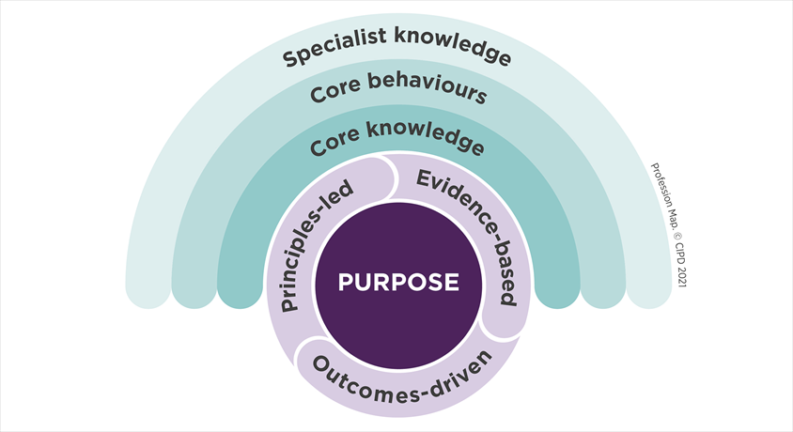

(AC 3.1)
Explore how the role of a people professional (either a generalist or a particular specialist) is evolving and the priorities this raises for continuing professional development (CPD)

As the workforce gets more complicated and varied, the function of a people professional is changing. People professionals must continue their professional development by picking up new skills and staying current with trends in order to remain competitive. According to Zhetoukhova and Baczor (2015) there are eight trends that will focus on the way the people professional’s role will evolve. These are
- utilisation of technology
- workforce diversity
- globalisation
- diversity of employment relationship
- industrial change
- individualism
- social responsibility
- quality of education
In addition to these future trends, CIPD (2018) suggests a strategy plan called continuous professional development (CPD) assists professionals in updating their knowledge and abilities so they can be completely competent in carrying out their present and future professional tasks. CPD is associated with learning to give professionals the opportunity to go through the development process, boost their confidence, and bolster their credibility to carry out responsibilities that may even appear demanding to them. Professionals identify their shortcomings through CPD and create strategies to effectively handle them. A strategy aids in the advancement of professionals. According to CIPD (2022), it is good practise to use the 7-stage cycle, which are
- identify
- plan
- act
- reflect
- apply
- share
- impact
CIPD (2022) suggests that not all organisations are the same or run the same therefore to follow the CPD index and focus on results.
Based on my personal people profession role, the post continues to evolve mainly through training. This is to educate and promote the culture, values inclusivity and diversity that are key to my organisation (Neath Port Talbot Council). In addition to this the recent introduction of AI technology to process back office administration (Lloyd, 2019) Based on technology advancement and with CPD organisational needs and behaviours along with the culture can influence the good working practice of a business.
(AC 1.2)

Discuss the concept of ‘ethical values’, and how at least three ethical values that you hold personally, impact (or could impact) on your work as a people professional.
CIPD (2022) suggests that Businesses ought to "do the right thing" because it is the moral thing to do. This opinion is supported by mainstream business organisations which shows how seriously organisations should take their ethical principles, CIPD (2022) also believes that an open culture raises spirits and an improves reputation which in turn states that ethical businesses overall perform better financially than their rivals
According to Taylor and Woodhams (2022), there are 3 areas of ethical values:
- Personal – the fundamentals of someone’s capacity to distinguish between right and wrong
- Professional – there may be variety of examples such as differences between the principles upheld by your profession and those in the organisation
- Public – Values that guide public life and are centred on the concept of common good.
There are many examples of Personal values such as fairness, inclusivity, evidence-based decision-making, equality, honesty and professional integrity
Three examples of my ethical values as a people professional are integrity, honesty, fairness, and respect. Integrity is about doing the right thing all of the time. For example, if a mistake is made I would always take accountability for my actions; another example is where I show respect to all my colleagues regardless of their status within the organisation and never condoning unethical behaviour. Honesty is a part of everyday values in my personal and professional life. For example. In my previous role, I had to lead on 100 consultations, which possible could have resulted in a redundancy situation. In the first instance it was essential that every employee had exactly the same message and the why this was happening, in one instance I had a conflict with the person involved as they were so angry at the message, In this instance I let them voice their concerns and terminated the meeting, with a further meeting arranged. When we reconvened I spoke honestly and clear and also advised the person I would do everything I could to secure employment for them within the company but also stressed this may not be an option however I could lead them to employment companies that I worked with closely. An example of fairness, respect and inclusivity is on a daily basis and regardless of whether I’m talking to the cleaner or Chief executive, every person deserves to be treated with dignity and respect and this could just be as simple as saying hello or thanking someone for their input that day before you leave.

(AC 1.3)
Explain why it is essential for people professionals to contribute confidently to discussions, and ways of doing this that are
- informed
- clear
- engaging.

According to CIPD (2022c), it has been suggested that people professionals need to possess the ability to persuade others and have the desire to question choices and actions and discussing the ideas of professionalism and ethical principles while emphasising the need to explain inclusiveness. In addition to this (CIPD, 2022) also state that a crucial component of the people practitioner role is to facilitate employee communication. Employee engagement, organisational culture, and productivity.

I frequently have to present a business case within my role as a job evaluator in the local authority. Any employee within the authority can send me an up to date version of their job description and personal specifications and then through a process I can establish if the post warrants a grade and pay increase. I have to use knowledge of the scheme and be very factual in my presentation. When the outcome has a negative effect of the employee, it is essential that I adapt my communication skills with confidence to provide all the evidence-based information as to why the employee has not been successful and through this encourage a further appeal where I will then coach them to improve the next stage outcome. Doing this work helps me provide concise communication to my senior managers.
To do these things effectively, the people professional needs to build relationships with others to understand their views, concerns and needs, and use the most effective ways to communicate with them in order to achieve positive outcomes.

(AC 1.4)
Discuss when and how to raise concerns when issues such as organisational policies or leadership approaches conflict with ethical values or legislation.

As a professional and people practitioner it is important to gain the best evidence-based practice to know how and when to raise concerns. According to CIPD (2015), there is no rulebook or "best practise that people professionals can use to their advantage. To continue using professional judgement effectively, practitioners must be able to identify and address ethical difficulties.

It is also essential that all employees regardless of status have the information and are aware of how to raise concerns. For example, The Public Interest Disclosure Act of 1998 protects individuals and is known as Whistleblowing and enables anonymity, typically, whistleblowing is where a worker expresses concern about the risk or illegality that could have a significant negative impact on the workers (CIPD, 2019).

According to CIPD (2022c) the core of professionalism is ethics, therefore when handling conflict, practitioners should uphold high levels of integrity in order to create cultures of openness and trust

In a previous role i raised concerns over the way in which we recorded debit and credit card details, as this was a travel agent the customer was often not in store whilst booking and it became standard practice (but not best practice) to write down the details of customers card details handwritten on the front of the file. A customer has put a complaint in that his card had been used for fraudulent activity after giving us his card details, he only reported this at store level and the outcome was that the travel agent was not involved. I raised the concern with my regional manager who in turn asked me to contact senior managers and the audit department to address the potential issue. Within 7 days, the whole process had changed nationally and a more secure system was introduced.
(AC 2.1)

Provide a robust argument for ethical people practice that is supported by academic theory and details both the business and human benefits of people at work feeling included, valued and fairly treated.

Any organisation must prioritise having staff that feels appreciated, included and fairly treated. Herzberg two-factor theory of motivation is the concept of job satisfaction through the motivating/hygiene model. It states that factors of motivation would include personal growth and recognition whilst the hygiene factors depict working conditions and salary. Whilst for example employees are involved, in decision-making, they feel valued and included, and ample rewards result in improved performance and motivation. (CIPD, 2021).

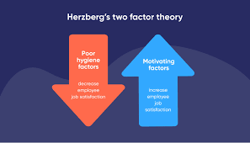
Regardless of our distinct cultural orientation, age, colour or disability, inclusion in practice of cultural and social endeavour in which many groups or individuals from various backgrounds are embraced and welcomed (Shore, Cleveland and Sanchez, 2018).

In order to understand further, Rock’s SCARF theory (2008) further explains the necessity for ethical people practice and is assessed in five domains, which include status, certainty, autonomy, relatedness and fairness.

- Status, our position in relation to other persons
- Certainty, our capacity for future prediction
- Autonomy, our perception of being in charge of things
- Relatedness, how secure we are with each other
- Fairness, how just do we believe interpersonal interactions to be? (Rock, 2008)

The SCARF theory emphasises how positive behaviour in the workplace might make others feel valued and fairy treat (Rock, 2008). In addition to the SCARF theory. According to CIPD (2019) Maslow’s hierarchy theory works through the motivation of human behaviour with each section representing a different human need, his theory includes five levels of order.

- Physiological need – basic elements of survival for example, food, air and drink
- Safety Needs – the need for safety and security
- Love and Belonging – after the safety needs at met, there is a human need for belonging, being connected with friendship, love and affection
- Esteem needs – respect and reputation
- Self-actualisation need - realisation of a full potential.

By combining, Maslow’s elements and understanding the basic human needs this can be applied in daily life to create the benefit of positive job satisfaction, improved retention greater efficiency and productivity.

(AC 2.2)
Drawing on your own or a hypothetical example of providing a people practice solution to meet a particular need or introducing a new policy or initiative, describe:
- strategies for designing the solution/initiative so that it will be inclusive
- strategies for checking that, when in practice, the solution/initiative engages and meets the needs of all those it is aimed at.

By introducing a new policy or initiative, the foundation would be collating enough evidence – based practice in the first instance to ensure the relevant positive outcome would be achieved.

According to the research (CIPD, 2019b) it can be determined that by incorporating inclusive behaviours and beliefs into an organisation’s culture, true inclusion can be developed. It has also been suggested that there are five key area fundamentals.

- involve all employees in inclusion – making inclusion meaningful to all employees by explaining what it means for their jobs
- develop line manager capability – Analyse recruiting and advancement data to check for bias and also introduce the necessity for training and development
- build senior commitment to inclusion – Set an example of inclusive behaviour for themselves, create and support inclusive
- evaluate policies and practises – introduce the formalities system that may be strengthened to promote inclusion, inform people about the regulations in place to enable inclusion.
- Examine organisational culture, climates and values – Assess people behaviour and be consistent with policy and practises inclusion.

Working in a large organisation I would work the L+D team to establish how all employees could have an input , for example during the Covid pandemic, I would create an online forum to discuss and explain the new working conditions, I would ask senior line managers to discuss in their performance reviews and promote. Create an online survey to ask the relevant questions and a request for any ideas from any level of employee. When this was in practice, I would then ensure that regular reviews are taking place across the network and the communication is constant, easily reachable and effective for example using the internal intranet. I would also continue to monitor progress helping to identify any need for improvement. According to Shanock et al. (2019) feedback shapes relationships between employers and employees therefore how an employer treat their staff would define how professional an organisation is run.

Word count 1072

TASK 2

ACTIVITY 1 (AC 2.3, AC 3.2). Using a range of information, including feedback from others, assess your practice against the FIVE CIPD Profession Map core behaviours listed below. The 5 core behaviours (all to be selected at associate level) are:

- Ethical Practice
- Professional Courage and Influence
- Valuing People
- Working Inclusively
- Passion for Learning

Evidence to be presented:
- In the main body of your assignment, write a short summary (approx. 150 words), of the information used to inform your assessment
- Add your assessment pages as an appendix.

From the self-assessment attached, I asked a senior colleague who has worked closely with me for many years to answer and review the questions and pinpoint my behaviour providing me with accurate feedback of where she thinks I stand under the core behaviours. This will help me further aid my learning journey and help identify a number of areas of strengths and weaknesses. According to Woodhams and Taylor (2022), People professional must focus on the precise goal of what needs to be achieved, with this in mind the evaluation process will be greatly aided by having clear learning objectives, allowing people professional to assess how through learning this will enhance the performance and knowledge to focus on what they need to achieve.

Having thought through and analysed the data of the process of how I will achieve this. I will set myself clear objectives. Of the five core behaviours it has become apparent that my weakness and lowest scoring element is the passion for learning and in contract to this my strength in the core behaviour is working inclusively.

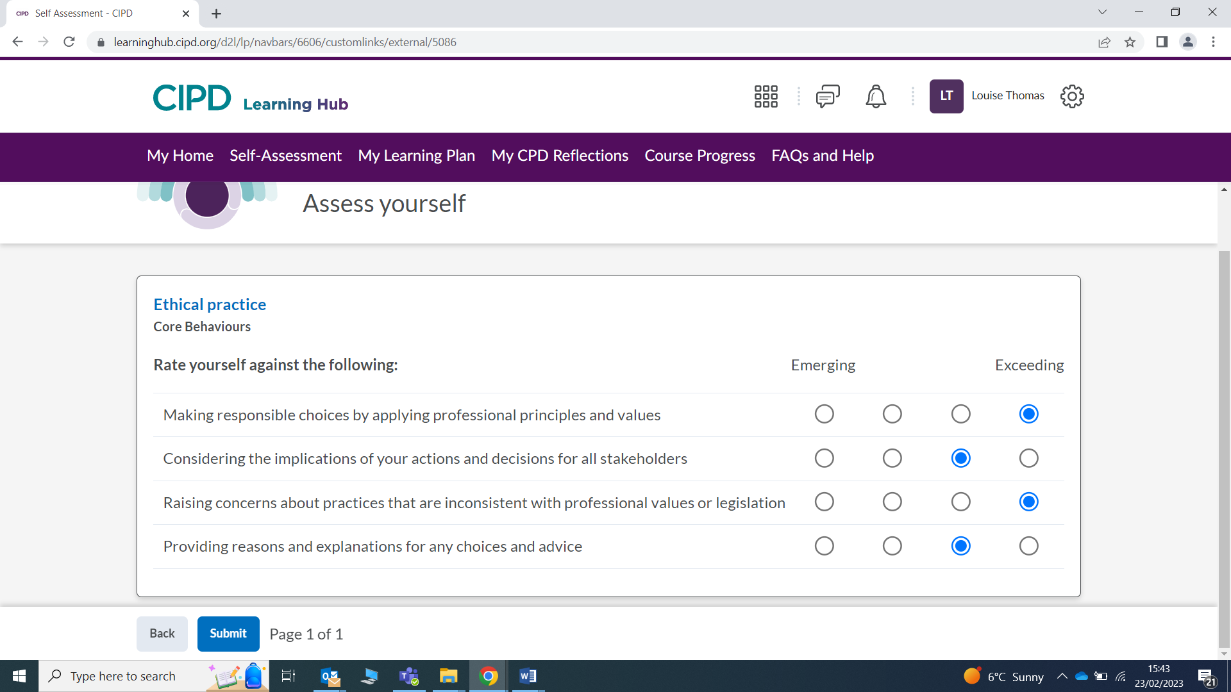
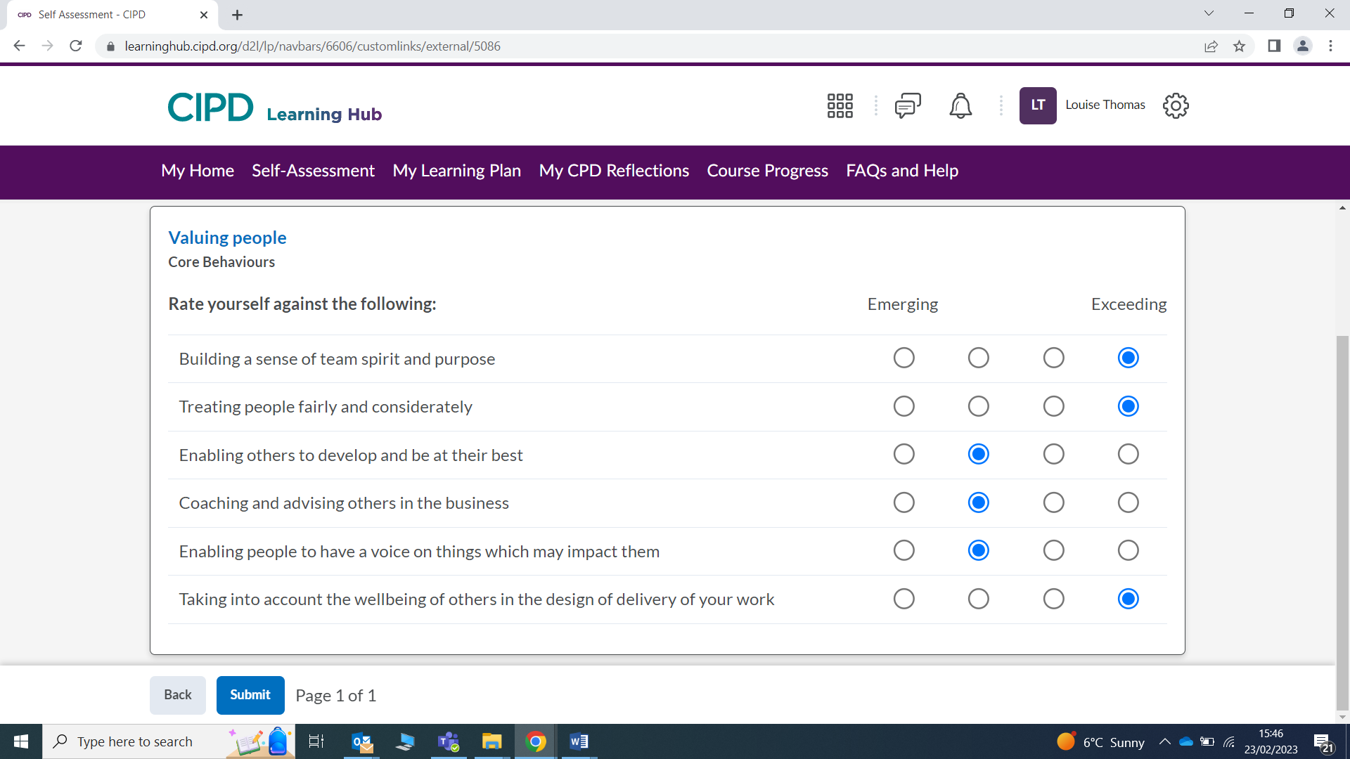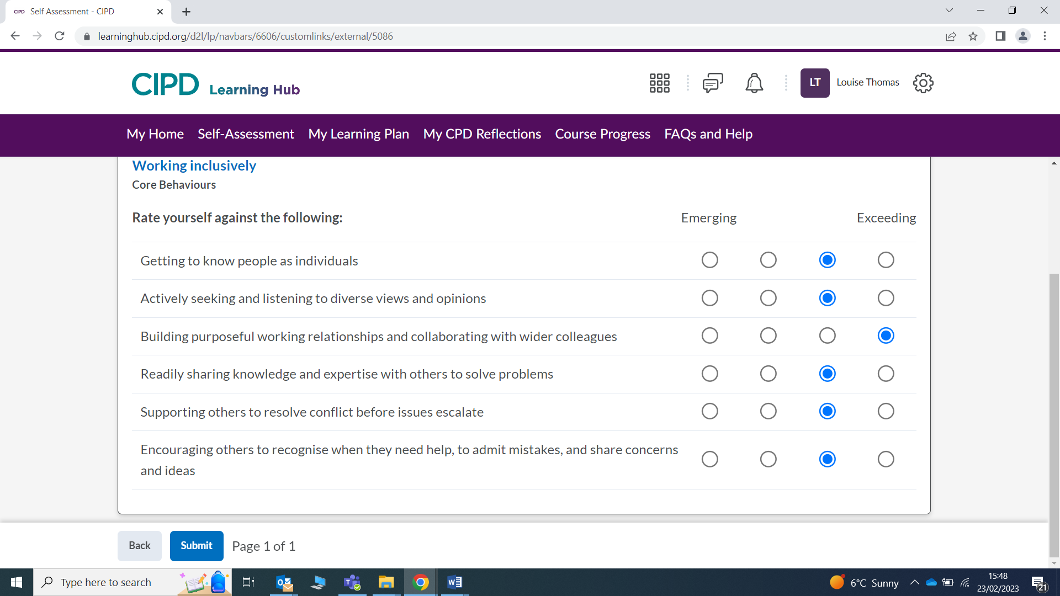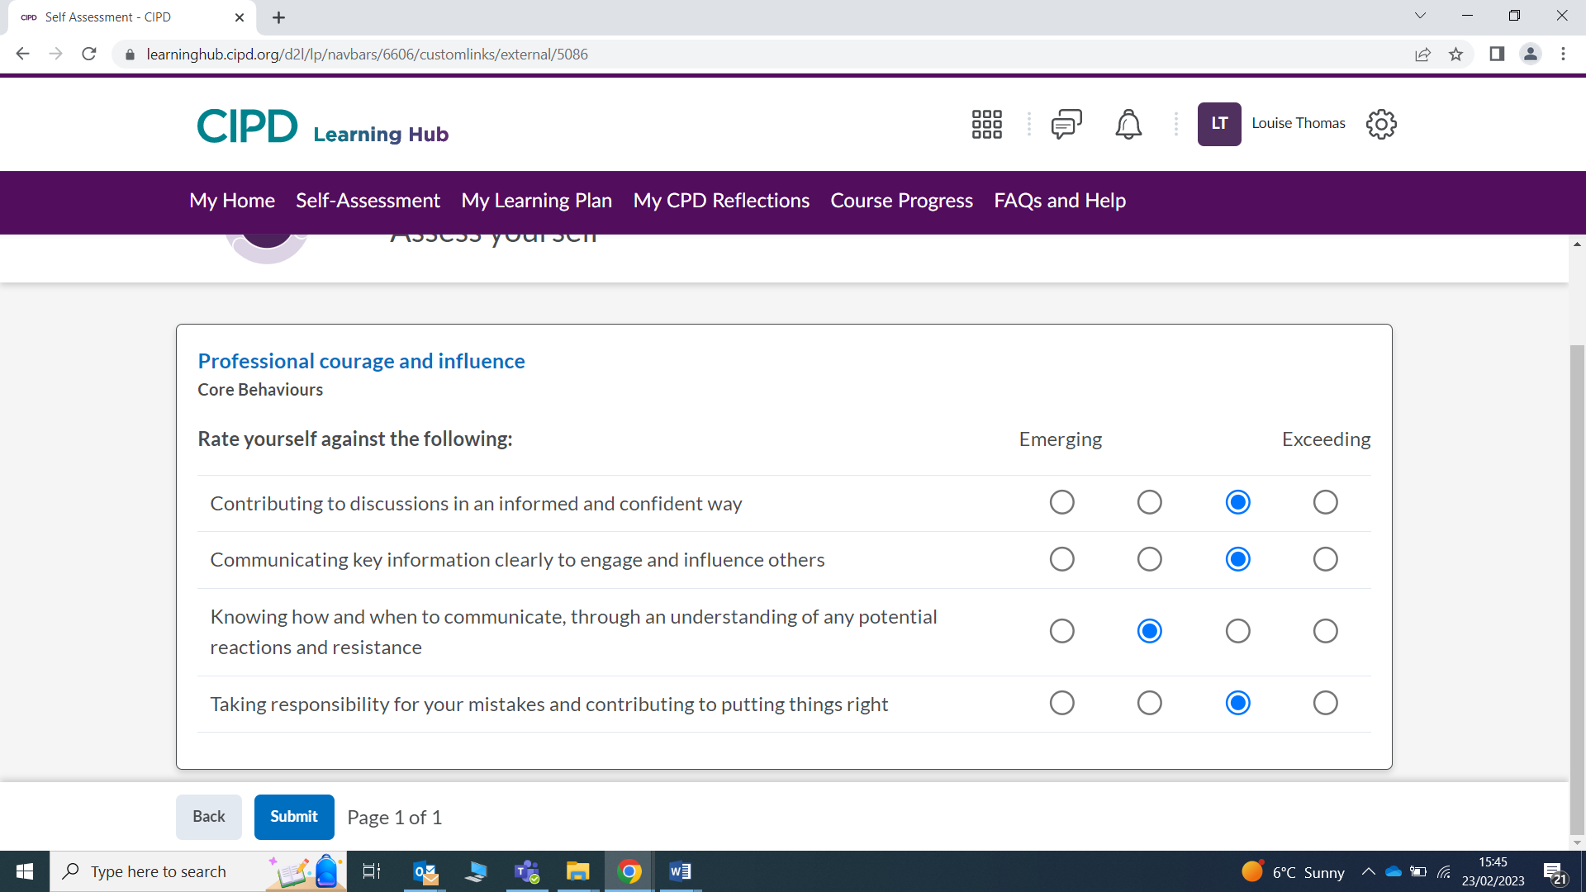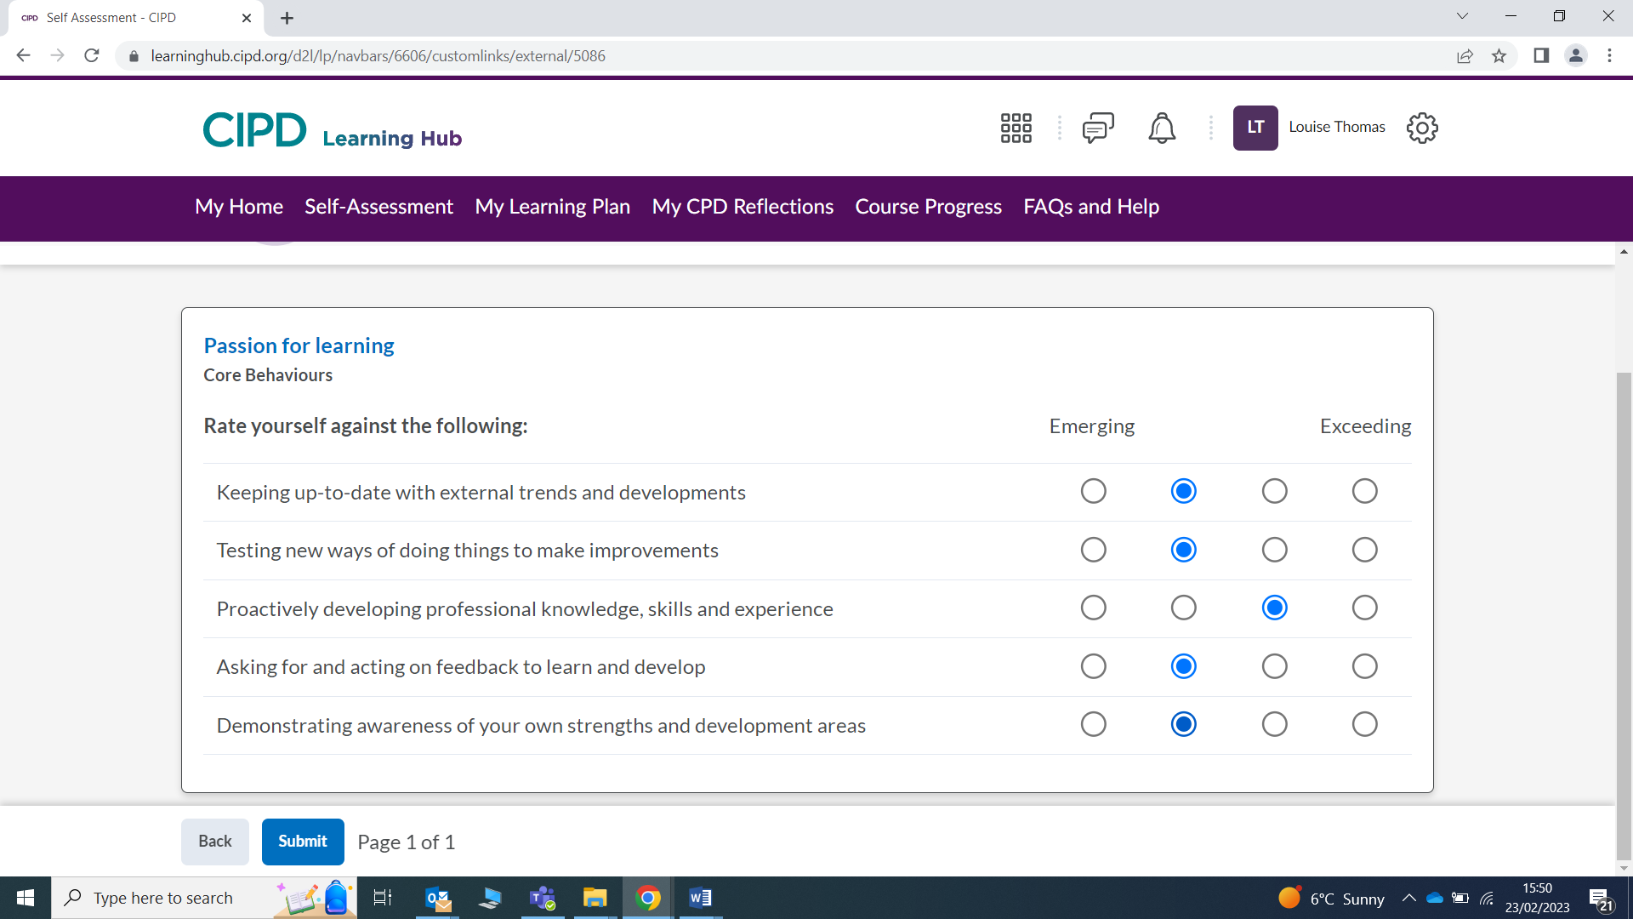

ACTIVITY 2 (AC 3.3) Having identified your main development needs in relation to these 5 areas, formulate appropriate development activities to meet these needs and add these to your professional development/learning plan.

Evidence to be presented:
- In the main body of your assignment, write a short explanation (approx. 250 words) for your choice of development activities
- Add the relevant pages from your development/learning plan as an appendix.

According to Woodhams and Taylor (2022), the human resources field is one that is continually evolving, so it is critical that you keep reading, picking up new skills, and staying informed about how the human resources professional's position is changing.

The CIPD profession map (2018) gives all people professional an insightful and concise model of how a workplace should set its standards, from decision making to wellbeing to having the confidence to deal with situations and also to constantly evolve and review in line with the changing world.

By breaking down the learning plan and self-assessment, there are three key areas of focus for me initially, which are ethical practice, valuing people and passion for learning. However, I have decided to focus on my main weakness area, which is passion for learning. I have discussed this area of development with my line manager and have agreed on the following objectives. I will be attending workshops and trainings (internal and external)and for example, have put myself forward to attend an external meeting on how to attract and recruit international talent into your organisation. I will continue to use the profession map (2018), and in addition to using the CIPD website for my studies, I will continue to use it for up to date people professional updates on an international level, along with using social media (Linkedin) to stay connected to likeminded professionals. This will be ongoing and reviewed on a monthly basis and I believe that using these behaviours will partake in my personal goal of being an experienced, fair and honest people practitioner, which in turn will able me to support, advise and educate employees in my organisation.

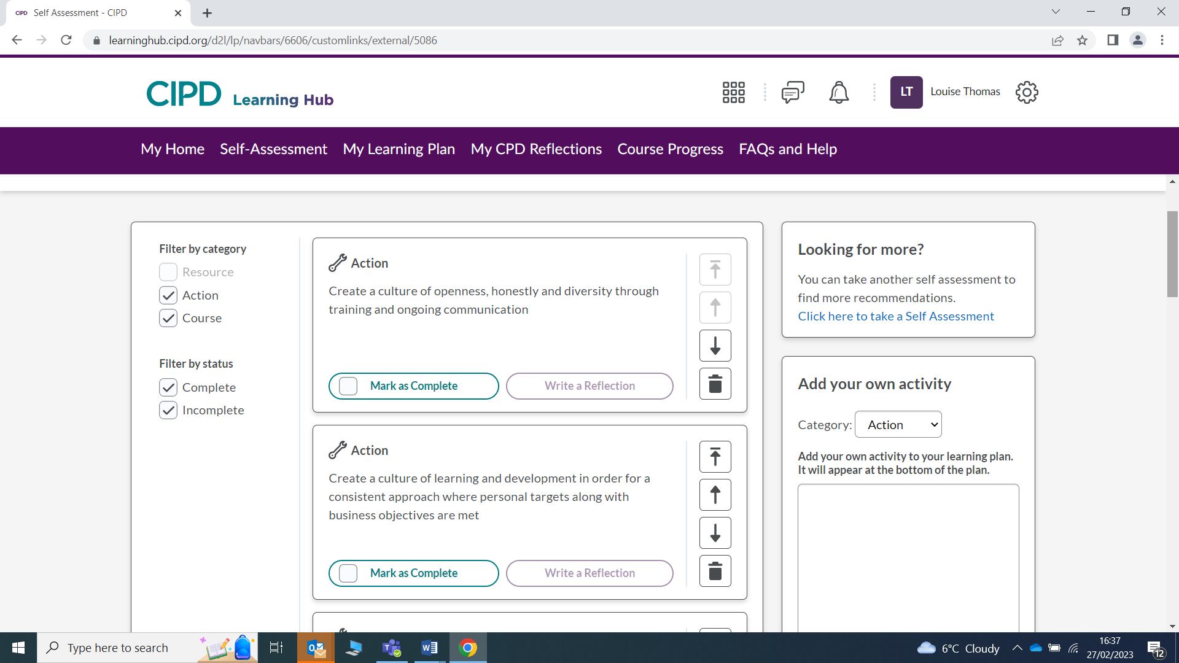

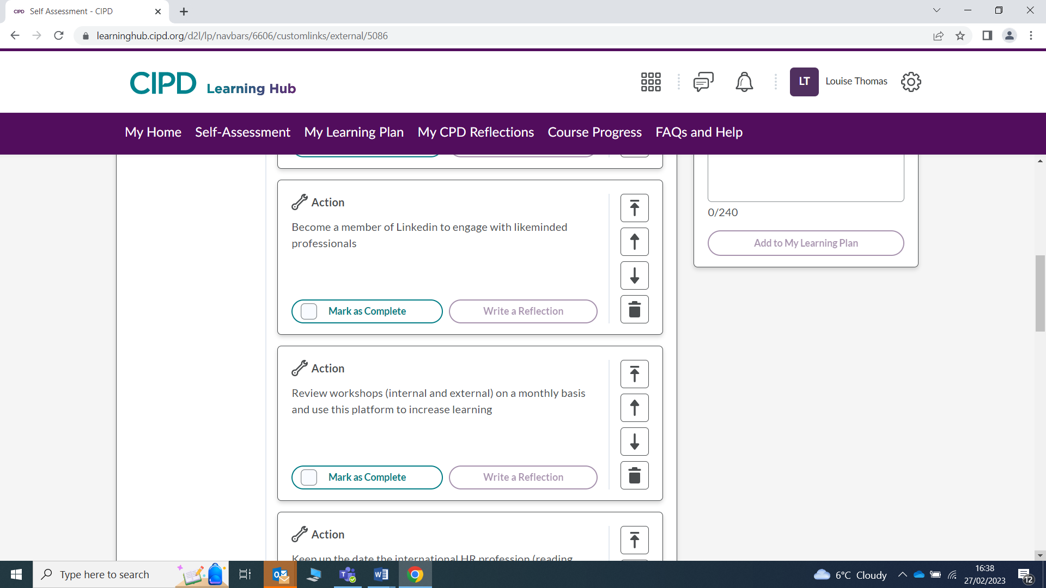

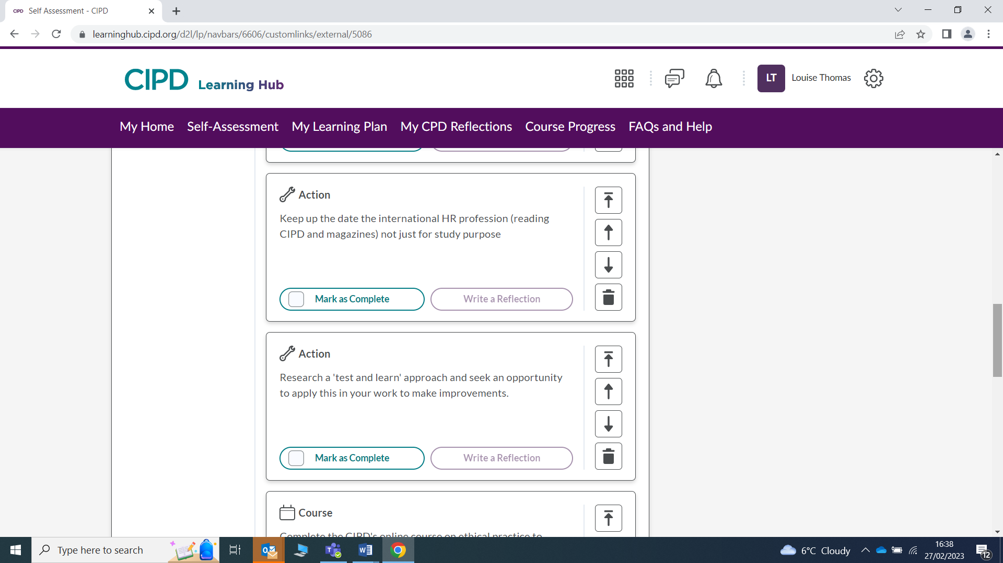

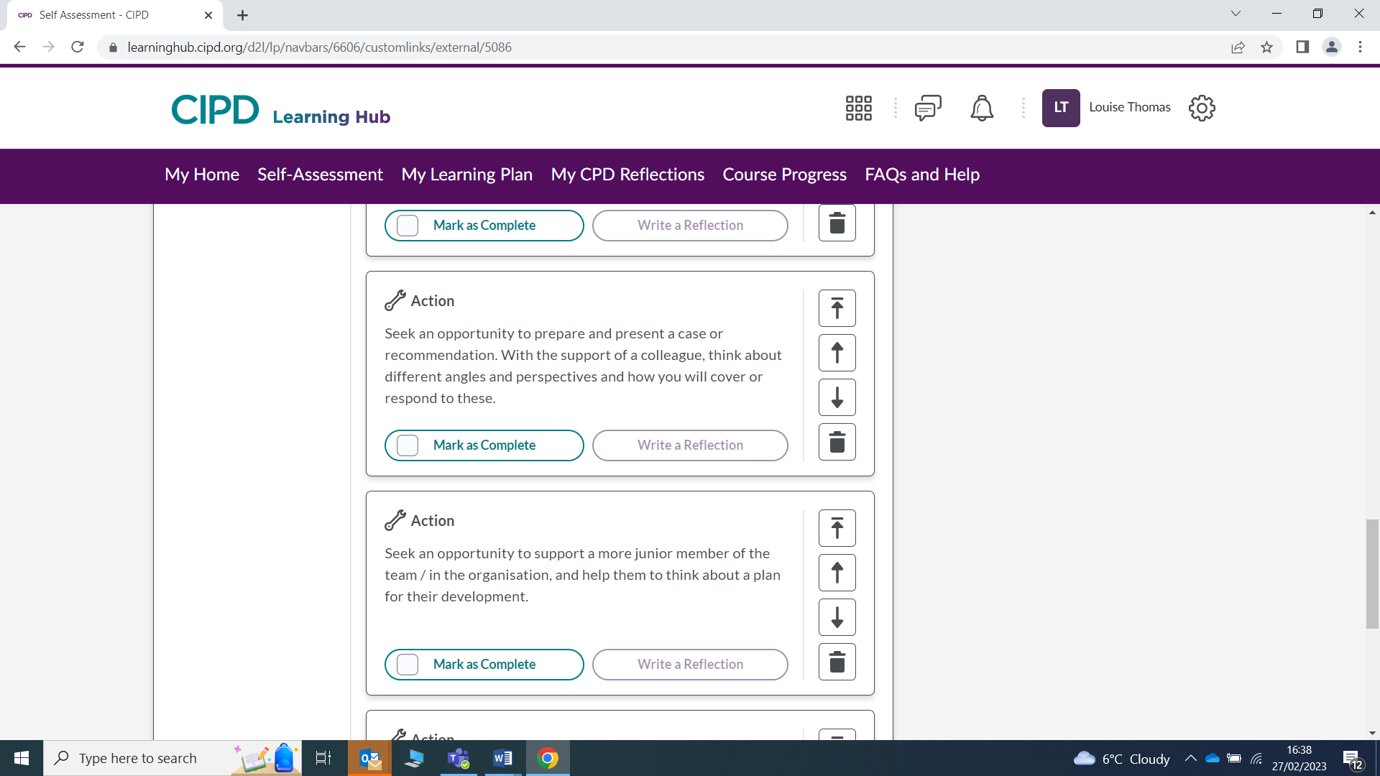

ACTIVITY 3 (AC 3.4) A key element of CPD is reflecting on the impact of our learning, so that we can make further decisions about how to progress. Select 3 formal or informal development activities you have undertaken over the last 12 months and reflect on how each of these activities has impacted your behaviour and performance. (Consider how effective the activity has been and the extent of its impact. You might also consider what new needs or action points the activity raised for you.)
Note: this reflection is retrospective and not connected to the activities planned in activity 2 above.
Evidence to be presented:
- Written reflections on 3 development activities (approx. 750 words)

Area 1. Reflecting on Wellbeing

Record Name: | Specialist Knowledge
Date: | 05/12/2022
Profession Map Area: | Wellbeing
Type of Reflection: | Course Reflections
Type of Learning Experience: | Reflection from a course activity
Grade: | N/A
Supporting material: | N/A

If you have a web page you'd like to reference, add the URL below (to open the link, right click and choose open in a new tab).
https://peopleprofession.cipd.org/profession-map/specialist-knowledge/wellbeing
What did I learn?
After attending CIPD roadshow, I learned that every organisation needs to incorporate wellbeing into the day-to-day running. It is essential for all employers to take responsibility for their employees by supporting mental health in the workplace and understanding the processes, the training aspects and keeping up to date with policies,
What did the learning experience tell me about myself?
I learned that every person has different needs and needs support in different ways. I also learned that by working with the L+D team and having correct data and statistics, builds trust and enables to provide the foundations for what needs to be achieved.
How does this learning experience impact my professional practice and the way I'll approach situations in the future?
Over the previous 12 months, I actively look for workshops and roadshows to attend to increase my knowledge and provide a more experienced, evidence based soundboard for my organisation. For example, this month I will attend International Women's day awareness, which will discuss gender pay; also, last month I attended Menopause awareness and how to support this in the workplace.
What do I need to do next for this learning experience to have a wider positive impact (eg on others, my organisation, the sector, the profession, society)?
I now have monthly meetings with my line manger to discuss my learning and then meet with the L+D department to implement any further updated finding I may have.

Area 2. Reflecting on Learning and development

Record Name: | Specialist Knowledge
Date: | 01/05/2022
Profession Map Area: | Learning and development
Type of Reflection: | Course Reflections
Type of Learning Experience: | Something I'm doing/I've done at work
Grade: | N/A
Supporting material: | N/A
If you have a web page you'd like to reference, add the URL below (to open the link, right click and choose open in a new tab).
https://peopleprofession.cipd.org/profession-map/specialist-knowledge/learning-development
What did I learn?
That training and development is key to being a people professional and that by making sure that I have the correct data, I can support the bigger network of employees but providing information, training and communication to enable all of us to do our jobs better.
What did the learning experience tell me about myself?
That i needed to get more actively involves in my personal development plan as well as constantly looking for ways to improve my organisations training and development for an individual.
How does this learning experience impact my professional practice and the way I'll approach situations in the future?
That people learn differently and one approach may not be for everybody. Giving employees a say as to how best they would like training maybe, for example, online and making sure a review is always completed after training as feedback would be essential to improve.
What do I need to do next for this learning experience to have a wider positive impact (eg on others, my organisation, the sector, the profession, society)?
Conduct training sessions for individuals. Involve employees and ask for participation to share ideas as well as online training for people to learn new things at their convenience and ease.
Area 3. Reflecting on Inclusion and Diversity

Record Name: | Specialist Knowledge
Date: | 01/02/2023
Profession Map Area: | Inclusion and diversity
Type of Reflection: | Other Reflections
Type of Learning Experience: | Something I'm doing/I've done at work
Grade: | N/A
Supporting material: | N/A
If you have a web page you'd like to reference, add the URL below (to open the link, right click and choose open in a new tab).
https://peopleprofession.cipd.org/profession-map/specialist-knowledge/diversity-inclusion
What did I learn?
That I need to understand, listen and have data analysis to attempt to create a trustworthy and fair culture and that my personal education journey and educating people further are a key area for an organisation
What did the learning experience tell me about myself?
That previously I have had opinions, which are unfounded with no evidence (quantitative or qualitative) to back up my views or thought process. Therefore would no enable me to provide the best outcomes from my learnings I appreciate that all people are different and have different needs and views.
How does this learning experience impact my professional practice and the way I'll approach situations in the future?
Making sure, I constantly review my own personal development, learning through reading/training courses, and gain valid evidence. Always making sure that all colleagues have a voice and providing training or working with the training department to ensure a consistent and effective approach therefore improving on the values and culture.
What do I need to do next for this learning experience to have a wider positive impact (eg on others, my organisation, the sector, the profession, society)?
Share my learning and development with the L+D team. Enable employees have a voice on culture, inclusivity and diversity and positively promoting and educating. Use valid sources such as CIPD website to instil the confidence that as a people professional I will ensure that my organisation has the most up to date information to provide a better work place for all employees, employers and stakeholders.
My ongoing professional development initiatives have had a very positive and favourable effect on my professional behaviour. I have found that staying up to date with changes and always looking to further my skills by attending workshops and seminars can only improve my knowledge in chosen areas. Also using my skillset to improve every aspect of my personal development along with being a proactive employee that gains the best and informative evidence and therefore using this to achieve excellence for my organisation
Bibliography
CIPD (2015). Ethical Decision Making in the Workplace | Reports. CIPD. Available at: https://www.cipd.co.uk/knowledge/culture/ethics/workplace-decisions-report.
CIPD (2017). professionalism: what do we stand for? Available at: https://peopleprofession.cipd.org/Images/professional-identity-research-report-updatedPFFMay20_tcm29-17960.pdf.
CIPD (2018). New Profession Map | CIPD Profession Map. CIPD People Profession. Available at: https://peopleprofession.cipd.org/profession-map#gref.
CIPD (2019a). Core purpose | CIPD Profession Map. CIPD Profession for the Future. Available at: https://peopleprofession.cipd.org/profession-map/core-purpose.
CIPD (2019b). Five actions you can take to foster inclusion. CIPD. Available at: https://www.cipd.co.uk/knowledge/fundamentals/relations/diversity/five-actions-fostering-inclusion#gref.
CIPD (2021). WORK MOTIVATION. Available at: https://www.cipd.co.uk/Images/work-motivation-scientific-summary_tcm18-89562.pdf.
CIPD (2022a). CPD Cycle Stages | CIPD. CIPD. Available at: https://www.cipd.co.uk/learn/cpd/cycle.
CIPD (2022b). Employee Communication | Factsheets | CIPD. CIPD. Available at: https://www.cipd.co.uk/knowledge/fundamentals/relations/communication/factsheet.
CIPD (2022c). Ethical Practice and the Role of HR | Factsheets. CIPD. Available at: https://www.cipd.co.uk/knowledge/culture/ethics/role-hr-factsheet#gref.
CIPD (2022d). Professional courage and influence | CIPD Profession Map.CIPD People Profession. Available at: https://peopleprofession.cipd.org/profession-map/core-behaviours/professional-courage-influence#gref.
CIPD (n.d.). Wellbeing | CIPD Profession Map.CIPD People Profession. Available at: https://peopleprofession.cipd.org/profession-map/specialist-knowledge/wellbeing [Accessed 6 Mar. 2023].
Duska, R.F., Brenda Shay Duska and Julie Anne Ragatz (2011). Accounting Ethics. Wiley-Blackwell.
Information on Whistleblowing | CIPD (2019). Information on Whistleblowing | CIPD.CIPD. Available at: https://www.cipd.co.uk/knowledge/fundamentals/emp-law/whistleblowing.
Lloyd, R. (2019). Council Leads the way in robot admin. South Wales Evening Post. 12 Sep.
Rock, D. (2008). SCARF - neuroleadership Journal. SCARF - Neuroleadership Journal, [online] 1(1). Available at: https://schoolguide.casel.org/uploads/sites/2/2018/12/SCARF-NeuroleadershipArticle.pdf [Accessed 17 Feb. 2023].
Shanock, L.R., Eisenberger, R., Heggestad, E.D., Malone, G., Clark, L., Dunn, A.M., Kirkland, J. and Woznyj, H. (2019). Treating employees well: The value of organizational support theory in human resource management. The Psychologist-Manager Journal, 22(3-4), pp.168–191. doi:https://doi.org/10.1037/mgr0000088.
Shore, L.M., Cleveland, J.N. and Sanchez, D. (2018). Inclusive workplaces: A review and model. Human Resource Management Review, 28(2), pp.176–189. doi:https://doi.org/10.1016/j.hrmr.2017.07.003.
Taylor, STEPHEN. and Woodhams, C. (2022). Studying Human Resource Management. 3rd ed. kogan.
Woodhams, C. and Taylor, S. (2022). HUMAN RESOURCE MANAGEMENT : people and organisations. 3rd ed. S.L.: Kogan Page.
Zhetoukhova, K. and Baczor, L. (2015). From best to good practice HR. cipd. Available at: https://www.cipd.co.uk/Images/pff-report-update-PFFMay20_tcm18-8731.pdf [Accessed 15 Feb. 2023].

Task 2 Bibliography
CIPD (2018). New Profession Map | CIPD Profession Map. CIPD People Profession. Available at: https://peopleprofession.cipd.org/profession-map#gref.
Taylor, STEPHEN. and Woodhams, C. (2022). Studying Human Resource Management. 3rd ed. kogan.
CIPD (2019). Diversity and inclusion | CIPD Profession Map. CIPD Profession for the Future. Available at: https://peopleprofession.cipd.org/profession-map/specialist-knowledge/diversity-inclusion.
CIPD (2019b). Learning and development | CIPD Profession Map. CIPD Profession for the Future. Available at: https://peopleprofession.cipd.org/profession-map/specialist-knowledge/learning-development.
CIPD (n.d.). Wellbeing | CIPD Profession Map. CIPD People Profession. Available at: https://peopleprofession.cipd.org/profession-map/specialist-knowledge/wellbeing [Accessed 6 Mar. 2023].

