  LOCATION Swansea | LLEOLIAD abertawe
LEVEL 4 | LEFEL 4
EXAMINATION PERIOD | CYFNOD ARHOLIADAU
May 2020 | Mai 2020

MODULE CODE: ACCA4001
COMPUTER ARCHITECTURE and NETWORKS
TIME: 1.5 Hours
answer all questions

Equipment or materials required – Computer with Internet Connection

The Candidates are expected to type their responses into this document and submit to Moodle by the required deadline. It would be acceptable for handwritten work to be scanned or photographed and embedded into this document prior to submission.

Candidates may use calculators, however where requested full evidence of workings should be evidenced.

Show all your calculations on this document.

ANSWER ALL FOUR QUESTIONS

QUESTION ONE (35 marks total)

Attempt all of the following. Do not simply use an electronic calculator. Write down and show all your manual calculations in your exam book. Simply providing the answer with no evidence of how you arrived at it will result in a zero.

a) Convert the following decimal numbers to Binary (3 marks each)

- 45

- 174

b) Convert the following binary numbers to base 10 (3 marks each)

- 10011010

- 01011111

c) Convert the following hex numbers to binary (2 marks each)

- 5C

- D6

d) Convert the following Hex numbers to decimal (3 marks each)

- 56

- CB

e) How many different/unique values can be represented by a 6 bit number? (3 marks)

f) You are required to calculate the file size and upload time of a full colour header graphic of dimensions 200*500 pixels where each pixel can be one of 16 million colours. Calculate:
i) The file size if you saved it in an uncompressed .BMP format (5 marks)

ii) The file size if you saved it as a JPG with a compression ratio of 10:1 (2mark)

iii) Approximately how long it would take to upload the BMP file if you were using a typical UK ADSL link with a 2Mb/s transfer speed (3 marks)

QUESTION TWO (20 marks total)

- Give typical current capacities and cost for the following devices: (2 marks each)
- USB Flash Drive (memory stick)

- SSD in a desktop computer

- Portable HDD for a regular user

- Compare the functional characteristics of Hard Disc Drives (HDD), Solid State Drives (SSD) and Optical Drives including advantages and disadvantages along with a typical use and storage capacity for each (14 marks)

QUESTION THREE (20 marks total)

- What typical expansion ports/slots can be found on a motherboard. What devices can be connected and what additional functionality could be gained through their use (10 marks).

- Calculate the transfer time (in minutes) for a file of size 4 GB and with a transfer speed of 80 Mbps: (5 marks)

- Produce a forwarding table for node A by calculating the lowest cost routes on the network: (5 marks)

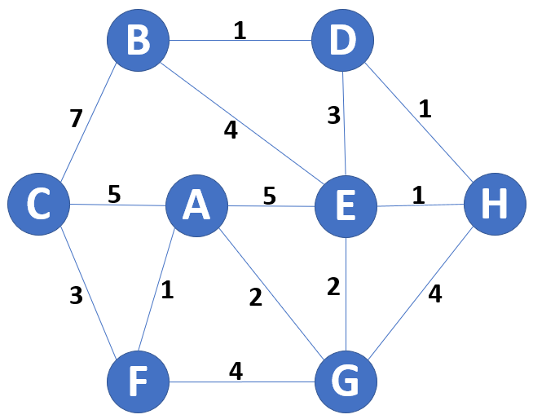
Destination | Cost | GoTo
A | 0 | A
B
C
D
E
F | 1 | F
G | 2 | G
H

QUESTION FOUR (25 marks total)

- Produce a diagram outlining the layers of the OSI model (3 marks)

- Briefly explain each layer of the OSI model (7 marks)

- Describe the main features of different RAID schemes. You should cover the most common types whilst including diagrams, advantages and disadvantages for each (15 marks)

