DIGITAL SKILLS & RESEARCH METHODS: ASSIGNMENT 2 – RESEARCH REPORT
IMPACT OF VIRTUAL LEARNING ENVIRONMENT

MODULE CODE: BMSW4003
STUDENT NAME: IONUT CATALIN GABUR
STUDENT ID: 2132852
LECTURER NAME: Suneth Fernando

Table of Contents

Introduction……………………………………………………… 2

Background…………………………………………………... 2,3

Aims and Objectives…………………………………………… 4

Method…………………………………………………………… 5

Results…………………………………………………. 6,7,8,9,10

Conclusion……………………………………………………… 10

Discutions……………………………………………………….. 11

Appendix………………………………………………………12,13

Reference List……………………………………………………14

- INTRODUCTION TO THE REPORT
  - Virtual education(overview)

The term "virtual education" describes instruction in a setting where the teacher and the student are separated by either time or distance, or both, where the teacher delivers course material via course management software, multimedia materials, the Internet, videoconferencing, etc. Whole facets of American life have been transformed by personal computers and the Internet. Numerous internet communication tools, like Facebook, Twitter, YouTube, Skype, and others, have made it possible for billions of people all over the world to quickly and sometimes for very little money communicate ideas. These developments in computer technology are both amazing and commonplace. However, most individuals are unaware of how Internet and computer technology are changing how pupils learn. This new educational paradigm, frequently referred to as "virtual learning," has the potential to raise student success, educational accessibility, and school costs. Virtual learning instructs students using computer software, the Internet, or both. As a result, there is less or no requirement for teachers and students to share a classroom. Even while these learning management systems are useful, they do not alter how students are taught. Therefore, virtual learning does not include the growing usage of email or online forums to help teachers better connect with students and parents about coursework and student progress. (Kanimozhi, 2018)

- BACKGROUND

Deakin University, a large Australian university where this project is based, focuses on creating educational experiences that are "flexible, student-centered, and accessible to our diverse range of students, utilising appropriate technology to enhance teaching and learning, and supplying student support services that are responsive to student needs and student support needs" (derived from the University Teaching and Learning Plan). Many e-learning research activities have been funded by the University in an effort to inform not only teaching practise but also policy development.
One of the projects awarded in 2010 was a research that attempted to improve students' e-learning experiences by producing tools for academics to help them make educated decisions about how to best employ e-technologies.
The first stage was to assess the e-technologies that were being utilised for teaching and learning at Deakin University at the time. This demonstrated that the University supported 23 key or power-linked components of the online learning environment, in addition to nine additional e-technologies The authors were also aware of at least seven e-technologies being employed ad hoc by faculty to enhance teaching and learning.
This list of e-technologies and Hamilton's classification were used as a starting point to build categories of relevant technologies. It should be emphasised that the more general categories of learning management systems (LMS), online learning environments (OLE), and virtual learning environments (VLE) were not included. Products like Blackboard, SAKAI, Moodle, Desire2Learn, and AJAX are excluded.
Contrary to the variety of e-technologies under investigation in the study, these very large systems are typically centrally supported within the university environment and have sufficient resources, support, and exemplars to allow informed decisions to be made about their use to support specific pedagogical requirements. Additionally, since the institution often forbids the use of such systems, educators are unable to choose not to utilise them. (Craig, Annemieke, Coldwell‐Neilson, Jo, Goold, Annegret, Beekhuyzen, 2012)

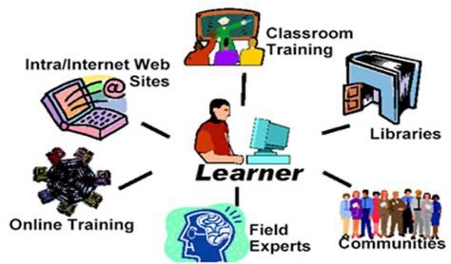

- AIM’S AND OBJECTIVES

Making education accessible to a large population is the goal of VLE . Therefore, the Internet will undoubtedly be employed in this project as the means of delivering the courseware for the virtual learning environment. With the majority of the globe already online, the remaining regions can no longer remain in the dark for very long and will eventually join the Internet. According to estimates, there are millions of computers linked to the Internet, and its popularity is rising quickly. By the end of the next decade, the majority of American families are expected to be utilising the Internet for one reason or another. This popularity is attributable to the ease with which one may use the Internet and the accessibility of practical data like free software, library access, and weather predictions. Therefore, the VLE's goal of providing education to all people can only be fulfilled online.
The purpose of this project is to create and put into practise a brand-new, cutting-edge
teaching paradigm in order to offer a flexible, affordable, and excellent learning environment for education. Students may access the virtual learning environment (VLE) at any time and from anywhere, and they can provide the teacher input on the course's design. Moreover, a VLE support software module will enable the VLE to monitor students' progress. The following are the main goals of the virtual learning environment:

- Give students access to an educational environment so they may take the courses without the time and geographical restrictions of a typical teaching setting.
- Permit participation in the courses offered through this learning environment for students with specific needs and constraints.
- Access to the range of courses offered through this learning environment should be made available globally.
- Access to the range of courses offered through this learning environment should be made available globally.
- Create an atmosphere for studying where students may progress through the content at their own pace and give institutions a setting where they can increase enrolment by incorporating a large number of students in the learning process.
- By entering a contract with the VLE, you may offer a course repository for several universities that lack the knowledge to offer a significant number of provider university elective and special courses. (KUMAR, PAKALA, RAGADE, WONG, 1996)

- METHOD

A research method consists of a strategy, procedures, and the gathering of data and supporting documentation for further processing and analysis to find new information for a deeper understanding. techniques for doing research, questionnaires, etc. Additionally, the research methodology is highly beneficial for carrying out this sort of study. Basically, this initiative has used the survey to gather real-time data.
The process of gathering, analysing, and interpreting non-numerical data, such as language, is known as qualitative research. In this study, 16 students were interviewed using quantitative research, and information on virtual learning was taken from an article using qualitative research. Data in the form of numbers was being gathered and examined. In essence, quantitative research is used to verify or test a hypothesis, whereas qualitative research is used to comprehend a topic. Both the survey's research and completion were helpful.
A statistical analysis revealed that, on average, students gave virtual learning a rating of three out of five when sixteen students were requested to do so. Once more, when asked whether any upgrading was necessary, a group of students shared their issues. That is how the research, both qualitative and quantitative, was used to create this project.
This type of project benefits more from primary research since it depends on first-hand research rather than relying on information that is already available on the market. Primary research costs money and takes time. In contrast to primary research, secondary research is quick and inexpensive because it is not gathered by the researcher. To finish the assignment on virtual learning, primary research was more helpful than secondary research. Data and information were gathered directly from the pupils.
The gathering of data is a crucial component of research technique. It is difficult to gather the proper data and use it in a way that is consistent with the research. Establishing a period, selecting the information to be gathered, gathering the data, and finally analysing it were the steps involved in data collection.
Students were requested to provide information about this study of virtual learning, and they gathered a lot of data that made it much easier to finish this project.

- RESULTS

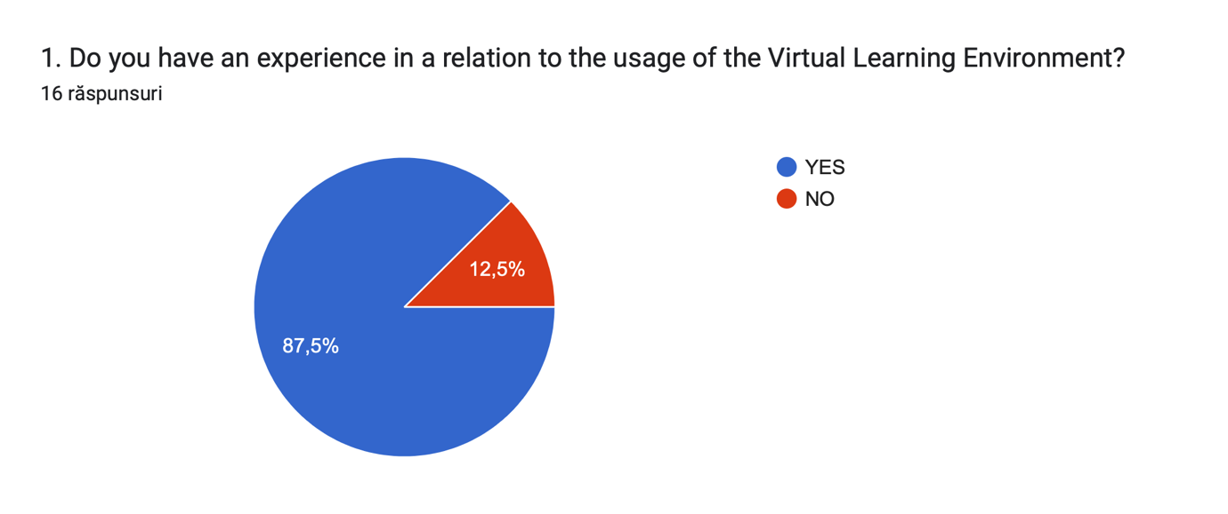

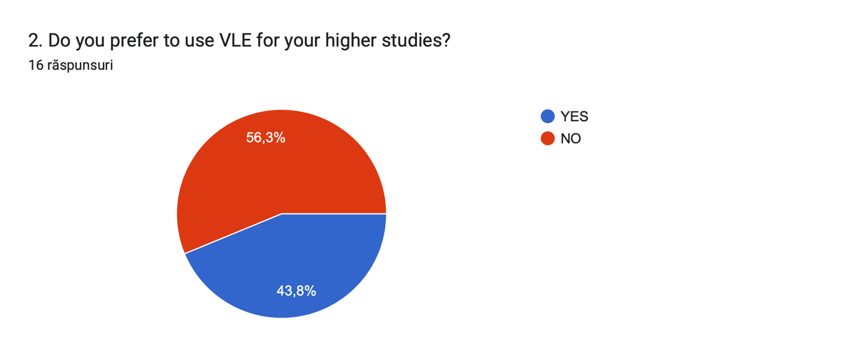

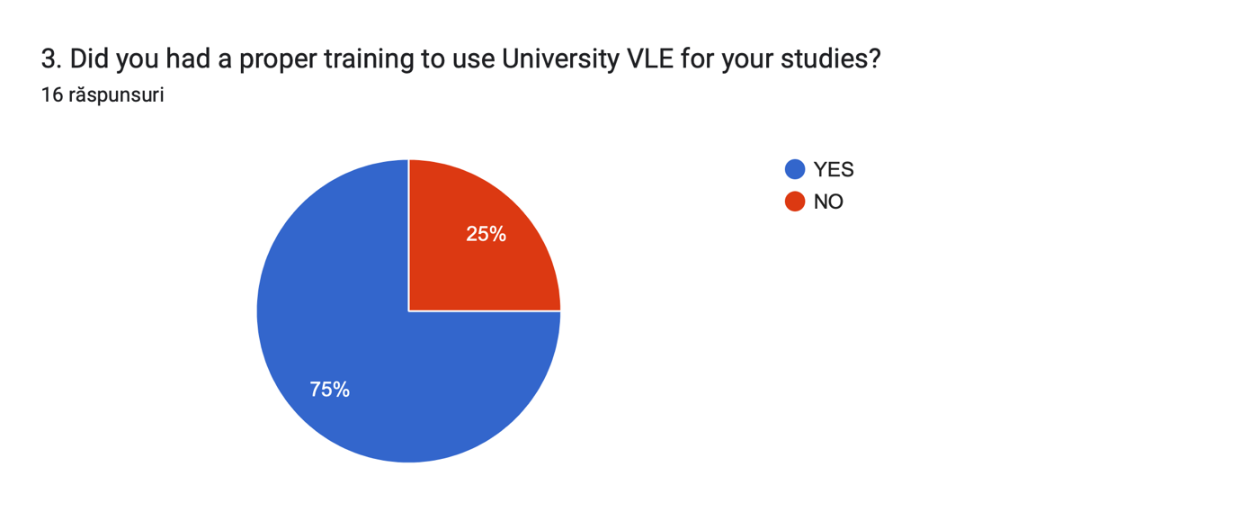

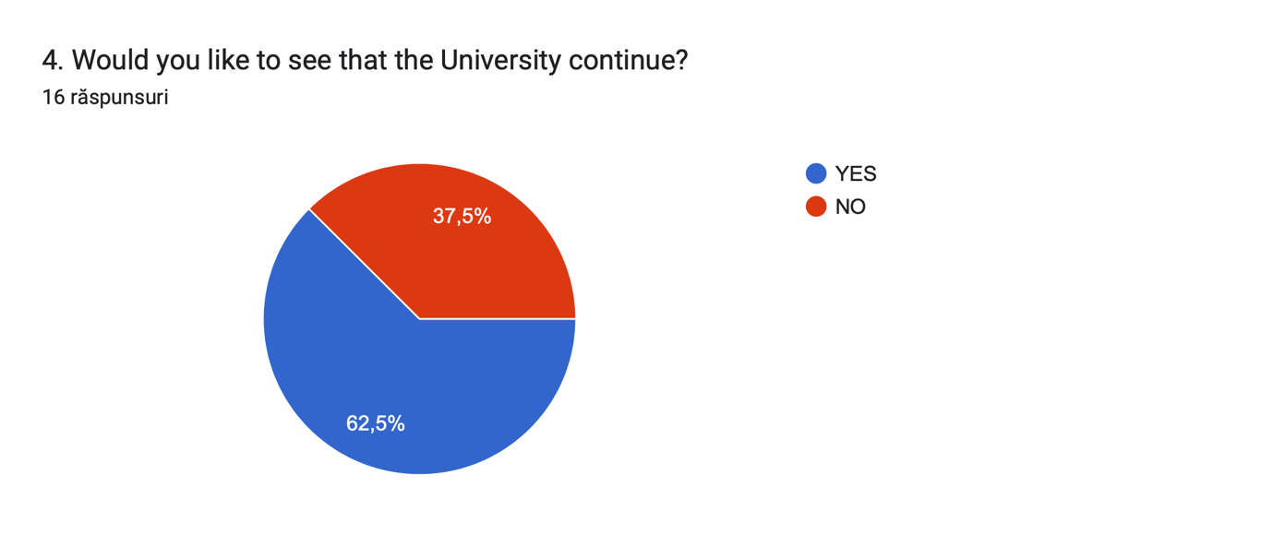

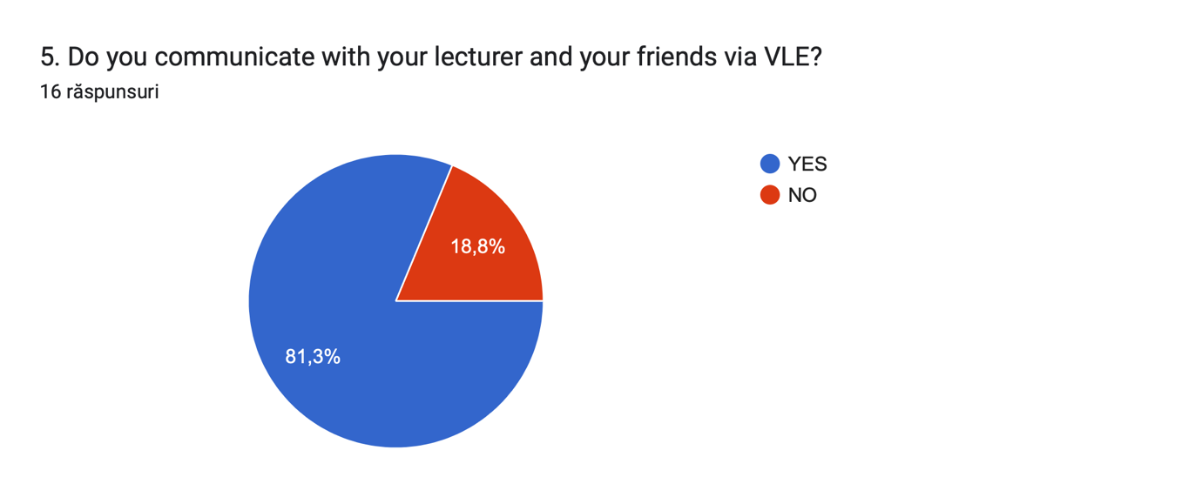

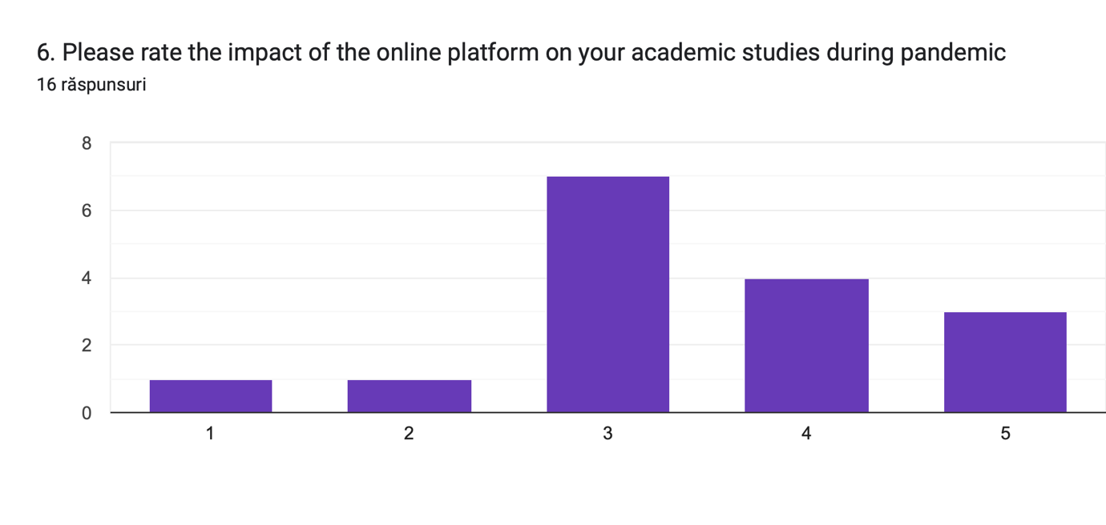

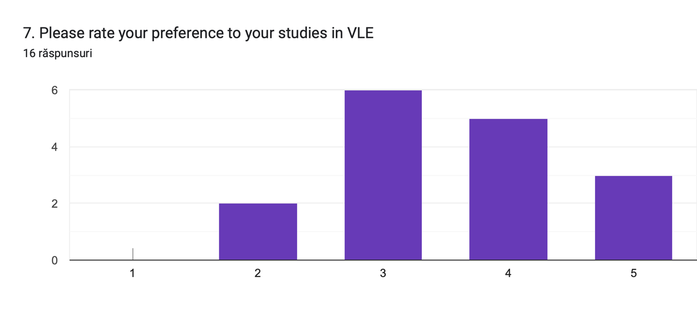

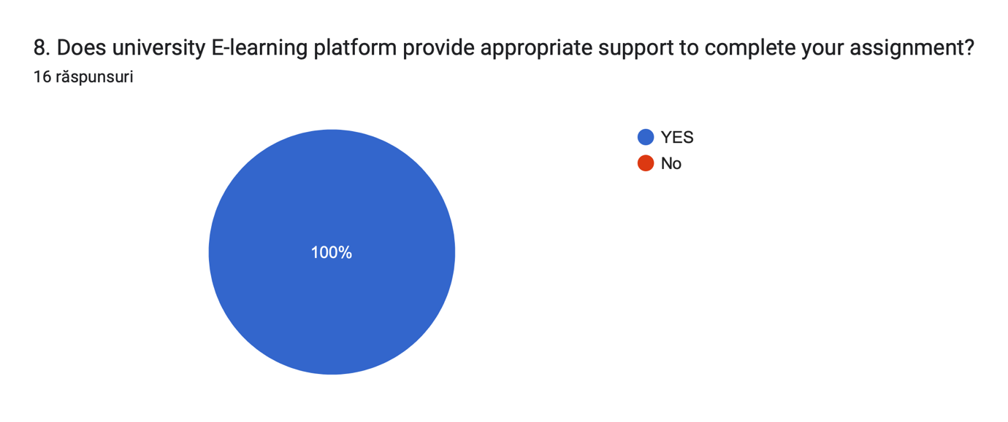

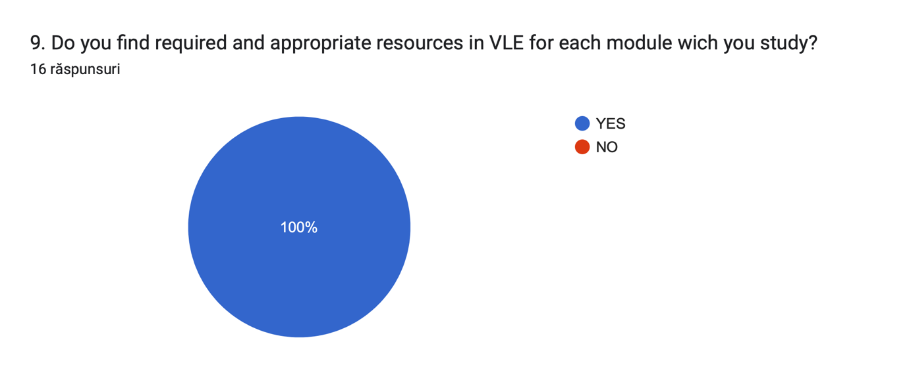

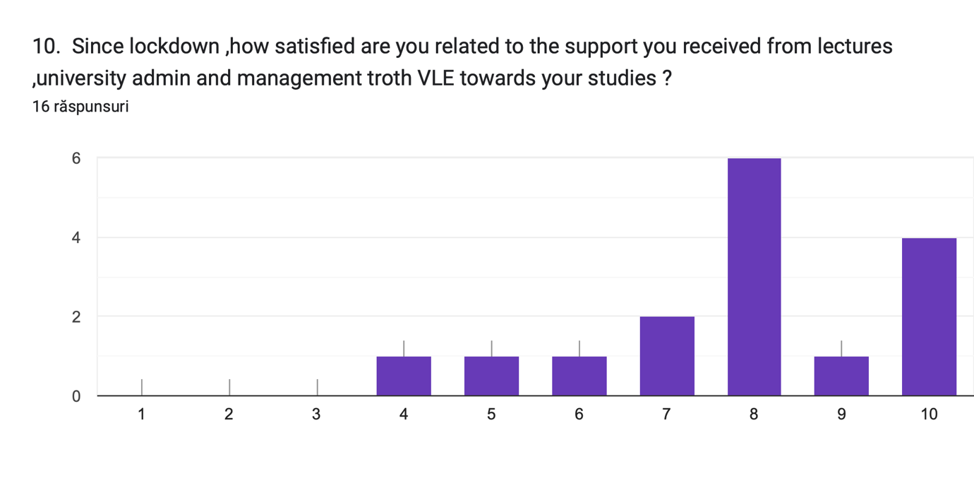

- Answers question 1, 2, 3, 4, 5, 8, 9

QUESTIONS | Answers (YES) | Answers (NO)
Question 1 | 14 | 2
Question 2 | 7 | 9
Question 3 | 12 | 4
Question 4 | 10 | 6
Question 5 | 13 | 3
Question 8 | 16 | 0
Question 9 | 16 | 0

- Answers question 6 and 7 from POOR to EXCELENT

QUESTIONS | POOR |  |  |  | EXCELENT
Question 6 | 1 | 1 | 7 | 4 | 3
Question 7 | 0 | 2 | 6 | 5 | 3

- Answers question 10 from POOR to EXCELENT

QUESTIONS | POOR |  |  |  |  |  |  |  |  | EXCELENT
Question 10 | 0 | 0 | 0 | 1 | 1 | 1 | 2 | 6 | 1 | 4

- CONCLUSION

The following are the primary features offered by VLE:
- Since the VLE system is established on the Internet, it doesn't require any other kind of connection to provide the courses. Additionally, there won't be any significant costs associated with creating a unique, high-performance network to provide these courses.
- The VLE system is available from any computer in the globe with an Internet connection since any Internet browser that supports HTML forms may be used as the frontend.
- Throughout the period that the course is available online, VLE courses can be taken at any time.
Despite being a fully functional virtual university with administration, admission, course registration, communication, and a system for course presentation all under one roof, VLE still requires some adjustments and improvements to be made in order to make it even more reliable and to improve its features.

- DISCUTIONS

According to the findings, students are showing interest in virtual learning courses, which bodes well for the future growth of Moodle, the programme used by institutions. The analysis of the aforementioned finding shows that the students will benefit greatly from the online learning environment and will find it simple to attend sessions because there are no stringent time restrictions. Since students have the freedom to take lessons from anywhere at any time, including their homes, the time limit is lowered. The findings of primary research show that virtual learning environments are employed in many other contexts in addition to the educational setting. It was discovered that businesses use online learning environments for their staff. They can train their staff thanks to this. Following the epidemic, it was discovered that everyone can communicate with anybody, anywhere, at any time. The debate was also examined, and it was discovered that most participants reported being thrilled and content with the online tutoring. However, there are a lot of individuals who disagree since, in their eyes, they are having issues and the university must act appropriately in order to focus on the areas that require development. Students often point out weak areas, one of which is the utilisation of online learning tools. They are unable to learn how to use platforms for online education.

- APPENDIX

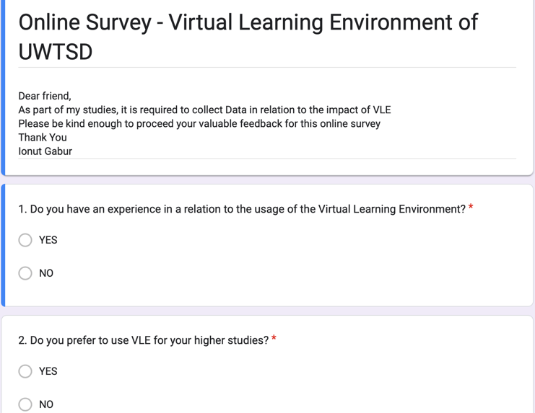

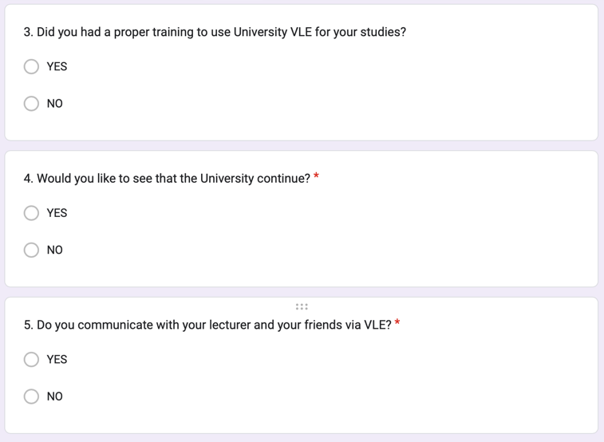

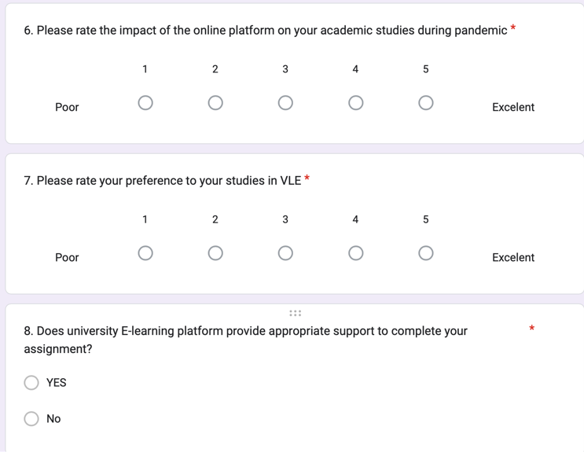

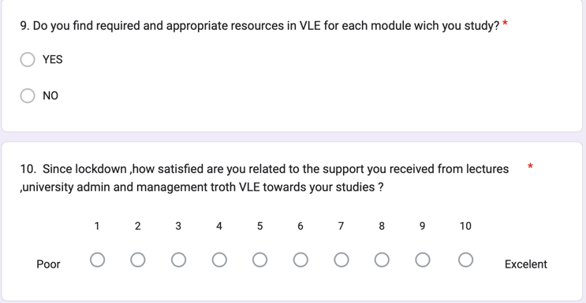

- REFERENCE LIST

Craig, Annemieke, Coldwell‐Neilson, Jo, Goold, Annegret, Beekhuyzen, 2012. [Online]
[Accessed 09 august 2020].

Kanimozhi, 2018. International Journal of Advanced Research in Computer Science. [Online]
[Accessed 19 July 2020].

KUMAR, PAKALA, RAGADE, WONG, 1996. THE VIRTUAL LEARNING ENVIRONMENT SYSTEM. [Online]
[Accessed 23 August 2022].

