

Module Name: Managing Enterprise
Module Code: BMSW4011
Assignment Name: Business Plan and Reflection
Student Name: Donna Watkins
Student Number: 2508071
Lecturer: Melanie Squire
Deadline: Friday 19th June 2026

AI Acknowledgement
I confirm that I have not presented any AI generated materials as my own work.

Contents Page

Task 1
- Product and service proposition
- Company name
- The story behind the business
- Business ownership
- Mission statement, AIM, Smart objectives, USP
- Location
- Human Resources
- Marketing activities
- Market Research
- Financial resources and Cash flow forecast
- Competitor analysis
- Critical appraisal (SWOT Analysis, PESTLE)
- Conclusion
- References
- Appendix
Task 1 Part 2
- What new and existing entrepreneurial skills have you exercised and developed throughout your lecture series and compiling your assessments?
- Explain and discuss if you would personally consider investing in your business idea. Explain your reasons why/why not.

Task 1
Velvet Glow Business Plan

Business Name: Velvet Glow
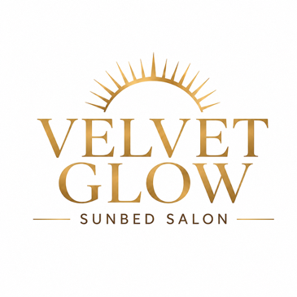
Business logo:

Business Owner: Donna Watkins
1. Product and Service Proposition
Velvet Glow will provide professional sunbed tanning services using modern tanning equipment, consisting of red light therapy. Customers can purchase single sessions, block bookings or monthly memberships. Additional revenue will come from tanning creams, skincare products and aftercare products.
Red-light therapy is a modern technology that has various benefits (Cleveland Clinic, 2024).
2. Company Name
The name "Velvet Glow" was chosen because it reflects luxury and confidence. "Velvet" represents comfort, elegance and quality, while "Glow" represents the healthy-looking tan and confidence customers want to achieve. Together, the name creates a strong image of a premium tanning experience.
3. The Story Behind the Business
The idea for Velvet Glow comes from my personal experience of using sunbeds. Having a tan has always helped me feel more confident and comfortable in my appearance. I often feel confident enough to leave the house without makeup because I feel my skin looks healthier and brighter.
I also believe that a tan can improve confidence when wearing different outfits and preparing for holidays, events and social occasions. Because tanning has had such a positive effect on my confidence, I wanted to create a business where other people can enjoy the same experience in a safe and professional environment.
Benefits customers often associate with sunbeds include improved confidence, a healthy-looking glow, convenience and relaxation. However, it is important to recognise the risks, including premature ageing, skin damage and increased skin cancer risk if used irresponsibly (Cancer Research UK, 2026). Velvet Glow will prioritise customer safety through guidance, equipment maintenance and ID verification.
4. Business Ownership
Velvet Glow will operate as a sole trader business owned by Donna Watkins.
Advantages:
• Full control of the business.
• Keeps all profits.
• Easy to set up.
• Simple decision-making process (Gov.uk, 2025).
Disadvantages:
• Unlimited liability.
• Personal responsibility for business debts.
• Less access to finance than limited companies (Gov.uk, 2025).
A sole trader structure is suitable because the business will initially be independently owned and managed.
5. Mission Statement, Aim, SMART Objectives and USP
Mission Statement:
To provide a clean, safe and luxurious tanning experience that helps customers look and feel their best.
Business Aim:
To become Cardiff's leading luxury tanning salon.
SMART Objectives:
1. Gain 300 regular customers within the first 12 months.
2. Achieve monthly sales revenue of £8,000 by month 12.
3. Maintain customer satisfaction ratings above 90%.
4. Introduce one additional beauty treatment within two years.
USP (Unique Selling Proposition):
Velvet Glow combines luxury surroundings, premium tanning equipment, strict hygiene standards and exceptional customer service in one convenient location.
6. Location
The proposed location is Western Avenue Business Park, Cardiff, next to Greggs. This location benefits from high footfall, excellent road access, customer parking and visibility from a busy commercial area.
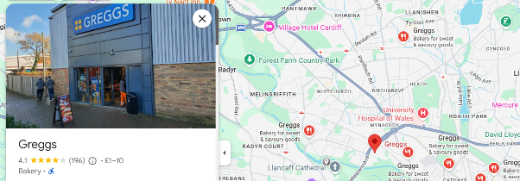

The location is ideal because it attracts local residents, workers and visitors, increasing opportunities for repeat business (FSB, 2024).
7. Human Resources
Initially, Velvet Glow will employ:
• 1 Owner/Manager (Donna Watkins)
8. Marketing Activities
Marketing activities will include:
• Business cards distributed locally.
• Flyers delivered to nearby homes and businesses.
• Facebook and Instagram business pages.
• Launch-day promotions.
• Loyalty cards.
• Referral discounts.
Example Facebook Launch Post:
"✨ GRAND OPENING ✨
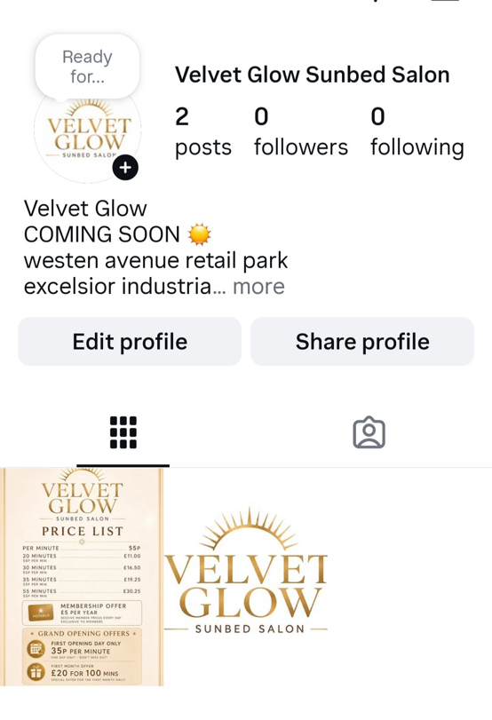
Velvet Glow is coming to Cardiff! Enjoy luxury tanning sessions, premium equipment and exclusive opening offers. Follow our page for updates and special promotions."
Brand colours will include gold, cream and black to create a luxury appearance.
9. Market Research
Primary Research:
An online survey was created using Google Forms to establish the level of interest in a tanning salon. The survey was distributed via social media, including Facebook and WhatsApp. 50 people aged between 18-45 responded to the survey. The results revealed:
Results:
In the Appendix

Secondary Research:
Industry reports show continued demand for beauty and personal care services (Nguyen, 2025).
Research findings influenced the decision to offer membership plans, premium equipment and strong hygiene standards.
Graphs showing survey results should be included within the appendix.
10. Financial Resources & Cash Flow Forecast
Funding Requirement: £75,000
Velvet Glow is a luxury tanning salon that will provide premium sunbed tanning services, skincare products, tanning packages and membership options. The business aims to become one of Cardiff's leading tanning salons by offering modern equipment, excellent customer service and a professional environment. Every new customer will be required to provide photo identification before using the tanning facilities.

Start-Up Costs:
• Sunbeds: £40,000
• Refurbishment: £15,000
• Furniture and Equipment: £5,000
• Marketing: £5,000
• Licences and Insurance: £3,000
• Working Capital: £7,000
Total: £75,000
Sources of Finance:
• Personal savings.
• Small business loan.
• Potential investor funding.
Cashflow chart
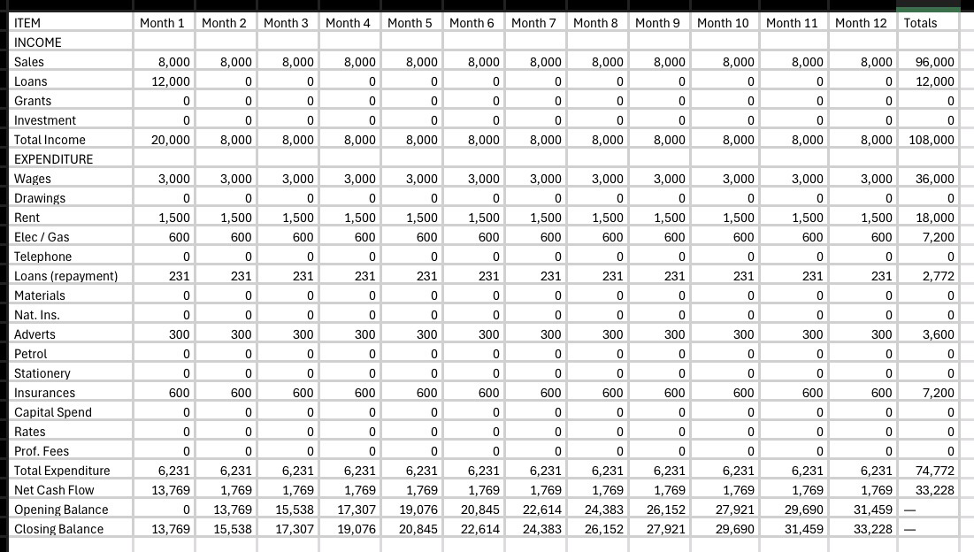

12-Month Cash Flow Forecast Summary
Average Monthly Income: £8,000
Average Monthly Expenses:
• Rent: £1,500
• Utilities: £600
• Staff Wages: £3,000
• Marketing: £300
• Insurance and Other Costs: £600
Estimated Monthly Profit: £2,000
The forecast suggests the business can become profitable within the first year if customer targets are achieved.
11. Competitor Analysis
Competitor 1: Lextan Tanning Salon
Lextan is a well-established tanning salon chain that has been operating for 16 years and continues to expand by opening new salons across Wales each year (Lextan, 2026)
They offer a range of tanning options, including several lay-down sunbeds and one stand-up sunbed. Customers are charged 75p per minute, with discounted minute packages available:
• 100 minutes for £40
• 80 minutes for £35
• 20 minutes for £12
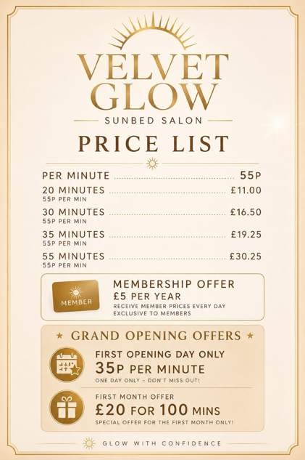

Lextan also sells tanning creams, with prices starting from £5. Customers who purchase a yearly membership for £8 receive discounted tanning sessions at £2.50 per session.
One of Lextan’s key strengths is its mobile app, which allows customers to purchase tanning minutes, monitor their remaining balance, and manage their account easily.
With multiple locations across Wales, competitive pricing, and a strong digital presence, Lextan is a significant competitor within the tanning salon market
Lessons Learned:
• High hygiene standards are essential.
• Membership packages encourage repeat business.
• Social media marketing is highly effective.
• Regular promotions to attract new customers and to create a loyal custom

12. Critical Appraisal (SWOT Analysis, PESTLE)
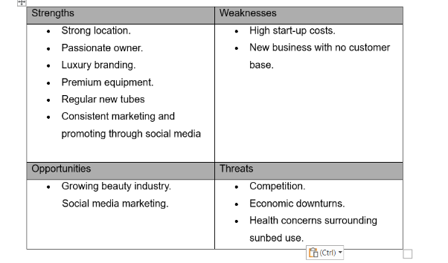
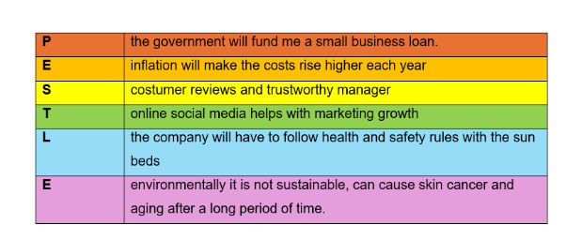

Task 1 part 2
Individual Reflection
- What new and existing entrepreneurial skills have you exercised and developed throughout your lecture series and compiling your assessments?
Throughout this module, I have developed a variety of entrepreneurial skills and improved some skills I already had. One of the main skills I have strengthened is planning and organisation. Creating a business plan required me to think carefully about every aspect of running a business, from marketing and finance to customer service and business objectives. It helped me understand how much preparation is needed before starting a business.
I also improved my research skills. To support my business idea, I carried out both primary and secondary research. Creating a survey and collecting responses helped me understand what potential customers want, while researching competitors and industry trends gave me a better understanding of the market. This helped me make more informed decisions when developing my business idea.
Another skill I developed was communication. I had to present information clearly throughout the business plan and explain why certain decisions were made. I also learned how important it is to communicate effectively with potential customers through marketing and social media.
My confidence has grown during this module as well. At the beginning, creating an entire business plan felt quite challenging, but as I worked through each section, I became more confident in my ability to generate ideas and make business decisions. I also improved my problem-solving skills by identifying potential risks and thinking about ways to overcome them.
I already considered myself quite creative, but this assignment allowed me to use that creativity when developing the Velvet Glow brand, choosing a business name, creating a unique selling point and thinking about how to attract customers. Overall, the module has helped me gain a much better understanding of entrepreneurship and what is involved in turning an idea into a realistic business opportunity.

2. Explain and discuss if you would personally consider investing in your business idea. Explain your reasons why/why not.
Yes, I would consider investing in Velvet Glow because I genuinely believe there is a market for the business. The idea is based on my own experiences, and I know how much a tan having can improve confidence for some people. Because I understand the target market, I feel confident that there would be customers interested in the services offered.
I also like that the business has more than one way of making money. As well as tanning sessions, customers could buy memberships, tanning creams, and skincare products. This would help increase revenue and encourage repeat customers.
The market research I carried out showed that there is interest in tanning services, and the location I selected has good visibility, parking, and footfall. These factors make me feel more positive about the business's chances of success.
However, I would still think carefully before investing because there are risks involved. The start-up costs are quite high, and there is already strong competition from established tanning salons. There are also health concerns surrounding sunbed use, which could affect customer demand in the future.
Overall, I would invest in Velvet Glow because I believe it has good potential and is based on something I am passionate about. While there are risks, I think that with strong marketing, excellent customer service and careful management, the business could become successful and profitable over time.

Reference List
.
- British Beauty Council (2025) UK Beauty Industry Overview. Available at: https://britishbeautycouncil.com (Accessed: 19 June 2026).
- Cancer Research UK (2025) Sunbeds and Skin Cancer. Available at: https://www.cancerresearchuk.org (Accessed: 19 June 2026).
- Cleveland Clinic (2024) Red Light Therapy: Benefits and Risks. Available at: https://health.clevelandclinic.org/red-light-therapy (Accessed: 19 June 2026).
- Federation of Small Businesses (FSB) (2024) Choosing a Business Location. Available at: https://www.fsb.org.uk (Accessed: 19 June 2026).
- Gov.uk (2025) Set up as a sole trader. Available at: https://www.gov.uk/set-up-sole-trader (Accessed: 19 June 2026).
- Lextan (2026) Tanning Salon Services and Pricing. Available at: https://www.lextan.co.uk (Accessed: 19 June 2026).
- Nguyen, S. (2025) UK Online Beauty and Personal Care Retailing Market Report 2025. Available at: https://www.mintel.com (Accessed: 12 June 2026).
- NHS (2025) Sunbeds and Risks. Available at: https://www.nhs.uk/live-well/healthy-body/sunbeds-risks (Accessed: 19 June 2026).
- Statista (2025) Beauty and Personal Care Market in the United Kingdom. Available at: https://www.statista.com (Accessed: 19 June 2026).
- Cancer Research UK (2026) How do sunbeds cause skin cancer? Available at: Cancer Research UK – How do sunbeds cause skin cancer? (Accessed: 19 June 2026).

Appendix



