Repository link: https://github.com/MattAlessandro/asd-maze-pathfinding-implementation

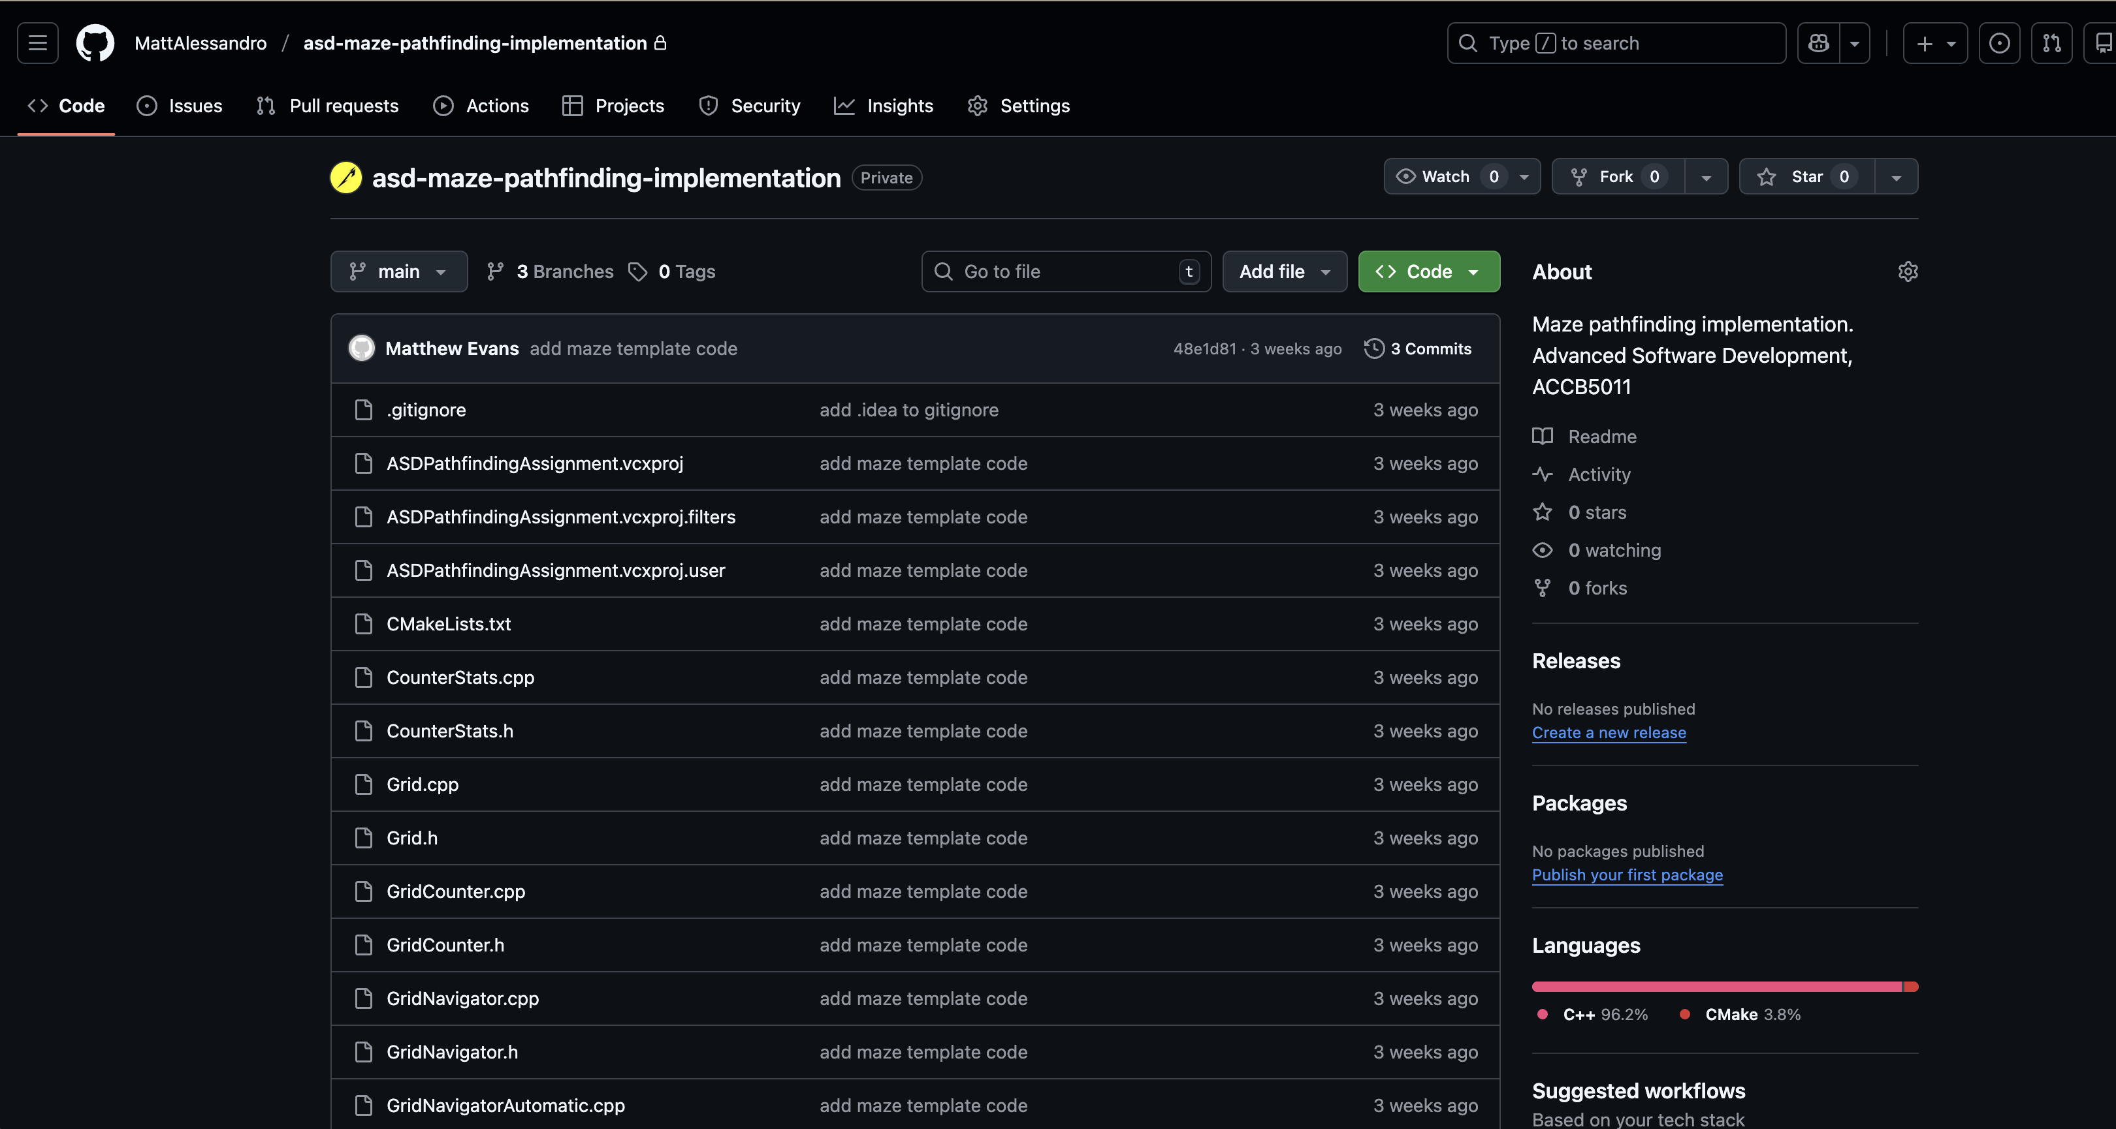

Please see ‘Branches’ for my two different solutions



- https://github.com/MattAlessandro/asd-maze-pathfinding-implementation/tree/v1-hug-the-left-wall-solution
- https://github.com/MattAlessandro/asd-maze-pathfinding-implementation/tree/v2-a-star-algorithm-solution

V2-a-star-algorithm-solution & v1-hug-the-left-wall-solution

