3/24/2025
University of Wales Trinity Saint David
London campus
E-Portfolio Link: Do not forget to share your e-portfolio (Wix) link here
Module Name: Learning In the Digital Era
Module Code: ACCA 4025

Student Name: Carlos Watson
Student ID:
Group: 1

Lecturer’s Name: Koushik Modak

LDE Assignment 1
E-Portfolio
Table of Contents
Introduction 2
Main Body 2
Task 1: Essential Academic and Employment Skills for the future career Path 2
Task 1 (a): Report on Essential Academic and Employment Skills 2
Task 1 (b): AI Assistant Tools 2
Task 1 (c): Evaluation of Task 1 (a) based on Similarity report 3
Task 2: Collaborative Mind Map and Individual Poster 3
Mind Map (Collaborative) 3
Poster (Individual) 3
Task 3: Virtual Collaboration and RefWorks 3
Report on Virtual Collaboration 3
Step-by-step process of using RefWorks with visuals 3
Task 4: E-Portfolio Creation and Evaluation 3
Task 4 (a): E-Portfolio Creation 3
Task 4 (b): Illustrative Review of E-Portfolio tool Selection 4
Conclusion 4
References 4
Task 1 References: 4
Task 3 References: 4

I will be discussing the different academic and work-related skills that are important for an employer or a teacher, I will also be presenting a mind map showcasing the difference in having these skills also one a e-portfolio of myself and talking about the different AI systems that are available what the use and function for these apps are. I will also be adding references also screenshots showcasing the different skills and AI system that are available. I will also be adding a similarity report of my work to showcase weather it is original or has been copied and paste from AI or google.

Essential academic and employment skills for future career paths are
- Loyalty
- Commitment
- Honesty and integrity
- Reliability
- Communication
Having loyalty in the workplace and academic settings allows you to show your employer and teachers your dedication to your work and coursework. This shows your employer that you want the company to succeed while your teachers see your commitment to your course. This allows you to progress in higher positions at your workplace because you become more trustworthy within the company.
Commitment in the workplace and academic settings, commitment to the work that ensures you finish the project no mater how hard it is in an efficient time. This allows the academic and workplace know you will be more willing to go beyond the job and course role.
Reliability shows you can complete any work, show up on time and capable of handling any tasks. This is a valuable skill to have for an employer to hire you and the academic facility to know you can complete any tasks.
Communication is good to have so you can understand any task while being able to explain the tasks to other people at a high level.
- Computer skills
- Leadership skills
Having good computer and leadership skills is a good skill to have as both skills can help you into a higher position in a job, or during an academic setting you can help your fellow classmates. Encourage them and helps to work together on group projects or in a job role. This can help you to negotiate with other businesses or resolve conflicts.
- Planning
- Learning
Being able to plan and have this as a skill is useful to have because you can prepare for any tasks. Being able to do this increases your chance of a good position job as you can plan out an event, without missing any details of what is needed. This is also good to have in an academic.
- Reading
- Writing
Being able to read and write helps improve your chances of success in the employment and academic setting because you are able to read your work to a high degree of understanding and to be able to write your work also.

setting because you can plan how you will do you work, when it will be finished by.
Being able to learn is a useful skill to have because you can be taught anything to do with a job or an academic setting. The work will become a lot easier for you; you can meet deadlines on time.

There are many essential skills for academic studies which are critical to have to succeed and progress in your course of choice. Each skill is pivotal to have if not learn. by learning these skills, you would greatly increase your chances of success and gives you an easier overview and understanding of your course of choice. This will also enable you to work well with others, such as.
- Teamwork
- Punctuality
- Critical thinking
- Research skills
- Reading
- Organization

Having good teamwork allows you to complete a task at a faster pace, allows you to bounce ideas from each other. If a task is heavy for one person, having 3-4 people instead can increase the time of the working being finished and allows you to lift the product which would normally be to heavy for one person, it also reduces stress.
Punctuality can be a difficult thing but having good punctuality is essential because it increases your chances of success in the academic settings, helps improves responsibility.
Critical thinking, researching skills and reading helps you to solve problems easier, search for the information and to be able to analyse and use it in your module and to use the correct information by reading it properly.
Organisational skills are good to have, know where everything is when you need it and where it is.

Task 1 (b): AI Assistant Tools

Criteria | ChatGPT | Copilot | Gemini
Generating answers
Creative work, code/diagram generation
Data analysis
Problem-solving

Gemini is a good Ai app to use generate a plan, write a document and brainstorming. It also has features to generate a business model, and code also gives you a data analysis of the business criteria, on how much is earned, gross profit and losses and on who uses the business. Gemini can also generate a problem you may encounter with the business and suggest solutions to fixing it. Gemini can also generate diagrams with a whole business layout. It also can direct you on where to go to upload your business code so the business can be visible anywhere in the world. It is also easy and simple to read. ChatGPT can generate a code also for a business app but not for public use it also tells you the code is only a prototype and generate answers for any topic/questions it does not help with building the app but guides you on how to do it. Copilot can also generate a code; build information on any questions you ask helps to solve your problem by letting you know what you will encounter. In my opinion Gemini is the better app to use because it creates the business for you, while ChatGPT and Copilot only talks about the business.

Gemini
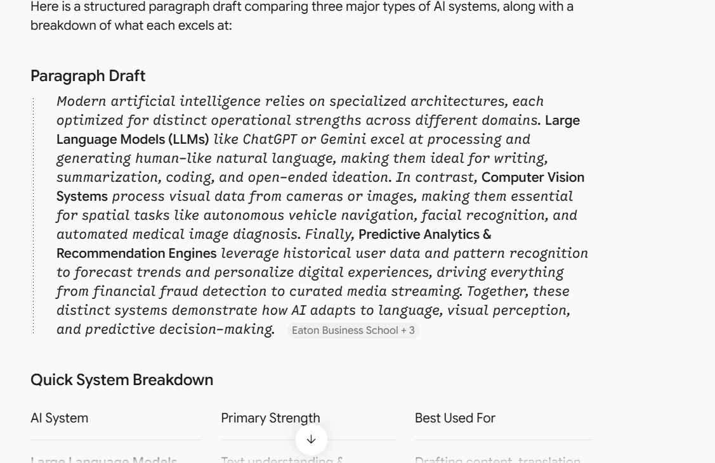
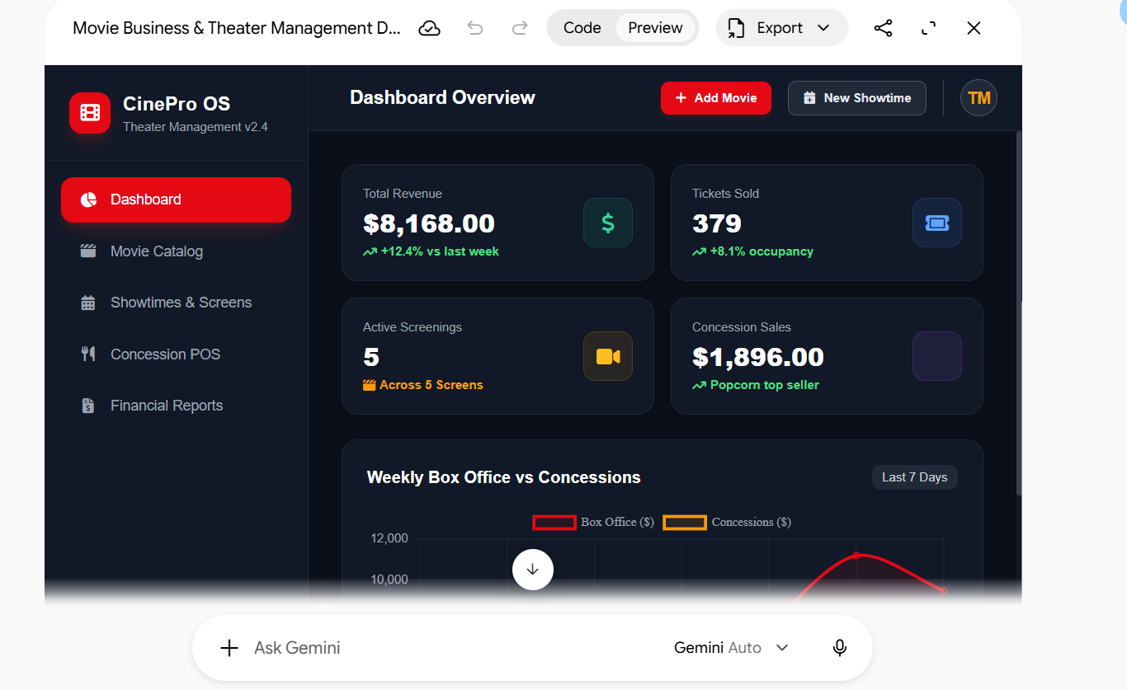
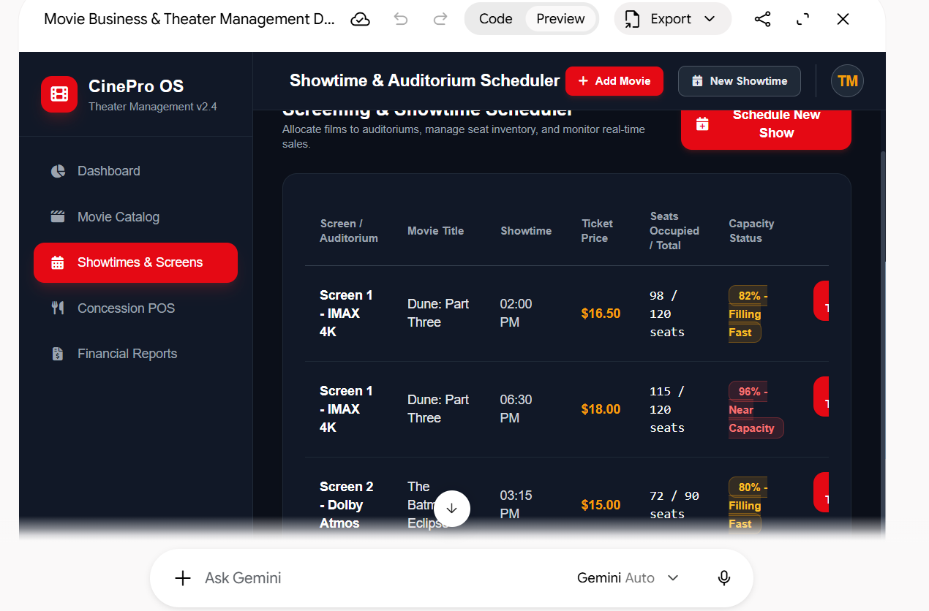
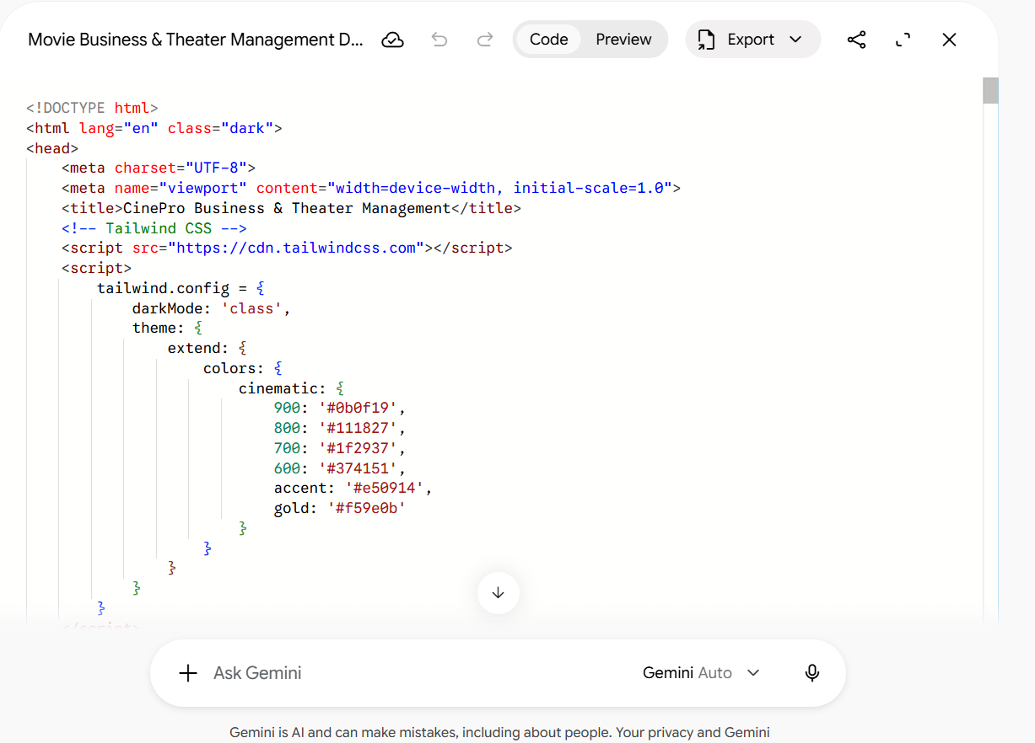
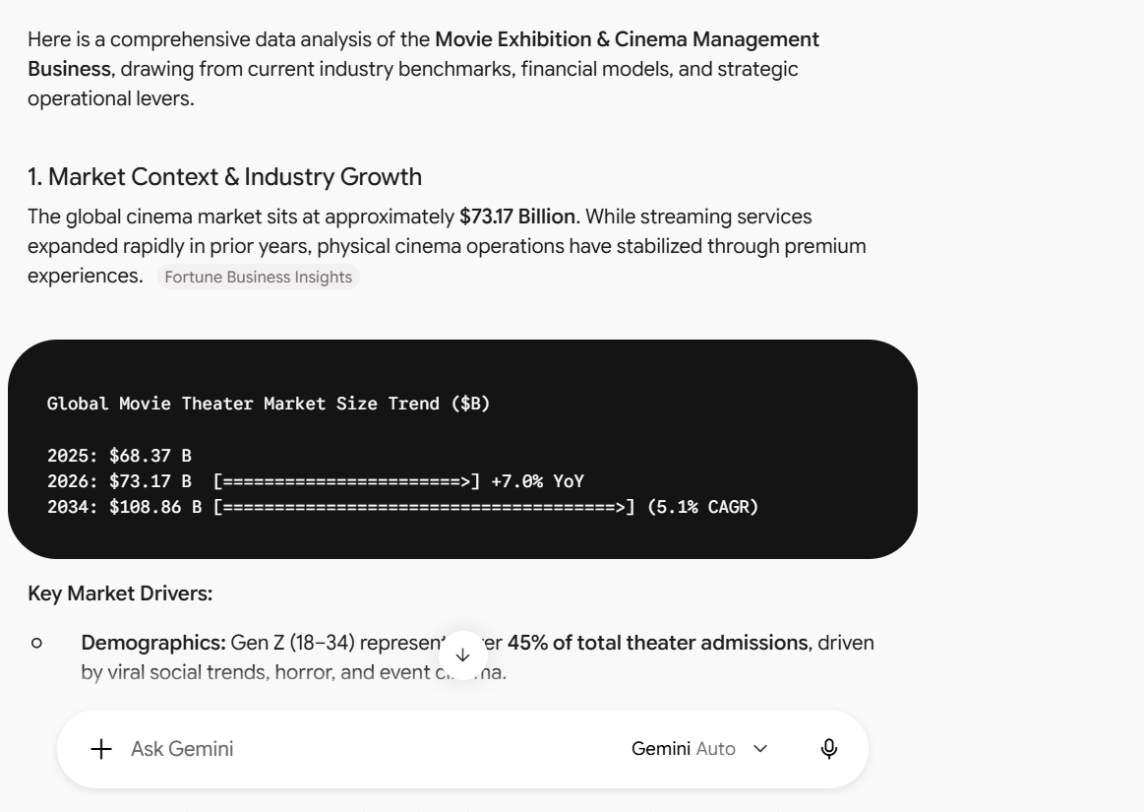
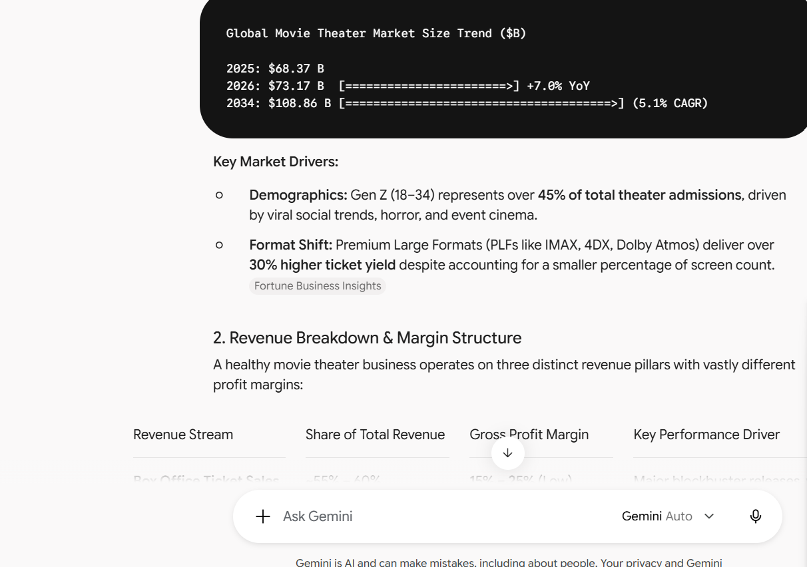
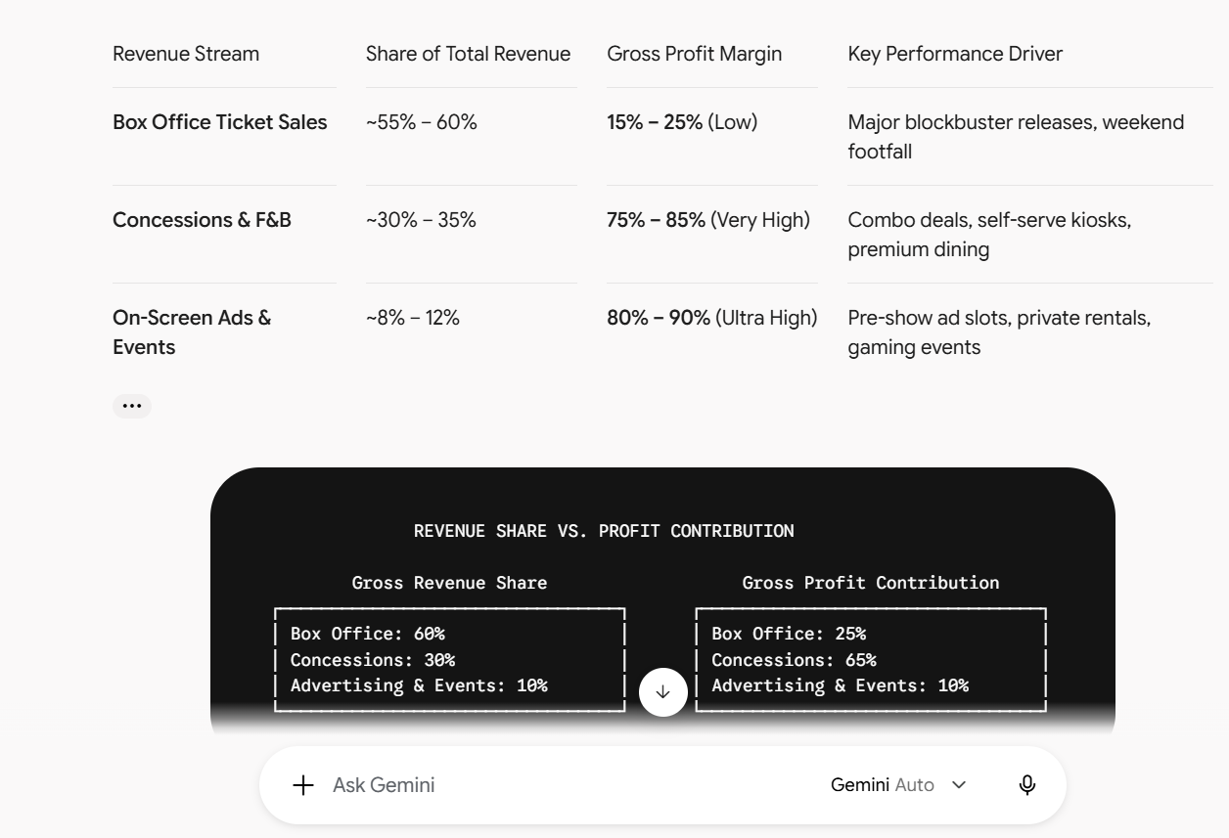
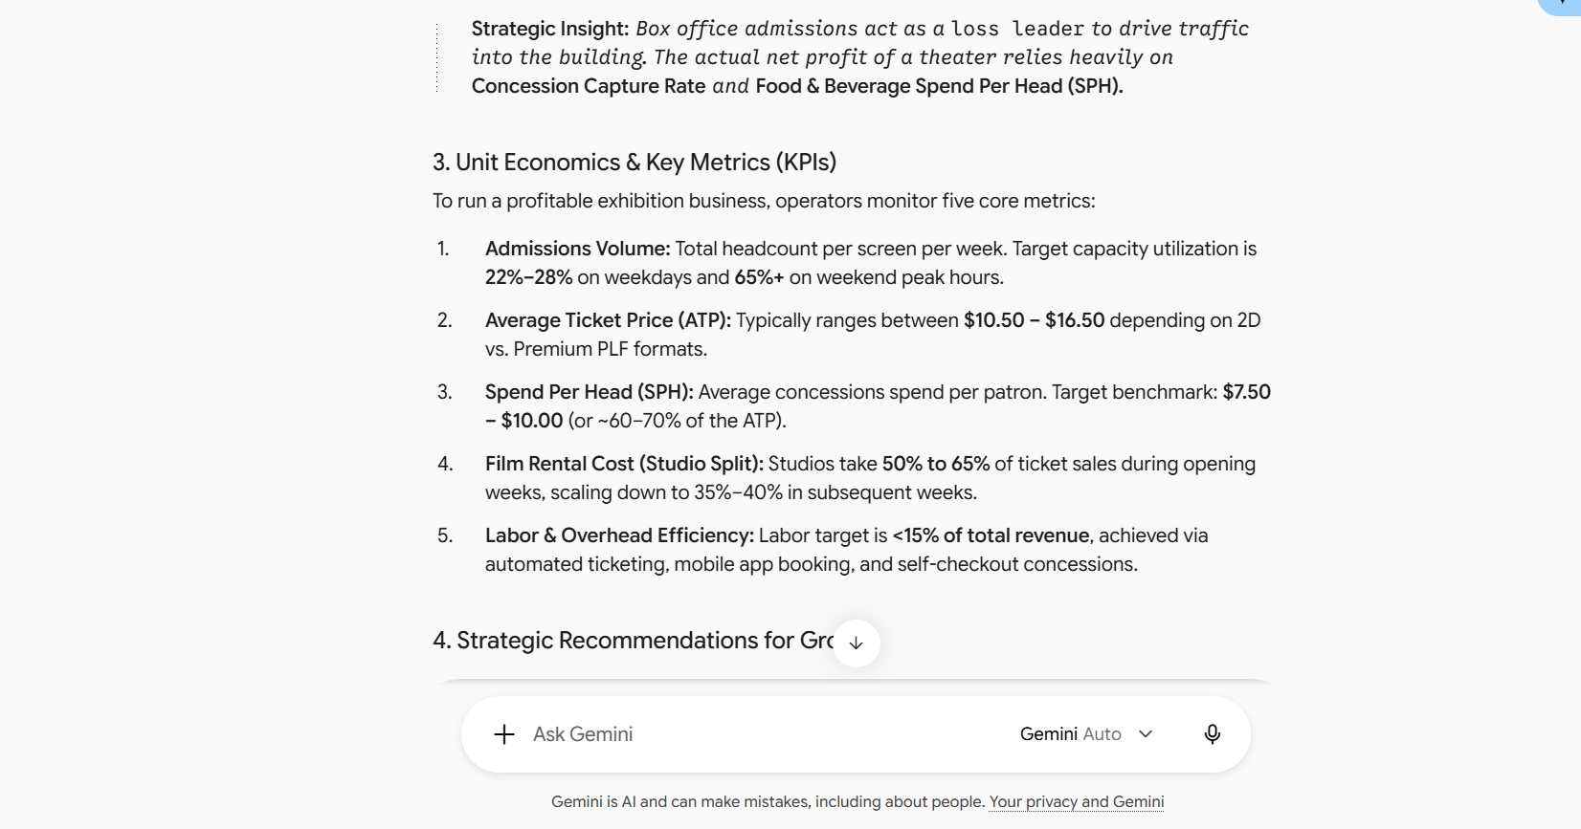
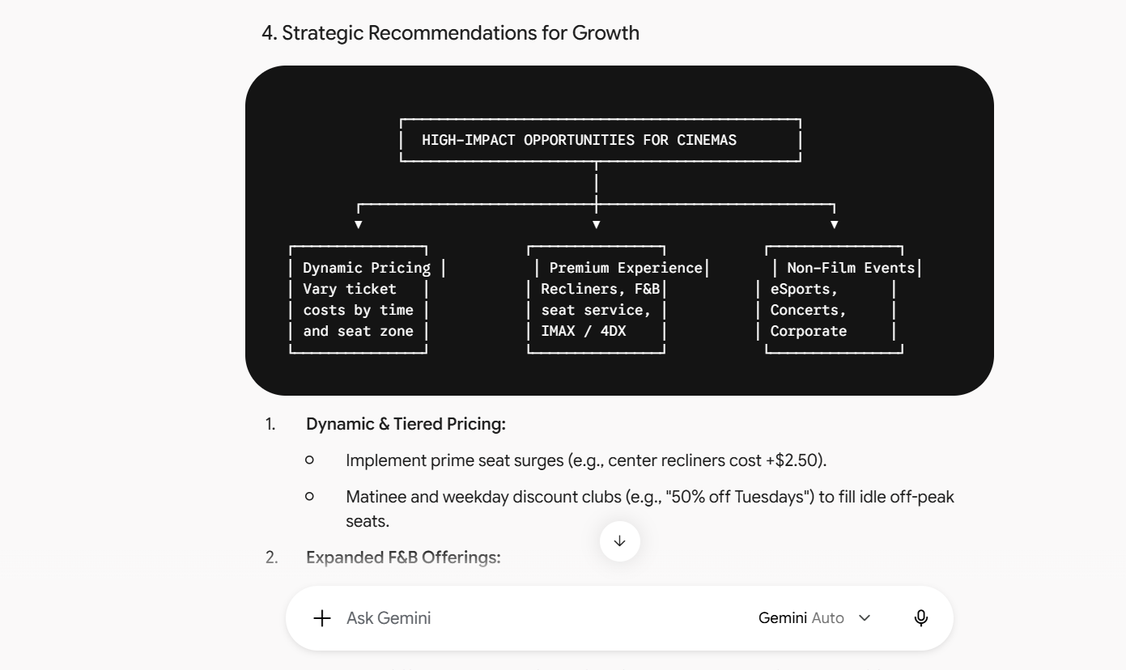
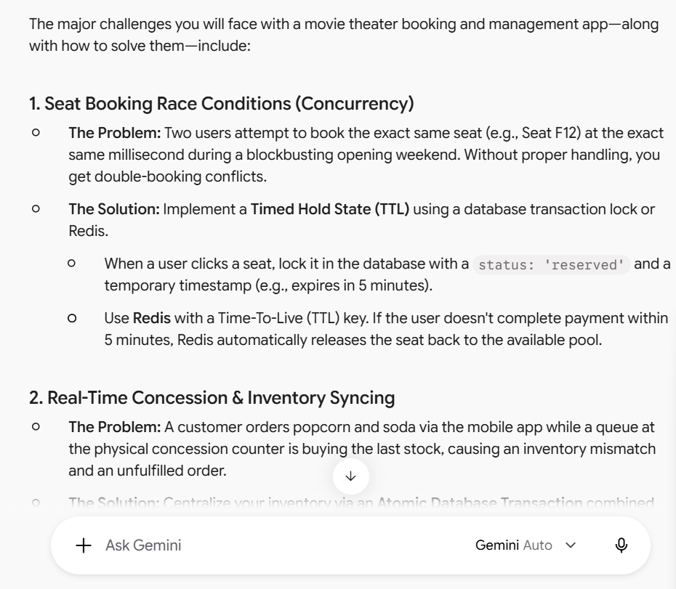
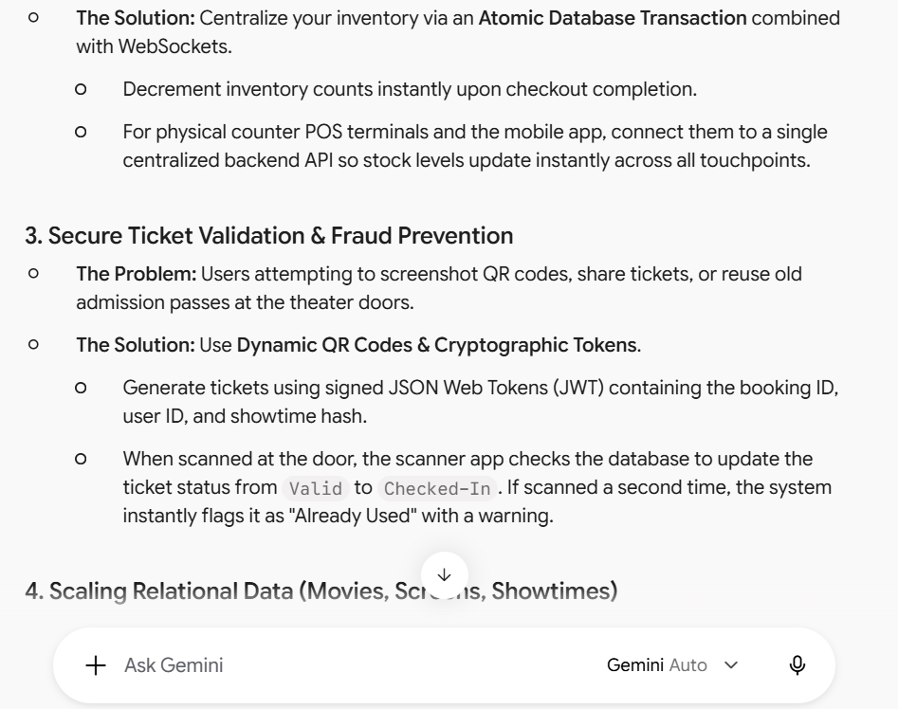
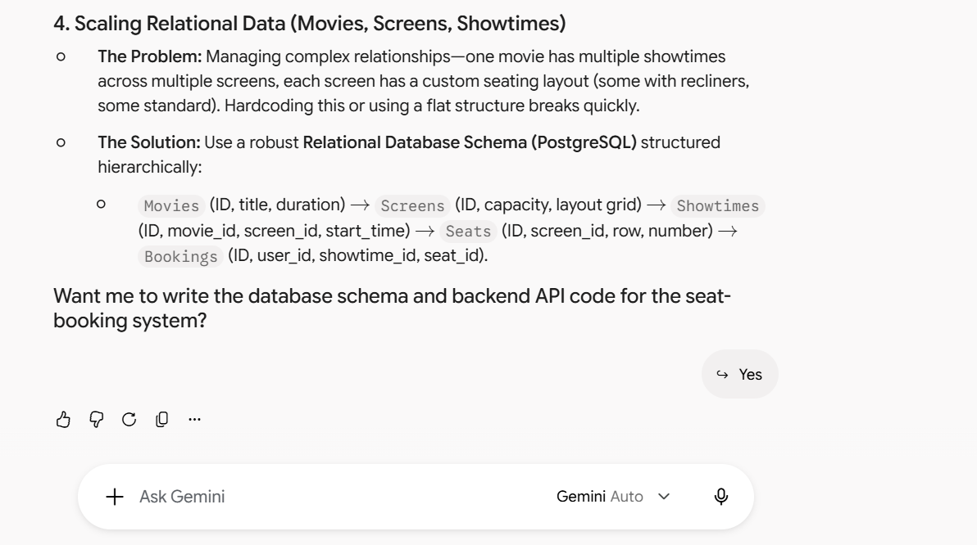
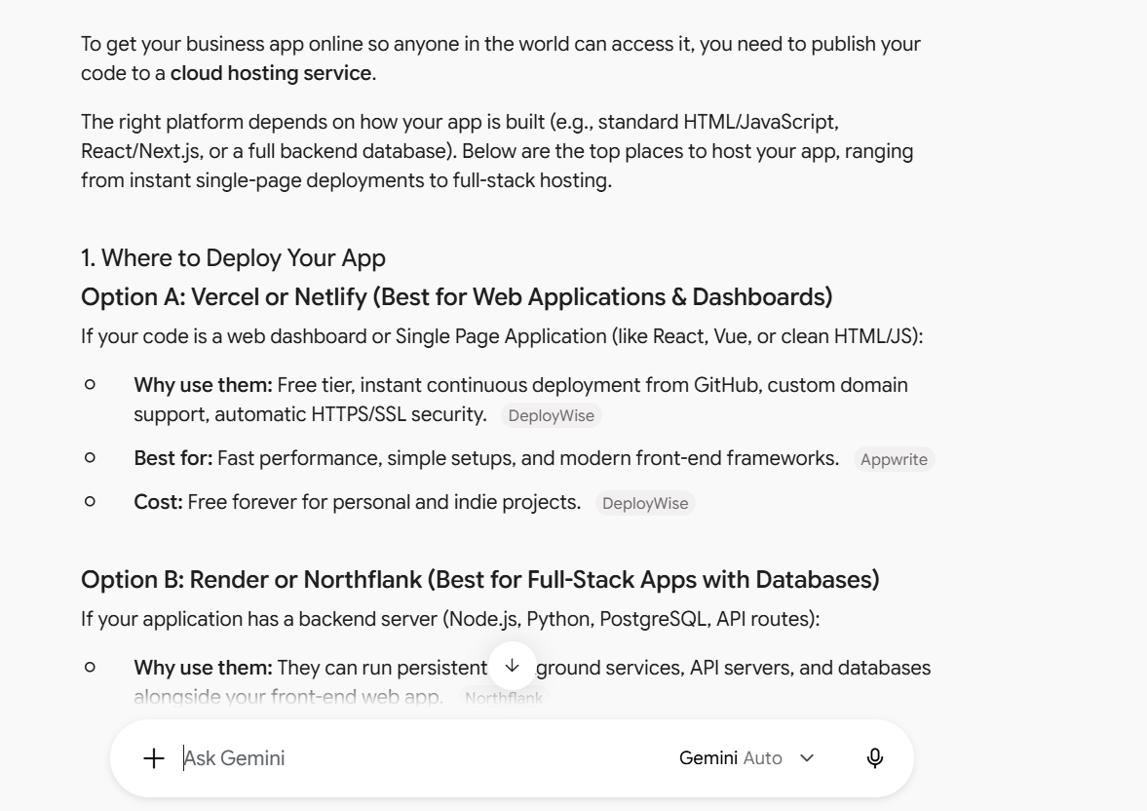

ChatGPT
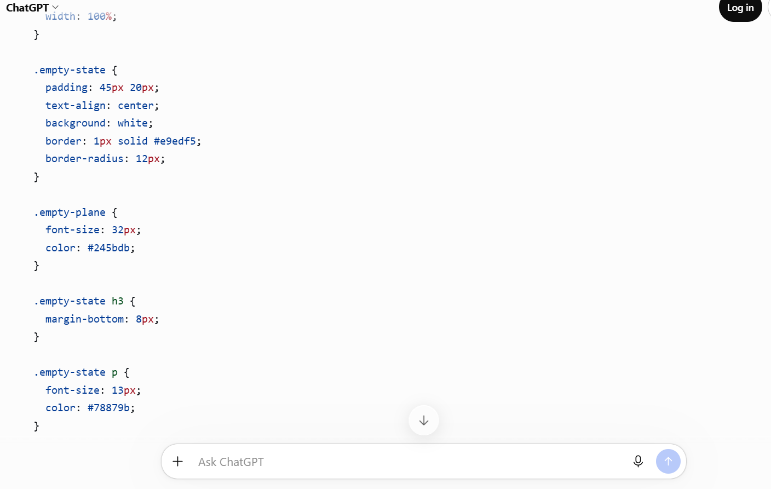
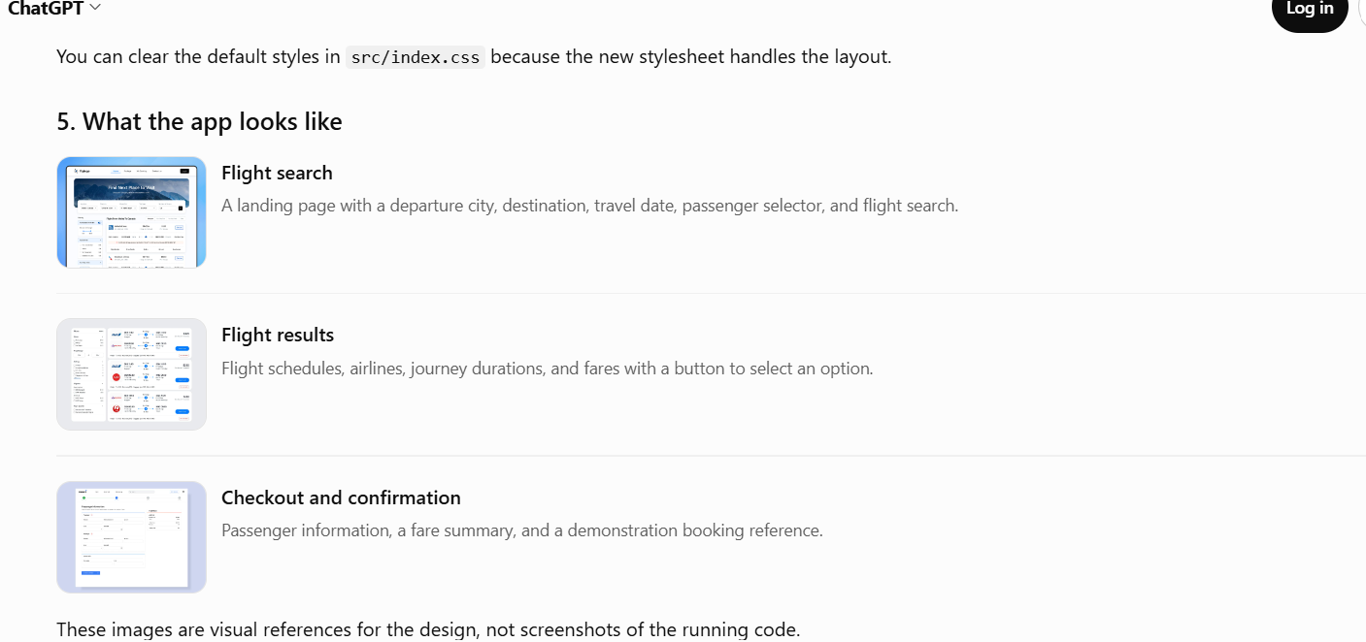
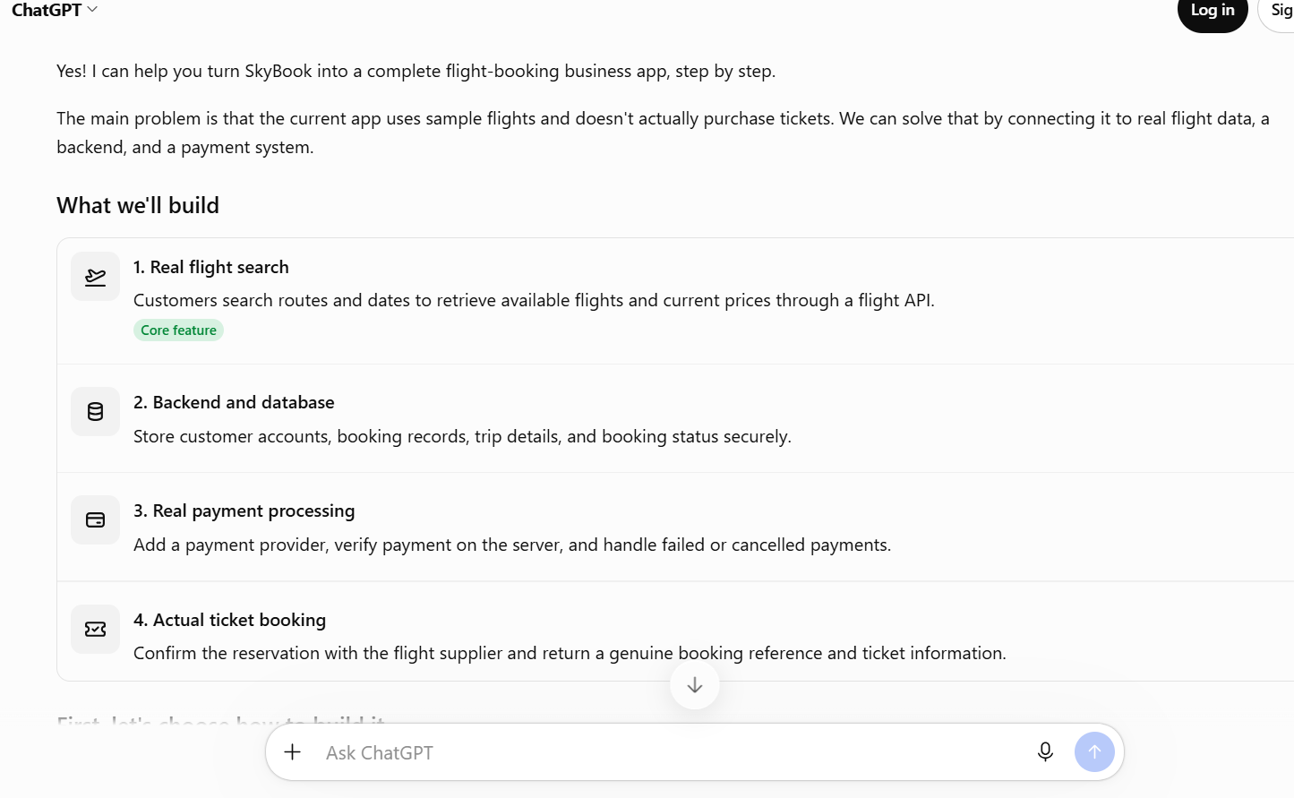
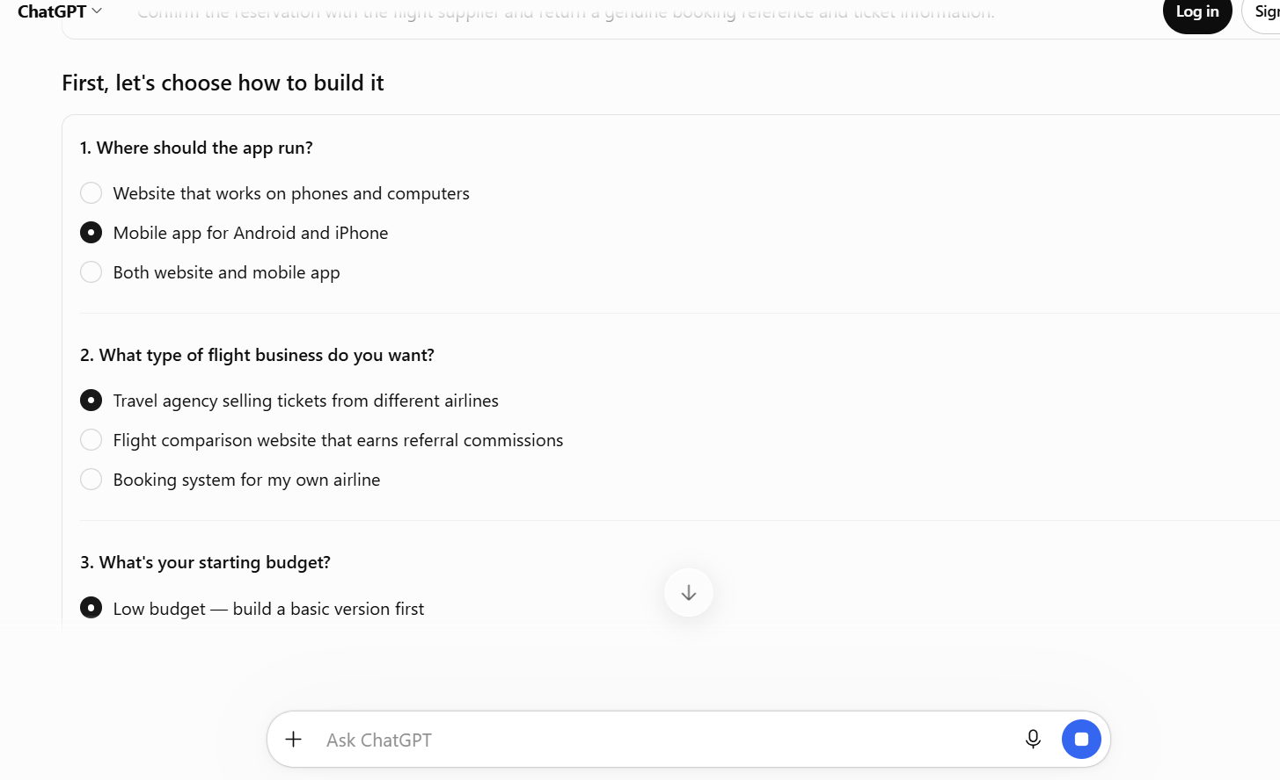

CoPilot
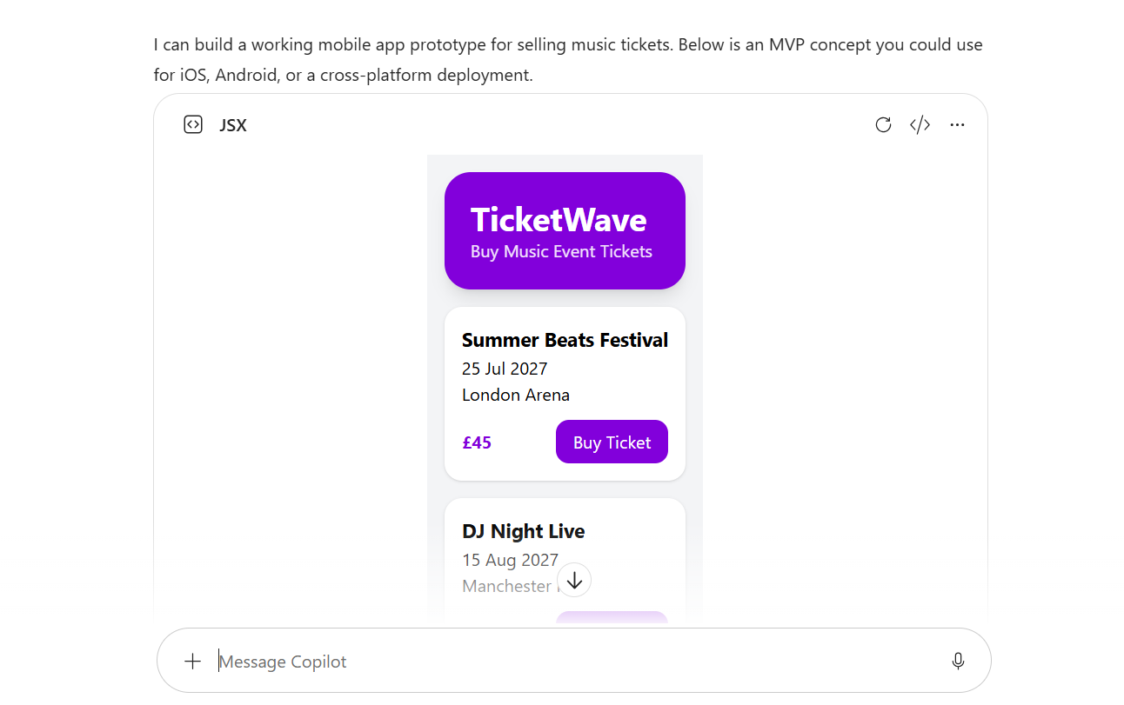
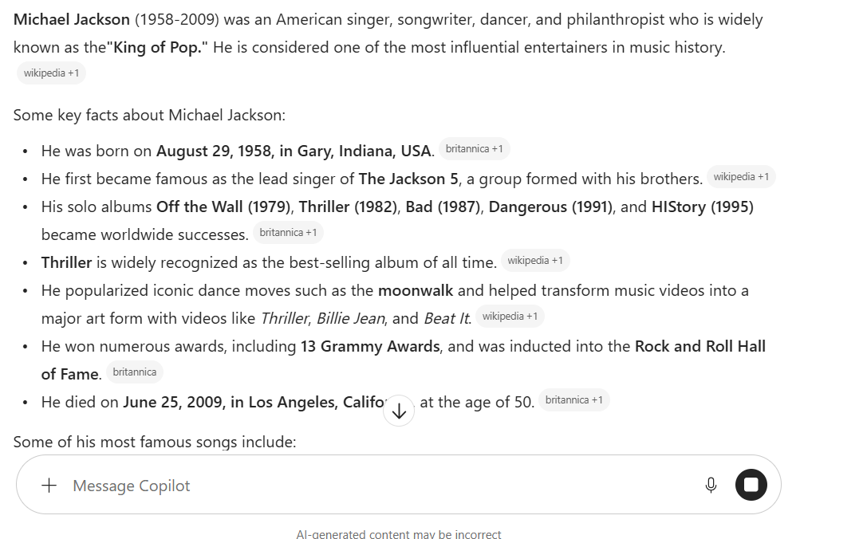

Here is a course from LinkedIn speaking about AI
Introduction to Artificial Intelligence | LinkedIn Learning

Task 1 (c): Evaluation of Task 1 (a) based on Similarity report
Submit the document prepared in Task 1 (a) to Turnitin and generate the similarity report and take a screenshot of your similarity report and paste it here. Please evaluate your similarity percentage. (200 words) – self-evaluation (approx. 200 words and 2 paragraphs where the first paragraph is about your similarity index and your areas of improvement. Then the second paragraph is about how much mark you deserve on your work with an appropriate justification-Remove this part after completing).

Task 2: Collaborative Mind Map and Individual Poster

Mind Map (Collaborative)
(approx. 450 words where 3 persons in one group and the contribution from each person should be 150 words approx..).

Poster (Individual)
No word limit. Mind Map must be inserted in the Poster

Task 3: Virtual Collaboration and RefWorks

Report on Virtual Collaboration
(approx. 350 words and 4-5 sources-Remove this part after completing).
Put your Chosen topic here and write a summary of that topic with IEEE referencing using RefWorks-Remove this part after completing.

Step-by-step process of using RefWorks with visuals
Put screenshots with appropriate discussion explaining what has been demonstrated in that screenshot-Remove this part after completing (100-150 words)

Task 4: E-Portfolio Creation and Evaluation

Task 4 (a): E-Portfolio Creation
Explain how you have created your e-portfolio with screenshots as evidence-Remove this part after completing.

Task 4 (b): Illustrative Review of E-Portfolio tool Selection
(approx. 100-150 words and 1-2 sources (if used)-Remove this part after completing).

Conclusion
(approx. 100 words -Remove this part after completing).

References

Task 1 References:
[1]
[1]
[1]
[1]

[1]

[1]

Task 3 References:

