Rusina begum-1710303
Benefits & Drawbacks of John Lewis CRM System

John Lewis CRM system allows them to collect data on their customers and their preferences, by collecting information which allows them to target profitable customers with products and services. Through CRM John Lewis can improve Customer Service by having better customer interaction, they can be more efficient because they have easy access to information which helps staff deal with queries quickly.
By improved customer service John Lewis can gain customers’ trust and improve the quality of their products and services and build better relationships with existing customers. The CRM systems allows them to have a direct communications link with their customers through their “My John Lewis” Loyalty Scheme.
Giving customers the opportunity to give feedback allows John Lewis to improve their services and customers feel that they are being heard.
The CRM system also benefits John Lewis by helping them to increase their customer base by advertising their offers and rewards they can gain more customers.
All these benefits help John Lewis to increase their profits by having repeat customers, cross selling and holding more events. Also, as John Lewis continue to grow the “My John Lewis” scheme, they will continue to increase profits.
Some of the drawbacks are the cost of IT system, system upgrades, training and data breach. In 2018, John Lewis reported a 99% fall in profits for the first half of the year, they blamed this mainly on increased IT cost (Butler 2018, Macdonald 2018). Although John Lewis have not had any data breaches to date, it is still important to make sure customers’ information is secure. Data breaches could lead to fines, loss of customers trust, loyalty and damaging John Lewis brand.

Appendix
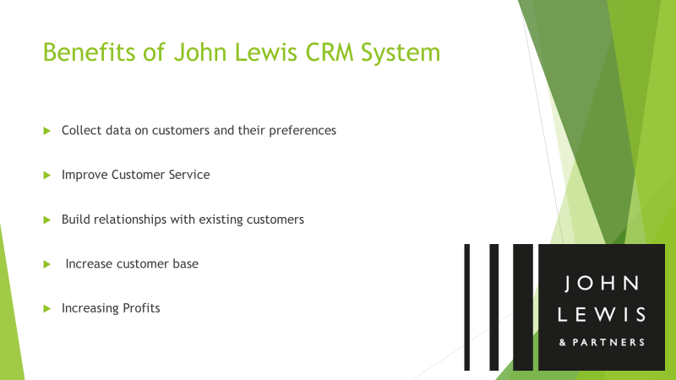
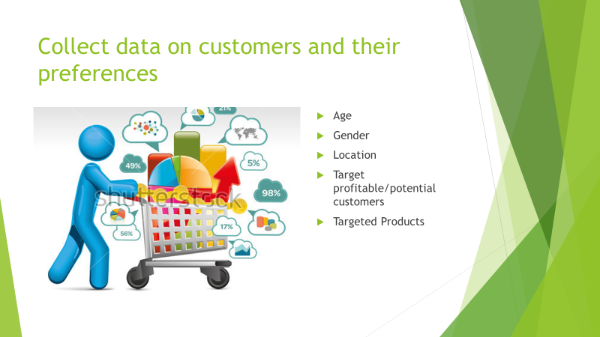
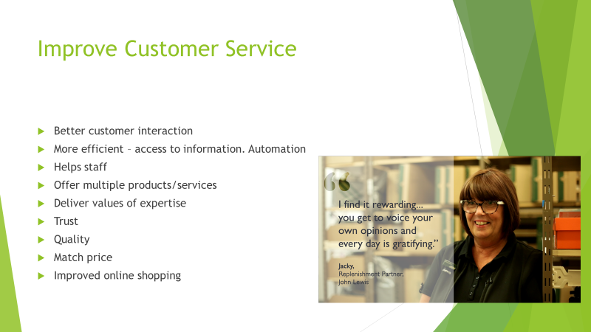
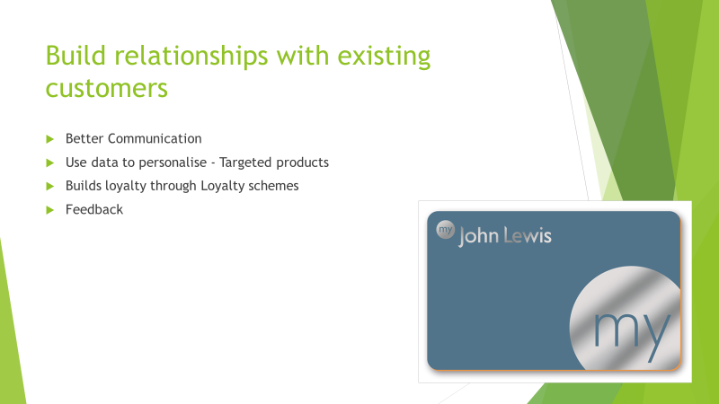
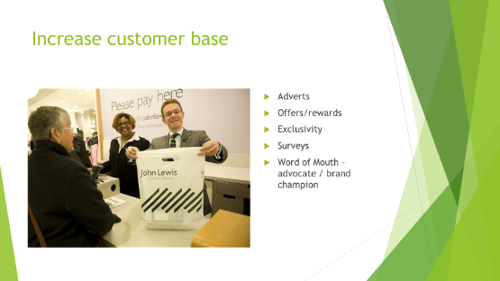



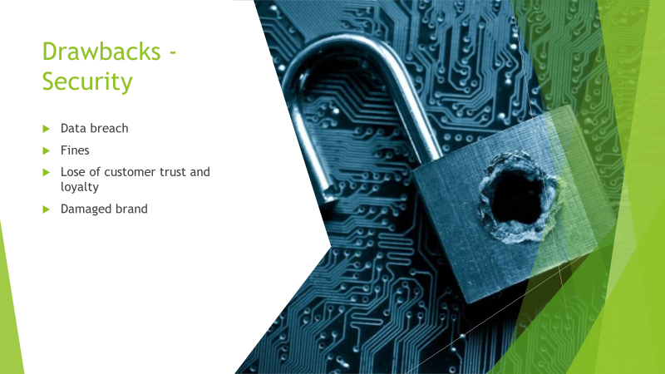
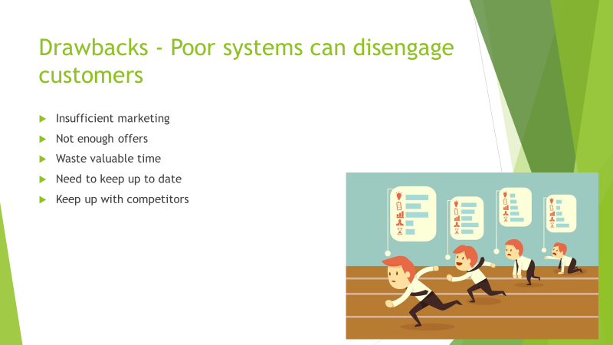
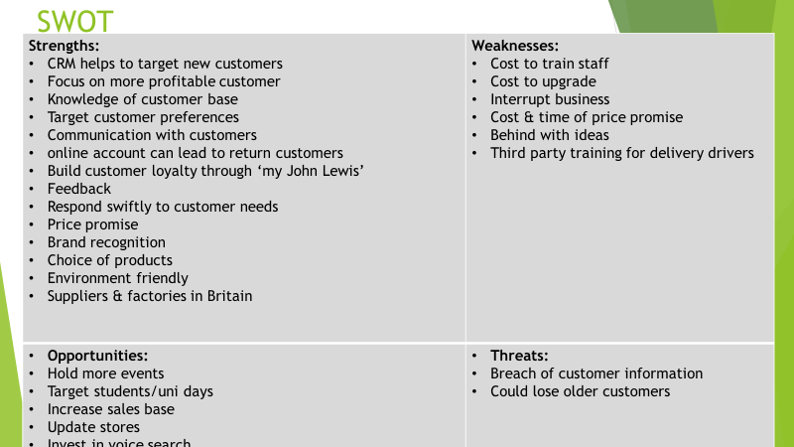

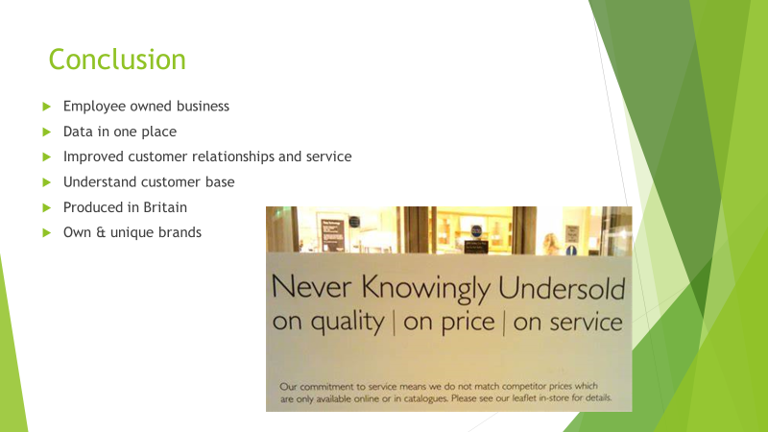
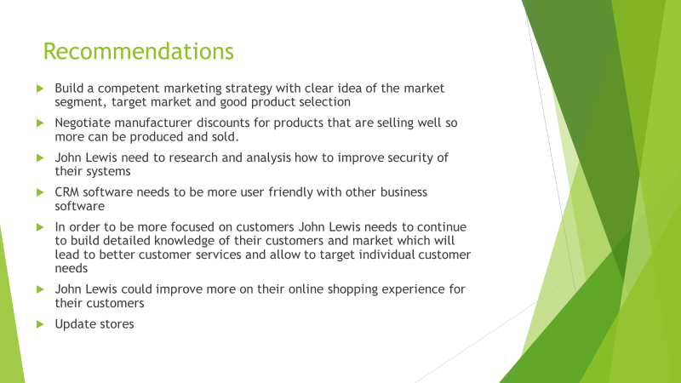

Bibliography
Butler, S. (2018) The Guardian. Available at: https://www.theguardian.com/business/2018/sep/13/john-lewis-profits-dive-99-percent (Accessed: 2nd June 2019)
Buttle, F. (2009) Customer Relationship Management. 2nd ED. UK: Elsevier Ltd.
John Lewis PLC. (2001-2019) John Lewis & Partners Available: https://www.johnlewis.com/customer-services/about-us (Accessed: 2nd June 2019)
McDonald, C. (2018) ComputerWeekly.com. Available at: https://www.computerweekly.com/news/252448604/John-Lewis-blames-profit-drops-on-high-IT-costs (Accessed: 2nd June 2019)
MarketLine. (2011) John Lewis Partnership UK retail chain is owned by its employees. Available at: file:///C:/Users/Student/AppData/Local/Packages/Microsoft.MicrosoftEdge_8wekyb3d8bbwe/TempState/Downloads/ML00001-032%20(3).pdf (Accessed 2nd June 2019)
Raab, G et al. (2008) Customer Relationship Management. England: Gower publishing Ltd.
Salaman G & Story J. (2016) A Better Way of Doing Business? Lessons from The John Lewis Partnership. Available at: https://www-oxfordscholarship-com.ezproxy.uwtsd.ac.uk/view/10.1093/acprof:oso/9780198782827.001.0001/acprof-9780198782827 (Accessed: 2nd June 2019)

