
Programme: Master of Business Administration
Module: International Business Concepts
Module code: LCMB7034
Assignment Title: Report
Lecturer:
Dr. Gladius Kulothungan
Student Name: Dhruv Solanki
Student ID: 2519348
Word Count: 5051

Table of Contents
1. Introduction 4
Section 1 6
2. Organisational Classification and Global Strategy 6
2.1 Bartlett and Ghoshal's International Strategy Model 6
2.2 Current Global Configuration 7
3. Macro-Environmental Appraisal and Market Attractiveness 8
3.1 Political Environment 8
3.2 Economic Environment 10
3.3 Legal Environment 12
3.4 Cultural Environment 14
3.5 OLI Framework 16
4. Entry Mode Strategy and Strategic Synthesis 18
4.1 Historical Entry Pattern 18
4.2 Entry Mode Evaluation 19
4.3 Final Recommendation 20
Section 2 21
5. Reflective Account (Gibbs Reflective Cycle) 21
5.1 Description 21
5.2 Feelings 21
5.3 Evaluation 22
5.4 Analysis 22
5.5 Conclusion 23
5.6 Action Plan 23
References 24

1. Introduction
Multinationals (MNCs) are increasingly looking to expand internationally to ensure sustainable growth, diversify markets and gain a competitive edge in the globalised market (Zahra and Mudambi, 2025). Going abroad into attractive markets can help companies access new market segments and can help in economies of scale and minimise dependence on domestic markets. Thus, the choice of the host country is a critical one, and the political, economic, legal and cultural environment needs to be evaluated thoroughly to minimise host country risks and maximise long-term host country returns.
J Sainsbury plc is a UK-based food retailer with a weekly reach of millions of customers across supermarkets, convenience stores and digital channels (J. Sainsbury, 2026). The company's financial performance and operating strength were very good in the 2025/26 financial year, with underlying group sales of £33.65 billion and 4.3% retail sales growth (excluding fuel) (J. Sainsbury, 2026).
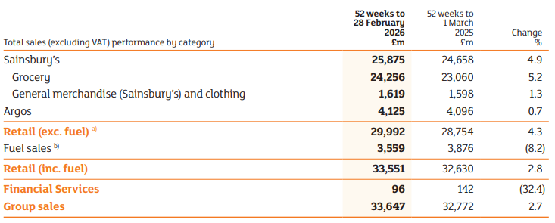
Figure 1: Group sales
(Source: J. Sainsbury, 2026)
The United States is chosen as the target market because it has the largest consumer economy in the world with about 342.942 million people, and the International Monetary Fund (IMF) predicts that real GDP in the United States will grow by 2.3% in 2026 (IMF, 2026). In this report, the suitability of the USA for Sainsbury's expansion is evaluated by analysing its international strategy, macro-environment, market attractiveness and appropriate entry mode before making evidence-based recommendations.
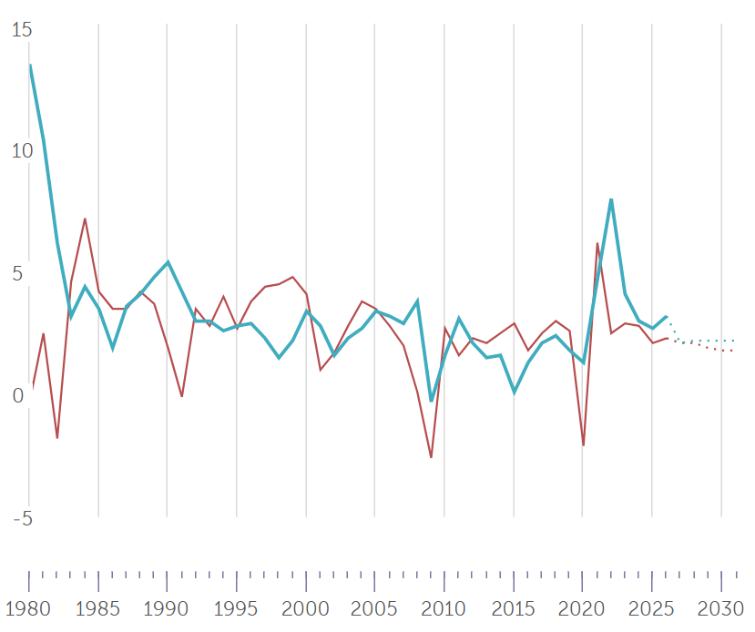
Figure 2: Country Data
(Source: IMF, 2026)

Section 1

2. Organisational Classification and Global Strategy

2.1 Bartlett and Ghoshal's International Strategy Model
Bartlett and Ghoshal's model classifies multinational corporations into four strategic approaches that are international, multidomestic, global and transnational based on the degree of global integration and local responsiveness (AQA, 2026).
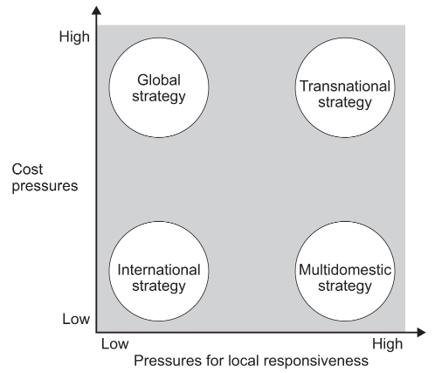
Figure 3: Bartlett and Ghoshal's Model
(Source: AQA, 2026)
The framework helps assess the firm's coordination of international operations and adaptation to local conditions (Chabowski, et al., 2025). In the context of Sainsbury's business model, it would be best analysed as an international firm with a high degree of domestic orientation. Sainsbury's business is almost entirely domestic, as opposed to retailers like Walmart or Carrefour, which have a significant retail arm overseas. The business has a domestic distribution network but adds value by having an integrated global sourcing network which provides food and non-food products from international suppliers, with the strategic decisions being taken in the country (J. Sainsbury, 2026).
This is backed up by Sainsbury's focus on consolidating its position in the UK market and not aggressively expanding internationally. Moreover, it has a 'Next Level Sainsbury's' approach which focuses on investments in value, technology, own-brand products and long-term partnerships with suppliers, such as over £5 billion invested in British and Irish agriculture, and supporting over 2,500 farms (J. Sainsbury, 2026). These projects enrich operational efficiency and quality of products but are mostly focused on the local market.
This approach has helped Sainsbury to become Britain's second-largest grocery business but offers little international market experience (Winton, et al., 2026). The company would have to shift its focus to become a transnational business that would include a global integration of procurement and operational efficiency, as well as accommodating the preferences, regulatory and competitive landscape of the USA.

2.2 Current Global Configuration
Sainsbury's business continues to be largely at home in the UK with supermarkets, convenience stores, Argos stores and digital grocery services (J. Sainsbury, 2026). However, it has a global value chain both with suppliers from around the world as well as with long-term partnerships with local producers to strengthen food security and sustainability. Its differentiators are a robust private label portfolio, innovative digital retailer functionality, the Nectar loyalty initiative, multi-channel integration and supply chain productivity. They have helped Sainsbury to secure the highest food volume market share for 10 years and have seen over 40 new stores open and around 1,200 new own-brand products launched in 2025/26 (J. Sainsbury, 2026).
But the company's limited experience working overseas is a big problem for a market as competitive as the USA. Therefore, Sainsbury must overcome the challenge of international expansion by making use of its existing strengths and adaptability for local markets and responsiveness.

3. Macro-Environmental Appraisal and Market Attractiveness

3.1 Political Environment
Foreign market success is greatly driven by the political environment, as it affects investment, trade, food safety and labour practices (Zeng, et al., 2025). The US is also one of the most predictable investment climates in the world thanks to its clean legal environment and robust institutions. The IMF predicts that the US economy will expand by 2.3% in 2026, inflation will be 3.2%, and the population will be around 342.9 million, providing a good backdrop for long-term retail investing (IMF, 2026).
Foreign direct investment (FDI) is still encouraged by the US government as it is a factor of employment, innovation and economic growth. Foreign retailers, however, are required to adhere to more stringent investment screening and customs regulations and supply chain reporting requirements (Stona, et al., 2026). These measures will make markets more transparent, while also creating higher regulatory demands for new market entrants. This brings additional compliance risk for Sainsbury, but greater certainty in political and regulatory policy for Sainsbury.
Another key factor is trade policy, as in recent times, trade policy in the United States has become more challenging and more implemented to protect domestic industries through the imposition of higher tariffs. The US tariff rate will settle between 7% and 8.5% on its products (York and Durante, 2026). Higher tariffs could make Sainsbury less price-competitive, as it will have to pay more for the imported own-brand food products and source from abroad. The creation of local sourcing partnerships would thus be an important strategic priority.
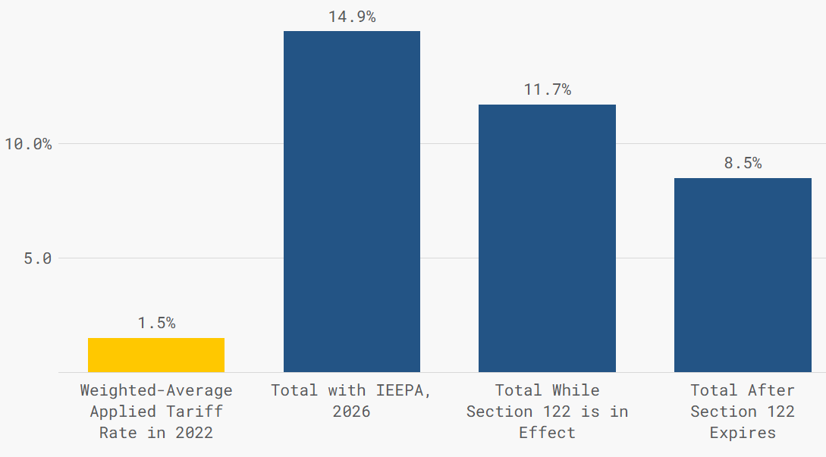
Figure 4: Trump's Tariffs Dramatically Raise Applied Tariff Rates
(Source: York and Durante, 2026)
Government policies on food and agriculture also have a significant impact on food retailing (Haque, et al., 2025). Retailers are subject to regulations under the jurisdiction of the Food and Drug Administration (FDA) and the United States Department of Agriculture (USDA) related to food safety, food product labelling and food quality. Also, federal agricultural programmes are very strong in promoting domestic food production and local procurement wherever possible. Labour regulations such as the minimum wage, workplace safety, and anti-discrimination laws further boost operating expenses, but contribute to and help keep the workforce stable and service quality (Ben-Salha, et al., 2025).
Overall, political stability and investment protection and transparent government are strong features of the US political environment for which opportunities are ripe. However, increased import tariffs, greater regulatory requirements and comprehensive labour law make entry into the market more complex and costly (Mabunda, et al., 2025). However, Sainsbury's expansion will be more successful if it is supported by local sourcing, solid regulatory compliance, long-term partnerships with US suppliers, and reduced political risk, as this will give the company a strong competitive edge.

3.2 Economic Environment
The U.S. is one of the most promising countries in the world for international food retailers due to its size, purchasing power and household spending habits. The International Monetary Fund (IMF) predicts that the US population will reach 342.9 million by 2026, and the growth in real GDP will be 2.3% and inflation will be 3.2% (IMF, 2026). These signs reflect a relatively stable macroeconomic backdrop and an environment that remains conducive to long-term retail investment amidst the current world economic uncertainty.
The good economic news makes it an even better time for Sainsbury to sell groceries, convenience food and higher quality own brands. Despite some slowdowns, the US economy continued to show economic strength in the first quarter of 2026, growing by 2.1% due to investment, exports, and consumer spending (Trading Economics, 2026). In addition, consumer spending is the biggest portion of US GDP, providing good conditions for supermarket retailers who do business on a high volume of household spending.
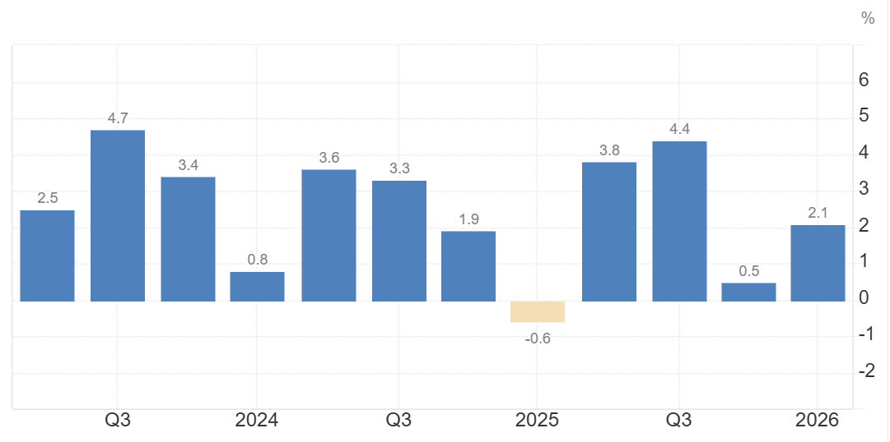
Figure 5: United States GDP Growth Rate
(Source: Trading Economics, 2026)
Inflation is a key factor, as it impacts how people spend and their operating costs (Priyatna and Suryadi, 2025). While inflation has subsided from earlier this year, food, labour and logistics prices are still high. For Sainsbury, it means keeping prices competitive and preserving the company's profitability by optimising its supply chain and sourcing more food locally. Likewise, the Federal Reserve has kept its interest rates quite high to keep inflation under control, thus hurting borrowing by retailers (FRB, 2026). The result is that Sainsbury will have to implement a gradual expansion scheme, instead of putting a significant amount of money into new stores up front.
There is another great opportunity related to the high disposable income and household expenditure. Households in America remain solid consumers with strong demand for high-quality groceries, fresh food and convenience items (Iman-Saliha, et al., 2026). Even as consumer confidence has weakened in recent months, retail spending has remained strong, with US retail sales rising 0.2% in June 2026 and core retail sales rising 0.5%, continuing to demonstrate strong consumer demand for spending (Trading Economics, 2026). This suggests that Sainsbury's own-brand products, which are high quality and have a focus on the customer, may appeal to middle and high earners.
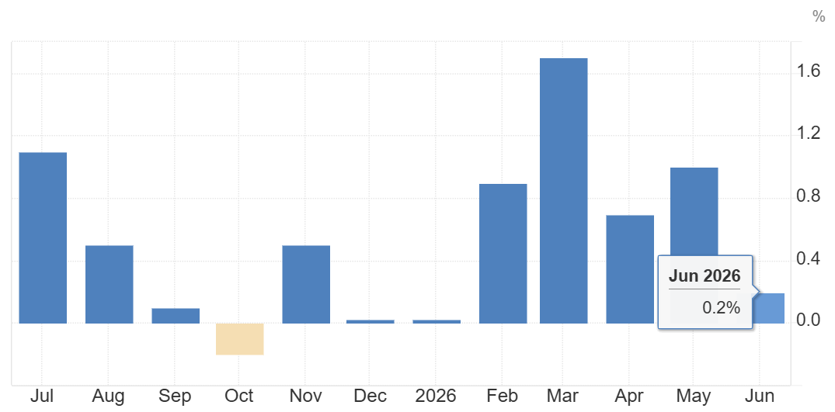
Figure 6: US Retail Sales
(Source: Trading Economics, 2026)
The value of the British pound and US dollar also affects the market entry decision. The impact of currency fluctuations can be to make imported products more expensive and profit margins smaller when revenues are converted back to pounds (Ou, 2025). Hence, it would be beneficial to develop a relationship with domestic suppliers in the US to limit foreign exchange risk and enhance price competitiveness.
Lastly, digital retailing is rapidly gaining traction in the United States, adding to the appeal of the market. Online retail sales are outpacing several retail outlets, with e-commerce sales rising by 0.2% in June 2026 and representing around 9.41% of retail sales, excluding vehicles and fuel (Dabo, 2026). The push is related to Sainsbury's new digital grocery initiative and its omnichannel approach, which will help the company to grow both in stores and online.
Overall, the US economic landscape offers significant opportunity with robust GDP growth, robust household spending and growing online grocery consumption. But rising inflation, increased financing costs, and fluctuating exchange rates would necessitate a cost-effective, digitally integrated and localised growth plan to maintain profitability over the long-term for Sainsbury.

3.3 Legal Environment
Strict food safety and product standards, employment, competition and consumer rights regulations are all important in the legal environment that could affect Sainsbury's plans for expansion into the United States (Sievert, et al., 2025). While these regulations will drive up costs, they will also provide a clear and predictable business setting, allowing for long-term investments.
The Food and Drug Administration (FDA) is responsible for the safety, product quality and product labelling of about 80% of the food consumed in the United States (US Food & Drug, 2026). The legislative emphasis has been on food safety incident response rather than on food safety prevention because of the Food Safety Modernisation Act (FSMA), which contains provisions that require risk-based controls, monitoring of the food supply chain and importer responsibility. To emphasise strict adherence, FDA estimates that each year 48 million Americans fall ill from eating contaminated food (US Food & Drug, 2025). It would involve Sainsbury investing in traceability systems, verifying and quality checking the companies they are buying from, which would be an extra cost at the start but would provide extra consumer security.
Product labelling requirements also present important legal obligations. Retailers are responsible for giving accurate nutritional information and ingredient lists and allergen declarations, and to ensure that the marketing claims are not misleading or false (Ankiel, et al., 2025). With the rise in online grocery shopping, the FDA is continuing to work on guidelines for online grocery food labelling. This would result in Sainsbury having to change both their packaging and their website information to meet US requirements, which would make things more difficult for them, but clearer for customers.
The employment law is another major factor, as minimum wage, workplace safety, anti-discrimination and benefits for employees are regulated by federal and state laws. Compliance will add to the cost of labour but will help to maintain workforce stability and lower the legal risks (Jørgensen, et al., 2025). In the same way, U.S. competition laws prevent anti-competitive conduct and mergers that significantly lessen the degree of competition, thereby obligating Sainsbury to make sure that any future partnerships or acquisitions adhere to anti-competitive laws.
With the growth of retailers' digital reach, consumer protection and data privacy laws have also gained significant importance. Sainsbury would have to protect customer information, have safe payment systems and adhere to state privacy laws regarding loyalty schemes and online grocery stores. Sustainable packaging, waste management and food traceability would be a significant investment, but are very consistent with Sainsbury's sustainability plan (Davidescu, et al., 2025).
Overall, the US legal environment presents both opportunities and challenges. While compliance adds to the cost of entry and complexity of operations, following strong food safety, consumer protection and environmental regulations would help build Sainsbury's brand credibility and allow for sustainable, long-term growth in the US grocery market.

3.4 Cultural Environment
Culture has a huge impact on consumer behaviour, buying decisions and retail strategies (Florea, et al., 2025). The UK and the United States have many cultural similarities, but there are some differences which necessitate customisation of Sainsbury's products, marketing and customer experience when it enters the US market, as described in Hofstede's Cultural Dimensions. In the comparison, the UK has higher scores for Individualism (76 vs. 60) and for Long-Term Orientation (60 vs. 50) while the US has higher scores for Power Distance (40 vs. 35) and for Uncertainty Avoidance (46 vs. 35). Both countries score high on Masculinity (66 vs. 62) and Indulgence (69 vs. 68) reflecting high levels of consumer aspirations for winning, convenience, and lifestyle-related products (The Culture Factor, 2026).
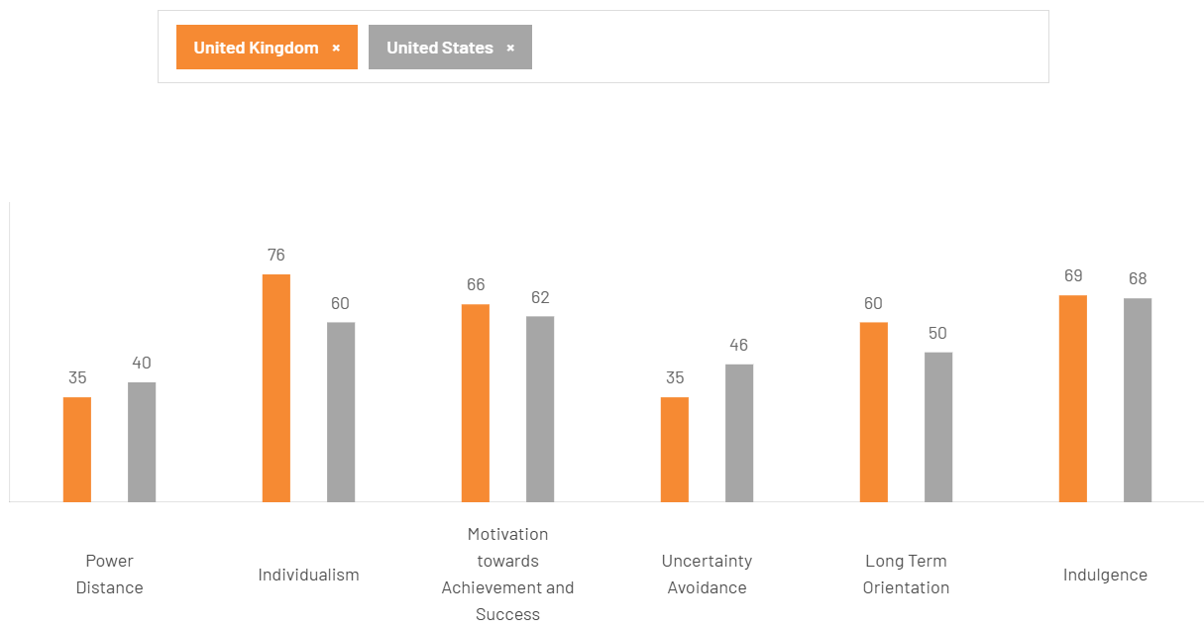
Figure 7: Cultural Comparison
(Source: The Culture Factor, 2026)
These cultural traits are directly related to shoppers' behaviour. Overall, UK consumers have a stronger focus on long-term value, sustainability and retailer loyalty, while American consumers focus more on convenience, variety of products and immediate value (Chitez, et al., 2025). The North American grocery landscape is becoming more transactional, with more frequent store visits, smaller basket sizes and savvy price comparisons, which means that the retailer must offer competitive prices and a seamless omnichannel experience.
There are also some preferences for food in the two markets. Consumers in the UK are more willing to accept fresh, locally sourced products that are sustainably produced, while consumers in the USA want more variety, more sizes, and more customisation around the product. Meanwhile, in the US, rising awareness regarding health has pushed the demand for organic, high-protein and nutritious food products to retailers, leading them to expand healthier food product lines (Raghuramapatruni, et al., 2026). As evidenced in the industry recently, consumers are shifting their focus away from ultra-processed foods and towards healthier options and cleaner ingredients.
Sainsbury has a great opportunity with private label acceptance (J. Sainsbury, 2026). Private label products in the UK and wider Europe may represent a larger percentage of groceries sold than in the USA, but there is a growing trend of consumer acceptance in the USA. About 21% of Americans trust store brands, and the share of private-label goods sold is on the rise and is growing faster than that of national brands, as consumers come to view private brands as synonymous with quality and value (Ou, 2025).
Convenience and digital shopping have also emerged as hallmarks of the US grocery market. Studies show that 62% of the US population have bought groceries online, compared with 45-56% of the UK population and several other similar countries (Bennett, et al., 2025). Also, 70% of all North American online shoppers indicated that the benefit of home delivery due to time saving and flexibility was a top factor for purchasing groceries online (Inklebarger, 2026).
In general, while both countries have a solid cultural basis, there are some differences. Such as in buying patterns, food attitudes and convenience expectations, which Sainsbury must take into consideration when choosing the product lines. It should include the quality and quantity of its own-brand healthy and premium lines, the development of its online grocery offering and the localisation of its marketing communications. This adaptation would enhance customers' acceptance and provide an effective way for the company to compete in the fiercely competitive American grocery market (Nazara, 2025).

3.5 OLI Framework
Dunning's Ownership-Location-Internalisation (OLI) Paradigm is a useful tool for studying the strategic capabilities to expand into the United States that Sainsbury has. The results of the political, economic, legal and cultural analyses suggest that all three advantages of OLI are related to international expansion (CFI, 2020).
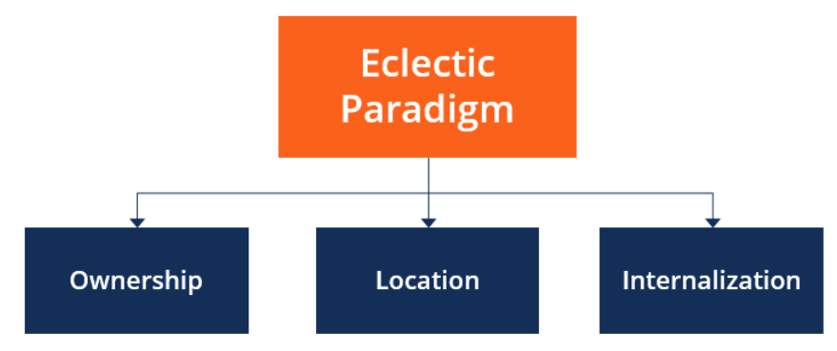
Figure 8: Eclectic Paradigm
(Source: CFI, 2020)
Ownership advantages are the special resources and competitive strengths of the firm. Sainsbury's has achieved a good level of brand reputation, a successful Nectar loyalty scheme, a wide range of own-brand products and an efficient supply chain (J. Sainsbury, 2026). In addition, some 1,200 new own-brand products were introduced over the course of the year, which further enhanced product differentiation and customer loyalty (J. Sainsbury, 2026). These capabilities give Sainsbury several competitive advantages that can be used in the US market.
The USA is a desirable expansion market due to its location. The country has a population of about 339.99 million people, high disposable income, a well-developed logistics system, and one of the world's largest grocery retail markets (Statista, 2026). The supermarket industry operates under favourable conditions, with high consumer purchasing power, high penetration of digital retail, efficient transport network. But the competition and regulation are intense, and Sainsbury will need to adjust their product offering and pricing to meet the local market.
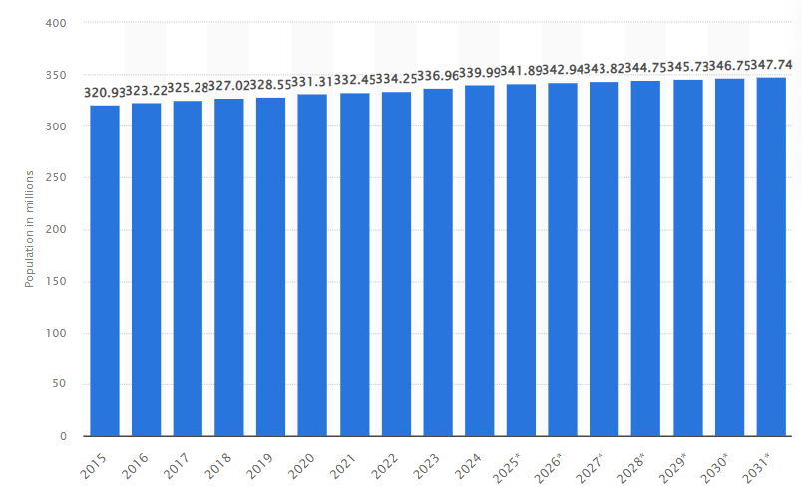
Figure 9: Total population of the United States from 2015 to 2024, with a forecast until 2031
(Source: Statista, 2026)
Internalisation benefits are the ones that help direct investment, instead of licensing or franchising (Strange, 2026). Sainsbury's would have more control over quality, safeguard the brand and have better control over suppliers if it operated its own stores. Internalisation would also enable the company to take advantage of its digital retail functionality, seamless supply chain and data-driven Nectar loyalty programme, as well as provide for a uniform customer service and operational standards. Such factors help minimise reliance on third parties and improve long-term competitiveness (Hamlehvar and Aazami, 2025).
In general, the OLI framework is a very good fit for Sainsbury's to expand into the USA. The company has important ownership advantages, such as a location advantage in the United States, and by internalising operations, strategic assets can be protected, and operational efficiency can be improved. But these assets, in conjunction with local sourcing, regulatory compliance and adaptation to American consumer tastes, will be vital to success in the long term (Alhindawi, et al., 2025).

4. Entry Mode Strategy and Strategic Synthesis

4.1 Historical Entry Pattern
Sainsbury's growth strategy has been dominated by organic growth with some selected acquisitions, long-term partnerships and internationally integrated buying, instead of the drive for international expansion (J. Sainsbury, 2025). Whereas other multinationals like Walmart or Carrefour have focused on improving their market shares overseas, Sainsbury has chosen to invest in improving its position in the domestic market through new stores, digital, and efficiency. It is committed to investing in organic growth, with the company opening over 40 new stores in the 2025/26 financial year and launching around 1,200 new own-brand products in the last five years (J. Sainsbury, 2026).
Acquisitions have also played a role in Sainsbury's growth, with the recent sale of Argos and Habitat bringing diversification and enhancing Sainsbury's omnichannel retail strategy (J. Sainsbury, 2025). These acquisitions have been targeted at strengthening its operations in the UK, but not on international expansion. Meanwhile, the business has built long-term supply chain partnerships with more than 2,500 farms in Britain and Ireland, with over £5bn to support them, to provide resilience in supply chains and quality in products (J. Sainsbury, 2026). In addition, international sourcing adds to this strategy by providing competitively priced products that still meet high quality standards.
Sainsbury's main historical entry mode has been organic growth with strategic acquisition of businesses in the UK and working with partners such as suppliers. The cautious and low-risk strategy has helped build its operational strength and financial health (Jadala, 2026). However, its current underwhelming experience in international expansion indicates that it may not be able to do so quickly and on a massive scale in the United States as it might in other markets.

4.2 Entry Mode Evaluation
Choosing the right entry strategy is essential for Sainsbury's to succeed in the long term in the US market as it will have different levels of investment, operational control and risk from political and financial exposure. Exporting, licensing and franchising are less applicable to grocery retailing and have lower investment demands (Stepanov, 2025). For efficient distribution to local customers and to ensure quality control and service to customers, these low-control entry modes are not suitable for protecting Sainsbury's brand and own-label reputation with fresh food products.
The relationship between a joint venture is the most suitable first-step entry strategy. Sainsbury could gain from the local understanding and established relationships with suppliers and local regulators in the USA but also share the investment and operational risk with an established retailer or food distribution company. This helps to alleviate political and monetary uncertainty as both sides bring their resources and market expertise (Adil, et al., 2025). It also gives Sainsbury more flexibility than ownership, as it allows it to learn about the US customer before it makes more significant investments. But joint ventures can pose problems of shared decision-making and differing strategies. However, these constraints are more than compensated for by the chance of reducing risks and developing local capacity (Parker, et al., 2025).
Acquisition would immediately offer them access to a proven customer base, distribution system, and supply chain, thus allowing for a quick entry into the market (Rainer Jr, et al., 2025). It also provides more management control than a joint venture. But acquisitions demand a huge investment and a high level of financial risk, especially from the organisational culture, technology system and operating practices integration challenges. Sainsbury would face significant financial risk in the highly competitive US grocery market in case of a failure to turn a profit on the business, and a high risk that it will fail to achieve long-term sustainable profitability.
A Greenfield investment also provides the greatest amount of control in running the business, and closely mirrors Sainsbury's approach of organic growth (Understand UPSC, 2026). The company would have the opportunity to apply its own standards, ensure brand consistency and, from the start, incorporate digital retail capabilities that are at the forefront of the retail industry. The company can evidence this approach by having built over 40 new stores, invested around £1.3bn in customer value over the last five years and invested over £5bn in long-term partnerships with suppliers (J. Sainsbury, 2026). Although the investment can be strong, it also has the highest financial investment, the longest time to market and regulators and competition that can pose the highest risk.
In summary, a staged approach starting with a joint venture and then moving towards Greenfield investment is the best strategic alignment. A joint venture would mitigate initial market entry risk and offer the benefit of local knowledge. Brand consistency and long-term competitive advantage would be further reinforced by Greenfield expansion once sufficient local market knowledge and customer acceptance are achieved.

4.3 Final Recommendation
The analysis above suggests a market entry strategy for Sainsbury's to the United States market based on the premise of a phased approach starting with a joint venture and moving to a Greenfield investment. A joint venture is the best middle-ground approach to some resources, low political and financial risk, and local market knowledge, supplier networks and regulatory expertise (Stephan, et al., 2026). This would allow Sainsbury to gain insight into the preferences of America's consumers and build brand recognition without committing to large-scale long-term investments.
After the company has accumulated adequate market experience, greenfield investment will be implemented to establish 100% owned stores and distribution centres (Mueller and Swoboda, 2025). This would give them improved control in their operations, safeguard the reputation of the Sainsbury's brand and ensure uniformity in the quality of their own brands, online presence and customer service. Effective local sourcing, compliance with regulations, digital retailing, and adapting to U.S. consumer tastes will be key to this strategy's success (Yan and Chin, 2025).
However, there are some implementation challenges, such as strong competition from other retailers, evolving trade policies, labour costs and regulatory complexity (Cheng, et al., 2025). Overall, the synergies between a joint venture and subsequent Greenfield expansion are the most significant and provide Sainsbury with the lowest initial risk and the greatest long-term sustainability and competitiveness in the US grocery market.

Section 2

5. Reflective Account (Gibbs Reflective Cycle)

5.1 Description
This report was developed by following a structured research process guided by Gibbs' Reflective Cycle, which encourages learning through six stages that are description, feelings, evaluation, analysis, conclusion and action plan. I started by examining the assessment needs and decided to pick Sainsbury plc as the multinational company since it did not have any significant operational presence in the United States. Then I gathered data from academic journals, lectures, Sainsbury's Annual Report, and reports of various organisations such as the IMF, World Bank and US government agencies. Once the evidence was collected, I critically evaluated the theories of international business, such as Bartlett and Ghoshal's model, Hofstede's Cultural Dimensions and Dunning's OLI Paradigm to assess the appropriateness of the USA as a target market. Lastly, I studied alternative entry modes before suggesting the best alternative from an evidence-based, theoretically supported choice.

5.2 Feelings
I initially thought expanding into an international market was primarily based on picking a big and economically favourable nation. So, at first I thought that the best way to expand the business would be to the United States, given that their consumer base is large and that they have a high purchasing power. My research continued, and I found that much more needs to be considered when evaluating political stability, legal compliance, cultural differences, consumer behaviour and strategic fit for successful international expansion. I found the breadth of information difficult to assess, but using structured frameworks and methods of international business helped build confidence and confidence to make informed decisions on international expansion.

5.3 Evaluation
The use of credible academic literature and industry and government reports was one of the more successful parts of this assignment. Having a clear understanding of theory and up-to-date statistical data has enhanced the quality of my arguments and made it possible to make recommendations based on facts, not opinion. The assignment also helped me to compare alternative entry strategies rather than just summarising the characteristics of these entry strategies.
However, there were several issues that arose in the research process. Market information was quite different in terms of access to recent and reliable information from one source to another, so it was important to compare the information before choosing suitable evidence (Murad, 2025). Also, it was hard to apply more than one theory from international business in a single report without repeating information (Lauring, et al., 2025). Another difficulty was differentiating descriptive discussion from critical analysis. To overcome these, I reviewed the assessment brief regularly and structured the information based on each assessment requirement, making sure that all the theories had a clear link to the proposed expansion for Sainsbury's rather than being explained as individual theories.

5.4 Analysis
The module theories led me to make a much better analysis and gave me good structures to analyse the decision of international expansion. By using the model developed by Bartlett and Ghoshal, I was able to identify Sainsbury's current strategy and understand that in the USA there would be a need for a more localised approach to strategy but also a need to keep operational efficiencies high. The framework was not just a classification of the company but also an explanation of why the strategy has to change to benefit from international growth (Aljohani, et al., 2025).
Hofstede's Cultural Dimensions have broadened my knowledge of why, in marketing and product adaptation, differences in consumer values, shopping behaviour and purchasing preferences can affect the process. I knew that the convenience shopping habits, private label preferences, and digital shopping behaviours were different across the UK and USA, and therefore applied a market-specific approach.
Similarly, Dunning's OLI Paradigm enabled me to incorporate political, economic, legal and cultural findings in one strategic framework. It proved that ownership advantages of Sainsbury's, location advantages in the USA and the benefits of internalising operations made overseas direct investment worthwhile. Lastly, Entry Mode Theory helped me to make a critical comparison of joint ventures, acquisition and Greenfield investment in terms of risk, control, flexibility and long-term strategic fit. All of these theories helped to shape my thinking from just business environment description to making evidence-based strategic recommendations, backed by academics and market data.

5.5 Conclusion
This assignment helped me to improve my understanding of international business strategy and was a good example of how international expansion is a combination of theory, evidence and critical judgement. I came to understand that selecting the right market is not only about the economic opportunities but also the political, legal and cultural aspects. Above all, I improved my capacity to use the international business frameworks as tools to inform actual organisational decisions, rather than stand-alone theoretical ideas.

5.6 Action Plan
For future research, I will be going deeper into my critical analysis by consulting a greater volume of peer-reviewed journal articles and industry reports before drawing connections and conclusions. In addition, I will work on making more quantitative comparisons between competing theories and on providing a more quantitative basis for recommending strategies. Last, I will build my understanding of the decision-making process in international business by staying up to date with current developments in the global markets and by applying academic theories to real business situations. This will help me to write more balanced and evidence-based analyses of international business decisions in future postgraduate assessments.

References
Adil, M., Hussain, R.Y., Rassas, A.H.A., Hussain, H. and Irshad, H. (2025) Assessing the impact of economic policy uncertainty on corporate leverage structure: do foreign ownership act as buffer?. Cogent Economics & Finance, 13(1), p.2476100.
Alhindawi, R., Abu Nahleh, Y. and Kumar, A. (2025) Navigating sustainable supply chain management in the perfume industry: challenges and solutions. Sustainability, 17(2), p.723.
Aljohani, T.M., Assolami, Y.O., Alrumayh, O., Mohamed, M.A. and Almutairi, A. (2025) Sustainable energy systems in a post-pandemic world: A taxonomy-based analysis of global energy-related markets responses and strategies following COVID-19. Sustainability, 17(5), p.2307.
Ankiel, M., Halagarda, M., Piekara, A., Sady, S., Żmijowska, P., Popek, S., Pachołek, B., Jefmański, B., Kucia, M. and Krzywonos, M. (2025) Role of Certifications and Labelling in Ensuring Authenticity and Sustainability of Fermented Milk Products. Sustainability, 17(18), p.8398.
AQA. (2026) Teaching guide: Bartlett and Ghoshal's international, multi-domestic, transnational and global strategies. [Online]. Available at: https://www.aqa.org.uk/resources/business/as-and-a-level/business-7131-7132/teach/teaching-guide-bartlett-and-ghoshals-international-multi-domestic-transnational-and-global-strategies [Accessed on: 21 July 2026].
Bennett, R., Gomez-Donoso, C., Zorbas, C., Sacks, G., White, C.M., Hammond, D., Gupta, A., Cameron, A.J., Vanderlee, L., Contreras-Manzano, A. and Backholer, K. (2025) Prevalence of online food delivery platforms, meal kit delivery, and online grocery use in five countries: an analysis of survey data from the 2022 International Food Policy Study: Epidemiology and Population Health. International Journal of Obesity, 49(7), pp.1307-1316.
Ben-Salha, O., Abid, M., Alnor, N.H.A. and Gheraia, Z. (2025) Breaking Barriers to Sustainable and Decent Jobs: How Do Different Regulatory Areas Shape Informal Employment for Persons with Disabilities Under SDG 8?. Sustainability, 17(21), p.9727.
CFI. (2020) Eclectic Paradigm. [Online]. Available at: https://corporatefinanceinstitute.com/resources/management/eclectic-paradigm/ [Accessed on: 21 July 2026].
Chabowski, B.R., Gabrielsson, P., Hult, G.T.M. and Morgeson III, F.V. (2025) Sustainable international business model innovations for a globalising circular economy: a review and synthesis, integrative framework, and opportunities for future research. Journal of International Business Studies, 56(3), pp.383-402.
Cheng, L., Sun, R., Wang, K., Yu, F., Huang, P. and Zhang, M. (2025) Advancing sustainable electricity markets: Evolutionary game theory as a framework for complex systems optimization and adaptive policy design. Complex & Intelligent Systems, 11(7), p.320.
Chitez, C.F., Mustafa, S., Sergio, R., Boateng, B., Mataruna-Dos-Santos, L., Iqbal, N. and Shah, A. (2025) The Factors Influencing Customer Loyalty in UK-Based Coffee Businesses. In International Conference on Business and Technology (pp. 557-570). Cham: Springer Nature Switzerland.
Dabo, M. (2026) US retail sales extend growth streak as June spending rises. [Online]. Available at: https://finance.yahoo.com/economy/articles/us-retail-sales-extend-growth-081020274.html [Accessed on: 21 July 2026].
Davidescu, M.A., Pânzaru, C., Mădescu, B.M., Poroșnicu, I., Simeanu, C., Usturoi, A., Matei, M. and Doliș, M.G. (2025) Advances and Challenges in Smart Packaging Technologies for the Food Industry: Trends, Applications, and Sustainability Considerations. Foods, 14(24), p.4347.
Florea, N.V., Croitoru, G., Coman, D.M. and Coman, M.D. (2025) The influence of fashion retailers on customer psychology using visual merchandising and store layout to improve shopping decision. Journal of Theoretical and Applied Electronic Commerce Research, 20(1), p.40.
FRB. (2026) How does the Federal Reserve affect inflation and employment?. [Online]. Available at: https://www.federalreserve.gov/faqs/money_12856.htm [Accessed on: 21 July 2026].
Hamlehvar, T. and Aazami, A. (2025) Prioritizing the selection criteria of a third-party logistics company using the best-worst method. International Journal of Research in Industrial Engineering, 14(4), pp.651-668.
Haque, M.L., Oosterveer, P., Reynolds, C. and Vignola, R. (2025) Does food safety governance in Bangladesh include the urban poor? An analysis of government strategies and policies for the retail food environment in Bangladesh, 2013–2022. Habitat International, 159, p.103372.
Iman-Saliha, J., Azman, E.M., Noranizan, M.A., Yazid, S.N.E. and Purnomo, E.H. (2026) High-pressure processing as a potential opportunity for reducing food loss and environmental impact in the ASEAN region. Food Innovation and Advances, 5(2), pp.240-250.
IMF. (2026) United States: Country Data. [Online]. Available at: https://www.imf.org/en/countries/usa [Accessed on: 21 July 2026].
Inklebarger, T. (2026) Walmart and Amazon's rapid-delivery war raises consumer expectations. [Online]. Available at: https://www.foodnavigator.com/Article/2026/06/24/walmart-amazon-escalate-grocery-delivery-war-as-same-day-demand-surges/ [Accessed on: 21 July 2026].
J. Sainsbury. (2025) Annual Report and Financial Statements 2025. [Online]. Available at: https://corporate.sainsburys.co.uk/media/e1lfnybd/sainsbury-annual-report-and-financial-statements-2025.pdf [Accessed on: 23 July 2026].
J. Sainsbury. (2025) Sainsbury’s confirms talks regarding sale of Argos. [Online]. Available at: https://corporate.sainsburys.co.uk/news/press-releases/sainsbury-s-confirms-talks-regarding-sale-of-argos/ [Accessed on: 23 July 2026].
J. Sainsbury. (2026) About us. [Online]. Available at: https://corporate.sainsburys.co.uk/about- us/ [Accessed on: 21 July 2026].
J. Sainsbury. (2026) Annual Report and Financial Statements 2026. [Online]. Available at: https://corporate.sainsburys.co.uk/media/z01g231u/j-sainsbury-plc-annual-report-and-financial-statements-2026.pdf [Accessed on: 21 July 2026].
J. Sainsbury. (2026) Building global food system resilience with Fairtrade. [Online]. Available at: https://corporate.sainsburys.co.uk/purpose-in-action/building-global-food-system-resilience-with-fairtrade/ [Accessed on: 21 July 2026].
J. Sainsbury. (2026) Our brands. [Online]. Available at: https://corporate.sainsburys.co.uk/about-us/our-brands/ [Accessed on: 21 July 2026].
J. Sainsbury. (2026) Our business model. [Online]. Available at: https://corporate.sainsburys.co.uk/about-us/our-business-model/ [Accessed on: 21 July 2026].
J. Sainsbury. (2026) Our strategy. [Online]. Available at: https://corporate.sainsburys.co.uk/about-us/our-strategy/ [Accessed on: 21 July 2026].
J. Sainsbury. (2026) Preliminary Results for the 52 weeks ended 28 February 2026. [Online]. Available at: https://corporate.sainsburys.co.uk/media/qxuhq1w0/j-sainsbury-plc-preliminary-results-2526-statement.pdf [Accessed on: 21 July 2026].
J. Sainsbury. (2026) Sainsbury’s strengthens backing for farmers with £5bn multi-year investment through expansion of long-term agreements with 2,500 British and Irish farms. [Online]. Available at: https://corporate.sainsburys.co.uk/news/press-releases/sainsbury-s-strengthens-backing-for-farmers-with-5bn-multi-year-investment-through-expansion-of-long-term-agreements-with-2-500-british-and-irish-farms/ [Accessed on: 21 July 2026].
Jadala, S.K. (2026) Post-Quantum Cryptography Readiness: Cybersecurity Strategies for the Quantum Computing Era. International Journal of Emerging Trends in Computer Science and Information Technology, 7(2), pp.227-245.
Jørgensen, B.N., Gunasekaran, S.S. and Ma, Z.G. (2025) Impact of EU laws on AI adoption in smart grids: A review of regulatory barriers, technological challenges, and stakeholder benefits. Energies, 18(12), p.3002.
Lauring, J., Jonasson, C. and Sanden, G.R. (2025) When can resistance to a standardization policy result in destandardization? The case of corporate language implementation. International Business Review, 34(4), p.102446.
Mabunda, G.P., Nemukondeni, N. and Selaledi, L. (2025) Sanitary and phytosanitary (SPS) measures and their implications for international agricultural trade: challenges and opportunities; comprehensive review. Discover Agriculture, 3(1), p.117.
Mueller, M. and Swoboda, B. (2025) Determinants of Wholly Owned Foreign Direct Investments in E-Commerce Firms: A Hierarchical Country-and Firm-Level Analysis: M. Mueller et al. Management International Review, 65(4), pp.699-736.
Murad, M.H.R. (2025) Machine Learning–Based Consumer Behavior Prediction Models for E-Commerce Platforms: Enhancing Digital Financial Inclusion and Market Accessibility. ASRC Procedia: Global Perspectives in Science and Scholarship, 1(01), pp.2078-2118.
Nazara, D.S. (2025) Marketing strategy innovation: Enhancing competitiveness and differentiation of local products in the global market. Oikonomia: Journal of Management Economics and Accounting, 2(3), pp.101-112.
Ou, X. (2025) Private label market in the U.S. - statistics & facts. [Online]. Available at: https://www.statista.com/topics/1076/private-label-market/?srsltid=AfmBOor_FgkefDJeQb0UU8_9P3zMGlO2plCiN41zwNy_M0XktNPwVD2c#topicOverview [Accessed on: 21 July 2026].
Ou, Z. (2025) Research on the Impact of Exchange Rate Fluctuation on International Trade. In 2025 3rd International Conference on Digital Economy and Management Science (CDEMS 2025) (pp. 673-686). Atlantis Press.
Parker, W.E., Brown, M.K. and Linares, R. (2025) Greenhouse gases reduce the satellite carrying capacity of low Earth orbit. Nature Sustainability, 8(4), pp.363-372.
Priyatna, H.N. and Suryadi, I. (2025) Facing Global Inflation: Economic Strategies to Strengthen People's Purchasing Power. MSJ: Majority Science Journal, 3(1), pp.73-81.
Raghuramapatruni, R., Ramana, S.V., Anand, N., Banerjee, A. and Sachuthananthan, B. (2026) Investigation of consumer preferences and purchase intentions in health-conscious markets for legumes as a sustainable protein source. Asian Journal of Dairy and Food Research, 45(1), pp.61-69.
Rainer Jr, R.K., Richey Jr, R.G. and Chowdhury, S. (2025) How robotics is shaping digital logistics and supply chain management: an ongoing call for research. Journal of Business Logistics, 46(1), p.e70005.
Sievert, K., Botha, T., Wood, B., Baker, P., Scapin, T. and Sacks, G. (2025) Global market trends and financial performance of the corporate fast-food industry and their potential contributions to diets high in meat and ultra-processed foods. Globalization and Health, 21(1), pp.1-18.
Statista. (2026) Total population of the United States from 2015 to 2024, with a forecast until 2031. [Online]. Available at: https://www.statista.com/statistics/263762/total-population-of-the-united-states/?srsltid=AfmBOor0dVCeq8iSEbAxyt59a8dcWjccHbvZh8c8pjVfJg3VHfJ9jxdP [Accessed on: 21 July 2026].
Stepanov, M. (2025) Diversification and adaptation of small enterprises to the dynamic changes in international demand in the context of globalization. Professional Bulletin: Economics and Management, (3), pp.26-31.
Stephan, U., Uhlaner, L.M. and Stride, C. (2026) Institutions and social entrepreneurship: A hierarchy of institutions to revisit institutional voids, support, and configurations. Journal of International Business Studies, 57(1), pp.4-25.
Stona, A.C., Khoo, Y.K., Moe, L., Wulandari, S., Agoramurthy, S., Getchell, M., Mak, T.M., Pang, J., Liu, E.J., Selva Kumar, S. and Lim, J.C. (2026) Strengthening supply chains for pathogen genomic surveillance in Asia. BMJ Global Health, 11(2), p.e019241.
Strange, R. (2026) The future of the multinational enterprise: An appreciation and an assessment. International Business Review, 35(4), p.102598.
The Culture Factor. (2026) Country Comparison tool. [Online]. Available at: https://www.theculturefactor.com/country-comparison-tool?countries=united+kingdom%2Cunited+states [Accessed on: 21 July 2026].
Trading Economics. (2026) United States GDP Growth Rate. [Online]. Available at: https://tradingeconomics.com/united-states/gdp-growth [Accessed on: 21 July 2026].
Trading Economics. (2026) US Retail Sales. [Online]. Available at: https://tradingeconomics.com/united-states/retail-sales [Accessed on: 21 July 2026].
Understand UPSC. (2026) Greenfield Investment. [Online]. Available at: https://www.understandupsc.com/greenfield-investment/ [Accessed on: 23 July 2026].
US Food & Drug. (2025) People at Risk of Foodborne Illness. [Online]. Available at: https://www.fda.gov/food/consumers/people-risk-foodborne-illness [Accessed on: 21 July 2026].
US Food & Drug. (2026) Human Foods Program 2026 Priority Deliverables. [Online]. Available at: https://www.fda.gov/about-fda/human-foods-program/human-foods-program-2026-priority-deliverables [Accessed on: 21 July 2026].
Winton, A., Howcroft, D. and Rubery, J. (2026) Sociotechnical change in British supermarkets: Examining the role of labour. New Technology, Work and Employment, 41(1), pp.45-56.
Yan, G. and Chin, L.Y.S. (2025) Adapting to Local Consumer Behaviour and Competitive Pressures_ A Case Study of Digital Transformation in Retail. pdf. Jesselton Journal of Educators and Scholars, 2(1), p.16.
York, E. and Durante, A. (2026) Tracking the Impact of the Trump Tariffs & Trade War. [Online]. Available at: https://taxfoundation.org/research/all/federal/trump-tariffs-trade-war/ [Accessed on: 21 July 2026].
Zahra, S. and Mudambi, R. (2025) Leveraging the interplay of digitalization and mobile resources to promote MNE entrepreneurship. Global Strategy Journal, 15(2), pp.289-314.
Zeng, R., Abate, M.C., Cai, B., Addis, A.K. and Derebe Dereso, Y. (2025) A systematic review of contemporary challenges and debates on Chinese food security: integrating priorities, trade-offs, and policy pathways. Foods, 14(6), p.1057.

