FOREIGN LANGUAGES

STUDENT ID: Madalina Ionela Preda
ID NUMBER:2213175

Table of Contents
PROFESSIONAL REFLECTION 3
PRESENTATION 5
STUDENT SELF-REFLECTION 13
REFERENCES 15

PROFESSIONAL REFLECTION
As a student pursuing proficiency in Spanish within the framework of the hospitality business, I have experienced various scenarios that emphasised the potential for cultural misunderstandings to occur between front-of-house workers and hotel visitors. One such instance stands out in my memories, demonstrating how language challenges can lead to misinterpretation and the importance of personal growth in managing such scenarios effectively. It was a crowded evening at the premium hotel where I was interning, and my role as a front-of-house employee required me to greet visitors, assist with check-ins, and provide information about the hotel's services. A Spanish-speaking pair approached the front desk. Although my Spanish proficiency was at a moderate level, I felt confident in my ability to talk effectively (King, 2023).
The pair were originally from Mexico and were seeking information about area sights and eateries. They spoke limited English, and I quickly switched to Spanish to assist them. Initially, our chat went pleasantly, but when they moved into more particular concerns, I found it difficult to grasp them entirely. Their accents were dissimilar from what I had heard in my Spanish studies, and they utilised colloquial phrases and regionalisms that I was unfamiliar with. In the midst of our chat, I misread a query concerning travel to a local museum. Instead of providing them with clear directions, I accidentally steered them to a whole different region. The duo trying to be pleasant, nodded in seeming comprehension, but it was evident that my explanation had left them perplexed (Alsina Naudi, 2020). Their uncertainty intensified when they learned they were headed in the wrong route, and they returned to the hotel, visibly frustrated.
Reflecting on this encounter, I saw how cultural misunderstandings may often emerge, even when both sides are really trying to communicate. The experience revealed numerous significant variables contributing to the misunderstanding:
Language Variation: Spanish, like any language, has regional differences in vocabulary, pronunciation, and colloquial idioms. My earlier language teaching had not entirely prepared me for these intricacies.
Assumption of Understanding: I assumed that my skill in Spanish was adequate to communicate well in all circumstances, neglecting the possible challenges that develop when interacting with native speakers from diverse regions.
Failure to Clarify: Instead of asking clarification when I did not fully grasp the customer’s concerns, I attempted to offer an answer based on partial comprehension, which prolonged the confusion.
To prevent similar cultural misunderstandings in the future, I realize the obligation to develop specific competencies and make behavioural changes:
Continued Language Improvement: I must dedicate more time in enhancing my language skills, particularly by exposing myself to a larger range of dialects and regional idioms within the Spanish language.
Active Listening: Instead of presuming I understand a guest's query, I should ask follow-up questions to clarify their needs and ensure they leave with the knowledge they want.
Cultural Sensitivity: I need to become more culturally aware and empathetic to the diverse cultures and traditions of hotel visitors. This includes acknowledging that my own cultural perspective may not coincide with theirs and adapting my communication style accordingly.
Empathy: It's vital to empathize with guests who may feel unhappy due to communication challenges, and be proactive in fixing any mistakes or errors immediately (Márquez and Hidalgo, 2020).

PRESENTATION

Slide 1


Slide 2
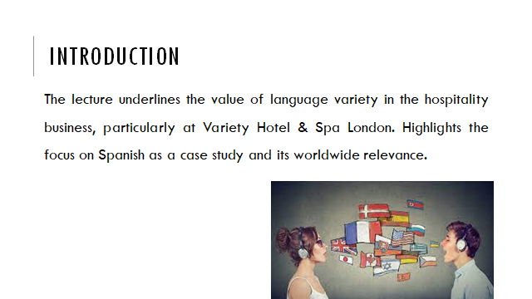
In this presentation, Diversity Hotel & Spa London highlights the profound relevance of multilingualism and the crucial role of language awareness abilities within the field of the hospitality industry. As a hub for global guests, understanding the power of language and culture is vital (Makhmudov, 2020). The chosen language for debate, Spanish, shows the universal appeal of language diversity. From its ubiquitous usage to the intricacies of civility in Spanish business culture, the team goes into a holistic view of how understanding Spanish can boost visitor experiences.

Slide 3
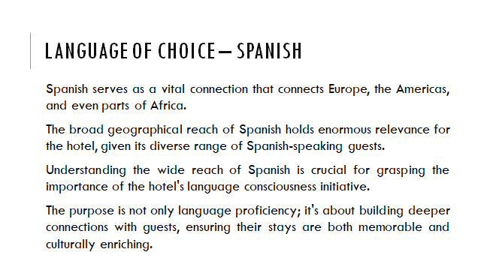
Spanish, frequently viewed as a language of opportunity, is spoken in 21 nations across Europe, the Americas, and Africa. It is the official language of Spain, Mexico, and most of Central and South America. Its global ubiquity makes it highly relevant for Diversity Hotel & Spa London (Palion-Musioł, 2019).
For our hotel, the relevance of Spanish rests in its capacity to link us with a varied variety of clients, including tourists, business travellers, and event attendees, hailing from Spanish-speaking nations. By delivering services and communication in Spanish, we can create a more welcoming and inclusive atmosphere, promoting strong guest relationships and loyalty. Furthermore, it positions us as a hotel that supports cultural diversity and is devoted to offering excellent guest experiences.

Slide 4
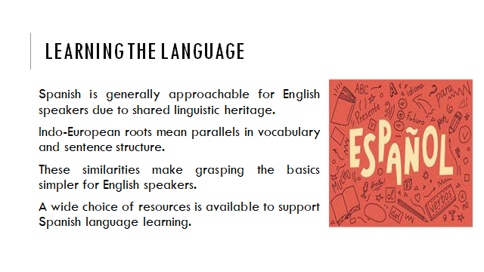
Learning Spanish is a journey filled with gratifying experiences, and it's well worth the effort. While any language confronts its problems, Spanish offers several advantages that make it a relatively accessible language for English speakers. Firstly, Spanish and English share a shared linguistic heritage as both are Indo-European languages. This implies they have parallels in vocabulary and sentence structure, making it easier for English speakers to understand the essentials. Secondly, there is a multitude of tools accessible to aid in learning Spanish, ranging from books and language applications to classes and online courses. These tools cater to diverse learning styles and levels, allowing our employees to choose the approach that suits them best. Our effort to studying Spanish is a tribute to our dedication to offering great guest service. By being skilled in Spanish, we not only strengthen our communication abilities but also exhibit our commitment to diversity, helping guests from Spanish-speaking nations feel even more welcomed and cherished during their stay (Rius-Ulldemolins, Rubio Arostegui and Flor, 2021).

Slide 5
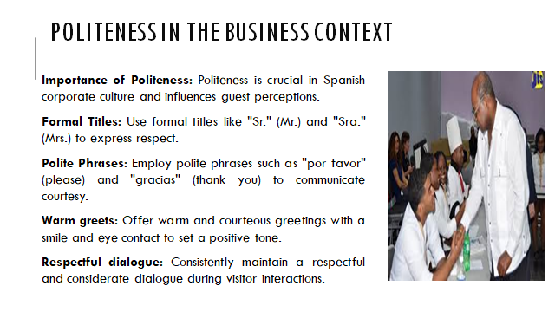
Politeness in Spanish company culture plays a crucial part in visitor relations. To deliver outstanding service to our Spanish-speaking clients at Diversity Hotel & Spa London, recognising these cultural subtleties is crucial:
Formal Address: Addressing guests using formal titles such as "Sr." (Mr.) or "Sra." (Mrs.) is a display of respect. Using these titles, even if not explicitly asked, shows our dedication to honouring their status (Ho, 2020).
Polite Phrases: Incorporating expressions like "por favour" (please) and "gracias" (thank you) into our encounters displays our appreciation for their presence. These expressions establish a friendly and courteous attitude.
Warm Greetings: The importance of a warm greeting with a smile and eye contact cannot be emphasised. This initial connection sets the tone for the entire visitor experience and reflects our genuine interest in their comfort and contentment (Haynes-Mendez and Engelsmeier, 2020).
By adhering to these cultural conventions, we show respect and admiration for our Spanish-speaking visitors, making a lasting favourable impression and ensuring their stay at Diversity Hotel & Spa London is both fun and memorable.
Slide 6
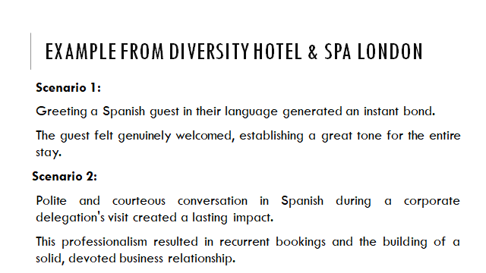
Scenario 1: The guest from Spain came to our hotel and we greeted them in Spanish, I allowed us to form an instant connection. The customers were pleasant and delighted, were also delighted and felt a true feeling of welcome in the hotel. The initial approach created a kind of connection which established a wonderful tone for the entire visit.
Scenario 2: During the time of visit by the group from Spain, the professionals in our team respectfully communicated while they were leaving for the last impression. This professionalism led to recurrent bookings and the building of a strong and loyal business relationship (Tahiri et al., 2021).
These instances highlight how our commitment to language awareness positively improves guest experiences, increases guest loyalty, and enhances our reputation as a hotel that truly understands and respects our guests' different cultures and languages.

Slide 7
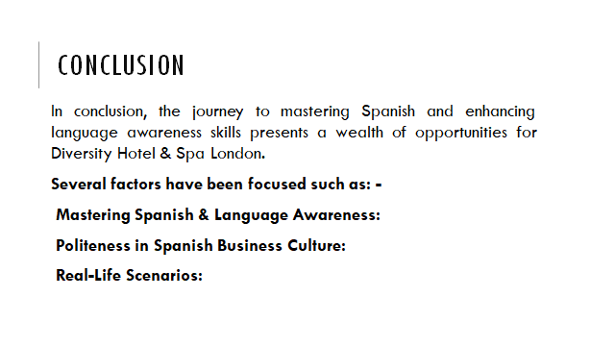
In conclusion, the route of acquiring Spanish and increasing language awareness abilities presents a plethora of chances for Diversity Hotel & Spa London. The capacity to communicate effectively in Spanish unlocks doors to different visitor encounters and cultivates an environment of inclusivity and friendliness. As the team navigates the complexities of civility in Spanish corporate culture, the potential for producing lasting positive impressions becomes obvious. Real-life events underline the practical rewards of this dedication, including greater visitor connections, memorable stays, and enhanced loyalty. With these language skills, our hotel reiterates its dedication to great service, maintaining its status as a welcome and culturally aware facility.

Slide 8
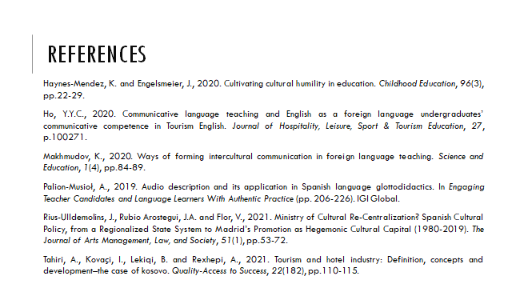

STUDENT SELF-REFLECTION
Throughout the process of preparing and presenting the presentation on multilingualism and language awareness, I underwent substantial personal and professional growth. I will utilise the Gibbs Reflective Cycle, a widely established self-reflection paradigm, to analyse my learning experiences, changes in knowledge, and the influence this has had on me as a student.
Description
The experience began with the knowledge that I needed to thoroughly investigate and comprehend the subject matter. I chose the topic of multilingualism and its significance in the hotel business, focusing on Spanish as an example. My first understanding was limited, mostly focusing on the value of language diversity in a globalized world (Ho, 2020).
Feelings
At the outset, I was both curious and rather overwhelmed by the profundity of the subject matter. Learning about the geographical reach of Spanish and its importance to our hotel was enlightening but created the problem of managing varied linguistic needs. However, as I looked deeper into the research.
Evaluation
The process of developing the presentation needed precise planning and organization. It requires that I combine a tremendous quantity of information into simple, coherent presentations. I had to closely examine the importance of each point and its prospective impact on our property. This assessment approach considerably boosted my comprehension of the subject (Deale, 2019). It allowed me to pinpoint the important lessons that I wanted to convey to my audience.
Analysis
As I evaluated the facts, it became evident that language awareness surpassed mere conversation (Makhmudov, 2020). The main factor was about building an inclusive and cultural awareness environment for the guests in the organisations, I started to comprehend how the factors like language, etiquette and cultural understanding are inextricably linked.

Conclusion
While preparing for the presentation, I was able to learn the language in the strong aspects and instrument for building connections. The real-life experience has allowed me to be committed to language awareness to avail the actual benefits, not must for the hospitality organisations but for all the guests as well. It was a satisfying factor to see who it was making an attempt to communicate the language to build a sense of belongingness and respect.
Action Plan
The event pushed me to work effectively on my learning path, and I was able to understand that language is the key to proficiency which is not simply a skill but also works as the tool to enhance the level of guest experience. I continuously explored the diverse set of spectrum for the people, in order to strive to encourage and assist fellow students in their language pursuits.
In conclusion, the report has explored the path of self-reflection about the acquisition of knowledge and cultural awareness within the hospitality business. The primary scenario throws light on the possibilities for cultural aspects to assist the firm thrive by adapting different traditions and conventions. Such remarkable experiences are being queried in order to comprehend the challenges and the rewards of it. The reflection also analyses the fundamental lessons acquired from the experience and highlights the need for continued growth and development.

REFERENCES
Alsina Naudi, A., 2020. Community service-learning translations in a legal Spanish course. L2 Journal, 12(1).
Deale, C.S., 2019. Learning preferences instead of learning styles: A case study of hospitality management students’ perceptions of how they learn best and implications for teaching and learning. International Journal for the Scholarship of Teaching and Learning, 13(2), p.11.
Ho, Y.Y.C., 2020. Communicative language teaching and English as a foreign language undergraduates’ communicative competence in Tourism English. Journal of Hospitality, Leisure, Sport & Tourism Education, 27, p.100271.
King, H.M., 2023. Complex intersections of language and culture: the importance of an ethnographic lens for research within transnational communities. Journal of Multilingual and Multicultural Development, 44(8), pp.718-736.
Makhmudov, K., 2020. Ways of forming intercultural communication in foreign language teaching. Science and Education, 1(4), pp.84-89.
Márquez Reiter, R. and Hidalgo Dowing, R., 2020. Intercultural Communication in a globalised world: the case of Spanish.

