BMIH5006 Sustainable hospitality & tourism management
  - A Vision of Change: Sustainability in the hotel industry

Student name : Abul Imran
Student number : 2110029
Module name: Sustainable Hospitality and Toryism manage-week
suitability in the hotel industry
Lecture name: Ruth Taylor Davies.

Contents
Introduction 3
Discussion 3
Conclusion 9
Reference 10

Introduction
According to Higgins, et.al., (2019), Sustainability is frequently accepted as an essential component towards having a profitable company in the modern era. Sustainability has emerged as a top priority for both the general public & business communities, and also the hospitality sector is certainly not distinct. Sustainability implies that ecosystems in the environment have the ability preserve lives & offer valuable assets to the generations that follow. It is clear that tourism places more demands upon the surroundings including the resources that are available. Nevertheless, the tourism industry highly depends upon the environment which consist of golden shores, scenic views, icebergs, water bodies, aquatic life, streams, & oxygen-rich air; every single one of that make for excellent destinations for tourists. It has a high possibility that humans may destroy the cornerstone that supports hospitality sector. This sector adapted swiftly to the latest advancements, and the sector has begun to become "green." (Fatima, et.al.,2020)The biggest organizations in the hotel and hospitality sector including Intercontinental Hotel Group, Hilton Worldwide, Starwood, Carlson Rezidor and Marriott releases reports about sustainability describing the measures to mitigate adverse environmental impacts. Managing the environment is just one aspect of sustainability; it also involves business expansion & growth in society.

Discussion
Three Pillars of Sustainability
The triple bottom line, 3 PS, or 3 E's, are an arrangement that is considerably better known as the four foundations of sustainability. Social, Human, Environmental, & Economic Sustainability represent the four main aspects of sustainability. These constitute the four key areas where in achieving sustainability is necessary for long-term growth of an organization (Sharma, et.al.,2020).
Concentrating upon the human dimension in a company along with society at large is called "human sustainability." It is a crucial component of a successful company since an extended period of growth is possible only with the support by workers and every person involved in the supply chain of a company. With the help of green urban planning, including buildings, and goods and services which can help everyone involved, social viability seeks to ensure the health, unity, justice, & growth of community. For enterprises, sustainability involves making improvements to the broader social advancement of the geographic region in which they trade. Economic sustainability indicates that a company must keep expanding and prosperous for it to be long-lived; otherwise, it would cease to exist. Every market is built on this. Environmental sustainability seeks to enhance people's health & sustainable development through environmental protection as well as responsible utilization of resources (Sobaih, et.al.,2021).
Adoption of Sustainability
The tourism industry is being pushed to give carbon neutrality projects, good green practices, and ethical socioeconomic practices a priority in order to meet the rising demands of consumers and staff. On the environmental front, several major internationally traded hotel groups are currently dedicating themselves to achieving the reduction objectives for GHG emissions set forth in the Paris Climate Agreement. Many hotel chains have begun implementing the Global Reporting Initiatives (GRI) , International Sustainability Standards Board (ISSB) and European Financial Reporting Advisory Group (EFRAG), in order to establish a company-wide structure for the submission of reports. The tourism sector's stakeholders may now compare progress to ESG goals and comprehend them due to the aforementioned reporting obligations (Hong, et.al.,2018).
Numerous nonprofit groups work alongside the hospitality sector to create studies and guides to assist hotels in recognizing the way they affect the environment. One of them is Greenview, a global firm issued a manual on the Net Zero Approach to help companies of all sizes develop and manage sustainability plans for their brands to achieve zero net emissions before 2050. Greenview, along with additional parties created the Cornell Hotel Sustainability Benchmarking Index to maintain an eye on performance (Legrand, et.al.,2022). The Index enables chain hotels to compare progress in various sustainability categories against that of their competitors. The Cornell Hotel Sustainability Index includes hotels across 25 nations, and the information provided below shows the efficiency of electricity & use of water.
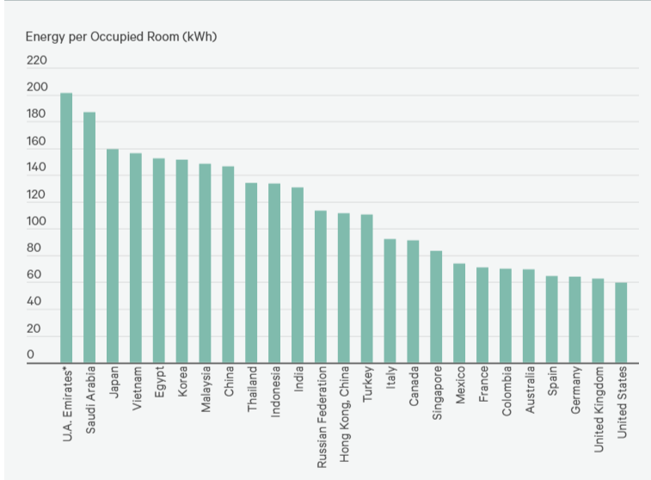Electricity
Source: Cornell Hotel Sustainability Benchmarking Index, Greenview, 2021
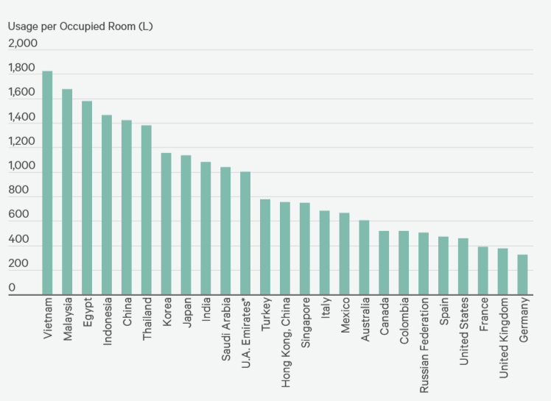Water
Source: Cornell Hotel Sustainability Benchmarking Index, Greenview, 2021.
All these participation and worldwide association has immediate effects on the operations of a hotel in addition to helping it become an ecologically conscientious identity. By incorporating sustainability ideas within their corporate goals & business plans, business leaders may exercise an important part (MacKenzie, et.al.,2019). The majority of the sustainable adaptations are very simple like lowering pressure of water, water pipe maintenance to avoid leaking or collecting rainfall infrastructure, lowering water consumption and much more. Savings may be substantial and this can cut down water usage by 15%. By substituting the smaller refrigerators & coffee makers in all rooms with shared services, hotels might save energy. Reducing the production of greenhouse gases, purchasing appliances that save energy, installing smart systems for managing electricity, or improving properties. Additionally, energy savings of between 5% and 15% are produced by these efficiency measures, which frequently compensate for them in just a few years.
Initiatives
According to Wikhamn (2019), Digital technology helps the environment by decreasing the use of plastic and paper, for example. Using a computerized visitor's ipad instead of traditional offering or pamphlets can have an instant positive impact by reducing. Efficiency as well as safety for everyone require paperless entries, smart bedroom access, as well visitor interaction forums. For instance, with the help of an innovative solution Hilton designated “Connected Room” through which visitors can customize and handle each component of their visit using their mobile devices.
Hospitality may support indigenous societies' well-being as well upkeep cultural and environmental assets. For the purpose to accomplish it, the hospitality industry can look for public-private collaboration to get beneficial effects and to encourage tourist support for environmentally responsible activities (Shen, et.al.,2020). For instance, the NGO Inkaterra Asociación (Peru) partnered with the Machu Picchu Town Hall and the global food and drink firm AJE Group to develop a strategy to make Machu Picchu the initial town in Peru & Latin America to properly handle almost every bit of its organic garbage. Sustainability is seen by governments throughout the globe being the path to a better tomorrow, & multiple things are currently underway.
To encourage "green" enterprise, the government of all countries all over the world has implemented a number of programmes (Piramanayagam, et.al.,2023). In addition, merely energy saving could be achieved by the use of green power, lowering waste production, & the adoption of policies that promote recycling and waste disposal. Businesses that participate in promotional programmes obtain tax deductions, cost of insurance savings, monetary aid, & expedited authorization from regulators. Furthermore, cutting-edge, green technology may result in savings in the long run. The cumulative impacts of reducing energy consumption, decreasing waste, as well as other environmentally friendly practices can result in investing a smaller amount altogether as time passes, even though they can initially be more expensive (Ertuna, et.al.,2019).
Sustainability strategies have been established by numerous hospitality organizations. Implementing environmentally friendly methods into all business operations is part of this deliberate strategy. Efforts for sustainability may assist with the reputation of a company. It was discovered than sixty-two percent of visitor’s selected greener accommodation and mode of transport, while sixty-nine percent of respondents stated that they planned to carry on making green trips in the years to come (Sakshi, et.al.,2020).
Corporate Social Responsibility
According to Guzzo, et.al.,(2020), Society & environmental issues constitute two of the main facets of corporate social responsibility (CSR) programmes in the hospitality industry. Environmental campaigns, which include offsets for carbon, anti-poaching initiatives, including restoration of the environment, have become one of the major endeavors within the tourism sector. For instance, businesses devoted to finding and creating offsets for greenhouse gases trade them to businesses such as tourism organizations in an effort to lessen their environmental impact. Tourism concentration has been turned fully sustainable as well as its difficulties since they've arrive to realize the advantages associated with adopting greener decisions and the fact that satisfying those they serve's desire for greater "conscious consumerism" was merely good business (Rhou, et.al.,2020). Concerns regarding the environment, technological advances use, community acknowledge & the use of energy lies at the very core of CSR.
Tourism businesses have certain obligations towards the natural world & the places where they are located and where they operate. Better administration and planning within the hospitality industry takes into account environmental growth in addition to consumer preferences and demands from stakeholders (Khatter, et.al.,2019). CSR programmes are typically included among environmentally friendly acts used by businesses throughout the hotel industry. Employing CSR techniques for hotels that are ecologically friendly may help in decreasing hotel’s running costs.
A subsection within the tourism sector comprises the hospitality industry. However, the sector is fast growing and becoming known for being a distinct sector in its very own right on an international level. The increase in demand of the hospitality industry is primarily due to the availability of both historical & resources of nature, extensive aviation reach, meticulous preparation and growth of the hospitality sector, low rate of turnover, as well as cheap cost of production (Iyer, et.al.,2019). It is seen that hotels' dedication to conservation goes as far as the end of the 1960s, & "the last few decades have brought about an increasing concern across hospitality companies & shareholders concerning the social and ecological consequences of the development of hotels." By tackling community and ecological issues while pursuing long-term development, hotels may prosper. It is seen that hospitality segment have shown the indication of forceful adoption of environmentally friendly and green habits primarily as an outcome of stakeholder’s force and demand. The stakeholders comprise, the governing body tourists, NGO, workers s, tour operators, etc. Consumers are one among all who have the greatest power in forcing hotels to embrace sustainable habits & an ethic of ethics (Font, et.al.,2018).
Based on the 4 pillars of sustainability, CSR of the hospitality segment must include certain practices.
CSR's position on an ethical problem state that in order to win over the trust of every stakeholder category which includes travelers, staff members, leaders, and others, an organization should make sure it upholds the most stringent standards of morality and ethics.
CSR's perspective upon environmental issues, a business must implement initiatives that lessen the company's ecological footprint while employing resources in an efficient manner which minimizes its effect on the environment, otherwise companies’ danger getting negative attention.
CSR's stance on social issues, the morals as well as different social characteristics of the local communities that surround the organization where it operates ought not to be negatively affected by that business.
CSR's economic perspective, to reduce operational expenses, businesses must make investments in more effective conventional methods of operation & cutting-edge technology for the environment.

Conclusion
It is obvious that vacationing contributes to concerns. According to Achmad, et.al.,(2022), Professionals from the hospitality and tourist sectors, nevertheless, possess the capacity to make a contribution towards a current problem. The hospitality sector has made it assure that respects neighbors and workers, cannot overindulge resources, strives to safeguard nature & is aware on the environmental effects on society and the economy. The industry defends its very survival by doing this. Eco-tourism has become popular for both of these reasons. This method promotes environmental awareness while emphasizing the preservation of natural resources & environmental processes. There are numerous advantages to using environmentalism in the tourism sector. In addition to bringing in additional consumers & appropriately addressing something that many view as an ethical obligation in regard to the present environmental calamity green initiatives offer advantages for companies in hospitality. Leaders with vision can adopt the three sustainability pillars as their blueprint for reshaping the businesses they run while making certain that our nation's incredible heritage and cultural resources remain viable for subsequent generations of visitors to take pleasure in (Purvis, et.al.,2019). The hospitality sector now requires people who are capable of creating an atmosphere that ethical, ecological, & economic responsibility while adopting sustainability techniques.

Reference
Achmad, W. and Yulianah, Y., 2022. Corporate social responsibility of the hospitality industry in realizing sustainable tourism development. Enrichment: Journal of Management, 12(2), pp.1610-1616.
Ertuna, B., Karatas-Ozkan, M. and Yamak, S., 2019. Diffusion of sustainability and CSR discourse in hospitality industry: Dynamics of local context. International Journal of Contemporary Hospitality Management.
Fatima, T. and Elbanna, S., 2020. Balanced scorecard in the hospitality and tourism industry: Past, present and future. International Journal of hospitality management, 91, p.102656.
Font, X. and Lynes, J., 2018. Corporate social responsibility in tourism and hospitality. Journal of Sustainable Tourism, 26(7), pp.1027-1042.
Guzzo, R.F., Abbott, J. and Madera, J.M., 2020. A micro-level view of CSR: A hospitality management systematic literature review. Cornell Hospitality Quarterly, 61(3), pp.332-352.
Higgins-Desbiolles, F., Moskwa, E. and Wijesinghe, G., 2019. How sustainable is sustainable hospitality research? A review of sustainable restaurant literature from 1991 to 2015. Current Issues in Tourism, 22(13), pp.1551-1580.
Horng, J.S., Liu, C.H.S., Chou, S.F., Tsai, C.Y. and Hu, D.C., 2018. Developing a sustainable service innovation framework for the hospitality industry. International Journal of Contemporary Hospitality Management, 30(1), pp.455-474.
Iyer, G.R. and Jarvis, L., 2019. CSR adoption in the multinational hospitality context: A review of representative research and avenues for future research. International Journal of Contemporary Hospitality Management, 31(6), pp.2376-2393.
Khatter, A., McGrath, M., Pyke, J., White, L. and Lockstone-Binney, L., 2019. Analysis of hotels’ environmentally sustainable policies and practices: Sustainability and corporate social responsibility in hospitality and tourism. International Journal of Contemporary Hospitality Management, 31(6), pp.2394-2410.
Legrand, W., Chen, J.S. and Laeis, G.C., 2022. Sustainability in the hospitality industry: Principles of sustainable operations. Taylor & Francis.
MacKenzie, N. and Gannon, M.J., 2019. Exploring the antecedents of sustainable tourism development. International Journal of Contemporary Hospitality Management, 31(6), pp.2411-2427.
Piramanayagam, S., Mallya, J. and Payini, V., 2023. Sustainability in hospitality education: research trends and future directions. Worldwide Hospitality and Tourism Themes.
Purvis, B., Mao, Y. and Robinson, D., 2019. Three pillars of sustainability: in search of conceptual origins. Sustainability science, 14, pp.681-695.
Rhou, Y. and Singal, M., 2020. A review of the business case for CSR in the hospitality industry. International Journal of Hospitality Management, 84, p.102330.
Sakshi, Shashi, Cerchione, R. and Bansal, H., 2020. Measuring the impact of sustainability policy and practices in tourism and hospitality industry. Business Strategy and the Environment, 29(3), pp.1109-1126.
Sharma, T., Chen, J. and Liu, W.Y., 2020. Eco-innovation in hospitality research (1998-2018): a systematic review. International Journal of Contemporary Hospitality Management.
Shen, L., Qian, J. and Chen, S.C., 2020. Effective communication strategies of sustainable hospitality: A qualitative exploration. Sustainability, 12(17), p.6920.
Sobaih, A.E.E., Elshaer, I., Hasanein, A.M. and Abdelaziz, A.S., 2021. Responses to COVID-19: The role of performance in the relationship between small hospitality enterprises’ resilience and sustainable tourism development. International Journal of Hospitality Management, 94, p.102824.
Wikhamn, W., 2019. Innovation, sustainable HRM and customer satisfaction. International Journal of Hospitality Management, 76, pp.102-110.

