Project report
BAME and Women entrepreneur’s success in Wales

Mihaela Titiriga
Student number:1518982

Table of contents:
Introduction
Executive summary
Main findings
Conclusion and Recommendations

Introduction

Projects are excellent opportunities for businesses and people to complete their business and non-business goals more efficiently through implementing change. Projects enable making desired changes in an orderly and less likely to fail manner. (Managementguide.com, 2019)
Project management is the use of techniques, methods, abilities, knowledge, and experience to achieve particular project objectives within agreed-upon constraints. Final outputs are bound by a certain timeframe and budget in project management.
A significant distinction between project management and 'management' is that project management has a final result and a fixed timeframe, whereas management is a continuous activity. (Apm.or.uk,2016)

Executive summary

In 2019, 5.1 percent of UK small and medium companies were led by an ethnic minority majority (excluding White minorities)
Employers with a majority of ethnic minorities were more numerous in England (5.4%) and Scotland (4.3%) , a lot less than in Northern Ireland (2.1%) or Wales (1.5 percent ). (Gov.uk)
Black entrepreneurs have a success rate for launching a firm that is comparable to the UK average. Entrepreneurs from Asian and Other Ethnic Minority backgrounds, on the other hand, had a much lower success rate, accounting for roughly 3.5 percent of company owners but more than eight percent of those who attempted but failed to establish a firm.
Such disparities in company success can thus only be explained by a plethora of interrelated and systemic elements. These include disparities in financial access, social capital, deprivation, and household income, as well as the under-representation of particular ethnic groups among managers, directors, and officials in the workplace, which limits the ability to develop business-relevant skills, information and networks.
For women part of BAME, results are thought to be exacerbated by cultural, gender roles, including as main caregiving for children and elderly relatives. Even when these caring duties are taken into consideration, female entrepreneurs still have poorer success.(Diversity UK,2020)
In this report there will be used the following tools studied to conduct this project : project life cycle, smart model, quad chart, stakeholder analysis, Work breakdown structure, Gannt chart, network diagram, risk assessment, iron triangle and evaluation.

Main findings

Project life cycle

The project life cycle is a tool or a framework that helps us manage any project. It has a beginning and an end, and between these two points we identify four stages: Initiation, Planning, Execution, and Closure.
This model is not always adequate for the complex projects, as it fails to take into consideration the human component that exists in every project. A projects success needs to have constant feed-back and reviews in order to be sustainable. The project life cycle is therefore unrealistic, as it requires also stages like analysing, review, reflection and predicting.

1.Initiation phase

In the initiation phase we define the project, the prospect, the answer to the problem and the objective of the project. This is the most critical phase of the project life cycle. The objective needs to be very specific and clear. Many projects fail because the initiation phase is vague and team members do not take into consideration all the aspects and implications, assuming that the project will be a success. (Westland. J, 2007)

The purpose of our project is to discover what kind of challenges BAME groups and women encounter in Wales while attempting to start or run a company.

A Quad chart is a form in four parts that needs to be used consistently during a project. It shows problems, performance and ideas, it includes data that can be analysed all in one chart. (Sheldon ,DH 2007)
The Quad chart presents the purpose of the project, the stakeholders involved, measures of success and desired end result .
Using the Quad chart for this project we can define the purpose as being to highlight the experience of women and BAME entrepreneurs in Wales and the challenges they face when starting a business. The aim of the project is to raise awareness on the real issues faced and make them known to Welsh Government.
The stakeholders who took part in the project are four entrepreneurs, four team members, the university, the community and one representative of the government.
The measures of success will be the facts that the four entrepreneurs will complete four surveys, and the government will be notified about the result.
In the end of the project, the desired result will be the fact that the surveys will be completed successfully and an analysis finalized that will be presented to Welsh Government.

2.Planning phase
In the planning phase of the project a stakeholder analysis was conducted, and priorities set as high, medium and low as follows:
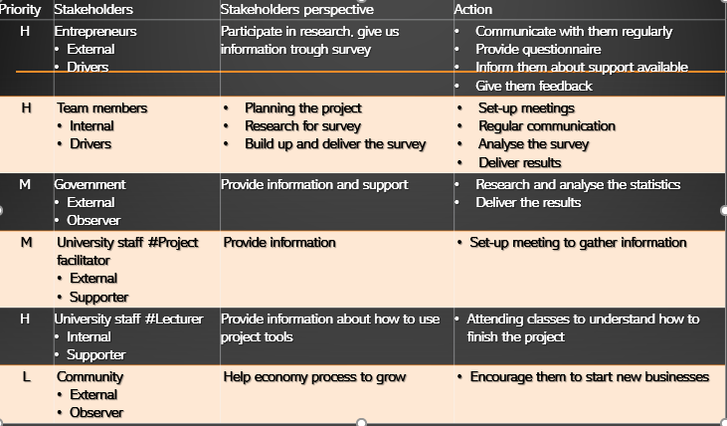

3.Execution Phase
The project execution phase is frequently the most time-consuming and difficult step of the project life cycle. If you are not cautious, your team may get off course, have communication issues, or cease adhering to your well established processes.
Making sure your team adheres to the project plan is critical, but it is not your sole responsibility. It is critical that you also motivate, support, and cheer for the squad. Pausing to celebrate each incremental win is one approach to show the team how much you appreciate them and to motivate them to keep working hard.
A Work Breakdown Structure (WBS) is a deliverable-oriented hierarchical decomposition of the work to be performed by the project team in order to achieve the project objectives and generate the necessary deliverables. A work breakdown structure (WBS) is the foundation of efficient project planning, execution, controlling, monitoring, and reporting. The work in the WBS must be identified, estimated, planned, and completed.
(Visual-Paradigm.com, 2019)

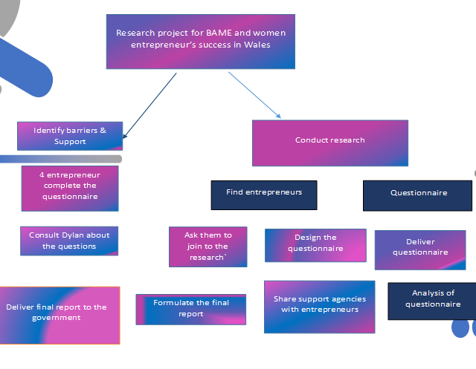
The WBS used for this project presents the steps used to ensure the project will be successful .
Another tool that has been used for this project in the execution phase was the Gannt chart.
Karol Adamiecki, a Polish engineer who operated a steelworks in southern Poland and had grown interested in management concepts and practices, created the first Gantt chart in the mid-1890s.
Henry Gantt, an American engineer and project management consultant, created his own version of the chart 15 years after Adamiecki, and it was this version that became generally recognized and appreciated in Western countries. As a result, Henry Gantt's name became synonymous with these types of charts.
A Gantt chart, which is widely used in project management, is one of the most popular and practical methods of displaying activities (tasks or events) against time. A list of the activities is shown on the left side of the chart, and a time scale is shown at the top.
( Gantt.com, 2019)
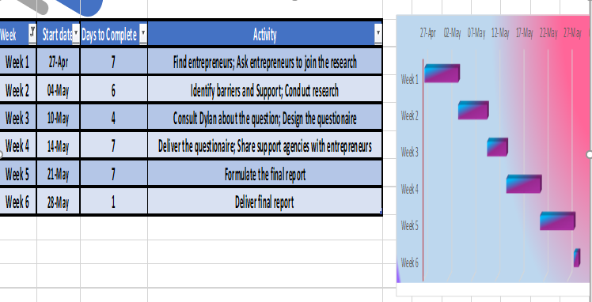

In a project context, a project schedule network diagram depicts the sequential and logical link between activities. The precise description of the chronology of activities and occurrences is essential for this visualization. A project network diagram is most commonly shown as a chart with a series of boxes and arrows. This network diagram tool is used to plan out the project's timetable and work sequence, as well as track its progress through each step - from start to finish. A network diagram is also effective in illustrative purposes since it covers the significant activities that must be completed during the project's length.
For the BAME and women entrepreneurs in Wales project, the network diagram done by the team is presented in the following graph:
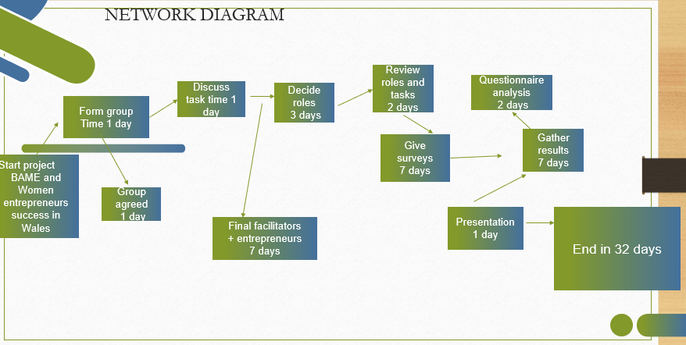

4.Closure and evaluation phase
The iron triangle, also known as the triple constraint, project management triangle, or flexibility matrix, depicts the constraints that project managers must deal with on each project they oversee.

The three constraints that project managers must work within are budget, scope, and deadline. The schedule (or time) is at the top of the model (shaped like a triangle) The project's scope is on the left, while the budget (or cost) appears on the right side of the triangle. Depending on the project or who is involved, each of these restrictions may be the most important to the final user.
When modifying limitations to achieve the project's desired end, project managers must find the right balance, keeping in mind that too much alteration may have an unfavourable effect on the other two constraints.
Expenses for a project might involve a variety of items, including resources – both materials and people – as well as any external costs that affect the project.

In some circumstances, expenses are fixed and cannot be changed; in others, costs are flexible and may be modified to meet demand. For example, if a portion of the project is to be done by contract workers and the rest of the project is to be completed by in-house workers. In our project case the cost is represented by resources.
(Shukla, Kartikeya. 18 June 2021)
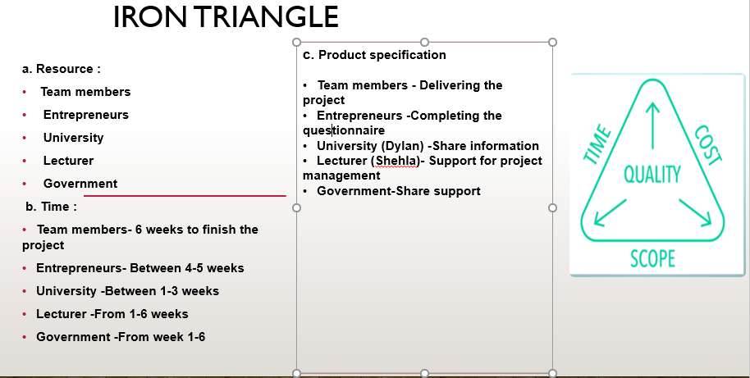
While we will never be able to foresee the future with precision, we can use a basic and streamlined risk management approach to anticipate project risks and reduce their incidence or effect. This increases the likelihood of a successful project completion and minimizes the risks associated with it.
Risks should be recognized and addressed as early in the project as feasible. Identifying risks takes place throughout the project life cycle, with a focus on critical milestones.

One of the main issues discussed at frequent project status and reporting meetings is risk identification. Some risks may be obvious to the project team—known hazards—while others would require greater effort to discover. Risk analysis entails determining how the risk event's influence will affect project outcomes and objectives.

Once the risks have been identified, they are analysed to determine the risk's qualitative and quantitative influence on the project so that suitable mitigation measures may be adopted. The guidelines below are used to assess hazards.
There may not be any simple fixes to minimize eliminate all of a project's hazards. Some hazards may need to be deliberately handled and decreased over time. As a result, action strategies for reducing these risks should be devised.
Risk management not only assists in reducing crisis situations, but also in remembering and understanding from previous errors. This increases the likelihood of a successful project completion and minimizes the risks associated with it.
(Lavanya, N, 3 Mar. 2008).

In the BAME project, there were identified two types of risk factors, Internal represented by team members and lecturer, and external represented by the four entrepreneurs, the university and government.
The risk analysis conducted is as follows:
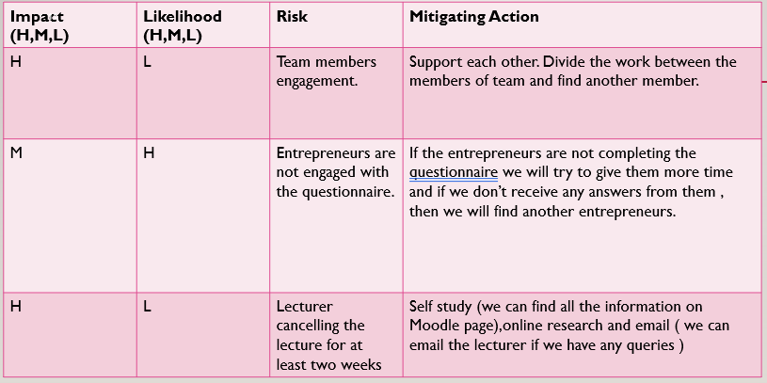

In the evaluation part a review has been made of what went well and wrong during in the project.
What went well was the fact that the aim of the project was achieved, there was a response from our four entrepreneurs to the surveys and they highlighted issues faced when having or trying to start a business in Wales, information was gathered and there was a lack of support felt by the entrepreneurs, financial difficulties faced and lack of knowledge or trainings .
The project faced difficulties as well, the initial two entrepreneurs found did not participate as expected in the survey, so there was necessary to find others to replace them, the team who worked at this project was not always communicating as often and efficient as expected, and what went wrong was also the fact that the feedback gathered from the entrepreneurs was not formal, but informal and therefore hard to evidence.

Hard evidence found was the fact that four entrepreneurs answered questions, two entrepreneurs offered information about what they would like to ask Welsh Government -they would like to know more info about financial support, and free advice and trainings available on how to start a business and one entrepreneur mentioned that they had financial difficulties
Soft evidence was , the entrepreneurs enjoyed sharing their experience, they all highlighted the lack of knowledge regarding the options available and support offered.
The survey used had twelve questions with multiple choice answer and also option to write a personal opinion.
Few of the relevant answers will be presented:
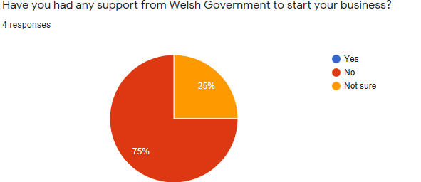
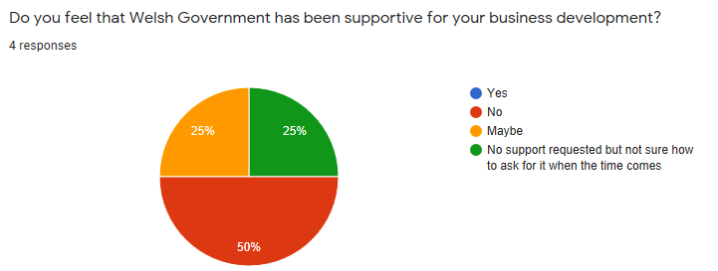
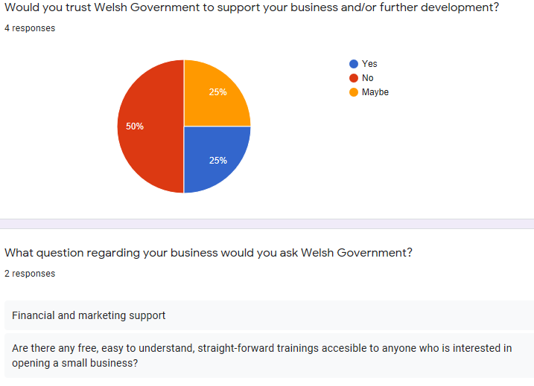

To plan, procure, and execute a project, project managers must possess a diverse set of talents. They must ensure that everything is on track and that everyone involved is working to their maximum capacity. If there are any challenges, delays, or problems, the project manager will work with the client or firm to figure out how to resolve them. They do not participate in the hands-on job, but instead monitor progress and keep everyone on track.
Some examples of the abilities and skills required for being a good project manager are:
Good presentation techniques, excellent communication in writing (Emailing, Reports, and so on), communication through words, active listening is a skill that allows you to pay attention, tolerance to stress, conflict resolution, non verbal communication.
Any project's success hinges on the capacity to manage and encourage a team. While protecting against late or bad work, project managers must settle personality disputes and build team morale.
People management is necessary for efficient work. Setting objectives, evaluating performance, and encouraging cooperation are all responsibilities of a project manager, from allocating work to holding employees accountable.
Clients will negotiate a suitable timeline and scope of work with project managers. They'll dispute over specific resources and labor. Negotiating to acquire what they need to succeed while keeping everyone happy is a talent that can be learned and refined through time.
If project managers are careless or forgetful, they are unlikely to succeed. They must be organized in both their work and personal life since they are juggling so many different elements. It is critical for project managers to establish an organizational structure.
However, because not every issue can be foreseen, project managers must be nimble in dealing with unexpected challenges and ensuring that small issues do not become significant setbacks.
(The Balance Careers, 2014 )
Considering me as a Project manager for this project, I found myself suitable and comfortable in the role.

Conclusion and recommendations
BAME and Women entrepreneurs success in Wales project was successful, the desired outcomes were achieved and there were real and accurate results at the end of the project.
The tools used for this project were suitable most of them, and provided guidance and a good framework to begin with.
The limitations of the project life cycle are the fact that it is unrealistic and linear, and the most suitable tool used was Work Breakdown Structure as it provides specifics and clarity on the tasks that need to be acted on.
The risk assessment was also essential, as in any project unexpected things can happen, and it is efficient to be able to categorise and plan in case things go wrong.
Overall the team communicated well, and the skills mix was suitable to make this project a success.

References
“Advantages & Disadvantages of Gantt Charts.” Analysistabs.com, 2018, analysistabs.com/gantt-chart/advantages-disadvantages/. Accessed 20.06.2021
APM. “What Is Project Management?” Apm.org.uk, 2016, www.apm.org.uk/resources/what-is-project-management/. Accessed 20.06.2021
Brownlee, Dana. The Unwritten Rules of Managing Up: Project Management Techniques from the Trenches. Google books, Berrett-Koehler Publishers, 26 Feb.2019. Accessed 21.06.2021
“BAME Entrepreneurs Face Worse Business Outcomes.” Diversity UK, 21 Oct. 2020, diversityuk.org/bame-entrepreneurs-face-worse-business-outcomes/. Accessed 20.06.2021
“Business and Self-Employed - GOV.UK.” Www.gov.uk, 2020, www.gov.uk/browse/business. Accessed 20.06.2021
Gantt. “What Is a Gantt Chart? Gantt Chart Software, Information, and History.” Gantt.com, 2019, www.gantt.com/. Accessed 21.06.2021
https://www.facebook.com/thebalancecom. “Project Manager Skills List and Examples.” The Balance Careers, 2014, www.thebalancecareers.com/essential-project-manager-skills-2062461. Accessed 21.06.2021

Lester, Albert. Project Management, Planning and Control: Managing Engineering, Construction and Manufacturing Projects to PMI, APM and BSI Standards. Google Books, Butterworth-Heinemann, 2007, Accessed 22.06.2021

Lavanya, N, and T Malarvizhi. “Risk Analysis and Management.” Pmi.org, 3 Mar. 2008, www.pmi.org/learning/library/risk-analysis-project-management-7070. Accessed 22.06.2021
“Leadership of Small and Medium Enterprises.” Www.ethnicity-Facts-Figures.service.gov.uk, www.ethnicity-facts-figures.service.gov.uk/workforce-and-business/business/leadership-of-small-and-medium-enterprises/latest#by-ethnicity-and-area-smes-with-employees. Accessed 10.06. 2021.

“Project Management Life Cycle: Complete Guide to Project Delivery Process.” The Digital Project Manager, 4 June 2019, thedigitalprojectmanager.com/project-management-life-cycle/. Accessed 22.06.2021

Shukla, Kartikeya. “What Is the Iron Triangle of Project Management?” Digital Gyan, 18 June 2021, digitalgyan.org/what-is-the-iron-triangle-of-project-management/. Accessed 22.06.2021
Sheldon,Donald H.Lean Materials Planning and Execution: A guide to Internal and External Supply Management Excellence, Google books, J Ross Publishing, 15 Nov.2007, Accessed 23.06.2021
The Execution Phase of Project Management | Workfront.” Www.workfront.com, www.workfront.com/project-management/life-cycle/executing. Accessed 23.06.2021
The Project Life Cycle | the 5 Stages | the CCM UK. 10 Nov. 2020, www.theccm.co.uk/the-project-life-cycle-the-5-stages/. Accessed 24.06.2021
“The 6 Essential Project Management Skills Every PM Needs.” Www.teamwork.com, 26 Feb. 2020, www.teamwork.com/project-management-guide/project-management-skills/. Accessed 23.06.2021

Visual-Paradigm. “What Is Work Breakdown Structure?” Visual-Paradigm.com, 2019, www.visual-paradigm.com/guide/project-management/what-is-work-breakdown-structure/. Accessed 24.06.2021
Westland,Jason. The Project Management Life Cycle: A complete Step-by-Step Methodology for Initiating, Planning, Executing & Closing a project Successfully . Google Books, Kogan Page Publishers, 2007, Accessed 24.06.2021
What Is a Project? - Definition and Key Characteristics.” Mymanagementguide.com, 2019,mymanagementguide.com/basics/what-is-a-project/. Accessed 24.06.2021
“What Is the Project Life Cycle | Mavenlink.” Mavenlink.com, 2015, www.mavenlink.com/resources/what-is-the-professional-services-project-life-cycle. Accessed 24.06.2021

