University of Wales Trinity Saint David
School of Engineering



Group Industrial Project
ACMA5000

Cori-James Davies (1303441)
28/10/2024

Abstract
This project focuses on developing an electronic Permit to Work (ePTW) system to improve operational efficiency, enhance risk management, and strengthen contractor oversight in industrial environments. Traditional paper-based permit systems often lead to inefficiencies, miscommunications, and increased safety risks. By leveraging advanced visual management tools and digital technologies, the ePTW system facilitates streamlined permit issuance, tracking, remote approvals and visual monitoring processes. Key features of the system include real-time visibility into permit statuses, improved risk assessments, and comprehensive dashboards that provide critical insights into contractor activities. The project aims to minimise administrative burdens, reduce errors, improve communications and ensure that safety protocols are consistently followed. Ultimately, this ePTW solution enhances organisational compliance and safety and fosters a culture of accountability and proactive risk management within the workforce.
This project aims to develop a user-friendly system designed to enhance operational efficiency. The system will enable on-site completion through intuitive digital tools, allowing users to input and manage data directly and seamlessly in the field. Additionally, it will incorporate functionality for remote approval, facilitating quicker decision-making processes and reducing delays.
Utilising the Microsoft Power Platform to achieve these goals, which provides robust tools for app development, automation, data analysis, and collaboration. This approach will ensure that the system is efficient and adaptable to the needs of various users and stakeholders involved in the project. Through this integrated solution, we aim to streamline workflows, enhance communication, and ultimately improve overall productivity.

Table of Contents
Abstract 1
Table of Contents 2
1 Introduction 4
2 Literature Review 5
2.1 Current Systems 5
2.2 Permit to Work Systems and Regulatory Guidance 5
2.3 Digital Transformation of Permit to Work Systems 6
2.4 Risk Management and Data Dashboarding in ePTW Systems 7
2.5 Organisational and Behavioural Considerations 7
3 Methodology 8
3.1 Methodologies Used 8
Hybrid Project Management Approach (Waterfall & Agile) 8
Stakeholder Interviews and Workflow Analysis 8
User Interface Design 8
3.2 Tools & Techniques 9
Microsoft Power Platform (PowerApps, Power Automate, Power BI) 9
Mobile Integration 9
3.3 Risk Assessment Tools 9
3.4 Measurement and Validation of Results 10
Performance Metrics Tracking 10
Trial & User Feedback 10
4 Results & Discussion 11
4.1 Electronic Permit to Work (ePTW) System 11
4.2 Testing Results 14
Success 14
Improvements 14
4.3 Feedback 15
Permit User 15
Familiarisation with digital systems 16
16
Navigation 16
Permit Completion 17
Expectations 17
Benefits 18
Improvements/Suggestions 18
Recommendations 19
5 Conclusion 20
6 Self-Evaluation 22
Technical Knowledge & Development 22
Personal Growth & Contribution 22
7 References 24
8 Appendices 25

Figure 1: Electronic Permit to Work Homepage 11
Figure 2: Mobile and Webpage access 11
Figure 3: Remote automated approvals 12
Figure 4: Example of a completed Electronic Permit to Work 12
Figure 5: Visual management of permit status 13
Figure 6: Visual management for open live permits 13
Figure 7: Dashboard for high-risk activities 14
Figure 8: Feedback form via Microsoft Form 15
Figure 9: Feedback results role and usage. 16
Figure 10: Familiarisation with digital systems 16
Figure 11: Navigation feedback. 17
Figure 12: Permit completion feedback 17
Figure 13: User Expectations 18
Figure 14: User Recommendation 19

Introduction
Ensuring safety and compliance during work activities in hazardous environments is paramount in contemporary industrial settings. Traditional paper-based Permit to Work (PTW) systems, historically utilised by organisations such as Enersys, Dŵr Cymru Welsh Water, and Tata Steel UK, have increasingly been scrutinised due to their notable limitations. These systems, which have served the industry for decades, rely on manual processes and increase the risk of errors and miscommunication, which can lead to operational inefficiencies and pose significant safety risks that could jeopardise personnel and organisational integrity.
This project explains the creation and development of an Electronic Permit to Work (ePTW) system using Microsoft's Power Platform, including Power Automate, Microsoft Forms, PowerApps, and Power BI. The system aims to enhance communication and efficiency in permit management, risk assessment, and contractor monitoring, ensuring information is securely stored and accessible for integration with other company systems.
The primary objectives of this project are as follows: firstly, it aims to analyse the limitations of traditional PTW methods, increase the efficiency of current processes, and improve the interaction and control over permits. Secondly, the transition aims to improve risk management, accuracy and responsiveness in risk assessments. Thirdly, it will enhance the monitoring of contractors and employees, enhance communication, and improve compliance with safety regulations. Finally, to ensure that recorded information is accessible and aligned with other audits and applications.

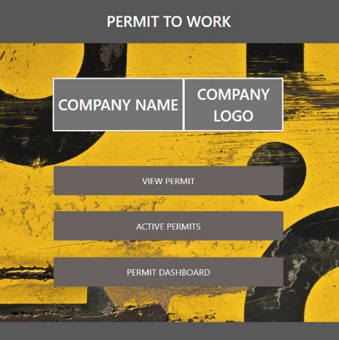


Literature Review
Creating an electronic Permit to Work (ePTW) system necessitates in-depth research on workplace safety and regulatory compliance. This research focuses on essential concepts and frameworks to design an effective ePTW system, utilising regulatory guidelines, industry standards, and technological advancements.

Current Systems
Representatives from Enersys, Dŵr Cymru Welsh Water, and Tata Steel UK have reported some success with their traditional paper-based Permit to Work (PTW) systems. However, it is essential to recognise the significant drawbacks associated with these systems. Challenges in legal compliance, safety, efficiency, and overall operational effectiveness can jeopardise an organisation's financial health and reputation within the industry. Manual entry and data processing in paper-based permit systems heightens the risk of errors, misinterpretation, and oversight. This can result in incomplete or inaccurate permits, posing a safety risk as (Jones, 2024) argued. Moreover, completing, approving, and disseminating paper permits is significantly time-consuming compared to electronic systems, which can hamper workflow, cause mistakes, and reduce productivity.
Additionally, (Rogers, 2024) Was of the view that paper's physical nature renders it less accessible than its electronic counterparts. Paper permits are required at the work site, and their misplacement or damage can impede the quick retrieval of essential information. Furthermore, the storage and retrieval of paper permits necessitate physical space and can be labour-intensive and time-consuming for audits or review.

Permit to Work Systems and Regulatory Guidance
The foundation of any Permit-to-work (PTW) system is rooted in regulatory compliance, especially in industries that involve hazardous activities. The (Health and Safety Executitive , 1974) Establishes the framework for workplace safety in the UK. This legislation outlines the general responsibilities of employers to ensure the safety of both employees and the public during operational activities. It emphasises the need for a systematic approach to risk management, which is crucial for an ePTW system.
Regulations like the Management of Health and Safety at Work Regulations (MHSWR) (UK Goverment , 2015), mandate that employers perform detailed risk assessments and implement safety controls before starting any hazardous work. The Permit to Work (PTW) system reinforces these requirements by documenting all necessary risk assessments and approvals before any work commences. The Control of Substances Hazardous to Health Regulations 2002 (COSHH) (UK Goverment, 2020) and the Confined Spaces Regulations 1997 (Goverment UK, 2024)provide specific requirements for handling hazardous materials and working in confined spaces. These regulations are essential for the Permit to Work (PTW) processes.
The Guidance on Permit-to-Work Systems, outlined in (Health and Safety Executitve, 2005), plays a crucial role in the development of the modern PTW system. Created by the Health and Safety Executive (HSE), this guidance delineates best practices for implementing Permit-to-Work systems, especially in high-risk industries such as oil, chemicals, and construction. (Health and Safety Executitve, 2005). It emphasises that a Permit-to-Work system should focus on issuing permits and incorporate robust mechanisms for authorisation, training, and continuous monitoring of safety procedures.

Digital Transformation of Permit to Work Systems
The shift from paper-based to ePTW systems is part of a broader digital transformation trend in safety management. Electronic systems significantly improve efficiency, compliance, and real-time tracking of work permits. The advantages of ePTW systems have been well documented in the literature, (Reddy & Reddy, 2015), emphasise the notable reduction in human error, quicker permit issuance, and enhanced tracking capabilities through automated workflows and digital signatures. Additionally, these systems improve compliance by ensuring that all safety checks and approvals occur in the correct order, thereby reducing the risk of oversight.
Recent research by (Eder Martinez, 2023) on development platforms, such as Microsoft Power Platform, underscores the significant benefits of utilising these tools for creating customisable and scalable ePTW solutions. By leveraging Power Automate and PowerApps, organisations can digitise their PTW processes, streamline workflows, and boost operational efficiency. These tools automate repetitive tasks, including permit approvals and notifications, reducing administrative workloads and enabling teams to focus more on critical safety responsibilities.
Integrating ePTW systems with other enterprise technologies and mobile applications is an emerging trend in the industry. These devices can continuously monitor work environments for hazardous conditions, sending data to the ePTW system and automatically triggering alerts when safety thresholds are exceeded. Additionally, mobile capabilities enhance flexibility by allowing workers and supervisors to access, review, and approve permits from remote locations, which improves responsiveness and reduces downtime.

Risk Management and Data Dashboarding in ePTW Systems
Risk management is vital for any Permit-to-work (PTW) system, and digitisation enhances safety outcomes. An effective ePTW system features dynamic risk assessment tools that help users identify, evaluate, and mitigate task-related risks. This real-time evaluation is crucial in high-hazard industries, where conditions can change rapidly, and new risks may emerge.
Integrating data dashboarding into ePTW systems enhances risk management by allowing organisations to monitor permit trends, identify non-compliance, and track near misses or incidents, (Erin Burrell Nickell, 2023). These insights support continuous improvement in safety procedures, reducing future accident risks. Leveraging data for decision-making is a crucial advantage of digital systems, equipping organisations to manage safety risks effectively.

Organisational and Behavioural Considerations
Despite the clear advantages of ePTW systems, their successful implementation requires careful consideration of organisational and behavioural factors. Resistance to change is one of the biggest challenges in transitioning from paper-based to electronic systems (Reddy & Reddy, 2015). Employees accustomed to traditional processes may hesitate to adopt new technologies, particularly if they perceive them as complex or disruptive to their workflows.
Compliance with the General Data Protection Regulation (GDPR) and relevant ISO/IEC standards is essential for managing sensitive data. (Goverment UK, 2019). As organisations use electronic systems for data storage, implementing encryption and multi-factor authentication is crucial to prevent unauthorised access and data breaches.

Methodology

Methodologies Used

Hybrid Project Management Approach (Waterfall & Agile)
The Waterfall method enabled thorough initial planning, ensuring that all project requirements were clearly defined. This approach allowed for systematic resource allocation, where each team member’s strengths matched specific tasks. Additionally, comprehensive risk management strategies were developed to identify potential challenges early on and devise strategies to mitigate them.
In contrast, the Agile approach was employed during the execution phase through iterative sprints. This allowed the team to develop project elements incrementally, promoting flexibility and responsiveness to dynamic requirements. Each sprint offered opportunities for review and adjustment, ensuring that the project could adapt quickly to new insights or changes in stakeholder needs. This combination of methodologies enhanced the planning rigour and the adaptability of the project execution.

Stakeholder Interviews and Workflow Analysis
Interviews were conducted with key stakeholders from each organisation at the beginning and the end to gather a comprehensive set of requirements for the new system. This process aimed to ensure complete adherence to relevant legislation and industry standards. During the interviews, we actively sought to understand each stakeholder's unique needs, pain points, and expectations, ensuring we considered various perspectives.
To better understand the current processes, we thoroughly mapped out the existing workflows associated with the paper-based PTW system. This involved a detailed analysis of each step in the workflow, allowing us to pinpoint specific inefficiencies, bottlenecks, and areas where time was unnecessarily wasted. By doing so, we created a clear and comprehensive picture of the system's shortcomings, highlighting areas that required improvement.
Our goal was to develop a solution that effectively addresses the identified inefficiencies, enhances safety protocols, and ensures compliance with regulatory requirements. This holistic approach aims to create a more efficient, user-friendly, and compliant ePTW system that meets the evolving needs of all stakeholders.

User Interface Design
Throughout the later stages of development, internal testing sessions were carried out, ensuring smooth usability testing with no errors. Following this were the user software trial and feedback surveys collated from end users, which provided critical insights into the system's performance and usability, which are explained further in the report.

Tools & Techniques

Microsoft Power Platform (PowerApps, Power Automate, Power BI)
A user-friendly interface was developed specifically for managing permits. Using PowerApps, which is the platform that enables users to create custom applications without needing extensive programming knowledge. Which allowed individuals from various backgrounds to navigate the app to create and submit their permit requests. The goal was to simplify the process, making it accessible and efficient for all users, including those who may not be tech-savvy.
Workflows were set up to handle the permit approvals process, which included sending notifications to relevant parties when a permit is submitted and reminders about pending approvals. This was created by utilising Power Automate, a cloud-based service that helps automate repetitive tasks and workflows. Automating these tasks made the permit management process more efficient, reducing the time and effort required to track and manage approvals manually.
Visual management reports and dashboards were created from the data to allow real-time insights into permit tracking. This includes visualising the status of various permits, analysing risk assessments, and assessing the performance of the permit management system. Using Power BI, stakeholders can make data-driven decisions and quickly identify issues or trends.

Mobile Integration
Implementing integrated mobile capabilities has empowered vital stakeholders and process leads to approve and manage permits from remote locations. This advancement has significantly enhanced system accessibility, allowing users to conveniently access critical information and functionalities. Consequently, this has led to a notable reduction in time delays, streamlining the overall permitting process and improving efficiency across various operations.

Risk Assessment Tools
The system now features automated risk assessment sections designed to guide users in evaluating the potential risks associated with each permit. This enhancement allows for a thorough analysis by prompting users to consider various risk factors relevant to their situations. Additionally, the dashboard has been enhanced to prominently display high-risk activities, making it easier for users to quickly identify areas that require close monitoring via audits or inspections. This includes both ongoing high-risk activities that are currently open and those that have been previously completed, allowing users to assess risk trends over time and make informed decisions to mitigate future issues.

Measurement and Validation of Results

Performance Metrics Tracking
Power BI was used to develop comprehensive visual dashboards that provide real-time insights into system performance, allowing for immediate identification of trends and areas for improvement. This facilitated informed decision-making and strategic planning based on up-to-date performance data.

Trial & User Feedback
Comprehensive internal trials were conducted to evaluate the system's performance thoroughly. The fault-finding process was imperative, progressing through multiple stages until the system operated seamlessly.
After completing the internal trials, we performed tests involving employee interfaces to gain real-world insights. To assess the system's usability effectively, we distributed Microsoft Forms surveys to employees, collecting their feedback. This survey evaluated their experiences and interactions with the system, helping us pinpoint specific areas for improvement and enhancement.

Results & Discussion
Implementing the ePTW system across the three companies had several significant outcomes that underscore its effectiveness. Transitioning from a paper-based system to a digital platform has resulted in significantly faster permit processing times. The workflow automation reduced manual tasks, allowing for quicker approvals and modifications. Figure 1 shows the home page to navigate to a specific page.

Electronic Permit to Work (ePTW) System

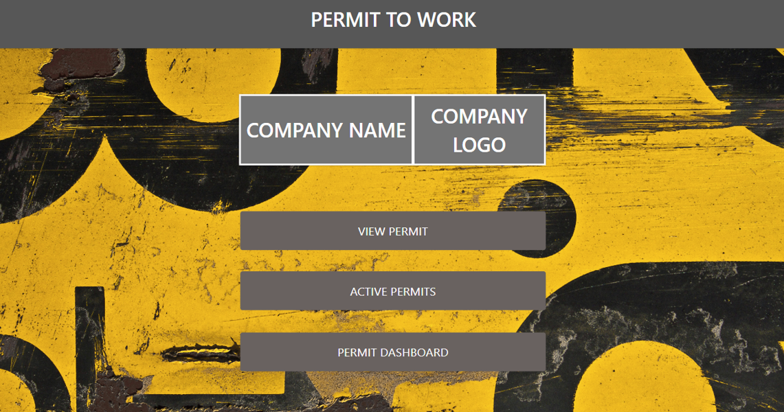
Figure 1: Electronic Permit to Work Homepage
A user-friendly interface ensured ease of use for all personnel, regardless of their technical expertise. The digital format required completion of the Microsoft form, which allows for quick updates and a clear understanding of potential hazards associated with specific work activities. Figure 2 shows access through Mobile integration via a QR code or webpage, which allows employees to access permits and safety information on the go as or when required. (Scan the QR code to trial the system).


Figure 2: Mobile and Webpage access

The new system improved team communication by providing a joint effort to produce the permit, discussing the task, the risks involved, and what controls would be implemented to manage the risks. Also, it can be carried out remotely on-site, where you can clearly understand the area and identify any further dangers. Once the form is completed, it transfers the data into SharePoint lists, where the initial permit is stored, pushing a notification and approval via Microsoft Teams.
Integrating automated notifications ensured timely updates to the approval via Microsoft Outlook email, which can be accessed anywhere at any time to approve the permit, as seen in Figure 3. Approvals can be assigned to single or multiple personnel depending on the organisation's needs.
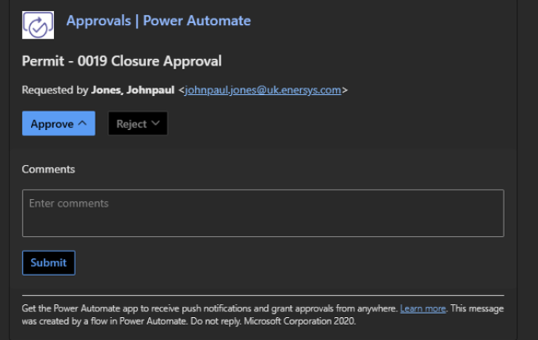
Figure 3: Remote automated approvals
Following the approval of the permit, it is then electronically returned to the initiator as a word, as seen in Figure 4. This permit is now a live document and will be available to access by the person in charge of carrying out the task, who can brief his team on site via a phone or tablet whilst in the working area, which will promote the correct pre-task checks promoting an improved health and safety culture.
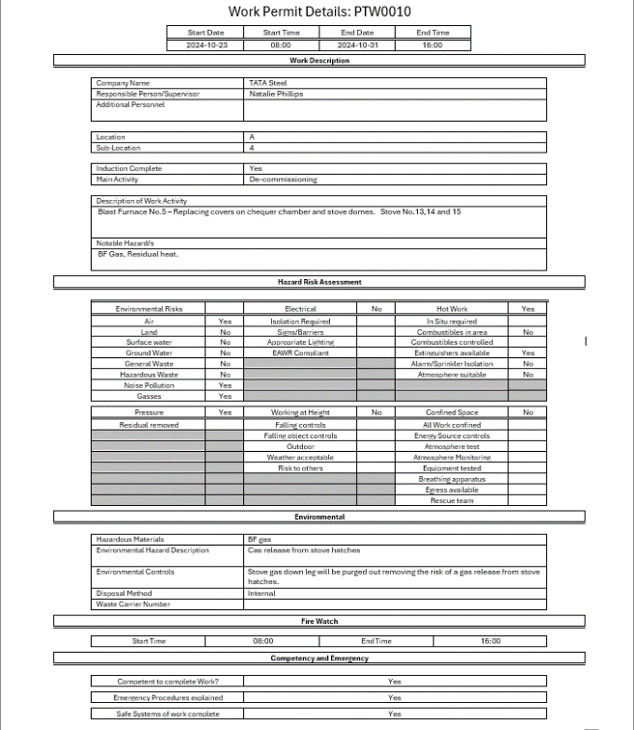

Figure 4: Example of a completed Electronic Permit to Work
The visual management of permit status enhances clarity by providing a clear overview of the current state of each permit via Microsoft Teams, as seen in Figure 5. This approach helps all stakeholders quickly access information, significantly reducing confusion and misunderstandings arising from unclear communication. By implementing visual tools like dashboards or status boards, teams can quickly identify which permits are pending, approved, or require additional action, ultimately streamlining the management process and improving overall efficiency.
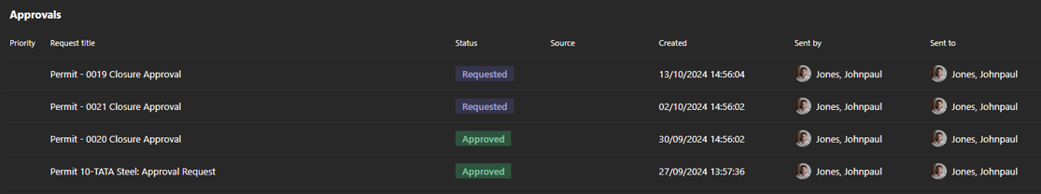
Figure 5: Visual management of permit status
Figure 6 shows visual management for the open live permits via the Power app, which is crucial for maintaining clarity and efficiency within the permitting process. By displaying real-time information about permit statuses, stakeholders can quickly identify who initiated each permit. This allows an action to inspect the areas, make contact with those who made the permit live, highlight the risks associated with each task, and ensure there is no clash with any other work that will be required.
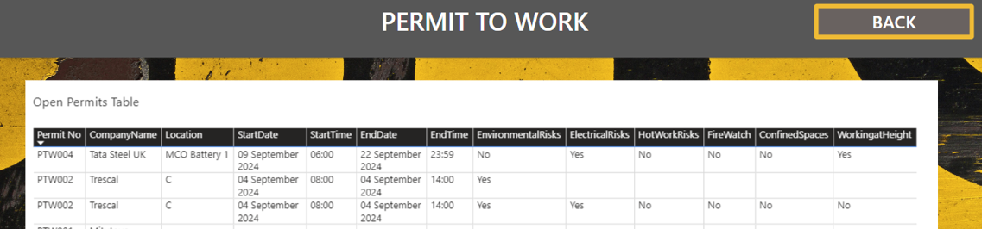
Figure 6: Visual management for open live permits

Furthermore, the dashboard for monitoring high-risk activities was created with information from Power BI and integrated into Power App, as seen in Figure 7. This is a valuable visual management aid for seeing activity on the site. This will promote proactive site inspections/audits to ensure the tasks are carried out correctly and controls are in place.

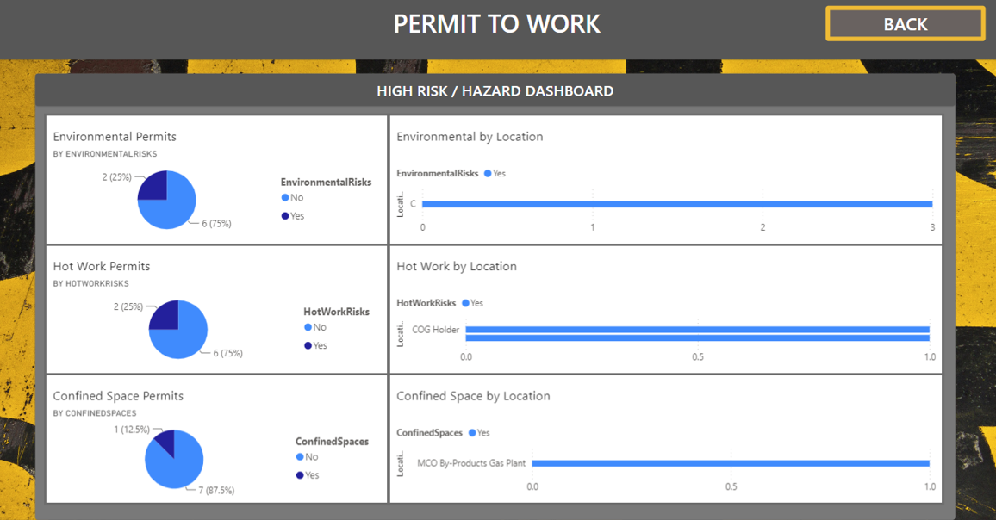
Figure 7: Dashboard for high-risk activities

Testing Results
The testing results present a mixed picture, revealing positive outcomes and areas requiring further attention. While specific processes have shown significant improvement, others highlight challenges that must be addressed.

Success
- The average time taken to complete forms remains stable, indicating consistency in the process for users.
- There has been a marked improvement in permit approval time, suggesting a more efficient review process that benefits all stakeholders.
- The expiry date for permits may now extend beyond the previous limit of 14 days in Tata’s case. This change is particularly relevant for Enersys and Welsh Water as the current process would require a new permit daily, which can be very repetitive. This adjustment enhances transparency and facilitates smoother transfer processes, eliminating the daily need for a new permit.
- The timeframe for closing permits has been significantly reduced, leading to quicker resolutions and improved overall efficiency in permit management.

Improvements
- Editing existing permits poses challenges, primarily because it requires the presence of an administrator or an approver available to make changes in real time. This can lead to potential delays, as the availability of the necessary personnel may fluctuate depending on the organisation's set-up.
- Closure approvals are also a concern, as the updates do not reflect immediately. Instead, they only take effect during the server update times, which occur at 3 PM and 6 PM daily. This can lead to confusion when high levels of activity are going on and is a risk that would need to be addressed depending on the organisation's setup, which could be carried out via a server upgrade.
- Amendments can only be made if and when an authorised admin is available to process at the time of edit, which can lead to delays in work progress or will encourage incorrect standards by personnel. A recommendation would be for companies to have the correct cover at any time when work activity is ongoing.

Feedback

User trials of the system and feedback surveys were required to gather insights into the current standards and also for continuous improvement. This was done via Microsoft form, as seen in Figure 8. (Scan the QR code for feedback).

Figure 8: Feedback form via Microsoft Form

Permit User
The trial feedback for the ePTW system revealed encouraging user insights, as seen in Figure 9. Notably, 62% and 69% of participants were front-end daily users, highlighting a significant engagement level among those who frequently interact with the system. This high percentage suggests that the ePTW system is being well-received by its primary users, indicating a substantial likelihood of continued positive, constructive feedback as it is further implemented and refined. The comprehensive input from these front-end users will be invaluable in optimising the ePTW for broader applications in the future.
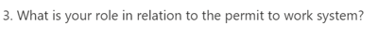
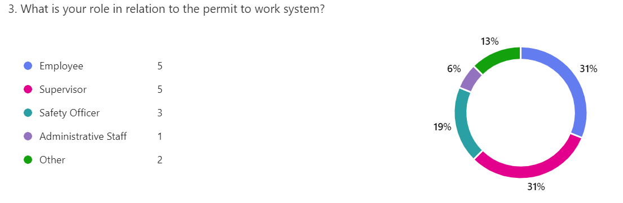
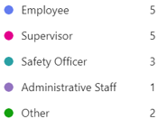
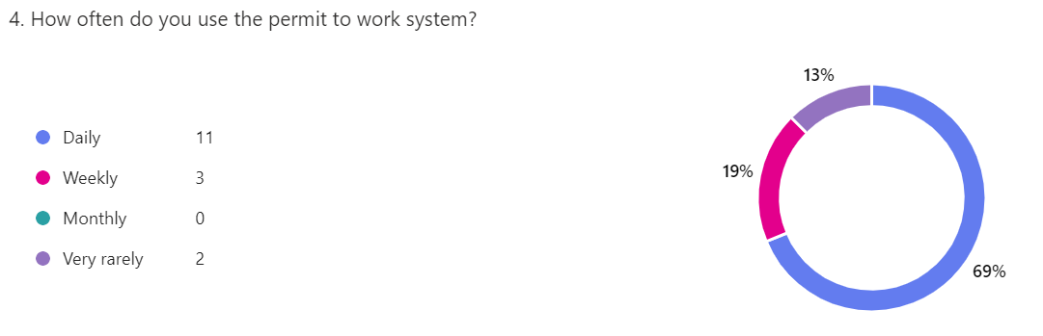
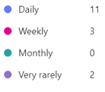
Figure 9: Feedback results role and usage.

Familiarisation with digital systems
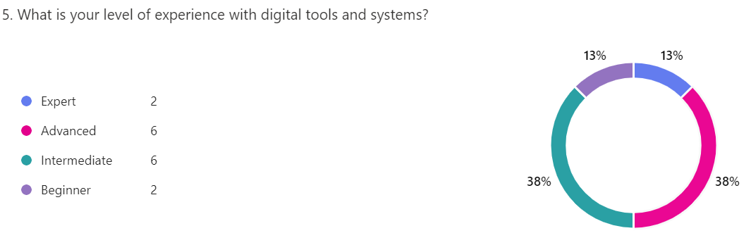

The participants demonstrated a balanced distribution in their familiarity with digital systems. As shown in Figure 10, half showed confidence in navigating and utilising various technologies effectively. This indicates a divided comfort level when engaging with digital tools, suggesting the need for further training or support for those who may be less confident.

Figure 10: Familiarisation with digital systems

Navigation
Figure 11 explains the user's feedback on the system's navigation; survey results revealed that 57% of users reported finding it easy to use, indicating a positive experience overall. Additionally, 31% of users maintained a neutral stance, suggesting that while they didn't find it particularly challenging, they did not see it as exceptionally user-friendly. Conversely, only 13% of users experienced difficulties, highlighting that the majority navigated the system without significant issues.

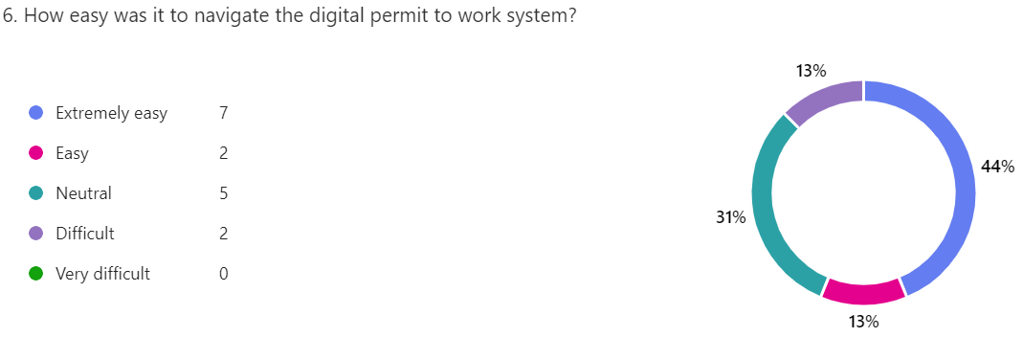
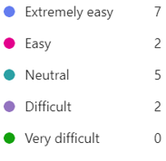
Figure 11: Navigation feedback.

Permit Completion
When completing permits, as explained in Figure 12, 56% of users reported that they could quickly fill out the forms. Meanwhile, 25% indicated they required only minor assistance to complete the application. Additionally, it is worth noting that a commendable 68% of users experienced no technical issues while navigating the system, highlighting the overall effectiveness and user-friendliness of the process.
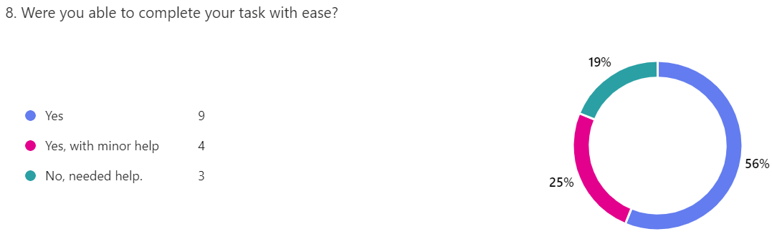
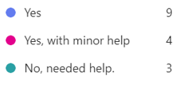
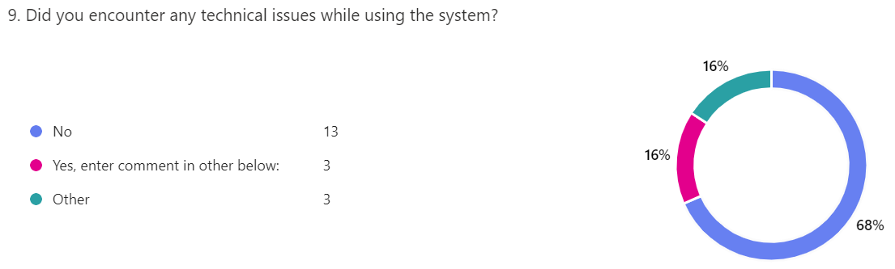

Figure 12: Permit completion feedback

Expectations
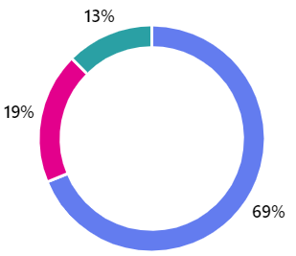

When evaluating how well the system met users' expectations, as seen in Figure 13, it was found that 69% of participants felt it adequately addressed their needs. Furthermore, 63% reported being satisfied with the system's overall functionality, indicating a positive user experience. Regarding future use and recommendations, 69% of users stated they would be inclined to recommend the system to their colleagues, suggesting a strong confidence level in the app. Additionally, these users expressed a high likelihood of using the app again, reflecting a positive reception overall.
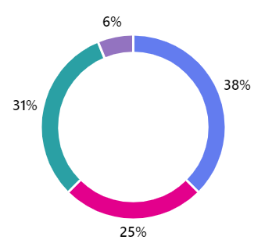
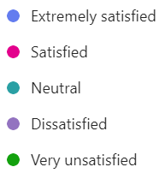
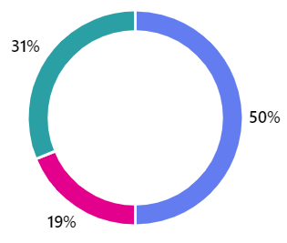
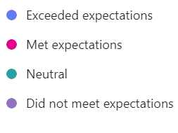
Figure 13: User Expectations
13. How would you rate your overall satisfaction with the digital permit to work system?

Benefits
The collected feedback revealed encouraging and positive comments from Welsh Water employees, as one stated: “It is simple to carry out via a tablet/smart device as we cover the whole of Wales and can use it remotely with the teams. It allows us to do permits on-site to assess the risks thoroughly”. They noted real benefits stemming from the coverage across Wales, particularly regarding remote permits being sent back to a central location for authorisation. Additionally, the feedback from TSUK highlighted “Interaction between contractor and person writing the PTW, agreeing the task and control”, which states the importance of collaboration between the person drafting the permit and the contractor responsible for completing the task outlined in the license. Also, another TSUK employee comments, “If small discrepancies are addressed, this system would fit nicely into TSUK's framework”. This suggests minor adjustments but is a workable solution for embedding the system. The results from Enersys UK were positive, seeing real benefits; one employee said: “A lot more efficient, no papers to get lost or damaged. Would be beneficial for auditing purposes also as paper can be tiny writing and difficult to read”.

Improvements/Suggestions
The testing and survey feedback highlighted little to report on improvements at this early stage. However, there was a comment around a critical point, where one employee from Enersys stated: “Further training will be required before implementing”. Additionally, one TSUK employee proposed a “Trial on site would be nice to see”. A trial in a specific area would observe the system's performance in a controlled environment. This approach could provide valuable insights and allow for adjustments based on real-world use, ensuring a smoother transition for all users when the system is rolled out more broadly.

Recommendations
The survey feedback revealed strong support for the ePTW system, with an impressive 68% of participants indicating that they would recommend it to their colleagues, as seen in Figure 14. This endorsement highlights users' confidence in the system and suggests it effectively meets their needs.

Figure 14: User Recommendation

Conclusion
In conclusion, this project successfully developed the ePTW system, with the alignment of its initial objectives of analysing the limitations of traditional PTW systems, improving risk management, and enhancing the monitoring of contracts and employees.
Integrating Microsoft’s Power Platform (Power App, Power BI, and Power Automate) created a streamlined and efficient system that significantly enhances communication and risk management. A comprehensive analysis of traditional paper-based systems highlighted their limitations, further reinforcing the need for the transition to the electronic system.
Before the testing phase, the project team encountered minor issues integrating various Microsoft Power Tools. These issues were underestimated, leading to project delays and potentially impacting the milestone. The team discussed the situation and decided that front-end user testing needed to be improved. This was essential to ensure the process was efficient and provided a workable solution for personnel, avoiding further delays.
The feedback from the trial of the system provides positive insights into its potential benefits, especially in light of the changes needed to introduce a new system. The ePTW system improves overall efficiency by enabling tasks to be performed directly at the location within the plant where the work will occur. It helps identify risks in that area and encourages clear communication between the permit initiator and the permit receiver, fostering effective dialogue.
Further developments in the approval process, which can be reviewed, approved, or declined remotely, enhance efficiency within the system. However, this may present challenges depending on the organisation’s structure. For instance, if the plant operates 24 hours a day, competent authorities must always be available at all locations where work is being performed. Improvements in the visual management systems for specific activities are essential for maintaining control and compliance, ensuring that safety audits are up to date, particularly for high-risk activities. Another potential issue in similar organisations is the current server setup, which updates only twice daily (at 3 PM and 6 PM). Any permit status changes outside these windows may result in inaccurate information, leading to operational errors and potential safety concerns.
To improve and enhance this project, future efforts could focus on enhancing user training and incorporating a live trial period to gather detailed feedback. Additionally, integrating more advanced features like automated accident and incident reporting and automated notifications for permit expirations would significantly enhance its value. Exploring ways to utilise artificial intelligence (AI) could also improve real-time monitoring and decision-making processes. By addressing these challenges and prioritising continuous improvement, the ePTW system can develop into an even more effective tool for ensuring safety and compliance in hazardous work environments.

Self-Evaluation
As the Data Visualisation and User Experience Lead, I have been reflecting on my involvement in creating the ePTW system. This role required effective collaboration with a cross-functional team. This self-evaluation aims to outline my contributions, highlight vital learnings, and identify opportunities for future development.

Technical Knowledge & Development
One of the most significant areas of learning was my understanding of digital systems and their implementation in operational processes. I gained hands-on experience in system design and user navigation, which deepened my familiarity with various digital tools. Working with Power BI gave me a deeper understanding of data visualisation and the intricacies of dashboard creation. I gained hands-on experience in connecting to SharePoint lists and managing data, which enhanced my technical skills in data handling and reporting. Additionally, I learned how to integrate user feedback effectively into system enhancements, ensuring that the final product met the needs of all stakeholders.

Personal Growth & Contribution
Having worked on projects within TSUK previously, it is evident that with such a large organisation and subject matter experts (SMEs) in the respective area, something that can be taken for granted. Collaborating with the team to ensure everyone worked to their strengths was critical to ensuring efficiency for the overall project success. Addressing difficulties taught me how essential it is to have open lines of communication within the team specific to technology management. I learned to address these difficulties directly and proactively to ensure all members were on the same page.
Time management is critical to the project, and ensuring a fully functional team is communicating effectively and present for planned meetings is a challenge due to personnel workload and external factors, which had an impact.
My input to gaining the knowledge and fundamental skills from exposure to Microsoft Power tools to build visual management systems to improve visibility and enhance safety controls was the area in which I was most interested during the project. Furthermore, the user experience and collating the data from feedback were also other points of interest; seeing the project results was a highlight of such positive feedback. However, there is also potential to take it to the next phase and build more capabilities into the system. I have developed a stronger sense of accountability in my work, recognising that my contributions directly affect our project outcomes. Moving forward, I aim to carry these lessons into future projects. The project has been a transformative journey, and I am eager to apply these insights as I continue to grow in my career.

References
Eder Martinez, L. P., 2023. Benefits and limitations of using low-code development to support digitalization in the construction industry. In: Automation in Construction. Purdue: Elsevier.
Erin Burrell Nickell, J. S. P. G., 2023. An introductory audit data analytics case study: Using Microsoft Power BI and Benford’s Law to detect accounting irregularities. Journal of Accounting Education, 64(100855).
Goverment UK, 2019. Data Protection Act 2018. [Online]
Available at: https://www.legislation.gov.uk/ukpga/2018/12/contents/enacted
[Accessed 16 September 2024].
Goverment UK, 2024. The Confined Space Regulations 1997. [Online]
Available at: https://www.legislation.gov.uk/uksi/1997/1713/contents
[Accessed 10 September 2024].
Health and Safety Executitive , 1974. Health and Safety at Work Act 1974. [Online]
Available at: https://www.legislation.gov.uk/ukpga/1974/37/contents
[Accessed 11 May 2024].
Health and Safety Executitve, 2005. HSG 250 Guidance on permit-to-work. s.l.:Crown.
Jones, D., 2024. Conversation with Matthew Frey [Interview] (08 April 2024).
Reddy, V. & Reddy, I., 2015. Study of Electronic Work Permit System in Oil and Gas. IJISET - International Journal of Innovative Science, Engineering & Technology, 2(4), p. 533.
Rogers, K., 2024. Conversation with Andrew Madelin [Interview] (14 April 2024).
UK Goverment , 2015. The Management of Health and Safety at Work Regulations 1999. [Online]
Available at: https://www.legislation.gov.uk/uksi/1999/3242/regulation/1/2015-06-01
[Accessed 11 May 2024].
UK Goverment, 2020. The Control of Substances Hazardous to Health Regulations 2002. [Online]
Available at: https://www.legislation.gov.uk/uksi/2002/2677/regulation/9
[Accessed 12 May 2024].

Appendices

