

Intercultural Competence Report

Student Name: LOREDANA LEONTE
Student ID: 2234509

Module Title: Foreign Languages & Cultural Awareness

Module Code: BMIH5003

Lecturer: Heidi Prosser
Date: 26.02.2024

1. Executive Summary:
This report explores the complex key differences between England and Italy, which expand within the whole spectrum of economic, cultural, familial, and individual life (). It briefly examines these from the hospitality point of view. Key findings suggest that, while there are differences in the areas mentioned, there are also common grounds on which hospitality-based relationships can be created. Also, a GLOBE Project of Italy compared to England analysis is included, with a focus on culture and leadership.
2. Table of Contents:
- Executive Summary
- Table of Contents:
- Introduction
- Report 4.1. Differences 4.1.1 Cultural differences 4.1.2 Customs differences 4.1.3. Hospitality 4.1.4. Additional differences 4.2 GLOBE country analysis 4.3 Additional content
- Conclusion
- Recommendations
- References
3. Introduction
Cultural, customary, and hospitality difference awareness could mean the difference between a well-managed hotel and loss of business, especially nowadays, when globalisation has brought a widespread awareness of foreign values (Koc, 2020). Hotel management crucially impacts cultural awareness among team members. The report conducted for Inclusivity Hotel & Spa in Rome, Italy, offers recommendations for implementing cultural awareness in the London Inclusivity Hotel & Spa team.
4.1. Key differences between England and Italy
4.1.1 Cultural differences
Within the cultural spectrum, individualism vs. collectivism sees England as more inclined towards individualism (Warde et al, 2020, p. 234), valuing personal space and privacy, and Italy more towards collectivism (Burton et al, 2021), prioritising family, friendship, and communal bonds; formal vs. informal approach puts formality in England’s greetings and social interactions, and casual and expressive approach in Itlay’s.
4.1.2 Customs differences
With regards to each country’s customs, greetings in England resumes to handshake, while In Italy, cheek kisses are common among friends and acquaintances; eating customs see England with smaller portions, served in brief mealtimes, and Italy with longer breaks with larger, multi-course meals enjoyed leisurely (Cazzaniga et al, 2021). The well-known teatime, served at five o’clock or at supper in England has no correspondent in Italy, where coffee is served at dinner time. A peculiar tradition in Italy is the siesta, a midday break for rest and socialisation, while England does not have this custom.
4.1.3. Hospitality
In hospitality, some of the most important differences between England and Italy are found in the directness in welcoming guests. England takes a more reserved approach, expressing hospitality indirectly and respecting customs and traditions, while Italy welcomes guests openly and enthusiastically. When it comes to food and drinks, both countries offer culinary delights, but sharing plates among guests and extended dining experiences are more common in Italy. Gift-giving in England is often reserved for special occasions. In Italy, it's more frequent and informal, often being used as a token of appreciation for a minor gesture that someone has made, and seldomly implying anything of consequence.
4.1.4. Additional differences
There are some additional points worth mentioning, as they might have implications within the hospitality sector. For instance, humour: England favours dry, sarcastic humour, while Italy leans towards expressive and physical humour; leisure activities: England enjoys organized sports and outdoor activities, while Italy favours socializing in cafes, enjoying art, and strolling through piazzas; and communication: England values politeness and indirect communication, while Italy takes a more direct and expressive approach, gesture and body language play a more significant role in Italian communication compared to the more reserved British style, and also, Italians tend to speak louder and more expressively, while English conversations are typically quieter and more subdued; competency: seen as a resource (Özsungur et al, 2020), both country have their strengths and weaknesses, but some, like the culinary heritage, small hospitality businesses and fabulous locations are some of Italy’s strengths, whereas the renowned high standards, a modern infrastructure and a powerful marketing know-how are England’s strengths.
4.2 GLOBE country analysis
Difference between Italy and England with regards to cultural practices and cultural values are of interest for this analysis, as it directly affects communication and its interpretation (Tian & Tian, 2018), so it impacts hotel-industry. The GLOBE project is used for this analysis. From its 9 areas of interest, only 5 will be used. Each of these areas are represented graphically on a scale from 1 –very low– to 7 –very high, with an Average Globe Score (AGS), a Country Practice Score (CPS), and a Country Value Score (CVS).
4.2.1 Performance orientation
This refers to the “degree to which a collective encourages and rewards group members for performance improvement and excellence”. England scores 4.08 on CVS and 5.9 on CPS, while Italy scores 3.58 on CVS and 6.07 on CPS. According to the practice score, both countries seem to prioritise delivering excellent service.
4.2.4 Humane orientation
This refers to the “degree to which a collective encourages and rewards individuals for being fair, altruistic, generous, caring and kind to others”. England scores 3.72 on CVS and 5.43 on CPS, while Italy scores 3.63 on CVS and 5.58 on CPS. Both countries have a tendency to emphasise guest-oriented service in practice.
4.2.6 In-group collectivism
This refers to the “degree to which individuals express pride, loyalty, and cohesiveness in their organizations or families”. England scores 4.08 on CVS and 5.55 on CPS, while Italy scores 4.94 on CVS and 5.72 on CPS. This means that Italy may put their own guests before foreign guests, but overall emphasis on guest care will most probably be similar.
4.2.7 Gender egalitarianism
This refers to the “degree to which a collective minimizes gender inequality”. England scores 3.67 on CVS and 5.17 on CPS, while Italy scores 3.24 on CVS and 4.88 on CPS. In practice, England may accept female professionals in decision-taking roles as much as male professionals (Calinaud et al, 2020). Italy has the same tendency, but scoring lower might mean it prioritises this differently.
4.2.8 Power Distance
This refers to the “extent to which the community accepts and endorses authority, power differences, and status privileges”. England scores 2.80 on CVS and 5.15 on CPS, while Italy scores 5.43 on CVS and 2.47 on CPS. A lower CPS suggests more casual and friendly service, so Italy's service approach may be more casual and friendly. For this, it is important to emphasise a smart work culture (Pandey, 2023).
4.3 Additional content
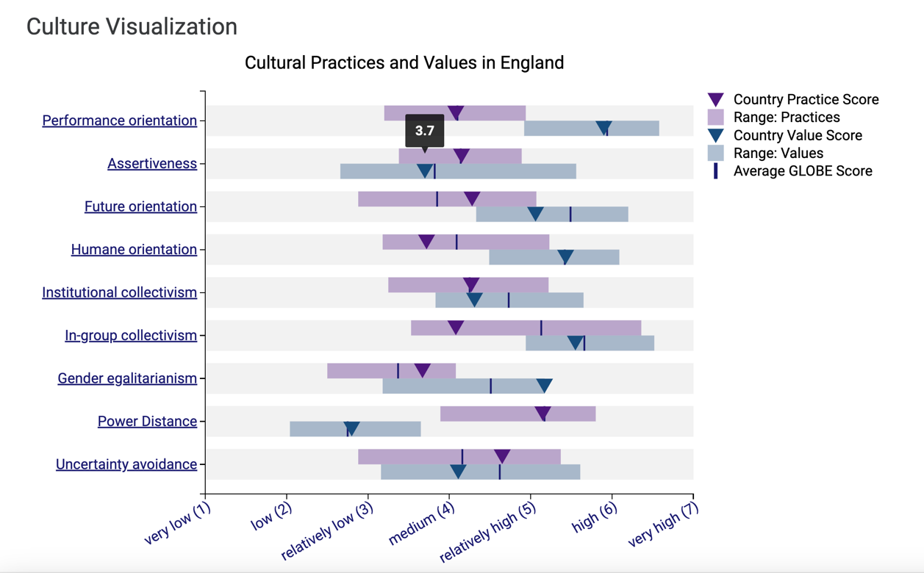
Cultural Practices and Values in England
(Emphasis on Assertiveness CVS: 3.7)
Source: https://globeproject.com/results/countries/GBR%3Fmenu=list.html#list

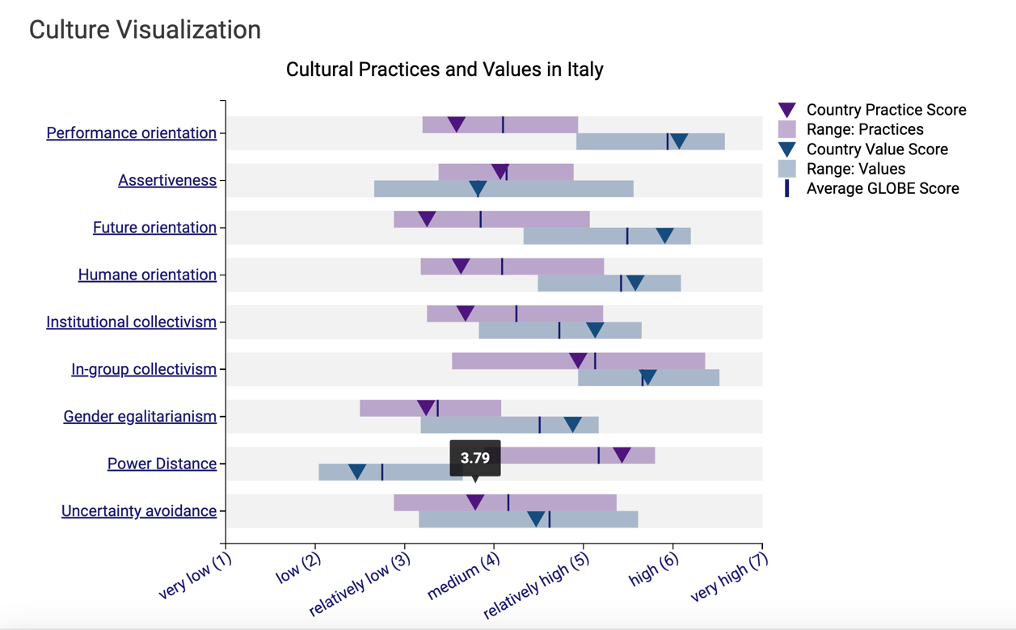
Cultural Practices and Values in England
(Emphasis on Assertiveness CVS: 3.7)
Source: https://globeproject.com/results/countries/ITA%3Fmenu=list.html#list

5. Conclusion
This data shows that Italy’s approach on performance orientation, humane orientation, power distance, and in-group collectivism favours implementation over values, which may show a possible prioritisation of local guests. Also, because of the Power Distance score, Italy's service approach may be more casual and friendly. England, on the other hand, places more emphasis on values themselves.
Overall, both countries seem to have some similar approaches to hospitality, with both countries emphasising good service, caring treatment of guests, and a casual service style.
6. Recommendations
- Service formality: Maintaining a warm environment is important. There might be a need to adjust the service towards a more casual approach.
- In-group collectivism: While welcoming all guests, ensure marketing and service don't inadvertently prioritise Italian guests, which might alienate English clientele.
- Cultural nuances: Cultural sensitivity is needed in communication styles, humour, and expectations to avoid misunderstandings.

References:
- Burton, L., Delvecchio, E., Germani, A., “Individualism/collectivism and personality in Italian and American Groups”, Curr Psychol 40, 29–34 (2021), https://doi.org/10.1007/s12144-019-00584-4.
- Calinaud, V., Kokkranikal, J., & Gebbels, M. (2021). “Career Advancement for Women in the British Hospitality Industry: The Enabling Factors”, Work, Employment and Society, 35(4), 677-695. https://doi.org/10.1177/0950017020967208
- Cazzaniga E., et al. “Eating Out of Home and Risk for Obesity: An Overview", Acta Scientific Nutritional Health, 5.2 (2021): 126-136.
- Tian, G., and Tian, K., "Cross-Cultural Business Communication: An Anthropological Approach Toward Diminishing Geographic Borders", Handbook of Research on Cross-Cultural Business Education, edited by Chandan Maheshkar and Vinod Sharma, IGI Global, 2018, pp. 183-198. https://doi-org.ezproxy.uwtsd.ac.uk/10.4018/978-1-5225-3776-2.ch009
- Koc, E., Cross-Cultural Aspects of Tourism and Hospitality, Routledge
- Özsungur, F., 5W “Principle in Export Incentive”, Cultural Factors and Performance in 21st Century Businesses, edited by Christiansen, B. et al., IGI Global, 2020, pp. 164-185. https://doi-org.ezproxy.uwtsd.ac.uk/10.4018/978-1-7998-3744-2.ch008
- Pandey, S. K. "Organizational Culture and Employee Productivity." Examining Applied Multicultural Industrial and Organizational Psychology, edited by Bryan Christiansen and Angela M. Even, IGI Global, 2023, pp. 58-77. https://doi-org.ezproxy.uwtsd.ac.uk/10.4018/978-1-6684-7212-5.ch004
- Warde, A., Paddock, J., Whillans, J., The social significance of dining out, 2020 Manchester, Manchester University Press.
- https://globeproject.com/results/countries/ITA%3Fmenu=list.html#list
- Alex Roe, “Cultural Differences Between Italian and UK Families”, https://italychronicles.com/culture-1/ (accessed on 20 February, 2024)

Cultural Practices and Values in England, https://globeproject.com/results/countries/GBR%3Fmenu=list.html#list
Ibidem
Ibidem
Ibidem
Ibidem

