
A Reflective Review of my Learning Journey through Personal Development


laura yildiz (1816439)
UNIVERSITY OF WALES TRINITY SAINT DAVID

Table of Contents
Introduction 2
Main Findings 3
Personal Development Overview 3
Self – Awareness 3
Self – Assessment 4
Professional Career Development Skills 6
Learning Styles / Personality Tests 7
Go M.A.D Framework 9
Personal Development Plan 9
Conclusion 12
References 13
Appendices 15

Introduction
The purpose of this assignment is to have a reflective review on my learning journey through personal development to demonstrate my knowledge and understanding of the necessary skills and actions required to establish a successful career within a management role. Throughout the assignment, I will demonstrate my understanding of the various development areas necessary to establishing my employment goals; including self-awareness and self-assessment. Using the knowledge I have acquired so far through my learning journey, I will support my findings by applying some of the following models, techniques and theories to my studies –

- Maslow’s Hierarchy of Needs Theory
- Johari Window Model
- SWOT Analysis
- TOWS Matrix
- VARK & Honey and Mumford Learning Style Questionnaires
- Myers – Briggs Personality Profiling Test
- Personal Development Plan

Professional Career Development is a continual lifelong process which enables individuals to continuously refresh or upgrade their skills and competencies; meaning they can remain current within the ever-changing environment. It provides assistance and guidance through one’s journey, enabling them to set realistic and achievable goals (Management Study Guide, 2019). Through actively applying some of the methods above, the assignment will allow me to highlight the knowledge and skills I have developed so far and underlines the areas I need to maintain focus on, in order to achieve my future objectives.

Main Findings

Personal Development Overview
When beginning my studies on this course, I was still undecided about my definite future career goals. Having already gained a fair amount of knowledge and experience in previous management roles before leaving to raise a family, my main objectives were to expand my knowledge of these skills, develop an understanding of how to improve weaknesses and to study in an industry sector that I was more passionate about and, where my skillset could be fully utilised.

The Professional Career Development module has been a great start to my learning journey and, on reflection, has enabled me to identify my development areas, understand my best approach to learning and how to apply various models, theories and methods to support my personal development. Ultimately, this has assisted me in establishing that the International Travel & Tourism Management sector is the industry I would like to develop into.
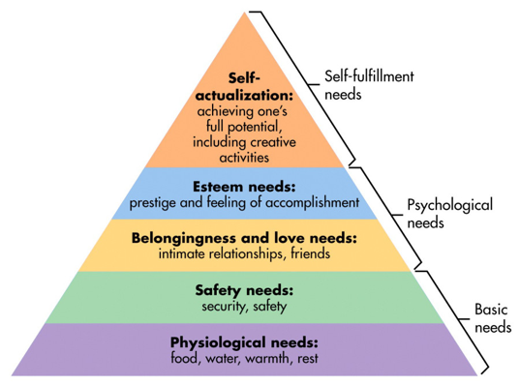
To achieve the best outcome to my learning journey, I first needed to understand what factors drive our motivation to accomplish goals. Being introduced to ‘Maslow’s hierarchy of needs theory’ (1943) gave me an opportunity to become more aware that actually, in order to really drive motivation to achieve my full potential (Self-actualisation), I needed to ensure that first, the basic needs were being reasonably satisfied (McLeod, 2018). I discovered that, by applying this theory to the start of my development journey, I would be able to better approach situations and life experiences that may cause disruption to my progress, ensuring I can maintain a reasonable level of satisfaction within each of the hierarchy tiers. As a result, this has also begun to development my self-awareness; the starting point to my personal development.
Maslow’s Hierarchy of Needs, 1943

Self – Awareness
Self – Awareness is a vital part of personal development as it is about understanding yourself on a deeper level, which enables you to effectively build on, from a more solid base (Cottrell, 2015, p.25). It is the starting point on any learning journey as it can provide us with essential knowledge and information about ourselves; to ensure we can plan ahead effectively. It can highlight our positive and negative traits, areas of improvement and development, and enable us to re-evaluate our needs to make better decisions about our future opportunities and objectives.

With many aspects of our lives, including our happiness, contentment and sense of fulfilment influenced by self – awareness, it is important to take time to reflect on ourselves and identify how we will continue to progress within our development (Cottrell, 2015, p.4).

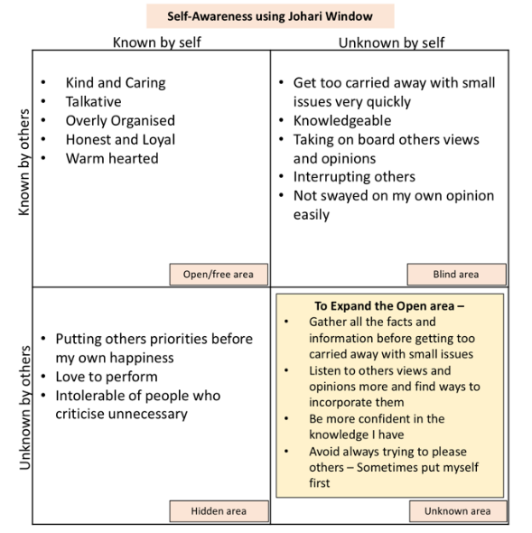
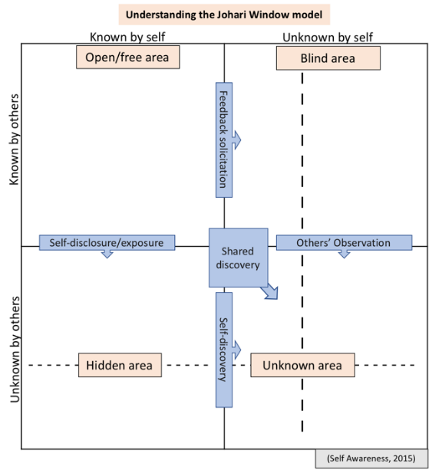
A useful tool that can be applied to understand and improve self – awareness is the Johari window, created my Joseph Luft and Harry Ingham in 1955. The idea behind the model is that by focusing on expanding the arena (open) area, we begin to develop a better understanding of our own self – awareness and how others perceive us. This is achieved by sharing information about ourselves to others, learning about others through information they disclose to us, and receiving feedback regarding our own personal traits. The model is simple to apply to a variety of situations and is a great tool for developing many of our soft skills; including interpersonal development and team working (Self Awareness, 2013).

By learning how to apply the Johari window to myself, I have developed a better understanding of how others perceive me, my areas of improvement and development strategies necessary to continue to expand the arena (open) area; thus, improving my self – awareness. Without such self - awareness, I would be more likely to become disconnected and may find it difficult to maintain confidence, motivation and high levels of energy towards achieving my goals (Cottrell, 2015, p.25).

Self – Assessment
The next part of my learning journey has been self-assessment. This is, a judgement we make about ourselves regarding our qualities, skills and actions. Similarly, an effective self-assessment can also check in on progress made towards set objectives. As a student, it is important to learn how to self-assess efficiently, as it is essential for every personal and career development (Cleverism, 2019).

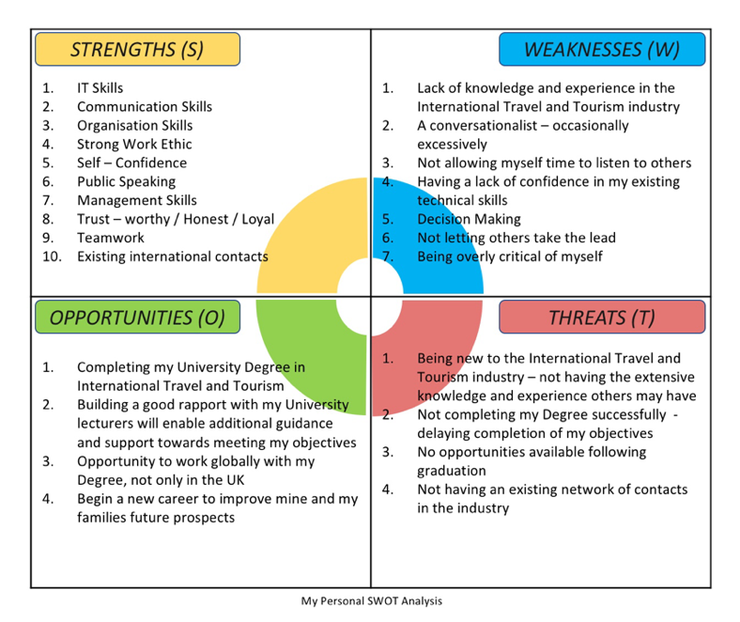
A simple, yet effective way, used for self-assessment‘s, is by applying the SWOT analysis technique, created by Albert Humphrey in the 1960’s. Carrying out a SWOT analysis provides an in-depth focus on capabilities, improvement areas, as well as creating a solid foundation for personal development plans. It is a useful tool for assessing your level of readiness for a new job role or task and can help to efficiently identify the core of an issue quickly (Cottrell, 2015, p.98).

By conducting a SWOT analysis, I was able to highlight my current skill strengths, identify weaknesses or areas of improvement, consider opportunities that could be available and determine potential threats to my development journey.

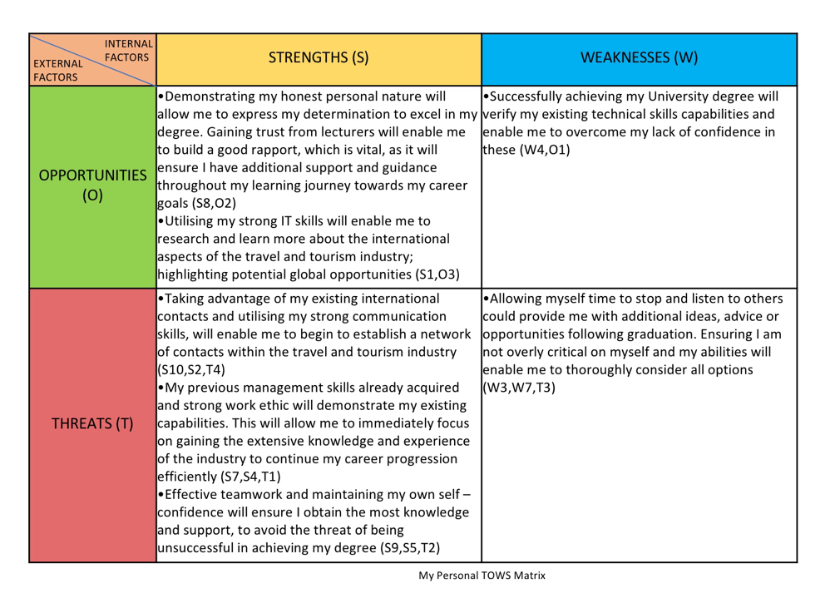
Having gained an understanding of how; by analysing the external factors and my internal factors, and effectively applying conversion strategies to the information from the SWOT analysis; I am able to gather a considerable amount of knowledge to really strengthen my current position.

By utilising my strengths, I can take advantage of opportunities; whilst also enabling me to minimise threats and can use opportunities to overcome weaknesses. As a result of applying the conversion strategies to produce my TOWS matrix (Weihrich, 1982, pp. 54-66), I have achieved a clearer understanding of the necessary course of action to reach my objectives.

Professional Career Development Skills
Although my self-assessment analysis’ provides me with a detailed starting point of my current position, it is vital for my professional career development, to ensure that I analyse my capabilities across all skill areas; particularly those that apply to my future career objectives. The knowledge I have acquired throughout my learning journey, regarding the various skills areas, has become an essential guide towards my development. The table below identifies many of the career development skill areas that should be applied to any development journey.
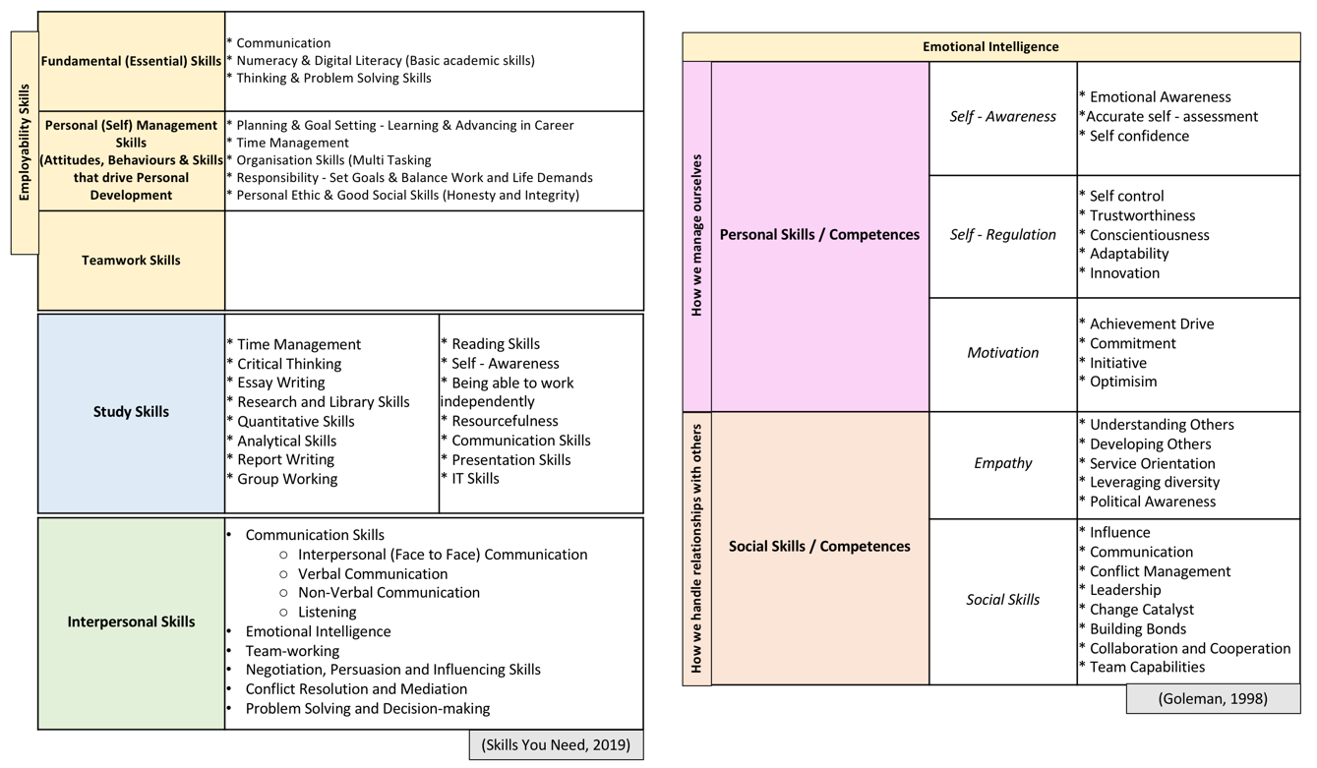
Professional Career Development Skills

The table above provides extensive information of the essential skills areas, however in order to prioritise which development areas to initially focus on, further research was carried out. This included; identifying the top skills employers look for, essential management skills and analysing specific skills vital for the travel and tourism management industry.

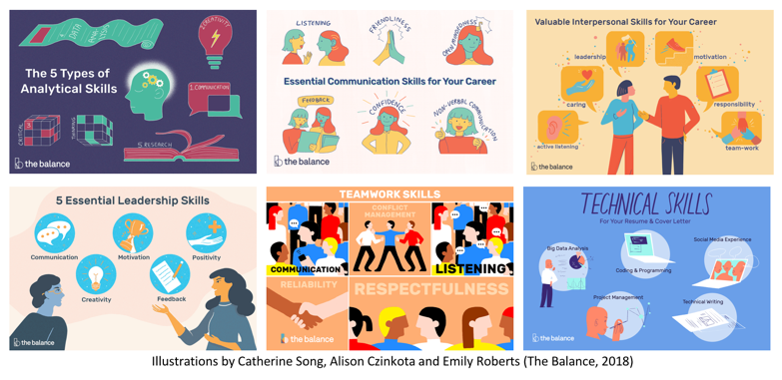
According to ‘The Balance Careers’ (Doyle, 2019), the top skills and attributes employers look for are:

Establishing strong management skills are also a vital part of my personal development. In order to ensure focus is applied on developing the right skills for my objectives, I carried out extensive research into the management skills that most organisations seek. The Corporate Finance Institute’s (2019) article ‘Management Skills’, detailed that management and leadership skills are often interchangeable. Most managers are already good leaders; however, they should also possess the following management skills –

- The 3 Basic types of management skills –
  - Technical Skills
  - Conceptual Skills
  - Interpersonal Skills
- The 6 Essential management skills –
  - Planning
  - Communication
  - Decision-making
  - Delegation
  - Problem-solving
  - Motivating

Lastly, having carried out research to investigate the specific industry skills relevant to my career goals, I established that, according to Top Universities (2016), the following five essential soft skills should be included in my development plans –
- Empathy and Emotional Intelligence
- Teamwork
- Stress and Time Management
- Problem-solving
- Strategy and Innovation

With the information acquired, I have gained a better understanding of my skills gaps that require developing; in order to demonstrate my readiness for employment and avoid being disadvantaged in any way.

Learning Styles / Personality Tests
Understanding my preferred learning style and establishing how my personality is structured would enable me to gain more awareness of the most efficient approach to learning and understand why I react and respond in certain ways; demonstrating my personality type and gaining more self-awareness. The introduction of ‘learning style questionnaires’ and ‘personality tests’, has provided a greater understanding of these areas.

To extract the most valuable information, I undertook two learning style questionnaires; VARK questionnaire, created by Neil Fleming in 1987, and Honey and Mumford questionnaire (Honey and Mumford, 1992). Both questionnaires adapted the same approach, consisting of multiple questions and, based on responses, provided results of preferred learning style. VARK’s results focus on the preferred method of learning, whilst Honey and Mumford provides an insight into the type of learner.

- The VARK results (Appendix 1) established two preferred methods of learning; Aural/Auditory (A) and Read/Write (R). These preferences mean the most effective learning is achieved by; information being verbally heard and discussed (A), or information being displayed as words (R) (VARK Learn Limited, 2019).

- The Honey and Mumford result (Appendix 2) established that the type of learner I am is a Theorist. In summary, this learning style is preferred by individuals who are logical thinkers, they prefer structured situations with clear purpose and have a low intolerance of uncertainty. Theorists prefer to understand the theory behind the actions and need models and statistics to engage in the learning process (University of Leicester, 2019).

The personality profiling tests apply a similar approach to the learning style questionnaires, however this time, the outcomes provide a clearer insight into our personality structures. The test I carried out was Myers Briggs Type Indicators, created in 1942, and is designed to help people identify their psychological type preferences by how they perceive the world and make decisions (The Myers & Briggs Foundation, 2019).

- The Myers Briggs result (Appendix 3) identified my personality profiling type as ESFJ, part of the Sentinels (Consul) category. This personality type describes individuals as “Extraordinarily caring, social and popular people, always eager to help” (16 Personalities, 2019)

The outcomes provided accurate representations of my personality type and preferred learning styles. The benefits gained from learning about these is the information that is provided for each category group. It provides guidance and ideas for the most effective method to learning; which will enable me to adjust my approach going forward.

Go M.A.D Framework
During my learning journey, I have also been introduced to the Go M.A.D Thinking model, developed by Andy Gilbert and Ian Chakravorty in 1997. The purpose of the model was “to improve the world through better thinking” (Go MAD Thinking, 2019) and create a framework that was results focused. The model was designed to be a straightforward model, providing simple explanations, clear communications and inspire people to make a difference (Go MAD Thinking, 2019). Applying the framework to my own objective has provided a clear pathway to achieve great success.

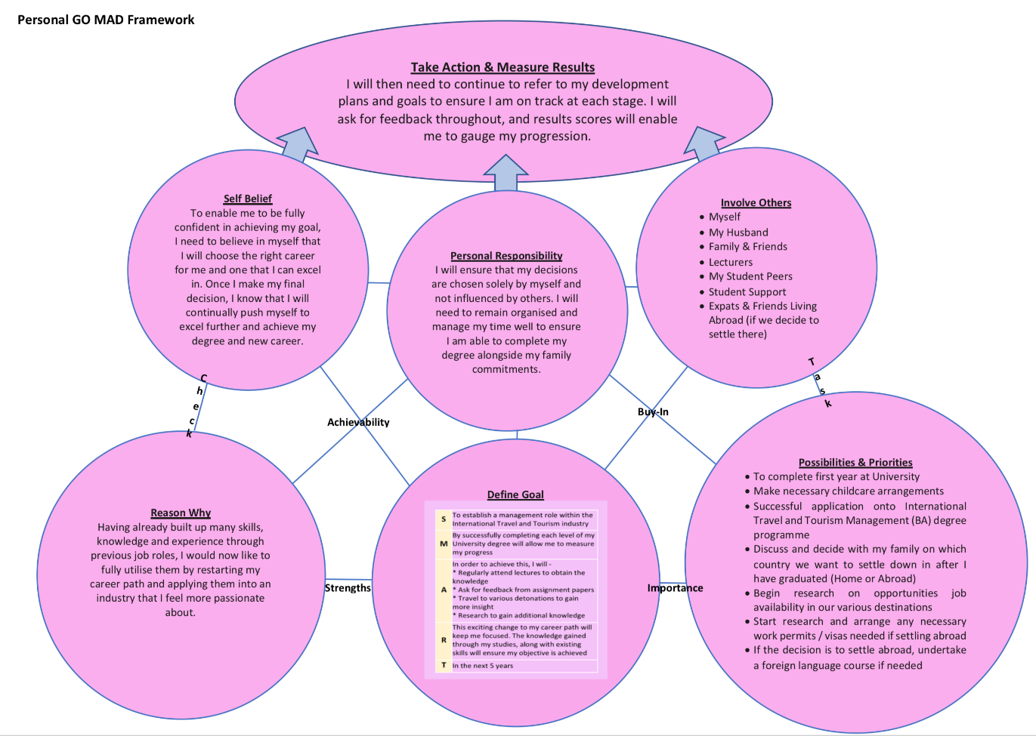

Personal Development Plan
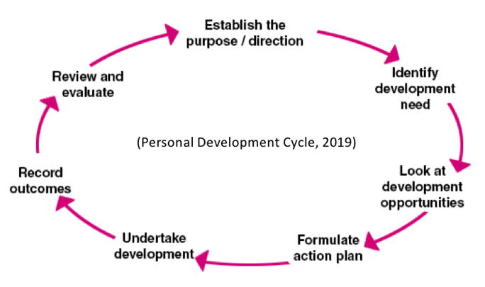
A Personal Development Plan is a detailed document of self-analysis, personal reflection and honest appraisal, drawing attention on strengths and weakness. It should include all the appropriate steps needed to access the best opportunities in the future and to achieve objectives. A PDP needs be personal and include all aspects of life; studies, values, careers and future. It allows us to go through a journey, exploring many options and possibilities, so requires continual reflection, as we learn new knowledge, experience and skills through studies; meaning things can regularly change (Cottrell, 2015, p.4). The Personal Development Cycle (Managers, 2019), is an effective tool that can be used as a guide when producing a personal development / action plan.

PERSONAL DEVELOPMENT PLAN
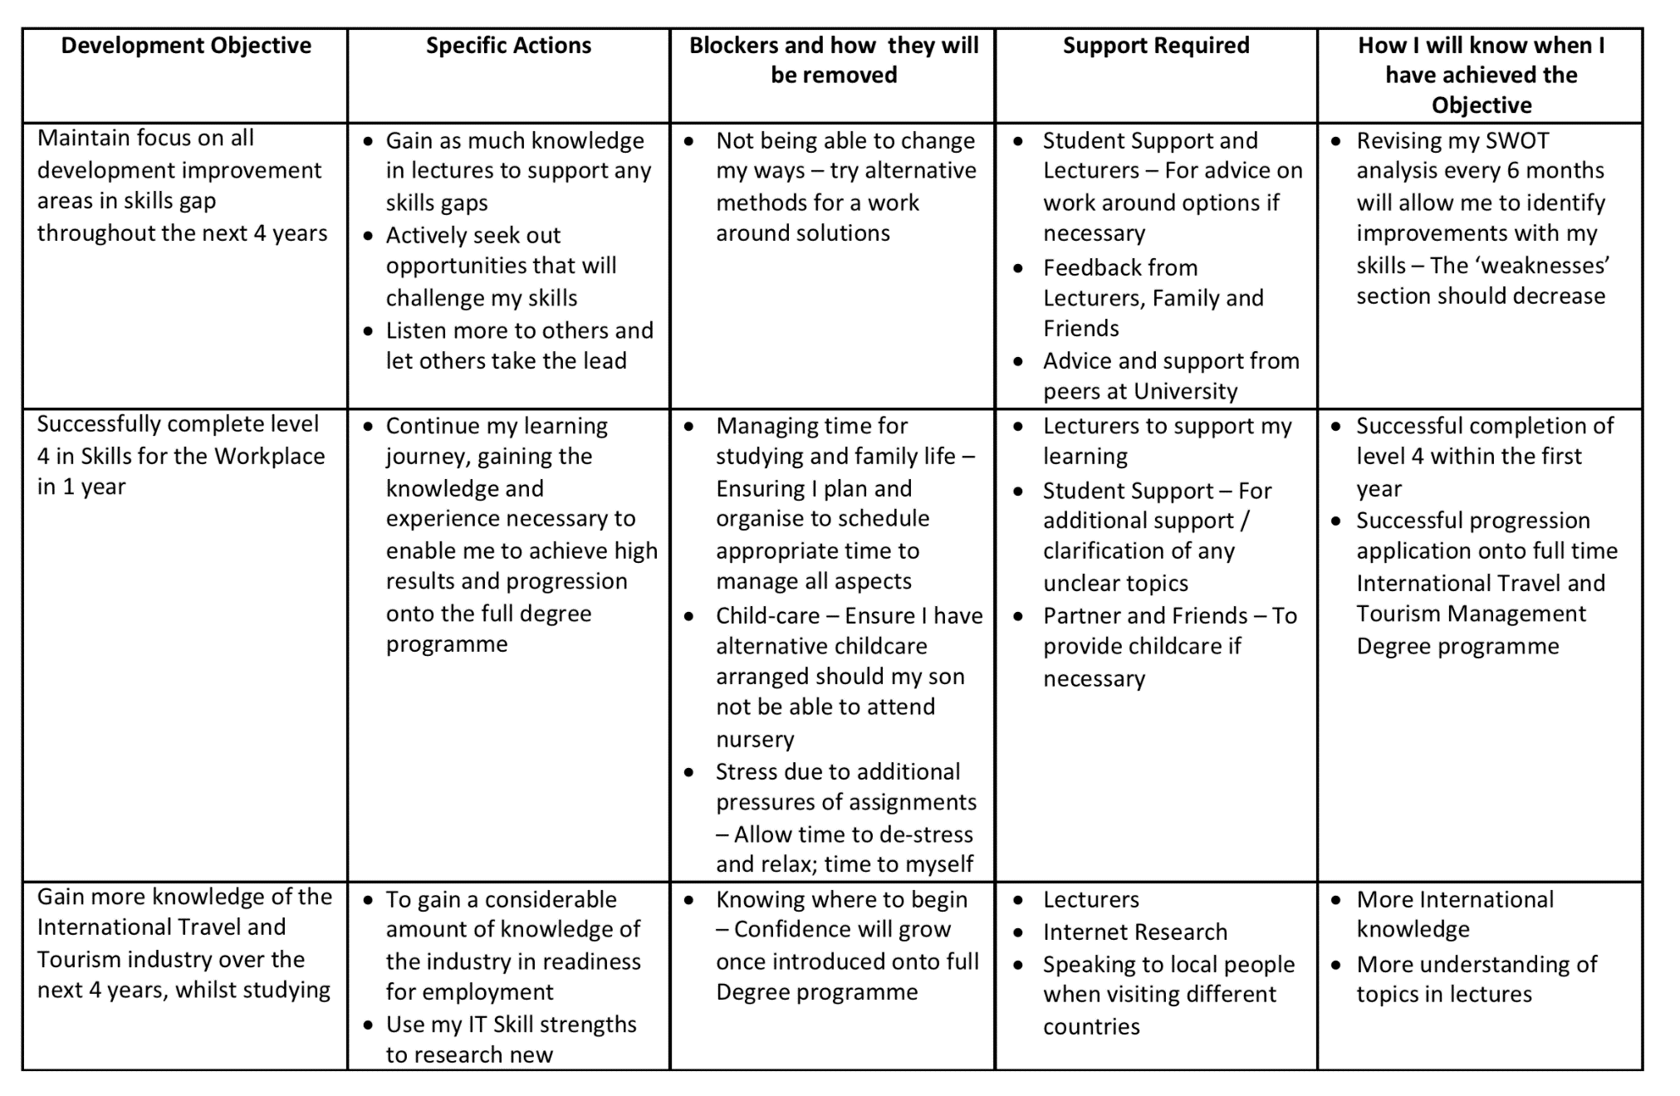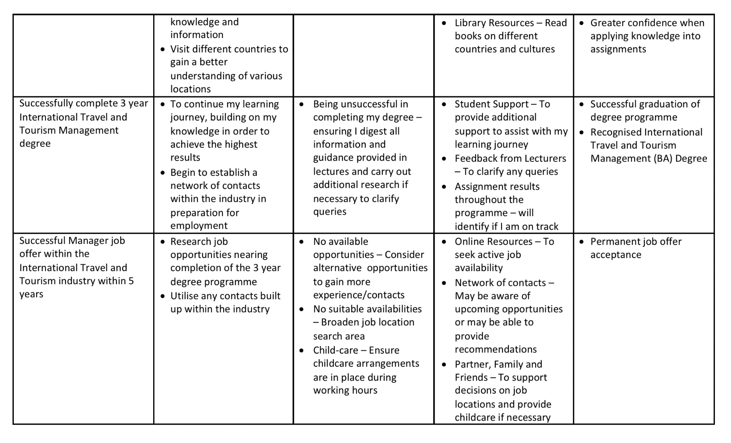

Conclusion
In conclusions, by reflecting on my learning journey so far, I have identified that, in order to achieve great success in meeting my objectives, an important course of action is to go through each stage of the development process. This reflection has enabled me to identify where my key development areas are and the most effective methods of approaching them.

The knowledge I have gained during my learning journey has allowed me to benefit from the best resources and support available, gain new useful knowledge and guidance to support with my development journey and learn previously unknown methods and models which can be applied to provide a much clearer, more realistic way of developing objectives, and ultimately achieving them.

References

Cleverism (2019) Self-assessment. Available at: https://www.cleverism.com/skills-and-tools/self-assessment/ (Accessed: 18th June 2019).

Corporate Finance Institute (2019) Management Skills. Available at: https://corporatefinanceinstitute.com/resources/careers/soft-skills/management-skills/ (Accessed: 14th June 2019).

Cottrell, S. (2015) Skills for Success: Personal Development and Employability. 3rd Ed. Basingstoke: Palgrave Macmillan.

Doyle, A. (2019) Top Skills and Attributes Employers Look For. Available at: https://www.thebalancecareers.com/top-skills-employers-want-2062481 (Accessed: 14th June 2019).

Goleman, D. (1998) Working with Emotional Intelligence. New York: Bantam Books.

Go MAD Thinking (2019) Visions and Values. Available at: https://www.gomadthinking.com/about/our-vision-values/ (Accessed: 16th June 2019).

Honey, P. And Mumford, A. (1992) The manual of learning styles. 3rd Ed. Maidenhead: Honey.

Management Study Guide (2019) Importance of Career Development. Available at: https://www.managementstudyguide.com/importance-of-career-development.htm (Accessed: 19th June 2019).

Managers (2019) Personal Development Planning. Available at: https://www.managers.org.uk/knowledge-bank/personal-development-planning?sc_trk=follow%20hit,{86CB756B-AB02-44E6-995A-305C69252B29},PDP (Accessed: 19th June 2019).

Maslow, A.H. (1943) A Theory of Human Motivation. Midwest Journal Press

McLeod, S. (2018) Maslow’s Hierarchy of Needs. Available at: https://www.simplypsychology.org/maslow.html (Accessed: 18th June 2019).

Self Awareness (2015) Understanding the Johari Window model. Available at: http://www.selfawareness.org.uk/news/understanding-the-johari-window-model (Accessed: 15th June 2019).

Skills You Need (2019) Interpersonal Skills. Available at: https://www.skillsyouneed.com/interpersonal-skills.html (Accessed: 13th June 2019).

Song, C. and Czinkota, A. and Roberts, E. (2018) Top Skills and Attributes Employers Look For [Illustrations]. Available at: https://www.thebalancecareers.com/analytical-skills-list-2063729 (Accessed: 14th June 2019).

The Myers & Briggs Foundation (2019) MBTI Basics. Available at: https://www.myersbriggs.org/my-mbti-personality-type/mbti-basics/ (Accessed: 19th June 2019).

Top Universities (2016) 5 Essential Soft Skills for Careers in Hospitality and Tourism. https://www.topuniversities.com/student-info/careers-advice/5-essential-soft-skills-careers-hospitality-tourism (Accessed: 16th June 2019).

University of Leicester (2019) Honey and Mumford. Available at: https://www2.le.ac.uk/departments/doctoralcollege/training/eresources/teaching/theories/honey-mumford (Accessed: 19th June 2019).

VARK Learn Limited (2019) The VARK Modalities. Available at: http://vark-learn.com/introduction-to-vark/the-vark-modalities/ (Accessed: 19th June 2019).

Weihrich, H. (1982) ‘The TOWS Matrix – A tool for situational analysis’, Long Range Planning, 15(2), pp. 54 – 66. DOI: https://doi.org/10.1016/0024-6301(82)90120-0

16 Personalities (2019) Personality Types. Available at: https://www.16personalities.com/personality-types (Accessed: 15th June 2019).

Appendices
Appendix 1
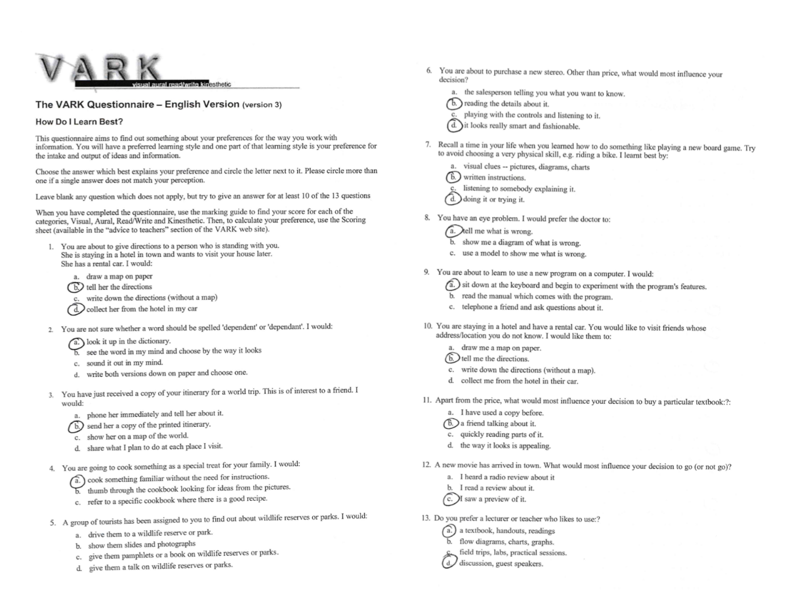
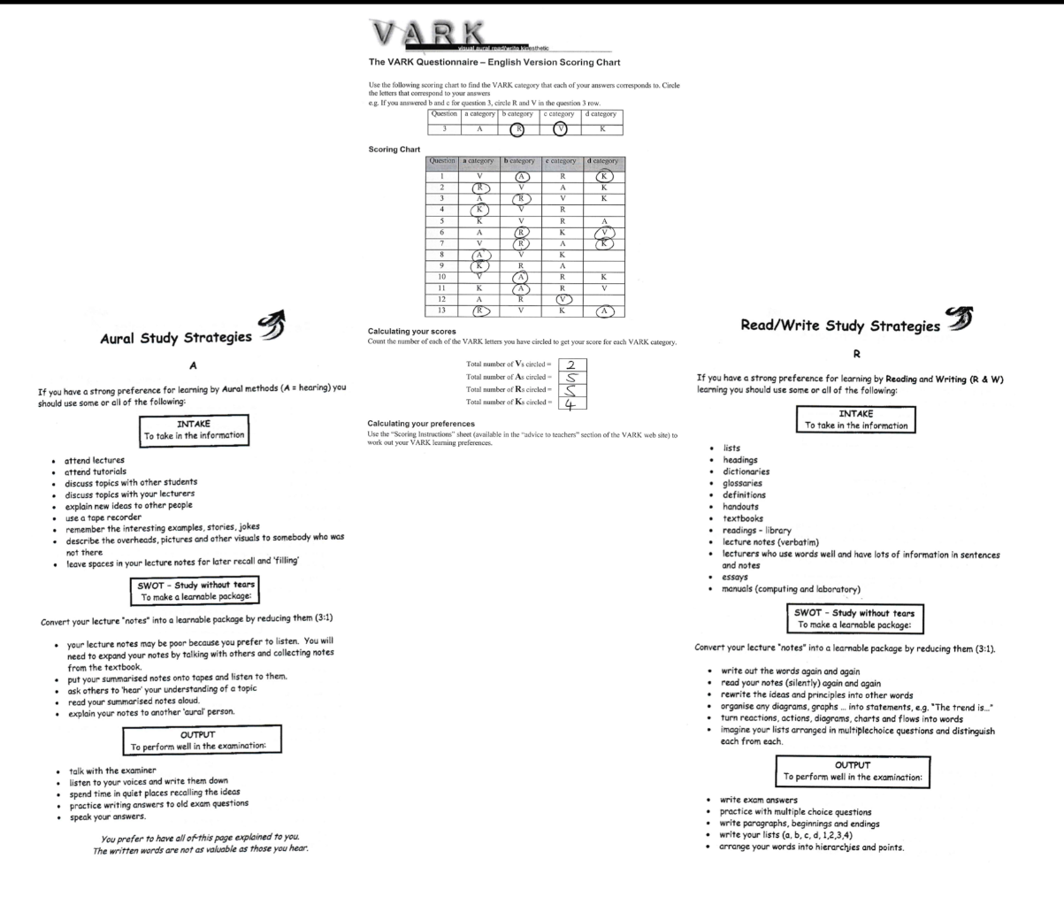

Appendix 2
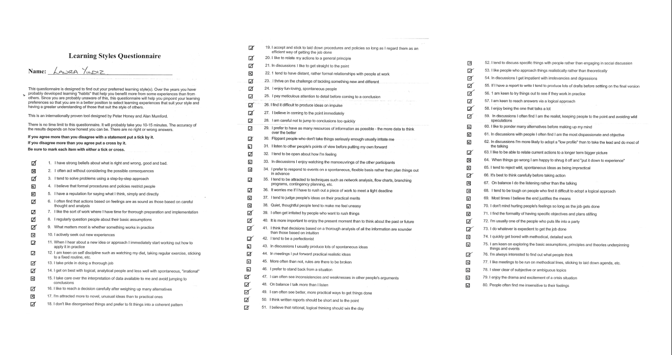
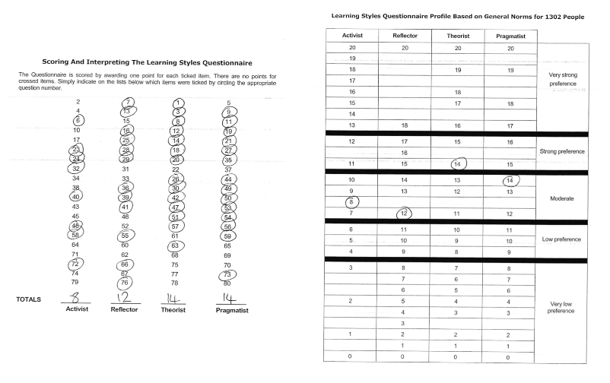
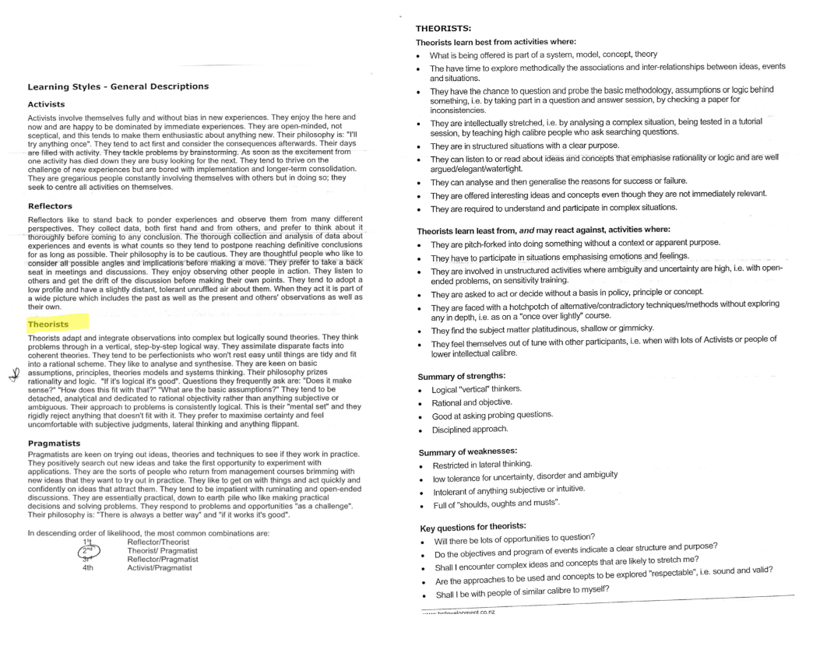
Appendix 3


